PROJECT MANAGEMENT

Module Code: LCLM5003_LON

A Project Portfolio: Reopening of Highway after the West Midlands Floods
Submitted by: Polina Sakhnevych
Student ID: 2417381 Lecturer:
Lecturer: Sukhpreet Grewal

PROJECT MANAGEMENT 1
Module Code: LCLM5003_LON 1
A Project Portfolio: Reopening of Highway after the West Midlands Floods 1
Part A: Project Portfolio Poster 3
Part B: Reflection on Feedback 3
Part C: Project Management Plan 5
1. Introduction 5
2. Project Description 5
3. Scope 6
3.1 In-Scope Activities 6
3.2 Out-of-Scope Activities 6
3.3 Project Objectives 6
4. Work Breakdown Structure 6
4.1 Assessment and Survey 7
4.2 Clearance Operations 7
4.3 Repair and Reconstruction 7
4.4 Final Inspection and Reopening 7
5. Quad Chart 7
6. Gantt Chart 8
7. Stakeholders' Involvement 9
8. Allocation of Resources 11
9. Risk Analysis 12
10. Conclusion 14
11. References 15

List of Figures and Tables

- Figure 1: Gantt Chart of the five-week project schedule
- Table 1: RACI matrix of project work packages and role groups
- Table 2: Risk register with concrete mitigation actions

Part A: Project Portfolio Poster
The poster presented at the Week 6 pitch is reproduced below. It was developed for the original pitch and is included unchanged so that the reflection in Part B can be read against the work that received the feedback. The improvements identified through that feedback are reflected in Part C.

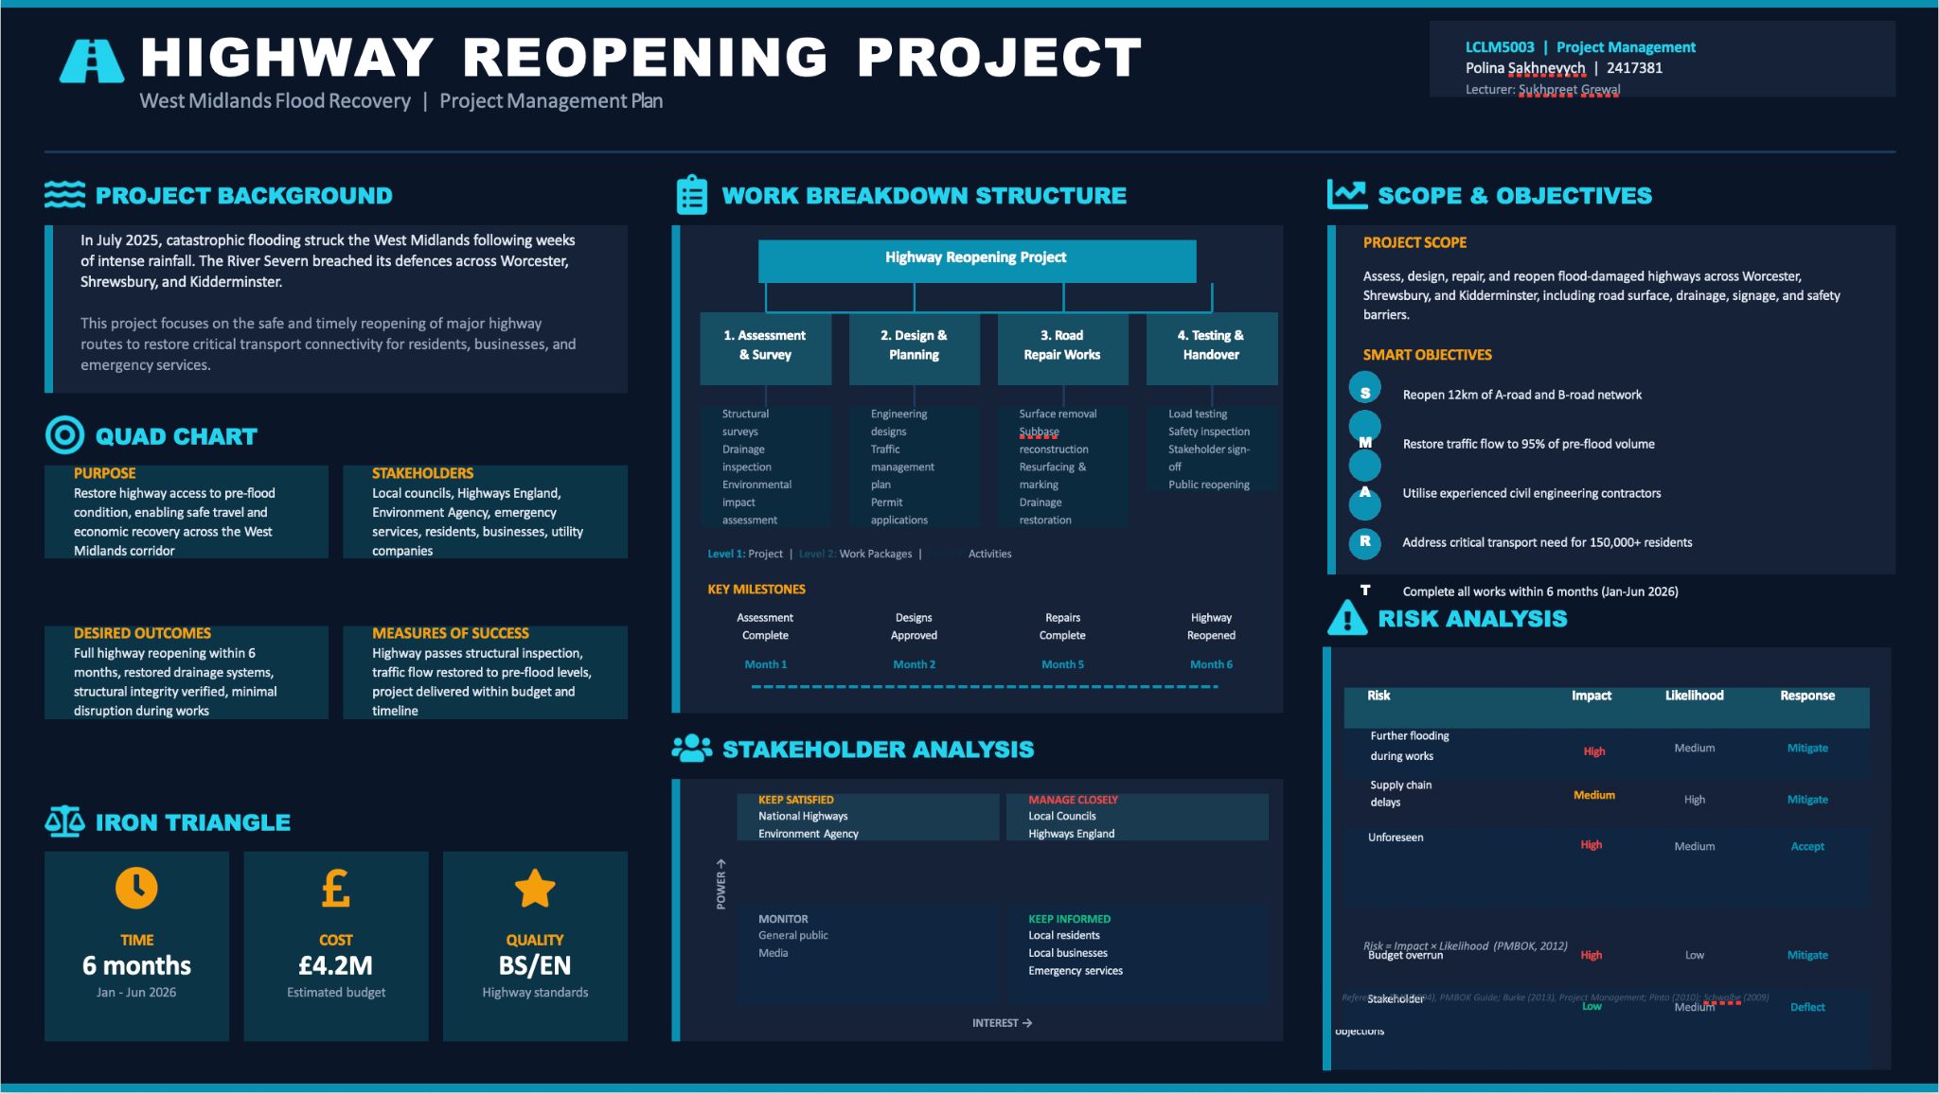

Figure A1: Project Portfolio Poster as pitched in Week 6

Part B: Reflection on Feedback
The feedback received from the tutor and peers during the Week 6 poster pitch provides valuable direction for strengthening the final project management plan. The discussion identified clear strengths alongside several areas requiring further development before final submission.

The Quad Chart was acknowledged as conveying the key project parameters effectively, with strong alignment between purpose, stakeholders, desired outcomes and measures of success. The Work Breakdown Structure attracted no critical comment, suggesting that the three-level decomposition communicates the project's components clearly. The scope statement and SMART objectives were broadly accepted, and the Mendelow power-interest grid was recognised as the right stakeholder tool, even where the population required expansion.

The most significant challenge concerned the proposed six-month timeframe. The tutor noted that the project is framed as emergency repair of approximately twelve kilometres of carriageway, not a reconstruction or replacement programme. A six-month duration is therefore difficult to defend in an emergency recovery context, where rapid restoration of mobility is itself part of the value the project delivers. The final plan addresses this by adopting a five-week schedule, justified through a phased approach combining assessment, clearance, repair and reopening, supported by overlapping activities and contingency provisions.

The absence of a Gantt Chart on the poster was a clear omission. The tutor was explicit that progression and dependency cannot be communicated through milestone bullets alone. The final plan therefore includes a developed Gantt Chart showing weekly task breakdowns, predecessor logic and overlapping activities across the four phases.

Stakeholder coverage on the poster was incomplete. Suppliers, contractors, utility providers and insurers were not represented. In addition, National Highways and Highways England appeared in two separate quadrants, although these refer to the same organisation following the 2021 rebrand. The final plan consolidates this and expands the stakeholder population, with a full Mendelow analysis and a supporting RACI matrix.

The risk register on the poster relied on single-word response labels such as "Mitigate" or "Accept" without specifying mitigation actions. The tutor emphasised that the risk analysis exists to protect the iron triangle, since budget, schedule, quality and scope are non-negotiable. The final plan rewrites each risk response as a concrete action plan, identifying triggers, owners and tolerances rather than category labels.

The feedback also highlighted that the absence of a RACI matrix made it difficult to identify who is responsible, accountable, consulted and informed across the work packages. The final plan corrects this by introducing a RACI matrix aligned to the work breakdown structure, with the project manager as the consistent accountable role across all phases.

The feedback collectively reinforced that strong tools require equally strong analytical commentary, and that descriptive use of project frameworks is not the same as critical application. The final plan therefore prioritises critical justification, defensible scheduling, comprehensive stakeholder management, specific risk responses and explicit accountability.

Part C: Project Management Plan

1. Introduction
Severe weather events place exceptional demands on transport infrastructure, particularly when flooding compromises the integrity of strategic road networks (Environment Agency, 2024). In July 2025, an unusual Atlantic weather system delivered weeks of intense rainfall across the West Midlands, raising the River Severn to critical levels. Defences breached at multiple points across Worcester, Shrewsbury and Kidderminster. Streets were submerged, electricity networks failed, and several principal road corridors were closed to traffic.

This project management plan sets out a structured response to one element of the recovery effort: the emergency reopening of approximately twelve kilometres of A-road and B-road network connecting the three affected towns. The plan applies established project management principles drawn from the APM Body of Knowledge (APM, 2023) and the PMBOK Guide (PMI, 2021) to deliver a defensible, time-bound and cost-controlled response.

The plan is organised around the eleven elements specified in the assessment brief. It defines the project scope, decomposes the work into a structured breakdown, presents a Quad Chart and a five-week Gantt Chart, identifies and analyses stakeholders, allocates resources, examines risks with concrete mitigation actions, and concludes with reflections on critical success factors. The treatment throughout is intended to be analytical rather than descriptive, recognising that tools alone do not deliver projects.

2. Project Description
The project addresses the emergency reopening of a flood-damaged highway corridor in the West Midlands following the July 2025 flooding. The corridor comprises approximately twelve kilometres of carriageway across A-road and B-road sections linking Worcester, Shrewsbury and Kidderminster. The corridor carries commuter, freight and emergency service traffic on an average of forty thousand daily movements. Closure has therefore generated significant secondary disruption, including diverted freight, delayed emergency response times and economic loss to local businesses (National Highways, 2023).

Damage profiling indicates four principal failure modes. The carriageway surface has been undermined by sustained water saturation, with confirmed scouring and pothole formation across multiple sections. Drainage culverts and gullies are blocked or collapsed. Embankments show evidence of slippage on three sections. Roadside furniture, including signage, barriers and lighting, has been displaced or destroyed.

The project objective is to restore the corridor to a fully operational and inspected condition within five weeks, at a budget of £4.2 million. The plan adopts a phased approach comprising assessment, clearance, repair and reopening, with deliberate overlap between activities to compress the schedule without compromising safety. The phased structure also enables progressive reopening of less damaged sections, reducing the duration of full closure for road users (Lock, 2020).

The project is framed as emergency repair, not reconstruction or replacement. Burke (2023) emphasises that the framing of a project's nature is one of the most consequential planning decisions, since it determines the standards, procurement approach and regulatory pathway. The reframing from a six-month reconstruction to a five-week emergency repair therefore has implications well beyond the schedule, including expedited procurement under the Procurement Act 2023 emergency provisions and temporary regulatory consents from the Environment Agency.

3. Scope
A clearly defined scope is essential to controlling cost, schedule and quality in any infrastructure project (Kerzner, 2022). The scope of this project is bounded as follows.

3.1 In-Scope Activities
The in-scope activities are: structural and geotechnical surveys of the affected carriageway and embankments; clearance of debris, residual water and obstructions; repair and resurfacing of damaged carriageway sections; restoration of drainage capacity to pre-flood standards; reinstatement of signage, road markings, barriers and lighting; safety inspection, certification and a phased return to public traffic.

3.2 Out-of-Scope Activities
The following are explicitly out of scope: long-term flood defence redesign or capital investment in flood mitigation infrastructure; capacity expansion of the highway network, including widening or new junctions; aesthetic, landscaping or non-essential improvements; insurance settlement administration with affected parties.

3.3 Project Objectives
The project objectives are framed using SMART criteria. The corridor will reopen to twelve kilometres of carriageway within five weeks of project commencement. Traffic flow will be restored to ninety-five per cent of pre-flood volume on reopening. Civil engineering contractors with confirmed Sector Scheme accreditation will be engaged. The project will serve approximately one hundred and fifty thousand residents and the local freight economy, with completion targeted within the period February to March 2026.

4. Work Breakdown Structure
The Work Breakdown Structure (WBS) decomposes the total scope into manageable work packages, supporting clear allocation of responsibility and progress measurement (Maylor and Turner, 2022). The structure adopted has three levels: project, phase and activity.

4.1 Assessment and Survey
This phase establishes the technical foundation for repair design. Activities comprise a structural survey of carriageway and bridges, a geotechnical inspection of embankments and subgrade, a drainage system condition assessment, and an environmental impact screening to identify protected habitats or species affected by works.

4.2 Clearance Operations
This phase restores safe access. Activities comprise debris removal, residual water pumping, drainage clearance, and the establishment of site safety perimeters and traffic management diversions for the works period.

4.3 Repair and Reconstruction
This is the largest phase by cost and duration. Activities comprise carriageway resurfacing including subbase reinstatement where required, embankment stabilisation, drainage rehabilitation, utility coordination with electricity and telecommunications providers, and reinstatement of road furniture.

4.4 Final Inspection and Reopening
The closing phase verifies quality and manages the controlled return to traffic. Activities comprise load and structural testing, regulatory certification under the Design Manual for Roads and Bridges, public communication on reopening schedules, and a phased reopening managed through traffic control points.

The WBS deliberately stops at activity level rather than descending to task level. This supports the project manager in delegating effectively to package leads while retaining clarity at the planning, monitoring and reporting tiers (Pollack and Adler, 2021). Each activity rolls up to a phase deliverable, and each phase deliverable rolls up to the project objective.

5. Quad Chart
The Quad Chart provides a one-page summary of the project on four dimensions, supporting executive communication and rapid alignment among stakeholders (PMI, 2021).

The purpose is to restore the West Midlands highway corridor to a safe, fully inspected operational condition, supporting community recovery, emergency service access and economic continuity.

The principal stakeholders are Worcestershire and Shropshire County Councils, National Highways, the Environment Agency, civil engineering contractors, utility providers, insurers, the emergency services, residents and businesses along the affected corridor, and the travelling public.

The desired outcomes are full reopening within five weeks, restoration of drainage capacity to pre-flood performance, verified structural integrity to current highway standards, and minimal disruption during works through phased delivery.

The measures of success are independent passing of structural and safety inspections on first submission, restoration of traffic flow to ninety-five per cent of pre-flood volume, delivery within the £4.2 million budget envelope, and zero reportable safety incidents during the works period.

6. Gantt Chart
The schedule compresses the four phases into a five-week window through deliberate overlap of activities. Figure 1 presents the Gantt Chart for the project, showing weekly task breakdowns and predecessor relationships.

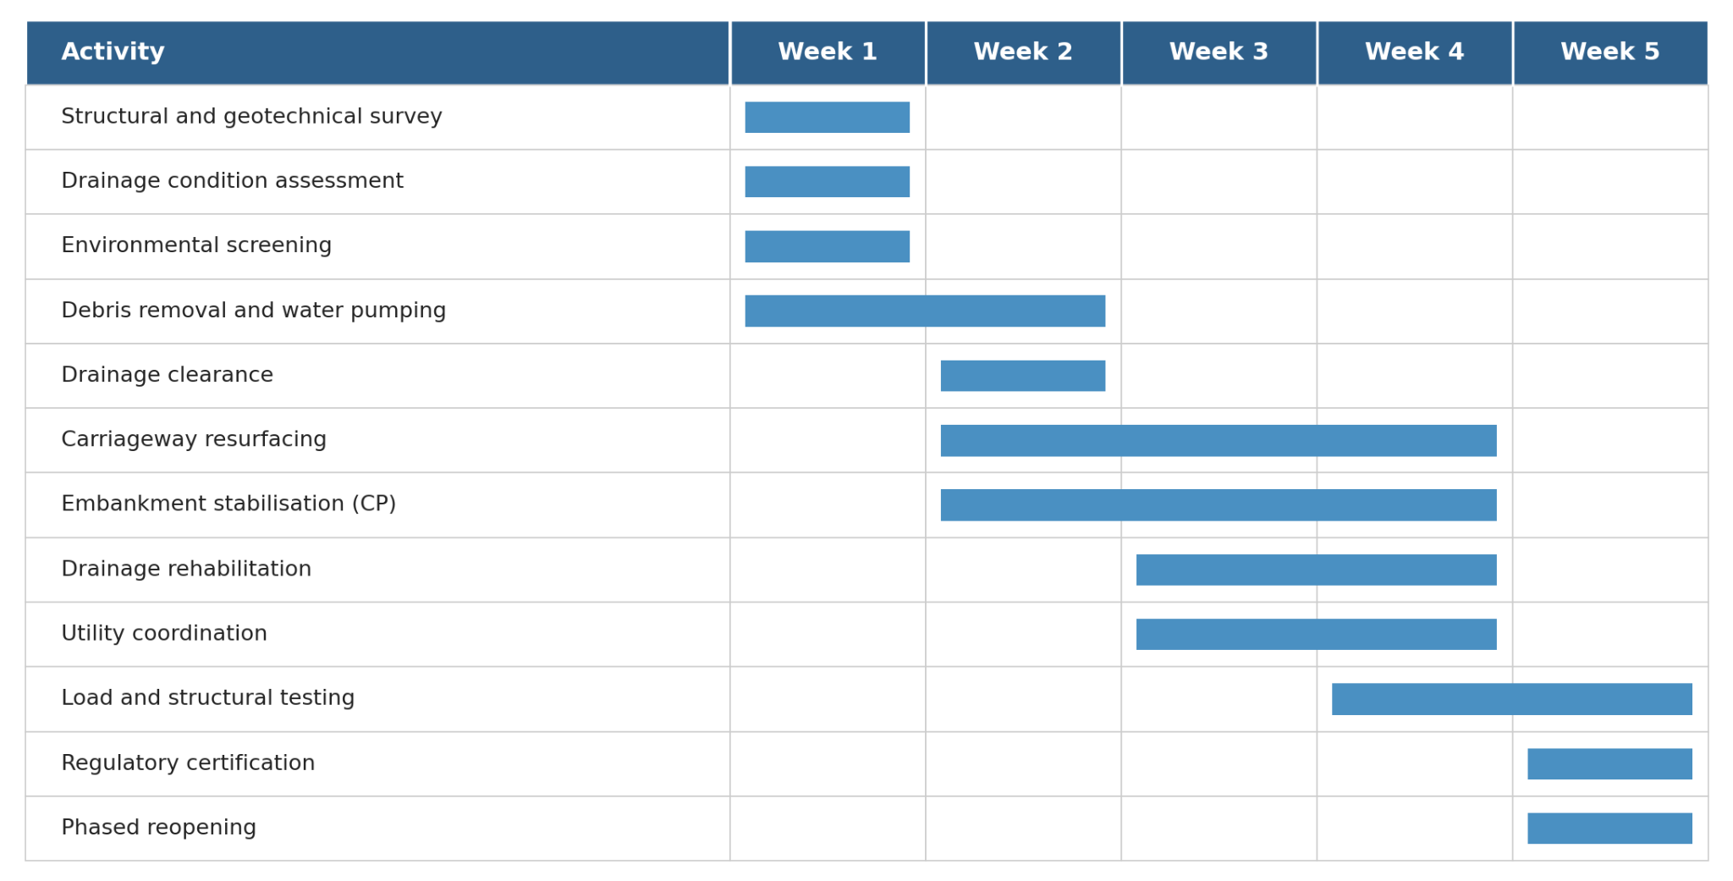

Figure 1: Gantt Chart of the five-week project schedule. CP marks the critical path activity.

Week 1 is dedicated to the assessment phase, with structural, geotechnical and drainage surveys progressing in parallel. Clearance operations begin partway through Week 1, allowing safe access to be established as soon as priority survey points have been recorded. Clearance continues through Week 2.

Repair and reconstruction begins in Week 2 on those sections where clearance and survey are complete, and continues through Week 4. Drainage rehabilitation overlaps with carriageway resurfacing where physical separation of works permits. Utility coordination is sequenced to avoid double-handling of the carriageway.

Final inspection and reopening occupies Weeks 4 and 5. Load and structural testing begins on completed sections from the end of Week 3, with regulatory certification and phased reopening completed by the end of Week 5. The critical path runs through the embankment stabilisation activity within the repair phase, and is monitored daily by the project manager.

7. Stakeholders' Involvement
Effective stakeholder management requires both identification and structured engagement (Turner, 2020). Stakeholders are mapped using the Mendelow power-interest grid, then accountability is defined through a RACI matrix.

In the high power, high interest quadrant sit Worcestershire and Shropshire County Councils, National Highways and the emergency services. These stakeholders are managed closely, through weekly project board meetings and continuous communication.

In the high power, low interest quadrant sit the Environment Agency and primary contractors. These are kept satisfied through scheduled regulatory submissions, contract performance reporting and monthly review meetings.

In the low power, high interest quadrant sit residents, local businesses and community organisations along the affected corridor. These are kept informed through council communication channels, site signage, social media and a dedicated project webpage.

In the low power, low interest quadrant sit utility providers, insurers, and the wider travelling public outside the immediate corridor. These are monitored through standard sector communication channels.

The classification of National Highways as a single organisation is deliberately corrected from earlier mapping, since Highways England rebranded as National Highways in 2021 and operates as a single entity (Department for Transport, 2024).
Table 1: RACI matrix of project work packages and role groups. R = Responsible, A = Accountable, C = Consulted, I = Informed.

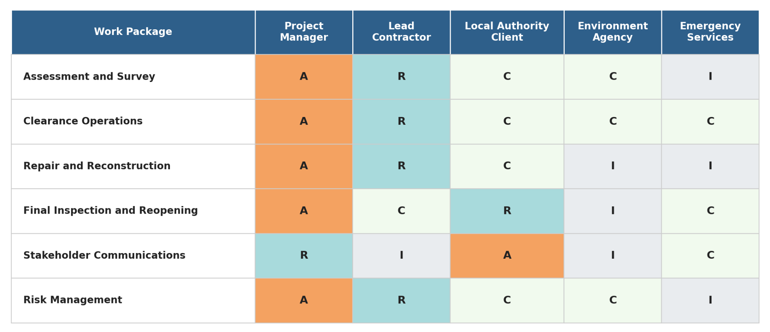

Table 1 presents the RACI matrix mapping the four principal work packages against five core role groups: the project manager, the lead contractor, the local authority client, the Environment Agency and the emergency services. The matrix clarifies that the project manager is accountable for all phases, while responsibility passes to the lead contractor for clearance and repair, and to the local authority client for the final reopening.

8. Allocation of Resources
Resource allocation balances the competing demands of time, cost and quality across the project (Hillson, 2022). The project draws on three categories of resource: human, physical and financial.

Human resources include a project manager, a deputy project manager, two site engineers, a structural specialist, a drainage specialist, an environmental advisor, a stakeholder communications lead, and contractor crews provided by the appointed civil engineering firm. A research and analytics function supports the project manager with progress reporting and earned value analysis.

Physical resources include surfacing materials, drainage components, signage and barriers, and a plant fleet comprising excavators, pavers, rollers, compactors, water pumps and traffic management equipment. Materials are pre-ordered against a rolling forecast to compress lead times.

The £4.2 million financial allocation is structured approximately as follows: forty per cent for surfacing and structural works, twenty per cent for drainage rehabilitation, fifteen per cent for clearance and traffic management, ten per cent for assessment and certification, ten per cent for project management and overhead, and five per cent for contingency held by the project manager. Monthly cost reporting is performed against earned value, with variance thresholds triggering escalation to the project board.

9. Risk Analysis
The risk analysis protects the iron triangle of cost, schedule and quality, recognising that none of these is negotiable in an emergency repair context (Hillson, 2022; Cabinet Office, 2023). Five principal risks are identified, with concrete mitigation actions specified rather than category labels. Table 2 presents the full risk register.

Table 2: Risk register with concrete mitigation actions, owners and tolerances.

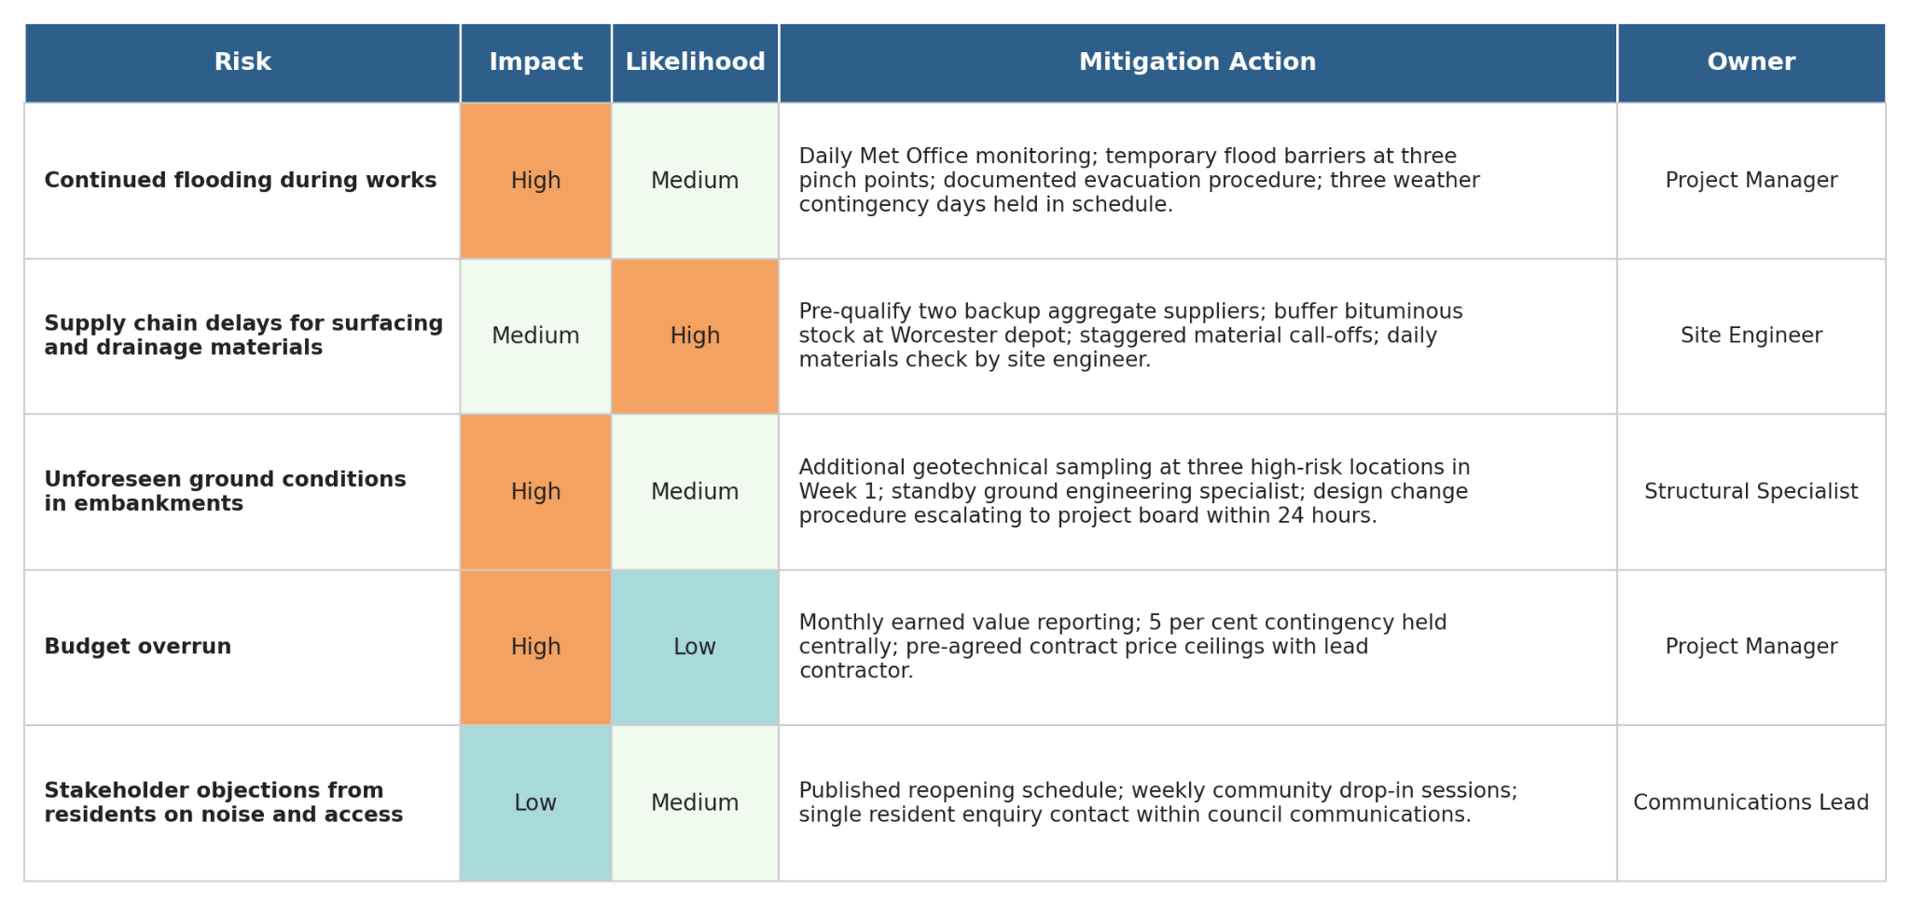

Continued flooding during works presents a high-impact, medium-likelihood risk. The mitigation comprises daily Met Office forecast monitoring, deployment of temporary flood barriers at three identified pinch points, a documented site evacuation procedure, and the inclusion of three weather contingency days within the schedule.

Supply chain delays for surfacing and drainage materials present a medium-impact, high-likelihood risk. The mitigation comprises pre-qualification of two backup aggregate suppliers, a buffer stock of bituminous material held at the Worcester depot, staggered material call-offs across the four phases, and a daily materials status check by the site engineer.

Unforeseen ground conditions, particularly in embankment sections, present a high-impact, medium-likelihood risk. The mitigation comprises additional geotechnical sampling at three identified high-risk locations during Week 1, a contracted standby ground engineering specialist, and a defined design change procedure that escalates to the project board within twenty-four hours.

Budget overrun presents a high-impact, low-likelihood risk under current planning assumptions. The mitigation comprises monthly earned value reporting, a five per cent contingency held centrally, and pre-agreed contract price ceilings with the lead contractor.

Stakeholder objections, particularly from residents affected by phased reopening or noise, present a low-impact, medium-likelihood risk. The mitigation comprises a published reopening schedule, weekly community drop-in sessions at the project office, and a single point of contact for resident enquiries within the council communications team.

10. Conclusion
The reopening of the West Midlands highway corridor is a time-critical emergency repair project, not a reconstruction programme. This distinction shapes the schedule, scope and expected output throughout this plan. The five-week schedule, the £4.2 million budget envelope, and the phased delivery approach combine to balance the iron triangle of cost, schedule and quality without compromising safety.

The plan recognises that project tools alone do not deliver projects. The Quad Chart, Work Breakdown Structure, Gantt Chart, stakeholder analysis, RACI matrix and risk register are presented with analytical commentary explaining their application to the specific project context. Critical success factors are defensible scheduling, comprehensive stakeholder engagement, specific risk responses with named owners, and clear accountability through the RACI matrix.

The plan also recognises the limits of its own assumptions. The five-week schedule depends on dry working conditions, the timely arrival of pre-ordered materials, and the absence of major secondary embankment failures. Each dependency is captured in the risk register with a specified mitigation, and the contingency design is sized to absorb foreseeable variability without compromising delivery (HM Government, 2023).

The implementation of this plan supports the timely and safe restoration of a strategic transport corridor for residents, businesses and emergency services across Worcester, Shrewsbury and Kidderminster, contributing both to immediate community recovery and to the longer-term resilience of the West Midlands network in the face of increasingly frequent and severe extreme weather events driven by climate change.

11. References
Association for Project Management (2023) APM Body of Knowledge. 7th edn. Princes Risborough: APM.

Burke, R. (2023) Project Management: Planning and Control Techniques. 7th edn. Chichester: Wiley.

Cabinet Office (2023) The Orange Book: Management of Risk - Principles and Concepts. London: HMSO.

Department for Transport (2024) Road Investment Strategy 3: 2025-2030. London: HMSO.

Environment Agency (2024) National Flood Risk Assessment 2024. Bristol: Environment Agency.

Hillson, D. (2022) The Risk Management Handbook: A Practical Guide to Managing the Multiple Dimensions of Risk. 2nd edn. London: Kogan Page.

HM Government (2023) UK Climate Change Risk Assessment 2023. London: HMSO.

Kerzner, H. (2022) Project Management: A Systems Approach to Planning, Scheduling, and Controlling. 13th edn. Hoboken, NJ: Wiley.

Lock, D. (2020) Project Management. 11th edn. London: Routledge.

Maylor, H. and Turner, N. (2022) Project Management. 5th edn. Harlow: Pearson.

National Highways (2023) Network Resilience and Recovery: Operational Framework. Birmingham: National Highways.

Pollack, J. and Adler, D. (2021) 'Resilience in major infrastructure projects', International Journal of Project Management, 39(2), pp. 113-128.

Project Management Institute (2021) A Guide to the Project Management Body of Knowledge (PMBOK Guide). 7th edn. Newtown Square, PA: PMI.

Turner, J.R. (2020) The Handbook of Project-Based Management: Leading Strategic Change in Organizations. 5th edn. Maidenhead: McGraw-Hill.

