Name:
Student ID Number:

University: University of Wales Trinity St David
Programme: MBA Online Carmarthen
Module: Business Research
Module Code: (BMMB7028D)
Assignment Title: Research Proposal
Submission Date: 11/07/2025
Word Count: 4536

Table of Contents
Introduction 3
Academic Focus and Research Rationale 3
Research Topic 3
Background 4
Aims and Objectives 5
Aim 5
Research Questions 5
Objectives 5
Literature Review 7
Leadership Styles 7
Autocratic Leadership 7
Democratic Leadership 8
Delegative Leadership 8
Transactional Leadership 9
Transformational Leadership 9
Situational Leadership 10
Leadership – Performance Impact 11
Methodology 14
Research design 14
Data Collection and Population Sample 16
Justification 17
Reliability 17
Credibility 18
Data Analysis 18
Ethical Considerations 19
Limitations 19
Timeline and Resources 20
Resources 20
Timeline 20
References 23

Introduction
This research proposal will be presented for the Business Research unit of the Master of Business Administration. It will include an in-depth rationale for the research, an aim accompanied by a number of objectives which will enable the research questions to be fulfilled by completion of the dissertation. The focus of the research proposal will be on how leadership styles can impact the performance of the organisation and employees that work within the organisation at QuidelOrtho. There are many leadership styles and through data capture and analysis, recommendations and conclusions can be drawn to educate, pass on best practices, identify areas for improvement and create a more inclusive, cohesive, empowered and engaged higher performing teams and organisation. A review of literature will be conducted to see how leadership has already proven to impact performance to provide a basis to strengthen the findings within QuidelOrtho. How the research is justified, credible, reliable and ethical will be explained. Finally, a timeline will be explained and visualised through a chart for the planning, execution and submission of the Dissertation which will be undertaken during 2026.

Academic Focus and Research Rationale

Research Topic
The research topic is “The impact of leadership styles on organisational and employee performance within QuidelOrtho UK”. Where background literature will be reviewed to establish the different leadership styles and how they impact performance positively and negatively of both the organisation and the employees, including any direct impact to other areas that could impact performance as an outcome.

Background
Leadership is a commonly practiced skill throughout most organisations. Leadership is having a set of goals and/or a vision and actively engaging and influencing a team of individuals to achieve these (Wen et al., 2019). Leadership is about gaining traction, empowering people and creating a group of followers who are committed to a goal and how a leader deploys the resource at hand to gain the best possible results from the willing followers is just as important (Wilson, 2022). This research is based on formal leadership and focused-on organisation appointed leaders. According to (Wen et al., 2019) it also has a direct and indirect impact to the performance of the employee. The manager is now required to recognise the impact on employee performance that leadership styles have (Wen et al., 2019). QuidelOrtho in some areas have experienced a high turnover of staff and as shown by (Iheriohanma, 2015) leadership styles can have a great impact on initiating or mitigating employee turnover which invites further research into QuidelOrtho and how the organisation is affected by leadership styles. It is believed by many experts that if only one thing determined whether an organisation would be successful or unsuccessful that effective leadership would be it. (Afshari et al., 2017)

Furthermore, according to (Wang, Chich-Jen and Mei-Ling, 2010) there is a relationship between leadership style and human resource management (HRM) strategy where it is believed that the strategy needs to be at the core, in addition to the correct leadership style to support a sustainable and growing organisation which could have a positive impact on organisational performance. To enable the organisation and employee to be successful the leader needs to ensure that the employees have the knowledge and tools to succeed (Siraj et al., 2022). Leadership styles have an impact on the knowledge management system and aligning leadership styles with the organisational strategy can create support and momentum from senior management within the organisation.

A change from one leadership style to another can be what increases the performance of the employees and the organisation. Leadership styles have different impacts on motivation, innovation, performance, and overall results as shown by (Baig et al., 2021). Even though through research it is identified that leadership styles have an impact on performance, it should be understood that other factors such as hope, resilience, optimism and self-efficacy of the individuals are a moderating variable. This can impact the performance which creates different results from different employees, even though the leadership style and approach could be the same (Baig et al., 2021).

Aims and Objectives

Aim
To assess the impact of multiple leadership styles on organisational and employee performance.

Research Questions
What is the most common leadership style practiced within QuidelOrtho?
Which leadership style has the most positive impact on employee and organisational performance?
How can the most effective leadership style be adopted within QuidelOrtho?

Objectives
Following on from the research question identified, there are a few objectives that need to be completed to be able to answer the questions following the dissertation. Below are the objectives that are required to enable successful completion and a positive outcome of the research.
- To identify multiple leadership styles
- To critically analyse each identified leadership style
- To examine the impact of each leadership style on employee and organisational performance
- To conclude findings and develop recommendations that can be used to increase organisational and employee performance through leadership within QuidelOrtho.

Literature Review

Leadership Styles
Through research six leadership styles have been identified and will be focused upon for the purpose of this proposal. These include Autocratic, Democratic, Delegative, Transactional, Transformational shown by (Tedla and Vilas B, 2022), (Ecohumanism.co.uk, 2025), and Situational leadership styles shown by (Junaedi, E. and Ali, J., 2025) and (Manyuchi and Sukdeo, 2021). The ability to adopt a natural style to more attractive styles given the situation a leader is faced with is a very beneficial and rare trait. (Peterson, Abramson and Stutman, 2025.)

Autocratic Leadership
This type of leadership style also known as (Authoritarian) is solely based around the leader and all decisions are made without input or consideration to other employee’s views. This produces quick decision-making, consistent outcomes and one point of control. The negative impact of this means that creativity and innovation are diminished along with team collaboration (Tedla and Vilas B, 2022). The outcome of Autocratic leadership can be poor performance, lower morale and poor effort from individuals which is due to the leader making all decisions without accepting and acknowledging employee feedback, which is an important part of succeeding for an organisation (Jaafar, Zambi and Fathil, 2021). (Jaafar, Zambi and Fathil, 2021) shows that there is a negative correlation between employee motivation and autocratic leadership which can lead to poor performance. (Zheng et al., 2025) shows that there is a positive correlation between an authoritarian leader and burnout and according to (Lei, Alam and Bashir, 2025) burnout is associated with poor performance which should be considered in this research and data analysis.

Democratic Leadership
The democratic leadership style is very different to the autocratic where input from the team on decision making is encouraged. This type of leadership can excel when the leader and the employees are skilled. This type of leadership style can motivate employees, create trust and enhance creativity. Due to the increased involvement in the decision-making process this can make it time consuming, create communication failures and sometimes poor decisions can be made if the correct skills and knowledge are not present within the team. (Tedla and Vilas B, 2022). There is a positive correlation shown between employee motivation and democratic leadership (Jaafar, Zambi and Fathil, 2021).Where increased performance is linked directly to a followers motivation the cohesion between follower and leader is increased (Jaafar, Zambi and Fathil, 2021).

Delegative Leadership
The delegative leadership style puts an emphasis on autonomy, delegation and empowerment which can improve performance as shown by (Hummingbirdjournals.com, 2025). It is also argued that at times the lack of autonomy and delegation can lead to poor performance through lack of decision making, which can lead to strict processes and procedures being incorporated (Hummingbirdjournals.com, 2025). The negative impact of a delegative leadership style can be that inefficiencies, poor communication, and uncertainty of the role (Hummingbirdjournals.com, 2025). It also comes with risks of increased errors due to the lack of guidance and direction which can have a detrimental effect on performance (Syahlan, F., Sobandi, A. and Santoso, B., 2024).

Transactional Leadership
This style of leadership uses authority to increase motivation through reward and punishment (Benmira and Agboola, 2021). This type of leader is normally confident, determined, and driven to meet and exceed goals with power (Dong,2023). The issue that can arise from this type of leadership can be a decrease in employee morale and great care needs to be taken to ensure that steps are taken to mitigate this (Dong,2023). It is also concluded by (Dong,2023) that although transactional leaders can increase organisational and employee performance, there is a potential to limit growth and innovation. A transactional leader invests time to understand the wants and needs of a follow and communicates to the follow what they will achieve or be reward if successful in achieving the goals set, with both parties agreeing the reward is proportional to the effort (Purwanto, A, et al,. 2020). Transactional leadership can excel when dealing with crisis or when the environment is clearly well structured with clear roles, responsibilities and processes (Ecohumanism.co.uk, 2025).

Transformational Leadership
Transformational leaders drive achievement of goals through creating a culture of trust, shared values and development that increases motivation and commitment (Alessa, 2021). It is also shown that transformational leaders change the followers’ attitude and values to enable the team to be more focused and aligned with the organisations strategic outlook (Alessa, 2021). Although (Alessa, 2021) shows that transformational leadership has a positive effect on employee and organisational performance, (Smith, 2015) argues that there are a few challenges and barriers present through transformational leadership implementation. These can be the resistance to change from employees, lack of guidance through no dictation or direction, and conflict through a dislike of leader or follower where the leadership style relies heavily on relationship, teamwork and empowerment (Smith, 2015). Further research shows that this leadership style cannot be ignored, and the impact generated by transformational leaders is crucial. Transformational leadership gets into the heart of individuals and can bring much greater achievements including performance results (Ausat et al., 2024).

Situational Leadership
Situational leadership is a style which relies on categorising followers by their competence, job maturity, and commitment which then allows the leader to adopt the style to suit (Manyuchi and Sukdeo, 2021). The first situational leadership theory by Blanchard and Hershey’s was redeveloped later by Kenneth Blanchard which led to the focus on competence and commitment (Manyuchi and Sukdeo, 2021). The four different styles mentioned by (Manyuchi and Sukdeo, 2021) as Directing, Coaching, Supporting, and Delegating should be matched to suit the competence and the commitment of the individual.

However, (Benmira and Agboola, 2021) share that Fred Fielder who developed one of the very first contingency leadership theories and believed that a leader’s style is fixed, which argues against the theory of a situational leader. (Benmira and Agboola, 2021) does further explain that Fred Fielder did believe the individuals’ leadership style can be suited to a situation, so leaders should be matched with the situation that suits them best, this way a more effective leadership can be established (Benmira and Agboola, 2021).

Although two different types of situational era theories have been discussed (Dugan, 2024) believes that one of the reasons that a leadership style is static and not changeable still exist, is due to the revisiting and focus around born leaders. (Dugan, 2024) also mentions that if leaders are born and not made, this can remove accountability and responsibility which opens the door of excuses and reasoning for poor leadership (Dugan, 2024).

During the pandemic the Situational Leadership style remerged and according to (Khan et al., 2025) helped many organisations adapt and lead through those challenges.

Leadership – Performance Impact
Performance can be described as the work achievement of an employee or organisation. The output of an employee’s completed tasks and achievements can be considered a measure of performance. To create high employee performance good leadership is needed (Palinggi and Agustina, 2025). According to (Bhargavi and Yaseen, 2016) Leadership does have an impact on performance. It is also discussed that ensuring correct employment selection is key to reflect positively on the performance of the organisation, although investment is still needed to develop all leaders to ensure capability and drive company values through leadership (Bhargavi and Yaseen, 2016).

The suggested model drawn from conclusions by (Bhargavi and Yaseen, 2016) in Figure 1 will have a positive impact on organisational performance. The view that needing to lead yourself as well as your work to enable an increase in performance is key to success. The values which are dependent on organisation could change the strategic vision for all. The “RADAR” model to lead the work originates from the European Foundation for Quality Management (EFQM) (Mccarthy et al., 2002).
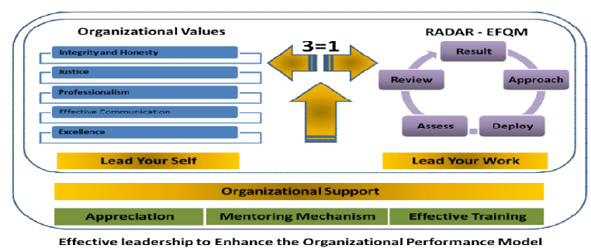
Figure 1: Suggested Leadership Model (Bhargavi and Yaseen, 2016).

In Figure 2 leadership is shown as one of the main driving enablers to produce results. It must be noted that (Mccarthy et al., 2002) shows that all 5 enablers are needed to produce high results.
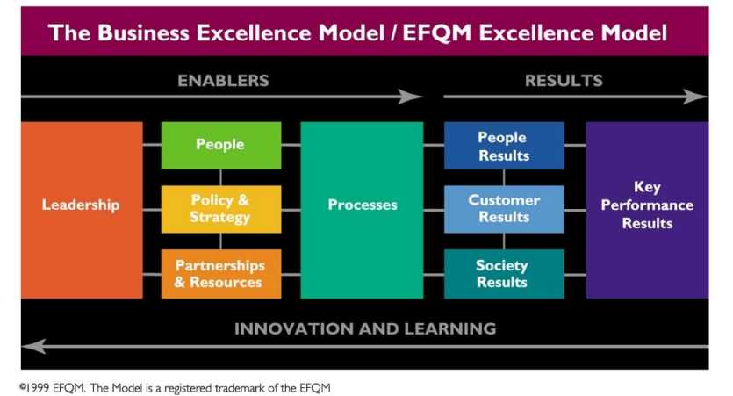
Figure 2: Business Excellence Model/EFQM Excellence Model (Mccarthy et al., 2002).

(Sulej and Iqbal, 2022) go further into the impact on performance and how leadership styles can produce sustainable development leading to increased and sustainable performance. (Sulej and Iqbal, 2022) shows that total quality management (TQM) can have a mediating role on overall performance. This can change how much of an impact leaders have on individuals and the organisation. Depending on the leaders style and willingness to learn, there are multiple benefits of introducing and combining TQM into leadership (Lakshman, 2006).

It is discussed by (Awadh, A.M. and Saad, A.M., 2013) that organisational performance is affected by the culture of the organisation. To enable and create a good culture comes the need of storytelling to engage followers or manipulate followers (Connable, 2025). It is also concluded that culture can enhance the productivity and employee commitment which all has a healthy impact on performance of the employee and organisation (Awadh, A.M. and Saad, A.M., 2013). Further research into organisational culture reveals that a culture is built around leadership styles and rituals which can enhance change and organisational performance (Odiakaose, 2018). Ensuring that leadership qualities are enhanced and developed can boost the growth and potentially achieve more ambitious results (Buryk, Piatnychuk and Biloshkurskyi, 2025). Although it needs to be understood that leadership development includes working on cognitive, emotional, and behavioural skills which needs to be done individually (Buryk, Piatnychuk and Biloshkurskyi, 2025).

Methodology

Research design
The research design has been formulated around the Research Onion (Saunders, Lewis and Thornhill, 2009) which can be seen in Figure 3.

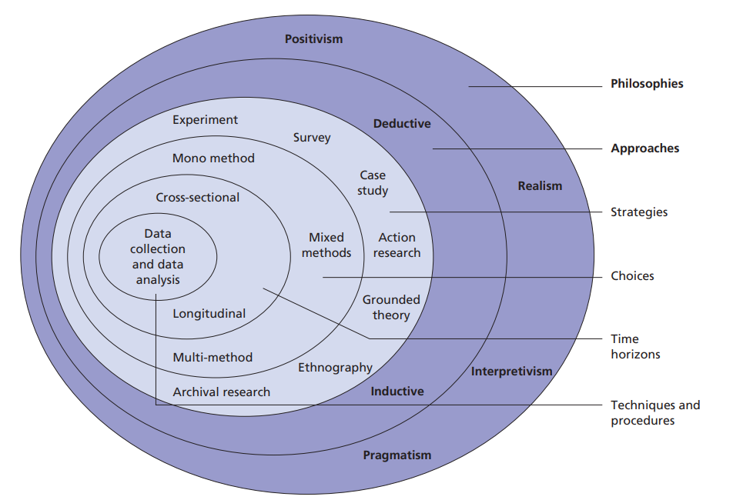
Figure 3: Research Onion (Saunders, Lewis and Thornhill, 2009)

- Philosophy – Pragmatism where a real-world issue is being researched and this topic will include Quantitative (financials, work completion, turnover) and Qualitative ( interviews with managers, survey/questionnaire with employees) data. (Saunders, Lewis and Thornhill, 2009) suggests that the pragmatism approach allows a mixture of methods, quantitative and qualitative which would be appropriate.
- Approach to theory development – Deduction approach as there are multiple theories showing the impact of leadership styles on employees and organisations. By comparing these with real world data and examples through data capture and analysis within QuidelOrtho, a conclusion will be drawn to agree or disagree with the current case studies, data and theories. This causal relationship between leadership style and performance would fit into the deduction approach as shown by (Saunders, Lewis and Thornhill, 2009). It will allow a move from theory to data, taking current principles and using real data to produce results and conclusions to be used to improve QuidelOrtho.
- Methodological Choice – Multi method simply using Quantitative (financials, work completion, turnover) and Qualitative ( interviews with managers, survey/questionnaire with employees). It is shown that a better opportunity to answer all research questions comes with the use of a mixed method. However, it is also argued that the mixed method can produce unanticipated results and findings in some cases (Saunders, Lewis and Thornhill, 2009).
- Strategy – A mixture will be used including archival research to identify and analyse different leadership styles, case studies where previous conclusions have been drawn, narrative inquiry where experiences from employees will analysed to see the impact of different leadership styles, and finally action research where the problems will be identified and recommendations will be drawn to improve the situations that surround different leadership styles.
- Time Horizon – Cross-sectional short-term study to collect data of how leadership styles have impacted employees and the business through the eyes of both managers and employees. This design is simple and cost effective (Slater and Hasson, 2024).
- Techniques and Procedures – Secondary data will be drawn upon to form a background into the wider issue of the effect leadership styles have on performance. Although the main part of the research will be focused on primary data gathered from QuidelOrtho employees.

Data Collection and Population Sample
Data collection will be very important, and the mixed method approach will help ensure that the data can be cross referenced to try and expose any bias if present. The Key performance Indicators (KPI’s), feedback from employees and manager evaluation should bring an overall complete view that is backed by research.

A stratified random sampling method will be used as the organisation has departments that are led by different leaders. This should show the differences between leaders and the impact on the performance of the organisation and employees and improve the precision as shown by (Hendon et al., 2025).

The data collection and sample will consist of semi-structured Interview’s with 10 employees in different areas of the business. Although (Wholey, Hatry and Newcomer, 2015, pp.365–377) shows that they are time consuming and labour intensive but as discussed are very valuable when trying to expose thoughts of individuals within a group which will suit this application. In addition to this, the performance will be analysed within multiple areas through observation and compliance with standard operating procedures and working instructions, as well as the organisations key performance indicators for the qualitative insights. A survey will then be carried out on one hundred employees, also in different areas and departments of the business. A Likert scale will be used to outline and identify the perceptions of the employee’s managers and the departmental performance . The Likert scale as discussed by (Taherdoost, 2019) is a widely used measurement instrument for surveys and according to (Nattapong, R.K., 2025) gives a higher level of reliability compared with other scale rating types. An odd number of response options will be used to ensure people with a truly neutral stance on questions will not be forced to take a side. These neutral answers can then be removed so we focus on the negative and positive feedback.

Justification
The data collection and population sample is justified to provide learning and development of the leadership within QuidelOrtho UK. It will provide valuable insights into the behaviours and decisions made that impact the organisation and employee’s performance, both positively and negatively. This will provide data driven recommendations to enable development, continuous improvement, and strengthened culture within the organisation. This research study adopts specific epistemological and ontological positions to examine and analyse the organisations current practices and beliefs. These findings will then be used to build recommendations that will support personal and business growth, while positively adapting new leadership styles in departmental areas to increase organisational and employee performance.

Reliability
Great care will be taken to ensure the findings and results from the research are reliable but there is a risk to reliability given the nature of the research proposal. This proposal is based on the effects of leadership styles on employees and organisation performance. The different leadership styles can also create a participant bias if they are worried about the leader finding out what information they provided. Due to this anonymising the data will be needed. The time in which the data is collected could also impact the reliability. There could still be errors but the working schedule of each individual will be reviewed to ensure that they are participating at the most neutral time to avoid the natural highs and lows that employees can feel during their working cycle. (Saunders, Lewis and Thornhill, 2009).

Credibility
As a fully trained engineer, successful apprentice of leadership and management, level 7 qualifications of strategic leadership and management, and a chartered manager I believe myself as a credible researcher with no bias but with an interest to know how best to drive the department and organisation into the right direction through leadership. A deep data capture will be completed using valid and reliable sources reinforced by triangulation where multiple methods will be used to capture evidence. These methods will provide credibility to the research according to (Patton, M.Q., 1999) and (Lim, 2024).

Data Analysis
To analyse and present the Quantitative data from the survey diverging stacked bar charts will be used, while removing the neutral responses to clearly show the only the results that have negative and positive impacts on performance. A diverging stacked bar chart will outline the positive and negative bars in opposite directions to enable easy visualisation of the balance in responses. This will make the data easier to interpret as shown by (Koo and Yang, 2025). To analyse and present the qualitative data illustrative quotes will be used to provide credibility and depth to the research. All data that’s collected will be analysed and reviewed to ensure that it is complete and correctly filled in. Any data that is not complete or filled in correctly will be disregarded. Clear instruction and advice on how to complete the survey will be given to minimize any mistakes. The data analysed from the qualitative research will then be cross referenced with the quantitative data to ensure that extreme bias is identified.

Ethical Considerations
It is considered that truths cannot be obtained unless ethics are considered in research. To solve problems through research ethical considerations must be used to enable professional and reliable results (Hasan et al., 2021). Ethics are a major part of ensuring that the participants of research have their rights and dignity always protected (Hasan et al., 2021). All findings will be properly cited using Harvard referencing technique ensuring authenticity and accuracy. The data collected will be anonymised, all personal data will be kept private and confidential and limited, so unnecessary personal information is not obtained. The only individuals taking part in this research will be through voluntary participation and will have the option to be removed from the study at any point. These are all valid considerations as shown by (Laryeafio and Ogbewe, 2023). The consent for participation will be gained before the participant is entered into the research and they will be fully aware of why and what they are consenting to (University of Oxford, 2021).

Limitations
The first limitation that has been identified is that there will be a limited number of participants due to time and resource requirements. Being voluntary it may not gather the full number of participants anticipated. Secondly, the use of a survey provides a risk of bias where people volunteer to partake when knowing they have a bias (Andrade, 2020). The Bias can come in many forms, but an example would be a family member working within a leader’s team or department. Thirdly, as shown by (Andrade, 2020) is that if the survey is completed by Microsoft Forms it will create a bias to computer literate individuals. Finally, people who are interested in the subject are more likely to respond according to (Groves, Presser and Dipko, 2004).

Timeline and Resources

Resources
To conduct the survey amongst the one hundred participants Microsoft Forms will be used so visualisation and exportation is easily carried out (Cumbria.ac.uk, 2025). This will allow easy access to all employees with no impact to their working hours.

A voice recorder will be used in conjunction with a notetaker to ensure accurate recording of interviews. Once written up into final draft form these will then be destroyed when no longer needed.

Agreement with senior management will be required to enable time resource availability from the participants of the secondary research. The primary resource will require resources from libraries, journals, and websites. There will be a requirement for adequate office/meeting rooms to be able to accommodate the interviews. All time invested into the dissertation excluding interviews will be personal time outside of normal working hours to ensure no direct negative impact on current job role and organisation.

The survey will need to be completed within a specific timeframe to enable a fair and neutral result that is not impacted by a bias, this will also need approval from senior management within QuidelOrtho to allow the volunteering partakers the time to complete.

Timeline
It is understood that all research has a time constraint, and these constraints within this proposal are determined by the academic timelines for course completion. A project plan will be developed to keep track of key dates and milestones to ensure on time completion. Contingency will be built into the project plan to ensure that any external influences that affect any task will not impact the project as a whole. It should be noted in some unfortunate circumstances that deadlines can still be missed due to the external factors out of the researcher’s control.

Below is a detailed timeline followed by a visual timeline indication in Figure 4.

Proposal; Planning of the dissertation will start in January 2026 where a proposal will be completed and submitted for approval by the end of January 2026.
Survey and Interview Creation; A survey will then be created to gain the quantitative insights along with the interview layout for the Qualitative, starting the first of February and completed by the end of February.
Survey and Interview Completion; Microsoft forms will be used to create and distribute the survey to the randomly stratified samples generated. Interviews will be carried out with ten individuals, ensuring that they are quickly transcribed shortly after. This will be completed from the start of March until the end of March.
Analysis; The results and finding from both the Survey and Interviews will be critically analysed looking for key standout factors, arguments, insights, behaviours and correlation to identify what and if any specific leadership styles and behaviours affect performance of employees and the organisation. This will be completed over the month of April.
Literature Review; Literature review around the impact of leadership on organisational and employee performance will be completed within the month of May.
Conclusion and Recommendations; Conclusions drawn and recommendations suggested will be written up and first draft of dissertation compiled during the month of June.
First Draft Submission and Rework; First draft of dissertation submitted to tutor during first week of July with a view of being returned by the end of July.
First Draft Rework; First draft rework will be completed from the tutors feedback during August
Final Draft Submission; Final draft submitted for marking in the first week of September 2026.

Contingency; A completion deadline of one academic year is given for dissertation submission, so a plan of nine months has been decided for completion. This ensures that contingency is built into the plan and that if any other personal or professional priorities become more important, it will not have a detrimental effect on submission and successful completion will still be achievable.

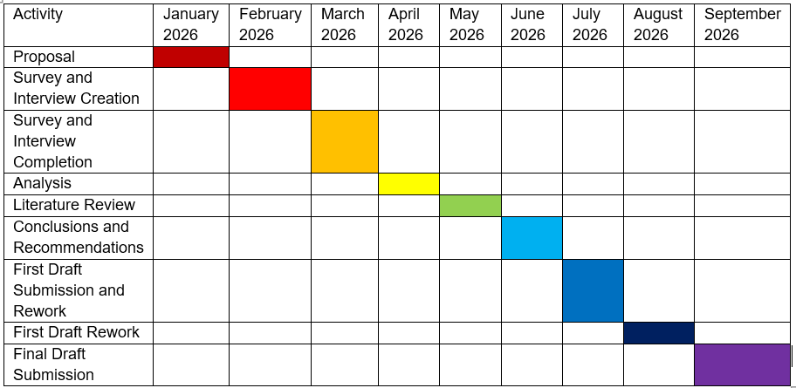
Figure 4: Timeline Table for Dissertation Completion.

References
Afshari, J., Moein, Z., Afshari, F., Sharifi-Rad, J., Balouchi, A. and Afshari, A. (2017). A comparison of leadership styles with respect to biographical characteristics. SA Journal of Human Resource Management, [online] 15(0), p.7. doi:https://doi.org/10.4102/sajhrm.v15i0.817.

Alessa, G.S. (2021). The Dimensions of Transformational Leadership and Its Organizational Effects in Public Universities in Saudi Arabia: A Systematic Review. Frontiers in Psychology, [online] 12(1), pp.1–16. doi:https://doi.org/10.3389/fpsyg.2021.682092.

Andrade, C. (2020). The Limitations of Online Surveys. Indian Journal of Psychological Medicine, [online] 42(6), pp.575–576. doi:https://doi.org/10.1177/0253717620957496.

Archanjo de Souza, D.S. de O., Pedro Salgado, A.M., Marins, F.A.S. and Muniz, J. (2020). The influence of leaders’ characteristics on the relationship between leadership and knowledge management. Knowledge Management Research & Practice, 18(4), pp.1–12. doi:https://doi.org/10.1080/14778238.2020.1730716.

Ausat, A.M.A., Shafiq, M.A., Wafik, D. and López, N.A.S. (2024). The Role of Transformational Leadership in Improving Employee Psychological Wellbeing: a Review. Apollo: Journal of Tourism and Business, 2(1), pp.148–157. doi:https://doi.org/10.58905/apollo.v2i1.239.

Awadh, A.M. and Saad, A.M., 2013. Impact of organizational culture on employee performance. International review of management and business research, 2(1), pp.168-175.

Baig, S.A., Iqbal, S., Abrar, M., Baig, I.A., Amjad, F., Zia-ur-Rehman, M. and Awan, M.U. (2021). Impact of leadership styles on employees’ performance with moderating role of positive psychological capital. Total Quality Management & Business Excellence, [online] 32(9-10), pp.1–21. doi:https://doi.org/10.1080/14783363.2019.1665011.

Benmira, S. and Agboola, M. (2021). Evolution of Leadership Theory. BMJ Leader, [online] 5(1), pp.3–5. doi:https://doi.org/10.1136/leader-2020-000296.

Bhargavi, S. and Yaseen, A. (2016). Leadership Styles and Organizational Performance. Strategic Management Quarterly, [online] 4(1), pp.87–117. doi:https://doi.org/10.15640/smq.v4n1a5.

Buryk, Z., Piatnychuk, I. and Biloshkurskyi, M. (2025). Leadership, Management, and Socio-Economic Adaptation: Contemporary Challenges and Strategic Perspectives. International Journal of Organizational Leadership, [online] 14(First Special Issue 2025). doi:https://doi.org/10.33844/ijol.2025.60450.

Connable, S. (2025). With a Great Story Comes Great Responsibility: Role of Narrative in Leadership Development. PubMed. doi:https://doi.org/10.1002/yd.20659.

Cumbria.ac.uk. (2025). Microsoft Forms | MyCumbria. [online] Available at: https://my.cumbria.ac.uk/Student-Life/Learning/Skills-Cumbria/Digital-Skills/Microsoft-Office/Microsoft-Forms/.

Dong, B. (2023). A Systematic Review of the Transactional Leadership Literature and Future Outlook. Academic Journal of Management and Social Sciences, 2(3), pp.21–25. doi:https://doi.org/10.54097/ajmss.v2i3.7972.

Dugan, J.P. (2024). Leadership theory: Cultivating Critical Perspectives. John Wiley & Sons.

Ecohumanism.co.uk. (2025). View of Impact of Leadership Practices on Organizational Work Environments | Journal of Ecohumanism. [online] Available at: https://ecohumanism.co.uk/joe/ecohumanism/article/view/6182/6295 [Accessed 10 Jul. 2025].

Groves, R.M., Presser, S. and Dipko, S. (2004). The Role of Topic Interest in Survey Participation Decisions. Public Opinion Quarterly, 68(1), pp.2–31. doi:https://doi.org/10.1093/poq/nfh002.

Hasan, N., Rana, R.U., Chowdhury, S., Dola, A.J. and Rony, M.K.K., 2021. Ethical considerations in research. Journal of Nursing Research, Patient Safety and Practise (JNRPSP) 2799-1210, 1(01), pp.1-4.

Hendon, J.M., Hoffmayer, E.R., Pollack, A.G., Mareska, J., Martinez-Andrade, F., Rester, J., Switzer, T.S. and Zuckerman, Z.C. (2025). Impacts of survey design on a Gulf of Mexico bottom longline survey and the transition to a unified, stratified - random design. Frontiers in Marine Science, 11. doi:https://doi.org/10.3389/fmars.2024.1426756.

Hummingbirdjournals.com. (2025). View of Delegative Leadership Strategies and Quality Education Service Delivery in Tertiary Institutions in Bayelsa State. [online] Available at: https://hummingbirdjournals.com/jcer/article/view/343/365 [Accessed 26 Jun. 2025].

Iheriohanma, E. (2015). NEXUS BETWEEN LEADERSHIP STYLES, EMPLOYEE RETENTION AND PERFORMANCE IN ORGANIZATIONS IN NIGERIA. European Scientific Journal, [online] 11(13), pp.1857–7881. Available at: https://core.ac.uk/download/pdf/236407206.pdf. [Accessed 26 Jun. 2025].

Jaafar, S.B., Zambi, N.M. and Fathil, N.F. (2021). Leadership style: Is it autocratic, democratic or laissez-faire? ASEAN Journal of Management and Business Studies, [online] 3(1), pp.1–7. doi:https://doi.org/10.26666/rmp.ajmbs.2021.1.1.

Junaedi, E. and Ali, J., 2025. The Influence of Situational Leadership Style and Work Orientations on Employee Performance in Jakarta Islamic Banking Industry. ITQAN: Journal of Islamic Economics, Management, and Finance, 4(1), pp.11-22.

Khan, M.A., Ghafoor, M.M., Aamna Tariq Mukaram, Zubair, S.S. and Bokhari, S.Z. (2025). A New Age of Leadership in Academia: Need for Change and Innovation During COVID-19. SAGE Open, 15(1). doi:https://doi.org/10.1177/21582440241304901.

Koo, M. and Yang, S.-W. (2025). Likert-Type Scale. Encyclopedia, 5(1), pp.18–18. doi:https://doi.org/10.3390/encyclopedia5010018.

Lakshman, C. (2006). A theory of leadership for quality: Lessons from TQM for leadership theory1. Total Quality Management & Business Excellence, 17(1), pp.41–60. doi:https://doi.org/10.1080/14783360500249729.

Laryeafio, M.N. and Ogbewe, O.C. (2023). Ethical Consideration dilemma: Systematic Review of Ethics in Qualitative Data Collection through Interviews. Journal of Ethics in Entrepreneurship and Technology, 3(2), pp.94–110. doi:https://doi.org/10.1108/JEET-09-2022-0014.

Lei, M., Alam, G.M. and Bashir, K. (2025). The job performance and job burnout relationship: a panel data comparison of four groups of academics’ job performance. Frontiers in Public Health, 12. doi:https://doi.org/10.3389/fpubh.2024.1460724.

Lim, W.M. (2024). What Is Qualitative research? an Overview and Guidelines. Australasian Marketing Journal (AMJ), [online] 33(2), pp.199–229. doi:https://doi.org/10.1177/14413582241264619.

Manyuchi, M. and Sukdeo, N. (2021). Application of the Situational Leadership Model to Achieve Effective Performance in Mining Organizations Teams. [online] Available at: https://www.ieomsociety.org/brazil2020/papers/217.pdf. [Accessed 06 Jul. 2025].

Mccarthy, G., Mccarthy, G., Greatbanks, R. and Yang, J.-B. (2002). Guidelines for self-assessment Guidelines for assessing organisational performance against the EFQM Model of Excellence using the Radar Logic 1. [online] Available at: https://personalpages.manchester.ac.uk/staff/jian-bo.yang/JB%20Yang%20Book_Chapters/McCarthyYangGreatbanks_MSM_Guidelines_for_Selfassessment.pdf.

Melnikovas, A. (2018). Towards an Explicit Research methodology: Adapting Research Onion Model for Futures Studies. Journal of Futures Studies, [online] 23(2), pp.29–44. doi:https://doi.org/10.6531/JFS.201812_23(2).0003.

Nattapong, R.K., 2025. COMPARATIVE ANALYSIS OF 5-POINT AND 6-POINT LIKERT SCALES IN PSYCHOLOGICAL TEST QUALITY. Ayden Multidisciplinary Research Journal, 13(2), pp.39-44.

Odiakaose, H. (2018). Organisational Culture and Dynamics Organisational Culture and Dynamics. Global Journal of Management and Business Research: A Administration and Management, [online] 18(1), pp.23–29. Available at: https://pdfs.semanticscholar.org/182e/3e766df0a248625267bfd409896c0a843943.pdf.

Palinggi, S.Y. and Agustina, T.S. (2025). Analysis of That Influence Employee Performance: Work Environment, Leadership, and Mental Health. Golden Ratio of Human Resource Management, 5(1), pp.177–186. doi:https://doi.org/10.52970/grhrm.v5i1.803.
Patton, M.Q., 1999. Enhancing the quality and credibility of qualitative analysis. Health services research, 34(5 Pt 2), p.1189.

Peterson, S., Abramson, R. and Stutman, R. (n.d.). How to Develop Your Leadership Style Concrete advice for a squishy challenge. [online] Available at: https://s3.amazonaws.com/kajabi-storefronts-production/file-uploads/sites/2147813802/themes/2154675110/downloads/631f8ce-61b5-18-3ac0-6a28d53f4b2b_HBR_Leadership_Style_2020.pdf [Accessed 10 Jul. 2025].

Purwanto, A., Bernarto, I., Asbari, M., Wijayanti, L.M. and Hyun, C.C., 2020. Effect of transformational and transactional leadership style on public health centre performance. Journal of Research in Business, Economics, and Education, 2(1).

Saunders, M., Lewis, P. and Thornhill, A. (2009). Research Methods for Business Students. 5th ed. Pearson Education Limited.

Siraj, N., Hágen, I., Cahyadi, A., Tangl, A. and Desalegn, G. (2022). Linking Leadership to Employees Performance: The Mediating Role of Human Resource Management. Economies, [online] 10(5), p.111. doi:https://doi.org/10.3390/economies10050111.

Slater, P. and Hasson, F. (2024). Quantitative Research Designs, Hierarchy of Evidence and Validity. Journal of Psychiatric and Mental Health Nursing, [online] 1(1). doi:https://doi.org/10.1111/jpm.13135.

Smith, R. (2015). ScholarWorks Advantages and Barriers to Transformational Leadership Implementation in a Scientific Laboratory. [online] Available at: https://scholarworks.waldenu.edu/cgi/viewcontent.cgi?article=1301&context=dissertations. [Accessed 30 Jun. 2025].

Sulej, K.P. and Iqbal, Q. (2022). Leadership styles and sustainable performance: A systematic literature review. Journal of Cleaner Production, 382(134600), p.134600. doi:https://doi.org/10.1016/j.jclepro.2022.134600.

Syahlan, F., Sobandi, A. and Santoso, B., 2024. Leadership Styles in Management. The Eastasouth Management and Business, 2(03), pp.249-263.

Taherdoost, H. (2019). What Is the Best Response Scale for Survey and Questionnaire Design; Review of Different Lengths of Rating Scale / Attitude Scale / Likert Scale. International Journal of Academic Research in Management (IJARM), [online] 8(1). Available at: https://hal.science/hal-02557308. [Accessed 06 Jul. 2025].

Tedla, B.A. and Vilas B, G. (2022). An Essence of Leadership, its Styles: A Review and Personal Account Commentary. International journal of health sciences, 6(S2), pp.175–183. doi:https://doi.org/10.53730/ijhs.v6ns2.5083.

University of Oxford (2021). Informed Consent. [online] University of Oxford. Available at: https://researchsupport.admin.ox.ac.uk/governance/ethics/resources/consent.
(Accessed 10/07/2025)

Wang, F.-J., Chich-Jen, S. and Mei-Ling, T. (2010). Effect of leadership style on organizational performance as viewed from human resource management strategy. African Journal of Business Management, [online] 4(18), pp.3924–3936. Available at: https://academicjournals.org/journal/AJBM/article-full-text-pdf/0B1696A16102.

Wen, Ho, Kelana, Othman, Syed ; Wen, T., Ho, T., Kelana, B., Othman, R. and Syed, O. (2019). Leadership Styles in Influencing Employees’ Job Performances. International Journal of Academic Research in Business and Social Sciences, [online] 9(9), pp.55–65. doi:https://doi.org/10.6007/IJARBSS/v9-i9/6269.

Wholey, J.S., Hatry, H.P. and Newcomer, K.E. (2015). Handbook of Practical Program Evaluation. San Francisco: Jossey-Bass, pp.365–377.

Wilson, D.C. (2022). Defining Leadership. Philosophy of Management, [online] 22(1). doi:https://doi.org/10.1007/s40926-022-00210-7.

Zheng, X., Song, J., Shi, X., Kan, C. and Chen, C. (2025). The effect of authoritarian leadership on young nurses’ burnout: the mediating role of organizational climate and psychological capital. BMC Health Services Research, [online] 25(1). doi:https://doi.org/10.1186/s12913-025-12403-7.

