Content
1.Introduction 2
1.1 Project introduction 2
1.2 Programming language, IDE, database and some other tools for the development 2
2. Specific roles and works in the team 3
3. Risks and solutions of it in the process 3
4. Sustainability Impacts 5
5. Ethical issues for the management department of student services. 6
6. Legal issues in terms of software developing 7
References 8

1.Introduction

1.1 Project introduction
According to the project initiation document our team produced last semester, our project is to develop information management system for student services management. In details, the aim for the project is to develop a management information system for the University of Wales Trinity Saint David (UWTSD) Student Services for the Swansea campus. This system will secure staff records securely, such as background and government checks, professional memberships, staff training and accreditation, and notify the relevant members of staff when these are due to expire, so they can be renewed or sorted before problems arise.

1.2 Programming language, IDE, database and some other tools for the development
After finishing the student services management information system project initiation document and the design of Gantt Chart, at the stage of planning for the development of system, these was an important thing that choosing the suitable sort of software will be used to develop system. In the first meeting, our team decided to use Java programming language, Netbeans, SQLite database, Bitbucket to store our codes and the Git tools to upload and download codes from Bitbucket. There are some reasons why opted these sort of programming language and tools.
- Java programming language [1] : Java has been opted by our team because there are four members in our team and there are three people have studied or used this programming language and another reason are that Java is easy to learn and to use.
- Netbeans [2] : at the beginning, our team decided to use Eclipses to develop but we found the problem in time that is using Eclipse is not easy to build a software with many user interfaces, so we changed to the NetBeans because it is very easy to develop user interfaces of a software and the system will be developed need to develop many user interfaces.
- SQLite database [3]：SQLite is a lightweight, cross-platform relational database. Especially, according to the internet tutorials of it, it is also quite easy to learn and use.
- Bitbucket [4] : Bitbucket is a free support for private warehouses, which is incomparable. Because this project is a teamwork, so we need a code warehouse on the Internet to upload and download codes at any time. In addition, in order to upload or download codes from Bitbucket, we still need a tool Git [5] to achieve it.
In a work, regarding to the management information system with many user interfaces, it is very suitable to use Java, Netbeans to develop and others like SQLite database are also quite suitable to be used in thin project.

2. Specific roles and works in the team
According to interesting area, there are 4 members of our team who have been assigned to 2 groups:
- Group 1: the main works for group 1 are to develop software, like establishing user interfaces, background programming and the database development. In details, Cerys is my partner, we were together in charge to the works of group 1 and my main works of the development were that developing user interfaces of the software, establishing the database and Cerys works were that designing the tables of database and the background programming.
- Group 2: the main works for group 2 are the testing and some other works like design causal map, suitability and so on.
Especially, every Wednesday in the process was the review day that means in that day, we will come together to review the works should be done last week and to find whether the works go ahead following the steps of the planning and to check if there any difficulties for anybody to cope with.

3. Risks and solutions of it in the process
In the process, there are various inevitable risks of the project, such as cannot accomplish the works on time, cannot achieve any function and so on. Therefore, it is very necessary to imagine some risks may come and the solutions to cope with it.
3.1 Risk management process
There are several steps in the risk management procedure that is based on the PRINCE2 [6] :
- Identify: record threats and opportunities in the risk register.
- Assess: assessing the impact, proximity and the probability of each risk and update the risk register. Besides, gather all risks to make sure their related impact in the project by plotting them against the probability impact grid.
- Plan: make sure the responses to the threats and the opportunities using the response category examples and adding them to the register.
- Implement: assign the responsibilities in order to execute and monitor the effectiveness of the responses and recording them in the register.
In details, risk management will primarily consist of a Risk Register which is a table where risks that are identified by the project management team, and the developer of the project can be logged. And the Risk Register is subdivided to reflect the steps detailed in the risk management procedure. This allows it to be used as a checklist to be followed to ensure the quality of the risk management process. Whereas the register stands as a record of all risks, a report will be written where the project has transcended an unacceptable level of risk. This will include the register and a written assessment which will then be handed to the stakeholders for advice on whether to proceed to the next milestone or for alternative action to be taken. Risks are to be recorded into the register on an ad-hoc basis (when identified). Their severity will be assessed as part of the recording process. At the end of each week the risks will be evaluated and the project escalated if necessary.
3.2 Casual map and risks will meet
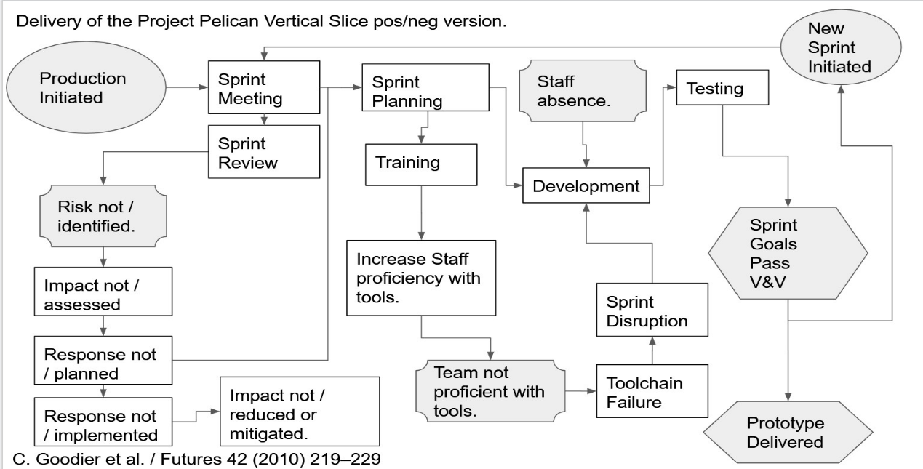
Figure 1: Casual map in the process
Figure 1 is the casual map in the process designed by our team, according to the casual map, there are some risks maybe occur in the process:
Risk 1:
- Cause: Email notification service does not function correctly.
- Event: Qualifications or certification are not renewed in time.
- Effect: Staff cannot do their job. Loss of productivity.
- Response: Ensure alternative notification infrastructure or procedures are put in place.
Risk 2:
- Cause: Project not scheduled properly to fit scope.
- Event: Project does not meet milestones.
- Effect: Delivery of a reduced scope or incomplete system by the delivery date. A system which does not provide the necessary functionality needed to ensure qualification documents are renewed in a timely manner and that paper usage is reduced leading to unnecessary complications in the processes used at student services.
- Response: Features are built incrementally in rank of criticality to the proper functioning of the system.
Risk 3:
- Cause: Prototype not scheduled properly to fit scope.
- Event: Prototype does not meet milestones.
- Effect: Delivery of a reduced scope or incomplete system by the delivery date. A system which does not provide the necessary functionality needed to ensure that a representation of the project is not communicated effectively leading to insufficient feedback from student services.
- Response: Further sprints are only scheduled once the current sprint has been reviewed.
Risk 4:
- Cause: Infrastructure not configured by deadline and tested.
- Event: Prototype does not meet milestones.
- Effect: Delivery of a reduced scope or incomplete system by the delivery date.
- Response: An alternative process or software is identified to replace the resource which is not available. The whole pipeline is tested by the group prior to initiating the first sprint.
Risk 5:
- Cause: Project team member ill or otherwise absent.
- Event: Prototype does not meet milestones.
- Effect: Delivery of a reduced scope or incomplete system by the delivery date.
- Response: Sprint meetings are scheduled twice a month.

4. Sustainability Impacts
According to the methodology to derive sustainability indicators for software development projects Giuseppe Lami, Fabrizio Fabbrini, Mario Fusani, we designed an appropriate sustainability framework for the whole process and the software as following:
Green Drivers | Power | Effort/Time | Paper | Fuel
People
System Users | More electricity. | Less time. | Less paper. | Less fuel.
Managers | More electricity. | Less time. | Less paper. | Less fuel.
Developers | More electricity. | More time. | N/A | N/A
Project Content
Resources | More electricity. | N/A | Less paper. | N/A
Technology | More electricity. | N/A | N/A | N/A
Development
Project Methodology | N/A | N/A | N/A | N/A
Table 1: Sustainability framework
For this sustainability framework, we considered it in terms of resources of electricity, paper and fuel, in which we concluded some factors may consume much resources and time such as the hardware of computers, the electricity of workplace and so on.

5. Ethical issues for the management department of student services.
It is quite struggle when meet the ethic issues in the project area, for example, the driverless car, how to make a car in the programming area to choose which obstacles to impact and must have a decision to program. Regarding to this case, at this moment, I do not have very exact idea because it is actually struggle and we must to consider about.
Regarding to the student service project, when development related software, it is must be considered of the ethical issues for example, before making any decision of the project, make sure it is no possible to make misunderstanding points to the students when they are getting services.
On the other hand, in order to avoid encountering some inevitable ethic issues, it is very recommended for computer engineers to strictly obey the code of conduct and practice such as the British Computer Society Code of Conduct and Practice and some others. There are some norms in the BCS code of conduct related to the ethical issues:
- Must pay more attention to the public health, security and the privacy.
- Must respect and attach importance to the alternative viewpoints and seek, accept and offer honest criticisms of work.
- Must accept personal responsibilities to take actions.
- Try to do best on avoiding any situation that may relate to a conflict between you and any relevant authority.
In a work,

6. Legal issues in terms of software developing
When it comes to the legal issues of the software developing area or computer area, there are 3 basic aspects need to consider:
- Data protection: at this aspect, first of all, the most important thing is to consider about the General Data Protection Regulation which is a data privacy protection bill pushed by the European Union, which will come into force on May 25 this month. Therefore, there are some specific issues related to GDPR for developer:
  - Developer must ask users in a clear way, without defaulting in any way to grant developers data licensing rights.
  - If users do not agree to collect their data, developers must be able to process PII as non-PII information and not be compiled back to PII information.
- Intellectual property: it is the exclusive rights enjoyed by people in accordance with the law in respect of their intellectual achievements, which are usually granted by the state to the creators for a certain period of time. When in process, developer must pay more attention on this point and make sure whether using a point correctly.
- Computer misuse
Finally, in a word, the issues mentioned above must be paid significant attention for the developer particularly to the data protection and the intellectual property.

References

[1] | Raffles, Thomas E.: History of Java. Oxford University Press, 1965, p. 2.
[2] | Boudreau, Tim; Glick, Jesse; Greene, Simeon; Woehr, Jack; Spurlin, Vaughn (October 15, 2002). "NetBeans: The Definitive Guide" (First ed.). O'Reilly Media: 672. ISBN 0-596-00280-7.
[3] | "SQLite Release 3.28.0 On 2019-04-16". Retrieved 16 April 2019.
[4] | "Bitbucket.org Alexa Ranking". Alexa Internet. Retrieved 23 June 2017.
[5] | Initial revision of "git", the information manager from hell". Github. 8 April 2005. Archived from the original on 16 November 2015. Retrieved 20 December 2015
[6] | "What is PRINCE2®?". AXELOS. Retrieved 1 February 2017.
[7] | "Presidency of the Council: "Compromise text. Several partial general approaches have been instrumental in converging views in Council on the proposal for a General Data Protection Regulation in its entirety. The text on the Regulation which the Presidency submits for approval as a General Approach appears in annex," 201 pages, 11 June 2015, PDF". Archived from the original on 25 December 2015. Retrieved 30 December 2015.

