Christopher James Denning
Jdenning.151597@student.uwtsd.ac.uk
Electronic system design : MARINE weather logger

Contents
Introduction. 3
Task 1: Background literature of Data Buoy. 4
Task 2 5
Task 2.1 identify ports and data protocols. 7
Task 3: Microcontroller 9

Introduction.
This paper documents the progress of designing a marine data logger (Data acquisition system) that will measure the requested factor over a demanded period of seven days. This is to be achieved with the use of a micro-controller that will read and transfer the signals attained from the external sensors and transducers.
The conditions of the data logger are intended to meet the standards and operation for amateur marine weather forecaster.
The sensor that are required the marine weather forecaster are as follows:
- Temperature
- Humidity
- Wave height
- Wind direction
- Sun brightness
- GPS position.
The design of the device must also include other features such as the ability to collect data onto a non-volatile external memory device that can be read and cleared once the device is connected though a USB connection.

Task 1: Background literature of Data Buoy.

What is a data buoy?
A Data buoy: floating platform that is dispatched in open sea that measures particular data in an marine environment by autonomous sensors which are sent and received to the central Data Acquisition system/unit to be processed for storage on either on-board the device, on an external device or transmitted. (Measurement)(Metrological)(1988)

Uses and Applications
The device is used for Meteorological and Oceanographic applications certain parameters of importance. Measuring surface temperature of the sea, water temperature at certain depths, wind direction and speed. The information is then transmitted in real-time accompanied with the buoys’ position. Data is then received to create a numerical weather production model.
Therefore considered as automatic weather station or defined as a “Meteorological station”
Other applications for the data buoy are as follows:
Monitoring the ocean temperature is beneficial for fishing application. Such as locating certain species of fish which would both save time and fuel, monitoring stock, reproduction and ocean disturbances.
Data gathered from these devices can be collected to establish a Drift forecast model for search and rescue applications, by extracting data based on wind and ocean current parameters.

DAQ Buoy examples.
A list of data acquisition buoys has been created to give an example and comparison of what Morden day buoys which that are available. These devices will be compared to see what feature are available.
MOBILIS – DB 14000
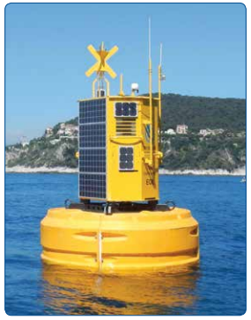
This data buoy has a 3.6m diameter hull, comprising of multiple section polyethylene floats which are bolted around the steel structure. Its hull supports the same large marine grade aluminium towers as its predecessors, which allows its large equipment payloads to store way in a protective casing.
This Data Buoy has been designed with a large diameter tower to allow more equipment to be applied to the device and allow technicians to gain access to underwater instruments.
This installation contains multiple meteorological sensors suited for measuring wind speed and direction, air temperature, relative humidity, and a spatial wave sensor to determine the wave hight, period and direction.
MOBILIS DB 4000
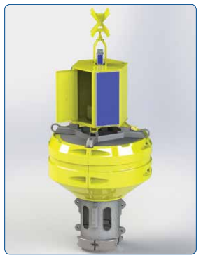
This data buoy has 2.4m diameter hull comprising of multiple section polyethylene floats which are bolted around the steel structure, with though-hull access for underwater instrumentation and cabling.
This comprises of a 1.4 hexagonal tower which provides internal space for instrumentation, batteries and a large external area mounting solar panels.
MOBILIS E.O.L
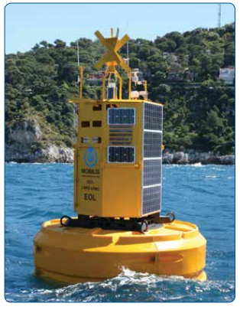
This platform comprises of a 3.6 diameter hull constructed like is other counterparts, with multiple section polyethylene floats which are bolted around the steel structure and also with though-hull access for underwater instrumentation and cabling.
All data that is gathered by this device both logs data onboard the device and transmits data to shore. The large tower allows technicians to undertake checks and routine maintenance of sensors and data acquisition system within the safe confines of the tower.

Modal | MOBILIS DB 14000 | MOBILIS DB 4000 | MOBILIS E.O. L
Image

Construction
Central hall | Glass flake painted steel | Glass flake painted steel | Glass flake painted steel
Floats | MDPE – min 20 mm thick | MDPE – min 20 mm thick | MDPE – min 20 mm thick
Tower  /equipment | Marine grade aluminium | Marine grade aluminium | Marine grade aluminium

Physical
Hull diameter | 3600 mm | 2400 mm | 3600 mm
Total hight | 6650 mm | 4945 mm | 6800 mm
Freeboard (fully laden) | 1750 mm | 770 mm | 1500 mm
Focus hight | 1870 mm | 2490 mm | 3800 mm
Hull buoyancy | 14000 Kg | 4000 Kg | 14000 Kg
Reverse buoyancy  (Total buoyancy) Kg | 10750 Kg | 1984 Kg | 10500 Kg

Power systems
Solar panels (W) | 760 | 3 x 90 | 400
Batteries  (Ah @ 12v DC) | 600 | 2 x 100 | 1320

applications
Offshore | yes | yes | yes
Ocean | yes | yes | yes

Task 2: component list
This section lists the requested components for the Marine data logger. Each component that was requested is accompanied with an alternative variation which specifications are compared.

GPS
A GPS module is requested for tracking the costal position of the Device while severing marine parameters in open water conditions.
Specifications
Device | GPS LS2003(3) | Neo-6/M/V | SAM-M8Q
Image | 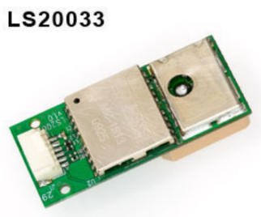 | 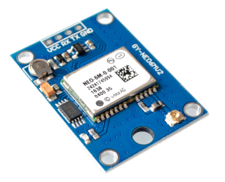 | 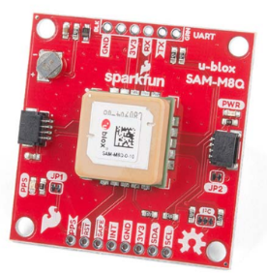
Voltage conception | 4.7 - 5.2 Volts | 2.7-3.6 Volts | 3.3V
Current consumption | 34 mA | 63 mA | 29 mA
Up-date rate | 1Hz – 10KHz | 1 Hz | 18 Hz
Number of channels | 66 channel support | 50 channel support | 72 channel support
Antenna | MC-1513 | U-box 6 Receiver | GNSS Receiver
Accuracy |  | (GPS): 2.5 m
  Autonomous: 3 m
  SBAS: 2.5 m
  Velocity Acc: 0.05m/s
  Heading Acc: 0.3 degrees
Pin count | 5 Pins | 24 Pins | 14 Pins
Time-to-first-fix  (TTFF) | Cold: 35s  Hot: < 2s | Cold: 26s  Hot: 1s | Cold: 26s  Hot: 1s
Interface | RS232 | UART, USB, SPI | UART, I2C, SPI
Additional Features | - Build-in micro battery to restore data.  - LED indicator for GPS fix or no fix.  (not available: LS20033). | - RTC CRYSTAL.  - 3X Configure pins.  - 1xtime-pulse.  - An External interrupt/Wakeup.  - GPS L1 Frequency  (C/A code). | GPS is based on the U-box, allowancing configuration for board rate, update rate, spoofing detection.  On board battery provides power to RTC on chip reducing TTFF from Cold to Hot.

Light density
UV-B sensor (GUVA-S12SD)
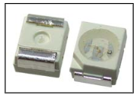
Items | symbol | value | unit
Forward current | If | 1 | mA
Reverse voltage | Vr | 5 | V
Operating temperature | Top | - 30 to +85 | C

Light- to frequency converter (TSL235R)
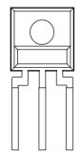
Parameters | Test conditions | type | unit
High level output voltage | I_ oH = - 4 mA | 4 min | V
Low level output voltage. | I_ oL = 4 mA | 0.4 maz | V
Supply current |  |  | MA
Temperature coefficient | Wavelength < 700nm | Tolerance of 150 | KHz

NSL19M51
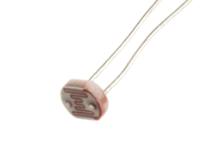
Paramotors | Value | units
Voltage peak | 100 (Max) | V
Power dissipation | 50 | mW
Operation temperature | -60 to +75 | C
Light resistance | 20 – 100 | K-Ohms
Dark resistance | 20 | M-ohms

Ultrasonic
To determine the hight of the ocean wave ultrasonic modules will be used with their traditional sense of producing an ultrasonic pulse from the module to the surface of the water, which will return to bounce and return back.
The method of determining the hight of the wave requires a means of comprising both the natural hight of the water against the oscillating wave of the water. To measure both hights of water, two tubes are needed. One tube will be completely open to receive the waves of the water and the other will have multiple holes that will gradually rise or fall to the natural water high.
HC-SR04 (ultrasonic module)
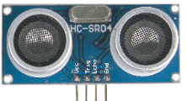
Electronic parameters | Values
Operational voltage | 5V DC
Operational current | 15 mA
Operational frequency | 40 Khz
Max range | 4 m
Nearest range | 2 cm
Measuring angle | 15 degrees

MOTUS Wave sensor
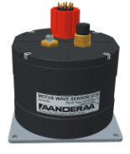
Supply voltage | 6.30 v (DC)
Sampling frequency | 100 Hz
wave period | 1.42 – 33 seconds
Wave direction | 0 – 360 degrees
Resolution | 0.5
Wave calculation update rate | 2 minutes

Temperature
This is required to acquire temperature data in the local facility.
LM35 (NEB package)

Parameter | Value
Supply voltage | -0.2 to +35 volts (DC)
Output voltage | -1 to +6 volts (DC)
Maximum junction temperature | 150 degrees Celsius

DS18B20
Supply voltage | 0.5 to + 6 volts DC
Operating temperature range | -55 to + 125 degrees Celsius
Storage temperature range | -55 to + 125 degrees Celsius
Solder temperature

Wind speed sensor
MBMet-100(C)
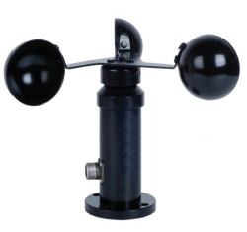
Measuring range | 0 - 60 m/s
Communication output | 0 – 5 Volts (DC)
Accuracy | ±3%FS
Input voltage | 12 to 24
Operating temperature | -30 to +70 degrees
Starting windspeed | <0.8 m/s
Survival windspeed | 70 m/s

Andera-Wind speed sensor (2740)
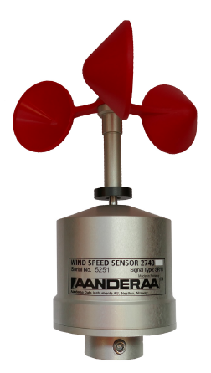
Measuring range | Up to 79 m/s
Accuracy | ±2% m/s
Operating voltage | 7- 14 volts (DC)
Output signals | - Average wind speed, SR10
 | - Wind gust, SR10
Operating temperature | -40 to +65 degrees

Hanwell -wind sensor (wireless connection.).
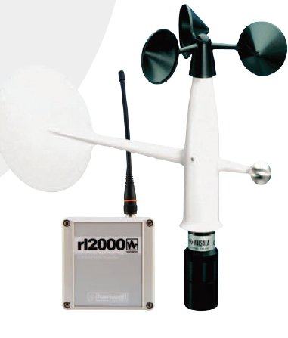
Parameters | Values and other.
Sensor/ transducer type | Potentiometer
Operation voltage | 3 to 15 volts (DC)
Supply voltage for radio transmission | 240 volts
Operating temperature. | -40 to +55 degrees
Range | 0.4 to 60 m/s

Humidity.
To measure the local areas humidity for meteorological studies
DHT-11
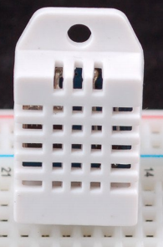
Paramotors | values
Power | 3 to 5 volts (DC)
Temperature range | -40 to +80 degrees
Temperature Accuracy | ±5% RH
Measurement range | 20 – 90% RH
Humidity accuracy | 2-5 %
Sample rate | 0.5 Hz

AM1001 (Humidity sensor)
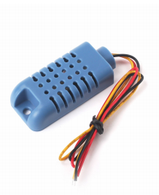
Model | AM1001
Power supply | 4 to 5.5 volts (DC)
Output signal | 0.6 – 2.7 Volts (DC)
Sensing element | Polymer resister
Operating range | Humidity 20-90%
Accuracy | ±5%RH

Wind direction
(Somfy) Wind direction sensor
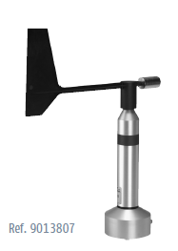
Supply voltage | 24 V(DC)
Measuring element | Blade wind vane
Measuring principle | Hall sensor array
Measuring range | 0 to 360 degrees
Accuracy | ±2 degrees
Resolution/starting value | 2 degree (<0.7M/s)
output | 0(4) … 20mA- max load 600 ohms

Wind directional sensor
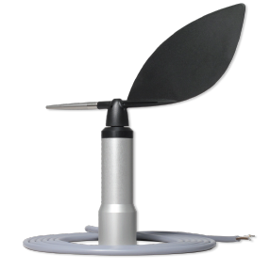
Operating voltage | 9 to 30 voltage
Signal output | 4 to 20 mA
Accuracy | ± 2 to 5 degrees
Measuring principle | Magnetic, contactless

Task 2.1 identify ports and data protocols.
With the external devices selected to measure the required factors of interest, each signal output can be identified along with protocols to determine what micro controller will be adequate.
The first table identifies which external device/peripherals have a common analogue or digital signal interface.
Parameters | Interface | Signal type | Pin Count | Purpose
Wind speed. |  | Digital | D(1) | Determine speed of wind
Wind direction. |  | Analogue | A(1) | Determine direction of wind
Temperature. |  | Analogue | A(1) | Measure local temperature
Humidity. |  | Digital | D(1) | Measure local humidity
Light. |  | Analogue | A(1) | Measure density of light in local area.
Ultrasonic. |  | Digital | D(2) | Calculate approximate height of ocean wave.
LED. |  | digital | D(1) | Indicate device operation.
Start butt. |  | digital | D(1) | Connect/disconnect power supply
Table Main peripheral signal output.
The next table identified external peripheral that have a more complicated means of connection which required data protocols.

Other peripherals | interface | description | Pin Count | purpose
USB port. | USB interface | Tx (transmit digital data)  Rx (receive digital data) | D(2) | Connects to PC
SD card. | SPI | Serial Data Out (SDO)  Serial Data In (SDI)  Chip Select (CS)  Serial Clock (SCK) | D(4) | Connection to external removable storage
GPS. | RS232 to  UART |  | D(4) | Transmit device location.
Table for other peripherals with interface

With the table identifying all input and output types that will be present for the device, a final table concludes the number of pins needed for signal and data protocol type.
Connection type | Used by | Number of pins | Pin allocation
Analogue | Light sensor.  Wind direction sensor.  Temperature Sensor. | 3 Pins | 3 (A/D converters)  Light Sensor x1  Wind direction Sensor x1  Temp. sensor x1
Digital (Excluding data transfer protocols) | LED.  Start button.  Wind speed sensor.  Humidity sensor.  Ultrasonic sensor. | 6 Pins | 1 (Power supply)  1 (Pin connection)  1 (External interrupt)  1 (Pin connection)  1 (CPP)
USB | USB module | 2 Pins | 2 (USB data ports)
SPI | SD card | 4 Pins | 4 (SPI connections)
UART | GPS module | 4 Pins | 4 (UART connections)

Task 3: Microcontroller
Once the components have been identified with what signal type is produced and interface they use, the paramotors of a microcontroller can be selected based on the scope/specifications established.
Specification | Value/Quantity
Analogue. | 3 pins
Digital. | 16 pins
Minimum pin count. | 20 Pins
Clock speed. | 16 KHz
Program memory. | 28 – 125 KB
SRAM | 500 (0.5) Bytes
Analogue to digital converter (A/D) (Minimum). | 3
Timers/Counters (Minimum). | 2
CPP | 1
External interrupts (Minimum). | 1
USB compatibility (Minimum) | 1
Serial peripheral interface. | 1
Universal asynchronous receiver transmitter | 1
Table final evaluation

Microcontroller (PIC18F45K50)
The previse table was established for final evaluation from identifying the external peripherals required to for the data-logger to determine the pin count and signal output type for selecting the microcontroller which will be acceptable for the device’s applications.
This component was selected for its wides range of ports for both Analogue/Digital signals and its selection of data protocols which are required for particular external peripherals.

Specification
Flash (Program memory) | 32k
SRAM | 2048
PINS | 44/40
I/O | 36
A/D converters | 25
Comparators | 2
CCP/ECCP | 1/1
MSSP | 1
EUSART | 1
Timers | 2 (8-bit) / 2 (16-bit)
USB | confirmed

Task 4: Data sampling rate

Signal types and sample rates
Factors | Component signal types  (Analogue/Digital) | Sample rate | Number of Bytes
Temperature | 1 – A  (analogue input) | 10 min | 2
Wind speed | 1 – D  (Digital input) | 0.5 sec | 1
Wind direction | 1 – A  (analogue input) | 0.5 sec | 2
humidity | 1 – D  (Digital input) | 15 min | 1
Wave height | 1 – D  (Digital input) | 1 sec | 1
Light density | 1 – A  (analogue input) | 0.5 sec | 2

To determine the number of Bytes gained over the duration of 7-days period, here are the workings out.
Wind speed  Sample rate = 0.5 sec / 1 s | 0.5sec x 2 = 1 sec/2 samples | Multiply by 2 to determine the number of samples per second
1 sec / 2 samples | 1 sec x 10 = 10 sec/20 samples | Multiply by 10 to determine the number of samples per 10 seconds
10 sec/20 samples | 10 sec x 6 = 60 sec(1min)/120 samples.
60 sec(1min)/120 samples. | 1 min x 60 = 60 min (1hr)  /7200 samples
60 min (1hr)  /7200 samples | 1 hr x 24 = 24 hrs/172,800 samples
24 hrs/172,800 samples | 24 hrs x 7 = 1,2009600 Bytes

Conclusion of Total memory calculation.
Factors | Number of Bytes  (7 day-duration) | Justification
Temperature | 2,016 | Local template will gradually change over time
Wind speed | 1,209,600 | Due to the device being fare out in water, wind speed will change drastically
Wind direction | 2,419,200 | Due to the device being fare out in water, wind direction will change drastically
humidity | 1,344 | Drastic change will not dramatically with local area conditions
Wave height | 1,209,600 | Ocean wave hight oscillate quickly
Light density | 2,419,200 | Change will be sudden depending on weather conditions
Total | 7,260,960 (7.2 MB) | Total number of Bytes within a 7-day period.

SD card and connecter.
The following information consists of a Micro-SD card and card connecter which are the selected type of data storage device to act as external storage.
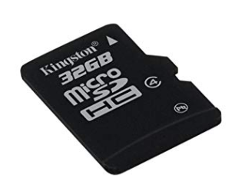
Title | Specification
Brand name: | Kingston
Item model number/Series: | SDC4/32GB
Batteries | 1 Nonstandard battery.
From factor: | 8-pin micro SD
RAM size: | 32768 MB
Hard Drive: | 32 GB
Voltage: | 3.3 volts
Item weight: | 9.07 g
Product dimensions | 1.1 x 0.1 x 1.5 (cm)

SD card connecter.
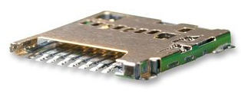
Title | Specification
Overview: | microSD card connector
Part number / Series: | 5033981892
Style: | Push-Push
Pitch – Mating Interface: | 1.10 mm
Height: | 1.28 mm
Termination interface (style): | Surface mount.
Voltage (Maximum) | 10 volts

Task 5: Proteus layout
in this section the circuitry for protecting the microcontroller and signal conditioning will be shown. Signal conditioning will be applied for both analogue and digital signals, including other digital signals from data protocols. This section will also show the pin connection for the selected microcontroller and required features, such as a USB port and SD card slot.
Microcontroller.
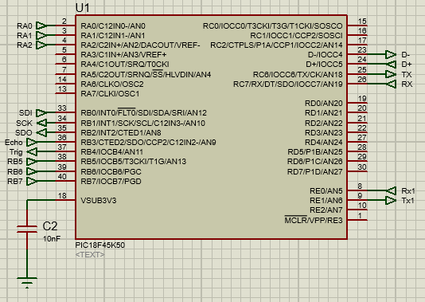
The microcontroller selected is a PIC19F45K50. It was chosen based on the required number of pins and onboard peripherals, analysed from the third and last table in section 2 that identifies all input signal types.
Presently attached to this micro controller, are three analogue ports which are RA0 RA1 and AR2 and Digital pins are addressed as RB5, RB6, RB7. The SD card are connected to the SPI pins addressed as serial data in (SDI), serial data out (SDO), serial clock (SCK).
The pins for universal series bus (USB) are addressed an D+ and D- and the pins for the enhanced universal synchronous asynchronous receiver and transmitter (EUSART) that is connected to GPS module is addressed as transmitting (Tx) and (Rx) Receiving.

Power regulation.
A 5-volt regulator has been applied to regulate the voltage output.
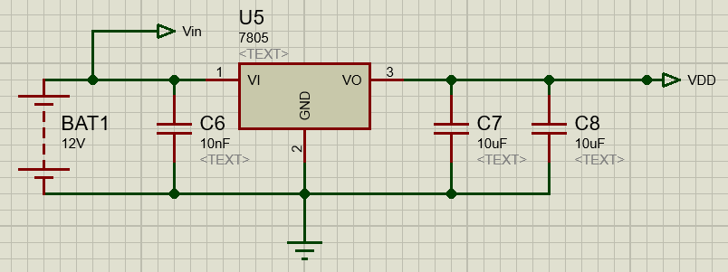
The 7805-voltage regulator has been used to ensure that the voltage applied to the main central device and other peripherals receive a steady 5 volts supply. Capacitators have been applied to smooth the static and noise that may be applied to the regulator. Two capacitors have been applied to the output of the regulator to prevent high levels of current from being drawn to the main device. The voltage output pin has been designated as VDD.
The selected wind speed sensor
SD card slot.
This slot is to store an external non-volatile memory card to store the data read and gathered by the microcontroller.
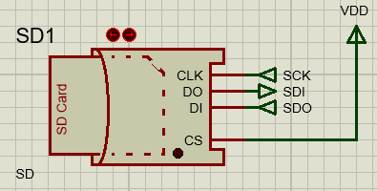
The connection for a SD card slot required the SPI pin to transfer data to be stored or read by the main component. A clock signal is required to run or operate the slot with to data pins and is connected to the CLK pin of the slot to the serial clock pin of the microcontroller.
Data pins of the slot are connected to the device for data transfer. Data out (DO) of the SD slot is connected to the serial data in (SDI) of the main device and data out (DI) of the SD slot is connected to the serial data out (SDO) of the main device.
The chip select pin is attacked to VDD to set the pin as high. This will keep the device enabled for data transfer. This would change if more than one storage device is available, for now this external storage is mainly used.
USB port.
As requested, a USB port is connected to the device so that a computer can connect to the data acquisition device (DAQ) to either read or extract data.
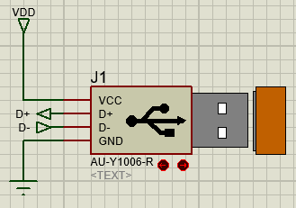
As shown, the USB as only to data pins connecting to the main component. These pins are designated as D- and D+. Voltage supply from the voltage regulator is connected via the VDD pin and GND pin is grounded as see on the image.

The GPS connection
The selected GPS has a RS232 interface, which will require a means of converting the signals produced from the GPS to be altered so that they may be read to the min device.
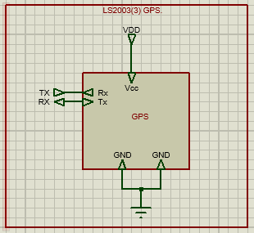

To implement the presence of a GPS, a block with port is applied to indicate is pin layout. The LS20033 GPS has 2 data pins for transferring data at TTL levels to the main device with the enhanced universal synchronous asynchronous receiver and transmitter (EUSART) interface, which data pins are addressed as transmit (Tx) and receive (Rx).

Temperature sensor.
For signals that are analogue, these signals need to under signal configuration conditions so that the signal values are not altered or disrupted.
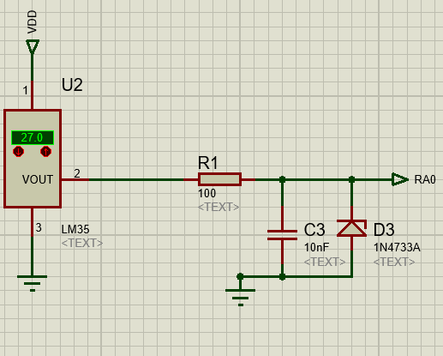

The LM35 temperature sensor is the component of choice to measure the local temperature. to The operate the component a voltage input of 5 volts is applied to pin 1, which will be the max voltage level for the output signal also.
To ensure that the voltage level, current surge, or noise dose to interface with the main component a clamp configuration is put in place. The resister is placed in series to reduce and limit the amount of current being applied to the data pin. The signal will the reach and will be read by the by the microcontroller.
In parallel are one capacitor and one Zena diode, the capacitors purpose is to smooth or remove noise that could be received, interfering with the signal. The Zena diode next to the capacitor will clamp down on the voltage level above the Zena diode specification which is 5.1volts. Any voltage under this value will be acceptable, nut if the voltage rises over this limit the Zena diode will keep the voltage at 5.1 volts.

Light density.
To monitor the light in the local area an LDR circuit is used to determine light density.
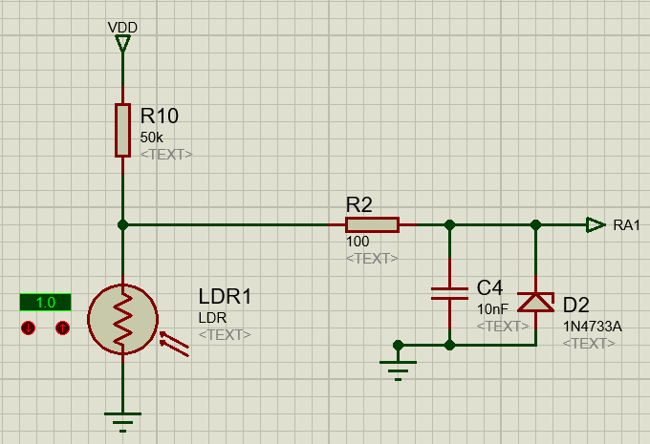
The LDR is set in a potential divider configuration, when light increase or decrease the voltage will also alternate also depending on the resistance of the light dependant resister, which its resistance is influenced by light intensity.
To prevent any noise or large current drawn, three components comprised of a Zena diode, capacitor and resistor are arranged to form a clamp circuit.

Ultrasonic
To measure the wave high of the ocean, an ultrasonic device is used in this case.
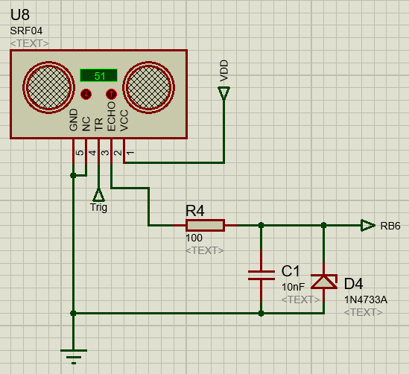
When a trigger signal is produced by the microcontroller, produced at the designated trigger pin, the ultrasonic module will simultaneously produce an ultrasonic sound wave which will travel the modules maximum distance, and a digital pulse, produced from the module itself from the Echo pin, will generate a pulse which its width represents the duration of the sound wave.
Once the sound wave reflects/ricocheted back to its point of origin, the digital wave will be set back to a low level. The echo signal is applied to the microcontroller though another clamp circuit.
As for the other pins, voltage supply is connected to VDD to operate the module with both GND an NC (no connection) tethered to ground.

Wind speed sensor.
As requested from the devices paramotors, a wind sensor connection is applied to determine the wind speed in the local area.
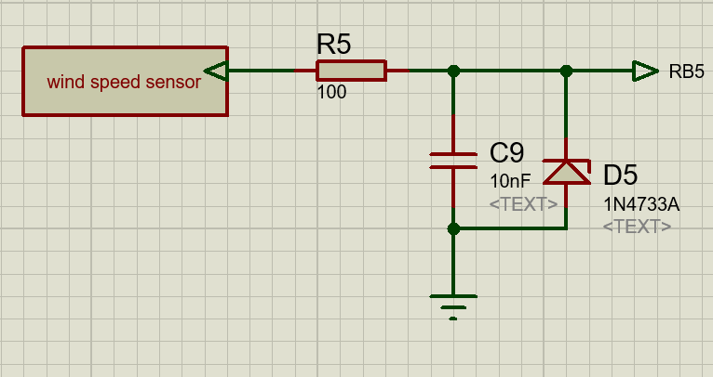
As a digital signal is applied to the microcontroller form the anemometer wind sensor. The digital signal is well in level band for the microcontroller, only a clamp circuit is required to prevent noise and over current drawn.
Humidity sensor.
For determining the humidity in the local area in open waters.
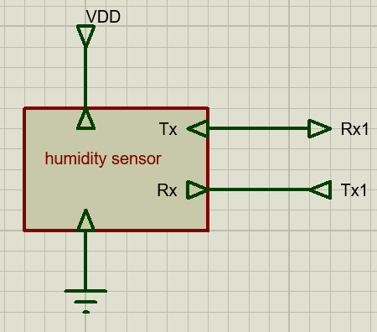
The humidity sensor uses a RS232 interface to transmit the data to the micro controller. Although Tx and Rx pin are in use on the main device. RS232 software can be applied to the micro controller to designate alternative transmitting and receiving pins, to exchange data correctly. This is exceptional due to the voltage levels of RS232 are that of a TTL level but require code to transfer data correctly.

conclusion
investigating into marine data acquisition devices I have gained the concept of data sampling will finding the resolution of a signal measured. The short inquiry into the operation of A DAQ for the purpose meteorology is explained though their standards of design and specification.

