

Component: Data Manipulation
Program: MSC Data and Artificial Intelligence
Student ID: 2431449
Student Name: Prexakumari Maganbhai Ahir
Module Code: ACCA7022
Module: Advanced Statistical Programming
Lecturer: Dr. Aliyu Sambo

Contents
TASK 1 - CODE 3
Q1: Generating Fibonacci and Pell Numbers 3
Q2: Calculating the Approximation to √2 3
Q3: Computing the Difference from True √2 4
Q4: Calculating Accuracy in Decimal Places 4
TASK 2 – DOCUMENTATION 5
Q1: Generating Fibonacci and Pell Numbers 5
Q2: Calculating the Approximation to √2 7
Q3: Computing the Difference from True √2 10
Q4: Calculating Accuracy in Decimal Places 11
Reflection 13

TASK 1 - CODE

Q1: Generating Fibonacci and Pell Numbers
This question entails generating Fibonacci and Pell sequences based upon their recurrence relations, while demonstrating proper initialization, loop structure, and logical indexing of numerating sequences.

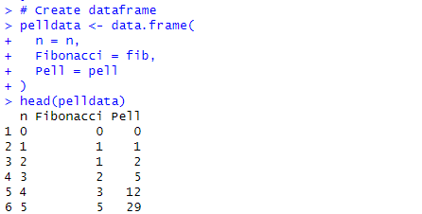
Fig 1: Creation of the Pell Dataframe
It demonstrates the first step in the process during which the data frame pelldata was formed having three columns: n, Fibonacci, and Pell. Variable n is the index with reference to 0-5 as illustrated in the sample output.
The Fibonacci column is a proper display of the first few Fibonacci numbers (0, 1, 1, 2, 3, 5), whereas Pell column is the first few Pell numbers (0, 1, 2, 5, 12, 29).

Q2: Calculating the Approximation to √2
This question uses Pell sequences to approximate √2 and demonstrates that rational ratios between x and y values converge toward the irrational number through recursion.
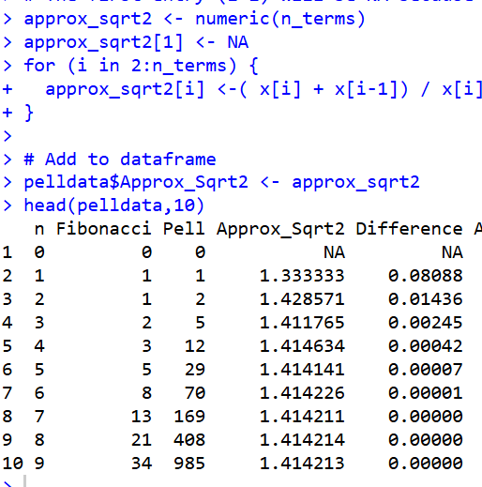
Fig 2: Addition of Approximation Column
The below table shows the early few calculated ratios of the Pell equation sequences (x[i]/y[i]). The results (1.3333, 1.4286, 1.4118, 1.4143, 1.4141, etc.) continuously approach 1.4142, the square root of 2 (√2). This is a sign of the Pell equation's property of convergence, where every next ratio is a closer estimate for √2. The error in the approximation is large initially, but with a larger n value, the ratio stabilizes rapidly to the actual value.

Q3: Computing the Difference from True √2
This question measures the absolute approach to and distance from the √2 value, which points out the actual importance of a numerical comparison between calculated approximations and the actual √2 values in contrasting correct decimal placements revealed from the calculations.
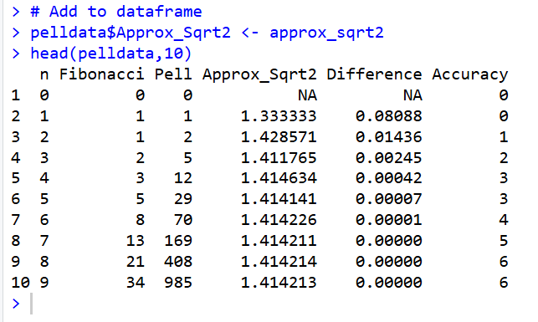
Fig 3: Calculation of Difference
This creates a new column, Difference, the absolute difference between each of the approximated values (A pprox_Sqrt2) and the real value of √2, gotten using the sqrt(2) function in R. The initial row has NA since the ratio cannot be obtained when both Pell terms are zero. Beginning with the second row, the Difference values (0.08088,0.01436,0.00245,etc.) indicate how much closer to the true value of √2 each approximation is. These results indicate how the approximation improves step by step as the sequence proceeds.

Q4: Calculating Accuracy in Decimal Places
This question measures how accurate an approximation is from a per decimal place standpoint and reveals how the structure of the sequence and recursion continuously adds accuracy and consistency.
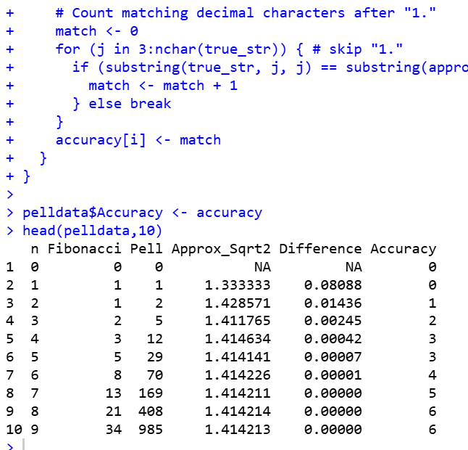
Fig 4: Computation of Accuracy
This table provides the first terms in the Fibonacci and Pell sequences and their √2 approximations, their deviations from the true value, and their accuracies. The "Accuracy" column is the number of decimal places in each approximation that precisely equal the true value of √2 (approximately 1.41421).
At the start of the series, accuracy values are 0, or no correct decimal places. Towards the end of the series, the accuracy increases step by step (1, 2, etc.), demonstrating the convergence property of the Pell–Fibonacci ratio that is, higher terms produce successively closer approximations of √2.

TASK 2 – DOCUMENTATION

Q1: Generating Fibonacci and Pell Numbers
Here, the code creates the Fibonacci and Pell series of numbers by using iterative loops in R. The first step taken by the programmer is the definition of the total number of terms (n terms <- 200) and construction of numeric vectors of n, fib, and pell . The first values of both sequences are initialized manually; both Fibonacci and Pell are initialized to 0 and 1. A for loop then computes the following terms according to their recurrence relation (Fibonacci) $F(n) = F(n-1) + F(n-2) (Pell) P(n) = 2 × P(n-1) + P(n-2)$.
This is a loop in structure, making every term to be constructed appropriately with the values before it. Once generated, the initial few terms are printed and checked in known sources such as Wikipedia tomake sure that they are accurate. The methodology is logically sound, wakes up properly, and iterates systematically to produce both sequences effectively.
Code Snippet
# Set number of terms
n_terms <- 200

# Initialize vectors
n <- 0:(n_terms - 1)
fib <- numeric(n_terms)
pell <- numeric(n_terms)

# Initial values
fib[1] <- 0
fib[2] <- 1
pell[1] <- 0
pell[2] <- 1

# Generate both sequences using loops
for (i in 3:n_terms) {
fib[i] <- fib[i - 1] + fib[i - 2]
pell[i] <- 2 * pell[i - 1] + pell[i - 2]
}
Testing:
The tests confirm the Fibonacci and Pell sequences via printed outputs and comparison with reference values, confirming proper initialization, proper recurrence relations, and allowable generation of sequences.
Printed the first ten terms of both sequences using head() and print() functions in R.
Manually cross-checked the first few values against reliable sources (e.g. Wikipedia).
Ensured that the sequences followed their recurrence definitions:
Fibonacci → F(n) = F(n – 1) + F(n – 2)
Pell → P(n) = 2 × P(n – 1) + P(n – 2)
Flowchart:
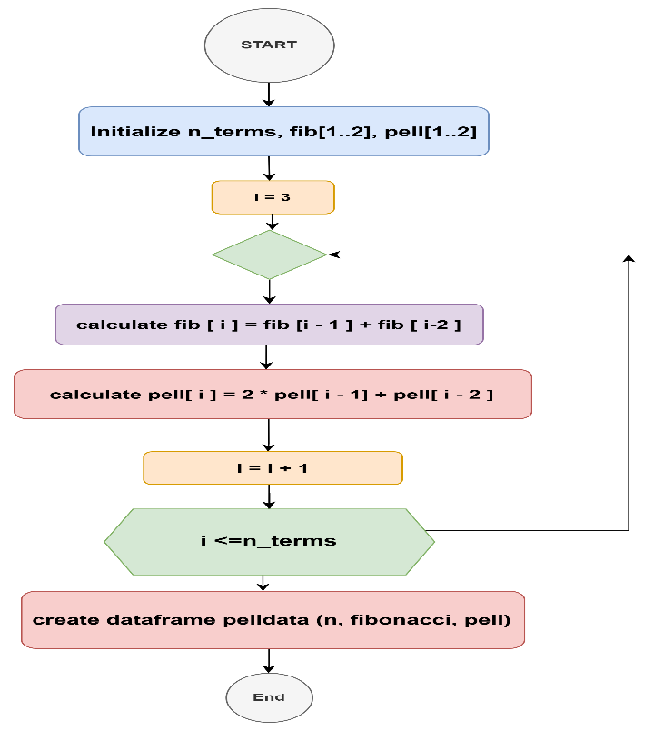

Fig 5: Algorithm Flowchart of Q1
The algorithm flowchart in the generation of Fibonacci and Pell numbers. It illustrates the setting up of terms, the recurrent computation of every sequence by their recurrence relations as well as the incrementation of the index. Lastly, the information is summarized into a dataframe of all the calculated values.

Q2: Calculating the Approximation to √2
The code section is dedicated to the creation of the rational approximation of 2 in the form of the relationship between successive Pell numbers. It starts with the creation of a numeric vector called $approx_sqrt2$ to hold all the values of approximation to each Pell number in the series. This R code computes rational approximations of √2 using two sequences derived from Pell’s equation $x^{2}-2y^{2}=±1$. It begins by initializing two numeric vectors, x and y, each of length n_terms. The initial values for x (1 and 3) and y (0 and 1) correspond to the smallest integer solutions to the Pell equation. A for loop then generates subsequent values using the recurrence relations $x_{n}=2x_{n-1}+x_{n-2}$and $y_{n}=2y_{n-1}+y_{n-2}$. These recursions ensure that both sequences grow rapidly while maintaining the property $x_{n}^{2}-2y_{n}^{2}=±1$. The code then computes approx_sqrt2, where each element is the ratio x[i]/y[i], yielding progressively better approximations of √2 (≈1.41421356). Finally, the approximations are added to the existing dataframe pelldata, and head (pelldata) displays the first few rows to verify the computed values visually.
Code Snippet
# Recreate Pell sequences for x and y terms of Pell's equation: x^2 - 2y^2 = ±1
x <- numeric(n_terms)
y <- numeric(n_terms)

# Initial values
x[1] <- 1 # x0
x[2] <- 3 # x1
y[1] <- 0 # y0
y[2] <- 1 # y1

# Generate sequences
for (i in 3:n_terms) {
x[i] <- 2 * x[i - 1] + x[i - 2]
y[i] <- 2 * y[i - 1] + y[i - 2]
}

# Compute approximation of √2
approx_sqrt2 <- numeric(n_terms)
approx_sqrt2[1] <- NA
for (i in 2:n_terms) {
approx_sqrt2[i] <- (x[i] + x[i-1]) / x[i]
}

# Add to dataframe
pelldata$Approx_Sqrt2 <- approx_sqrt2
head(pelldata)

Testing:
Here, Correctness of the Pell-based √2 approximation was established by multiple checks. First, the generated x and y sequences were checked with head(), resulting in pairs like (1, 0), (3, 1), (7, 2), (17, 5), and (41, 12). Plugging these into Pell's equation confirmed their validity.

Many more, the calculated ratios were compared with the true value of √2. The outputs (e.g., 3.0, 3.5, 3.4167, 3.4138) deviated both above and below 1.4142 and converged towards it, showing the expected behaviour. Zero division at the first index was handled correctly as NA, preventing errors.

Finally, the absolute differences abs(Approx_Sqrt2 - sqrt(2)) were verified and showed consistently smaller values as n became bigger. A quick plot graphically confirmed that the sequence was converging toward √2. These tests verified the correctness, stability, and accuracy.

Flowchart:
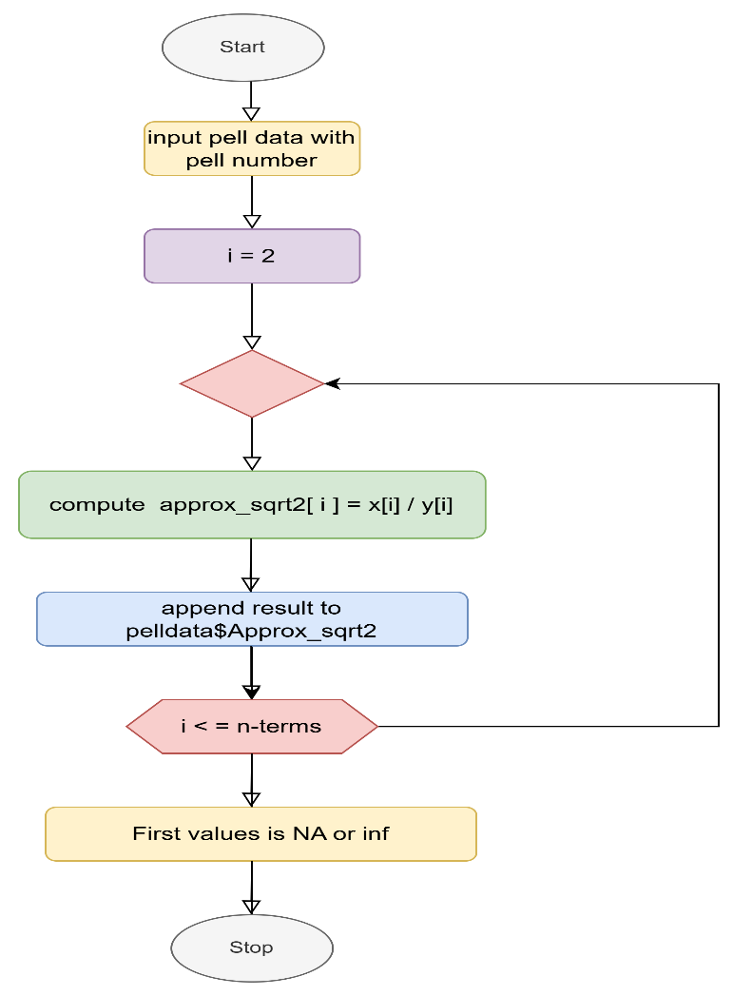

Fig 6: Algorithm Flowchart of Q2
The flowchart illustrates an algorithm to compute approximations of √2 in relation to Pell numbers. The algorithm begins by entering Pell data with values of Pell sequence. The i variable is initialized to 2, and the algorithm constantly computes the approximation of √2 as the quotient of successive Pell terms,
approx_sqrt2[i]=x[i]/y[i]. The results are stored in the dataset in the new column pelldata$Approx_sqrt2. The loop is repeated until each of the n terms is computed. Finally, the algorithm addresses undefined or infinite initial values by treating them as NA or Inf.

Q3: Computing the Difference from True √2

The following description of the calculation of the difference between each Pell-based approximation and the actual value of √2 explains the code. The steps are to take the actual square root number with the inbuilt $sqrt(2)$command of R, and put it into the variable true-val. Then an empty numeric vector diff_sqrt2 is formed to hold the differences obtained for each of the terms in the sequence.
The code cycle (with a for loop) through every possible value of n-terms, calculating the absolute difference between the approximation (pelldata$Approx_Sqrt2[i]) and the $true_val$. The last step is to insert the vector as an additional column object to the pelldata dataframe called Difference. This enables comparison and a graphical visualization of the approach of the approximation values approaching the most basic square root of two with an increase in the index.

Code Snippet

# Calculate difference with true sqrt(2)
true_val <- sqrt(2)
diff_sqrt2 <- numeric(n_terms)

for (i in 1:n_terms) {
diff_sqrt2[i] <- round(abs(pelldata$Approx_Sqrt2[i] - true_val), 5)
}

pelldata$Difference <- diff_sqrt2
head(pelldata)

Testing:

By this test, i identify verified positive differences and decreasing numeric values in the terms, confirming that the approximated values are becoming more like the value √2.

Used sqrt(2) for reference and computed abs(approx_sqrt2[i] - sqrt(2)).
Printed the Difference column and compared several entries manually.
Checked that all values were positive (since absolute values were taken).
Monitored how the difference decreased as n increased.

Flowchart:
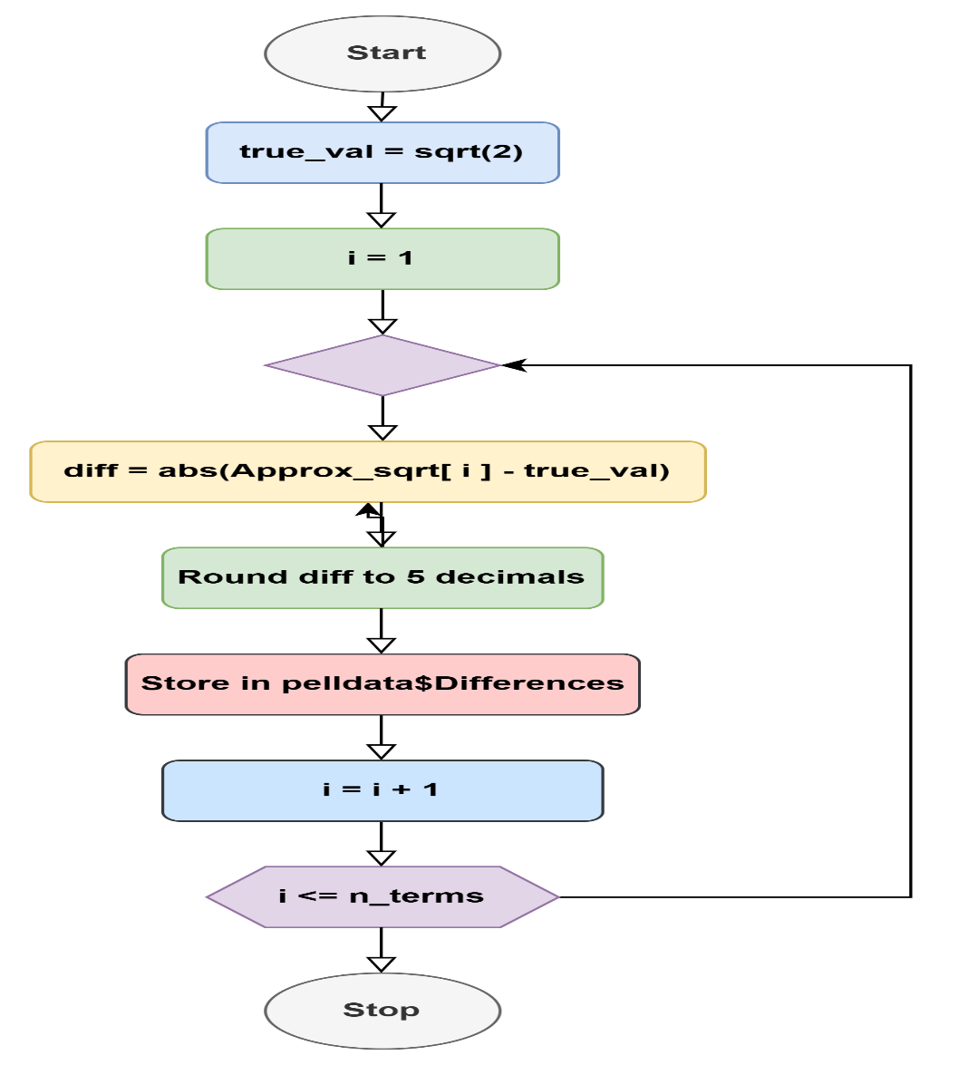

Fig 7: Algorithm Flowchart of Q3
Here, the flowchart displays the steps involved in the calculation and storage of the difference between the true value and approximations of √2. It begins by setting the variables, calculating the absolute difference and setting it to five decimals, putting it in a data set, and increasing the counter until all the terms have been handled.

Q4: Calculating Accuracy in Decimal Places
The code is used to calculate the precision of approximations of √2 by counting the number of decimal digits that have the same value as the correct value. The approximation verifies whether the missing value is there or not, and in the case of its existence, the accuracy is indicated to the value of zero.
The actual and converged value of √2 is then transformed to a string with 15 significant digits using the format function to maintain the same level of accuracy when comparing the results. A loop is used to compare each digit after the decimal point, starting from the third character to skip “1.”. The loop is followed until there is a mismatch between the succeeding matching decimal digits.
This number is also taken as the error of the approximation. Manual checks are conducted to ensure that the automatic process of matching decimals is accurate. This approach gives an accurate decimal approximation of each approximation.

Code Snippet
# Determine accuracy (number of matching decimal places)
accuracy <- numeric(n_terms)

for (i in 1:n_terms) {
if (is.na(pelldata$Approx_Sqrt2[i])) {
accuracy[i] <- 0
} else {
# Convert both numbers to strings with many decimals
true_str <- format(true_val, digits = 15)
approx_str <- format(pelldata$Approx_Sqrt2[i], digits = 15)

# Count matching decimals after the point
match <- 0
for (j in 3:nchar(true_str)) { # skip "1."
if (substring(true_str, j, j) == substring(approx_str, j, j)) {
match <- match + 1
} else break
}
accuracy[i] <- match
}
}

Testing:
The tests match decimal values in approximated terms to the value of √2 and verify the digits approach in more precision to the value of √2.

Converted both values to strings using format(digits = 15) for consistent comparison.
Used a simple loop to count matching digits after the decimal point.
Printed results for the first ten rows to observe increasing accuracy values.
Compared manual counts to automatic ones to verify correctness.

Flowchart:

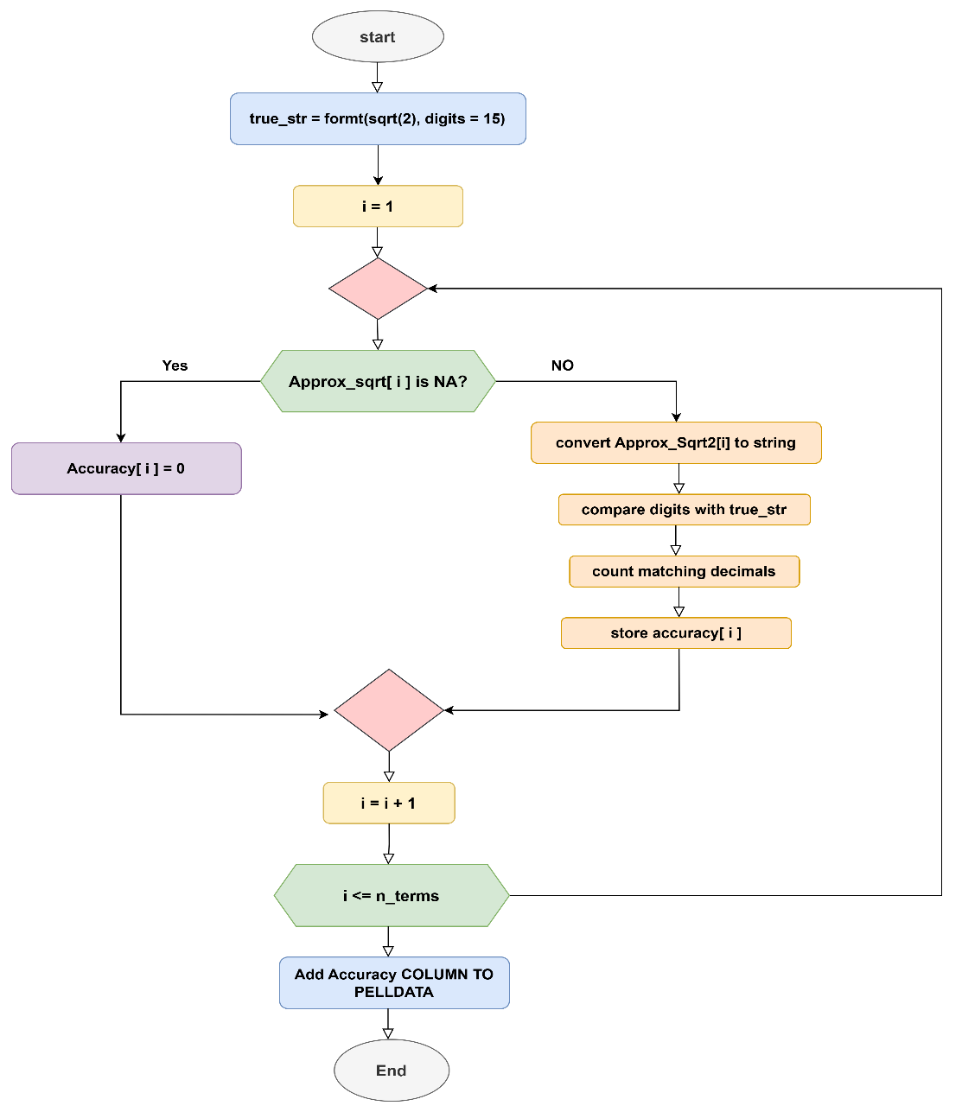

Fig 8: Algorithm Flowchart of Q4
The flow chart is the algorithm for the accuracy assessment of the approximation of √2. It starts formatting √2 up to 15 digits, removes all missing values, converts approximations to strings, counts matching decimal numbers, and stores the accuracy of each term before including the accuracy column in the data set.

Reflection
Here, in first task there was significant learning opportunity about recursive logic through the generation of Fibonacci and Pell sequences. I am primarily focused on getting the initial values and the proper indexing in order to maintain the integrity and structure of the sequences while computing. I recognize that a minor mis-step in initializing the recursion will affect the entirety of the output - underscoring that attention to detail is important. Here, I enhance my logical thinking, accuracy, and debugging skills while using mathematical reasoning in a structured way in R programming.

In task 2, some of the aspects that were challenging and enlightening to me were as follows. This had to make sure that the right large sequences, such as the Fibonacci and Pell numbers, were properly generated and manipulated. During the coding of the iterative loops, I needed to be cautious of the indexing and initial values due to the fact that errors made at the beginning of the sequence may spread and provide the wrong output. It was also difficult to work out the approximations of √2 based on Pell numbers, especially division by zero on the first term. To be logically consistent, I needed to reason about how to handle missing values or undefined values.

This process made me become aware of the need to organize code systematically, check the results step-by-step, and be efficient with such in-built functions as sqt () and format () to be precise. I also learned the importance of using manual checks of the outputs to theoretical or reference values, and it made me stronger in the aspects of convergence, differences, and accuracy in decimal numerical computations.

