An analysis of Swansea Ospreys marketing & how social media impacts their audience

- Aims & Objectives
The aim is to discover and research what customer motivations are when it comes to marketing of sporting events, such as rugby, and how social media is used to help promote the Ospreys and rugby to the public and how they market their club to the public, whether that’s just in Swansea or other regions around the UK. The aim of the research is to better understand what attracts people to watch the Ospreys, whether that’s with marketing material they use, or whether its from use of any social media platforms, which is a dominant tool in the world of marketing to attract audiences and finally why visitors and fans attend the sport which can vary from person to person. A questionnaire will be given to attendees of an Ospreys match to ask what they thought of the match they attended, was it marketed enough through social media and how did they know about the match they just watched was on. This is to demonstrate if the Ospreys are making use of their social media and marketing departments in the right way, and if there is any room for improvements too be made to help better themselves. During the research its hoped that the objectives will be met and have established how the Ospreys use their social media platforms and marketing and for the future how they can be improved for better use.
- Background
The topic specified is a look in to how Ospreys attract and bring in audiences for their Pro 14 games and cup games. What motivates audiences to attend these matches and do the audiences that attend feel that the Ospreys gets enough publicity through social media and marketing advertisements. From research, what is gathered is that people who attend these matches are usually from the local area, in this case from Swansea or the regions surrounding the Swansea area. However, it is understandable that other factors play in to how audiences find out about these matches, such as from other local rugby teams. If they are playing against the Ospreys, they will have allocated tickets that their fans can buy for the game. The main research behind this is to find out as explained, how the Ospreys as a region market, promote and make use of social media towards their audiences and how it can be potentially improved upon. With the steady decline of people watching less TV, its beginning to have an impact on not just TV but sports as well. This is why sports are starting to reinvent and deliver better way to let fans watch the games they want. An example is the Facebook live feature where teams and WRU are starting to broadcast not only just on TV, but through Facebook. This is starting to become popular, especially with younger audiences who use Facebook a lot through their daily lives. (https://www.campaignlive.co.uk/article/need-know-sports-marketing-2017-beyond/1424873#Trend01) The Ospreys could incorporate something like this and make it their own to help with their branding of the club.
- Rationale
Sport tourism is a big industry with varying reasons why people attend sporting events, whether its out of interest or visitors/participants have a big passion for that particular sport. The following is a brief definition of what sports tourism is and explains that sports tourism is defined as travelling from one destination, to another to watch or participate in a sporting event, such as football, rugby and more. “Sports tourism is traveling from one region, country, state, etc. to another to watch a sports competition or game.” (http://www.sports-management-degrees.com/faq/what-is-sports-tourism/)
- Methodology
Collecting research, there is a variety of different approaches that can be chosen to carry out during the research. The picture below shows the different ways of collecting data and utilising research from Saunders, et al. 2009.
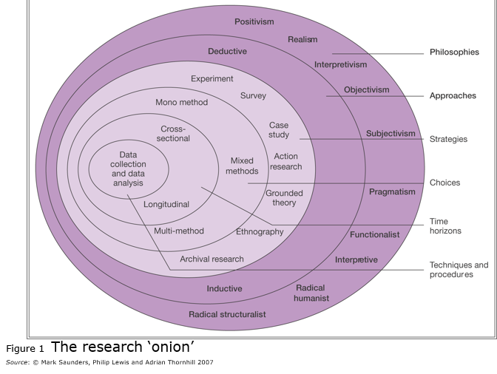
Qualitative research is in depth research which requires interviews and detailed responses from participants. This will require the researcher to build a rapport with their participants through interviews and contact where possible. Qualitative research can be rushed by participants, or participants may not want to answer the questions that are provided for various reasons. There is potential for false information being answered. This can become time consuming and take a long time to carry out the research.
Quantitative research is simple questionnaires that are carried out and people are familiar with. These are simple answers with tick boxes. The data that is collected from these are easy to collect and put together as participants may have similar answers to the next participant of the questionnaires. Using quantitative research is the best way to get a large amount of answers from a group of people in a short amount of time if carried out correctly and consistently. However, participants for quantitative research could provide false answers in their questionnaires. Also, participants may not want to/feel uncomfortable answering the questions provided. Finally, this could have time concern restraints as the researcher will need a minimum of 100 people to answer the questionnaires.
Primary data is information that has been collected by the researcher for specific use of the chosen topic. This data is collected by conducting interviews and handing out questionnaires to participants that are willing to get involved with the topic. Secondary data is data that has been collected by someone and has been published before. Secondary research is still relevant to the topic of the researcher, however will mean that the researcher will need to use both their secondary and primary research to compare what may have changed.
Interviews are linked with qualitative research and requires the researcher to interview and ask participants a few questions about the chosen topic provided by the researcher. This again means building up a rapport with the participant to gather information for primary data that can be used for the research topic.
Questionnaires are used as quantitative research and is used to gain information from a group of participants about the chosen topic. Again, this research can be used as primary data with the potential of secondary data being available. This helps gain an understanding from a group of people with the same base questions as answers may overlap with participants who have carried out the questionnaire.
For this research topic, using quantitative research would be useful for the topic, as the research can be carried out during match days where it will make it easier to ask fans, whilst they are waiting if they can fill the form out if they have a spare 5 minutes. During match days when the questionnaires are handed out, they will be given to a minimum of 150 people. The questions that will be asked through these questionnaires are as follows:
- How often do you attend Ospreys matches?
- Do you feel that advertisements for the Ospreys as a region is good or bad?
- How did you find out about the Ospreys?
1. Through social media
2. Live locally
3. Advertisements in the local area/region
As can be seen below is a small example of what the questionnaire will look like once it has been completed and ready for use with participants.
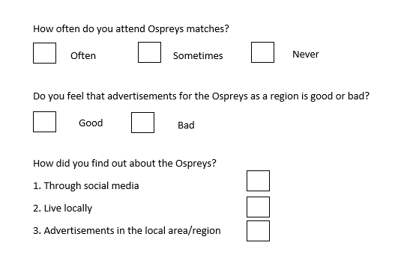
- Research design
As discussed in methodology, the research method that will be carried out for this topic is quantitative research, and will help with gathering and analysing data that is collected from the questionnaire that the participants will be filling in. The information that will be gathered through this research will be recorded to identify any trends or inconsistencies from other participants of the questionnaires. The data that will be taken from these questionnaires will be brought on to a spreadsheet/graph to better understand the information compiled from the questionnaires and help analyse if there are any trends in the data that was gathered. The graph that could be used for this type of data is pie charts, which could refer to the participants age ranges and nationalities. What can also be done using these is creating a line graph which shows the age ranges and if the participants are male or female.
- Resource planning
This topic will require a few resources. This will mean books which can be obtained from the university as hard copies, online journals and other online resources which can be attained from the internet such as google scholar and other online articles/journals. Help from the tutors that teach the events management course. Time will be of very high importance throughout the dissertation and having realistic times set during the period that the researcher can stick by through that period. A Gantt chart will be prepared and will demonstrate a timescale which will run from October 2018 to May 2019.
- Ethical issues & Risk
For the chosen topic, its hard to identify any ethical risks associated to the topic choice. However, the questions that will be created for the questionnaires will stay away from anything that will or could become an ethical issue. All data that will be collected from participants through the questionnaires will be notified before filling it out that this is anonymous questionnaire to help the participant feel at ease whilst filling out the questionnaire. Due to the nature of the topic there won’t be any questions that will cause any controversy, thus meaning consent forms before the participants fills out the questionnaire won’t be necessary and shouldn’t pose any risk to both the participant or the researcher. However, to be safe, it will be best to create a consent form that just indicates that the participant is OK with filling out the form and that they are of age to fill out the questionnaire. If they are not, then they will not be able to participate. The aim is to generate data that can be used accurately within the topic area, so the data will be important during this obtaining period.

References
Sports-management-degrees.com. (2018). Cite a Website - Cite This For Me. Available at: http://www.sports-management-degrees.com/faq/what-is-sports-tourism/. 1 Mar. 2018.
Campaignlive.co.uk. (2018). What you need to know about sports marketing in 2017 and beyond. Available at: https://www.campaignlive.co.uk/article/need-know-sports-marketing-2017-beyond/1424873#Trend01. 2 Mar. 2018.

