
LCMB7024 Marketing Management
Assessment Component 2: Marketing Portfolio

Student Name: Md Rony Sheak
Student ID: 2434287

Lecturer Name: Dr Laila Maazouz (London)

Word Count: 2713

Table of Contents
Introduction 3
Element 1: STDP Analysis for ASOS Nova SmartBelt 4
Company Overview and New Brand Concept 4
Why the New Brand Appeals to the Current Market 5
Segmentation 6
Targeting 7
Differentiation 8
Positioning 8
Element 2: 4Ps Marketing Mix 9
1. Product Strategy 9
2. Price Strategy 10
3. Place (Distribution) Strategy 11
4. Promotion Strategy 11
Element 3: Marketing Strategy Pitch 12
Element 4: Reflection 13
Conclusion 16
References 17
Appendix 19
Element 3: Poster 19

Introduction
Marketing management can be defined as the actual process of planning, performing and controlling strategies to bring value to the customer and the delivery of organisational objectives (WALTERS, 2024). With the fast-changing retail landscape, brands will have to be innovative to stay competitive, particularly with the changing consumer behaviour that is turning towards wellness-oriented and technology-integrated products. This report outlines a brand development strategy at ASOS via the introduction of Nova, the smart fashion-tech brand and the Nova SmartBelt, the fusion of style, biometric tracking, and smart, adaptive comfort. The strategy will be in line with the new demand of Gen Z and Millennials who are gravitating towards fashion-built wearable tech.

Element 1: STDP Analysis for ASOS Nova SmartBelt

Company Overview and New Brand Concept
ASOS is a leading online fashion retailer in the UK with a base of over 26 million active consumers across more than 85,000 apparel and accessory product offers (ASOS, 2024). ASOS is a digital-first company, with 90% of its sales being done via mobile devices and the EPS of the company was 2.55 USD in 2023.
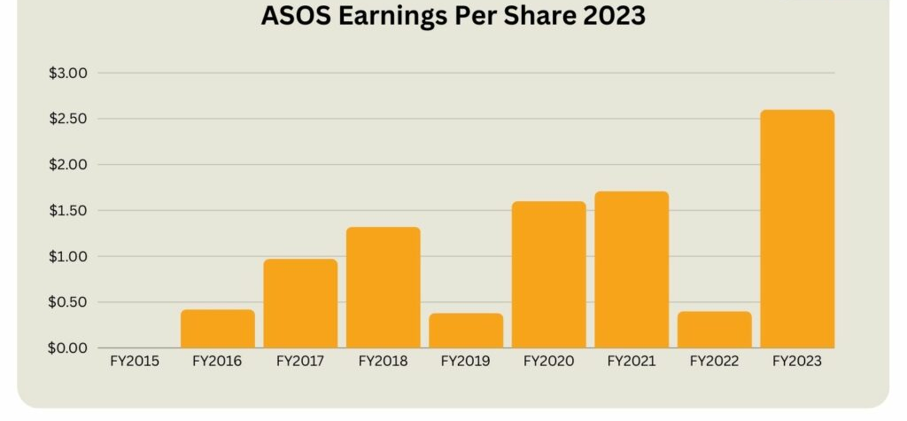
Figure 1: ASOS Earning Per Share in 2023
Source: (Helplama, 2023)
The smart wearables market in the UK is in a booming phase with the current market worth 4.2 billion in 2024 and is expected to increase as consumers become accustomed to health monitoring and life optimisation in their daily life. Using this transition, ASOS launches Nova, a smarter fashion-technology label that fuses the aesthetic design with understated wearable smartness. The Nova SmartBelt, the hero product, incorporates biometric sensors, automatic comfort sensors, the ability to connect with apps, and posture notifications, placing ASOS as a leader in the new fashion-tech accessory market.
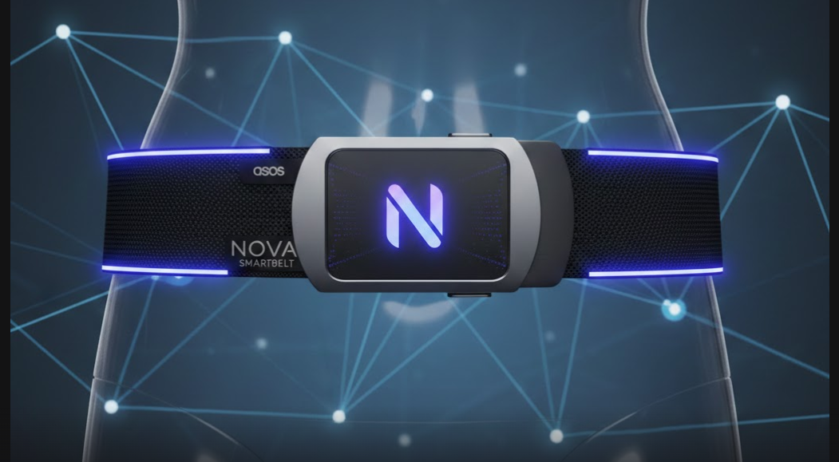
Figure 2: New Brand (Nova SmartBelt)
Source: (Self-Made)

Why the New Brand Appeals to the Current Market
- Growing Demand for Wearable Technology: The importance of wellbeing is rising among the consumers of the UK, with 72 per cent monitoring their health or activities using some form of technology. Making health tracking an aspect of a fashion product will enable Nova to fulfil the trend of ever-increasing demand of devices that optimise their daily health without looking too technical.
- Shift Toward Wellness and Daily Health Monitoring: Gen Z buyers are more attracted to wearables embedded into clothing or accessories than traditional smartwatches, and younger buyers favour more low-profile technical wearables instead of bulky wrist watches (Flodemark and Zumbuehl, 2021). A smart belt will offer health information without interfering with personal style.
- Rise of Fashion-Tech Integration: Shoppers demand the products to be flexible to their lives; more than 60 percent of the consumers prefer tailor-made or customised fashion experience. The SmartBelt also is suitable to the trend of comfort-driven innovation since the adaptive-fit system can respond to the movement and posture (ASOS, 2024).

Segmentation
ASOS Nova uses multi-dimensional segmentation model to target fashion-forward customers who are smart in their lives. The application of market segmentation is following:
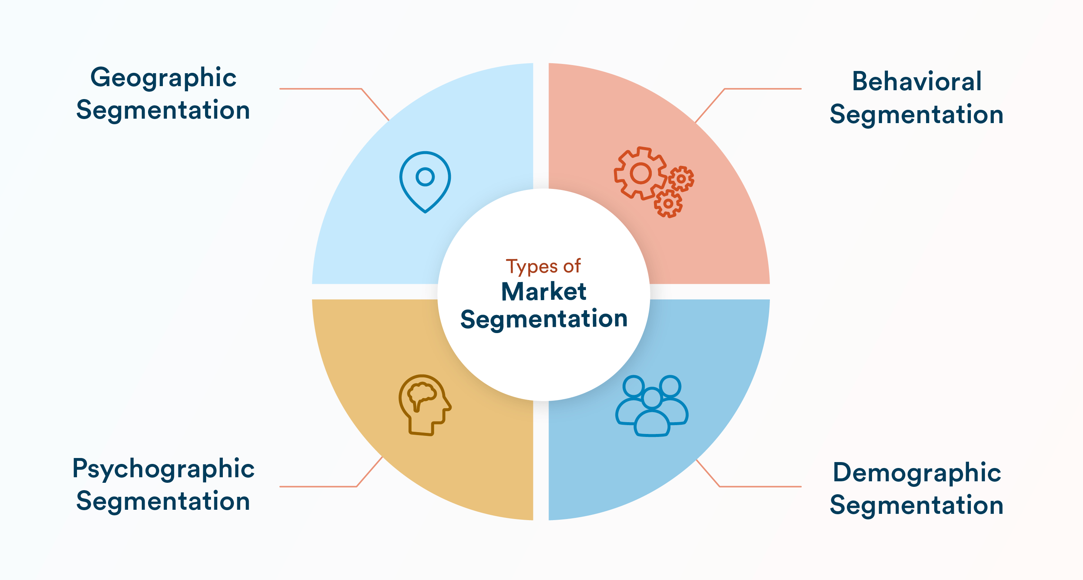
Figure 3: Types of Market Segmentation
Source: (Banerjee, 2024)
Segmentation Type | Detailed Description
Demographic | • Age: 18–35, the most active wearable adopters, accounting for over 60% of UK smart wearable purchases.  • Income: Middle to high income; willing to pay premium for fashion-tech products.  • Occupation: Students, young professionals, and remote workers who rely heavily on technology for productivity and well-being.
Geographic | • Focus on UK urban and metropolitan regions such as London, Manchester, Birmingham, and Bristol (Handley et al., 2025).  • Urban consumers make up 75% of wearable device penetration due to accessible digital infrastructure and rapid delivery logistics.  • High concentration of fashion-forward populations and higher disposable incomes.
Psychographic | • Tech-savvy digital natives who enjoy experimenting with new innovations.  • Value a lifestyle that blends fashion, optimisation, and self-care.  • Identity-driven shoppers—55% of Gen Z prefer brands that reflect personal style and digital culture (Flodemark and Zumbuehl, 2021).
Behavioural | • Frequent online shoppers—UK 18–30-year-olds make over 70% of fashion purchases online.  • Early adopters of smart gadgets and app-connected devices.  • Prioritise comfort, convenience, and time-saving product features.

Targeting
ASOS Nova is aimed to focus on youthful adults aged between 18 and 35 and reside in urban conditions as well as mature technology and design. This group is very active on the Internet, 69% of them shop fashion via mobile applications and keep in touch with product trends on Tik Tok, Instagram, and YouTube (Statista, 2023). They constitute the most rapidly expanding category of the wearable market in the UK since smart accessory uptake among Gen Z and Millennials has grown by 18% annually. The target market would want pieces that are stylish, convenient, and supportive of wellbeing, and the SmartBelt fits the criteria perfectly by being a timely alternative to more noticeable wearables such as smartwatches.
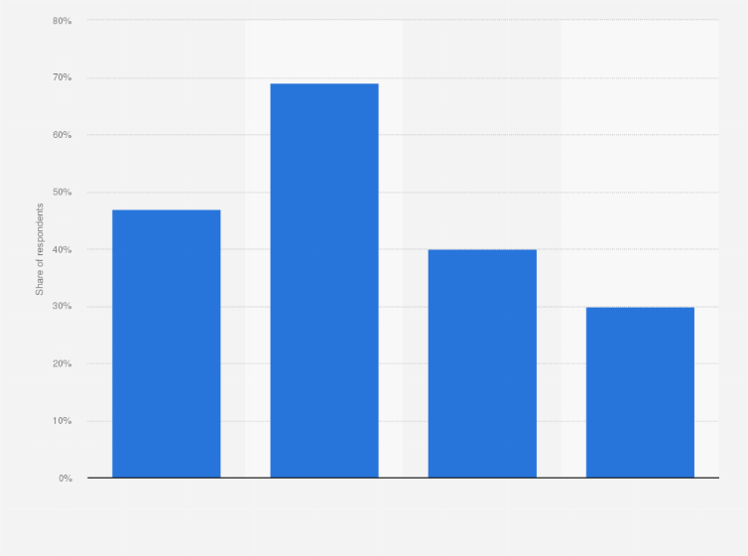
Figure 4: UK: Online Fashion Shoppers by Generation 2023
Source: (Statista, 2023)

Differentiation
1. Fashion-Embedded Technology: Nova also separates itself by adding smart features to a classic fashion piece (ASOS, 2024). When competitors prioritise the wrist-based product, Nova provides a hidden wearable that fits the daily fashion, tackling the untapped demand on technology without showing visual noise.
2. Adaptive Comfort System: The automatic adjustment feature of the SmartBelt is a unique value: the belt reacts to movement, sitting, and changes in posture, which is not provided by other fashion accessories. This is a solution to a typical comfort problem and increases well-being.
3. Data-Driven Personal Lifestyle Insights: Nova offers the essential biometric monitoring and posture information without the need to use a lot of screen time (Finnegan and Armstrong, 2024). This will be attractive to the users who desire passive health tracking in their day-to-day wear, unlike smartwatches that require attention all the time.

Positioning
Nova brands itself as the best smart fashion-tech wearables in the UK, with sleek, subtle and intelligent accessories that can be used in modern times. It lies between high-end fashionable accessories and practical wearable technology and occupies a marketing void among consumers who want to have a combination of style, comfort, and health optimisation (Elena, 2024). Nova is a promise of the fashion-powered intelligence, so smart living will be easy, and attractive in a visual way.

Element 2: 4Ps Marketing Mix
The application of 4Ps marketing mix of the Nova SmartBelt is following:
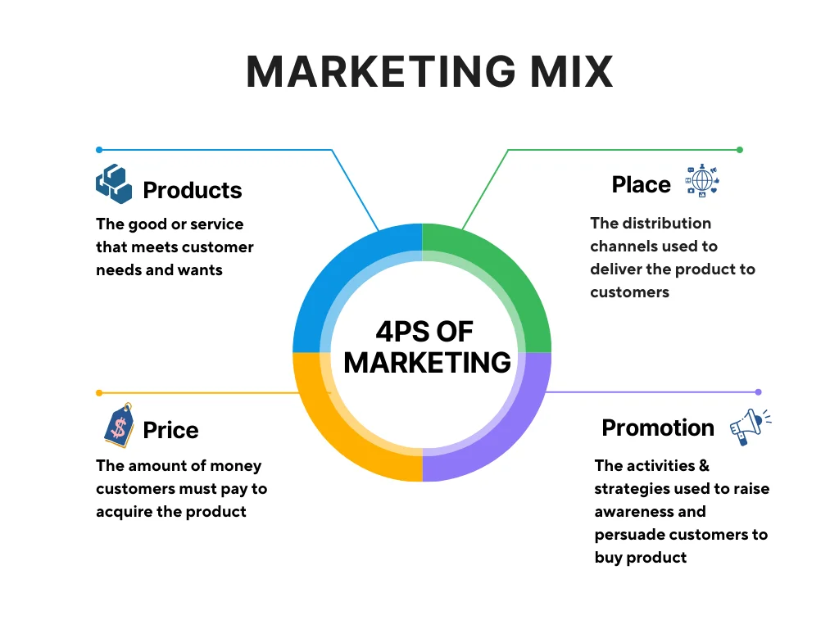
Figure 5: 4Ps of Marketing Mix
Source: (Nguyen, 2024)

1. Product Strategy
1.1 Core Product Value: The Nova SmartBelt offers an array of fashion, functionality, and unobtrusive wearable technology. People are seeking smarter and smarter products that can be worn like everyday clothing, and over 60 per cent of fashionable Gen Z and Millennials favour invisible or clothing-based technology over eagerly visible fitness bracelets (Flodemark and Zumbuehl, 2021). The SmartBelt solves this by integrating biometric sensors, posture notifications, motion tracking, and smart-fit options within a stylish everyday belt.
1.2 Actual Product Features: The belt is made using high-quality vegan leather, a recyclable alloy buckle, and a smart module that is flexible and hidden in the strap. A narrow sensor strip tracks the number of steps, posture positioning, spinal mobility and light hydration indicators. The buckle has a micro-vibration alert system that reminds the user of slouching or inactivity in one position. The information connects through Bluetooth to Nova app which enables customisation of comfort as well as tracking goals.
1.3 Augmented Product Elements: To increase brand value, ASOS provides extended warranty, damage cover, and free one-year premium features on the Nova Insights App (ASOS, 2024). Virtual 24/7 support, online set-up guides, and personal styling recommendations via the ASOS app lead to improved post-purchase experience. Nova resonates with the growing consumer demand of eco-friendly fashion-tech, with its free belt customisation and sustainable packaging; almost three-quarters of online buyers like brands that are socially responsible.

2. Price Strategy
2.1 Premium-Accessible Pricing: ASOS places Nova as a smart and high-quality accessory that is affordable. SmartBelt will sell at between £79 and 99 based on customisation and material of the belt (ASOS, 2024). Such pricing will be between typical fashion belts (25-60) and typical wearables (100-250), which will enable ASOS to draw in customers who desire technology but cannot afford expensive smartwatches.
2.2 Psychological and Competitive Pricing: The premium high-end price (£99) adopts psychological pricing to support the quality perception (Sudhir, 2023). Another opportunity available to ASOS is that of competitive positioning: there is no other large fast-fashion store that is gigawear-equipped with a belt. This will give Nova a pricing edge and enable the company to compete without price battles.
2.3 Dynamic Pricing: ASOS uses seasonal pricing, spike pricing, and interactive pricing, which is the dynamic pricing on the internet. Demand of wearable tech usually grows by 30-40 percent during holidays, and ASOS can adjust the prices and provide such a bundle as the SmartBelt and an accessories set. Price accessibility is further supported by student discounts and rewards and other loyalty points to younger segments.

3. Place (Distribution) Strategy
3.1 Digital-First Distribution: ASOS is already an online store, and Nova is using this advantage with the help of international distribution via e-commerce (ASOS, 2024). ASOS delivers to more than 200 nations and 80 percent of its traffic is delivered through the use of mobile devices. The Nova section on the site and app is dedicated to increased product visibility, with 360 views, AR try-on, and compatibility tests of the user devices.
3.2 Selective Marketplace Placement: ASOS collaborates with chosen marketplaces which are highly regarded to have tech-savvy audiences like the wearable-tech section in the Amazon UK (Okur and Saricam, 2025). Exposure in the marketplace adds more credibility because approximately 70 per cent of online buyers visit more than one website before they buy a new technology gadget.
3.3 Efficient Logistics and Returns: The promise of convenience in Nova is supported by the strong logistics network of ASOS that provides next-day delivery in the UK and fast worldwide shipping. Since over 80% of ASOS clients deem convenient returns as crucial, Nova offers a streamlined returns and recalibration procedure. Smart package is equipped with troubleshooting and repair booking QR codes which are scannable to facilitate easy user experience (Santoro, 2024).

4. Promotion Strategy
4.1 Brand Positioning and Messaging: Promotional theme of Smart Style Everyday conveys the exclusive combination of fashion and wellness-intelligence of the belt. Messaging is about discretion, convenience and empowerment. Polls indicate that three-quarters of Gen Z are attracted to brands that help them establish their lifestyle, as opposed to selling individual items, so in its communication Nova emphasises something that the belt fits daily like a glove (Flodemark and Zumbuehl, 2021).
4.2 Digital and Social Media Campaigns: ASOS engages strongly with TikTok, Instagram Reels, YouTube Shorts and Pinterest, all platforms where short-form fashion-tech content has flourished (Kim, 2024). Such real-life uses cases that Tech-fashion influencers demonstrate include posture enhancement, occupational attire, and office style. This guarantees quick virality since TikTok fashion content has more than 1.5 billion monthly viewers.
4.3 Launch Events and Collaborations: An online launch with technologic reviewers and fashion designers will assist Nova to establish authority within the two sectors (Petkova, 2024). They make cross-category appeals by working with fitness applications and ergonomic workspaces brands, as well as wellness influencers. ASOS home page has pop-up digital experiences that emphasise posture notifications and smart-fit adjustment.

Element 3: Marketing Strategy Pitch
New Brand Development
ASOS launches Nova, the smart fashion-tech clothes brand meant to combine fashion with smart wearables (ASOS, 2024). The main product, the ASOS Nova SmartBelt, is a mix of simple fashion and high-tech elements that make ASOS the leader of the smart-accessories segment.
Alignment with Customer Trends
ASOS Nova reacts to the increased demand for health-tracking wearables, convenience-oriented fashion, and accessories with tech. The contemporary customers are concerned with fashion, utility, and personal information (Klein, 2024). Combining an inconspicuous fitness tracker, posture notifications, and an intelligent comfort system, the ASOS Nova SmartBelt is a trendy way to wear smart fashion every day.
Segmentation
ASOS Nova focuses on tech-savvy Millennials and Gen Z, urban professionals who appreciate inconspicuous wearable technology, and fashionable customers who appreciate innovation (Houghton, 2025). The ASOS Nova SmartBelt attracts users who desire style and smartness in one accessory.
Marketing Mix (Promotion and Product)
Product: The ASOS Nova SmartBelt has been designed to have biometric tracking, integration with apps, smart-fit adjustability, and high-quality ASOS design features.
Promotion: ASOS Nova will leverage the power of influencer collaboration, TikTok tech-fashion, AR interactive demos, and smart-lifestyle brand partnerships to generate excitement in the market.
Conclusion
ASOS Nova makes the company a fashion-tech innovator, providing investors with a solid growth potential and customers with an intelligent, stylish everyday accessory with the ASOS Nova SmartBelt.

Element 4: Reflection
The model by Gibbs promotes the systematic consideration of the reflection in six steps: Description, Feelings, Evaluation, Analysis, Conclusion and Action Plan (Channell, 2023). In this section, I will apply the Reflective Model by Gibbs to reflect on my learning process and analyse my performance.
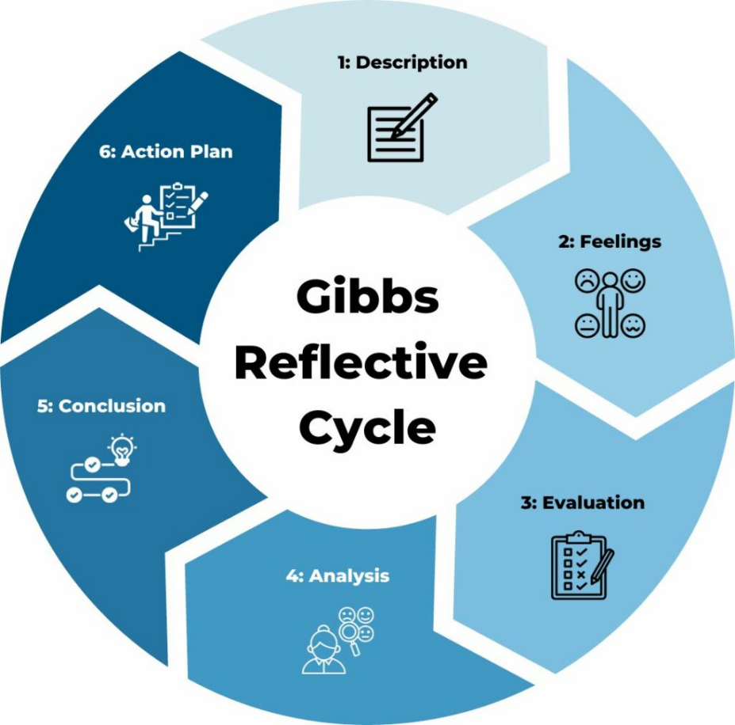
Figure 6: Gibbs Reflective Cycle
Source: (Channell, 2023)
Description
The assignment was to design a new fashion-tech brand, Nova, at ASOS, develop the hero product Nova SmartBelt, and the 4Ps marketing strategy. Another thing I did was to prepare and present a marketing strategy pitch utilising digital presentation tools. The project involved carrying out a lot of market research on the wearable technology market in the UK, consumer behaviour and competitor analysis to make the brand not only innovative but attractive to Millennials and Gen Z.
Feelings
At first, I was very enthusiastic about the opportunities of mixing fashion with technology because it gave me a chance to investigate the latest tendencies in smart wearables. I also felt a little bit nervous, though, more so about making accurate consumer response predictions and choosing the best promotional tools. As I was working on the pitch, I experienced both nervous and motivational feelings to develop a professional, data-driven plan reflecting creativity and strategic vision.
Evaluation
The project in general was very rewarding. Intertwining of the market research with brand strategy was developed by the creation of Nova, making me practise the combination of consumer needs and product innovation, when designing a fashion-tech accessory. The pitching of the marketing strategy enhanced my communication skills and capacity to articulate confusing ideas. One of the weaknesses was that I had initially underestimated the time that would be needed to combine technical wearable elements with a trendy product storey.
Analysis
This process helped me to realise that it is necessary to integrate quantitative and qualitative knowledge. Relevant product features such as the 72% of users in the UK who use technology to monitor their health were used to design my product. Knowing more about digital-first behaviour and the preference of Millennials and Gen Z to engage with TikTok and Instagram, it became necessary to develop specific promotional approaches. Also, the reflective process also focused on strategic thinking, creative problem-solving, and aligning product innovation with consumer lifestyle which is paramount in brand building.
Conclusion
The experience reinforced my analysis, creativity, and communication abilities and improved my knowledge about digital marketing, fashion-tech integration, and consumer behaviour. I came to the conclusion that to create a successful brand, one must strike a balance between innovation, beauty, and user-friendly design, as well as use data to make decisions. The pitch showed my skills in persuasion and presentation, but time management and depth of strategic insights can be improved.
Action Plan
In future, I will dedicate more time to combine technical functions with the interest of consumers and schedule incremental feedback to improve strategies. I would also like to deepen my understanding of digital marketing, specifically, influencer campaigns and AR technology, and master my skills as a speaker to make even more convincing pitches. More accurate and effective brand strategies are also possible with more actual case studies and consumer behavioural data.

Conclusion
This report identifies the way ASOS Nova reacts strategically to the trends in the market introducing a discreet, stylish and functional smart accessory that keeps fashion and wellbeing aligned. With the help of the segmentation offered, the possibility of premium pricing, digital-only distribution, and the influenceful promotional strategies, Nova makes ASOS an upcoming leader in the field of fashion-tech innovations. The project highlighted the importance of integrating research, creativity and consumer insight to develop a strong brand proposition. The reflection also reinforced major analytical, communication, and strategic planning skills that would require in the future marketing effort.

References
ASOS (2024). About ASOS: Everything you need to know about us, ASOS. Available at: https://www.asos.com/about/ [Accessed: 25 November 2025].
Banerjee, A. (2024). Target Market vs. Market Segmentation: Key Differences Explained. [online] CleverTap - All-in-One Customer Engagement Platform. Available at: https://clevertap.com/blog/target-market-vs-market-segmentation/ [Accessed 5 Dec. 2025].
Channell, M. (2023). Gibbs Reflective Cycle – How to Learn from Experience and Become a Better Leader. [online] TSW Training. Available at: https://www.tsw.co.uk/blog/leadership-and-management/gibbs-reflective-cycle/ [Accessed 4 Dec. 2025].
Elena, J. (2024). The disruptive impact of technology on the fashion industry. [online] dspace.mit.edu. Available at: https://dspace.mit.edu/handle/1721.1/111471 [Accessed 7 Dec. 2025].
Finnegan, O.L. and Armstrong, B. (2024). The utility of behavioral biometrics in user authentication and demographic characteristic detection: a scoping review. Systematic Reviews, 13(1). doi: https://doi.org/10.1186/s13643-024-02451-1.
Flodemark, C. and Zumbuehl, R. (2021). Generation Z’s Perceived Value of Customised Fashion: A Mixed Method Approach. [online] www.diva-portal.org. National Career Development Association. Available at: https://www.diva-portal.org/smash/record.jsf?pid=diva2:1596374.
Handley, J.F., Ennos, A.R., Pauleit, S., Theuray, N. and Lindley, S.J. (2025). Characterising the urban environment of UK cities and towns: A template for landscape planning. Landscape and Urban Planning, [online] 87(3), pp.210–222. doi: https://doi.org/10.1016/j.landurbplan.2008.06.008.
Helplama (2023). ASOS Revenue And Usage Statistics 2023. [online] Helplama.com. Available at: https://helplama.com/asos-revenue-usage-statistics/ [Accessed 7 Dec. 2025].
Houghton, P.M. (2025). ASOS launches a new Generation Z-focused brand, LS. Available at: https://www.lsnglobal.com/article/view/22750 [Accessed: 25 November 2025].
Kim, C.M. (2024). Social Media Campaigns. 2nd Edition. | New York : Routledge, 2021. | Revised edition of the author’s Social media campaigns, 2016.: Routledge. doi: https://doi.org/10.4324/9781003020196.
Klein, M. (2024). Privacy concerns and consumer willingness to provide personal information - Joseph Phelps, Glen Nowak, Elizabeth Ferrell, 2000. Available at: https://journals.sagepub.com/doi/abs/10.1509/jppm.19.1.27.16941
Nguyen, S. (2024). 4 Ps Of Marketing. [online] Mageplaza. Available at: https://www.mageplaza.com/blog/4-ps-of-marketing.html [Accessed 4 Dec. 2025].
Okur, N. and Saricam, C. (2025). Digital Markets and E-Commerce Applications in Fashion Retailing. Sustainable Textiles: Production, Processing, Manufacturing & Chemistry, 4(2), pp.71–111. doi: https://doi.org/10.1007/978-3-031-97419-9_3.
Petkova, I. (2024). Between high-tech and high-fashion: How E-Commerce fashion organizations gain moral and pragmatic legitimacy in the fashion field. Poetics, 57(3), pp.55–69. doi: https://doi.org/10.1016/j.poetic.2016.04.001.
Santoro, F. (2024). Optimizing Industrial Operations: A Web Application for QR Code-Based Machinery Information Management - Webthesis. Polito.it, [online] 9(2). doi: https://webthesis.biblio.polito.it/secure/31910/1/tesi.pdf.
Statista (2023). UK: Online Fashion Shoppers by Generation 2023| Statista. [online] Statista. Available at: https://www.statista.com/statistics/1337816/online-fashion-shoppers-by-generation-uk/?srsltid=AfmBOoox14HdOSSi6swL01k5t48srIr0Xpfo7jQ9GVJsdwoezUDcFIgU [Accessed 1 Dec. 2025].
Sudhir, K. (2023). Competitive Pricing Behavior in the Auto Market: A Structural Analysis. Marketing Science, 20(1), pp.42–60. doi: https://doi.org/10.1287/mksc.20.1.42.10196.
WALTERS, C.G. (2024). What Is This ‘Marketing Management’?. The Southwestern Social Science Quarterly, [online] 46(1), pp.28–36. Available at: https://www.jstor.org/stable/42867236 [Accessed 7 Dec. 2025].

Appendix

Element 3: Poster


