Section 7

The Reflective Essay

THE REFLECTIVE ESSAY

EXPLANATORY NOTES AND EXERCISES

As a starting point, re-read the discussion about reflection

Your reflective essay is required in order to complete this module and is an evaluation of your learning on the module. It is marked according to the University of Wales Trinity Saint David’s generic and specific assessment criteria at the appropriate level. If successful, you will receive your mark and 15 credit points for this following the Professional Practice Examination Board.

Guidelines for your reflective essay

- It should be the correct word length. Look at the module descriptor to identify the correct length for the level you are working at.

- The essay must be received by the deadline date for completion of course work, otherwise it will not be able to be submitted to the Examination Board.

- It should be a separate piece of work from your portfolio and it will be assessed separately. You should submit two copies: one hard copy including all evidence and one soft copy to include all written work e.g. Initial pages, CV, Job Description, Learning Area Reflection and the Reflective Essay.

- It will be assessed according to the assessment criteria. Look at for details of how we assess academic work. This is important if you are to meet the academic criteria and ensure that your effort is appropriately directed.



Look at information in the Handbook regarding guidelines on presentation and how to avoid plagiarism.


Writing your reflective essay

Purpose
- In order to successfully complete the module, you are required to submit an essay in addition to your portfolio
- The essay is your personal reflection upon what assembling your claim has involved and what significance it has for you - in other words, what you have learned from undertaking the module and preparing your RAL portfolio.

Format and content of the essay

The essay is your own reflection on what you have learned from the module. Consequently, there is no right or wrong way of structuring your essay. It will help you to decide how to write your essay to know that the assessor will want to evaluate your essay in terms of:

- the development of a reasoned train of thought (typically answering the questions ‘how?’, ‘why?’ and ‘with what consequences?’);

- sufficient analysis to suggest that you have seriously reflected upon the learning process involved in compiling your RAL portfolio;

- the effectiveness of your communication.

What you should do

1. Write your reflective essay using the information provided.

2. You may find the following resources useful:

- Your diary, if you kept one
- Reading on ‘Reflection’ (Section 2)
- Learning and Learning Styles
- Relevant theories (see VLE)
- guidance on essay writing techniques in Wilson, E and Bedford, D (2009) Study Skills for Part-time Students

3. You may find it helpful to ask yourself the following questions:

- Why did you wish to take the module?

- What were your initial expectations? Did this change during the course of the module?

- What did the process of assembling the claim involve (the emphasis should focus on any problems encountered and how you coped with them, how did the process develop)?

- Have you discovered anything about yourself or your work role from your claim?

- Has it changed the way you approach or think about your work?

- Have you discovered new areas of learning you and/or your employer had not previously recognised or fully used or has the process confirmed what you already knew?

- How easy/difficult was it to identify learning and provide evidence of it?

- Has the identification of areas of learning made you think about areas you wish to focus on in future?

- Has the development of the portfolio and your reflection on it influenced/ altered how you view yourself, your work role(s) and/or your career aspirations?

It is essential you refer to appropriate theories of learning and reference these correctly. Look in your Student Handbook, or Wilson and Bedford (2009) for guidance on referencing techniques.
PERSONAL DEVELOPMENT PLAN

There are some useful web sites which can support your action planning for your programme and which could be included in your reflective essay. The following are examples which might be useful.

http://worldwork.biz/legacy/www/downloads/Personal_Development_Plan.pdf

http://www.businesslink.gov.uk/Horizontal_Services_files/PDPSample.pdf

http://www.ogrd.wsu.edu/r6ncura/2011ProgramMaterials/04_Weds_1030_Succession_Planning_Individual_Succession_Planning_Forms.pdf

http://www.ice.org.uk/getattachment/28abbbcc-3499-47c9-8891-197800dfec1a/ICE-3006A---Continuing-Professional-Development.aspx

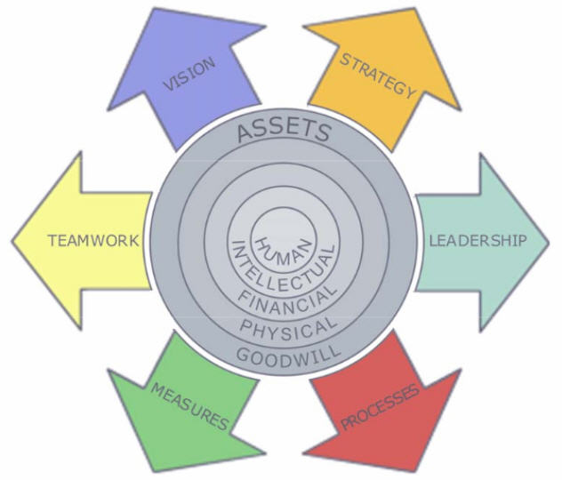
The model below may also provide some themes which could be considered.
http://www.personal-development-coach.com/personal-development-plan-sample.html

