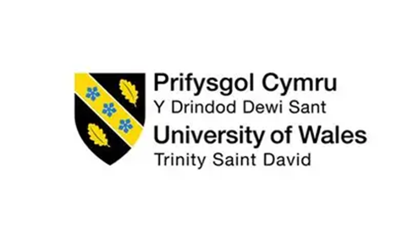

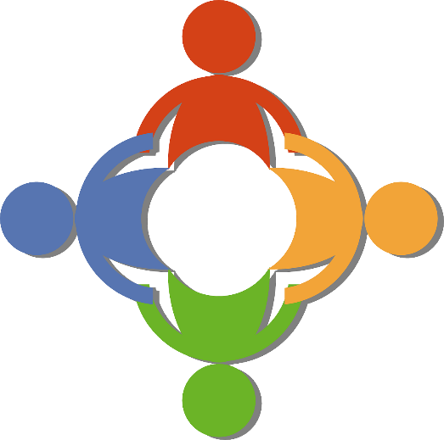
STAKEHOLDER ENGAGEMENT PORTFOLIO

Module Leader:
Ivan Rodriguez Hernandez
Programme: BA (Hons) Business Management Module: LCBB4013 – Stakeholder Engagement Assignment Title: Portfolio – Coursework (Component 1)
Your Full Name Ateeq Ur Rehman Student ID: 2322964 Submission Date:21st November 2025

Table of Contents
Canley Housing Redevelopment Project, Coventry (2025) 3
Introduction 3
Key Stakeholders and Their Benefits 6
Importance of Engagement 9
Application and Stakeholder Engagement Strategies 9
Power, Influence, and Interest Analysis 9
Stakeholder Power–Influence–Interest Table 10
Practical Example 11
Stakeholder Map (Power–Interest Grid) 11
Stakeholder Categories 12
High Power / High Interest 12
High Power / Low Interest 12
Low Power / High Interest 12
Low Power / Low Interest 12
Why Mapping Matters for Canley 13
Communication Plan 14
Consultation Strategy 15
Ethical Considerations 17
Conclusion and Reflection 20
Conclusion 20
Reflection Using Gibbs’ Reflective Cycle (Gibbs, 1988) 22
Reference List 25

Canley Housing Redevelopment Project, Coventry (2025)

Introduction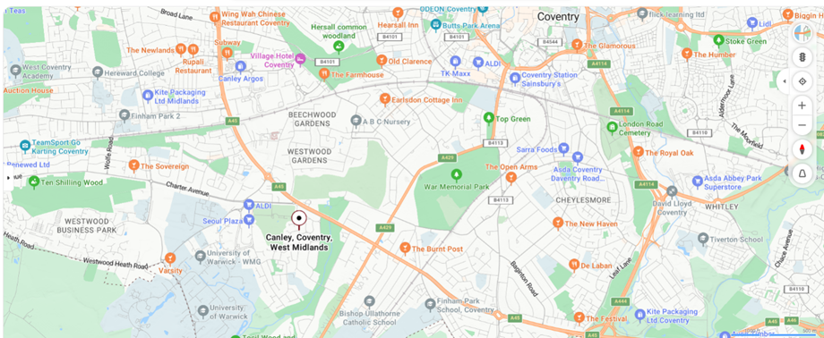

Figure1: https://www.google.com/maps/place/Canley,+Coventry
The transformation of Canley, a neighbourhood located in the southwest of Coventry, marks a major initiative by Coventry City Council aimed at comprehensive urban renewal. This project intends to raise the quality of life in an area known for its economic and social diversity, as well as its varied architectural character. Canley features a blend of post-war housing, student residences, social housing units, and green spaces. However, much of the existing infrastructure is outdated, with issues such as inadequate insulation, inefficient heating systems, and poor accessibility still prevalent. For instance, homes along Prior Deram Walk often depend on outdated boilers, which contribute to high energy costs — a particular concern for low-income households.

The redevelopment zone mainly includes areas like Prior Deram Walk, Charter Avenue, and nearby residential streets within the CV4 8FU postcode and surrounding locations.
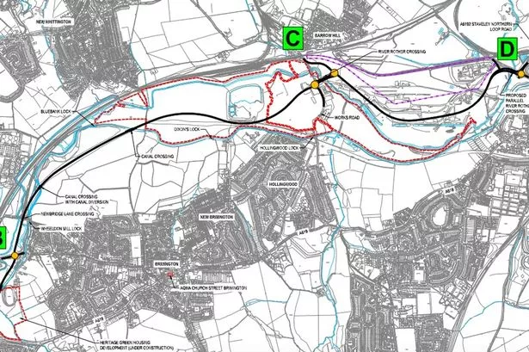
Figure2:https://i2prod.derbytelegraph.co.uk/article6805291.ece/ALTERNATES/s615/0_150322BYPASS.jpg
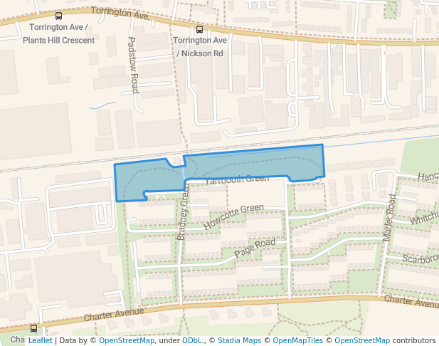
Figure3: https://cdn.pacer.cc/osm/park/753576232/thumb_2403.png

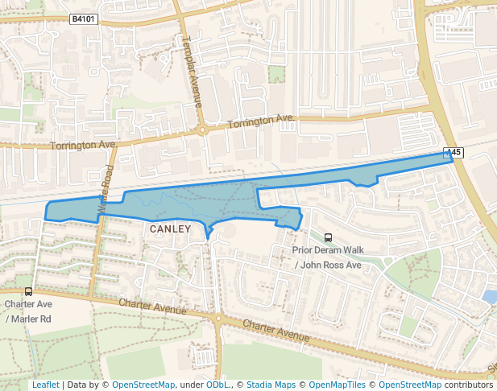
Figure4: https://cdn.pacer.cc/osm/park/753576232/thumb_2403.png
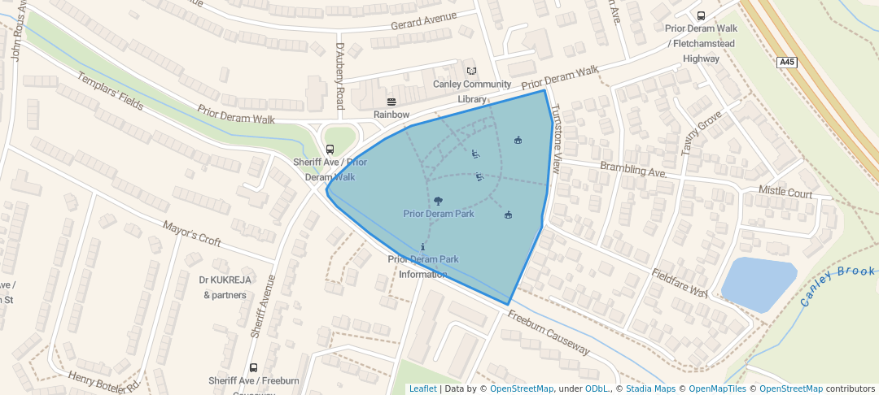
Figure 5: https://cdn.pacer.cc/osm/park/685561334/large_2403.png

Figures 2 through 5 illustrate key parts of the Canley area, including affected community facilities and streets that are central to the regeneration plans.

In line with Coventry City Council’s 2022 Housing and Regeneration Strategy, Canley has been designated a priority area due to long-standing challenges in health, income, and housing conditions. The proposed redevelopment aims to tackle these issues through the delivery of modern, energy-efficient homes, upgrades to walking infrastructure, enhancements to public spaces, and improvements to local amenities. These goals support wider national objectives promoting sustainable, inclusive, and resilient urban development (MHCLG, 2020). Research indicates that poor housing conditions are closely linked to negative outcomes such as respiratory diseases, mental health problems, academic underachievement, and social exclusion (Public Health England, 2019).

For example, children living in homes with damp or mould may face aggravated asthma symptoms, leading to more school absences and reduced learning opportunities.

This redevelopment also aligns with Coventry’s broader strategy to promote equity and economic inclusion (West Midlands Combined Authority, 2022). Groups such as older adults, people with disabilities, and low-income residents are expected to benefit significantly from improved insulation, better-designed homes, and safer, more accessible environments. Additionally, the transition to modern heating systems supports the UK’s net-zero goals (Homes England, 2020).
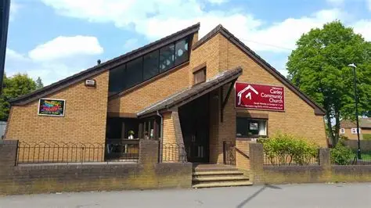
..

Figure 7: Find Us – Canley Community Church


Figure 8: Warwick Islamic Society Masjid - Coventry, England, United Kingdom - Prayers Connect
Local institutions such as Canley Community Centre (see Figure 7) and faith-based organisations, including churches and the Warwick Islamic Society (Figure 8), can serve as vital partners in spreading information and engaging with residents from diverse backgrounds. Additionally, the Canley cremation graveyard ( see Figure 9) represents an important site of local memory and cultural significance, offering a place of reflection for bereaved families. Moreover, specialist services like Change Grow Live, which offers substance misuse support, play an essential role in reaching residents impacted by addiction or social marginalisation.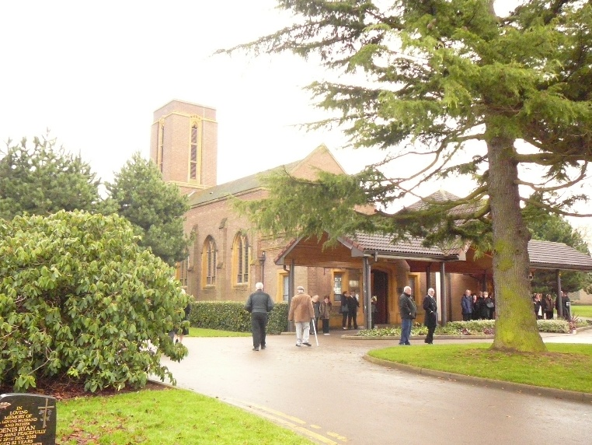
Figure 9: Canley Garden Cemetery and Crematorium in Canley, West Midlands - Find a Grave Cemetery
Funding Overview
The Canley Housing Redevelopment Project is funded through a combination of local and national sources. Coventry City Council has allocated capital from its regeneration budget, supported by regional funding from the West Midlands Combined Authority (WMCA). Additional support is expected through Homes England grants, aimed at delivering affordable, energy-efficient housing. Contributions from developers via Section 106 agreements may also fund improvements to public spaces and community facilities (Coventry City Council, 2022; WMCA, 2022; Homes England, 2020; MHCLG, 2020).

Key Stakeholders and Their Benefits
The Canley redevelopment will benefit a wide range of stakeholders, both directly and indirectly.
Local residents will gain from improved housing, reduced energy bills, safer public spaces, and enhanced local amenities. These improvements are especially impactful for low-income households facing fuel poverty and health risks (Joseph Rowntree Foundation, 2019).
Coventry City Council will meet regeneration targets while reducing long-term maintenance costs and enhancing social outcomes.
Housing associations such as Citizen Housing benefit through better-quality housing stock, improved tenant satisfaction, and regulatory compliance (Citizen Housing, 2022).
Local businesses may see increased footfall and customer activity as the area becomes more attractive post-regeneration.
Community organisations like Canley Community Centre gain improved spaces for delivering social activities, advice services, and support to marginalised groups.
Faith-based groups, including churches and the Warwick Islamic Society, benefit from safer, more accessible environments and can serve as trusted venues for resident engagement and consultations.
Rehab and Support Services
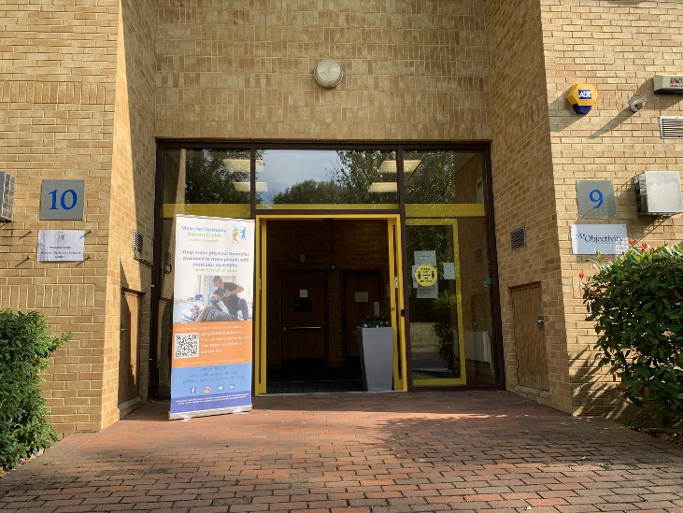
Figure 10: Our Locations - MD Support Centre
Support services such as Change Grow Live will operate more effectively in upgraded, safer community settings, improving access to recovery and wellbeing services.
Example: Figure 9 could illustrate the type of local support facility that may become more accessible post-redevelopment.
University of Warwick
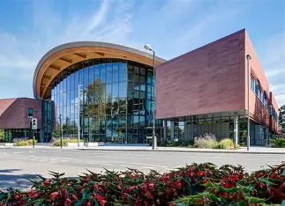
Figure11: The University Of Warwick - British Academic Center
The University of Warwick, though indirectly involved, benefits from a safer local area and better accommodation options for off-campus students. (Figure 10).

Importance of Engagement
Regeneration affects people’s homes, routines, public spaces, and sense of identity. Therefore, effective engagement is essential to ensure the redevelopment reflects community needs and builds trust. Research shows that inclusive engagement increases legitimacy, reduces conflict, and leads to more sustainable outcomes (Bowen et al., 2010).
Example: When residents are informed early about demolition dates, they can prepare and avoid unnecessary stress.
This introduction establishes the foundation for the stakeholder analysis, communication plan, consultation strategy and ethical considerations explored in the next sections.

Application and Stakeholder Engagement Strategies

The operations of the Canley Housing Redevelopment Project include the planning and delivery of inclusive engagement strategies, coordination of stakeholder consultations, and the development of communication tools. These activities are supported by collaboration with local partners such as Canley Community Centre, faith institutions, and public service organisations. The operational framework ensures that the project's implementation is ethical, inclusive, and transparent.

Power, Influence, and Interest Analysis
Understanding stakeholder power, influence, and interest helps teams decide who needs close collaboration, updates, or targeted support (Freeman, 1984; Mitchell, Agle, and Wood, 1997). In Canley, the diverse mix of institutional actors, residents, and community organisations makes structured analysis critical for ethical and effective engagement.
This framework distinguishes between:
• Power – the ability to control or make decisions.
• Influence – the ability to shape opinions or outcomes indirectly.
• Interest – the degree to which the stakeholder is affected by the project.
Understanding these dimensions helps identify which stakeholders require intensive involvement and which may need regular updates or targeted outreach.

Stakeholder Power–Influence–Interest Table
Stakeholder | Power | Influence | Interest | Justification
Coventry City Council | High | High | High | Leads the project, controls planning and funding, and ensures policy compliance
Developers / Contractors | High | Medium | Medium | Responsible for delivering the physical redevelopment and managing site risk
Local Residents | Medium | High | High | Directly impacted by changes; shape local legitimacy and social outcomes
Housing Associations | Medium | Medium | High | Responsible for tenant wellbeing and managing long-term housing stock
Community Organisations | Low | Medium | High | Represent marginalised voices and build trust through advocacy
Local Businesses | Low | Medium | Medium | Affected by disruption during construction and potential future footfall
University of Warwick | Low | Low | Medium | Indirectly affected via student housing demand and safety perceptions
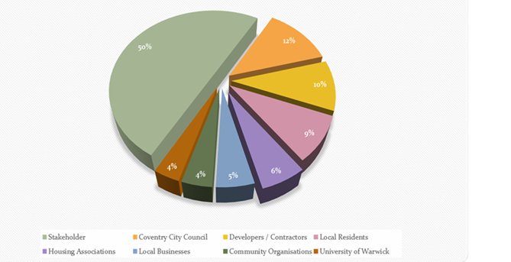
In addition to the stakeholder table, the following chart illustrates the proportional focus of stakeholder engagement in the Canley Redevelopment Project. It highlights the importance of prioritising local residents, who represent the highest-interest group, despite having limited institutional power (Involve, 2019).

Figure 12: Rehman(2025).
Proportional Stakeholder Engagement Focus – Canley Redevelopment Project

Practical Example
For instance, although local residents lack statutory power, they hold high interest and influence. Their collective voice can shape public discourse, influence council decisions, and impact project timelines. In previous Coventry consultations, public opposition led to revisions in housing design and improved transparency in communication (Coventry City Council, 2022; Coventry Telegraph, 2023). Local partners such as Canley Community Centre and Warwick Mosque can help collect views from residents who might not otherwise attend council-run meetings.

Stakeholder Map (Power–Interest Grid)

The stakeholder map categorises participants into four groups based on their level of power and interest in the Canley redevelopment project. This tool helps guide how communication and engagement efforts should be tailored to ensure inclusivity and prevent the exclusion of less powerful voices.

Stakeholder Categories

High Power / High Interest

Examples: Coventry City Council, Developers / Contractors

These stakeholders play a central role in decision-making and implementation. They require regular engagement, strategic dialogue, and active collaboration.

High Power / Low Interest

Examples: Central government departments, national funding agencies

These actors need to be kept informed, mainly through compliance updates and progress reports, but are unlikely to engage deeply unless policy priorities shift.

Low Power / High Interest

Examples: Local residents, housing providers, community groups, faith organisations, and support services like Change Grow Live

These stakeholders are highly affected by the project but lack formal authority. It is essential to empower them using accessible engagement methods and consistent communication.

Low Power / Low Interest

Examples: Residents outside the immediate project zone, University of Warwick

These groups may not be directly involved, but maintaining basic transparency helps sustain broader community trust.

The following map presents a visual framework for this classification and supports more nuanced decision-making around engagement strategies, ensuring efforts are inclusive and ethically grounded (Mitchell et al., 1997).
Figure 13: Stakeholder Power–Interest Grid for the Canley Redevelopment Project
A visual framework categorising stakeholders by their level of power and interest, used to guide inclusive engagement strategies (Mitchell et al., 1997).
Power / Interest Level | High Interest | Low Interest
High Power | Coventry City Council  Developers / Contractors | WMCA (West Midlands Combined Authority)  Central Government Departments
Low Power | Local Residents  Community Organisations (e.g., Canley Community Centre)  Faith Groups (e.g., Warwick Islamic Society)  Support Services (e.g., Change Grow Live) | University of Warwick  Residents outside the immediate project zone

Figure 13

Why Mapping Matters for Canley

Understanding the diverse population in Canley — including families, students, and culturally varied communities — is essential for inclusive regeneration. Stakeholder mapping helps ensure that underrepresented voices, such as low-income or non-English-speaking residents, are not overlooked.

It also supports ethical engagement by identifying which groups require targeted outreach and communication. By anticipating potential resistance and addressing community needs early, project teams can improve trust, reduce conflict, and create fairer outcomes (Public Health England, 2019).

Instead of focusing only on efficiency, stakeholder mapping promotes equity and ensures no group is excluded based on power or access to formal consultation.

Communication Plan
Effective communication is vital to ensuring transparency, trust, and community support throughout the Canley Redevelopment Project. Ineffective communication in regeneration projects can result in misunderstandings, reduced public trust, and greater resistance from the community (ATSDR, 2020).

Key Audiences
• Local residents (including tenants, students, and families)
• Coventry City Council and developers
• Housing associations (e.g. Citizen Housing)
• Community groups, local businesses, schools, and media
• Faith groups such as local churches and Warwick Islamic Society (Figure 7)
• Local support hubs such as Canley Community Centre and drug and alcohol services like Change Grow Live (Figure 8)

What Will Be Communicated
•Project purpose and benefits
•Timelines, phases, and key dates
•Disruption impacts (e.g. traffic, noise, safety)
•Feedback opportunities and consultation outcomes
• Who to contact with questions or concerns

Communication Timeline
Stage | Activities | Purpose
Pre-Planning | Awareness campaigns, needs surveys | Understand local priorities
Planning | Exhibitions, feedback surveys, consultations | Shape proposals through input
Pre-Construction | Traffic notices, safety updates | Prepare stakeholders for disruption
Construction | Newsletters, drop-in Q&As, social media | Maintain engagement and transparency
Post-Completion | Handover info, impact reports, final feedback | Review outcomes and close project

Channels and Tools
• Project website and email updates
• Printed newsletters and local newspapers
• social media, public meetings, pop-up stalls
• Multilingual leaflets and noticeboards
• Posters and information boards at churches, Warwick Mosque and Canley Community Centre
This multi-channel approach ensures communication is accessible, inclusive, and responsive to the needs of a diverse community (NSCE, 2016; LGA, 2019).

Consultation Strategy
A robust consultation process gives stakeholders meaningful opportunities to shape outcomes. In Canley’s diverse context, this means using inclusive, flexible methods that reduce barriers to participation (Involve, 2019; LGA, 2019).

Principles of Good Consultation
• Inclusivity: Engage all groups regardless of age, language, or digital access
• Transparency: Clearly explain the scope and limitations of the project
• Respect: Value all contributions equally
• Accessibility: Use varied methods suited to different needs

Consultation Methods
Method | Purpose
Public Meetings | General updates and shared concerns
Co-Design Workshops | Collaborative planning with residents
Paper/Online Surveys | Broad, flexible feedback collection
Pop-Up Stalls | Casual engagement in public spaces
Home Visits | Reaching residents unable to attend events
Focus Groups | Detailed feedback from specific groups
These methods help ensure that no group is excluded by language, time, mobility, or digital skills. Offering both digital and in-person formats increases reach and fairness (Neighbourhood Renewal Unit, 2019). Pop-up stalls and consultation boards at Canley Community Centre and Warwick Islamic Society (Figure 7 and 8) can help reach residents who may not attend formal council events.
Example: Pop-up stalls at Canley Centre on weekends allow working parents to participate without needing appointments.

Why multi-Method?
Using just one form of consultation, such as public meetings, may inadvertently marginalise individuals who are less confident in group settings or who lack digital literacy. A mixed-methods approach enables the inclusion of a broader range of perspectives and helps address potential inequalities in participation (Involve, 2019).
Example: Some older residents may prefer paper surveys by post, while students may respond better to QR-coded online forms.

Ethical Considerations
Ethical stakeholder engagement is crucial in redevelopment projects, particularly where residents are likely to experience substantial changes. Upholding principles such as openness, voluntary participation, and inclusiveness helps safeguard community interests and fosters mutual trust between stakeholders and project leaders (ATSDR, 2020; LGA, 2019).

Informed Consent
It is essential that stakeholders clearly understand the goals of the consultation, the intended use of their input, and their right to choose whether or not to participate. In a community like Canley, where language proficiency and literacy levels may vary, communication materials must be accessible, using plain language and translations where appropriate. Working with local churches, Warwick Mosque and Canley Community Centre can support face to face explanations in familiar settings.
Example: At pop-up events, staff can explain: “This survey helps shape local housing. It is anonymous and optional.”

Transparency
Maintaining transparency throughout the redevelopment process strengthens credibility and mitigates community anxiety. Keeping stakeholders informed about project timelines, challenges, and realistic deliverables ensures honest communication. Making exaggerated claims or withholding critical information can damage trust and lead to resistance.
Example: Residents should be told clearly if demolition or relocation is delayed, even if the update is unfavourable.

Avoiding Harm
Engagement must avoid emotional distress, especially for vulnerable or low-income residents. Regeneration may trigger fears about rent increases, gentrification, or forced relocation. These risks reflect findings from previous regeneration studies, which show that redevelopment can lead to community displacement if not managed ethically (Tunstall, 2015).
Good practice includes:
•Avoiding false promises
•Providing reassurance
•Offering emotional support if needed
• Signposting residents to support services such as Change Grow Live for drug and alcohol issues, and other local wellbeing services (Figure7)

Data Protection
Consultations must comply with GDPR. Personal data collected via surveys or interviews should be anonymised, stored securely, and used only for the intended purpose.
Example: Paper surveys from community events should be locked securely and digitised anonymously.

Managing Bias
Bias can emerge when certain voices dominate or when the methods exclude marginalised groups.
Mitigation strategies:
• Offering translated and paper surveys
• Hosting small focus groups instead of large meetings
• Inviting underrepresented communities directly
• Using trusted locations such as Canley Community Centre and Warwick Mosque to reach groups who may not engage with formal council venues
Example: To include digitally excluded residents, consultation forms should be available at local libraries or shops.

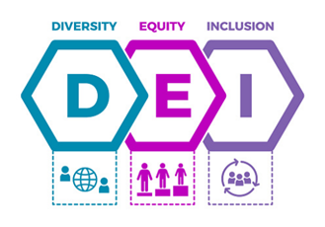
Diversity, Equity, and Inclusion (DEI)
Figure 14: 2+ Thousand Diversity Equity Inclusion Dei Royalty-Free Images, Stock Photos & Pictures | Shutterstock
Given the diverse demographic makeup of Canley—including variations in culture, age, and ability—identified in local housing and university assessments (Warwick University, 2022; Coventry JSNA, 2021), engagement strategies must be adaptable to these differences to ensure equity and avoid perpetuating systemic disadvantages.
DEI Measures:
• Wheelchair-accessible venues
• Events at different times (weekday/weekend)
• Childcare support
• Collaborating with local cultural and faith groups, including churches and Warwick Islamic Society
• Working with Canley Community Centre to host inclusive events and reach isolated residents
• Linking with Change Grow Live and other support agencies to ensure that residents affected by drugs and alcohol are not left out of engagement activities
Example: Translating materials into the top three community languages increases participation.

Feedback and Accountability
Residents should see how their input shapes decisions. Without feedback loops, engagement feels tokenistic.
Feedback Tools:
• “You Said, We Did” summaries.
• Public reports on consultation outcomes.
• Community noticeboards showing project updates at places like Canley Community Centre, churches, and Warwick Mosque.
Example: If residents request better lighting, the council should confirm whether it is feasible or explain why not.

Conclusion and Reflection
Ethical consultation is more than a procedural task—it requires a genuine commitment to transparency, fairness, and inclusive engagement (ATSDR, 2020; Involve, 2019). In a diverse community like Canley, applying these principles helps ensure that the views of underrepresented and vulnerable groups are meaningfully included. When power imbalances are recognised and addressed, and when feedback is respected and acted upon, trust is built, outcomes improve, and regeneration becomes truly community-led (Social Value UK, 2020; Bowen et al., 2010).
Examples: Delays in demolition should be clearly communicated. Translating surveys and doing walk-alongs can improve access and uncover overlooked issues.

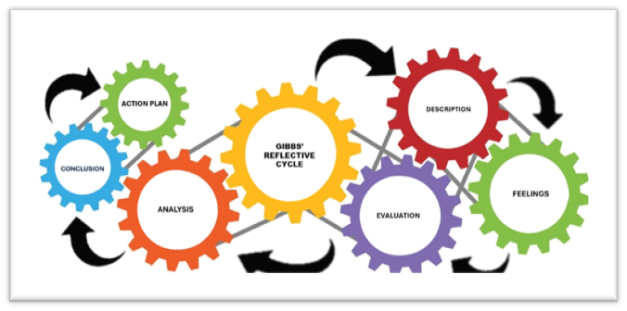
Reflection Using Gibbs’ Reflective Cycle (Gibbs, 1988)
Figure15: Rehman(2025)
Gibbs’ Reflective Cycle offers a structured way to reflect on learning and practice across six stages: description, feelings, evaluation, analysis, conclusion, and action plan (Gibbs, 1988). Using this model, I reflected on how my understanding of stakeholder engagement developed while completing this portfolio.
Description
Throughout the module, I learned about stakeholder analysis, communication planning, consultation methods and ethical principles. I applied this knowledge to develop a realistic engagement strategy for the Canley redevelopment. This involved identifying key stakeholders, mapping their power and interest, designing communication tools, planning consultations, and exploring ethical issues, which reflects the application of stakeholder theory in practice (Freeman, 1984).
Short example: When preparing the consultation plan, I realised how important it was to offer both online and paper survey options to reach all residents.
Feelings
Initially, I was unsure how to balance priorities and developers focused on cost and efficiency, while residents prioritised safety and community impact. I also felt unsure about designing engagement activities that would work for Canley’s diverse population. This emotional uncertainty is not uncommon in community projects, where the balance between power and vulnerability must be managed carefully (Bowen et al., 2010). Ethical guidelines, such as those by the ATSDR (2020), emphasise emotional safety as a key part of respectful stakeholder interaction and reinforcing my early concerns about doing no harm during engagement.
As I progressed, I became more confident. Understanding DEI and ethical communication made me more aware of how to support vulnerable groups and avoid exclusion (Public Health England, 2019). I realised that community engagement is less about having a perfect plan and more about being transparent, flexible, and responsive.
By the end of the portfolio, I felt more confident in my ability to design an ethical, inclusive, and evidence-based stakeholder engagement strategy.
Evaluation
There were clear strengths in my learning experience:
• The stakeholder mapping process helped me structure complex relationships in a clear way, reflecting models from stakeholder theory (Mitchell et al., 1997).
• The communication plan made me think critically about accessibility and inclusion.
• The DEI section highlighted the importance of designing processes that do not favour only confident or digitally literate residents.
• The ethical analysis helped me see engagement as a responsibility grounded in fairness and social value (Social Value UK, 2020).
However, I also faced challenges:
• Turning theory into realistic engagement actions was more difficult than learning concepts in isolation.
• Balancing the needs of powerful institutional stakeholders and those of vulnerable residents felt complex.
• Writing in clear, accessible language, rather than academic jargon, required conscious effort.
• It was sometimes hard to judge which engagement method was best for each stakeholder group.
Example: I found it challenging to decide whether students at the University of Warwick should be engaged directly or just kept informed as lower-interest stakeholders.
Analysis
The analysis stage of Gibbs’ model allowed me to explore what this learning meant in a deeper way (Gibbs, 1988). I learned that stakeholder engagement is not simply about telling people what will happen; it is about creating space for dialogue, negotiation, and shared understanding. Academic literature emphasises that effective engagement improves legitimacy, reduces opposition, and leads to more sustainable outcomes (Bowen et al., 2010; Involve, 2019). Applying these ideas to Canley helped me see the practical value of good engagement, not just the theory.
I also developed a stronger understanding of power dynamics. Stakeholders with less power often face greater vulnerability in redevelopment, requiring proactive support to ensure ethical inclusion (Mitchell et al., 1997; Public Health England, 2019). This influenced my decision to emphasise targeted outreach, home visits and translated materials for Canley. Furthermore, theories of inclusive participation highlight that relying on traditional public meetings can exclude those who are less confident, less mobile, or less familiar with formal processes (Neighbourhood Renewal Unit, 2019). This reinforced the importance of using a multi-method consultation strategy.
Overall, I realised that effective engagement is relational and continuous rather than a one-off exercise.
Conclusion
Reflecting on my experience, I can see that my understanding of stakeholder engagement has grown significantly. I now recognise that:
• Clear and inclusive communication is essential for trust (ATSDR, 2020).
• Multi-method consultation is necessary to reach all groups (Involve, 2019).
• DEI should be embedded throughout, not added at the end (National Standards for Community Engagement, 2016).
• Ethical practice protects residents and strengthens project legitimacy (Tunstall, 2015).
• Stakeholder theory is most powerful when applied practically (Freeman, 1984).
I feel more confident about applying these ideas in real projects and better prepared for roles where engagement and consultation are central.
Action Plan
Gain live facilitation experience
Improve conflict-resolution skills
Learn impact measurement tools
Develop accessible materials (e.g. “You Said, We Did”)
Review regeneration case studies for best practice
These steps will strengthen my future work in community-focused regeneration and stakeholder engagement.
Reference List
- Agency for Toxic Substances and Disease Registry (ATSDR) (2020) Principles of community engagement. [Online] Available at: https://www.atsdr.cdc.gov/communityengagement/ [Accessed: 10 November 2025].
- Bowen, F., Newenham-Kahindi, A. and Herremans, I. (2010) ‘When suits meet roots: The antecedents and consequences of community engagement strategy’, Journal of Business Ethics, 95(2), pp. 297–318. https://doi.org/10.1007/s10551-009-0360-1
- Canley Community Centre (2024) Community services overview. [Online] Available at: https://www.canleycommunitycentre.co.uk [Accessed: 10 November 2025].
- Canley Community Church (2025) Find us. [Online] Available at: https://www.canleycommunitychurch.org.uk [Accessed: 10 November 2025].
- Change Grow Live (2024) Coventry drug and alcohol service. [Online] Available at: https://www.changegrowlive.org/service/coventry-drug-alcohol/info [Accessed: 10 November 2025].
- Citizen Housing (2022) Annual report. Coventry: Citizen Housing. Available at: https://www.citizenhousing.org.uk/ [Accessed: 10 November 2025].
- Coventry City Council (2019) SuDS guidance for Canley regeneration zone. Coventry: CCC.
- Coventry City Council (2022) Housing and regeneration strategy. Coventry: CCC.
- Coventry City Council (2025) Online planning map. [Online] Available at: https://maps.coventry.gov.uk [Accessed: 10 November 2025].
- Coventry Telegraph (2023) ‘Canley redevelopment plans revealed’, Coventry Telegraph, 12 March.
- Find A Grave (2025) Canley Garden Cemetery and Crematorium. [Online] Available at: https://www.findagrave.com/cemetery/859632/canley-garden-cemetery-and-crematorium [Accessed: 19 November 2025].
- Freeman, R.E. (1984) Strategic management: A stakeholder approach. Boston: Pitman Publishing.
- Gibbs, G. (1988) Learning by doing: A guide to teaching and learning methods. Oxford: Oxford Polytechnic.
- Homes England (2020) Design and quality standards. [Online] Available at: https://www.gov.uk/government/publications/housing-design-standards [Accessed: 10 November 2025].
- Involve (2019) Public participation in decision-making: Principles and good practice. [Online] Available at: https://www.involve.org.uk/ [Accessed: 10 November 2025].
- Joseph Rowntree Foundation (JRF) (2019) UK poverty report 2019. York: JRF. [Online] Available at: https://www.jrf.org.uk/report/uk-poverty-2019 [Accessed: 10 November 2025].
- Local Government Association (LGA) (2019) Engaging communities in regeneration. London: LGA. [Online] Available at: https://www.local.gov.uk/ [Accessed: 10 November 2025].
- MHCLG (Ministry of Housing, Communities and Local Government) (2020) English housing survey 2019–2020. London: MHCLG.
- Mitchell, R.K., Agle, B.R. and Wood, D.J. (1997) ‘Toward a theory of stakeholder identification and salience: Defining the principle of who and what really counts’, Academy of Management Review, 22(4), pp. 853–886. https://doi.org/10.5465/amr.1997.9711022105
- National Standards for Community Engagement (NSCE) (2016) Engagement framework. Edinburgh: Scottish Community Development Centre. Available at: https://www.scdc.org.uk/what/national-standards [Accessed: 10 November 2025].
- Neighbourhood Renewal Unit (NRU) (2019) Community participation toolkit. [Online] Available at: https://webarchive.nationalarchives.gov.uk/ [Accessed: 10 November 2025].
- Public Health England (PHE) (2019) Improving health through the built environment. London: PHE.
- Social Value UK (2020) Principles of social value. Liverpool: Social Value UK. [Online] Available at: https://www.socialvalueuk.org/ [Accessed: 10 November 2025].
- Tunstall, R. (2015) ‘The impact of housing regeneration on communities’, Housing Studies, 30(2), pp. 287–312. https://doi.org/10.1080/02673037.2014.927042
- UK Government (2020) Planning practice guidance: Housing and sustainability. [Online] Available at: https://www.gov.uk/guidance [Accessed: 10 November 2025].
- Warwick Islamic Society (2024) Prayer Hall Information. [Online] Available at: https://masjidbox.net/warwickisoc [Accessed: 10 November 2025].

