Appendix – ECAD5010 Lucy Badham - 1800114

Appendix

Appendix 1 – Mosaic Approach.

 | Questionnaire.
Interview with pupils. | Research  Effect of feedback from pupil to teacher on assessment for learning. | Interview with teachers.
 | Observation of pupils and teacher.

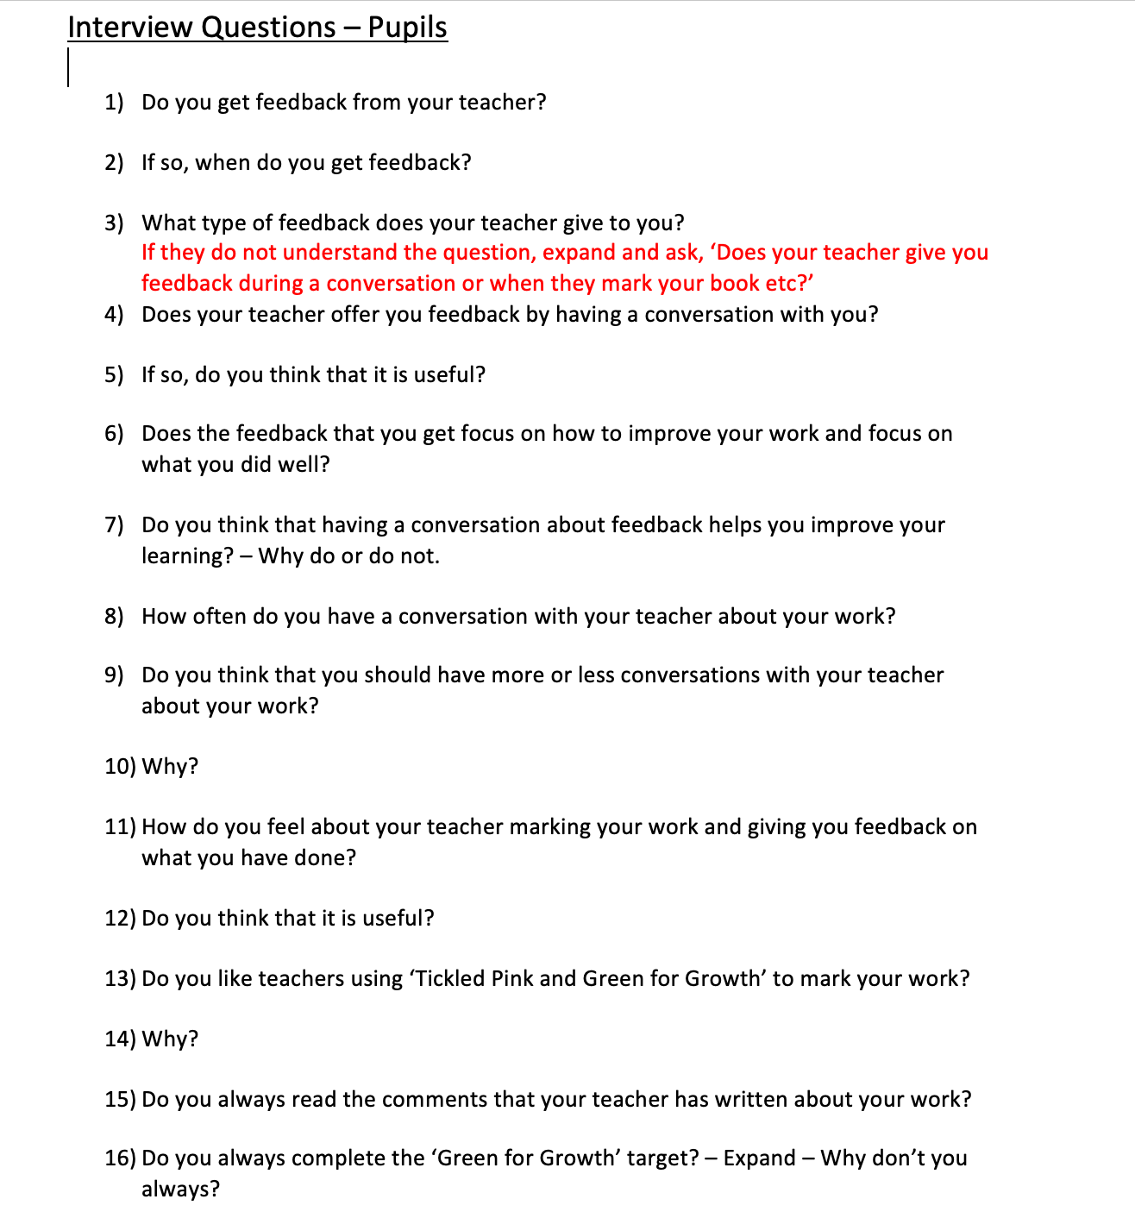
Appendix 2 – Interview Questions.

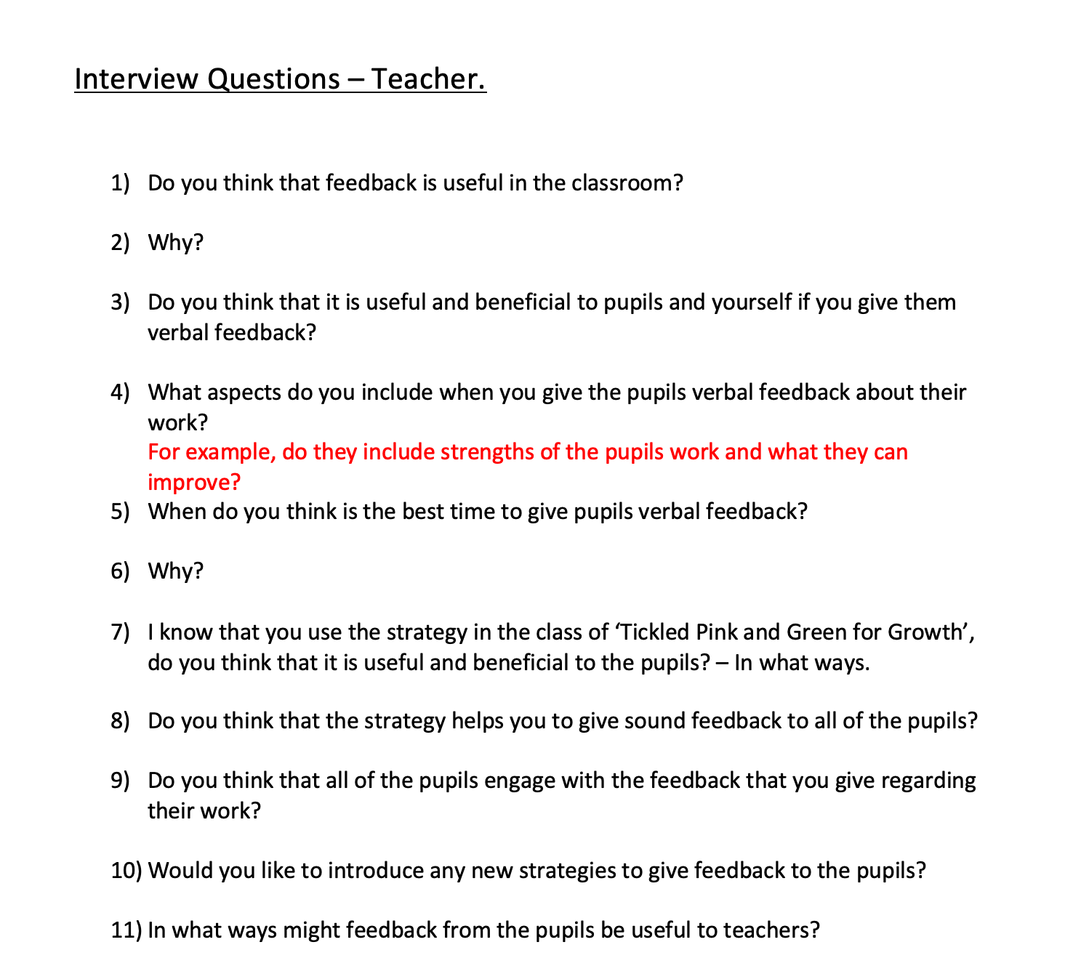

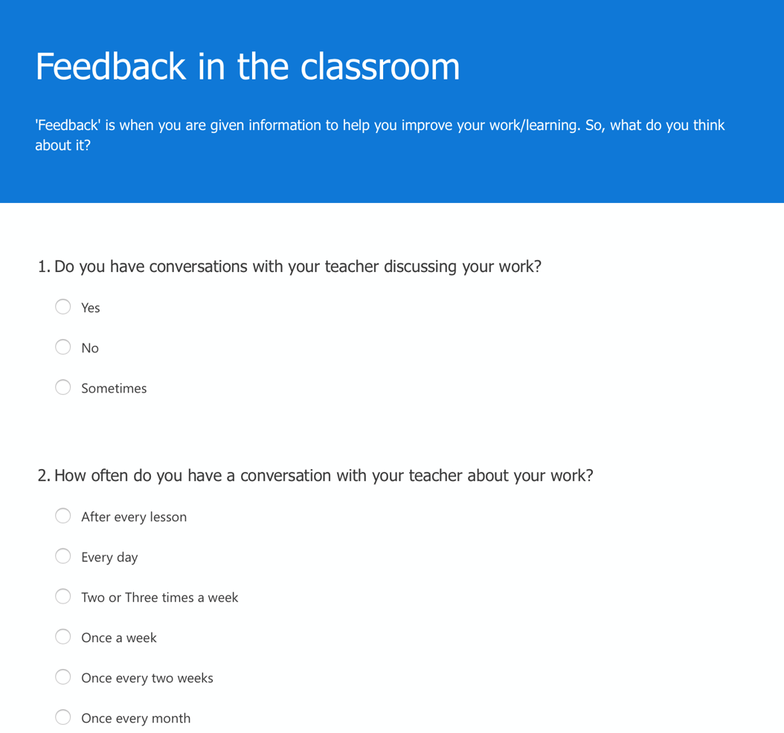
Appendix 3 – Blank Questionnaire.

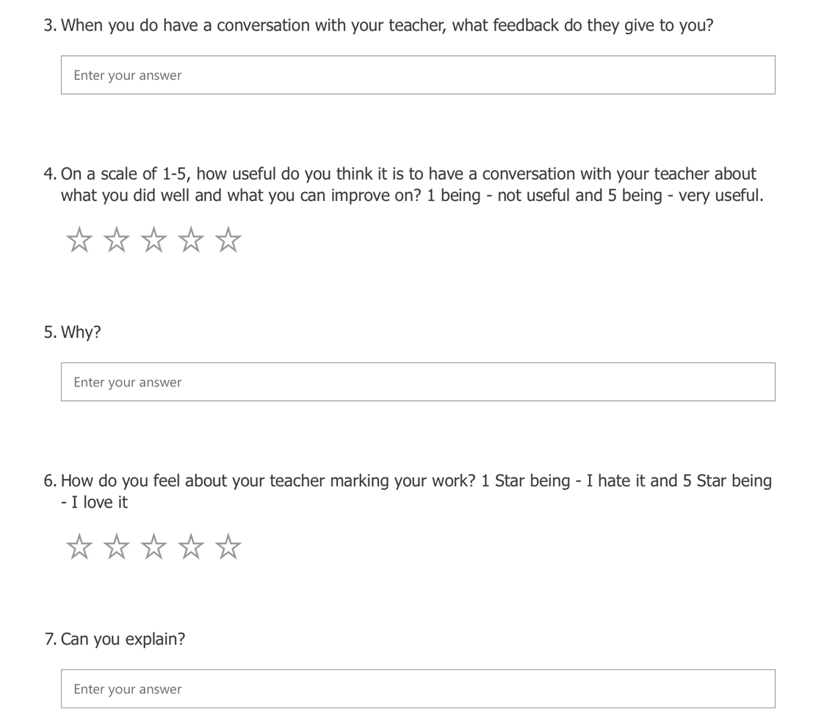

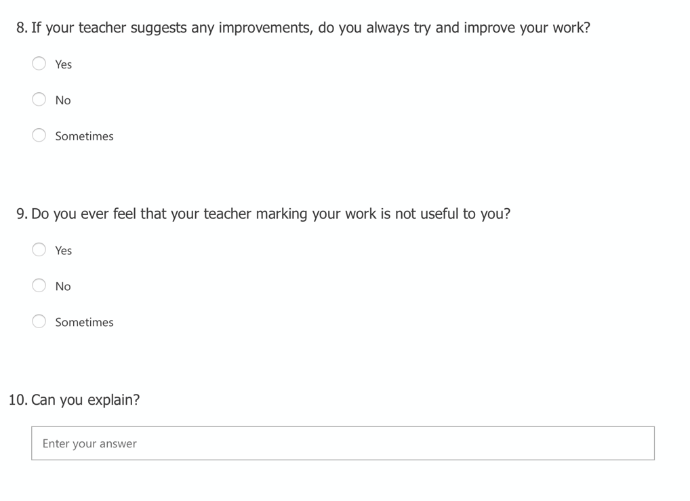

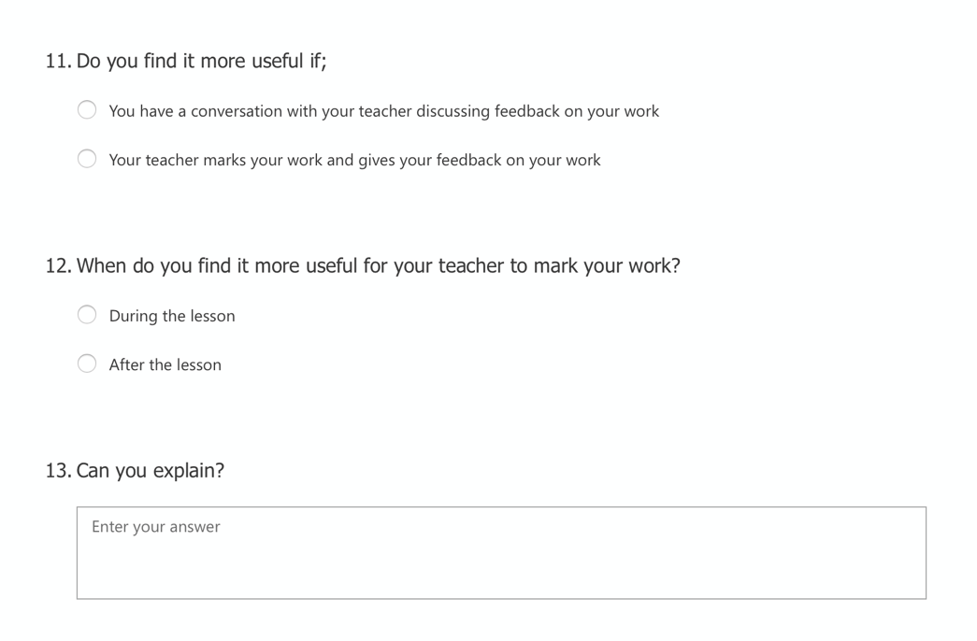

Appendix 4 – Observation Tools (Blank)
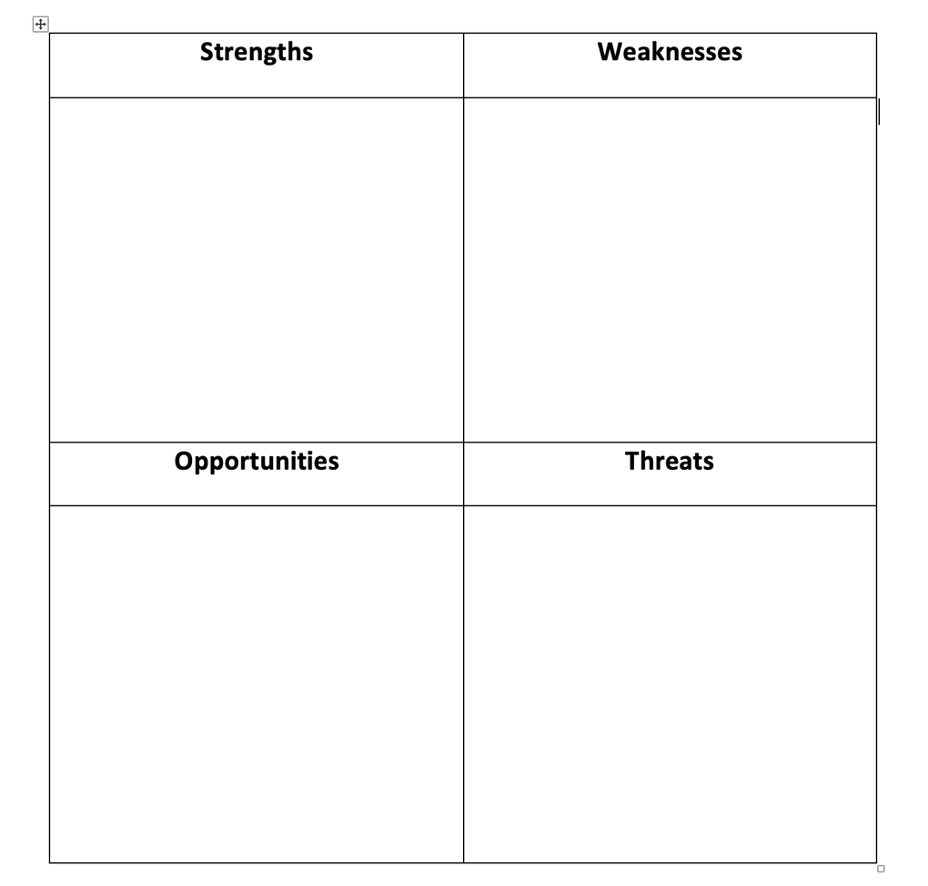

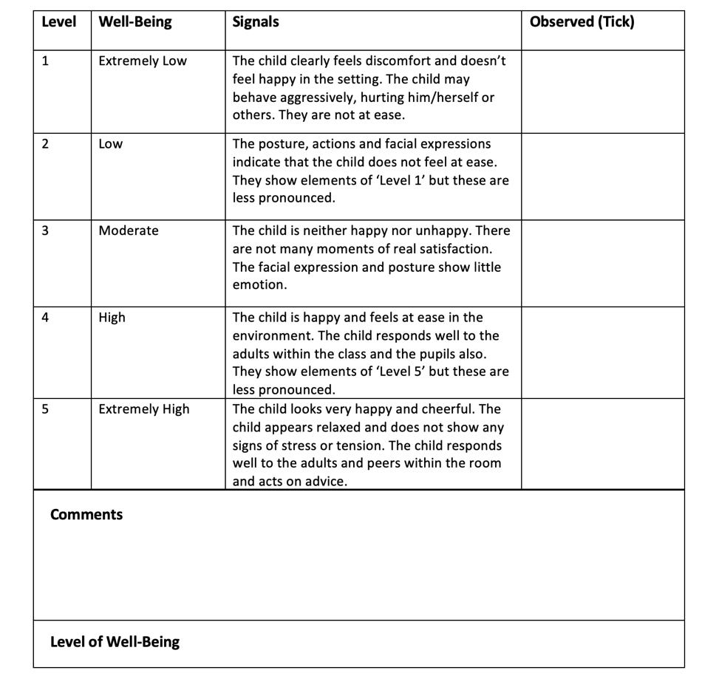

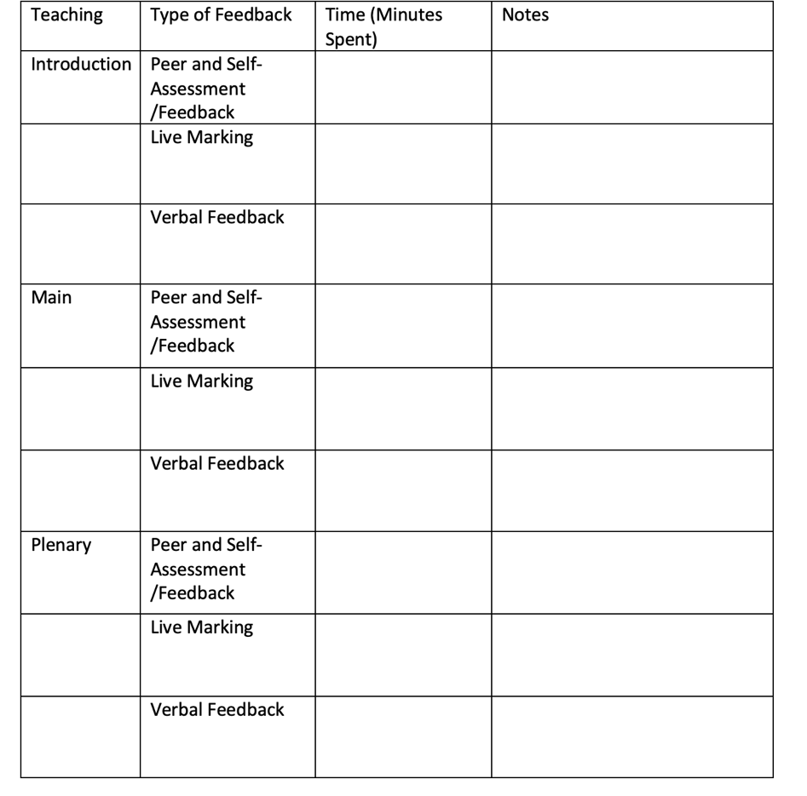

Appendix 5 – Interview Transcripts.

Do you get feedback from your teacher and when do you get it?
Pupil 1 | “I get feedback sometimes” “I get feedback at the end of the lesson or if she (the class teacher) is walking around”
Pupil 2 | “Yes, I get feedback” “We get feedback during the lesson”  Interviewer – “Do you think that is helpful to you?”  Pupil 2 stated – “I think it would be more useful after the lesson because if everyone is in the classroom then it is distracting”
Pupil 3 | “Yes, I do, and I think that it is very helpful” “I get feedback at the end of the lesson or if I ask for it”  Interviewer – “Why do you think it’s helpful?”  Pupil 3 stated – “It’s helpful because it shows you what you can improve on and what you can do better”

What type of ‘Feedback’ does your teacher give to you? If so, do you think it’s useful?
Pupil 1 | “What I can improve on and what I have done well”  Interviewer – “So, do you find it useful?”  Pupil 1 stated – “Yes, sometimes but I don’t sometimes because I don’t want to know if I have done things wrong?”
Pupil 2 | “She tells me what I did wrong and then moves on”  Interviewer – “Do you think you need to spend more time with your teacher individually?”  Pupil 2 stated – “I think so because if I get anything wrong then nobody in the class would know, but teachers are very busy”  Interviewer – “So, do you think that the feedback is useful to you?”  Pupil 2 stated – “Definitely, because you know what you did wrong and know what to improve on next time”
Pupil 3 | “She sometimes writes in our books and sometimes she talks to us” “Yes, it is useful to me”

Does your teacher offer you feedback by having a conversation with you?

Pupil 1 | “No, she has a conversation with the whole class”  Interviewer – “Do you think that is useful to you or would you prefer your teacher to have a conversation with you individually?”  Pupil 1 stated – “Sometimes, because it is nice to know what you can do better, so you can work on in straight away”
Pupil 2 | “Yes, it tells me what I’m doing”
Pupil 3 | “Yes, I do”  Interviewer – “Do you think it’s useful?”  Pupil 3 stated – “Yes because it lets you know what you’re doing from a teacher point of view”

Does your feedback that you get focus on what you have done well and what to improve on?
Pupil 1 | “Yes” – Pause as a bit unsure  Interviewer – “So, does your teacher maybe give you one thing that you have done well and one thing to improve?”  Pupil 1 stated – “Yes… a bit like two stars and a wish”
Pupil 2 | “Yeah she does”
Pupil 3 | “Yes, she does”  Interviewer –“Do you find it useful because you can recognise what you do well?”  Pupil 3 stated – Yes definitely”

How often do you have a conversation with your teacher about your work?
Pupil 1 | “Not often, maybe twice a week”
Pupil 2 | “Rarely. Maybe once a fortnight”
Pupil 3 | “I have a conversation with my teacher maybe once a week, not a lot”

Do you think you need more or less conversations with your teacher about your work?
Pupil 1 | “It depends, sometimes it is helpful but sometimes it makes me confused”  Interviewer – “Why do you think that it depends?”  Pupil 1 stated – “Because it can make you see what to improve, so you can improve next time, the feedback just confuses me sometimes”
Pupil 2 | “Yes, I think we should have more conversations as it is always good to know what to improve”
Pupil 3 | “Yeah, I think we should as it helps with the learning and shows you what to improve on”

How do you feel about your teacher marking your work and giving you feedback on what you have done?

Pupil 1 | “I don’t really like my teacher marking my book because it’s my book and I don’t really want anything done with it, but I do like seeing that I have done something right”  Interviewer – “Do you not like seeing if you have done something wrong?”  Pupil 1 stated – “No, I don’t mind, but if my friends get it right and I don’t then I get a bit frustrated”  Interviewer – “So would you prefer for your teacher to just write feedback in your book instead of having a conversation with you?”  Pupil 1 stated – “Yeah because then nobody else can see it”
Pupil 2 | “I think that it is useful because you know what you have done well and what you can improve on in the future”
Pupil 3 | “It’s ‘kinda’ good because you can go back and read what the teachers said it is nice when my teacher says something nice about my work”

Do you like your teachers using ‘Tickled Pink and Green for Growth’ strategy to mark your work? And why?
Pupil 1 | “I think that green is fine, it’s just simple” “It gets confusing when the teachers use the green pen for their comments on your work, not what you should be improving?”
Pupil 2 | “Pause Speech” “Yeah I think that it is useful but only if the teacher uses both of the pens”  Interviewer – “So, do you suggest that the teachers use both of the pens correctly?”  Pupil 2 stated – “Yes, they should use both of them correctly”
Pupil 3 | “Yes I do, but sometimes I get confused as the teachers use the green pen just to write comments”  Interviewer – “What would help you not get confused?”  Pupil 3 stated – “Maybe the teachers could write their comments in another colour”

Do you always read the comments that your teacher has written about your work?
Pupil 1 | “Yeah, I always read the comments”
Pupil 2 | “Yes, because then I know what to do. We also have DIRT time to do that”  Interviewer – Can you explain what DIRT time is?”  Pupil 2 stated – “It’s answering teachers comments and underlining and self-assessing at the end”
Pupil 3 | “Yes, I always try to, but sometimes I don’t”

Do you always complete your ‘Green for Growth’ target?

Pupil 1 | “No”  Interviewer – “And why do you not always complete your ‘Green for Growth’ target?”  Pupil 1 stated - “Because we may have gone onto a different topic or do completely different work, so you can’t use the it”  Interviewer – “If you have moved onto a different topic and you go back to your ‘Green for Growth’ target, do you think it still is beneficial to you?”  Pupil 1 stated – “No, I don’t think it is”
Pupil 2 | “I don’t think so”  Interviewer – “Can you tell me why you don’t complete them all of the time?”  Pupil 2 stated – “Sometimes we are not given enough time to complete our targets”
Pupil 3 | “Yes, I try to complete my targets”

Appendix 6 – Ethics Form.

APPLICATION FOR ETHICAL APPROVAL

In order for research to result in benefit and minimise risk of harm, it must be conducted ethically. A researcher may not be covered by the University’s insurance if ethical approval has not been obtained prior to commencement.

The University follows the OECD Frascati manual definition of research activity: “creative work undertaken on a systematic basis in order to increase the stock of knowledge, including knowledge of man, culture and society, and the use of this stock of knowledge to devise new applications”. As such this covers activities undertaken by members of staff, postgraduate research students, and both taught postgraduate and undergraduate students working on dissertations/projects.

The individual undertaking the research activity is known as the “principal researcher”.

Ethical approval is not required for routine audits, performance reviews, quality assurance studies, testing within normal educational requirements, and literary or artistic criticism.

Please read the notes for guidance before completing ALL sections of the form.

This form must be completed and approved prior to undertaking any research activity. Please see Checklist for details of process for different categories of application.

Delete the Guidance Notes at the end of the form BEFORE submitting your application

SECTION A: About You (Principal Researcher)
Full Name: |  | Lucy Badham
Tick all boxes which apply: |  | Member of staff: | ☐ | Honorary research fellow: | ☐
Undergraduate Student | ☒ | Taught Postgraduate Student | ☐ | Postgraduate Research Student | ☐

Faculty/School/Centre: | Initial Teacher Education, Yr Athrofa
Campus: | Carmarthen
E-mail address: | 1800114@student.uwtsd.ac.uk
Contact Telephone Number: | 07341337607
For students:
Student Number: | 1800114@student.uwtsd.ac.uk
Programme of Study: | BA Primary Education with QTS
Director of Studies/Supervisor: | Dr. Sioned V. Hughes

SECTION B: Approval for Research Activity
Has the research activity received approval in principle?  (please check the Guidance Notes as to the appropriate approval process for different levels of research by different categories of individual) |  | YES | ☒ | NO | ☐
 |  |  |  | Date
If Yes, please indicate source of approval (and date where known): Approval in principle must be obtained from the relevant source prior to seeking ethical approval | Research Degrees Committee |  | ☐
 | Faculty Research Committee |  | ☐
 | Other (write in) ECAD5010 Module Lead |  | ☒ | 27.02.20

SECTION C: Internal and External Ethical Guidance Materials
Please list the core ethical guidance documents that have been referred to during the completion of this form (including any discipline-specific codes of research ethics, and also any specific ethical guidance relating to the proposed methodology). Please tick to confirm that your research proposal adheres to these codes and guidelines.
UWTSD Research Ethics & Integrity Code of Practice | ☒
UWTSD Research Data Management Policy | ☒
BERA 2018 – Ethical Guidelines for Educational Research | ☒
 | ☐

SECTION D: External Collaborative Research Activity
Does the research activity involve collaborators outside of the University? |  | YES | ☐ | NO | ☒
If Yes, please provide the name of the external organisation and name and contact details for the main contact person and confirmation this person has consented to their personal data being shared.as part of this collaboration.
Institution
Contact person name
Contact person e-mail address

Has this individual consented to sharing their details on this form? |  | YES | ☐ | NO |  |  | ☐
Are you in receipt of a KESS scholarship? |  | YES | ☐ | NO |  |  | ☐
Is your research externally funded |  | YES | ☐ | NO |  |  | ☐
Are you specifically employed to undertake this research in either a paid or voluntary capacity? | Voluntary | YES | ☐ | NO |  | ☐
 | Employed | YES | ☐ | NO |  | ☐
Is the research being undertaken within an existing UWTSD Athrofa Professional Learning Partnership (APLP) | If YES then the permission question below does not need to be answered. | YES | ☒ | NO |  |  | ☐
Permission to undertake the research has been provided by the partner organisation | (If YES attach copy)  If NO the application cannot continue | YES | ☐ | NO |  |  | ☐

Where research activity is carried out in collaboration with an external organisation
Does this organisation have its own ethics approval system? | YES | ☐ | NO | ☒
If Yes, please attach a copy of any final approval (or interim approval) from the organisation

SECTION E: Details of Research Activity
Indicative title: | What are pupil perceptions of teacher feedback?
Proposed start date: | 02.03.20 | Proposed end date: | 01.04.20
Introduction to the Research (maximum 300 words)
Ensure that you write for a Non-Specialist Audience when outlining your response to the three points below:
- Purpose of Research Activity
- Proposed Research Question
- Aims of Research Activity
- Objectives of Research Activity
Demonstrate, briefly, how Existing Research has informed the proposed activity and explain
- What the research activity will add to the body of knowledge
- How it addresses an area of importance.
Purpose of Research Activity

- To explore pupils’ perceptions of teacher feedback and how teachers feel about written and verbal feedback.
- To trial different research tools in practice, specifically focusing on the research tools of ‘Questionnaires’. ‘Interviews’ with teachers and pupils and ‘Observations’ of pupils within a classroom environment.

Research Question

What are pupil perceptions of teacher feedback?

Aims of Research Activity

- To explore staff and learners’ perceptions of AfL, specifically focusing on the use of ‘verbal and written feedback’ within the classroom.
- To critically evaluate the different research tools that I have used throughout the research process.
- To further develop personal knowledge and understanding of AfL, which will therefore improve professional practice.
Objectives of Research Activity
- To explore the AfL strategy of feedback, exploring the strategies and approaches used by staff to develop pupils’ learning by providing the whole class with a questionnaire.
- To interview 10-11 year olds, focusing on the research question of their perceptions of teacher feedback. Additionally, to interview class teachers to identify their perceptions of feedback.
- To observe pupils and teachers, within a classroom environment focusing on the feedback used.
- To critically reflect on the process of using different research tools to collect data

Proposed methods (maximum 600 words)
Provide a brief summary of all the methods that may be used in the research activity, making it clear what specific techniques may be used. If methods other than those listed in this section are deemed appropriate later, additional ethical approval for those methods will be needed.
Interviews – Small groups of children from the age of 10-1, in year 6 will be involved in a semi-structured interview where they will be invited to respond to key questions to identify their perceptions of teacher feedback. They will be asked questions such as ‘How often do you have a conversation with your class teacher?’, ‘Do you think your teacher marking your work helps you improve your learning?’ and ‘Would you prefer for your teacher to mark your work or have a conversation with you about your work?’. The interviews with the pupils will be conducted in an informal setting, in order for the pupils to feel more comfortable. Throughout the interviews, I will be making notes of and audio record their responses. The pupils will be not be forced to participate and will be made aware that they do not have to answer any questions and can stop at any time. I will check that they still want to be involved regularly. No names will be recorded.

Questionnaire – A whole class of children from the ages of 9-11, in the years of 5 and 6 will be involved in completing a questionnaire for myself. All of the pupils will be asked to respond to a range of questions which focus on their perceptions of teacher feedback. The questionnaire will consist of 13 open and closed ended questions, by which pupils will then fill in the questions. Pupils will be asked questions such as ‘When do you have conversations with your teacher?’. The questionnaires will be conducted within the classroom, so the environment is familiar, and I will remind the pupils that they can withdraw at any times and will not have to complete the questionnaire.

Observations – The observation will take place within the classroom, and the observation will consist of two parts. Part one will focus on the pupils, I intend to observe how the pupils feel about verbal and written feedback and their well-being when receiving feedback from the class teacher. I will be observing specifically three children within the class and measure their well-being when given verbal or written feedback. Part two will consist of observing the class teacher. I intend to observe how many times the class teacher provides pupils with either verbal feedback, written feedback or peer/self-feedback. I will observe the pupils and the class teacher throughout a full lesson, which will last for one hour. All children will be asked if they would like to take part, and I will remind them that they do not have to be involved if they do not wish. I will check the pupil’s feelings regularly.

Location of research activity
Identify all locations where research activity will take place.
The school focused on is a small, rural school situated in West Wales. The school consists of approximately 78 pupils, including the 10 pupils who attend nursery. There are four mixed age classes for full time pupils, with two full time teachers. Pupils who attend the school are from rural areas. The school includes nursery infants and juniors and there are two phases; Foundation Phase and Key Stage 2. The school currently focuses their learning on the current curriculum; however, they are beginning to focus on the new and upcoming curriculum also. Therefore, they are committed to providing a high standard of education and care to all pupils.
Research activity outside of the UK
If research activity will take place overseas, you are responsible for ensuring that local ethical considerations are complied with and that the relevant permissions are sought. Specify any local guidelines (e.g. from local professional associations/learned societies/universities) that exist and whether these involve any ethical stipulations beyond those usual in the UK (provide details of any licenses or permissions required). Also specify whether there are any specific ethical issues raised by the local context in which the research activity is taking place, for example, particular cultural and/or legal sensitivities or vulnerabilities of participants.
N/A

(this box should expand as you type)
Use of documentation not in the public domain: Are any documents NOT publicly available? | NO | ☒
 | YES | ☐
If Yes, please provide details here of how you will gain access to specific documentation that is not in the public domain and that this is in accordance with prevailing data protection law of the country in question and England and Wales.

(this box should expand as you type)

SECTION F: Scope of Research Activity
Will the research activity include: | YES | NO
Use of a questionnaire or similar research instrument? | ☒ | ☐
Use of interviews? | ☒ | ☐
Use of diaries? | ☐ | ☐
Participant observation with their knowledge? | ☒ | ☐
Participant observation without their knowledge? | ☐ | ☐
Use of video or audio recording? | ☒ | ☐
Access to personal or confidential information without the participants’ specific consent? | ☐ | ☐
Administration of any questions, test stimuli, presentation that may be experienced as physically, mentally or emotionally harmful / offensive? | ☐ | ☐
Performance of any acts which may cause embarrassment or affect self-esteem? | ☐ | ☐
Investigation of participants involved in illegal activities? | ☐ | ☐
Use of procedures that involve deception? | ☐ | ☐
Administration of any substance, agent or placebo? | ☐ | ☐
Working with live vertebrate animals? | ☐ | ☐
Other primary data collection methods, please explain in this box  For example, ‘focus groups’. Please indicate the type of data collection method(s) in this box and tick the accompany box. | ☐ | ☐
Details of any other primary data collection method: | ☐ | ☐
If NO to every question, then the research activity is (ethically) low risk and may be exempt from some of the following sections (please refer to Guidance Notes).

If YES to any question, then no research activity should be undertaken until full ethical approval has been obtained.

SECTION G: Intended Participants
Who are the intended participants: | YES | NO
Students or staff at the University? | ☐ | ☐
Adults (over the age of 18 and competent to give consent)? | ☒ | ☐
Vulnerable adults? | ☐ | ☐
Children and Young People under the age of 8? (Consent from Parent, Carer or Guardian will be required) | ☒ | ☐
Prisoners? | ☐ | ☐
Young offenders? | ☐ | ☐
Those who could be considered to have a particularly dependent relationship with the investigator or a gatekeeper? | ☐ | ☐
People engaged in illegal activities? | ☐ | ☐
Others (please identify specifically any group who may be unable to give consent) please indicate here and tick the appropriate box. | ☐ | ☐
Other – please indicate here: | ☐ | ☐

Participant numbers and source
How will you identify participants and how will they be recruited?
How many participants are expected? | 15 Pupils will be asked to complete the questionnaire.  3 Pupils will be notified that they will be observed.  3 Pupils will be asked to complete an interview.  1 Teacher will be asked to be interviewed.
Who will the participants be? | My intention is to interview the class teacher and three pupils from the year six.
How will you identify the participants? | Previous PTE2 experience in the school

Information for participants: | YES | NO | N/A
Will you describe the main research procedures to participants in advance, so that they are informed about what to expect? | ☒ | ☐ | ☐
Will you tell participants that their participation is voluntary? | ☒ | ☐ | ☐
Will you obtain written consent for participation? | ☐ | ☐ | ☒
Will you explain to participants that refusal to participate in the research will not affect their treatment or education (if relevant)? | ☒ | ☐ | ☐
If the research is observational, will you ask participants for their consent to being observed? | ☒ | ☐ | ☐
Will you tell participants that they may withdraw from the research at any time and for any reason? | ☒ | ☐ | ☐
With questionnaires, will you give participants the option of omitting questions they do not want to answer? | ☒ | ☐ | ☐
Will you tell participants that their data will be treated with full confidentiality and that, if published, it will not be identifiable as theirs? | ☒ | ☐ | ☐
Will you debrief participants at the end of their participation, in a way appropriate to the type of research undertaken? | ☐ | ☐ | ☒
If NO to any of above questions, please give an explanation
(this box should expand as you type)

Information for participants: | YES | NO | N/A
Will participants be paid? | ☐ | ☒ | ☐
Is specialist electrical or other equipment to be used with participants? | ☐ | ☒ | ☐
Are there any financial or other interests to the investigator or University arising from this study? | ☐ | ☒ | ☐
Will the research activity involve deliberately misleading participants in any way, or the partial or full concealment of the specific study aims? | ☐ | ☒ | ☐
If YES to any question, please provide full details

SECTION H: Anticipated Risks

Outline any anticipated risks that may adversely affect any of the participants, the researchers and/or the University, and the steps that will be taken to address them.

If you have completed a full risk assessment (for example as required by a laboratory, or external research collaborator) you may append that to this form.
Full risk assessment completed and appended? |  | Yes | ☐
 |  | No | ☒
Risks to participants
For example: emotional distress, financial disclosure, physical harm, transfer of personal data, sensitive organisational information
Risk to Participant:  - Pupils may feel under pressure to give the correct answer to the questions.  - Pupils not understanding the questions and therefore feeling confused.  - Pupils may be at risk to accidents during the research period.  - Anonymise the students by presenting them as ‘Pupil A’ and ‘Pupil B’ etc.  - Do not reference the school or any sensitive organisational information. | How will you mitigate the Risk to Participant  - Pupils will be told that there is no consequence for anything they say. I will make it clear that I want open and honest answers. I will make it clear that the answers they give will not affect their education in any way and there will be no repercussions for their actions and answers in regard to the research.  - To ensure that all of the questions will be understood, check that the questions are suited to the age range of the pupils.  - Ensure that the area’s that are used to conduct research are safe and have no risks. If an accident does occur, then the appropriate procedure would be put in place, according to what the school does. When conducting research, an additional adult will be present.  - Refer to all pupils as ‘Pupil A’ and ‘Pupil B’ etc, so no pupils will be identified.  - Reference the school as ‘School A’ in order to anonymise the school that is being focused on.
If research activity may include sensitive, embarrassing or upsetting topics (e.g. sexual activity, drug use) or issues likely to disclose information requiring further action (e.g. criminal activity), give details of the procedures to deal with these issues, including any support/advice (e.g. helpline numbers) to be offered to participants. Note that where applicable, consent procedures should make it clear that if something potentially or actually illegal is discovered in the course of a project, it may need to be disclosed to the proper authorities
N/A

Risks to investigator
For example: personal safety, physical harm, emotional distress, risk of accusation of harm/impropriety, conflict of interest
Risk to Investigator:  - Allegations from pupils in the classroom while completing the research.  - Ensuring that the environment is safe and ready for the research to take place.  - A possible hostile occurrence when conducting research.  - If a disclosure is made during the research period from a child involved in the process. | How will you mitigate the Risk to Investigator:  - The majority of the research will be during a normal activity in the classroom. There will be another adult present within the classroom, while I am conducting the research.  - Making sure that there is no obstacles or objects that are within the environment that will cause harm.  - Make sure that there is an additional adult present if a hostile situation occurs.  - Immediately stop research and notify an adult or child protection officer in the school.
University/institutional risks
For example: adverse publicity, financial loss, data protection
Risk to University:  - Not behaving in a way that could impact the relationship between school and university.  - Confidential data being lost. | How will you mitigate the Risk to University:  - I will behave in a professional manner, at all times.  - Upload all data to the university ‘One Drive’ instead of using personal accounts.

Disclosure and Barring Service
If the research activity involves children or vulnerable adults, a Disclosure and Barring Service (DBS) certificate must be obtained before any contact with such participants. | YES | NO | N/A
Does your research require you to hold a current DBS Certificate? | ☒ | ☐ | ☐

SECTION I: Feedback, Consent and Confidentiality
Feedback
What de-briefing and feedback will be provided to participants, how will this be done and when?
N/A

(this box should expand as you type)
Informed consent
Describe the arrangements to inform potential participants, before providing consent, of what is involved in participating. Describe the arrangements for participants to provide full consent before data collection begins. If gaining consent in this way is inappropriate, explain how consent will be obtained and recorded in accordance with prevailing data protection legislation.
I will converse with my class teacher and senior mentor and inform them of the research I will be undertaking, providing reason and rationale behind the research. However, I will verbally ask children identified to participate whether they wish to participate, and I will state that they will be able to withdraw at any time and do not have to take part in the research. This will be an individual exercise so that the children are encouraged to respond honestly with their interest and well-being in mind. Children will also be informed they can approach me at any time to ask questions and discuss their contribution to the project.

(this box should expand as you type)
Confidentiality / Anonymity
Set out how anonymity of participants and confidentiality will be ensured in any outputs. If anonymity is not being offered, explain why this is the case.
No names will be recorded. I will not disclose names and I will ensure that no individual data (raw scores, individual identifiable performance outcomes) are made available to schools/parents etc.

SECTION J: Data Protection and Storage
In completing this section refer to the University’s Research Data Management Policy and the extensive resources on the University’s Research Data Management web pages (http://uwtsd.ac.uk/library/research-data-management/).
Does the research activity involve personal data (as defined by the General Data Protection Regulation 2016 “GDPR” and the Data Protection Act 2018 “DPA”)? | YES | NO
“Personal data” means any information relating to an identified or identifiable natural person (‘data subject’). An identifiable natural person is one who can be identified, directly or indirectly, in particular by reference to an identifier such as a name, an identification number, location data, an online identifier or to one or more factors specific to the physical, physiological, genetic, mental, economic, cultural or social identity of that natural person. | ☐ | ☐
If YES, provide a description of the data and explain why this data needs to be collected:
(this box should expand as you type)
Does it involve special category data (as defined by the GDPR)? | YES | NO
“Special category data” means sensitive personal data consisting of information as to the data subjects’ –  (a) racial or ethnic origin,  (b) political opinions,  (c ) religious beliefs or other beliefs of a similar nature,  (d) membership of a trade union (within the meaning of the Trade Union and Labour Relations (Consolidation) Act 1992),  (e) physical or mental health or condition,  (f) sexual life,  (g) genetics,  (h) biometric data (as used for ID purposes), | ☐ | ☐
If YES, provide a description of the special category data and explain why this data needs to be collected:
(this box should expand as you type)
Will the research activity involve storing personal data and/or special category data on one of the following: | YES | NO
Manual files (i.e. in paper form)? | ☐ | ☐
University computers? | ☐ | ☐
Private company computers? | ☐ | ☐
Home or other personal computers? | ☐ | ☐
Laptop computers/ CDs/ Portable disk-drives/ memory sticks? | ☐ | ☐
“Cloud” storage or websites? | ☐ | ☐
Other – specify: | ☐ | ☐
For all stored data, explain the measures in place to ensure the security of the data collected, data confidentiality, including details of password protection, encryption, anonymisation and pseudonymisation:
(this box should expand as you type)
All Data Storage
Will the research activity involve any of the following activities: | YES | NO
Electronic transfer of data in any form? | ☐ | ☐
Sharing of data with others at the University? | ☐ | ☐
Sharing of data with other organisations? | ☐ | ☐
Export of data outside the European Union or importing of data from outside the UK? | ☐ | ☐
Use of personal addresses, postcodes, faxes, emails or telephone numbers? | ☐ | ☐
Publication of data that might allow identification of individuals? | ☐ | ☐
Use of data management system? | ☐ | ☐
Data archiving? | ☐ | ☐
If YES to any question, please provide full details, explaining how this will be conducted in accordance with the GDPR and DPA (and/or any international equivalent):
(this box should expand as you type)
List all who will have access to the data generated by the research activity:
(this box should expand as you type)
List who will have control of, and act as custodian(s) for, data generated by the research activity:
(this box should expand as you type)
Give details of data storage arrangements, including security measures in place to protect the data, where data will be stored, how long for, and in what form. Will data be archived – if so how and if not why not.
(this box should expand as you type)
Please indicate if your data will be stored in the UWTSD Research Data Repository (see https://researchdata.uwtsd.ac.uk/ ). If so please explain. (Most relevant to academic staff)
(this box should expand as you type)
Confirm that you have read the UWTSD guidance on data management (see https://www.uwtsd.ac.uk/library/research-data-management/) | YES | ☐
 | NO | ☐
Confirm that you are aware that you need to keep all data until after your research has completed or the end of your funding | YES | ☐
 | NO | ☐

SECTION K: Declaration
The information which I have provided is correct and complete to the best of my knowledge. I have attempted to identify any risks and issues related to the research activity and acknowledge my obligations and the rights of the participants.

In submitting this application I hereby confirm that I undertake to ensure that the above named research activity will meet the University’s Research Ethics and Integrity Code of Practice
Signature of applicant: |  | Date:  27.02.20

For STUDENT Submissions:
Director of Studies/Supervisor: | Dr. Sioned V. Hughes | Date:  27.02.20
Signature: | S.V.Hughes | Date:  27.02.20

For STAFF Submissions:
Head of School/Assistant Dean: |  | Date:
Signature: |  | Date:

Checklist: Please complete the checklist below to ensure that you have completed the form according to the guidelines and attached any required documentation:
☒ | I have read the guidance notes supplied before completing the form.
☒ | I have completed ALL RELEVANT sections of the form in full.
☒ | I confirm that the research activity has received approval in principle
☐ | I have attached a copy of final/interim approval from external organisation (where appropriate)
☐ | I have attached a full risk assessment (and have NOT completed Section H of this form) (where appropriate) ONLY TICK IF YOU HAVE ATTACHED A FULL RISK ASSESSMENT
☒ | I understand that it is my responsibility to ensure that the above named research activity will meet the University’s Research Ethics and Integrity Code of Practice.
☒ | I understand that before commencing data collection all documents aimed at respondents (including information sheets, consent forms, questionnaires, interview schedules etc.) must be confirmed by the DoS/Supervisor, module tutor or Head of School.
☒ | I have deleted the guidance notes before submitting the PG2 for consideration

Appendix 7 – Completed Observation – Timing of Feedback, Leuven Scale and SWOT Analysis.



