Presentation with a business model canvas
Module: entrepreneurial innovation
Module number: BMBM4011
Libby James (2317249)

model canvas.
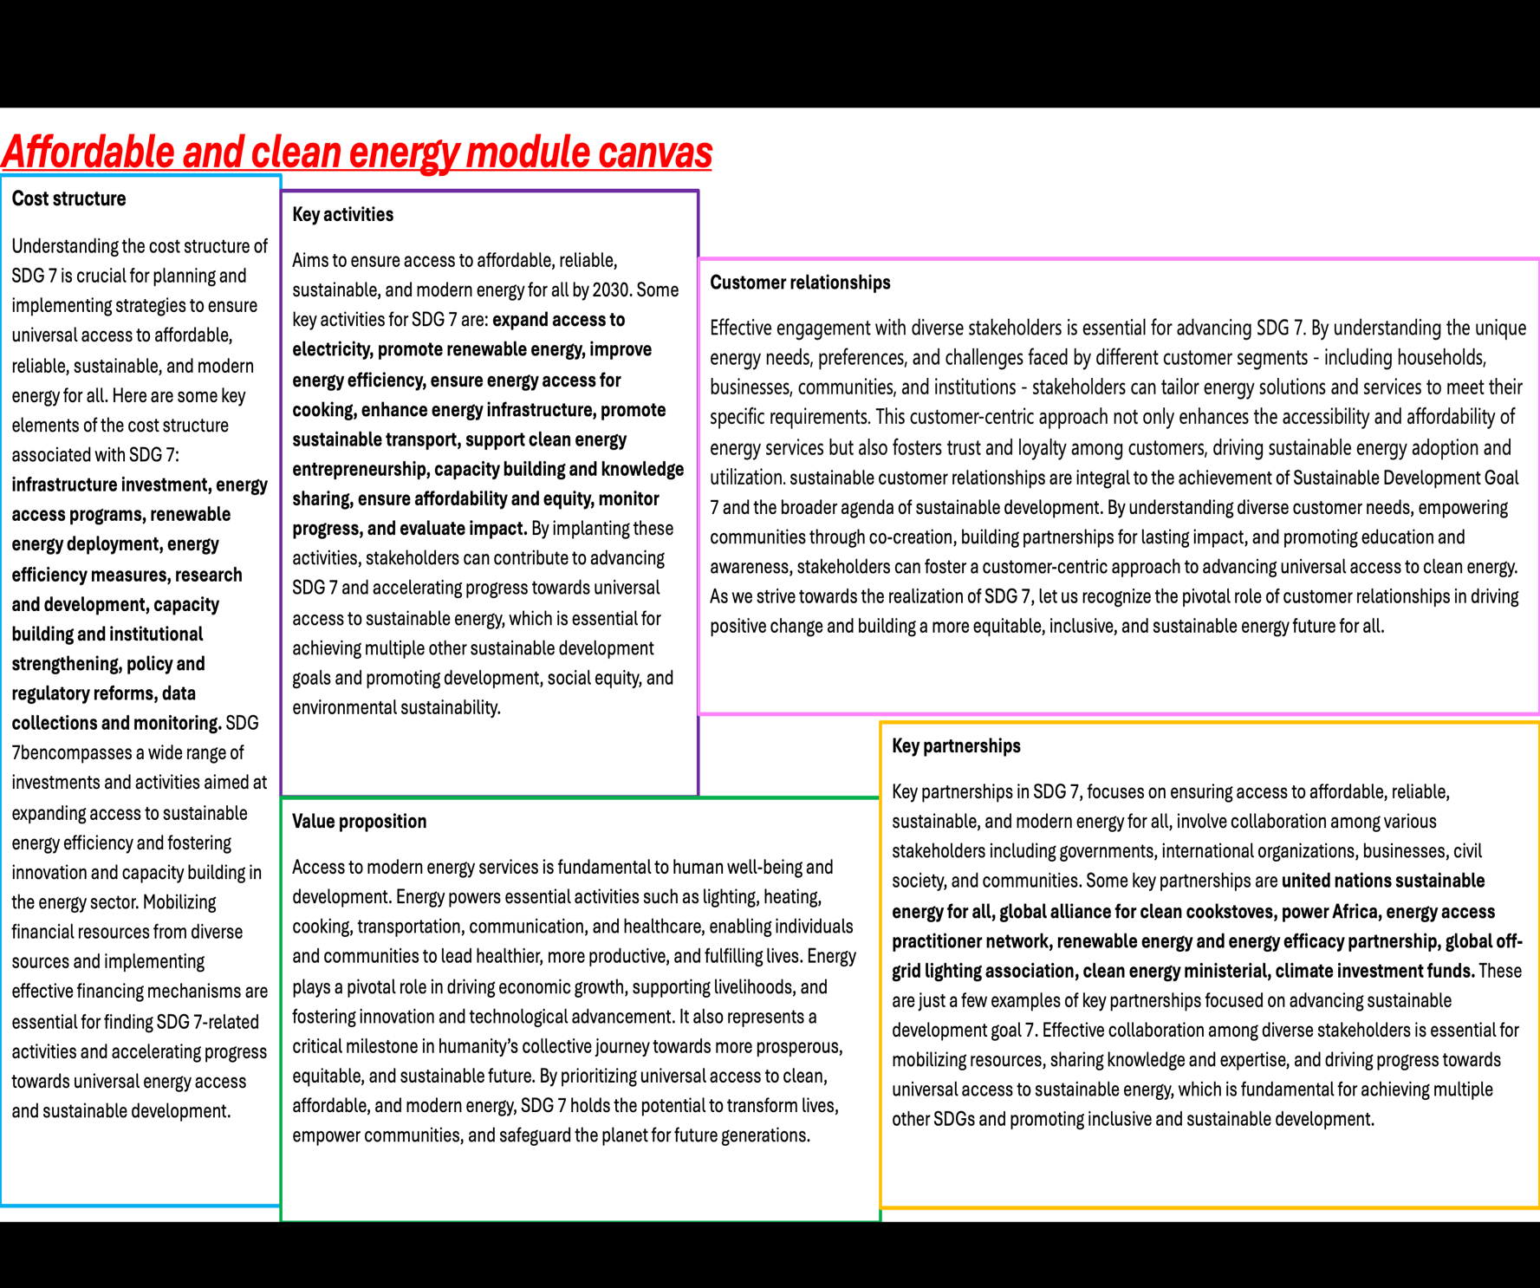

Presentation

https://uowtsd-my.sharepoint.com/:p:/g/personal/2317249_student_uwtsd_ac_uk/EcvQJaOw-ulPmZsEhY51ra8BIEuDcyF53wMV85iVWX65vA?email=robyn.griffiths%40uwtsd.ac.uk&e=V64eUQ

references.
(IISD, October 5th,2021.)
(UN environment program.)
(UN trade and development, September 18th, 2023.)
(Front, sustain, cities, October 29th,2021.)
(Alexandra Hepple, October 23rd, 2019.)

