In the case study presented the entities I Identified are: Supplier, Store, Order, Catering Service, Customer and Sales.
The relations I have assumed are:

Many to Many: Store can process one or more orders Order can be supplied by one or more supplier
- From this M:M relationship I have introduce a new entity called Purchase Invoice, giving a new primary key and assigning the two external foreign key from the parents entity and one from the Store entity.
Customer can require many catering services A type of catering service can be booked by many customers
- From this M:M relationship I have introduced a new Entity called Event, assigning a new PK and both foreign Keys from parent entities.
Customer can generate multiple sales Sales are generated by multiple customers
- From this M:M Relationship I have create a new identity called Customer Invoice, assigning a new PK and both foreign Keys from parent entities.
One to Many:
Store can provide many catering services A catering service is provided just by a store
An order is processed only by a supplier A supplier can process many order

List of Attributes:
Supplier: Supplier ID, Address, Phone, Email, Description
Order: Order ID, Description, Date, Quantity, Value
Purchase invoice: Invoice Number, Supplier ID*, Store ID*, Order ID*, Description, Total
Store: Store ID, Address, Phone, Email, Address
Catering service: Service ID, Type, Description, Quantity, Store ID*
Event: Event ID, Date, Location, Service ID*, Customer ID*, Type
Customer: Customer ID, Name, Address, Email, Requests, Details
Customer invoice: Invoice N, Customer ID*, Date, Amount, Description, Type, sales ID*
Sales: Sales ID, Date, Event ID*

Below the representation pf the ERD Diagram, Use case Diagram and Data Flow Diagram:

ERD Diagram
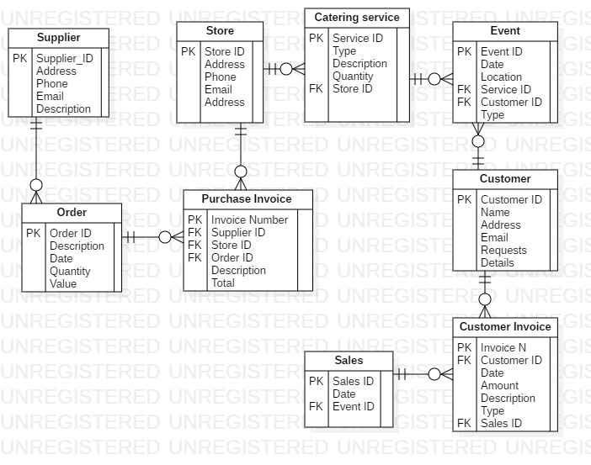

Use case Diagram
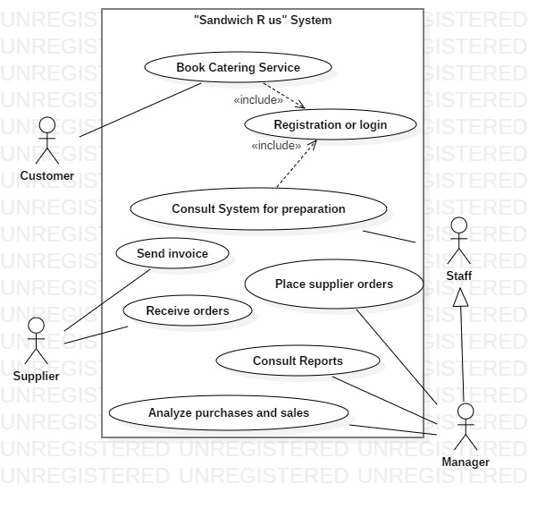

Data Flow Diagram

-Level 0
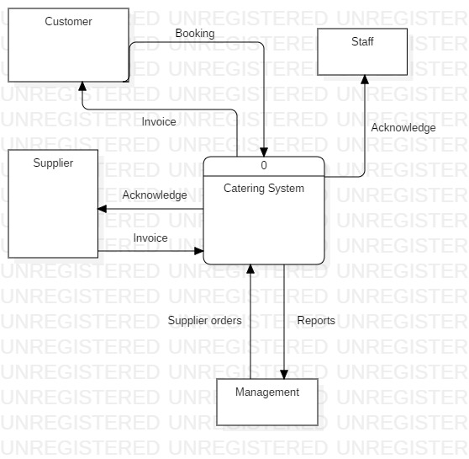

Level 1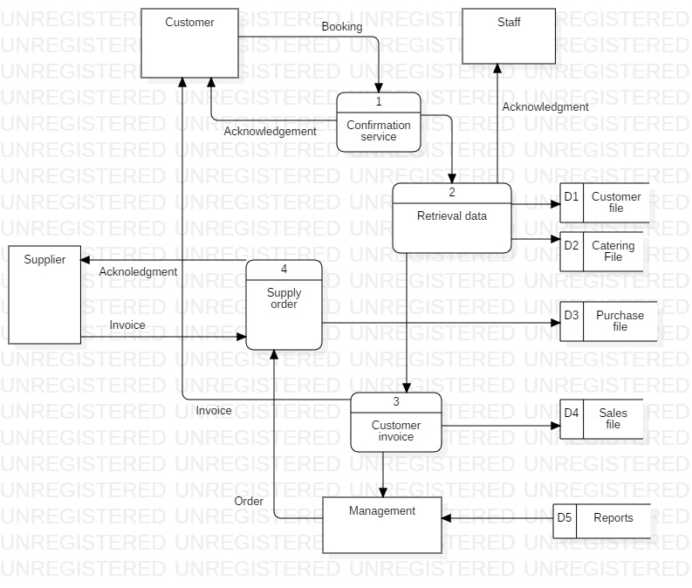

Level 2

