Rebecca Courtney Nash
2000419

ECAD6008 – Professional and Pedagogic Studies: Leading the Learning: what, how and why am I teaching?

Critically reflect on your progress in planning, preparing and teaching lessons that incorporate specific pedagogical principles. (This evidence should be taken from the Professional Learning Passport – PLP). Identify up to three of these pedagogical principles as an area for development and justify the next steps in your development.

Part 1 – Professional Experience Templates – Equivalent to 2000 words…p.3
Part 2 – Critical Discussion: Written…p.11
References…p.20
Total Word Count – 3266 (+10%)

Targets:
Target 1 | “Try to consider introducing the reader to the ‘so what’ of your literature – round off with the importance of what you have just discussed.”
Target 2 | “Consider whether some contractions actually reduce readability i.e. WG makes sense, but reader out of context may struggle with uncommon contractions.”

Part 1: Professional Experience Templates
Professional Experience Template 1
Pedagogy Standard | Assessment for Learning
Pedagogical Principle | Using Assessment for Learning to accelerate progress
What did you do and why? | Whilst on PTE3, I taught a series of daily Welsh sessions, launching a topic and introduction to the focus and finally landing on a close to meet the proposed Welsh language objective at the end of half term. The Welsh topic focus connected with the overarching class learning topic of ‘Conflict’ with topic lessons specifically looking at wind turbines as a sufficient source of energy in present society and understanding the effects of wind energy. From this the Welsh topic stemmed to focus on the weather (Y Tywydd) and describing the weather using various phrases and sentence patterns to develop learners’ Welsh language skills. Initially an independent success criteria was designed to fit the mid-term plan of the daily Welsh lessons which enabled both myself and learners to reflect against each lesson and skill objective in accordance with the age-related progression steps on the ‘Y Gromlech’ Welsh Learning Continuum website. This mainly consisted of a RAG/Traffic Light rating strategy, encouraging each learner to self-assess their confidence or ability levels to meet the proposed skill objective from each learning experience. Within each week of this learning period, multiple assessment for learning (AfL) strategies were used to acknowledge learning progress and identify any misconceptions and next steps to enable further progress and development. These strategies included exit cards, post-it note learning wall, confidence line ratings and online Kahoot assessment quizzes, and these mainly encouraged and followed the form of formative assessment, enabling learners opportunities to reflect against their learning experience and independently evidence their abilities and understanding. With the exit cards, I posed direct questions to all learners for them to record their responses on the proposed exit card, this would identify their current understanding levels and inform future lessons to tailor specific support or progress learning dependently. This was similarly evidenced within the post-it note learning wall, where learners were encouraged to record something that they could remember, reflecting against the specific week learning and collaboratively creating a learning wall of independent post-it note wall to evidence their learning progress from the week. Furthermore, the confidence line rating enabled learners to physically highlight their confidence and understanding of the proposed learning objective and skill which ultimately informed next steps for learning as low confidence levels proposed that extra support or reiteration of learning was required to meet the learning/skill objectives more coherently and successfully. Finally, the class Kahoot quiz consisted of a range of relative questions to the weeks learning and skill focus and encouraged learners to complete either independently or in collaboration of peer support to portray their ability to understand and respond correctly to the assessment questions. This strategy would also highlight any common misconceptions and aid information for further support next steps for learning within upcoming lessons.
What have you learned? | This experience clearly demonstrated that implementing multiple assessment strategies to articulate learning and pupil understanding limited a level of repetitive learning experiences and avoided learners feeling bored of constantly completing the same assessment material or strategy to evidence their learning. When considering the impact and experiences of day-to-day lessons weekly, AfL is pivotal in providing effective learning experiences, scaffolding learners’ understanding when improving their learning outcomes. Specifically to this experience, the assessment determined how the quality of student responses can be used to shape and improve learners’ competence (Sadler, 1989: Black & William, 1998), with the overarching purpose of assessment encouraging learners to make progress whilst demonstrating effective learning (Welsh Government, 2020). Through trialling, implementing and reflecting upon a range of AfL strategies, I have been able to identify which of these work best for specific learners and situations and I have therefore developed my overall knowledge and understanding on multiple assessment strategies and the appropriateness of each one to best acknowledge pupil understanding, learning and progress to determine their next stops for development which have and will continue to assist planning future lessons following a specific learning experience. I have additionally learnt in specific context to the Kahoot quiz that formative assessment can be engaging and enjoyable if/when incorporated effectively within the classroom, as this limits the pressure of ‘high expectations’ of learners and encourages them to interact with positive and enjoyable learning experiences, whist also assessing their understanding and ability of the proposed skills and learning objectives. This implementation encourages learners to develop a growth mindset by understanding their learning, rather than purely visualising their scores (Dweck, 2000).
What next? | I understand the importance of assessment for learning within pedagogy and acknowledge that it is a crucial element to promote pupil/learning progress. I plan to continue incorporate AfL within learning experiences to determine outcomes and next steps for progress, however, from the trial of multiple strategies I will carefully consider most effective and valuable ones to provide the most meaningful information to inform pedagogy, specifically exit cards and kahoot quizzes. I will continue to incorporate self-assessment when possible as I believe this is important for learners to identify their current learning levels and understand their strengths and areas for improvement which effectively informs my future planning as these assessment strategies highlight where further support is required and whether additional challenges are necessary to encourage extended progress. Additionally, I plan to continuously provide active and immediate feedback in both verbal and written form to support learners understand the reasoning behind the feedback in the moment of the learning experience to further enable quality improvements. Furthermore, I will continue to research and implement a variety of AfL strategies within each of the four elements to further deepen my knowledge of which strategies best support various learners in different circumstances and experiences.
Professional Experience Template 2
Pedagogy Standard | Blended Learning experiences
Pedagogical Principle | Employing a broad repertoire of teaching approaches
What did you do and why? | During PTE3, I planned and taught a maths carousel lesson which constituted over a two-day period, including four different pedagogical activities for all learners to engage with. The lesson activities continued to develop learners’ fluency skills regarding addition, multiplication and calculating perimeter whilst engaging with an introduction to calculating area to enable progress within the measurement topic in relation to the curriculum progression steps. The carousel lesson included a broad pedagogical approach to challenge and engage learners, consisting a teacher-focus task (progressing learning further within the math topic by introducing a new skill), LSA-focus task (progressing learning and abilities of a previous focus skill), Blended-Learning task, and various VIP tasks which enabled learners the choice of which activity they wanted to work on to develop math fluency skills (addition and multiplication). One of the group activities entailed a blended learning task which instructed learners to scan a created QR-code to engage with and watch a pre-recorded lesson video to support their understanding and learning when calculating shape perimeter. The video was created beforehand by myself which included a PowerPoint presentation to support learners visually with task-related questions and a recorded explanation linking with each slide to virtually deliver input to support learners’ understanding and ability to complete task questions. Within the video, I ensured to work through and model examples for each of the differentiated question levels to support all learners when working on the proposed activity, providing and delivering an inclusive pedagogical approach. This resource enabled and encouraged learners to work independently whilst receiving virtual teacher-input if and when necessary to promote self-direction and resilience within their learning. Following completion of this activity, learners were then instructed to scan an additional QR-code to complete an online quiz to assess their independent learning and understanding of calculating perimeter. Similarly, I had created a learning quiz online via ‘Nearpod’ which included a variety of questions and styles to assess learners’ perimeter skills which encouraged learners to employ their digital competence skills in order to successfully complete the learning experience. This enabled learners to complete an independent assessment activity which differed from previous lesson plenaries and assessment activities which were usually completed whole class (exit tickets, secret squirrel and self-reflection). This further promoted a virtual blended learning experience for learners to engage with and highlighted a high-quality learning experience which encouraged learners to develop their understanding and enhance their well-being.
What have you learned? | From this experience, I have learnt the importance and value of employing a range of teaching approaches within lessons as this combination of offline and online education support and learning enables learners to interact with teacher-led, study material, and peers both through physical classroom and online platforms (Giarla, 2016), whilst also encourages learners to direct their individual learning experience. This specific lesson employed a rotated, virtual and face-to-face approach for each learning group to interact with this multiple pedagogical approach increasingly catering to learners’ individual needs as most learners have unique learning styles and a blended approach better caters to those needs than a traditional whole class teaching experience (Trivedi, 2021). As highlighted within previous lessons, some learners voiced their preference for virtual learning experiences and this approach enabled an inclusion of their needs and interests to complete the lesson. Through providing a virtual support video for learners, I learnt that this encouraged high-quality learning progress as learners were able to work independently and direct their learning whilst practicing resilience. Furthermore, I learnt that providing a range of learning plenary activities engages learners and targets specific learning skills appropriate to task which highlighted next-steps for learning whilst enabling learners to engage with enhanced activities to evidence their progress and independent understanding.
What next? | In next steps for development, I plan to further research how blended-learning approaches can be additionally implemented and planned for within lessons to strengthen my understanding of how this principle can be effectively delivered to support and enhance learning progression. Specifically from this experience, I will continue employing a range of approaches within a lesson following direct teaching, virtual/digital learning and independent learning as these collaboratively enhance pupil learning in different ways and have deemed to be effective when maintaining pupil motivation and engagement throughout experiences. The virtual learning activities encourage learners to develop and use their digital competence skills effectively whilst interacting with the task objective either independently or in pairs, thus these skills can be exploited in alternate situations. Likewise, the independent learning tasks encourage learners to self-direct their learning and become active participants within the process as learners work at their own pace and chosen level of challenge and this will be something I continuously plan to incorporate and encourage within future lessons and plans. Perhaps a suggestion for improvement could be changing the blended-rotation to a two-way instead of a four-way to ensure a smoother flow and management of the learning environment whilst importantly still offering a directed-teaching and independent task for learners to engage with supportive explanations to enhance progression and also engaging in challenge independently to lead their own learning experience. Nonetheless, this rotation will be trialled to acknowledge the benefits of this, but I will also continue to implement four-way blended-rotations in response to experienced outcome effectiveness.
Professional Experience Template 3
Pedagogy Standard | Real life authentic contexts
Pedagogical Principle | Creating authentic contexts for learning

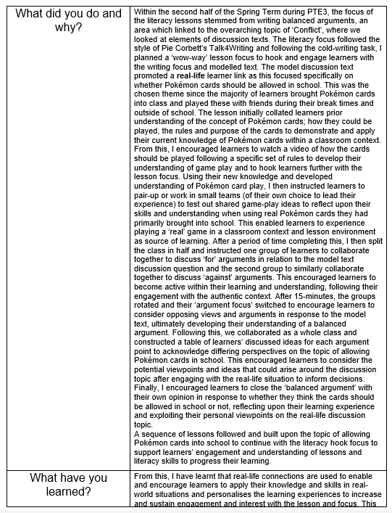
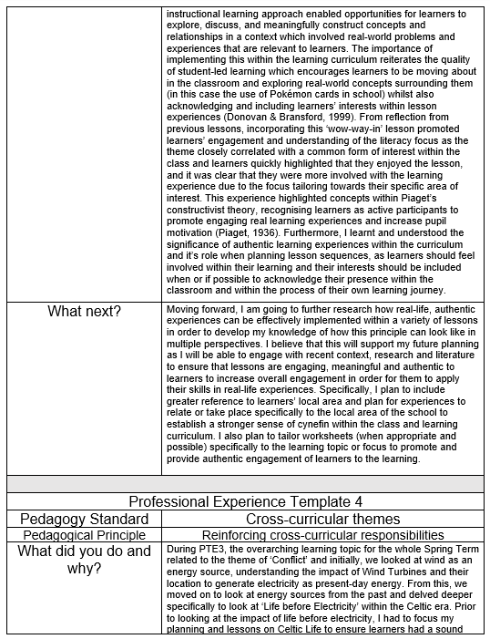
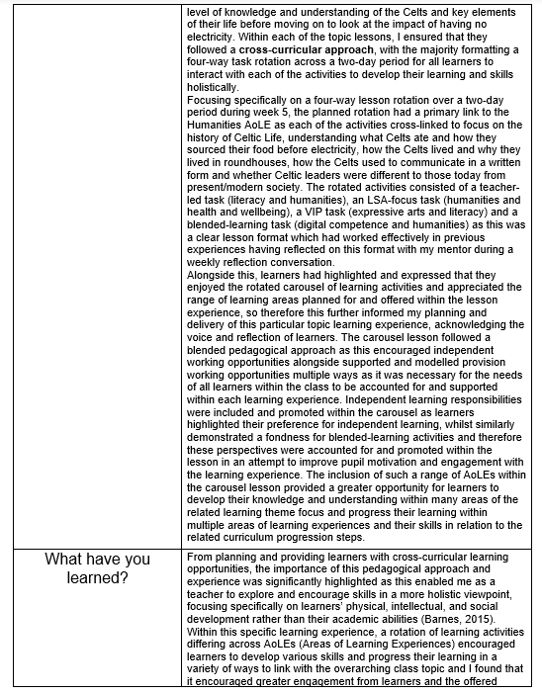
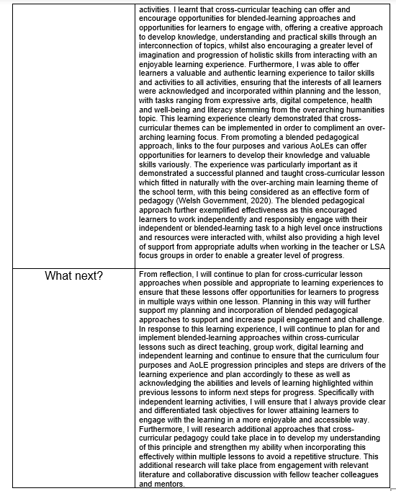
Part 2: Critical Discussion
Effective pedagogy refers to the classroom management which impacts pupil learning, providing teachers to explore their teaching abilities to perform effectively by actively involving them within classroom practices (Taggart, 2014: D’Angelo, 2021). In accordance with Welsh Government [WG] documentation, pedagogy acknowledges the heart of curriculum designs, ensuring that schools in Wales apply effective pedagogical approaches in correspondence to the four learning purposes (WG, 2023a). From this, pedagogy stems the definition of good teaching and learning and recognises the relation to develop valuable teaching-learning in support of learners’ holistic achievements (Zeng, 2021). In this context, according to Donaldson (2015), elements of good teaching demonstrates: subject knowledge and expertise, an understanding of the social and psychological factors that influence learning, and the ability to engage and inspire children to learn, additionally with an increasing independence (p.63). Pedagogy is consistently highlighted throughout the proposed twelve pedagogical principles, with more recent Curriculum for Wales [CfW] documentation (2022) emphasising that the principles underpin an inclusive curriculum design for all. Therefore, practitioners should build upon the principles to support pupil progression as this effective, learner-centred pedagogy should be responsive, dynamic and embedded in strong relationships to provide consistent, valuable learning opportunities and experiences (Strand, 2018: WG, 2023b). Reflection is an integral role as a professional practitioner, with importance regarding reflective teachers as effective teachers (Dymoke & Harrison, 2008: Kelly, 2020). The importance of reflection has further recently been recognised as a collaboration of good practice to develop holistically (Spalding, 2023), and according to Hattie’s previous research (2003) developing excellence in teaching can singularly influence student achievement. This assignment will address reflection and critical discussion on a specific pedagogical principle from part 1 to extend knowledge, understanding and skills to develop personal and professional pedagogy, further informing next steps within practice. Following experiences, part 2 of this assignment will focus specifically on the pedagogy standard “Cross-Curricular Themes” highlighted from the pedagogical principle of “reinforcing cross-curricular responsibilities”. I have chosen to concentrate on cross-curricular pedagogy because I wish to acquire a greater understanding of the principle and effectively implement this further within my practice; building upon my knowledge of how this principle enables pupil progression and how this could be embedded within planning and pedagogy.
Cross-curricular learning defines an application of skills and knowledge from multiple disciplines to a single theme, problem or experience (Barnes, 2015), offering a creative approach to develop knowledge, understanding and practical skills (Cooper & Rowley, 2009: Santos, 2022). Barnes (2015) advocates that there are five models of cross-curricular teaching which define; multi-disciplinary, interdisciplinary, opportunistic, double focus and hierarchical approaches, with methods encouraging positive social interactions between both teachers and pupils, ultimately leading to an acquisition of developed knowledge from enriched lesson experiences (Earley, 2019: Sullivan, 2019). Within the CfW (2022), three mandatory cross-curricular skill frameworks; literacy, numeracy and digital competence are considered essential for learners as they explore the range of opportunities from school curriculums, ultimately equipping them with lifelong, transferable skills (WG, 2020a). Conversely, the concentrated frameworks alone does not define the integration of cross-curricular teaching within planning, with guidance promoting collaboration and cross-disciplinary pedagogy, both within and across areas of learning (WG, 2020a) to complement valuable learning experiences, and enabling learners to establish learning connections (Barnes, 2015: Kerry, 2015). The integrated curriculum approach has since evolved from the initial outline shared within the Plowden Report (1967), and continuously evolves with theoretical understandings and approaches proposing that cross-curricular responsibilities should recognise unity within and between subject areas to effectively enhance learning. From this, Dewey’s educational theory recommends an interdisciplinary curriculum within classroom pedagogies as this encourages learners to pursue interests and build individual methods for acquiring and applying specific knowledge in various contexts (Thorburn, 2017). Modern research suggests that a thematic approach within pedagogy connects with effective implementation of cross-curricular teaching as multiple curriculum areas are connected together and integrated within a chosen theme (Okoro, 2016: Stanly, 2018). A thematic approach entails many benefits within classroom curriculums, specifically as this enables effective opportunities for pupils to learn and retain greater information. This suggests a result of greater involvement and engagement from all learning abilities (McDonald, 2011), further enabling learners to relate to authentic and real-life experiences to develop knowledge and understanding (Ashbridge, 2010).
In relation to part 1’s reflection of cross-curricular teaching, it is clear that the lesson experience highlighted a sequence of term topic lessons followed a thematic pedagogical approach, with lessons concentrating upon a proposed theme of ‘Life before Electricity’, leading on to focus on ‘Celtic Life’. Within the thematic approach to cross-curricular planning, topic lessons formatted a four-way task rotation, ranging across multiple subject areas to ensure that the subject interests of all pupils were accounted for to encourage greater pupil engagement and motivation levels. This approach enabled an exploration and greater encouragement of skills holistically, focusing upon learners’ physical, intellectual, and social development rather than just specifically their academic abilities (Barnes, 2015: Santos, 2022). However, when implementing a thematic approach within cross-curricular planning, it is vital that the learning themes are considered carefully in order to work effectively to inform and motivate learners, otherwise tenuous links and unclear aims could arise and limit learning progress (Faultley & Savage, 2011). In light of this, Barnes (2015) recommended that effective cross-curricular pedagogy should enhance learning in two or three integrated subjects. However, in the context of a thematic approach, research suggests a relevant and authentic theme may be used to develop learning across multiple subjects, far better than the generic recommendation of limiting cross-curricular work of two or three subjects (Stanly, 2018). Nonetheless, no subject should be included unless it is deemed essential to deepening understanding or broadening knowledge of the proposed theme, and therefore, from this I ensured to collaborate with staff colleagues when planning cross-curricular lessons to discuss the integration of planned subjects and activities to conclude appropriateness. Consequently, this secured a high-quality understanding of what skills and knowledge would be covered and how best to do this to best enable learner progress, ensuring that the lesson experience was valuable and meaningful to the learning theme (Gates, 2018: Ford, 2023).
However, literature contrasts the perspective of thematic teaching approaches and favours a multi-disciplinary cross-curricular approach as this aims to use a single experience to develop higher levels of understanding and performance within two or more disciplines, combining knowledge and methods to meaningful wholes (Klausen, 2014: McPhail, 2018). This differs from my planned and taught experience, as multi-disciplinary approaches integrates a maximum of three subjects within a single shared experience, where, as reflected upon with part 1, the specific topic lesson integrated a wide range of subject disciplines and skills from the curriculum cross-curricular frameworks. Whilst the single meaningful experience and sequenced subject learning may be shared, according to Jabareen (2011) teachers will hold no intention or plans to combine the subjects within multi-disciplinary cross-curricular approaches. Barnes (2015) echoes this perception and suggests this approach is widely acknowledged as the most appropriate cross-curricular approach for novice teachers as this does not involve planning of complex interrelationships between multiple subject disciplines. This proposes that cross-curricular planning across multiple subject areas can be time-constraining for teachers when planning across the curriculum as this demands a deep subject knowledge. Additionally this can apply pressure when integrating subject disciplines as links need to be essential to avoid a loss of distinctiveness or a retrieval of weak understandings from the learning objective (Laurie, 2010: Byrne & Brodie, 2013: Greenwood, 2013).
Moreover, the integrated curriculum approach has significantly changed and evolved since primarily outlined by Plowden (1967), however, despite this evolution, the approach remains child-centred. This associates with Dewey’s philosophy of education and concentrates on the importance of understanding children’s experiences, receiving appropriate and valuable levels of support and direction within structured learning experiences to achieve maximum benefits (Pring, 2007: Gray & MacBlain, 2012). In the context of Dewey’s philosophy, this could suggest that cross-curricular teaching encourages opportunities for learners to become active within their learning process and feel accounted for within the planning stages and integration of multiple subjects or discipline skills (Alexander, 2010). This implication further connotes Piaget’s theory of cognitive development (1953), acknowledging that learners are “powerfully and actively engaged” within learning processes (Gray & MacBlain, 2012, p.46). However, the discussed theories place little emphasis upon the role of the teacher within a child’s learning process, but later theorists Vygotsky (1978) and Bruner (1986) imply that teachers play a pivotal role with children’s learning development (Pritchard, 2017). Following this, in the context of cross-curricular pedagogy, the role of the teacher is essential when planning and effectively delivering the designed lessons, ensuring that they offer meaningful opportunities to maintain engagement, resulting from careful considerations within planning processes (Santos, 2022). In contrast to the Plowden Report (1967), cross-curricular pedagogy within modern society is much more rigorous at planning stages, whereas previously, learning topics were identified by titles, with teachers concentrating upon which activities could best fit topic titles (Farmery, 2015).
Specifically, within modern curriculum designs, cross-curricular pedagogies follow objective-led planning, and it is from the proposed learning objectives where activities can be determined, ensuring that each planned task offers a specific purpose (Houghton, 2017). Aligning with the CfW (2022) skill or objective-led planning is advised in order to best support and encourage learning progression within subject areas. Therefore, when planning for the cross-curricular learning experience, it was essential that I worked in accordance with the curriculum progression steps for each subject and highlighted specific skills from either progression step two or three to best suit the learning needs of all learners within the key stage two classroom. This was important as these progression principles alongside each subject statements of what matters form the mandatory basis for progression and support practitioner understanding of what it means for learners to progress, ultimately informing vital steps for effective teaching, learning and assessment (WG, 2021). However, it has been suggested that cross-curricular planning entail some challenges when integrating subjects within a single or sequence of lessons, as it can be difficult for teachers to effectively incorporate the subject and activities (Lynch, 2019). Additionally, Lynch denotes that cross-curricular planning holds a primary drawback in a lack of time for collaboration amongst teachers, an aspect shared in a perspective of Smith (2021) who further addresses the increasing level of responsibilities and expectations teachers face when following and delivering school curriculums. Despite this, when planning accordingly to subject purposes and appropriately to promote a meaningful learning experiences, planning and teaching following a cross-curricular learning approach promotes an enjoyable experience as creativity is explored, whilst offering opportunities to exploit knowledge and expertise within multiple subject areas (Barnes, 2007: Desailly, 2015). From this, when planning for the cross-curricular lesson, I ensured to focus objectives and imaginatively plan from the curriculum progression steps and principles to best support pupil progress, whilst also supporting my own knowledge and understanding on what was necessary to enhance learning and development in a meaningful way.
Furthermore, specific benefits of cross-curricular teaching acknowledge the integration of subject skills and disciplines as a mirror to a natural learning approach as meaningful learning experiences enable learners to establish connections (Parker, 2012). In accordance with this, a cross-application of learning can equally deepen and extend learning and promote authentic learning environments which offer greater opportunities for pupil-engagement (Barnes, 2015: Kerry, 2015: Timmerman, 2017). Subsequently, Abbs (cited in Barnes, 2007: 147) implies that without engagement deep learning experiences are not possible, therefore this suggests that opportunities to meaningfully contextualise learning, provide opportunities for breadth which may not be possible through subject-based lessons. From this, part 1’s cross-curricular lesson formatted a four-task carousel across a two-day period as this offered an engaging and enjoyable experience for learners to interact with and ultimately, this preference from learners had previously demonstrated effective and high-quality learning. Literature emphasises that a such multiple-pedagogical approach caters to individual learning needs, as learners promote unique learning styles, thus supporting these better than traditional whole-class teaching (Trivedi, 2021). In response to this, Kerry (2015) suggests that effective cross-curricular teaching encourages inclusion of all learners and abilities as lessons could implement a variety of ways to demonstrate learning, providing a wide range of resources and materials that meet diverse levels of knowledge (Giarla, 2016: Dangwal, 2017).
Additionally, literature denotes the value of implementing cross-curricular pedagogy through a blended-learning experience as multiple tasks greater offer learners to seek out information, think critically, solve problems and establish learning connections (Sullivan, 2019). Moreover, the promotion of independence emphasises a personalised learning experience and following Bruner’s (1986) constructivist perspective, encourages active engagement from learners within the learning experience as they are able to eloquently implement their skills to connect learning across subject disciplines within various activities. Similarly, Piaget’s cognitive-constructivist theory would favour the opportunity for independent learning tasks as this demonstrates child-centred pedagogy, thus encouraging imagination, critical-thinking and reflection upon abilities and understanding (Cerino, 2021). Likewise, Vygotsky’s social-constructivist theory (1986) would favour the blended cross-curricular learning approach as this offers learners to build valuable skills to support future experiences and encourage more knowledgeable others (MKO) to scaffold and support learning understandings and skills of peers following a cooperative learning strategy (Shaffer, 2004: Kerry, 2015). However, Bruner’s theory would also praise and value the role of the teacher within teacher-focus activities as this face-to-face and direct support can effectively develop learners’ thinking and learning, thus providing enriched explanations to support understandings of the subject knowledge connections (Smidt, 2011: McLeod, 2023). Despite this, if the lesson format and tasks are repetitive then this could result in a loss of engagement from learners as they are not experiencing authentic or exciting learning (Ktoridou, 2021). This challenge could further be suggested within cross-curricular approaches where teachers may struggle to plan for authentic or purposeful learning, therefore resulting in pupils limiting their engagement within the lesson (Swenson et al, 2018). This emphasises the importance of high-quality and considered planning when implementing cross-curricular approaches in order to maintain learner’s engagement and motivation across the planned learning phase (Wallace & Berry, 2009: Barnes, 2015).
Moreover, planning and delivering this blended cross-curricular approach established pressure and challenges upon time-management when preparing resources, resulting from the heavy-workload of planning a four-way activity rotation including multiple subject discipline areas. Therefore, Harrod & Kerry (2015) suggest a team-teaching approach would be more beneficial when delivering similar lessons following Loeser’s (2008) definition of team-teaching as a practice of including more than one teacher of equal status within the classroom to provide identical instructions to groups of learners. In more recent research McKenzie & Hains-Wesson (2022) echo this description and favour team-teaching when implementing either blended-learning or cross-curricular approaches as this cooperative planning and pedagogy significantly enhances pupil learning. In best response to part 1’s experience, Goetz (2000) could suggest either a collaborative (several teachers devise content within learner presence to implement a constructive learning progress) or similarly a parallel (division of class into small groups with each teacher delivering identical material, offering individualised support) team-teaching approach to greater encourage learning progress. A team-teach approach within cross-curricular pedagogy would not only encourage creative collaboration across professional planning but also offer opportunities for personal growth and development from the experience of paired-expertise, whilst additionally reducing teacher stress when planning and delivering lessons (Dalsky & Stewart, 2016). Furthermore, from a pupil perspective, cross-curricular team-teaching entail opportunities to encourage more effective learning outcomes following a personalised learning approach including varied opportunities to differentiate learning experiences (Harrod & Kerry, 2015). However, it would be essential to carefully consider teaching positionality as this suggested approach could determine a possible incompatibility of teaching styles and entail a lack of colleague participation (Hurley, 2012), ultimately stressing the significance of high-quality, considered planning when implementing a cross-curricular approach.
In summary, this assignment has critically discussed and enabled reflection upon progress made when planning, preparing and teaching lessons that incorporate specific pedagogical principles. The chosen principle for development concentrated upon cross-curricular responsibilities, and ultimately this assignment has further developed my knowledge and understanding of the integration of cross-curricular pedagogy within planning and delivery through engagement with relevant literature. This experience has provided opportunities to critically reflect upon planning for and implementing cross-curricular pedagogy within my practice and has enabled a deep exploration of the value of this approach within curriculum designs, whilst also acknowledging potential challenges. As a student teacher, I understand the importance of reflection within the profession and plan to continually complete this as an active, on-going process throughout my professional practice as reflection deepens teacher’s knowledge and understanding, thus encouraging holistic professional development (Pollard, 2019). Additionally, New South Wales Department of Education (2022) emphasise the importance of teacher’s reflecting upon their pedagogy, as this encourages a developing repertoire of context-specific and relevant teaching techniques, which promotes a positive learning environment (NSW, 2022), consequently evaluating the effectiveness of teaching and learning and the entailed impacts upon children’s learning and development (Donaldson, 2015).
When critically reflecting upon my experiences and engaging with literature, I discovered many benefits towards the specific cross-curricular lesson, however research suggests potential development within planning, teaching and implementing this pedagogical principle within lessons. As there were many activities planned for within the learning experience, the workload was very stressful and created significant pressure when preparing resources and planning appropriately and accordingly to support all learners. From previous discussion, Stewart (2016) proposed that team-teaching reduces practitioner planning and preparation workloads and enhances both personal and pupil growth whilst promoting child-centred pedagogy. Therefore, when developing my own future practice, I would like to participate in team-teaching a cross-curricular lesson in response to the collaboration QTS standard of working with in-school colleagues (WG, 2020b) to equally teach instructions to specific learning groups, following cooperative planning, whilst also exploring the potential benefits this approach could have upon enhancing pupil’s learning. This will also ensure more opportunities are given to promote personalised learning to encourage more effective learning outcomes from all ability acquired learners. Additionally, I found that reflection and appropriate assessment was vital when integrating cross-curricular disciplines within planning as these elements determine learner’s learning levels and skills to determine lesson and task relevance as, if these are too simple or complex, learners will lose motivation and lack engagement with lesson experiences (Barnes, 2015). Consequently, I plan to continuously reflect upon future lessons to strengthen understanding of learning levels and determine effective pedagogy to best support pupil progress. Additionally, appropriate and timely formative assessment specifically self-assessment will be completed at significant learning and lesson points to further determine whether planned experiences are meaningful and valuable to learning and progress, ultimately interlinking with the pedagogy, refining QTS standard of articulating “purposeful assessment” (WG, 2020b). Moreover, after acknowledging the benefits cross-curricular pedagogy entail, I will develop my planning of this approach, following an objective-led process and further integrating pupil voice appropriately to determine learning themes and lesson formats. This will tailor experiences from acknowledging pupil areas of interests, additionally attempting to increase learning motivation and engagement. Whilst sharing Piaget’s (1968) notion of children as active learners, expressing the importance of verbal expression (Hughes, 2002), this acknowledges the pedagogy, influencing QTS standard of “listening to learners”, encouraging learners to become active participants within their own learning (WG, 2020b), ultimately inspiring authentic, meaningful and enriched lesson experiences.
Overall, this assignment has emphasised by integrating subjects in a cross-curricular learning approach, elements of Gardener’s multiple intelligences theory (2011) explored the significance and implementation of such pedagogical delivery through a variety of learning styles, consequently supporting and enhancing learner progress. Ultimately, when teachers appropriately and effectively incorporate pedagogical principles and standards within their pedagogy, pupil progression is positively supported and prioritised, thus increasing overall individualised learning achievements (WG, 2021).

References:
Alexander. R, (2010), Children, Their World, Their Education: The report of the Cambridge Primary Review, London: Routledge.
Ashbridge. J, (2009) in Cooper. H & Rowley. C, (2009), Cross-curricular approaches to teaching and learning, SAGE, London.
Barnes. J, (2007), Strangely familiar: Cross-curricular and creative thinking in teacher education, 10.2. [online], available from: https://journals.sagepub.com/doi/10.1177/1365480207078580 [accessed 1st April 2023]
Barnes. J, (2015), Cross-curricular learning 3-14, (3rd ed.), SAGE Publications, London.
Bruner. J, (1986) A Constructivist Learning Theory, [online] available from: https://www.instructionaldesign.org/theories/constructivist/ [accessed 1st April 2023]
Byrne. E & Brodie. M, (2013), Cross-curricular teaching and learning in the secondary school, (1st Ed), Routledge, London.
Cooper. H & Rowley. C, (2009), Cross-curricular approaches to teaching and learning, SAGE, London.
D'Angelo, S. (2021). Effective Pedagogy in the Context of a Competency-Based Curriculum Reform: Perceptions of Teachers in the Dominican Republic. RECIE. 5(1), 7-18, [online] available from: https://doi.org/10.32541/recie.2021.v5i1.pp7-18 [accessed 26th March 2023]
Dalsky. D & Stewart. T, (2016), Team teaching and team learning in the language classroom: Collaboration for innovation in ELT. Routledge
Dangwal. L & Lata. K, (2017), Blended Learning: An Innovative Approach, Universal Journal of Educational Research, 5:1, 129-136, [online] available from: https://eric.ed.gov/?id=EJ1124666 [accessed 3rd April 2023]
Desailly. J, (2015), Creativity in the Primary Classroom, (2nd Ed), SAGE Publications.
Donaldson. G (Prof.), (2015), Successful Futures: Independent review of curriculum and assessment arrangement in Wales, [online] available from: https://gov.wales/sites/default/files/publications/2018-03/successful-futures.pdf [accessed 27th March 2023]
Donaldson. G (Prof.) in Welsh Government, (2015), Curriculum Reviews: Successful Futures, [online] available from: https://www.gov.wales/successful-futures-review-curriculum-and-assessment-arrangements [accessed 29th March 2023]
Dymoke. S & Harrison. J, (2008), Reflective Teaching and Learning, SAGE Publications, London.
Earley. S, (2019), An investigation into the Implementation of a Cross-Curricular Approach in an Irish Primary School Classroom, International Journal to Cross-Disciplinary Subjects in Education (UCDSE), 16.2, University College Cork, Ireland.
Farmery. C, (2015), in Kerry. T, (2015), Cross-Curricular Teaching in the Primary School: Planning and facilitating imaginative lessons, (2nd Ed), Routledge.
Faultley. M & Savage. J, (2011), Cross-curricular teaching and learning in the secondary school: The Arts – Drama, Visual Art, Music and Design, Routledge.
Ford. L, (2023), Collaborative Lesson Planning as an Effective Professional Development Tool in mathematics: Develop teachers and improve outcomes, [online] available from: https://thirdspacelearning.com/us/blog/collaborative-lesson-planning/#6-benefits-of-collaborative-planning [accessed 30th March 2023]
Gardener. H, (2011), Frames of Mind: The theory of multiple intelligences [Pbk. Ed], Basic Books.
Gates. S, (2018), Benefits of Collaboration: NEA Today, [online] available from: https://www.nea.org/professional-excellence/student-engagement/tools-tips/benefits-collaboration [accessed 30th March 2023]
Giarla. A, (2016), What are the benefits of blended learning? [online] available from: https://www.teachthought.com/?url=https%3A%2F%2Fwww.teachthought.com%2Ftechnology%2Fbenefits-of-blended-learning%2F%23%3A~%3Atext%3DBlended%2520learning%2520is%2520important%2520because%2520it%2520breaks%2520down%2Ccan%2520tailor%2520the%2520learning%2520experience%2520for%2520each%2520student [accessed 4th April 2023]
Goetz. K, (2000), Perspectives on team-teaching, Egallery 1(4), [online] available from: https://www.ucalgary.ca/~egallery [accessed 29th March 2023]
Greenwood. R.O, (2013), Subject-based and cross-curricular approaches within the revised primary curriculum in Northern Ireland: teachers' concerns and preferred approaches, Education: 3-13, 41(4), [online] available from: https://www.researchgate.net/publication/263339230_Subject-based_and_cross-curricular_approaches_within_the_revised_primary_curriculum_in_Northern_Ireland_teachers'_concerns_and_preferred_approaches [accessed 2nd April 2023]
Grey. C & MacBlain. S, (2012), Learning Theories in Childhood, SAGE Publications. Ltd, London, UK
Hattie. J, (2003), Teachers make a difference, What is the research evidence? Australian Council for Educational Research, ACER Research Conference, [online] available from: https://research.acer.ed.au/research_conference_2003/4/ [accessed 2nd April 2023]
Houghton. K, (2017), Objective led planning verses in the moment planning: Early Years Staff, [online] available from: https://www.earlyyearsstaffroom.com/objective-led-planning/ [accessed 3rd April 2023]
Hughes. M & Tizard. B, (2002), Young Children’s Learning, Understandings Children’s Worlds, (Second Edition), Blackwell Publications.
Hurley. S, (2012), Co-planning/co-teaching: a rich opportunity for breaking down the walls of our classrooms in perspectives, [online] available from: https://teachingoutloud.org/2012/06/21/co-planningco-teaching-a-rich-opportunity-for-breaking-down-the-walls-of-our-classrooms/ [accessed 2nd April 2023]
Jabareen. Y, (2011), Teaching Sustainability: A multidisciplinary approach, Scientific Research: Creative Research, Vol2:No4, [online] available from: https://www.scrip.org/html/7978.html [accessed 2nd April 2023]
Kelly. C (2020), 12 Benefits of Reflective Teaching and Learning, Reflective Teaching Journal, Benefits of Reflective Teaching for Teachers, [online] available from: https://reflectiveteachingjournal.com/benefits-of-reflective-teaching/ [accessed 27th March 2023]
Kerry. T, (2015), Cross-Curricular Teaching in the Primary School: Planning and facilitating imaginative lessons, (2nd Ed), Routledge.
Klausen, S. H. (2014). Transfer and cohesion in interdisciplinary education. Nordidactica – Journal of Humanities and Social Science Education, 2014(1), 1–20, Denmark
Ktoridou. D, (2021), Fostering meaningful learning experiences through student engagement, IGI, Global.
Laurie. J, (2010), Cross-Curricular Teaching in the Primary School: Curriculum planning and preparation for cross-curricular teaching, (1st Ed), Routledge. [online] available from: https://www.taylorfrancis.com/chapters/edit/10.4324/9780203840276-24/curriculum-planning-preparation-cross-curricular-teaching-judith-laurie [accessed 2nd April 2023]
Loeser. J, (2008), Team teaching, EBSCOHOST Website, Research Starters, Education, Team Teaching.
Lynch. M, (2019), Pros and cons of cross-curricular teaching, Teacher Advocate, [online] available from: https://www.theedadvocate.org/pros-and-cons-of-cross-curricular-teaching/ [accessed 3rd April 2023]
McDonald. D, (2011), Effective educating mentoring skills: A collaborative effort, New Zealand Journal of Teachers, 8(1), [online] available from: https://scholar.google.co.uk/scholar?g=mcdonald+2011+thematic+approach+in+teaching&hl=en&as_sdt=0&as_vis=1&oi=scholart#d=gs_qabs&t=1680793095819&u=&23p%3D6UBSKQ2dxkEJ [accessed 3rd April 2023]
McKenzie. S & Hains-Wesson. R, (2022), A team-teaching approach for blended learning: an experiment, Studies in Higher Education, 47.4, 860-874, [online] available from: https://www.tandfonline.com/doi/abs/10.1080/03075079.2020.1817887 [accessed 2nd April 2023]
McLeod. S, (2023), Jerome Bruner’s Constructivist Theory of Learning and Cognitive Development: Learning Theory, [online] available from: https://simplypsychology.org/bruner.html [accessed 2nd April 2023]
McPhail. G, (2018), Curriculum integration in the senior secondary school: A case study in a national assessment context. Journal of Curriculum Studies, 50(1), 56–76, [online] available from: https://www.tandfonline.com/doi/full/10.1080/00220272.2017.1386234 [accessed 2nd April 2023]
New South Wales Department of Education, (2022), Government Website, Reflective Practice, [online] available from: https://education.nsw.gov.au/teaching-and-learning/professional-learnng/teacher-quality-and-accreditation/strong-start-great-teachers/developing-focus/reflective-practice [accessed 4th April 2023]
Okoro, C.O (Ph.D.) & Okoro, C.U, (April 2016), Teachers’ understanding and use of thematic approach in teaching and learning of social studies, International Journal of Education, Learning and Development, University of Port Harcourt, pp.64-69, [online] available from: https://eajournals.org/wp-content/uploads/Teachers----Understanding-and-Use-of-Thematic-Approach-in-Teaching-and-Learning-of-Social-Studies-in-Rivers-State1.pdf#:~:text=Thematic%20approach%20is%20the%20way%20of%20teaching%20and,the%20broad%20aim%20to%20allow%20for%20creative%20exploration [accessed 29th March 2023]
Parker. J, (2012), Developing pre-service primary teachers’ perceptions of cross-curricular teaching through reflection on learning, teachers and teaching, 18:6, 693-716, [online] available from: https://www.tandofonline.com/action/showCitFormats?doi=10.1080%2F13540602.2012.746504 [accessed 3rd April 2023]
Plowden Report, (1967), Children and their Primary Schools. London: HMSO.
Pring. R, (2007), John Dewey: A Philosopher of Education for Our Time? London. Continuum International Publishing Group.
Pritchard. A, (2017), Ways of Learning: Learning Theories for the Classroom, (4th Ed), Routledge.
Pollard. A, (2019), Reflective Teaching in schools, (Fifth Edition), Bloomsbury Academic.
Santos. D, (2022), Cross-curricular activities: How to create meaningful learning opportunities, Cambridge University, [online] available from: https://www.cambridge.org/elt/blog/2022/12/07/cross-curricular-activities-how-create-meaningful-learning-opportunities/ [accessed 28th March 2023]
Smidt. S, (2011), Introducing Bruner: A guide for practitioners and students in early years education. Routledge.
Smith. F, (2021), Cross-Curricular Teaching Advantages and Disadvantages, Psychology Study, [online] available from: https://study.com/academy/lesson/cross-curricular-teaching-advantages-disadvantages.html [accessed 3rd April 2023]
Spalding. A, (2023), The Ultimate Guide to Reflective Practice in Teaching, [online] available from: https://blog.irisconnect.com/uk/blog/5-benefits-of-encouraging-teacher-self-reflection#second [accessed 28th March 2023]
Stanly. L, (2018), Thematic Approach – A new perspective in teaching, Department of Education, [online] available from: https://www.researchgate.net/publication/339586361_THEMATIC_APPROACH_-A_NEW_PERSPECTIVE_IN_TEACHING [accessed 30th March 2023]
Strand, V. C., & Popescu, M. (2018). An Effective Pedagogy for Child Welfare Education. Journal of Public Child Welfare, 12(3), 398-410, [online] available from: https://www.tandfonline.com/doi/full/10.1080/15548732.2018.1447530 [accessed 27th March 2023]
Sullivan. C, (2019), Approaches to Successful Cross-Curricular Integration: Scholastic Outreach Representative; M.A. in Curriculum and Instruction from Point Park University, [online] available from: https://www.teachhub.com/teaching-strategies/2019/11/approaches-to-successful-cross-curricular-integration/ [accessed 28th March 2023]
Swenson. R, Greiman. B & Nelson. R, (2018), Engaging students with experimental learning: A competency framework for Cross-curricular programs, NACTA Journal, 62(3), 260-266
Taggart. B & Siraj. I, (2014), Exploring Effective Pedagogy in Primary Schools: Evidence from Research, [online] available from: https://www.pearson.com/content/dam/one-dot-com/one-dot-com/global/Files/about-pearson/innovation/open-ideas/ExploringEffectivePedagogy.pdf [accessed 26th March 2023]
Thornburn. M, (2017), Dewey, democracy and interdisciplinary learning: A Scottish perspective, Oxford Review of Education, 43.2, [online] available from: https://www.researchgate.net/publication/313680686_Dewey_democracy_and_interdisciplinary_learning_A_Scottish_perspective [accessed 29th March 2023]
Timmerman. V, (2017), Cross-curricular teaching: How does it work? CIEP, [online] available from: https://web.archive.org/web/20180514171537id_/http://www.ciep.fr/sites/default/files/atoms/files/crosscut-cross-curricular-teaching-how-does-it-work-synthesis.pdf [accessed 3rd April 2023]
Vygotsky, L. (1978) Mind in Society: The Development of Higher Psychological Processes. Cambridge: Harvard University Press
Wallace. B & Berry. A, (2009), Teaching problem solving and thinking skills through science: exciting cross-curricular challenges for foundation phase and key stages one and two, Routledge.
Welsh Government, (2015), Education in Wales: A national mission, Action Plan 2017-21, [online] available from: https://www.gov.wales/sites/default/files/publications/2018-03/education-in-wales-our-national-mission.pdf [accessed 29th March 2023]
Welsh Government, (2020a) Curriculum for Wales guidance: 2022, Crown copyright, [online] available at: https://hwb.gov.wales/storage/afca43eb-5c50-4846-9c2d-0d56fbffba09/curriculum-for-wales-guidance-120320.pdf [accessed 27th March 2023]
Welsh Government, (2020b), Professional Standards for Teaching and Leadership: The five Professional Standards for Teaching and Leadership – Descriptors for teaching, pp.54, [online] available from: https://hwb.gov.wales/api/storage/19bc948b-8a3f-41e0-944a-7bf2cadf7d18/professional-standards-for-teaching-and-leadership-interactive-pdf-for-pc.pdf [accessed 4th April 2023]
Welsh Government, (2021), The Curriculum for Wales – Progression Code: Principles of Progression, [online] available from: https://www.gov.wales/sites/default/files/publications/2021-11/curriculum-for-wales-progression-code.pdf [accessed 3rd April 2023]
Welsh Government, (2023a), Curriculum for Wales: 2022, Designing your Curriculum: Pedagogy, [online] available from: https://hwb.gov.wales/curriculum-for-wales/designing-your-curriculum/pedagogy/#:~:text=Curriculum%20design%20for%20all%20learners%20is%20underpinned%20by,promote%20problem-solving%2C%20creative%20and%20critical%20thinking%20More%20items [accessed 27th March 2023]
Welsh Government, (2023b), Curriculum for Wales: The journey to curriculum roll-out, [online] available from: https://hwb.gov.wales/curriculum-for-wales/curriculum-for-wales-the-journey-to-curriculum-roll-out/#:~:text=In%20Curriculum%20for%20Wales%2C%20the%20principles%20of%20progression,response%20to%20any%20ongoing%20impacts%20arising%20from%20COVID-19 [accessed 2nd April 2023]
Zeng. C, (2021), Effective Pedagogy in Primary Education: A Review of Current Literatures, International Journal of Education.6, [online] available from: https://www.researchgate.net/publication/357302747_Effective_Pedagogy_in_Primary_Education_A_Review_of_Current_Literatures [accessed 27th March 2023]

