Hannah Jones
ECIE4004
Link to blog: https://sway.office.com/40IhNSuChYWvH0bw?ref=Link

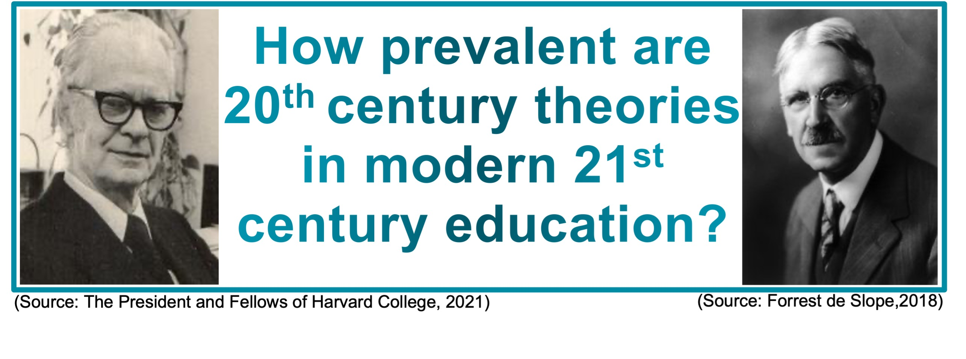You may be surprised to learn most of today’s teaching practices are based on theories from theorists a century ago. These theories play a vital role within education; they help write policies and procedures and they influence the curriculum.

The two theorist I will look at are:
- Burrhus Frederic Skinner with his behaviourism learning theory.
- John Dewey with his pragmatism learning theory.

Burrhus Frederic Skinner
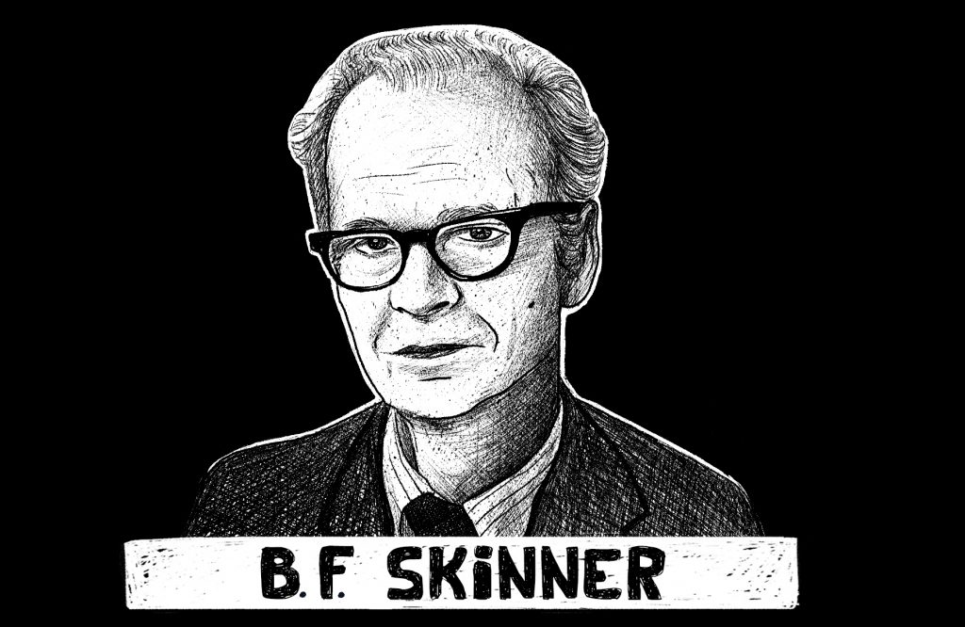
(Source: Theodore, 2020)

About B. F. Skinner:

B. F. Skinner is considered the most eminent psychologist of the twentieth century by the American Psychological Association (Theodore, 2020).

- Born in 1904 - in Pennsylvania
- Died in 1990
- He spent the 1930s and 1940s developing his operant conditioning theory
(Palmer 2001, p.57-58).

What is his theory?

Skinner’s theory is based on the idea that learning is a function of change in overt behaviour, which is a result of the individual’s response to events in the environment which then produces consequences (Culatta, 2021).
I don’t know about you, but I wouldn’t compare children to rats or pigeons? However, Skinner believed that both are organisms that differ only in their level of intelligence when faced with a learning environment (Pound, 2006, p.43). After subjecting animals and humans to a series of experiments skinner arrived at a concept, he termed radical behaviourism (Bates. 2019, p.34). Also known as operant conditioning, this theory describes how positive and negative reinforcers shape and maintain a child's behaviour (Gray and MacBain 2015, p.4) Chegg (2021) states “Operant conditioning is when an animal is conditioned or is programmed to perform a certain action with the help of a stimulus.”
For his experiments, Skinner used an operant conditioning chamber which was later known as The Skinner Box (McLeod, 2018)


(Source: McLeod, 2018)

The Skinner box was enclosed and contained a leaver, two lights and an opening. Initially Skinner wanted the rats to touch the lever in order to get a food pellet, this instilled in the rat the behaviour of touching the leaver would result in food. Once this behaviour had been developed Skinner introduced the lights. He taught the rat to touch the leaver when the light was on, skinner then brought in an electric shock so every time the rat touched the lever when the green light was off the rat would be shocked which was uncomfortable, this introduced the second light. This conditioned the rat to respond appropriately to the lights, when it was green the rat would receive food however if the light was red, they would be shocked if the leaver was touched (Chegg, 2021).

These experiments aided Skinner’s theory showing both positive and negative reinforcement and punishment.
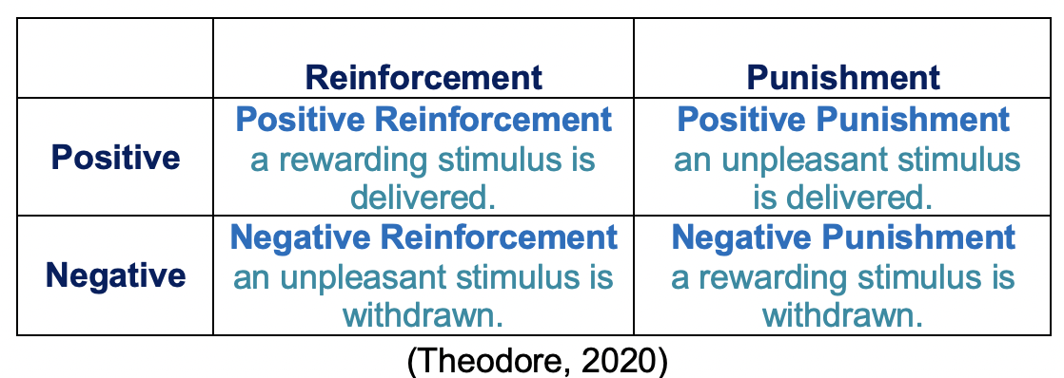

Skinner is widely considered as the "Father of Operant Conditioning," however his work was founded on Thorndike's (1898) law of effect. Skinner added a new concept to the Law of Effect which is reinforcement. The concept of reinforcement is that an action that is accompanied by pleasant results is more likely to be repeated, while behaviour that is followed by unpleasant consequences is less likely to be repeated (McLeod, 2018).
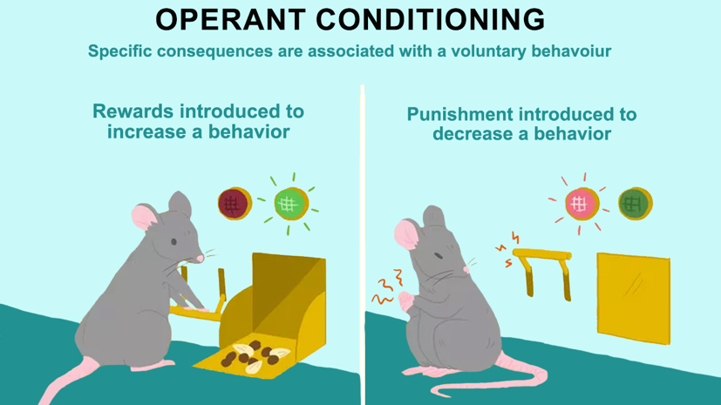
(Source: Chegg, 2021)

Skinner promoted reinforcement, positively used and encourage good behaviour whereas negative reinforcement is to discourage bad behaviour. Skinner contended that positive reinforcement not only had a longer lasting influence on behaviour than negative reinforcement, but that negative reinforcement may also be counterproductive (Bates, 2019, p.34-35)

John Dewey
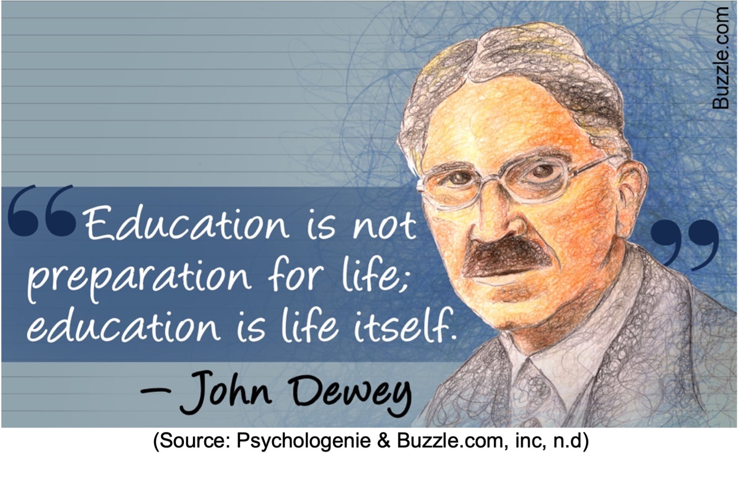

About John Dewey:
John Dewey was a philosopher and educator from the United States, he was a pioneer of pragmatism (Cherry, 2020)
- Born in 1859
- Died in 1952

Exploring your mind (2018) asserts “John Dewey is considered one of the most important educational psychologists in history.”

What is his theory?
Unlike what we know today, learning and teaching was quite formal at the time Dewey began formulating his theory and was ahead of his time when he created the notion of a child-centred approach (Gray and MacBain, 2015, p.37-38). It Is important to recognise how relevant Dewey’s theory is today in our education system.

Dewey introduced us to pragmatism which had a profound impact on educational thinking and practice which are still progressive now, his ideas have great significance for modern-day teachers (Bates, 2019, p.20-21). Aubrey and Riley (2021, p.317) state Dewey “…challenged the older traditional methods of teaching and learning in favour of a more child-centred approach to practice.

While currently working in a secondary school you often see developments or adaptations to the curriculum. Bates (2019, p.276) asserts “Dewey extended his ideas on experimental learning to incorporate curriculum design.” Dewey believes that broader curricular programmes are required in an interdisciplinary curriculum, he promoted learning by doing, also known as progressive education (Lorina, 2021). Currell (2020) supports this by stating Dewey “…believed in basing education on the principle of learning through doing.”

Dewey argued the aim of education was to promote growth and to do so there needed to be a flexible curriculum determined by learners not teachers (Bates, 2019, p.276). Jarvis (2004 p.208) asserts “For Dewey, the human being is born with unlimited potential for growth and development, and education is one of the agencies that facilities it.” Nall Noddings cited in Gray and MacBain (2015, p.36) would agree and asserts Dewey has “been hailed as the saviour of American education by those who welcome greater involvement of students in their own planning and activity.” While some were quick to criticise Dewey and believed he supported free, student-led education however this was not the case and Dewey believed children require clear structure and required direction to maximise their benefit from education (Gray and MacBain, 2015, p.38).

Dewey believed education should come from experience and that the teacher’s role is to provide this experience for the learner to gain knowledge and understanding to be able to develop and grow (Jarvis 2004, p.209). John Dewey believed linking education to a childs life away from school makes learning more meaningful (Currell. 2020).

Theoretical Approaches to learning
Behaviourism
Skinners theory operant conditioning come under the main learning theory which is behaviourism. Behaviourism was the dominant field in psychology at the turn of the 20th century (Nebel, 2021). Today behaviourism is more commonly used when it comes to behaviour management however Skinner once believed all learning could occur through a series of rewards or punishments (Padgett,2020).

A popular element of behaviourism is positive reinforcement in which a teach can utilise to help students learn, those who receive positive reinforcement will be more likely to retain information (Western Governors University, 2021). According to Palmer (2001) Skinner believed that “Teaching is the expediting of learning. Students learn without teaching but the teacher arranges conditions under which they learn more rapidly and effectively.”

Many criticise the use of rats in Skinners box experiment and some argue that humans have different anatomy and physiology to animals and others raise the question of extrapolation (McLeod, 2018). Walton and Goddard (2012) state “critics of behaviourism, however, point out that research in this area has been done only with animals and it therefore disregards any thought processes of which humans, but not animals, are capable.”

Gray and MacBain (2015, p.55) states that Skinner “disagreed with the tenets of classical conditioning...” Some people believe Skinner just validated Pavlov’s theory of classical conditioning however skinner disagreed and asserted the rats in his tests acted on their environment rather than to it, as in Pavlov's trials, and this became known as operant conditioning (Bates, 2019, p.34). Gray and MacBain (2015, p.56) suggests “Operant conditioning is more active, less rigid and more unpredictable than classical conditioning.”

McLeod (2018) asserts “Operant conditioning can be used to explain a wide variety of behaviors, from the process of learning, to addiction and language acquisition.” Skinner believed language could be taught similarly to behaviour, he gave the example of a baby receiving praise when they say ‘da-da’ (Pound, 2006, p.43) Bates (2019, p.210) supports this and suggests skinner believed “…that language acquisition was mostly a process of stimulus-response and developed through children watching and learning from their parents.” Pound (2006, p.43) states “Noam Chomsky, an American professor of linguistics, was so opposed to skinner’s views that he developed a theory, based on the idea of language development an innate process.”

Behaviourists believe if a person is being rude or silly it does not mean they intend to be like that nor are they destined to continue that way; behaviourism actually liberated people from the notion that free will alone determines human actions (Hallowell and Rate, 2021, p.91)

Though behaviourism was once the dominating tendency in psychology in the mid-twentieth century, cognitive psychology, which compares the mind to an information processing device such as a computer, has subsequently gained favour (Lim, 2019).

Pragmatism

Lorina (2021) states “Pragmatists believe that reality must be experienced” Drew (2019) states “In education, pragmatism is an approach to learning and teaching that focuses on keeping things practical.”

4 Principles:
- Unity – should be useful to the student and apply to their lives outside.
- Interest – the curriculum should include the students interests, Dewey believes these are conversation, investigation, construction and creative expression.
- Experience – students need to experience things to truly learn.
- Integration – linking of the curriculum content to bring subjects together.
(Drew, 2019)

Dewey felt teachers and children must learn together, to use their environment to adapt and learn, he believed in promoting an equal voice similar to that of democratic ideals (Lorina, 2021)

In our education systems we still have a long way to go when it comes to the learning theory pragmatism. Exploring your mind (2018) states “Even in current times, part of our educational system still isn’t up to date with Dewey’s contributions.”

How are these reflected in my school setting?
Skinner
If you were to observe lessons in a secondary school you would undoubtedly recognise these theories in practice, my school is not an exception. As a school we follow policies created with Skinner’s theory in mind. Our behaviour policy encourages staff to promote positive behaviour through praise and rewards while keeping negative behaviour to a minimum and reprimanding in private. This is known as the pivotal approach. The principle of this is RIP and PIP, reprimand in private and praise in public (Pivotal Education, 2021b). By using this approach, it creates a positive learning environment which encourages children to maintain by behaving appropriately. [School A] (2020) assert “Promoting a culture of praise and encouragement. In which all pupils can achieve.”

Gray and MacBain (2015, p.4) state “Skinner’s theory continues to exert a direct and profound influence on education and is particularly evident in the reward and punishment systems teachers use to shape and maintain pupil behaviour.” My school use a system called Class charts this records positive and negative points following the ready, respect, safe police my school enforces ([School A], 2020). This is where both positives and negatives are recorded, this can be accessed by all staff as-well as students and their parents to monitor their progression. At my school at the end of a term children without negative points on class charts are rewarded, in the past this has been selection boxes at Christmas or tea and cake with the Headteacher. This gives other students with perhaps negative points the opportunity to turn their behaviour around and start afresh to have that incentive to improve their behaviour.

As you can see Skinners theory on reinforcement is playing a vital role in my school, with staff leading and promoting positivity it allows students to be encouraged to display positive behaviour. They receive awards such as positive phone calls home this sometimes results in further rewards from parents in the home environment giving the child more incentive to behave appropriately.

John Dewey
With Dewey’s theory is becoming even more prevalent in schools in wales, making the child the centre of their education, this has impacted many changes especially in Wales with regards to the new curriculum and also the New ALN bill. With the new curriculum in Wales coming into force from September 2022, there many changes one in particular is how the curriculum will be delivered; with subjects being grouped into areas of leaning, this allows students to be taught a topic across a variety of subjects, creating a unique way of learning (Welsh Government, 2020).

In my school for a number of years we have had the provision of an alternative curriculum often aimed at students who may not achieve many GCSES however are capable of achieving alternative qualifications these are often based on children’s strengths and are taught in a variety of ways incorporating practical elements. In recent years the school have began working with a provision called Really Pro, they are a provider of vocational, employability and work experience programmes to engage learners who are 11+ in education (Really Pro Ltd, 2017). Our students can pick to attend this facility while choosing their GCSEs, their course involve practical and hands-on elements and students use the local area to complete products and course work.

In Wales students are required to complete a qualification alongside their GCSE and A levels called the Welsh baccalaureate, students are often set for this according to their ability, those who are placed into lower sets will complete an alternative qualification called Sweet. This involves the skills developed through PSE and Welsh Baccalaureate however is achieve through booklets which include practical elements. A similar course has been started this year within the Welsh department for those who would normally be disapplied from Welsh, such as children with ALN, this is called Wales, Europe and the World which is run by Agored Cymru. This qualification enables learners to take part in cultural activities, understand their lives both locally and globally and help improve the lives of others (Agored Cymru, 2021). With many of these courses students can use their interests and experience and tailor projects around them to ensure they enjoy and achieve their very best. Dewey emphasised the importance of schools as collaborative spaces in which the curriculum should be structured to fit the requirements of students in preparing them for the real world (Aubrey and Riley, 2021, p.317). I believe my school is achieving this to certain extent however could put further provision in place to make learning through doing a whole school approach rather than as an alternative provision. With the new curriculum coming in the near future this is a possibility for them to make many more changes which will benefit children and their attitude towards education.

Pivotal Education (2021a) state “Learners are at the heart of everything we do.” This is a very essential statement in education, and I believe Dewey would agree, which is why it is critical to place the child at the centre of their learning. Janse (2019) asserts Dewey “…rejected most of the theories that were popular at the time, such as behaviourism…” This is very apt because seeing as Skinners theory involves reinforcing positive behaviour, Dewey’s theory goes hand in hand in creating a positive, productive and pleasant environment for students to grow in, thus decreasing negativity and encouraging positive behaviour.

Let’s reinforce positivity and encourage learner’s individuality, allowing them to grow through their experiences and be at the centre of their educational decisions.

References

Agored Cymru. (2021) Wales, Europe and the Word. Available at: https://www.agored.cymru/Units-and-Qualifications/Learning-Core/Wales-Europe-and-the-World (Accessed: 6th November 2021)
Aubrey, K and Riley, A (2021) Understanding & Using Challenging Educational Theories. London: Sage

Bates, B. (2019) Learning theories simplified. London: Sage

Chegg Inc. (2021) Skinner's ideas on behavioral perspectives on personality. Available at: https://www.chegg.com/learn/psychology/introduction-to-psychology/skinners-ideas-on-behavioral-perspectives-on-personality (Accessed: 28th October 2021)

Cherry, K. (2020) Biography of John Dewey. Available at: https://www.verywellmind.com/john-dewey-biography-1859-1952-2795515 (Accessed: 24th October 2021)

Culatta, R. (2021) Operant Conditioning (B.F. Skinner). Available at: https://www.instructionaldesign.org/theories/operant-conditioning/ (Accessed: 24th October 2021)

Currell, J. (2020) The legacy of John Dewey. Available at: https://mathsnoproblem.com/blog/teaching-practice/legacy-of-john-dewey/ (Accessed: 28th October 2021)

Drew, C (2019) The 4 Principles of Pragmatism in Education. Available at: https://helpfulprofessor.com/pragmatism-in-education/ (Accessed: 6th November)

Exploring your mind (2018) Education Through the Amazing Eyes of John Dewey Available at: https://exploringyourmind.com/education-through-the-amazing-eyes-of-john-dewey/ (Accessed: 28th October 2021)

Forrest de Slope, J. (2018) John Dewey. Available at: https://www.bookofdaystales.com/john-dewey/ (Accessed: 24th October 2021)

Gray, C and MacBain, S. (2015) Learning Theories in Childhood. London: Sage

Hallowell, E. and Ratey, J. (2021) ADHD 2.0. New York: Ballantine Books

Janse, B. (2019) John Dewey theory. Available at: https://www.toolshero.com/change-management/john-dewey-theory/ (Accessed: 6th November 2021)
Jarvis, P. (2004) Adult Education & Lifelong Learning. London: Routledge Falmer

Lim, A (2019) What is Behaviourism in psychology? Available at: https://www.thoughtco.com/behaviorism-in-psychology-4171770 (Accessed: 6th November 2021)

Lorina (2021) John Dewey – Education Theory. Available at: https://aussiechildcarenetwork.com.au/articles/child-development/john-dewey-education-theory (Accessed: 4th November 2021)

McLeod, S. (2018) What Is Operant Conditioning and How Does It Work? Available at: https://www.simplypsychology.org/operant-conditioning.html (Accessed: 28th October 2021)

Nebel, C. (2021) Behaviourism in the classroom. Available at: https://www.learningscientists.org/blog/2017/8/10-1 (Accessed: 4th November 2021)

Padgett, D. (2020) Learning Theories: Understanding the 4 Major Ones for the Classroom, 2nd September 2020 [Blog]. Available at: https://www.leaderinme.org/blog/learning-theories/ (Accessed: 4th November 2021)
Palmer, J. (2001) Fifty Modern Thinkers on Education. London: Routledge
Pivotal Education (2021a) The CPI approach to Behaviour Management. Available at: https://pivotaleducation.com/behaviour-management/ (Accessed: 2nd November 2021)

Pivotal Education (2021b) The CPI approach to Behaviour Management. Available at: https://pivotaleducation.com/planning-for-behaviour/ (Accessed: 2nd November 2021)

Pound, L. (2006) How Children Learn. London: MA Education Ltd

Psychologenie & Buzzle.com, inc. (n.d) A Brilliant Insight into John Dewey’s Theories. Available at: https://psychologenie.com/john-dewey-theories (Accessed: 30th October 2021)

Really Pro Ltd. (2017) What we do. Available at: https://reallypro.co.uk/pro-education-what-we-do/#1484147715300-6d74d6f4-244b (Accessed: 6th November 2021)

[School A] (2020) [School A] Behaviour Policy. Pembrokeshire: [School A]. Unpublished

Sweet Education Ltd. (n.d) BTEC level 1 and level 2. Available at: https://www.sweet.education/level-1-2 (Accessed: 6th November 2021)

The President and Fellows of Harvard College. (2021) B. F. Skinner. Available at: https://psychology.fas.harvard.edu/people/b-f-skinner (Accessed: 30th October 2021)

Theodore. (2020) B.F. Skinner (Psychologist Biography). Available at: https://practicalpie.com/bf-skinner/ (Accessed: 24th October 2021)

Walton, A and Goddard, G (2012) Supporting Every Child. London: Sage

Welsh Government. (2020) Education is changing. Available at: https://gov.wales/education-changing (Accessed: 6th November 2021)

Western Governors University. (2021) Five Educational Learning Theories. Available at: https://www.wgu.edu/blog/five-educational-learning-theories2005.html#close (Accessed: 6th November 2021)

