Appendices

Appendix 1-Blank Consent Form

CONSENT FORM

PROJECT TITLE: Can background music improve pupils’ concentration?

Name of Researcher:

Please initial box

1.I confirm that I have read and understand the information sheet dated ADD DATE for the above study.

2. I understand that my child’s participation is voluntary and that I am free to withdraw my child from the study at any time, without giving any reason.

3. I understand that my child can choose to withdraw at any time, without giving a reason.

4. I understand that the information given by my child will be used in a university assignment.

5. I understand that my child’s name will not appear at any time.

6. I agree for my child to take part in the above study.

_____________________ _____________________________ __________
Child’s name Parent signature Date

When completed, please return to SCHOOL by the ……….. of …………….. (date)

Thank you.

Appendix 2- Information Sheet

INFORMATION sheet

PROJECT TITLE: Can background music improve pupils’ concentration?
Add date.

Dear Parent / Guardian,

My name is Olivia Leonard and I am studying for a PGCE qualification at Yr Athrofa, University of Wales Trinity Saint David. I am currently a student teacher within Knelston Primary School and am teaching in your child’s class.

I would like to invite your child to participate in my research project. The title of the project is ‘Can background music improve pupils’ concentration’ and I aim to research pupils learning over the course of a lesson. Through your child’s participation, I hope to ascertain data that will allow me to complete my research and improve my teaching practice.

The research will consist of a 30-minute lesson whereby the pupils will be observed by a fellow UWTSD university student, ………. We will be collecting data based on the pupils’ levels of concentration throughout the lesson. Three pupils will then be chosen for a brief interview with both myself and ……. to discuss their opinions on the lesson. We will be recording audio during the interview and transcribing the students’ responses for our research.

All names will be kept strictly confidential and will only be known by myself and my research partner, …….. Your child’s participation in this study is completely voluntary so you or your child can withdraw from the study at any stage. Your child will also be asked to give their assent before the beginning of the study.

After careful and precise analysis of the data obtained from the lesson observation and group interview, I would be happy to provide you with a copy of the findings at your request. The results of the research will be discussed in a university assignment that will contribute to my PGCE course. The results of this study will be stored on a password protected computer and all raw data will be destroyed once the assessment has been marked.

I thank you in advance for your time. If any questions do arise, feel free to contact me at your convenience.

Yours sincerely,

Olivia Leonard

Appendix 3-LS1: Lesson plan

Lesson Plan – Action Research

Student-teacher |  | Class: | Year 2/3
AoLE or Subject | Health and Wellbeing | Date: | 03.02.20
Lesson Focus: | Free writing
Meaningful links to Curriculum | LLC- write for different purposes
Meaningful links to:  Cross Curricular Responsibilities | Personal and Social Development, Well-being and Cultural Diversity: be aware of their feelings and express them in an appropriate way.

Learning Objectives (focus on Learning- use accessible vocabulary):
The pupils will learn to:

To write thoughts and feelings.

Assessment of Pupils’ Learning
Evidence
(What have the learners to say/write/do/produce – to demonstrate learning)
Concentration will be assessed through observation and a tally.

Time | Activities/Methodology/Key Concepts  (Teacher’s Role – including key teaching points, differentiation strategies and key questions) | Pupil Tasks  (Pupils’ role –including differentiation, engagement in formative assessment and homework) | Resources  (Including Health and Safety requirement)
Opening phase (with links to prior learning) | Discuss what free writing is, that students will be trying to write down anything that comes to their mind, doesn’t matter if it is a fleeting thought, an idea, a feeling, or even the fact that they can’t think of anything to write. Their aim is to try and write continuously for the period of time. | Differentiation through participation.  Assessment through observation.
Teaching & Core Learning | Give students their paper and allow them to start writing.  Half way through start playing the music – Baroque study music  https://www.youtube.com/watch?v=BjnnUCmNREI | Differentiation through participation.  Assessment through observation. | Paper  music
Plenary | Students hand in their writing.  The 3 students who have been observed come out for a brief interview. | Differentiation through participation.  Assessment through observation.

Highlight = Ambitious, capable learners
Highlight = Healthy, confident individuals
Highlight = Ethical, informed citizens
Highlight = Enterprising, creative contributors

Appendix 4-LS2: Lesson plan

Lesson Plan Phase 1

Lesson Plan – Step 1 Cynllun Gwers – Cam 1

Student-teacher | Olivia Leonard | Class: | Year 4/5
AoLE or Subject | Health and Wellbeing | Date: | 03.01.20
Lesson Focus: | Free writing
Meaningful links to Curriculum | LLC- write for different purposes
Meaningful links to:  Cross Curricular Responsibilities | Personal and Social Development, Well-being and Cultural Diversity: be aware of their feelings and express them in an appropriate way.

Learning Objectives (focus on Learning- use accessible vocabulary):
The pupils will learn to:

To write my thoughts and feelings.

Success Criteria (clearly linked to each Learning Objective and related to the process and/or product of learning) | Assessment of Pupils’ Learning  Evidence  (What have the learners to say/write/do/produce – to demonstrate learning)
I can write my thoughts and feelings. | Be able to write down my thoughts and feelings.  Concentration will be assessed through observation and a tally.

Time | Activities/Methodology/Key Concepts  (Teacher’s Role – including key teaching points, differentiation strategies and key questions) | Pupil Tasks  (Pupils’ role –including differentiation, engagement in formative assessment and homework) | Resources  (Including Health and Safety requirement)
Opening phase (with links to prior learning) | Discuss what free writing is, that students will be trying to write down anything that comes to their mind, doesn’t matter if it is a fleeting thought, an idea, a feeling, or even the fact that they can’t think of anything to write. Their aim is to try and write continuously for the period of time. | Differentiation through participation.  Assessment through observation.
Teaching & Core Learning | Give students their paper and allow them to start writing.  Halfway through, start playing the music.- relaxing waves.  https://www.youtube.com/watch?v=BklGhQYKl30 | Differentiation through participation.  Assessment through observation. | Paper  music
Plenary | Students hand in their writing.  The 3 students who have been observed come out for a brief interview. | Differentiation through participation.  Assessment through observation.

Links to the Four Purposes are highlighted in the following colours
Ambitious, capable learners
Enterprising, creative contributors
Ethical, informed citizens
Healthy, Confident individuals

Appendix 5- Observation schedule LS1
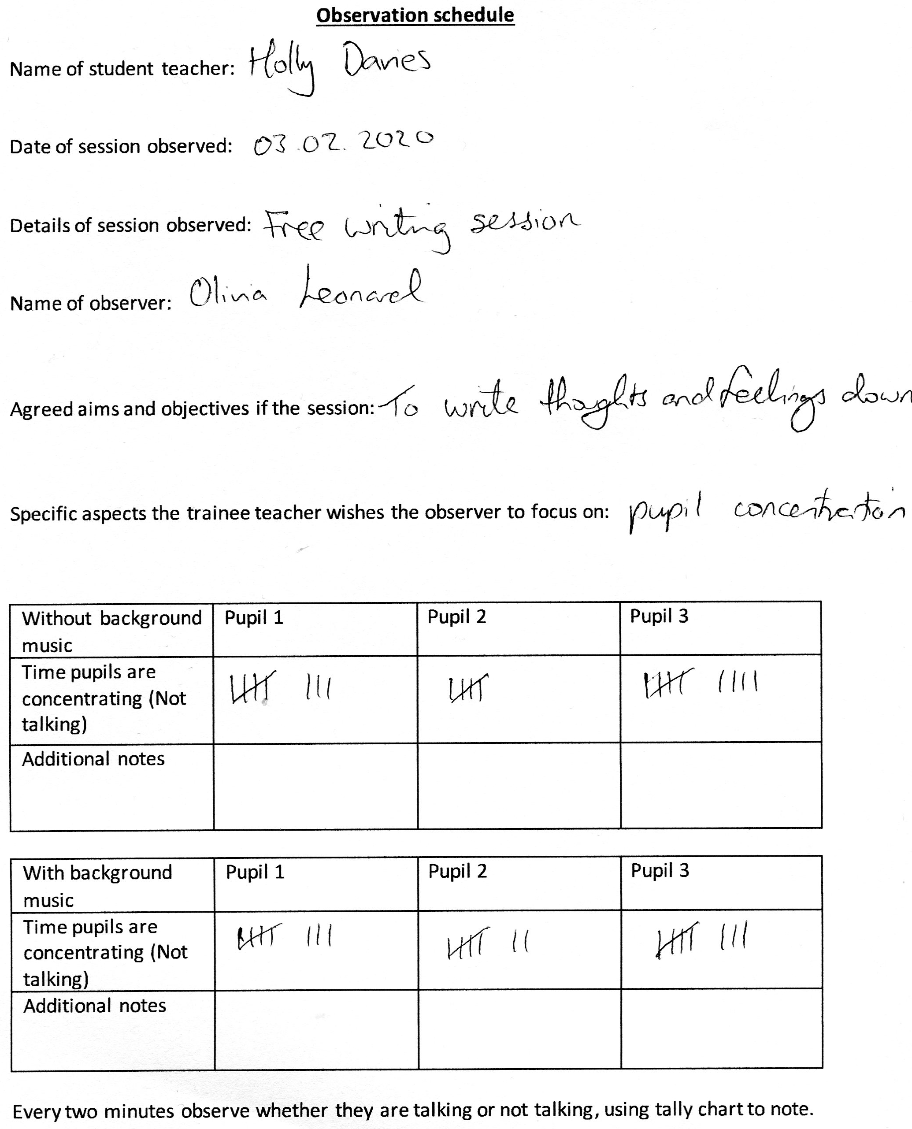

Appendix 6- Observation schedule LS2
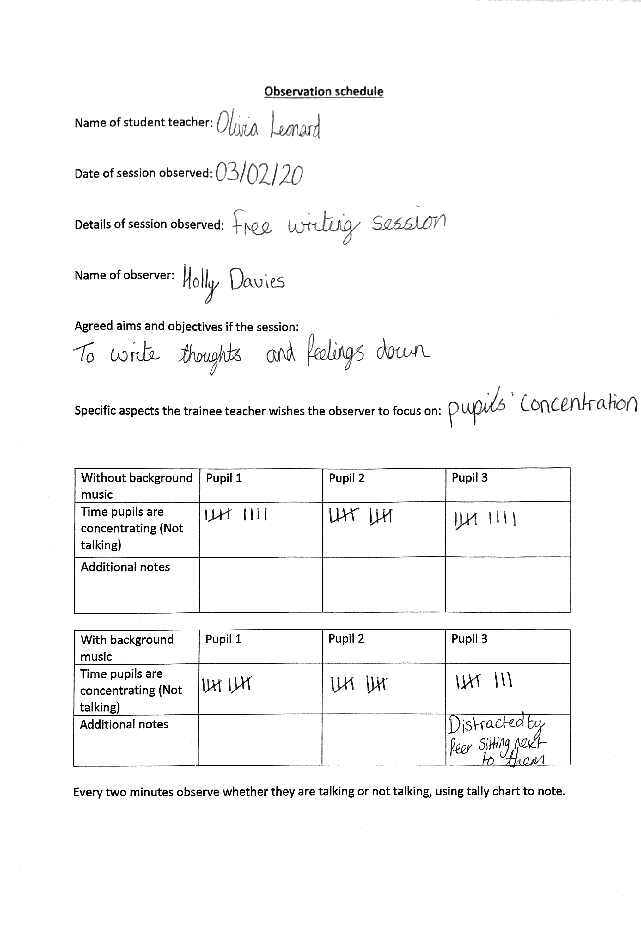

Appendix 7-Quantitative data- LS1: Results
Year 2/3 observation results
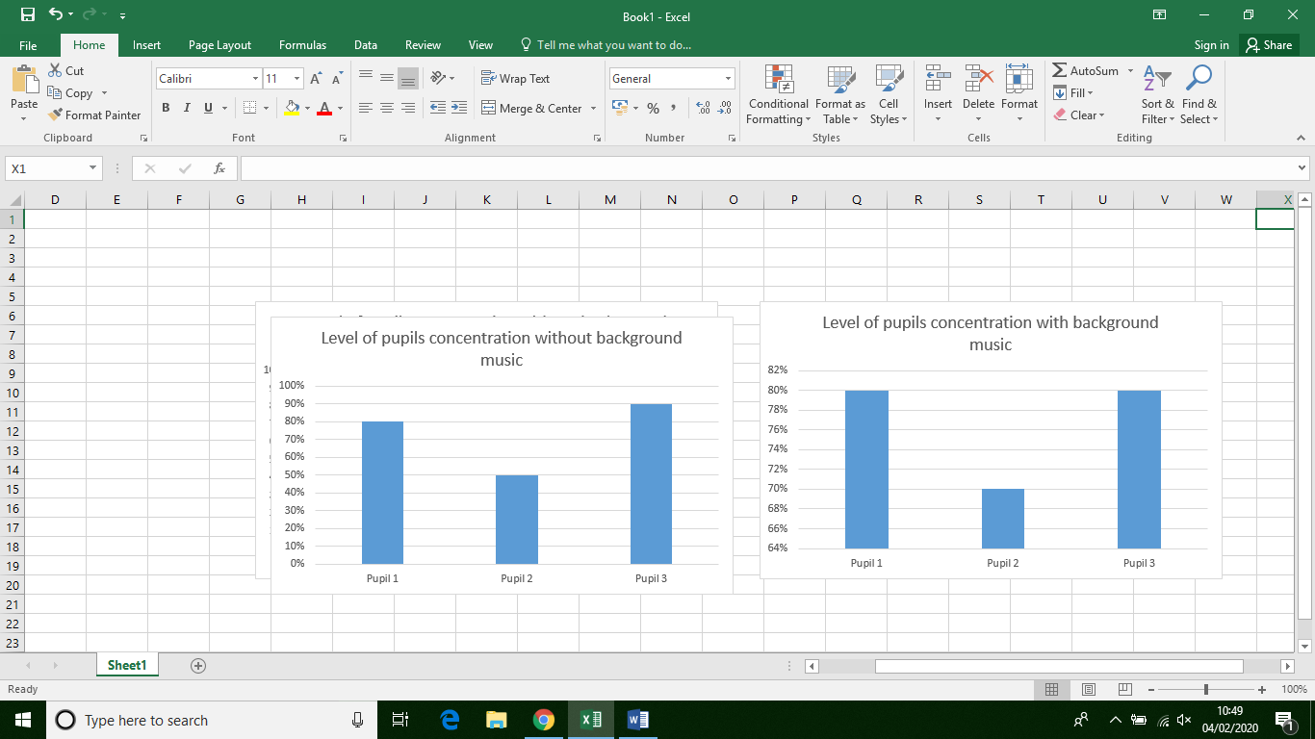

Appendix 8-Quantitative data- LS2: Results

Year 4/5 observation data
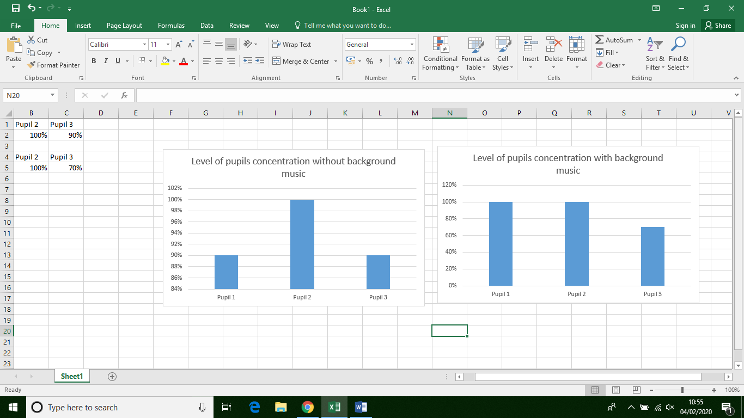

Appendix 9-Interivew questions

Interview questions

“Can background music improve pupils’ concentration during the during the lesson task?”

Pupil number:
Date:
Student Teacher:

How did having background music make you feel? Happy, sad, relaxed- have a list of emotions printed with faces next to them?
Did you prefer writing with background music or without background music? Why?
When we put background music on, did it make a difference to your work? Why?
How did the music change how you worked? (prompt – work they completed during the session is in front of them for reference)

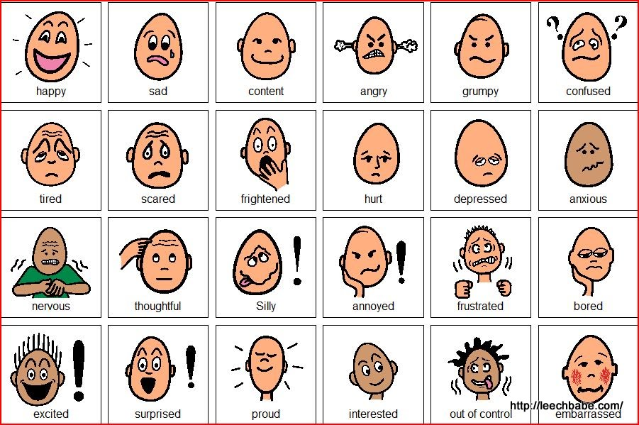

Appendix 10-Qualitative data: LS1 focus groups transcriptions
Year 2/ 3 transcription.
Interviewer 2: How did the background music make you feel? I’ve got some pictures here for you of emotions if you want to have a little look at those. Child 1 how did it make you feel?
Child 1: relaxed.
Interviewer 1: And you child 2, how did the background music make you feel?
Child 2: confused.
Interviewer 1: And Child 3? How did it make you feel?
Child 3: relaxed.
Interviewer 1: Wonderful, thanks. Right, so, Child 3, did you prefer writing with background music or without it?
Child 3: With the music.
Interviewer 2: So why did you like having the background music on?
Child 3: It was relaxing and helped me concentrate.
Interviewer 2: Lovely, and when we put background music on, did it make a difference to your work?
Child 3: Not really
Interviewer 2: Why was that?
Child 3: I don’t know
Interviewer 2: That’s okay, don’t worry.
Interviewer 1: What about you Child 1? Did it make a difference to your work do you think?
Child 1: No
Interviewer 1: No? Do you have a specific reason why?
Child 1: Because it makes me like, it makes me concentrate more.
Interviewer 1: Fantastic.
Interviewer 2: And Child 2, did the background music make a difference to your work?
Child 2: No.
Interviewer 2: No? And why do you think that is?
Child 2: I don’t know.
Interviewer 2: You don’t know? That’s alright.
Interviewer 1: Fab. So… do you think, did it change the way how you work? So not making a difference to your work, but how you work?
Child 1: No
Child 3: It kind of um…you could like.
Interviewer 2: It’s okay, you don’t have to say anything if you don’t want.
Interviewer 1: That’s alright. Did you have any other questions?
Interviewer 2: Did you enjoy the session?
All: Yes.
Interviewer 2: Did you like getting to write down everything you thought of?
Child 1+2: yes.
Interviewer 2: Would you like to do something like that again?
All: Yes.
Interviewer 2: Brilliant.
Child 3: You could just write anything, and everything.
Interviewer 2: Exactly. Right, well done.
Interviewer 1: You’ve done super.
Interviewer 2: Break time already, so if you all want to go over to your class now ready to go out, that would be great.
Interviewer 1: Thanks, you’ve been wonderful.

Appendix 11-Qualitative data: LS2 focus groups transcriptions
Year 4/5 Interview transcriptions
Interviewer 1: How did having background music make you feel? Happy, sad, relaxed-Have a look at this list of emotions.
Pupil 2: I felt relaxed because I was, it made me feel happy and cheerful.
Pupil 3: It clams me down when I hear the music, yeah say I was angry because my sister stepped on my toys, I just listen to that music and I feel better.
Interviewer 2: oh lovely.
Interviewer 1: what about you pupil 1?
Pupil 1: If I was worried or something I would listen to it and it would calm me down.
Interviewer 1: so the music would help to calm you down, brilliant.
Interviewer 1: So, pupil 2, did you prefer writing with background music or without background music?
Pupil 2: uuh, probably with it on because it made me feel relaxed and that I could write anything.
Interviewer 1: fantastic.
Interviewer 2: pupil 3 what about you?
Pupil 3: I preferred it with the background music because it just like helps me write, say if it was a hard word, I would just write it how I think it is and if there was not the background music I would have just stopped their thinking the whole time.
Interviewer 2: nice okay.
Interviewer 1: and what do you think pupil 1?
Pupil 1: umm, It’s like, I preferred it with background music because I find something quiet worrying it made me feel more like calm.
Pupil 2: I it kind of makes me feel like I can flow for a bit longer.
Interviewer 1: Lovely.
Pupil 2: and the when im thinking about it, I am with the music it makes me think about different things that I was before.
Interviewer 2: so it helped you actually to think about different things based on the music.
Pupil 2: yeah.
Interviewer 2: oh that’s cool.
Pupil 2: because that kind of gave me the idea, what to write.
Interview 1: ohh.
Interviewer 1: we put background music on, did it make a difference to you work? Why?
Pupil 2: it kind of made me, umm, it made me think that I can do it and that I can. And if I do it once I know I can do it. It helped me to think positive.
Interviewer 1: fantastic
Interview 2: pupil 3?
Pupil 3: first I was just writing and writing because I thought I need to get this done, but when I heard the music I got relaxed and I got more ideas.
Interview 1: very interesting.
Pupil 1: it also makes me write positive and happy stuff rather than writing sad and scared things.
Interviewer 1: How did the music change how you worked? Like not what you were writing but how you worked?
Pupil 2: uhhh it kind of made me feel like, it, that I could write in longer sentences and that I did not have to be as rushed.
Interviewer 2: oh so that good to know, so you kind of relaxed into it a bit when the music went on and you slowed down a bit.
Pupil 2: yeah because it, because I was struggling to write thing but then suddenly I thought of something and I wrote it down quite quick. The the music came on and then it kind of slowed me down and I was slowly doing it.
Interviewer 2: so do you think you would like background music on in more lessons?
All pupils: yes.
Interviewer 2: are there certain types of lessons that you don’t think you would want it on? Like do you think for maths, do you think it would be as helpful?
All pupils: no
Pupil 3: maybe
Pupil 1: maybe in English because it is like writing like a story.
Pupil 3: I think maybe not welsh.
Pupil 2: because if I was in maths I would be thinking and then, it would just make me feel quiet umm, like I wouldn’t be able to hear myself think.
Interviewer 2: ohh so it would be distracting?
Pupil 2: it would be distracting, as with, because then I would try and just work it out quite quickly in maths and then I can work it out instead I would find it harder if there was something in the background, distracting me. Like when there’s music on in a different class, it makes me feel a bit like uhhh.
Pupil 3: I think when it is the right music then it helps in maths like if its really punky music that wouldn’t work very well.
Interviewer 2: so do you think punky music would work in English, fast paced and that as well?
Pupil 3: umm no.
Pupil 2: I don’t think really fast music is good like if you.
Pupil 3: makes you rush
Pupil 2: if like you mediate, if you look up that you can sometime find just music, like water.
Pupil 1: if it was a fast song it would make you think like I have to rush this and finish this before this song ends and it’s going to end quite soon.
Interviewer 2: right so it would impact the way that you write, in that the fast song you would right quickly. That’s amazing!
Interviewer 1: fantastic
Interviewer 2: brilliant, thank you so much
Interviewer 1: amazing answers.

Appendix 12- Lesson reflection sheet from LS1
Our reflective model- based on Gibbs (1998)
Describe what happened
Pupils were given 20 minutes to write down anything that comes to mind. It was a free-writing session, so students had complete control over what they wrote. After the first 10 minutes baroque music was played. Throughout the 20 minute session the three participants were observed and a tally was taken to measure concentration. When the music first came on, pupils began to pretend to play the instruments they could hear, for example, pupil 3 pretended to play violin.

Describe your feelings and emotional responses
I felt interested because I often wondered whether background music will make a difference to pupil concentration. I was also slightly apprehensive because at the beginning of the session because the computer was glitching, and we were relying on the internet in order to get the background music.

Consider what was good, and bad, about your response.
Pupils enjoyed and were engaged in the task. However, due to the pupils being randomly selected, the students who participated in the interview were very shy during responses. Moving forward with the next interview, we will need to ensure that it is more informal.

How do you make sense of the situation (use sources, theories / academic research to help you make sense of your reflection)?
Christenson and James (2007) – age should have no impact on how you conduct your research study.
So even though they found it difficult to discuss their views, perhaps small talk prior to the interview is the way to easy them in, rather than excluding the interview from the process.

Christensen, P., & James, A. (2017). Research with children: Perspectives and practices (Third ed.).

What general conclusion can you draw from the event? What specific conclusions can you draw from your experience?
The results do show movement in concentration, but the movement is contrasting between students. Also, the interview suggested that students enjoyed the music for the most part.

Based on your reflection what would you do differently in the future? Do you have an action plan?
In the future the main task will have music that is more tranquil with a slower pace in order to ensure that the atmosphere is relaxed and appropriate for working.
We will also try to make the interview as informal as possible.

Appendix 13- Lesson reflection sheet from LS2.
Our reflective model- based on Gibbs (1998)
Describe what happened
Pupils were given 20 minutes to write down anything that comes to mind. It was a free-writing session, so students had complete control over what they wrote. After the first 10 minutes baroque music was played. Throughout the 20 minute session the three participants were observed and a tally was taken to measure concentration.

Describe your feelings and emotional responses
I felt interested because I wanted to find out the impact that background music would have.

Consider what was good, and bad, about your response.
Good – within the interview, pupils spoke about how much they enjoyed the task and having background music on.

How do you make sense of the situation (use sources, theories / academic research to help you make sense of your reflection)?
Perham and Withey (2012) found that music that participants like and enjoy impacts on their work and how they perform. Perhaps this played a part in why the students enjoyed the lesson.

Perham, N., & Withey, T. (2012). Liked music increases spatial rotation performance regardless of tempo. Current Psychology, 31, 168–181. doi:10.1007/s12144-012- 9141-6

What general conclusion can you draw from the event? What specific conclusions can you draw from your experience?
Results show that background music from the interview helped pupil’s concentration and gave ideas for their writing.
Data suggests background music can be distracting.

Based on your reflection what would you do differently in the future? Do you have an action plan?
Increase the use of background music during independent literacy tasks to improve concentration.

Appendix 14- Operational Definitions

Background music: music intended as an unobtrusive accompaniment to an activity.

Pupils’ concentration: through observation of 20 second intervals, the time pupils are not talking.

