Reflective Report

Name: Mihail Pecica
Student ID: 2124360
Module Code: BMSW4001_LON
Module Name: Academic and Employability Skills
Lecturer: Dr Lizeta Demetriou

Introduction

This report summarises my reflections on my Moodle Academic and Employability Skills. What it is Reflection? Reflection is an essential component of learning through experience. Whenever we learn something new, we gain the most benefit from reflecting on our experiences. It is particularly important when evaluating positives. In general, they are more difficult to recall than the negative aspects of any experience. (Fallin, 2020). We have many option to choose how to reflect, but I have chosen Gibbs 1988 as in my opinion is more successful.
The reflective model according to Gibbs is based on several stages, during which you are required to answer several questions in order to go as deep as possible with your reflections. Gibbs suggests the following stages: description, feelings, evaluation, analysis, conclusions, and action plan. (Gibbs, 1988)
The idea of this model is to systematise reflections and isolate feelings. The different stages usually help to slow down our thought processes so that we don’t jump to conclusions too quickly. (Brown, n.d.)

Reflection by Gibbs Reflective Model Cycle
On the lesson five, our lecturer introduced us to Reflection; what it is, why it is important to know about it, and how to do it. In addition, she also presented three types of Reflection: Gibbs reflective cycle (1988), Kolb reflective cycle (1984) and Driscoll’s Model (1994, 2000). Having read about them, I have chosen to write the Reflection by Gibbs Reflective Model Cycle. Given its cyclical nature, it lends itself particularly well to repeated experiences, allowing the user to draw lessons and plan based on both successful and unsuccessful experiences.
which I find to be more successful and easier to write bas there are six distinct stages that could aid you:
- Description – what happened? Do not waffle on about details that aren’t required
- Feelings – How did you feel at the time?
- Evaluation - How did things go? Positive and Negative
- Analysis - Why did things go well? Badly?
- Conclusion - What have you learnt?
- Action Plan - How /where can I use my new knowledge and experience?

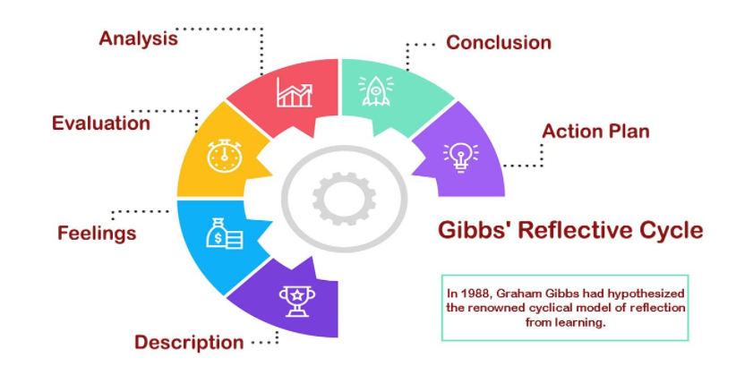
(Gibbs, 1988)

Time Management

Description: In the first day lecture the lecturer introduced Time Management and the importance of it for us to learn. Many of us have difficulty managing our time effectively and waste a lot of time doing unnecessary things. Another thing that stands out for me is SMART Goals - stand for specific, measurable, achievable, relevant, and time-bound (Carrier, 2020). The thing that I do not like is that I realised I am a poor time manager.
Feelings: On that day I realised how badly I manage time and how SMART Goals could help me improve it. I felt guilty for wasting so much time on nothing worthwhile, but I could have changed it by starting to study earlier and achieving my goals.
Evaluation: In the aftermath of the lesson, I thought a great deal about what to do and how I could make sure that I had enough time to study because I would need to write an essay of two thousand words and give another class presentation. As for social media accounts, I do not want to get rid of them, so I reduced them to one hour a day using a device.

Analysis: It was well explained by the lecturer that in order to get the job you want, you must act now, not wait until tomorrow because it may be too late. You should plan your time, do things to improve your skills and put aside the mobile phone. My favorite part of the course was that I understood the importance of time management and was motivated to put it into practice.

Conclusion: If you want to achieve your goals, you have to know how to manage the time you have, no matter if you are a student, a manager, or a simple worker. Otherwise, you will miss the deadlines and achieve nothing.

Action Plan: After my first lesson with SMART Goals I have been managing my time better as I want to complete my degree and be a successful person. Although I enjoy social media, I have already reduced the amount of time I spend on it by half, and I intend to reduce it further. In addition to this, I began studying daily instead of just once a week, which would help me with the assessments.

Paraphrasing
Description: Paraphrasing refers to expressing someone else's thoughts in your own words. When paraphrasing a source, the original meaning is maintained while the wording is changed. (Gahan, 2019) The lesson from this Moodle which I enjoyed the most was this one. I learned how to do paraphrasing quickly, and I realised the importance of it and what could happen if you will not paraphrase something which is not yours.

Feelings: About paraphrasing I didn’t know anything before the lesson, and at the beginning I felt very stressed as there were few ways to do paraphrasing and we need to know and practice all of them. However, once we began practicing, I quickly understood how to paraphrase and felt more confident than in the beginning.

Evaluation: After couple of minutes when I practice a bit, the things started to go to the right direction. Throughout the lesson, I have been very focused on this topic, as my lecturer had explained its importance to me from the beginning. However, the lecturer did her best to explain everything and to ask each of us to do an exercise, and to ensure that we understood how to paraphrase.
Analysis: The things was going well because our lecturer put her passion always to give the information clearly and untestable. She kept us awake always with exercises and practice that at the end all of us could paraphrase something. Also, I was aware that I will need to use this skill frequently in my assessments, and if I use a source but fail to paraphrase it, I may be accused of plagiarism.
Conclusion: The importance of paraphrasing was unknown to me at the beginning, but at the end I was able to paraphrase with synonyms or changing the wording without change the meaning. In order to improve my paraphrasing abilities, I should read more and increase my vocabulary, since in order to paraphrase, I need to be familiar with synonyms. Nevertheless, I have learned from these experiences that it is important to be able to have this skill and to be able to perform it correctly

Action Plan: My recommendation is that if I have the opportunity to repeat this lesson, I would do a search on the internet to find out what paraphrasing is and how I could do it, and at the lesson I would ask the lecturer what I don't understand. After the lesson, I studied more about paraphrasing and practiced some exercises to improve my skill.

Reflection
Description: Reflection has been introduced to us from the first day. At first, I was wondering what this was and why I should know about it. I was also unsure how to reflect on what you were doing, and how you should go about it.

Feelings: Initially I felt lost in all the information that was given by the lecturer and I did not understand the skill at all. As a student who has graduated from school many years ago, it is sometimes difficult to adjust and concentrate on the lessons, but nobody can fail to understand a lesson when the lecturer has the enthusiasm and motivation that Lizeta has.

Evaluation: As I mentioned above, things started moving very slowly at the beginning. There were not many people who knew about reflection. Also, it has been introduced that at the end of this Moodle we will each have to write a reflective report of two thousand words. Fortunately, at the end of the lesson, we had already been taught something about reflection, and our lecturer requested we write a reflective report in class in order to clarify the subject.

Analysis: There were several reasons why it did not work properly on the beginning, including the lack of knowledge of reflection on my part and misunderstanding the importance of it. It was very valuable for me to have the opportunity to reflect at the end of the class.

Conclusion: The lecturer introduced and explained how to use a few different types of reflection such as Gibb’s, Kolb’s and Driscoll’s. I am using Gibb's Reflective Circle as part of this report and consider it to be one of the most useful practices available today.

Action Plan: I can identify ways to improve my academic skills, improve my study habits, and increase my understanding of the topics we are studying. Additionally, I plan to become a chartered accountant in the near future, and these skills will be crucial to my success in this field.

Public speaking and giving presentation
Description: I am not one who enjoys standing in front of a crowd, but I read sources and watched videos to improve my speaking skills and I think I did a good job. According to Andrea Steward and Victoria Pearson to have a good impact you need to prepare yourself, create a plan, practice your presentation and use the body language to keep awake the public, which I tried to do it. (Stewart and Pearson, 2016)
Feelings: In the beginning, I felt very stressed since it was my first public speaking event, and I was unable to control my emotions, which affected my performance. Even though I received positive feedback on my draft presentation, I was still uncertain if it was good enough.
Evaluation: To be honest at some points I was bored when someone online didn’t know even how to read his own presentation or how to share the screen. Most of us used the body language and eye contact
Analysis: In my opinion we did a good job as a first presentation by putting a lot of effort into creating a successful presentation. I prepared for this presentation a lot, did my speech and repeat in front of the mirror but when I was speaking in front of the class completely forgot about everything as I was stressed and remake a new speech. At the end my colleagues asked questions

Conclusion: At this lecture, I was filled with so many emotions like never before. Firstly, I learned how to deliver a presentation and how to keep the public awake. Additionally, I have learned that you cannot control your emotions unless your speech is clear and you are confident about what you are saying.

Action Plan: My action after the lesson was that I re-watched all the presentation again and find out what could I improve in the future and what do I need to change. In the future, I could enhance this knowledge and use it in my career to become a leader, or even in my next assessment as a group presentation to do it much better. I have to work with my emotions to manage them better and learn more about body language.

