ACCA4023 : Introduction to Web and Database Concepts

Name : Diana Dias
ID : 2442070
Index
Introduction 3
Database Design Summary 3
Entity–Relationship Overview 3
Normalization 4
Implementation Summary 5
Create Tables 5
Sample data that was inserted : 7
Query Development 9
Validation and Testing 12
Validation and test screenshots: 13
Validation Summary 14
Overall Evaluation 14
Conclusion 14
References 15

Introduction
The main purpose of the project is to create a working database that can manage the daily operations of the EcoRide company. These operations include registering riders, assigning bikes, tracking rentals and also to record maintenance work. EcoRide’s current paper-based or spreadsheet methods are assumed to be inefficient for a growing service such as this. A structured database helps to avoid repeated/same data entries, speeds up record-keeping. It also ensures that information like rental costs, maintenance schedules and rider details stay accurate. The entire system was built using MySQL.

Database Design Summary
The EcoRide database has six main entities. They are Rider, Staff, Location, Bike, Rental and Maintenance. Each of these entities represent a table in the database. Also each table represents a specific business function and contains some key attributes that describe it clearly. For example, the Rider table stores customer information, while the Bike table records details of each bicycle and where it is stored.

Entity–Relationship Overview
- Rider : Stores each customer’s name, contact information, and a unique identification number.
- Staff : Contains details of employees such as their names, roles, and phone numbers.
- Location : Lists the physical sites where bikes are stationed, along with a manager name.
- Bike : bike type, condition, location ID, and purchase date.
- Rental : Links the riders to the bikes they have rented. Also stores rental dates, hours and cost.
- Maintenance : Keeps a record of when the bike was serviced and which staff member performed it, what issues were fixed and the next service date.
Each table is connected through primary and foreign keys. Also the relationships between them is clearly defined. For example, one rider can have many rentals, but each rental belongs to one rider. Each bike can appear in several rentals but only can be at one location at a time. The ER diagram shows these links visually. It also illustrates one-to-many relationships between Rider–Rental, Bike–Rental, Bike–Maintenance and Staff–Maintenance. This structure ensures that no information is repeated across tables and that every record can be traced back to its source.
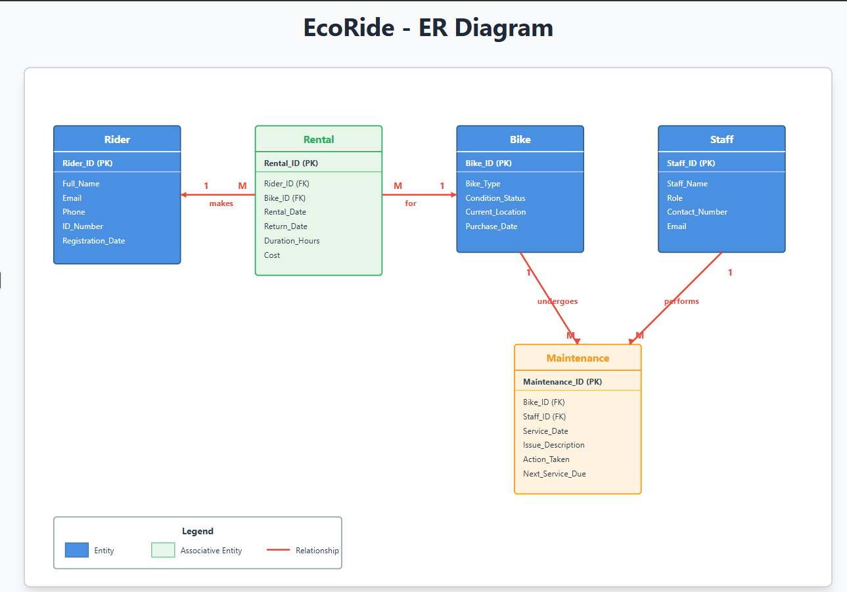

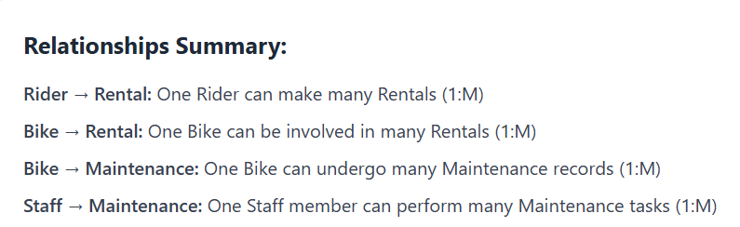

Normalization
The database design follows Third Normal Form (3NF) to eliminate redundancy and dependency problems.
- First Normal Form (1NF):
All tables contain atomic data. Each field holds a single value. For example, a rider’s phone number is not combined with their email in the same column. Repeating groups have been removed.
- Second Normal Form (2NF):
Partial dependencies were removed by ensuring that every non-key attribute depends on the entire primary key. In this database, each table has a single-column primary key, so this condition is automatically satisfied.
- Third Normal Form (3NF):
Transitive dependencies were removed so that non-key fields depend only on their table’s primary key. For example, the Location_Manager in the Location table depends on Location_ID, not on bike or staff details elsewhere. As a result, updates or deletions in one table will not cause inconsistency in others.
The final model, therefore, is stable, easy to query and expandable if EcoRide later adds new services such as electric-scooter rentals or online bookings.

Implementation Summary
The database was implemented using phpMyAdmin. A new database named EcoRide was created with the command CREATE DATABASE ecoride;
Tables were created according to the structure shown in the ER diagram. Each CREATE TABLE command defines primary keys, data types, and foreign keys that enforce relationships between tables. For example, the Bike table references Location_ID from the Location table, while the Rental table references both Rider_ID and Bike_ID.

Create Tables

CREATE TABLE Rider (
Rider_ID INT AUTO_INCREMENT PRIMARY KEY,
Full_Name VARCHAR(100) NOT NULL,
Email VARCHAR(70) UNIQUE NOT NULL,
Phone VARCHAR(15),
ID_Number VARCHAR(10) UNIQUE,
Registration_Date DATE DEFAULT CURRENT_DATE
);

CREATE TABLE Location (
Location_ID INT AUTO_INCREMENT PRIMARY KEY,
Location_Name VARCHAR(70) NOT NULL,
Location_Manager VARCHAR(700)
);

CREATE TABLE Bike (
Bike_ID INT AUTO_INCREMENT PRIMARY KEY,
Bike_Type VARCHAR(50),
Condition_Status VARCHAR(50),
Location_ID INT,
Purchase_Date DATE,
FOREIGN KEY (Location_ID) REFERENCES Location(Location_ID)
);

CREATE TABLE Rental (
Rental_ID INT AUTO_INCREMENT PRIMARY KEY,
Rider_ID INT,
Bike_ID INT,
Rental_Date DATETIME NOT NULL,
Return_Date DATETIME,
Duration_Hours DECIMAL(4,1),
Cost DECIMAL(6,2),
FOREIGN KEY (Rider_ID) REFERENCES Rider(Rider_ID),
FOREIGN KEY (Bike_ID) REFERENCES Bike(Bike_ID)
);

CREATE TABLE Maintenance (
Maintenance_ID INT AUTO_INCREMENT PRIMARY KEY,
Bike_ID INT,
Staff_ID INT,
Service_Date DATE,
Issue_Description TEXT,
Action_Taken TEXT,
Next_Service_Due DATE,
FOREIGN KEY (Bike_ID) REFERENCES Bike(Bike_ID),
FOREIGN KEY (Staff_ID) REFERENCES Staff(Staff_ID)
);
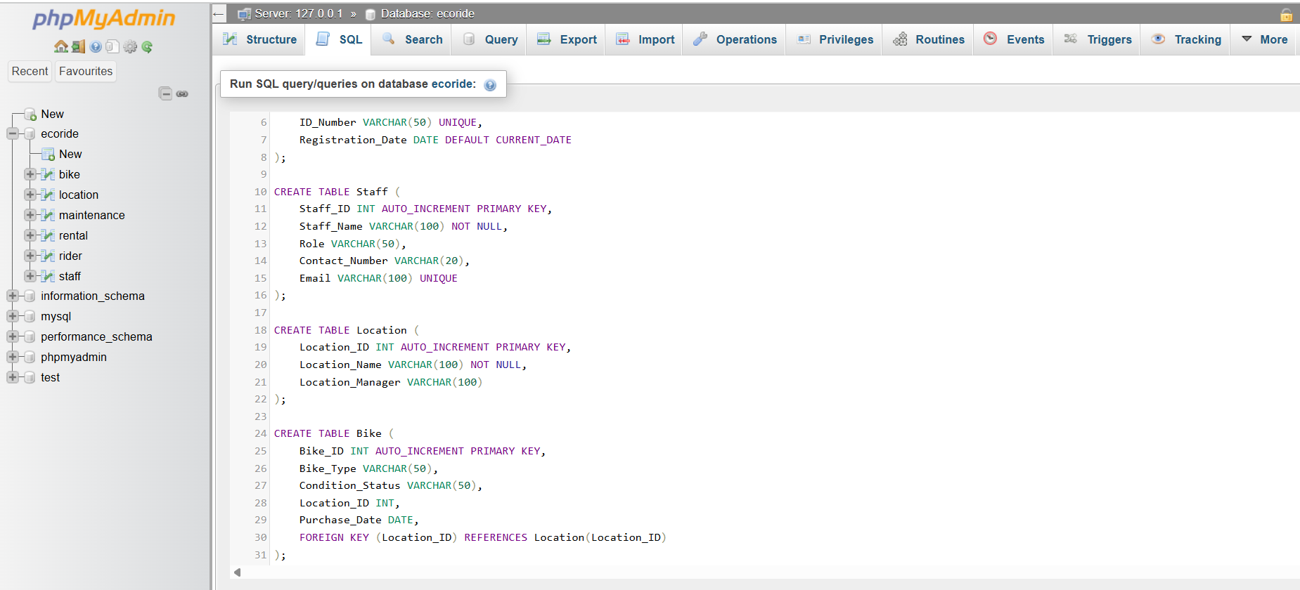
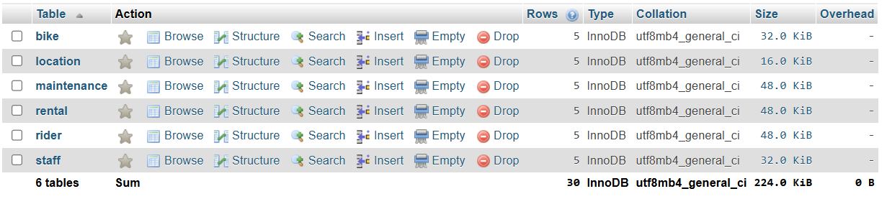
Once the structure was ready, sample data was inserted using a set of INSERT INTO commands. Each table was filled with five records that use realistic names and values. Such as names for riders and staff, meaningful bike types (City, Mountain, Hybrid, Electric) and logical dates for rentals and maintenance.

Sample data that was inserted :
INSERT INTO Staff (Staff_Name, Role, Contact_Number, Email) VALUES
('James Miller', 'Technician', '07123456789', 'james.miller@ecoride.com'),
('Olivia Smith', 'Inspector', '07234567890', 'olivia.smith@ecoride.com'),
('Daniel Brown', 'Mechanic', '07345678901', 'daniel.brown@ecoride.com'),
('Sophia Johnson', 'Technician', '07456789012', 'sophia.johnson@ecoride.com'),
('William Davis', 'Manager', '07567890123', 'william.davis@ecoride.com');

INSERT INTO Rider (Full_Name, Email, Phone, ID_Number, Registration_Date) VALUES
('John Harris', 'john.harris@gmail.com', '07911122334', 'R1001', '2025-10-01'),
('Emily Wilson', 'emily.wilson@gmail.com', '07922233445', 'R1002', '2025-10-02'),
('Michael Lewis', 'michael.lewis@gmail.com', '07933344556', 'R1003', '2025-10-03'),
('Sophia Clark', 'sophia.clark@gmail.com', '07944455667', 'R1004', '2025-10-04'),
('David Turner', 'david.turner@gmail.com', '07955566778', 'R1005', '2025-10-05');

INSERT INTO Bike (Bike_Type, Condition_Status, Location_ID, Purchase_Date) VALUES
('City', 'Available', 1, '2024-05-20'),
('Mountain', 'Available', 2, '2024-06-10'),
('City', 'In Use', 3, '2024-07-01'),
('Hybrid', 'Repair Due', 4, '2024-04-25'),
('Electric', 'Available', 5, '2024-05-15');

INSERT INTO Maintenance (Bike_ID, Staff_ID, Service_Date, Issue_Description, Action_Taken, Next_Service_Due) VALUES
(1, 1, '2025-10-01', 'Brake adjustment needed', 'Adjusted and tested brakes', '2026-01-01'),
(2, 2, '2025-10-02', 'Flat tyre reported', 'Replaced rear tyre', '2026-02-02'),
(3, 3, '2025-10-03', 'Battery performance check', 'Replaced old battery', '2026-03-03'),
(4, 4, '2025-10-04', 'Chain cleaning required', 'Cleaned and lubricated chain', '2026-04-04'),
(5, 5, '2025-10-05', 'Routine inspection', 'No issues found', '2026-05-05');
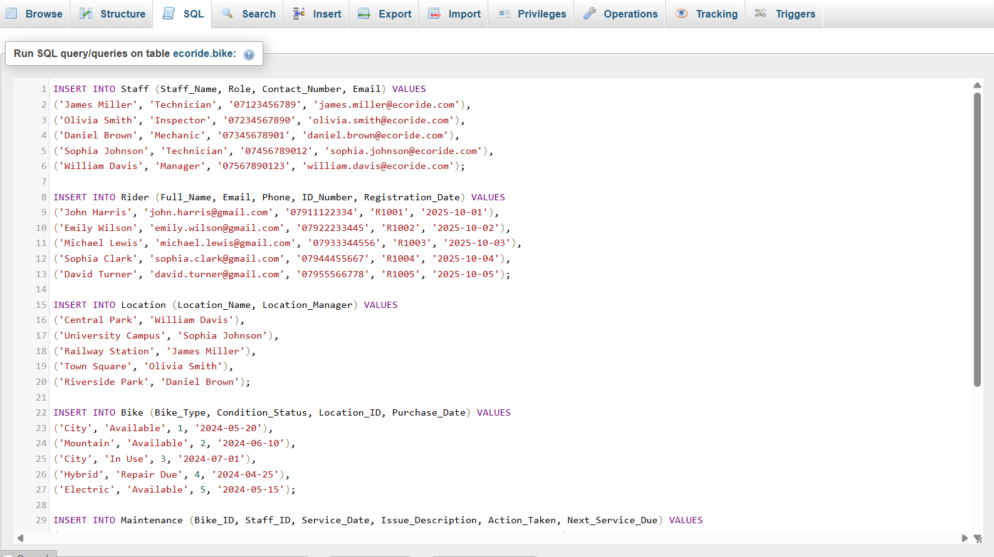
After data insertion, a few verification queries such as SELECT * FROM Bike; and SELECT * FROM Rental; were run to confirm that the records were stored correctly. Foreign key constraints ensured that no orphan data existed, meaning every rental corresponded to an existing rider and bike, and every maintenance record referred to an existing staff member and bike.
During the implementation stage, some common issues were tested and resolved. For instance, if a bike was inserted before a matching location existed, MySQL produced a foreign key error; this was fixed by inserting locations first or temporarily disabling key checks during bulk insertion. By following the correct order, ie. Staff, Rider, Location, Bike, Maintenance, Rental, the entire dataset loaded successfully.
Screenshots were then taken to show:
- All six tables created in MySQL,
- Data displayed in tabular form,
- The ER diagram generated from the schema and
- Example query results.
These images are included later in the report to support the written explanation. The implemented database now provides a complete, functioning model that can be queried for daily EcoRide operations.

Query Development
After completing the database, a series of SQL queries were written to check that the tables were linked correctly and to show how the system could support EcoRide’s daily tasks. The goal was not to use very complicated joins but to produce queries that a typical user or beginner database administrator could easily understand and reuse.
Each query has been tested successfully in MySQL, and screenshots of the results have been added to the appendix in the final report.
Q1. Show All Bikes and Their Status
Ans.
SELECT Bike_ID, Bike_Type, Condition_Status, Purchase_Date
FROM Bike;
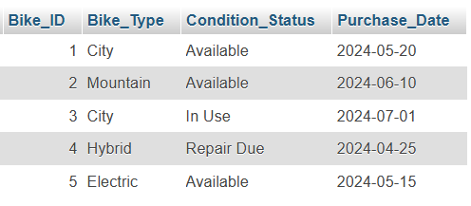
Q2. List All Riders Who Have Rented a Bike
Ans.
SELECT Rider_ID, Full_Name, Email
FROM Rider
WHERE Rider_ID IN (SELECT Rider_ID FROM Rental);
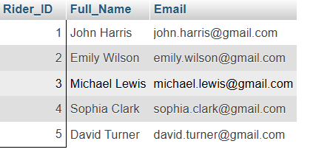

Q3. Find All Bikes Needing Maintenance or Repair
Ans.
SELECT Bike_ID, Bike_Type, Condition_Status
FROM Bike
WHERE Condition_Status = 'Repair Due';
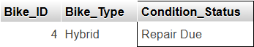

Q4. Show Each Rental with Rider Name and Bike Type
Answer:
SELECT
Rental.Rental_ID,
Rider.Full_Name,
Bike.Bike_Type,
Rental.Rental_Date,
Rental.Cost
FROM Rental
JOIN Rider ON Rental.Rider_ID = Rider.Rider_ID
JOIN Bike ON Rental.Bike_ID = Bike.Bike_ID;
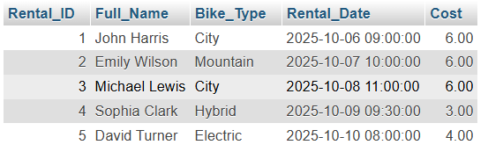
Q5. Show Maintenance Records with Staff and Bike Information
Ans.
SELECT
Maintenance.Maintenance_ID,
Staff.Staff_Name,
Bike.Bike_Type,
Maintenance.Service_Date,
Maintenance.Issue_Description
FROM Maintenance
JOIN Staff ON Maintenance.Staff_ID = Staff.Staff_ID
JOIN Bike ON Maintenance.Bike_ID = Bike.Bike_ID;
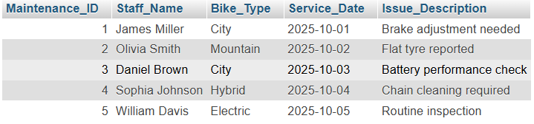
Q6 – Show rider names and their rental costs
Ans.
SELECT Full_Name, Cost
FROM Rider, Rental
WHERE Rider.Rider_ID = Rental.Rider_ID;

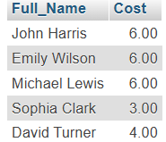

Summary of Query Results:
All six queries ran without errors and produced accurate results based on the sample data. Together, they cover the main operational needs of EcoRide (checking availability, monitoring rentals, managing maintenance, and summarising revenue)

Validation and Testing
Once the database and queries were complete, a set of simple tests was carried out to confirm that the system behaves correctly. Testing is mainly done on two main areas. They are data accuracy and constraint validation.
The goal was to ensure that relationships between tables worked properly. Also to ensure that incorrect data could not be inserted in the database. Important calculations such as total revenue, sum etc returned correct values.

Test ID | Test Objective | Method / SQL Used | Expected Result | Outcome
T1 | Check referential integrity between Rider and Rental | delete a rider who has a rental: DELETE FROM Rider WHERE Rider_ID = 1; | MySQL should block the deletion | Passed
T2 | Test inserting valid rental data | INSERT INTO Rental (Rider_ID, Bike_ID, Rental_Date, Duration_Hours, Cost) VALUES (1, 2, '2025-11-01 10:00:00', 2.5, 5.00); | Record accepted successfully | Passed
T3 | Attempt invalid foreign key | INSERT INTO Rental (Rider_ID, Bike_ID, Rental_Date, Duration_Hours, Cost) VALUES (99, 1, '2025-11-02 09:00:00', 2.0, 4.00); | MySQL rejects with foreign key error | Passed
T4 | Check revenue calculation | SELECT SUM(Cost) FROM Rental; | Total equals sum of all rental costs | Passed
T5 | Confirm no orphan rentals | Left join Rental and Bike; check for nulls. SELECT * FROM rental  LEFT OUTER JOIN bike  ON rental.Bike_ID = bike.Bike_ID; | No nulls returned | Passed

Validation and test screenshots:
T1 : 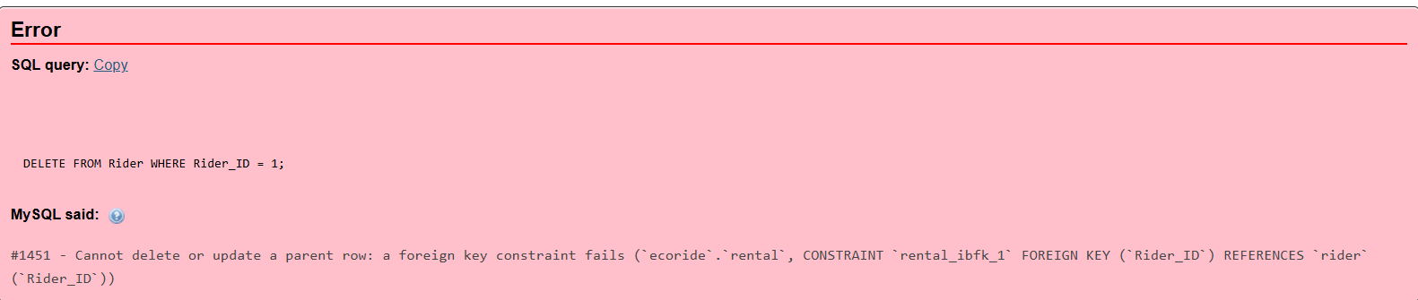
T2
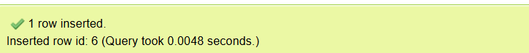
T3
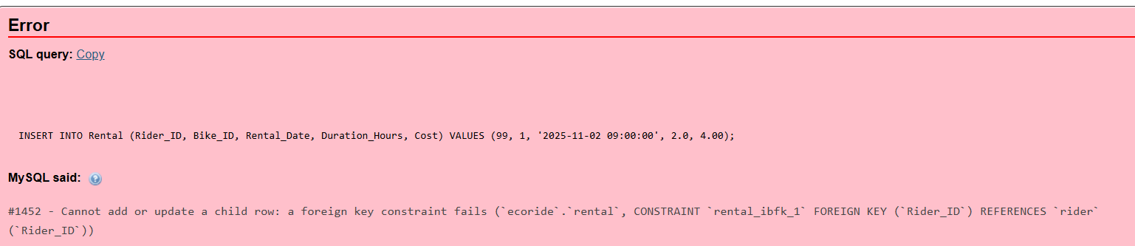
T4
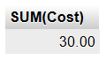
T5
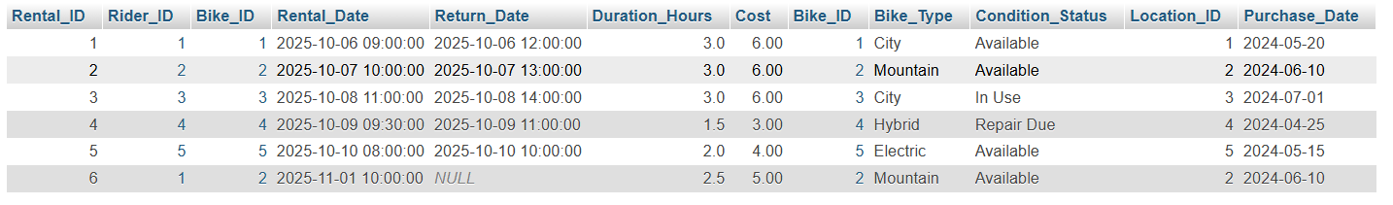

Validation Summary
All tests passed successfully. The foreign key rules stopped the deletion of records that were still linked/pending with other tables. This confirms that data integrity is preserved in all the tables. Numeric fields such as cost and duration were implemented correctly as the sum and revenue calculations returned correct values. Queries involving joins returned accurate outputs, showing that the relationships among Rider, Bike, Staff and Location tables were properly set up.
The testing process also proved that the order of data insertion matters. When correct sequence to insert was followed (start with Staff and Rider, end with Rental), all insertions succeeded without errors. This proves that the referential design (foreign key design/dependency) is flawless.

Conclusion
The EcoRide database project was created to handle the daily operations of the electric-bike rental service in a structured way. The new system now takes care of main functions like riders registration, tracking of rentals, bike maintenance records etc. The Third Normal Form prevents duplication of data in the database and ensures that information on all six tables is consistent. Relationships between entities such as Rider-Rental and Bike-Maintenance were clearly defined by foreign keys (ensures that each action links back to valid data in the DB). Overall, the database achieves the primary aims of the project. It has a well-organized structure, data integrity is maintained all the while catering to the requirements of EcoRide.

References
Coronel, C. and Morris, S. (2023) Database Systems: Design, Implementation, and Management. 14th edn. Cengage Learning.
MySQL (2025) MySQL 8.0 Reference Manual. Available at: https://dev.mysql.com/doc/ (Accessed: 12 November 2025).
TutorialsPoint (2024) SQL Basics for Beginners. Available at: https://www.tutorialspoint.com/sql (Accessed: 8 November 2025).
W3Schools (2025) SQL Tutorial. Available at: https://www.w3schools.com/sql/ (Accessed: 12 November 2025).

