Achia khan (2026002)

Module: Problem Solving and Decision Making
Module code: (BMSW4004)

Lecturer: Chijioke Uba

Assignment Title: Problem solving and Decision-making Task 2

Content page:

Content page: 2
Introduction 3
Nature of the complex problem on the employees and their organisation 4
Analysing the indirect factors contributing to the complex problem 5
PESTEL analysis contributing to the complicated problem 7
Evaluation to solutions to work-related stress and choosing the best appropriate solution to solve the problem 8
Conclusion 12
References 12

Introduction

This is a report in addition to the presentation that was part of task 1. This report is based on the case study of the stress related issues that affect our day-to-day life. It is a complex problem for the organisation and the employees in the U.K. where the scope is nationwide. The report will be focusing on the problem and stress in the context of the workplace and the employees. Stress is caused by unexpected pressures it varies from person to person with respect to their current situations and circumstances. Not only the current situation but also, the haunted past and upcoming future insecurities could also be the main reason to build up stress.
This report has four sections and firstly, is to recognise the nature and impact of the problem. The first section discusses the nature and impact of the problem of stress on UK workers and their organisation. The following section identifies the main causes of the problem using Fishbone Diagram and PESTEL analysis. Then we need to determine the best cause of action and identify practical solutions. To make that decision we need to evaluate and implement it with a solution. The (P.M.I.) is taken into consideration to decide the best action to be taken.

Nature of the complex problem on the employees and their organisation

Many day-to-day problems can be easily resolved but complex problems require lengthy consideration which is an issue for employees and their organisations nationwide. The causes of stress are work-related, monetary and health factors along with gender-related issues. The impact that stress has on employees is a long-term and uncontrollable problem on employees. A strategic issue is an unresolved matter which requires waiting for clarification or a decision. Operational problem is an overhead cost in the healthcare profession. Administrative problems are unexpected loss of employees. Internal and external factors need to be taken into considerations before deciding the complexity of the problem.
According to Regel, S. (2007), the main problem of stress is, when a person is working for too long, where they are over-stressed; can develop mental and physical health problems. Stress can affect a person mentally causing anxiety and depression, also physical issues can cause heart conditions and back problems. When someone is not well and the stress continues with health-related problems, a person will be absent from work which causes less staff, performance in the workplace is affected. Work performance will be declining, inconsistent and loss of motivation. Lack of commitment indicates that employees are suffering from excessive stress.
As Lazarus, R.S. (2006) mentions, stress can change an individuals' behaviour in the workplace. They show emotional signs such as moodiness amongst colleagues, and over-reacting towards issues one another, conflicts caused by stress. Constant health problems can build-upbuild frequent visits to the hospital and visiting the G.P. appointments which affect the working hours. Employees not attending regular shifts calling in sick every so often will impact the organisation. Mental stress can also have an impact on personal relationships and family orientation too.
Money related problems occur when people are stressed financially. Less income in the household and more expenditure. Often it happens that less finance compels you to borrow money from people or banks which cannot be paid on time. Therefore, causing more financial problems leading to bankruptcy struggle for money causes stress levels even higher. This could cause you more anxious with a worsening effect of mental health illnesses too.

Analysing the indirect factors contributing to the complex problem

To understand and solve the problem, we must identify the causes of the problem, to do that a fishbone analysis is conducted. A fishbone diagram is a visual tool to categorise the potential causes of a problem. This tool is used to determine or identify the root of the problem. It is a combination of brainstorming with a type of map template. It is to determine that accurate action is taken to solve the problem.
-the main categories of causes as branches form the main arrow.
-possible causes of the problem.
-each cause(why) it happens.
Below is a fishbone diagram which was created for the presentation task 1.

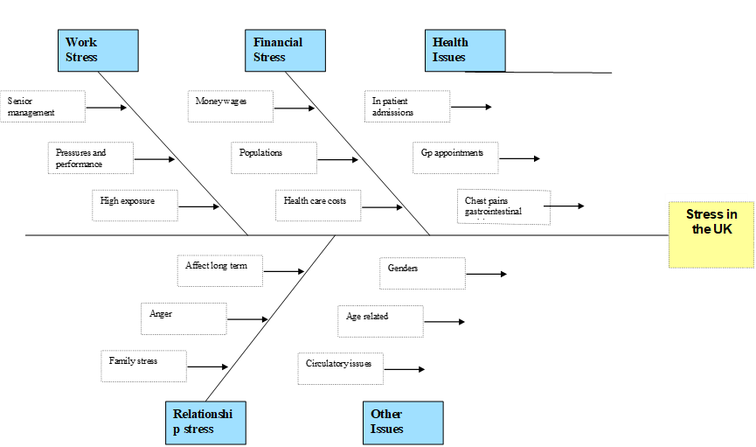

From this analysis we have identified four main causes of stress. Work, money, health, and gender. to address these causes we need to identify workable solutions to the problem. We need to determine the best cause of action to be taken.
Problems can often be deceptive. Minor problems can sometimes become to a be far bigger than expected. We need to focus outside the box think further beyond the picture in focus.
External factors contribute to the stress due to government legislation. For example, low and the impact it has on employees. According to Ryu, G (2016), ‘Results showed that having long working hours was not significantly and negatively related to public employee wellness, whereas having a higher salary was significantly and positively associated with employee well-being.’ (p.70).

PESTEL analysis contributing to the complicated problem

P.E.S.T.E.L analysis is another tool to identify probable causes of the problem. (Only the PESTEL factors linked to the stress are discussed.)
Political- can be a policy that government changes may relate to certain jobs (labour law). Code of practice on improving health within the work organisation. External factors to consider.
Economic- the financial stress, pressure at work may affect stress and health issues which affect economic growth. Health care expenditures and cost of living.
Social/cultural factors- age-related younger generation feel more stressed than baby boomers, and people from diverse cultural backgrounds and gender. Well-being and mental health issues arising in someone's home/private life can affect an individuals’ performance in their job role.
Legal – government legislation, health, and social care bill. Increasing democratic accountability and public policy.
PESTEL analysis method helps to identify factors in analysing stress and performance of employees in a workforce organisation.

Evaluation to solutions to work-related stress and choosing the best appropriate solution to solve the problem

To address the above causes, we identify 3 workable solutions. Improve the pay, that would help with the money-related problems too. Better mental/physical support system within the workplace. Opportunities for a better future, get skilled and qualified staff or give extra training to make the job easier. Below is the (P.M.I) a decision-making tool.

^{P.M.I - Decision making tool}
Improve pay, that would help money problems
Plus | Minus | Interest
More money means better satisfied employees +6 | Spending too much -3 | Releases financial difficulties +3
Better lifestyle +5 | You do not save what you have -4 | Your company would be in a better position and not be impacted with financial setbacks +5
It gives employers and employees more flexibility +3 | Increased wages would mean the organisation has to charge more for the goods -3
Total=14 | -10 | +8

Better mental/physical support system within workplace.
Plus | Minus |  | Interest
Healthy lifestyle exercise +5 | Health problems -3 |  | Feeling mentally better and more active +4
A productive, successful workplace +6 | Stress related problems -3 |  | Improve work service +4
Better mental health leads to better performance +5
Total= 16 |  | -6 |  | +8
Total = 18

Extra staff training to make the job easier
Plus |  | Minus |  | Interest
Helps develop skills for people +7 |  | Time consuming -8 |  | Increase productivity +5
More opportunities for work +8 |  | Different abilities -5 |  | Enhancing the performance of staff as well as building up the organisation +6
Creating a diversity different skilled people +7 |  | Learning at a slow and quicker pace -3
Training specific areas +8 |  | Increased stress -5
Able to find weaknesses and strengths  +8  Quality and performance are gained +9 |  | Loss of interest -7
Total= 47 | -28 |  | +11
Total = 30

Analyzing the fishbone and Pestel analysis also the (P.M.I.) decision-making making tool, the best decision had the most positive outcome. After the P.M.I. analysis, the decision that enhanced was there were more opportunities for the organization and employees to give extra staff training to help overcome this problem. Once the decision is made, we need to put a plan to solve the problem. Below is an action plan to staff training, who needs training? Who is going to be training them? When will they start their training?

Action Plan

Action (what to do) | Description (how) | TimeLine (when) | Responsible person  (who)
Identify training needed | Speak with the department manager, to completely identify training needs based on staff queries  Record the training needs received from queries. | 1st June 2018 -  8th June 2018 | Support manager
Identify trainees | Speak with the managers and check upon the complaints’ register to identify the staff that need the training. | 22nd October 2021-  25th October 2021 | Manager
Identify trainer | Identify experienced HR representative and 2 staff with the lowest number of absences and elevated levels of productivity. | 27th October 2021-  2nd November 2021 | Support manager
Create training schedule/ program me | Start program | 3rd November 2021-  6th November 2021 | Trainer

You also need to monitor the plan; this can be done by collecting the information from the outcome of the training. Make sure they arrived on time, level of engagement and did they complete the training, and how successful is the training.

 | Description | Period | Staff responsible
Participation | % Of trainees who participated in the staff training | Daily | Internal auditor
Engagement | People are they participating | Daily | Trainer
Understanding | Average score obtained in a well-designed assessment | End of training | Training manager

Key Performance Indicators

Success indicator(s) | Data source/information collection | Period | Staff who is responsible
Survey | Reported levels of stress indicator's (absentees, low productivity) | One month | Line managers

The Key Performance Indicator is evidence of progress towards achieving the desired result. This result indicates the outcome of the training. The absentees and how low is the productivity. We also can conduct surveys to determine its results for future references. The questions that were asked before implementing the plan are in this feedback. Looking at the statistics and facts of the findings is the final satisfaction.

Conclusion

To conclude, more individual support staff and identifying their needs is crucial, particularly in reference to Fishbone, Pestel, and the P.M.I. This could be done by actions such as extra staff training to improve efficiency and issues affecting their performance. As a result, well-trained staff will allow for a less stressful work environment, and they can make better decisions, benefitting both employer and employees.

References

Antonopoulou, P., Killian, M. and Forrester, D., (2017). Levels of stress and anxiety in child and family social work: Workers' perceptions of organizational structure, professional support and workplace opportunities in Children's Services in the UK. Children and Youth Services Review, 76, pp.42-50.
Çitilci, T. and Akbalık, M., (2020). The Importance of PESTEL Analysis for Environmental Scanning Process. In Handbook of Research on Decision-Making Techniques in Financial Marketing (pp. 336-357). IGI Global.
Lazarus, R.S., (2006). Stress and emotion: A new synthesis. Springer publishing company.

McCloud, T. and Bann, D., (2019). Financial stress and mental health among higher education students in the UK up to 2018: rapid review of evidence. J Epidemiol Community Health, 73(10), pp.977-984.
Phillips, J. and Simmonds, L., (2013). Using fishbone analysis to investigate problems. Nursing times, 109(15), pp.18-20.
Regel, S., (2007). Post-trauma support in the workplace: the current status and practice of critical incident stress management (CISM) and psychological debriefing (PD) within organizations in the UK. Occupational Medicine, 57(6), pp.411-416.
Ryu, G., (2016.) Public employees’ well-being when having long working hours and low salary working conditions. Public Personnel Management, 45(1), pp.70-89.
Setijono, D. and Dahlgaard, J.J., 2007. Customer value as a key performance indicator (KPI) and a key improvement indicator (KII). Measuring Business Excellence.
Taylor, D.W., 2013. Decision making and problem solving. Handbook of organizations, 20, pp.48-86.

