

_________________________________________________________________________________

Independent Project Proposal

Design and Implementation of an SO₂ Detection and Alarm Monitoring System within the Vale Nickel Refinery, Clydach

Module: Independent Project (ACCA6020)
Electrical & Electronic Engineering

Author: Luis Lloyd
Student Number: 2220588

20.10.2025

Contents

Contents 2
Table of Figures 2
1.0 Introduction 3
1.1 Project Field Context 3
1.2 Background Research 3
1.3 Problem Statement 4
1.4 Project Aim 4
1.5 SMART Objectives 5
1.6 Expected Outcomes / Deliverables 5
2. PROJECT DESIGN 6
2.1 Overview of System Architecture 6
2.2 Design and Development Methodology 7
2.3 Testing, Commissioning, and Validation 7
2.4 Risk, Safety, and Ethical Considerations 7
2.5 Environmental and Societal Impact 8
2.6 Data Analysis and Evaluation 8
3. RESOURCES & PLANNING 9
3.1 Resources and Tools 9
3.2 Project Timeline and Milestones 9
4. Conclusion 11
References 12
Appendix 1 13

Table of Figures
Figure 1- Simplified block diagram of SO₂ detection and alarm integration with Foxboro DCS, showing Intrinsic segregation between hazardous and safe areas. 6
Figure 2-Project Lifecyle Gantt chart. 10

1.0 Introduction

1.1 Project Field Context
Founded in 1902 by Ludwig Mond, Vale Clydach Nickel Refinery remains the world’s only facility operating the Mond carbonyl process to refine nickel to 99.9% purity [9], [10]. During this process, Sulphur dioxide (SO₂) is intentionally introduced at the activation-kiln stage to enhance nickel reactivity prior to forming nickel carbonyl, Ni (CO)₄. While chemically essential, this stage presents significant occupational health and environmental hazards.
Effective toxic-gas detection and alarm systems are therefore vital components of electrical and electronic engineering. SO₂ is a corrosive and highly toxic gas with a UK workplace exposure limit (WEL) of 0.5 ppm and 1 ppm 15-minute short term exposure limit [1]. Continuous fixed detection is critical for compliance with the Control of Substances Hazardous to Health Regulations (COSHH) and Control of Major Accident Hazards Regulations (COMAH) [8], [12], as personnel may be exposed to toxic SO₂ concentrations during normal operations within the activation kiln area.

1.2 Background Research
Recent studies and manufacturing data highlight the advantages of fixed gas-detection networks compared with portable monitors for continuous safety assurance in process industries [3], [4]. Fixed systems improve alarm reliability, enable automatic data trending, and support long-term exposure analysis. Modern transmitters using electrochemical SO₂ sensors achieve sub ppm sensitivity and fast response times [2], while integration with plant control systems such as distributed control systems (DCSs) provides real-time visibility and automated alarm handling [11].
At Vale Clydach, current SO₂ control relies on portable detectors vulnerable to battery and calibration faults, offering limited coverage. The proposed project therefore addresses this gap by installing five fixed SO₂ detection loops within the activation-kiln area, each interfaced via intrinsically safe (IS) 4–20 mA loops to the Foxboro FBM/TA I/O. IS protection to IEC 60079-11/14 limits circuit energy within the Zone 2 environment. Field Ex e sounder/beacons and a control-room HMI will provide visual and audible alarms, supporting proactive exposure control and regulatory compliance.

1.3 Problem Statement
The activation-kiln area currently has no fixed SO₂ detection system. Gas releases are only recognized when operators are already present either through Oduor detection or activation of personal portable gas monitors. Incidents have occurred where personnel have entered the area without monitors, resulting in uncontrolled exposure to toxic SO₂.
This represents a significant occupational-health risk under the Control of Substances Hazardous to Health Regulations (COSHH) and a loss-of-containment hazard under the Control of Major Accident Hazards Regulations 2015 (COMAH) [8], [12]. Installing a fixed SO₂ detection and alarm system will provide early warning via flashing Ex e sounder/beacons, indicating when the area is unsafe to enter. In the event of a major leak or elevated concentration, the system will automatically trigger the main plant's evacuation alarm, allowing personnel to reach safety before exposure occurs.

1.4 Project Aim
To design, install, test, and commission five fixed intrinsically safe (IS) SO₂ detection loops within the activation-kiln process area at Vale Clydach Nickel Refinery. Each detector will interface with the Foxboro I/A Distributed Control System (DCS) via FBM/TA IS I/O modules, providing local Ex e sounder/beacon alarms and a safe-area HMI for real-time trending and alarm history. The system will by the student to meet IEC 60079-14 and DSEAR (2002) requirements, verified in the Foxboro simulation environment, and validated through on-site commissioning and compliance inspection.

1.5 SMART Objectives
- Verify the existing Zone 2 classification and select suitable Ex-certified equipment in accordance with IEC 60079-14, updating the area-classification dossier to include the new devices.
- To design and document an intrinsically safe 4–20 mA SO₂ detection loop, completing entity verification, voltage-drop calculations, and loop drawings.
- To install and integrate the detection loops into the Foxboro I/A DCS (FBM/TA I/O), configure alarm logic and FAULT conditions with latching, silence, and manual reset functions.
- Develop a new HMI graphic consistent with existing site standards, displaying live gas concentrations, alarm states, trends, and history, and delivering operator training on its use.
- Commission and function-test the complete system using simulated 4–20 mA signals and SO₂ bump-gas verification, recording alarm thresholds, response times (<5 s), and verifying alarm outputs and zoning compliance.
- Evaluate overall system performance, confirm compliance with COSHH, COMAH, and DSEAR requirements, and produce a final commissioning and report demonstrating measurable safety improvement.

1.6 Expected Outcomes / Deliverables
- Design Documentation: Area classification update and protection concept; entity-parameter verification sheets; voltage-drop calculations; AutoCAD loop and wiring diagrams.
- Control and Alarm Configuration – Foxboro I/A DCS logic blocks for AL1, AL2, and FAULT alarms; alarm matrix; verified FBM/TA I/O allocations; and completed function-test records.
- HMI and Operator Interface – New HMI graphic integrated with existing site layouts, displaying SO₂ concentrations, alarms, and trends, operator training materials and attendance record.
- Installation and Commissioning Records – Installed transmitters and sounder/beacons with supporting photos; commissioning sheets for 4–20 mA simulation and SO₂ bump tests.
- Compliance and Evaluation Outputs – Completed DSEAR inspection checklist, proof-test and maintenance procedure, and final evaluation report comparing measured performance against design intent.

2. PROJECT DESIGN

2.1 Overview of System Architecture
The project involves the design, installation, and commissioning of five SO₂ detection loops within the activation-kiln process. Each loop uses an electrochemical transmitter installed in the process area, connected via a 4–20 mA intrinsically safe (IS) circuit through a certified galvanic isolator to the Foxboro I/A (DCS) using FBM/TA I/O modules. The FBM input forms the core interface between the hazardous-area instrumentation and the safe-area control system. Sounder/beacon units provide local visual and audible alarms.
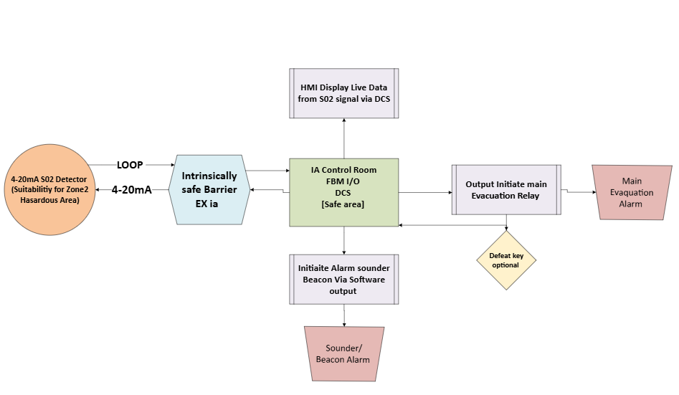
Figure 1- Simplified block diagram of SO₂ detection and alarm integration with Foxboro DCS, showing Intrinsic segregation between hazardous and safe areas.
The DCS hosts alarm logic, trending, and HMI displays. Set points configured as well as Alarms latch until acknowledged and reset by authorized personnel. Defeat keys will be proposed to the Plant superintendent to follow site standards as an option.

2.2 Design and Development Methodology
All configurations are first developed and verified within the Foxboro simulation environment, allowing alarm logic and HMI navigation to be evaluated without impacting live operations. Each FBM input is scaled 4–20 mA = 0–10 ppm SO₂ and tagged in accordance with the plant instrumentation index. The logic incorporates signal validation to detect open- or short-circuit conditions.
During implementation, IS segregation, cable identification, and gland selection based under the refinery’s electrical safety standards. AutoCAD will be utilized by (student) for all drawings, which will be verified and approved before installation on site.

2.3 Testing, Commissioning, and Validation
Each loop will undergo loop checks, including continuity, polarity, and DSEAR inspection, prior to energization. Live signal injection (4–20 mA) will verify scaling, fault detection, and open-circuit response within the DCS. Bump-gas testing will be completed under supervision of the commissioning engineer to confirm sensor functionality and alarm activation. All test data and verification results will be documented within the maintenance management system for traceability.

2.4 Risk, Safety, and Ethical Considerations
Principal risks include operator exposure to toxic SO₂, electrical ignition in the Zone 2 area, and unauthorized modification of live DCS code.
Mitigation measures are implemented through the site’s Risk Assessment and Method Statement process and include:
- Adherence to permit-to-work and isolation/LOTO procedures before intervention.
- Simulation testing and logic verification prior to energization.
- Installation of Ex-certified instrumentation compliant with DSEAR
- Senior engineering review and authorization of all DCS logic changes.
Ethically, the project enhances worker safety, involves no personal data processing, and fully complies with the university’s research-ethics framework. An approved ethics form accompanies this proposal.

2.5 Environmental and Societal Impact
The system directly supports the refinery’s sustainability by reducing unplanned releases and limiting operator exposure to hazardous atmospheres. Early detection of SO₂ also mitigates atmospheric emissions, contributing to improved environmental stewardship and community reassurance [10].

2.6 Data Analysis and Evaluation
Collected data (ppm vs. time, alarm logs, and trend CSVs) will be analyzed in Excel to confirm sensor linearity, alarm repeatability, and system latency. Mean response and standard deviation across all detectors will verify uniform performance. Results will be compared with historical portable monitor data to demonstrate enhanced safety coverage.

3. RESOURCES & PLANNING

3.1 Resources and Tools
The project will use standard industrial and academic resources.
- Hardware: Five transmitters, galvanic IS barriers, Ex e sounders/beacons, FBM/TA modules, and screened cabling, Terminals & control panel.
- Software: Foxboro DCS Configurator/ IA System, AutoCAD Electrical, Excel for data analysis.
- Standards: IEC 60079 series, BS EN 61511, DSEAR (2002), COMAH (2015).
- Personnel: EC&I project engineer (student), EC&I Senior Engineer (Vale Staff) Plant Superintendent (Vale staff), Commissioning Engineer (gas detection specific), Academic Advisor (UWTSD).

3.2 Project Timeline and Milestones
Progress will be reviewed weekly with the site’s Engineer (student) and with the university’s academic advisor. All drawings, test records, and calculations will be managed under the refinery’s quality-assurance (QA) system. The ethics form submitted with this proposal confirms compliance with institutional research-integrity requirements.

Figure 2 presents the project Gantt chart, illustrating the full lifecycle from concept through design, installation, testing, and commissioning. The chart also accounts for external factors such as deadlines, holidays, and hardware lead times. It will serve as a key project-management tool to ensure progress remains on schedule, and all milestones are achieved.
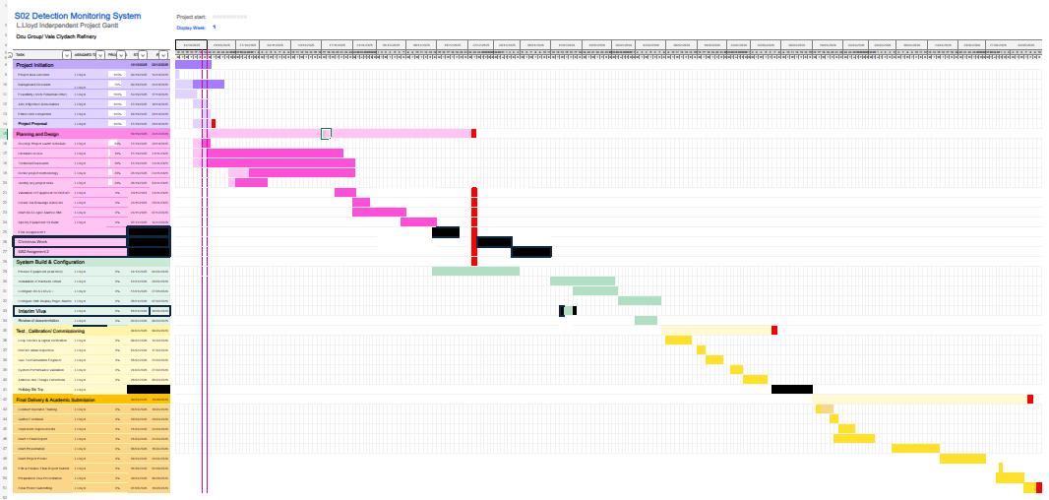
Figure 2-Project Lifecyle Gantt chart.

4. Conclusion
This proposal outlines the design, installation, testing, and commissioning of five intrinsically safe (IS) SO₂ detection loops integrated into Vale Clydach’s Foxboro DCS. The system replaces unreliable portable detection with a fixed, networked monitoring solution providing alarm history, trending, and exposure analytics. Designed to IEC 60079 and DSEAR/COMAH standards, the project delivers measurable safety improvements, supports the refinery’s sustainability objectives, and demonstrates applied EC&I engineering within a live industrial environment.

References
[1] HSE, EH40/2005 Workplace Exposure Limits, 4th ed., 2020.
[2] Crowcon Detection Instruments, Xgard Fixed Gas Detector Datasheet, 2024. Xgard-Datasheet-2025.pdf
[3] Menon, S.K., Kumar, A. and Mondal, S., 2025. Advancements in hydrogen gas leakage detection sensor technologies and safety measures. Clean Energy, 9(1), pp.263-277.
[4] Kumar NS, Chandrasekaran G, Rajamanickam KP. An integrated system for smart industrial monitoring system in the context of hazards based on the internet of things. International Journal of Safety and Security Engineering. 2021 Feb;11(1):123-7.
[5] Schneider Electric, EcoStruxure Foxboro DCS System Overview, 2024. What is a DCS? - Schneider Electric Blog
[6] Schneider Electric, FBM201/FBM204 Analog I/O Specification, 2024.
[7] IEC, IEC 60079-11:2023 Explosive Atmospheres — Equipment Protection by Intrinsic Safety ‘i’, 2023.
[8] UK HSE, Control of Major Accident Hazards Regulations 2015 (SI 2015/483), 2015. A guide to the Control of Major Accident Hazards Regulations (COMAH) 2015 - HSE
[9] Paserin, Vladimir, Vahid Barahimi, Param Dave, Alex Cimprich, Eric Croiset, and Steven Young. "Revisiting the Mond Process: The Greenest Approach to Battery-Grade Nickel, Iron, and Cobalt." In Conference of Metallurgists, pp. 1483-1486. Cham: Springer Nature Switzerland, 2024.
[10] Vale Nickel Refinery Clydach, In a pioneering and voluntary initiative, Vale releases report on sustainability-related financial information - Vale United Kingdom - Vale
[11] Bhullar, R. S. (1993). Strategies for implementing advanced process controls in a distributed control system (DCS). ISA Transactions, 32(2), 147-156.
[12] UK HSE, Control of Substances Hazardous to Health Regulations 2002 (SI 2002 No. 2677), HMSO, London, 2002. Control of substances hazardous to health (Sixth edition) - HSE
https://vale.com/documents/d/guest/transforming-the-future-vale-in-wales-u-k

Appendix 1
DCS | Distributed Control System
FBM | Field Bus Module
TA | Termination Assembly
IS | Intrinsically Safe
Ex e | Increased Safety (Equipment protection method)
SO2 | Sulphur Dioxide
COMAH | Control of Major Accident Hazards Regulations
COSHH | Control of Substances Hazardous to Health Regulations
DSEAR | Dangerous Substances and Explosive Atmospheres Regulations
RAMS | Risk Assessment and Method Statement
LOTO | Lock-Out / Tag-Out
HMI | Human Machine Interface
PPE | Personal Protective Equipment
QA | Quality Assurance
WEL | Workplace Exposure Limit
TWA | Time-Weighted Average
STEL | Short-Term Exposure Limit

