

Student name: Fatemeh Heydari
Student ID: 232355
Lecturer’s name: Caroline Salami
Module Name: BMHP5015-Changemaker Building your Personal Brand for Sustainable Employment

Contents
Introduction 2
Analysis of personal employability 2
Evaluate Your Own Skills 4
Building a Personal Brand and Professional 6
Action plan and timeline 7
Conclusion 8
References 10

Introduction

This report focuses on the role of a Health Care Support Worker (HCSW) within the National Health Service (NHS). A current job vacancy for this position, advertised on NHS Jobs (2025), outlines a frontline care role supporting patients with their physical, emotional, and personal care needs across healthcare settings, including hospitals and community services.
I am motivated to pursue the HCSW role because it aligns closely with my personal values of compassion, dignity, and supporting individuals during vulnerable periods of their lives. The role is appealing due to the opportunity for direct patient contact and the ability to make a meaningful difference through everyday care, emotional support, and teamwork. It also supports my long-term goal of building a career within the healthcare sector while developing core skills such as communication, resilience, empathy, and adaptability, which are essential in health and social care practice.
This report begins by analyzing the personal employability skills required for the HCSW role, drawing on the job description, person specification, and professional frameworks. It then critically evaluates my current skills in relation to these requirements before presenting an action plan and timeline for further development and progression into this role.

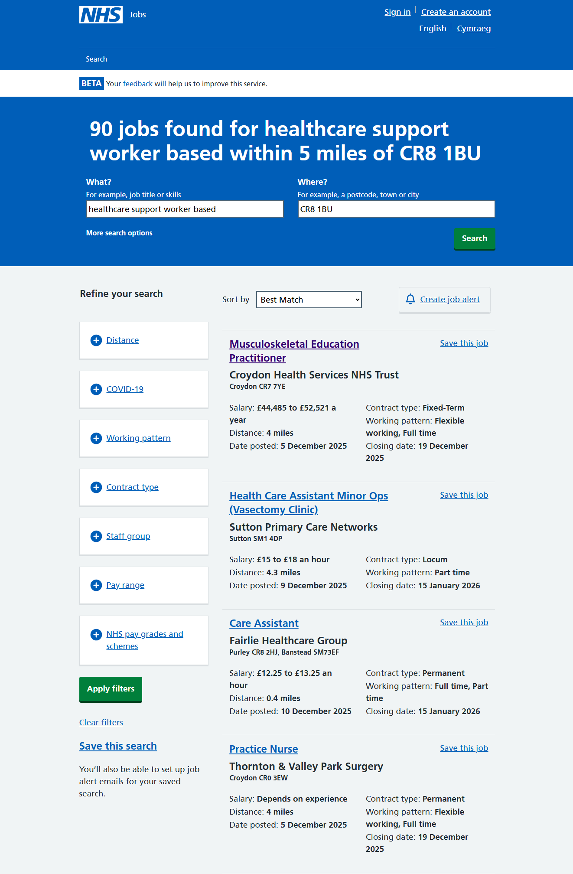

Analysis of personal employability

The role of a Health Care Support Worker (HCSW) within the NHS requires a diverse range of employability skills, professional behaviors, and foundational qualifications to ensure safe, compassionate, and effective care. According to a current NHS Jobs advertisement (NHS Jobs, 2025), HCSWs assist patients with personal care, support mobility, help with nutrition and hydration, monitor and record basic observations, maintain infection prevention and control standards, and escalate concerns to registered professionals. The accompanying person specification highlights key behavioral expectations, including reliability, respect for dignity and
confidentiality, emotional awareness, adaptability, and the ability to work effectively as part of a multidisciplinary team. Although often an entry-level role, it requires completion of mandatory training such as the Care Certificate, safeguarding, and moving and handling, demonstrating commitment to professional standards and patient safety.
Effective communication is among the most essential employability skills for HCSWs. Patients may feel anxious, confused, or vulnerable, and the ability to communicate calmly and clearly is vital to maintaining trust and dignity. The Skills for Care Core Skills Framework identifies communication as a foundational competence, emphasizing active listening, adapting communication styles, and responding appropriately to emotional cues (Skills for Care, 2020). This aligns with the NHS Values, particularly respect, dignity, and compassion, which underpin all patient interactions and promote person-centered care (Department of Health and Social Care, 2023). Clear communication is also critical for accurate information sharing within the care team.
Teamwork is another crucial employability requirement. HCSWs operate within multidisciplinary teams and must collaborate effectively with nurses, doctors, and allied health professionals. Teamwork involves following instructions, understanding role boundaries, supporting colleagues during busy periods, and contributing reliably to shared care tasks. Within the NHS Values framework, working together for patients demonstrates that high-quality care depends on cooperation and mutual accountability rather than individual performance alone (Department of Health and Social Care, 2023).
Resilience and emotional self-management are also key to the HCSW role. Healthcare environments can be emotionally demanding, particularly when patients experience pain, distress, or loss of independence. For example, a patient may become upset or resistant during personal care. In such situations, HCSWs must apply emotional intelligence to de-escalate the interaction by maintaining a calm tone, offering reassurance, explaining procedures clearly, and adjusting the pace of care to preserve dignity and safety. These behaviors reflect professional judgement and align with both Skills for Care expectations and NHS Values.
The STAR model provides a useful way to illustrate transferable skills from previous experiences. During my role at McDonald’s, I worked in a challenging, high-pressure environment requiring constant public interaction. On one occasion, a customer became visibly distressed and verbally confrontational due to a delay in service. My task was to manage the interaction while maintaining service standards and supporting team workflow. I responded by maintaining a calm tone, actively listening without interruption, acknowledging the customer’s frustration, and clearly explaining the situation while coordinating with colleagues to resolve the issue efficiently. As a result, the customer’s behavior de-escalated, communication became constructive, and the situation was resolved without further conflict. This example demonstrates how communication, teamwork, and emotional regulation are applied in practice and are directly transferable to the HCSW role, particularly when supporting patients who may feel distressed, frustrated, or fearful during care interventions.

Evaluate Your Own Skills

Evaluating my skills in relation to the Health Care Support Worker (HCSW) role requires a critical comparison between the competencies the role demands and those I currently demonstrate in practice. To guide this assessment, I employed a combination of self-assessment tools, including a SWOT analysis, a skills audit, and reflective self-questioning, enabling me to identify my strengths, areas for development, and overall readiness to progress within a health and social care environment.
A key strength identified through my SWOT analysis is communication, developed primarily through my paid employment at McDonald’s. This fast-paced, customer-facing role required consistent calm verbal communication, active listening, and emotional regulation, particularly when managing distressed or dissatisfied customers. Compared to the HCSW role, this experience has equipped me to maintain composure under pressure and respond respectfully to emotional situations. Informal feedback from my manager consistently highlighted my ability to de-escalate challenging interactions and maintain reliability during busy periods, demonstrating alignment with the communication and teamwork expectations of health and social care practice.
However, this experience also revealed a development need. While I communicated effectively, I initially prioritized task completion and speed over providing emotional reassurance. Through reflection, I realized that slowing down to acknowledge the individual’s emotional needs is often as important as problem-solving. This insight is particularly relevant to HCSW practice, where patients may feel anxious, frightened, or powerless, and emotional reassurance is a fundamental aspect of person-centered care.

In addition to communication, my employment at McDonald’s fostered teamwork, time management, and adherence to organizational standards, all of which are transferable to healthcare settings. My current role as a nanny has further strengthened my responsibility, emotional awareness, and safeguarding knowledge, which are critical for safe and effective care.
To deepen this evaluation, I applied Gibbs’ Reflective Cycle to a real experience from my nanny role. During a routine activity, a child becomes highly distressed and resistant. Initially, I felt frustrated and focused on completing the task. Reflecting on the situation, I recognized that my approach did not adequately address the child’s emotional needs. I adapted my response by slowing down, using a calm tone, offering reassurance, and addressing both the practical and emotional aspects of the situation. This experience reinforced the importance of emotional regulation, patience, and empathy, which are central to effective Health Care Support Worker practice.
Using Maslow’s Hierarchy of Needs, I also analyzed my motivation and development requirements. My interest in the HCSW role is driven by higher-level needs, such as purpose, contribution, and personal growth. At the same time, foundational needs, including competence and emotional security, emphasize the importance of structured training, supervision, and gradual exposure to clinical environments to build resilience and ensure safe practice. Furthermore, competence in basic digital tools is essential for supporting care delivery and maintaining accurate communication within healthcare teams.

Building a Personal Brand and Professional

Building a strong personal brand and professional identity is crucial for standing out in the competitive Health and Social Care (H&SC) job market. My personal values, including respect, dignity, empathy, personal achievement, and wellbeing, directly align with the principles underpinning H&SC roles. Respect and social dignity guide my interactions with service users from diverse backgrounds, while personal achievement motivates continuous learning and professional growth. Prioritizing health and wellbeing ensure that I can provide compassionate, person-centered care while maintaining ethical practice (Department of Health and Social Care, 2023).
To promote myself professionally, I use a targeted CV that highlights relevant paid experience, academic qualifications, and transferable skills. My online professional profile (LinkedIn) presents a clear narrative of my career focus, showcasing reflective posts, educational content, and voluntary or non-clinical experiences that demonstrate initiative and commitment to the sector. This visibility allows potential employers to see both my practical experience and my engagement with ongoing professional development. A screenshot of my LinkedIn profile would show: a professional photo, a clear headline (Aspiring Health Care Support Worker Psychology Level 3 Student), a summary of relevant experience, and links to volunteer work and sector-related activities.
My unique selling point (USP) is the combination of academic development and active professional engagement. Participation in psychology-related workshops, sector discussions, and reflective learning demonstrates both competence and a proactive approach to personal and professional growth. This aligns with the Career EDGE Model, which emphasizes the development of experience, reflection, and learning as essential for employability (Dacre Pool and Sewell, 2007).
Professional networking is central to my strategy. I plan to use LinkedIn to connect with H&SC professionals, join relevant groups, and access sector updates. This reflects Social Capital Theory, where networks enhance access to resources, mentorship, and career progression (Lin, 2001). Additionally, I engage with health-focused communities on Instagram, sharing educational content and attending workshops, to build professional visibility while demonstrating commitment to my chosen career path. These strategies collectively enhance my personal brand and position me as a motivated, knowledgeable, and networked candidate for the Health Care Support Worker role.

Action plan and timeline

This action plan demonstrates how I intend to close the skill gaps identified in my self-evaluation and progress towards my long-term career goal of becoming a registered nurse. The plan focuses on gaining relevant care experience, developing clinical and psychological knowledge, and building professional confidence through structured education and practice. In line with the assessment guidance, the plan includes short-term and long-term goals, presented through a clear timeline, and is informed by SMART planning principles and Bandura’s Self-Efficacy Theory.
Development focus | Planned action | Timeline | Resources required
Limited experience in formal care settings | Secure a part-time job in a care home or GP surgery to gain direct experience | Short-term | Time to apply, CV support, interview preparation
Limited voluntary experience related to healthcare | Fine a volunteering role related to health or care | Short-term | Placement access, time commitment
Need to stronger understanding of behavior and mental health | Finish Psychology Level 3 course | Short-term | Study time, tutor guidance, learning materials
Limited clinical skills | Start and complete a phlebotomy course | Short-term → Long-term | Course funding, access to accredited training
Academic progression | Complete Level 6 successfully | Long-term | Academic support, study time,
Career progression into nursing | Apply for nursing education after Level 6 completion | Long-term | UCAS guidance, academic references, funding advice

The short-term goals focus on building a strong foundation for employment in health and social care. Securing a part-time role in a care home or GP surgery will provide direct exposure to care environments, allowing me to develop confidence in patient interaction, teamwork, and professional conduct. Volunteering in a role related to my field will further strengthen empathy, responsibility, and understanding of service users’ needs. Completing the Psychology Level 3 course will enhance my understanding of behavior, emotional responses, and mental health, which are essential for delivering person-centered care. Beginning a phlebotomy course will introduce clinical skill development and increase employability within healthcare settings.
The long-term goals reflect progression and ambition. Successfully completing Level 6 will demonstrate academic resilience and commitment to professional development. Following this, applying for nursing education will allow me to build on my care experience, psychological knowledge, and clinical skills, supporting progression into a regulated healthcare profession. This pathway ensures that each stage prepares me for the next, creating a realistic and sustainable career trajectory.
This action plan is underpinned by Bandura’s Self-Efficacy Theory, which suggests that confidence and motivation develop through mastery experiences, feedback, and gradual progression (Bandura, 1977). By achieving achievable short-term goals and progressively taking on more demanding academic and clinical challenges, my belief in my ability to succeed in health and social care will strengthen. Overall, this structured plan provides a clear and realistic route to closing current skill gaps and achieving long-term professional goals.

Conclusion

This report has explored my suitability for the role of Health Care Support Worker within the NHS by analyzing the employability skills required, critically evaluating my current abilities, and developing a structured action plan for future growth. Through self-reflection and the use of employability and psychological frameworks, I identified strengths in communication, teamwork, and emotional awareness, alongside development needs in clinical experience and professional confidence. These insights allowed me to realistically assess my current profile against the expectations of the role.
The action plan provides a clear pathway for closing identified skill gaps through short-term and long-term goals, including gaining paid and voluntary care experience, completing relevant training, and progressing academically towards nursing education. By applying SMART planning principles and Bandura’s Self-Efficacy Theory, the plan highlights how confidence and competence can be developed gradually through experience, reflection, and feedback. This process has increased my understanding of professional expectations within health and social care and clarified my long-term career direction. Overall, this journey has strengthened my motivation to work within healthcare and provided a realistic and structured foundation for future professional development.

References
Bandura, A. (1977). Self-efficacy: Toward a unifying theory of behavioral change. Psychological Review, 84(2), pp. 191–215. Available at: https://educational innovation.sydney.edu.au/news/pdfs/Bandura%201977.pdf (Accessed: 11 December 2025).
Dacre Pool, L., and Sewell, P. (2007) ‘The key to employability: developing a practical model of graduate employability’, Education + Training, 49(4), pp. 277–289. Available at: https://www.emerald.com/insight/content/doi/10.1108/00400910710754435/full/html (Accessed: 11 December 2025).
Department of Health and Social Care (2023) The NHS Constitution for England. Available at: https://www.gov.uk/government/publications/the-nhs-constitution-for-england/the-nhs-constitution-for-england (Accessed: 11 December 2025).
Gibbs, G. (1988). Learning by Doing: A Guide to Teaching and Learning Methods. Oxford: Oxford Polytechnic. Available at: https://teachlearn.leedsbeckett.ac.uk/-/media/files/clt/using-assessment-to-support-student-learning-by-graham-gibbs.pdf (Accessed: 11 December 2025).
Kolb, D. A. (1984). Experience as the source of learning and development. Englewood Cliffs, NJ: Prentice-Hall. Available at: https://www.researchgate.net/publication/235701029_Experiential_Learning_Experience_As_The_Source_Of_Learning_And_Development ( Accessed: 11 December 2025).
Lin, N. (2001). Social Capital: A Theory of Social Structure and Action. Cambridge: Cambridge University Press. Available at: https://books.google.com.et/books?id=fvBzIu5-yuMC&printsec=frontcover#v=onepage&q&f=false (Accessed: 11 December 2025).
Maslow, A. H. (1943) ‘A Theory of Human Motivation’, Psychological Review, 50(4), pp. 370–396. Available at: https://psychclassics.yorku.ca/Maslow/motivation.htm (Accessed: 11 December 2025).
NHS England (2023) Compassion in Practice: The 6Cs. Available at: https://www.england.nhs.uk/nursingvision/6cs (Accessed: 11 December 2025).
NHS Jobs (2025) Health Care Support Worker [Job advertisement]. Available at: https://www.jobs.nhs.uk/candidate/search/results?keyword=healthcare%20support%20worker%20based&location=london&language=&page=1&skipPhraseSuggester=true (Accessed: 11 December 2025).
NHS Professionals (2025) What are the NHS values? Available at: https://www.nhsprofessionals.nhs.uk/nhs-staffing-pool-hub/working-in-healthcare/what-are-the-nhs-values (Accessed: 11 December 2025).
Skills for Care (2020) Core Skills Framework. Available at: https://www.skillsforcare.org.uk/Documents/Recruitment-and-retention/Careers-in-care/What-core-skills-do-I-need-to-work-in-social-care.pdf (Accessed: 11 December 2025).
Wijnen-Meijer, M., Brandhuber, T., & Schneider, A. (2022). Implementing Kolb´s Experiential Learning Cycle by Linking Real Experience, Case-Based Discussion and Simulation, PMC Available at: https://pmc.ncbi.nlm.nih.gov/articles/PMC9112303/ (Accessed: 11 December 2025).

