

MSc Data and Artificial Intelligence

ACCA7022 - Advanced Statistical Programming

Assignment Title: Data Analysis

Student Name: Rohan Ghanshyambhai Mendapara
Student ID: 2520811
Module Leader / Professor: Dr. Aliyu Sambo

Table of Contents
Task 1: Code 2
Step 1: Import Dataset and Understand the Data 2
Step 2: Exploratory Visualisation 5
Step 3: Correlation Analysis 7
Step 4: Hypothesis Test — Two Conditions 9
Step 5: Seasonal Group Comparison 13
Task 2: Reflective Summary 16
References 19

Task 1: Code

Step 1: Import Dataset and Understand the Data
The Port Talbot Hourly Air Quality dataset have been used for investing the main patterns of air pollutions, while establishing their relationship with the weather conditions for a period of 10-years. This dataset has been imported to R-environment, and have been stored within the data frame, named “AirQuality” [3]. Initial data checking were performed while successfully examining each variable names, the entire structure of the dataset and the data types for further confirming that this selected dataset has been imported successfully. All of the values entries labelled as “No data” were replaced with missing values for preventing any invalid observation. In addition to that, the date and time variables were combined forming a single variable named Datetime, as well as desired pollutants were selected and were converted into numeric format for proper statistical analysis.
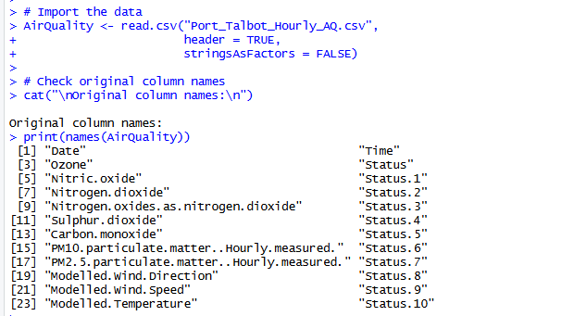
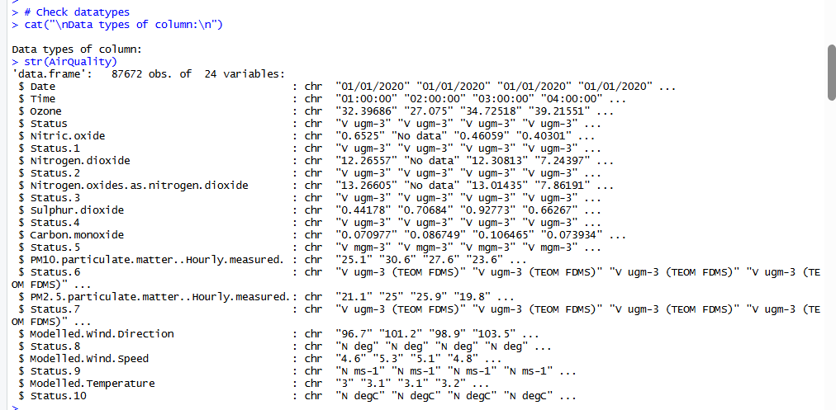
After completing data preparation, it was found that the cleaned dataset has been containing about 87,672 observations and 25 different variables, which clarifies that this dataset is providing a detailed record for hourly air quality measurement.
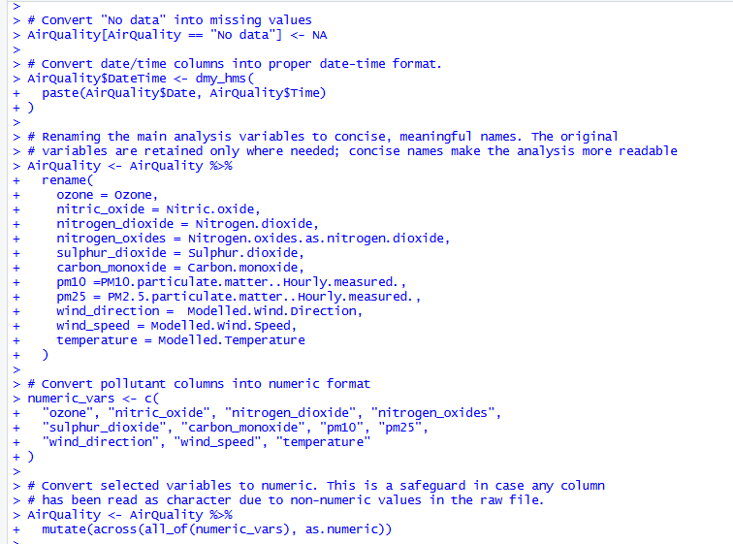
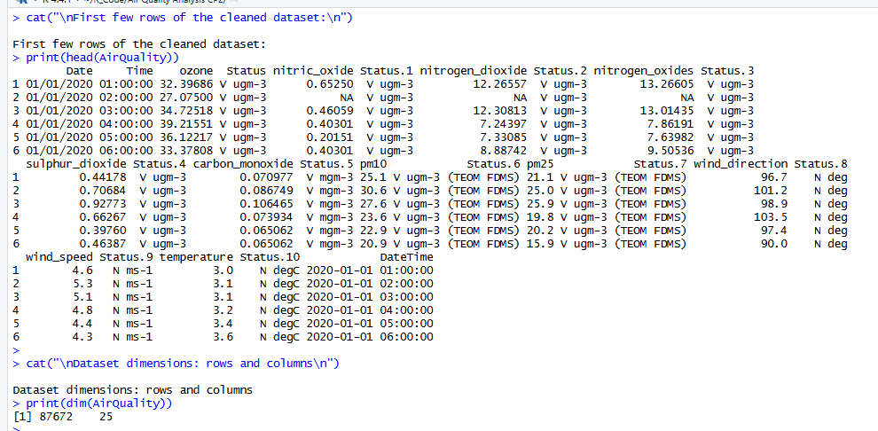
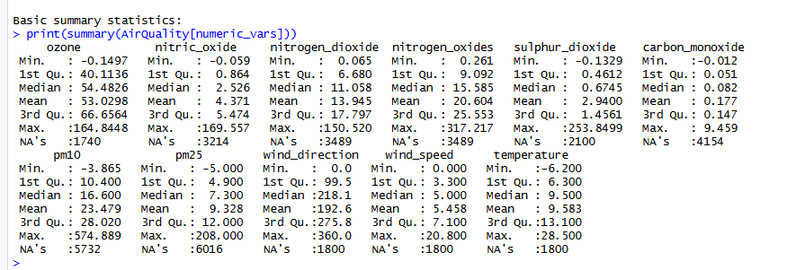
Summary Statics were then being generated for only the selected variables, based on which their distribution would be examined, while clarifying their central tendency and missing values before further proceeding with the graphical exploration.

Step 2: Exploratory Visualisation
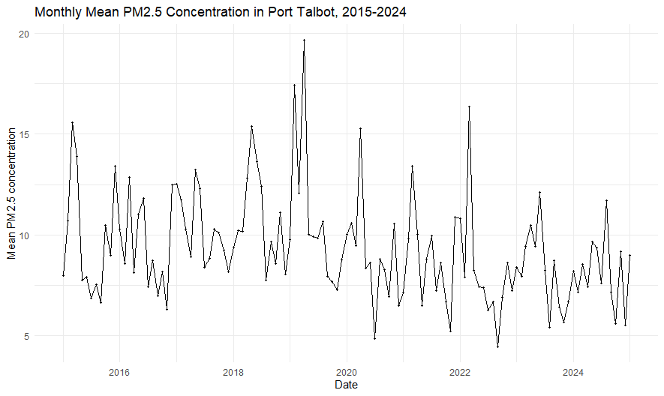
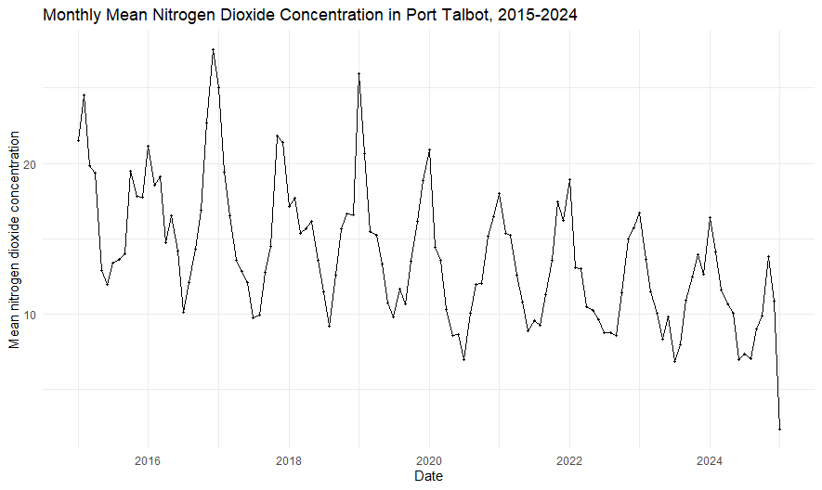
A Time-Series graph has been generated for PM2.5 and that for the nitrogen dioxide, since the dataset used here was containing hourly air quality data which were representing the time frame between 2015-to-2024. Hence, monthly average values were used here for presenting each of the long-term trends with more precision, so as to effectively reduce any effects of overly crowded hourly data [5].
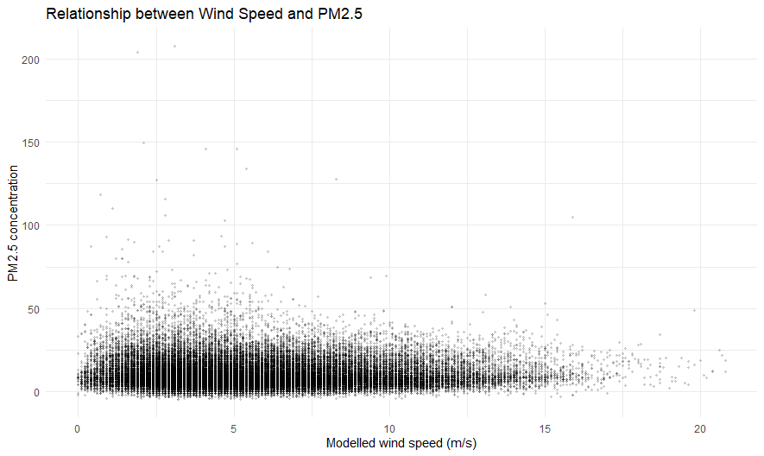
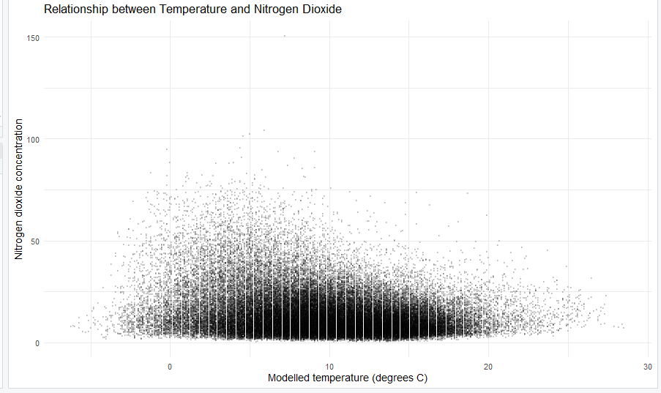
The scatterplot results highlights how increase in wind speed is responsible for lowering the concentration of PM2.5 in the air [1]. This same result is also obtained in case of nitrogen dioxide, where with a slight rise in temperature, the concentration of nitrogen dioxide lowers exponentially.

Step 3: Correlation Analysis
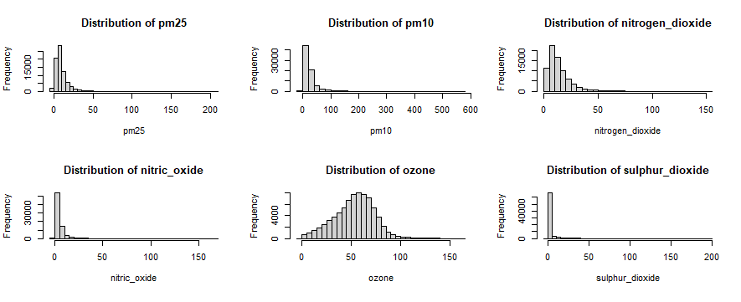
A generalized correlation analysis has been performed for investigating the basic relationship among different selected air pollutants, that has been including PM2.5, PM10, nitrogen dioxide, nitric oxide, ozone, as well as sulphur dioxide, respectively. Before further selecting the desired correlation methods, significant pollutant distributions were examined, and as a result, it was discovered that most of the data were right skewed with several extreme values.
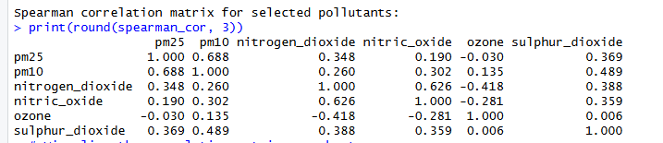
For this purpose, Spearman correlation method has been selected, as it seemed more appropriate to be used for any non-normally distributed environmental data [2]. During analysis, the correlation matrix have revealed that PM2.5 and that of PM10 were having a strong positive relationship with r=0.688, while nitrogen dioxide and nitric oxide were showing strong positive relationship with each other with an r=0.626. Compared to these strong connections, ozone is showing a moderate negative relationship within the nitrogen, with r= -0.418, while suggesting that these pollutants were not all similar under same environmental condition.
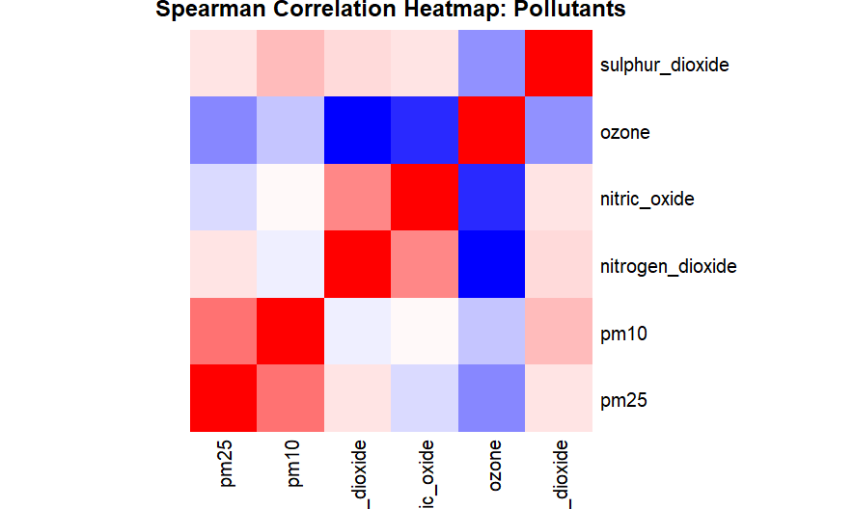
A very strong connection is seen in between particulate pollutants and that of the nitrogen-based pollutants. While the ozone is showing negative relation with certain of the nitrogen compounds, respectively.
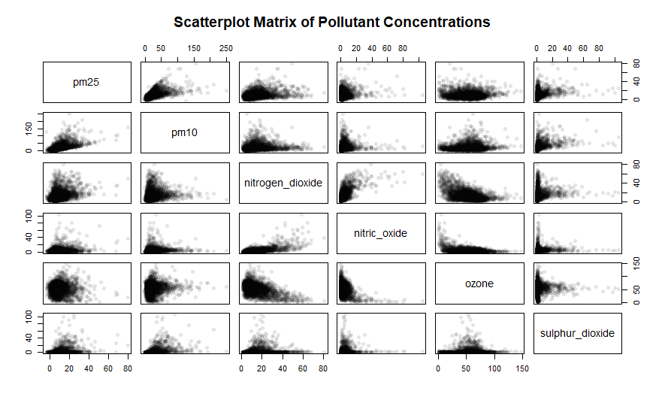
During inspection, it was found that most of the plots at Scatterplot were showing positive trends among each pollutant with much stronger correlations, whereas only the ozone is showing an opposite pattern when is being compared with a nitrogen-related pollutants [4].

Step 4: Hypothesis Test — Two Conditions
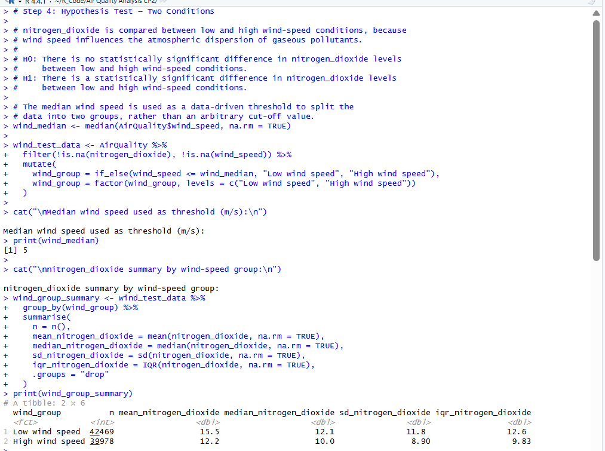
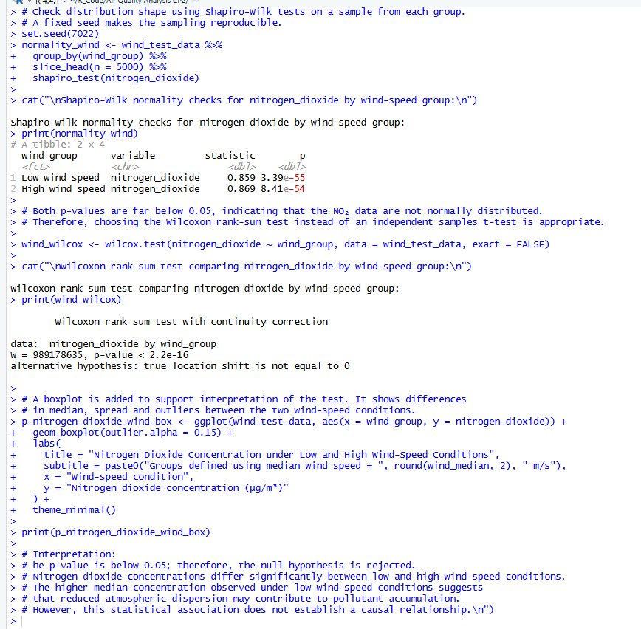
With the focus of finding out whether wind speed is being able to affect nitrogen dioxide levels, the nitrogen dioxide values were being separated into two different groups as per the wind speed. The selection of wind speed has been made because it has its influence on pollutions which move through the air. When wind speed is low, politics found to be remained within same area for a longer time, while within stronger winds it allows to carry the pollutants within different parts. Rather than selecting a wind speed value in a random manner, the median wind speed of 5 miles per hour has been utilized in the process of dividing the data into two equal groups. All observations with a wind speed of five miles per hour or below have been included in the process of low wind speed group, while observations which are above 5 miles per second were included in the high wind speed group. Where by making use of the median value, a fair and consistent method is provided to make a comparison of nitrogen dioxide levels within different wind conditions.
- Null hypothesis (H₀): There is no statistically significant difference in nitrogen dioxide concentrations between low and high wind speed conditions.
- Alternative hypothesis (H₁): There is a statistically significant difference in nitrogen dioxide concentration between low and high wind conditions.
Before selecting an appropriate statistical test, the distribution of nitrogen dioxide concentration within each of the wind speed group was assessed using the Shapiro-Wilk normality test. The results indicated statistically significant departures from normality for both groups (Low wind speed: W = 0.859, p = 3.39 × 10⁻⁵⁵; High wind speed: W = 0.869, p = 8.41 × 10⁻⁵⁴). Considering the fact that as both the P values were substantially below the 0.05 significance level, the assumption of normality was not satisfied [7]. Consequently, the Wilcoxon rank-sum test was selected instead of an independent-samples t-test, as it is more appropriate for comparing two independent groups when the data are non-normally distributed.
The summary statistics demonstrated clear differences between the two wind speed groups respectively. Particularly focusing on the low wind speed group, which included 42,469 observations. The average nitrogen dioxide concentration in this group was 15.5 µg/m³, while the median concentration was 12.1 µg/m³. In comparison of both the high wind speed group contained 39,978 observations on an overall basis with a lower average concentration of 12.2 µg/m³ and a median value of 10.0 µg/m³. The overall spread of the entire data was also much wider in the low wind speed group with an Interquartile range of 12.6 µg/m³ compared with 9.83 µg/m³ in the high wind speed group.
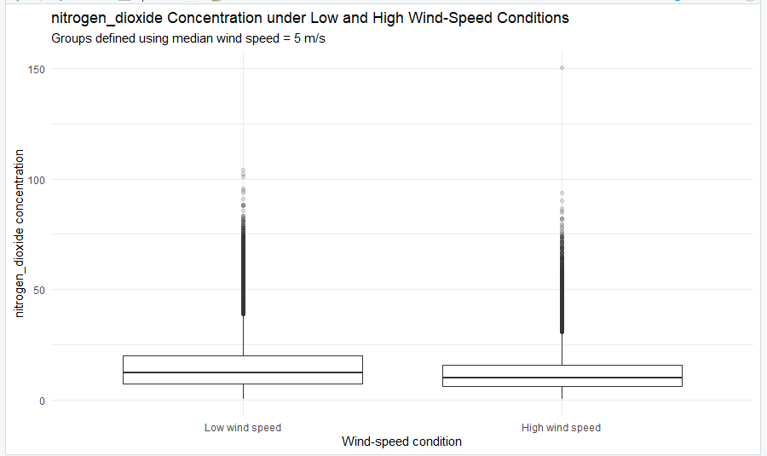
The box plot gives a clear visual comparison of the nitrogen dioxide concentration under low and high wind speed conditions, respectively. It shows that the median concentration is higher when the wind speed is low than when it is high. Although there are some unusually high values in both groups most of the nitrogen dioxide measurements are higher in the low wind speed groups [9]. This matches the result of Wilcoxon's rank some test which found a significant difference between the two groups. one possible explanation is that weaker winds do not carry pollutants away as effectively, allowing the nitrogen dioxide to remain in the air for a longer duration. Therefore, stronger winds help to spread pollutants over a wider area which may reduce their concentration significantly [10]. Therefore, the results suggest that lower wind Speeds are actually linked with higher nitrogen dioxide levels in the Port Talbot area.

Step 5: Seasonal Group Comparison
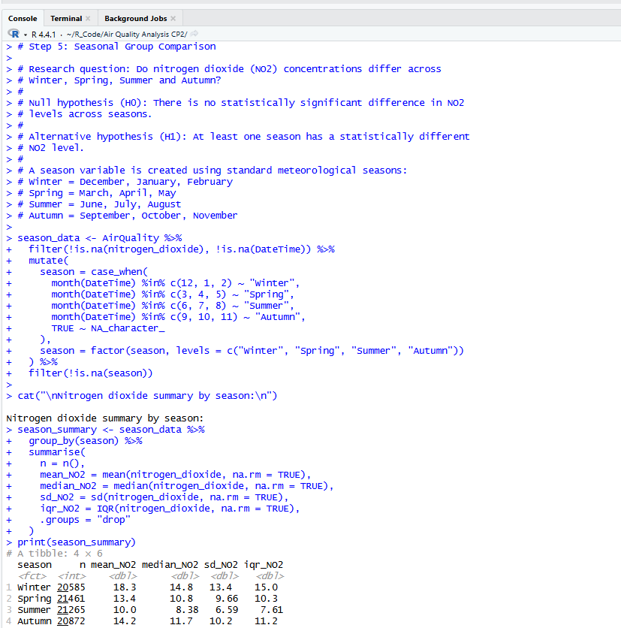
A seasonal comparison was carried out here to determine whether nitrogen dioxide concentrations varied across winter, spring, summer and autumn.
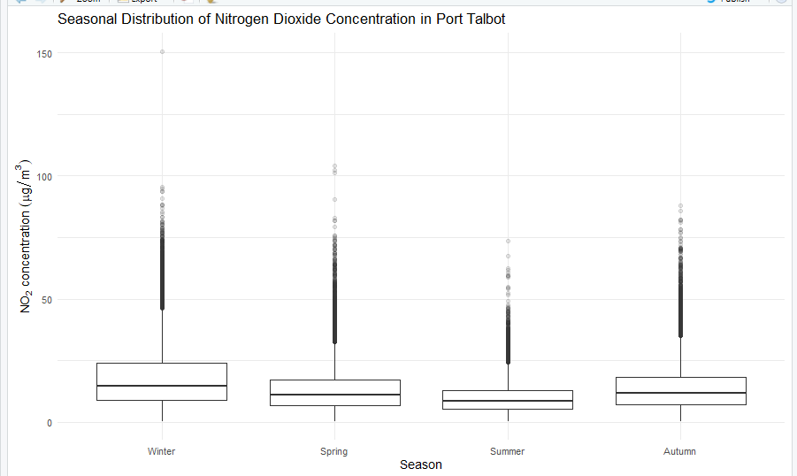
A box plot was actually created to compare nitrogen dioxide concentrations across the four seasons: Winter, Spring, Summer and Autumn.
This graph was actually selected because it clearly demonstrates the median values and spread the data and also identifies any unusual values in each of the seasons respectively. This may makes it a lot easier to see whether nitrogen dioxide levels changes throughout the year or not.
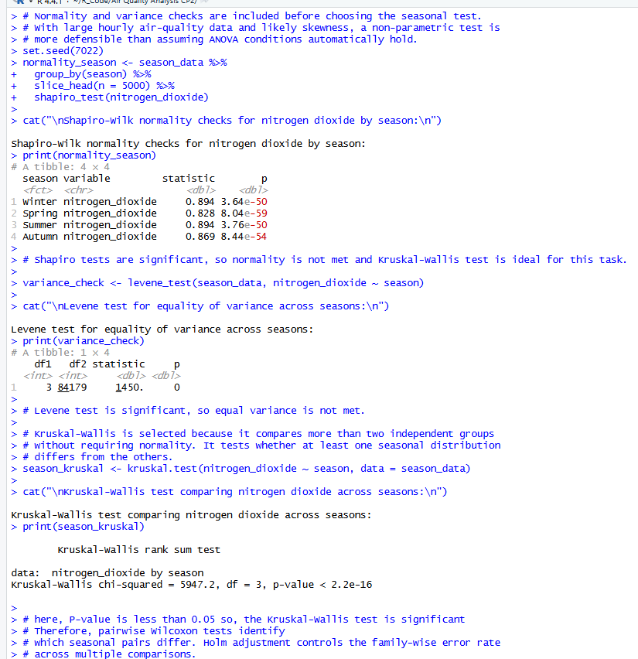
Before selecting a statistical test, the data were checked to see and identify if they met the assumptions for a parametric test. The Shapiro-Wilk test demonstrated that the data were not normally distributed in any of The Four Seasons. Lebanese test also demonstrated that the variations was not the same across each of the groups. Since these assumptions were not met the Kruskal-Wallis test was used because it is suitable for comparing more than two independent groups with non-normal data. Particularly looking at the hypotheses for the test that were involved are:
Null hypothesis (H₀): It is important to consider the fact that there is no significant difference in the nitrogen dioxide concentration between the 4 seasons at all.
Alternative hypothesis (H₁): At least one of the seasons has a different nitrogen dioxide concentration.
The Kruskal–Wallis test gave a value of χ² = 5947.2 with a p-value less than 2.2 × 10⁻¹⁶. Since the p-value was much smaller than 0.05, the null hypothesis was rejected. This means that nitrogen dioxide concentrations are not the same across all four seasons.
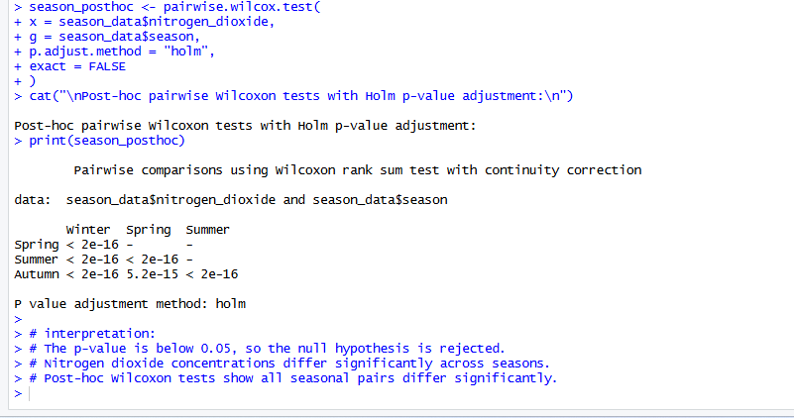
Pairwise Wilcoxon post hoc tests with Holm adjustment further confirm statistically significant differences between all the season pairs, suggesting that seasonal weather conditions and pollutant dispersion strongly influenced the nitrogen dioxide levels in the Port Talbot area.

Task 2: Reflective Summary
Approach to Analysis
I have started my analysis by having or detail examination of the structure of the Port Talbot air quality dataset before I applied statistical methods to it. As the dataset contains hourly observations from the year 2015 to 2024, where to make sure that a reliable and accurate analysis would take place, some careful preparation is needed. Where I have analysed the variable names, data types, and dataset structure in order to confirm that the data has been imported in a correct manner within R. Where entries which were recorded as “No data” has been converted into missing values. Also, a datetime variable was created, and important variables has been renamed. Then pollutant and weather variables have been converted into numeric format for making correct analysis [4].
Visualisation Reflection
I have made a selection of different types of visualisation methods because each one contributes to the process of explaining a specific part of the analysis. Monthly time-series graphs have been visualised for PM2.5 and nitrogen dioxide to have an analysis of details related to how the levels of pollutants have been changed over time. Where the use of monthly averages instead of hourly records made the patterns easier to understand because the main dataset contains a very large number of observations. Scatterplots have to visualised to have an analysis of possible relationships between PM2.5 and wind speed, and between nitrogen dioxide and temperature [2]. To have a comparison between nitrogen dioxide levels across different wind-speed groups and seasons Boxplot has been created.
Statistical Choices
The decision of selecting a statistical method was being made based on the characteristics of the dataset instead of making use of standard tests automatically. The pollutant data has been analysed first, and results have highlighted that is not being able to meet the assumptions for a normal distribution. Due to this, I have made use of Spearman correlation, because it is suitable for have an analysis of relationships which are present in uneven environmental data. The selection of the Wilcoxon rank-sum test has been made to make a comparison between nitrogen dioxide levels between low and high wind-speed conditions. This has been done because it provides dependable results for two independent groups without the requirement for normally distributed data [6]. In a similar manner, the Kruskal-Wallis test has been utilised to make seasonal comparisons.
Challenges and Solutions
Different types of challenges have been faced in the process of completing the analysis. One issue involved the “No data” entries, as these values have caused some variables to be stored as character data instead of numeric values. I have solved this problem by converting them into missing values before starting the analysis. Then, another challenge for me was the highly uneven distribution of pollutant measurements, which have made parametric statistical tests unsuitable. To deal with this challenge, I had to first analyse the data distribution and then select an appropriate non-parametric method.
Learning and Future Improvements
This complete project contributed to improving my level of understanding of data preparation, visualisation, and statistical analysis in R. I have learned the importance of selecting the correct methods on the basis of data characteristics. Where I am going to use regression and time-series modelling to have more detailed and better insights into long-term air quality patterns. If I have to repeat this analysis, I would include regression analysis and time-series modelling in order to have an analysis of the combined influence of multiple weather variables on pollutant concentrations.

Generative AI Use Statement
No generative AI tools have been utilized in the process of creating this assignment. All data preparation, R programming, statistical analysis, interpretation of results and report writing have been completed in an independent manner. By making use of my own knowledge, practical work, and on the basis of understanding of assignment requirements.

References
[1] E. Wójcik-Gront and D. Gozdowski, “Air Pollution Monitoring and Modeling: A Comparative Study of PM, NO₂, and SO₂ with Meteorological Correlations,” Atmosphere, vol. 16, no. 10, p. 1199, 2025.
[2] Y. Wu, X. Wang, M. Wang, X. Liu, and S. Zhu, “Time-series forecasting of PM2.5 and PM10 concentrations based on the integration of surveillance images,” Sensors, vol. 25, no. 1, p. 95, 2024.
[3] Z. Kazi, S. Filip, and L. Kazi, “Predicting PM2.5, PM10, SO₂, NO₂, NO and CO air pollutant values with linear regression in R language,” Applied Sciences, vol. 13, no. 6, p. 3617, 2023.
[4] S. Shelton, G. Liyanage, S. Jayasekara, B. Pushpawela, U. Rathnayake, A. Jayasundara, and L. D. Jayasooriya, “Seasonal variability of air pollutants and their relationships to meteorological parameters in an urban environment,” Advances in Meteorology, vol. 2022, no. 1, Art. no. 5628911, 2022.
[5] P. Cheewinsiriwat, C. Duangyiwa, M. Sukitpaneenit, and M. E. Stettler, “Influence of land use and meteorological factors on PM2.5 and PM10 concentrations in Bangkok, Thailand,” Sustainability, vol. 14, no. 9, p. 5367, 2022.
[6] M. N. Ibe, “Seasonal and temporal patterns of urban air pollutants and their differential influence on the air quality index: A comparative empirical study,” International Journal of Engineering Research & Technology (IJERT), 2026.
[7] T. F. Ediagbonya, J. I. Uche, V. O. Akpojivi, and D. O. Ijisemi, “Seasonal variation and health risk of atmospheric nitrogen dioxide in Ondo State, Nigeria,” Discover Public Health, vol. 23, no. 1, p. 1, 2026.
[8] H. Arima, “Seasonal variation in air pollutant levels and its effects on the sex ratio at birth on Fukue Island, Japan,” BMC Public Health, vol. 23, no. 1, p. 2471, 2023.
[9] M. Kida and S. Ziembowicz, “The impact of seasonality on air quality in terms of pollution with substances hazardous to the environment,” Applied Sciences, vol. 15, no. 12, p. 6551, 2025.
[10] E. Wawryk-Gawda, N. Miga-Orczykowska, J. Matusiak, D. Mańdziuk, K. Giżewska, and V. Opoka-Winiarska, “Air pollution exposure and the burden of pediatric upper respiratory tract infections in emergency departments: A retrospective time-series study,” European Journal of Pediatrics, vol. 184, no. 12, p. 753, 2025.

