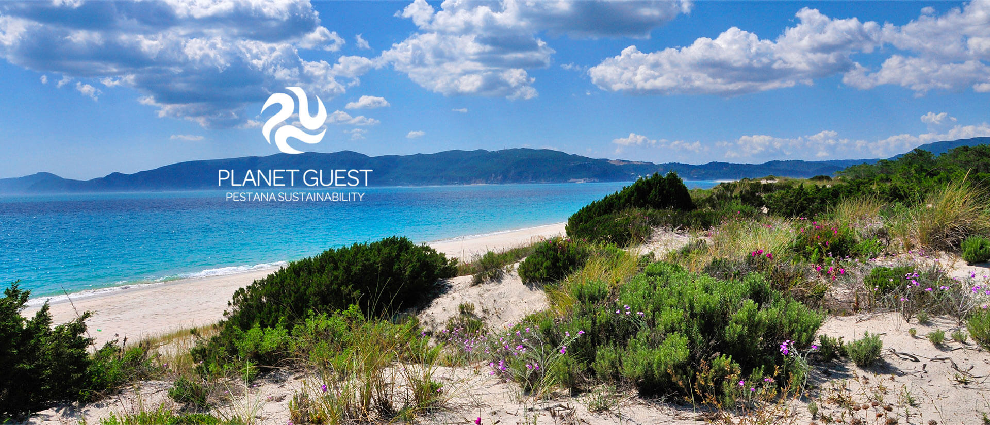
Programme: BA International Hotel Management
TITLE: Sustainable Hospitality and Tourism Management
Module code: M6X01925
Lecturer: Abdi Rahman

Pestana Tróia Eco-Resort
Student name:Elza Soares Student Number:1815430



Table of Contents
- Introduction
- Sustainability definition
- Sustainable good practice
- sustainability; tourism impact
- Pestana Tróia Eco-Resort
- Describe tourism
- Sustainability in Hospitality
- Eco-Tourism

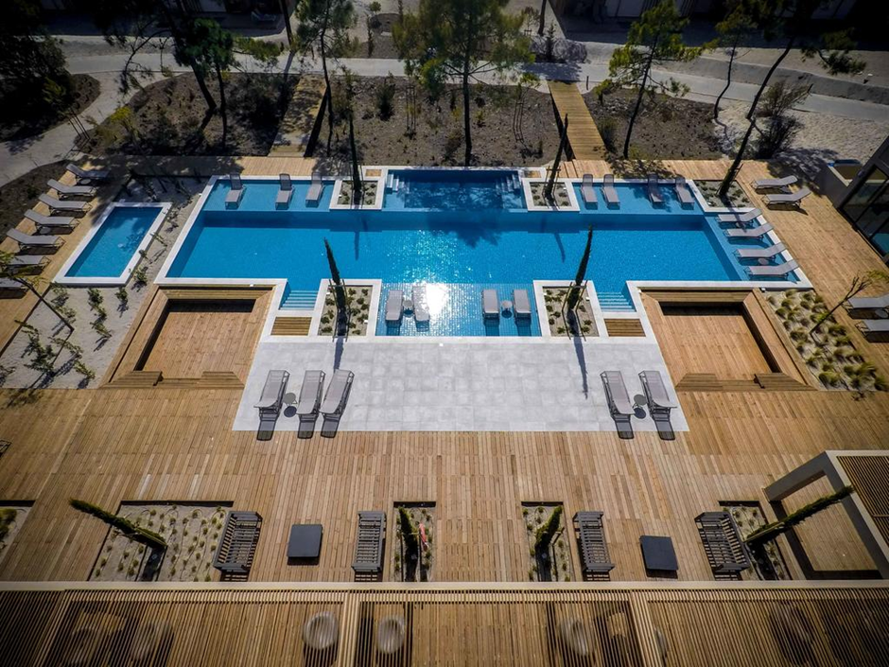

Introduction
In this admirable work, it provides a good overview of the debate and challenges of sustainability. It is well supported by theory and studies and is written in a clear and convincing manner. Sustainability has become a priority problem today, climate change, the economy, are the environmental challenges of the century, existing industries are implementing new strategies to comply with the legislation and maintain their licenses. Blowfield.(2020)
In the last decades, tourism has grown remarkably at an economic, cultural and social level, after decades of ignoring the environmental impacts.
the growth of climatic worlds society is becoming aware of the serious causes that this has become, threatening the cultures and ecologic in vulnerable tourist destinations.
Sustainability and a positive response is a determining factor for the future of tourism and hospitality and should be studied, used for development and environmental protection.
Through studies, deepen the knowledge of sustainability in this sector and adopt more ecological measure Pestana Tróia Eco-Resort Group on the Alentejo Coast, on the right track on sustainability of new green practices. At the applying the Sullivan matrix, it is concluded that the departments with greater diffusion and the infusion of ecological measures is the control of energy and air and, although the main obstacle the adoption of new environmental practices seems to be the high initial value investment, lack of knowledge about available alternatives and their impact on the hotel the routine was also evident. In a world that seeks new models of growth and economy rapid development, the fight against climate change and the adoption of good practices are not only considered an option or trend but a condition for survival and the success of the hotel sector. (www.pestana.com)

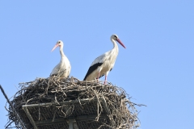
Sustainability
Through the dynamism of sustainability, all people will be able to improve and realize their potential, so that they can have a better quality of life and healthier support to the planet
(https://www.forumforthefuture.org/)

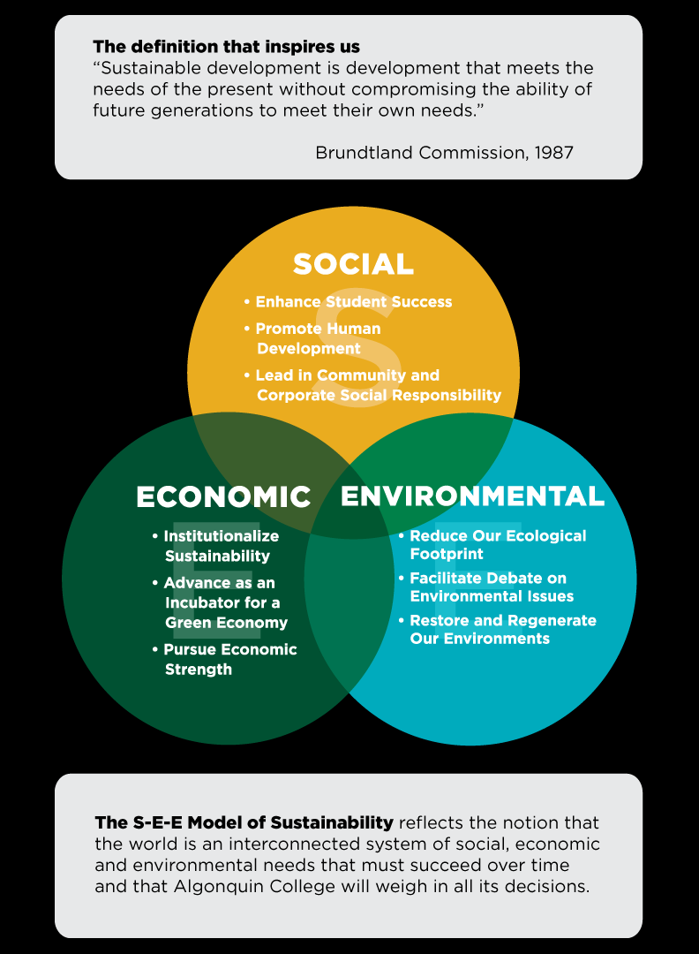
youtube.com (2020)
Today's society faces many environmental problems, we have to use sustainability efficiently to have a more positive impact, for that, we have to define the processes and actions, avoid the depletion of natural resources so we can have an ecological balance and greater life quality.
(https://youmatter.world/en/)
Sustainable good practice some examples
- Renovation and boldness
- Respect for the local ecosystem
- Preferential use of eco-efficient equipment
- Co2 reduction
- Uses recycled material and to recycle
- Reduce public water consumption
- Make hotels real and future, self-sufficient, depends exclusively on seawater
- Requalification of existing civil infrastructure
- Reduction in the cost of m3 of water (Grupo Pestana)

Sustainability in Hospitality
With the importance of sustainability for the hospitality and tourism industry, there was a concern to incorporate sustainability into universities and vocational training and tourism schools. Deale. (2009). And in determining the attitudes of stakeholders in hospitality and tourism towards teaching sustainability in the curriculum Barber.(2011). This study takes the discussion away from the case of sustainability being taught in the hospitality and tourism curriculum towards a debate on how to teach sustainability best. B. Bynum Boley(2020)
• Occupational safety, health and hygiene policies, improving quality of life with an impact on safety, health and hygiene at work
  - These factors strongly influence the quality of service, which is why they receive individual attention in daily activity. The concerted management of these aspects allows us to ensure a safe and healthy work environment.
  - Contributing so that everyone also has access to a perception of that bet. Service quality, combined with
  - safe facilities, prepared to respond to emergencies and guided by strict criteria of quality and food safety, will undoubtedly protect health.
• The Pestana Group has become the first global hotel group to issue a green bond issue, in accordance with the principles of the ICMA (International Capital Markets Association).
• Due to the high interest registered in the European market, it was a success, with demand exceeding supply three times.
• The green bond classification was certified through the issuance by DNV.GL of a second party opinion.
• Green bonds are issued to finance investments in projects that respect the principles of sustainability. These projects were developed from scratch: Pestana Tróia Eco-Resort and Pestana Blue Alvor.
The entrepreneur must seek solutions that contribute to the sustainability of his activity and society, thus generating benefits not only for his clients but also for the place in which he is inserted.
The entrepreneur should seek alternatives that minimise its impact, such as water reuse, energy and water savings, among others.
Primary factors to be observed in tourism planning:
- non-adoption of mass tourism;
- develop structures compatible with the environment in which you want to install;
- demonstrate to your client the profile of tourism that you want to build.

Eco-tourism
Ecotourism is travelling with responsibilities. We must conserve what nature offers our well-being, training employees and the population, in general, to instil the importance of ecotourism in the best way. Focus on local cultures, conciliar how to live to improve the future of leaving bad habits..TIES.(2015).Western Samoa, National Ecotourism Programme)

Conservation
We have to offer solutions not only for the moment but for the long term, eco-tourism and conservation, protecting the planet, heritage and communities.
Creating local jobs to help fight poverty and achieve more sustainable development
Interpretation
the enrichment of personal experiences and environmental awareness through interpretation, ecotourism helps promote greater understanding and appreciation for nature, local society and culture.
Principles of ecotourism
Having a functional plan to minimize physical, social, behavioral and psychological impacts, so communities and sustainable travel can be more conserved, Reducing physical, social, behavioral and psychological impacts as much as possible.
- Be aware of and respect for the environment and culture.
- Give positive experiences to visitors and hosts
- Provide direct financial benefits for conservation.
- It generates financial benefits for the local population and private industry.
- Offer memorable interpretive experiences to visitors that help to increase sensitivity to the political, environmental and social climate of the host countries.
- Design, build and operate low-impact facilities.
- Recognise the religious rights and beliefs of indigenous peoples in your community and work in partnership with them to create empowerment. (https://ecotourism.org/)

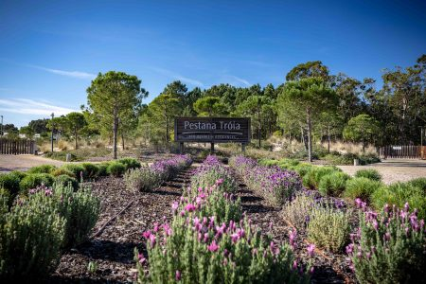
Pestana Tróia Eco-Resort
Since its founding in the 70, the Group has been expanding its activity, either nationally or internationally. Although only in 2009, we decided to report our performance and management approaches, our performance has always been based on the principles aimed at business sustainability in its different aspects.
A company with significant growth and continues its internationalisation process for hotels with a consolidated presence in 9 countries - Portugal, England, Brazil, Argentina, Venezuela, Mozambique, South Africa, Cape Verde and São Tomé and Príncipe. These are planned openings in the United States.
ECO-RESORT
ecosystem
• Carefully designed ecological buildings
• important to know: minimize its impact, use materials but with care not to damage nature.
• renewable energy
• Study the environment to preserve the local pestanatroia@pestana.com)

PESTANA PLANET GUEST
MOTTO
Corporate identity for the transversally of Social Responsibility in the Pestana Group: PLANET GUEST, Pestana Sustainability Program, with the slogan "We are just guests on the Planet".
That incorporates all the initiatives that promote the sustainability of the Pestana Group in its three main areas: Nature, represented by the green line, society by the orange line, and economy by the blue line.
PLANET
MOTTO
In the Pestana Group: this group has a social responsibility PLANET GUEST, this program promotes sustainability and focuses on 3 main areas: Nature that is represented by green, orange represents society and blue represents economy. Employees and guests respect the values ​​of the environment, society and business ethics as factors responsible for the balance of the world in which we live.
It is with this slogan that they demonstrate a posture of deep respect and gratitude towards the planet on which we live and of our responsibility for future generations. (www.planetguest.com)
At Eco-Troia, they addressed the great bet on preserving the environment from its roots, with an impact on the natural environment, giving value and being concerned with the heritage and local history, the culture of the communities and with local suppliers, this experience has given very positive result.DL Edgell Sr. (2019)
The values ​​that promote:
• Positive and proactive attitude;
• enthusiasm and friendliness;
•Team spirit;
• ethics and responsibility;
•Better quality;
• Renovation and boldness.
(www.planetguest.com)
At Eco-Troia, they address the impact on the natural environment, are concerned with the heritage and local history, the culture of the communities and bet on local suppliers, producing positive economic results and quality of growth for the tourism industry. So local communities, the private sector, non-profit organisations all benefit from it. DL Edgell Sr. (2019)
The values ​​that promote:
- Positive and proactive attitude;
- Enthusiasm and friendliness;
- Team spirit;
- Ethics and responsibility;
- Better quality;
- Renovation and boldness.

Sustainability tourism impact
Tourism is responsible for the most significant human migration in history, with negative and positive consequences for the protection of nature, society, economy and cultures, of course, there are economic benefits. The doubling of tourism in the coming years is inevitable, and the multiple consequences of rapid growth requiring a professional and strategic preventive approach to avoid intense negative impacts. Tour operators play significant roles in affecting changes in behaviour and attitudes towards more responsible forms of tourism. The new reality is mass tourism that can be neglected by efforts to support sustainable tourism. There is a large and rapid spate of tourist resorts with a significant negative impact on the environment (Journal of Cleaner Production)
Tourism generates enormous wealth in the world today; it is estimated that tourism is among the top 5 exporters
Comparing export earnings from different industrial sectors, tourism ranked first in 1998 (Fig. 1), surpassing all other categories of international trade; this is a crucial reason for the preference of tourism by investors in relation to other economic sectors.
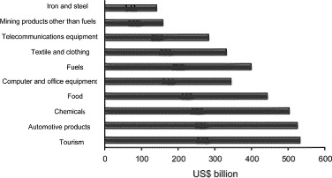
Figure 1
Worldwide exports earnings (1998. Source: WTO, 2000)
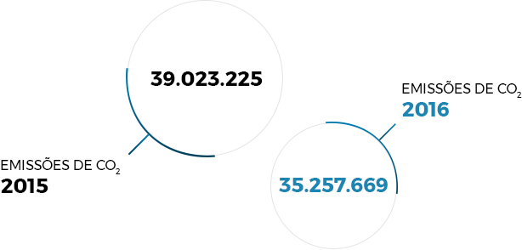
Fig 2
(sustainability reportshttps://www.pestanagroup.com/pt/sustainabitity)

  - The Pestana Group has become the first global hotel group to issue a green bond issue, in accordance with the principles of the ICMA (International Capital Markets Association).
  - Due to the high interest registered in the European market, it was a success, with demand exceeding supply three times.

Conclusion
Tourism is a right for everyone, as is the quality of life for human beings, dependent on environmental quality. Tourist practice is only viable if it is economically sustainable, socially compatible, and that contributes to conservation with knowledge and correct use of its attractive base, the environment.
Understanding the cause and types of impacts generated by tourism on the environment is essential in its planning, development and management, as demonstrated by this work.
Management that has to know how to manage in order to maintain the environmental integrity of its service/product and the quality of the tourist experience. It must be borne in mind that demand will continue to increase, with more and more segmentation of the market, which requires the design of specialised products, with environmental responsibility, but without detriment to comfort convenience and quality. The tourist is increasingly demanding and autonomous, is concerned with ethical and ecological issues, so the industry must know how to deal with this change in perceptions and attitude of the
consumer. However, the economic component must cease to be a priority, and environmental, cultural and economic balance is necessary, equity between the three axes. That is not at all impossible, as is the case with this investigation, only a little confusing until the hedonistic and consumerist thinking of today's society is changed.
The transition to sustainable tourism requires a reorientation of its development by the public and private sector. There is a long way to go towards sustainability in tourism, which is expected to be increasingly demanded by
consumers (who are aware of their environmental responsibility, but who themselves are far from living in a conservationist society). In this context, the Eco Troia Project emerges as an innovative example of sustainable tourism development, with the quality and comfort essential today.
Give value to the local economy through an integrated and sustainable tourism project of unrivalled quality in the country, with environmental, economic and socio-cultural benefits that will spread in the long term. I think I also managed to respond to the
second starting question, verifying that project management is innovative management.

References:
Blow field. M (2012) Business and Sustainability,OUPOxford
Boley.B Bynum.(2013) Boley, B.(2011). Sustainability in Hospitality and Tourism Education: Towards an Integrated Curriculum. Journal of Hospitality & Tourism Education, 23(4), pp.22-31.
Boley, B. (2011). Sustainability in Hospitality and Tourism Education: Towards an Integrated Curriculum. Journal of Hospitality & Tourism Education, 23(4), pp.22-31.
Barber, N., Deale, C. and Goodman, R.(2011) Environmental Sustainability in the Hospitality Management Curriculum: Perspectives from Three Groups of Stakeholders. Journal of Hospitality & Tourism Education, 23(1), pp.6-17.
Budeanu Adriana.(2020) Journal of Cleaner Production Volume 13, Issue 2, January (2005), Pages 89-91
Boley, B., 2011. Sustainability in Hospitality and Tourism Education: Towards an Integrated Curriculum. Journal of Hospitality & Tourism Education, 23(4), pp.22-31.
Barber, N., Deale, C. and Goodman, R., 2011. Environmental Sustainability in the Hospitality Management Curriculum: Perspectives from Three Groups of Stakeholders. Journal of Hospitality & Tourism Education, 23(1), pp.6-17.
Deale
https://ecotourism.org/(2020) Ecoturism
www.Guestplanet.com(2020)
Grupopestana.com (2020)
Journal of Cleaner Production Volume 13, (Issue 2, January 2005) Pages 89-97
planetguest@com (2020)
www.pestanatroia@pestana.com
www.planetguest.com(2020)
TIES (2015) The International
Western Samoa, National Ecotourism Programme)
Western Samoa (2020) National Ecotourism Programme)
www.youmatter.world/en/ (2020)
https://youmatter.world/en/ (2020)
(https://youmatter.world/en/ (2020)
(pestanatroia@pestana.com)
DL Edgell Sr, ( 2019)
(Journal of Cleaner Production) Volume 13, Issue 2, January 2005, Pages 89-97
B. Bynum Boley.( 2013)
(TIES, 2015).
(https://ecotourism.org/)
Sustainable Development - An Introduction to Two Theories - YouTube
youtube.com

