Requirement Analysis and Flowchart Solutions
Scenarios 1–10: Booking and Allocation Systems
Each scenario is solved using MoSCoW requirement analysis, identified variables, a standard pictorial flowchart, and a written explanation of the algorithm.

Scenario 1 – School Library Study Room Booking
A school library has six study rooms with different capacities. The booking process must prevent double-bookings and allocate each group to the smallest room that fits them — reducing wasted seats.

MoSCoW Requirement Analysis
Must Have | Should Have | Could Have | Won't Have
Check room capacity ≥ group size | Sort rooms by capacity for efficient search | Offer a waitlist when no room is available | Payment or membership verification
Prevent time-overlap double-bookings | Display booking confirmation with room and time | Send email confirmation to the requester | Integration with external calendar systems
Allocate the smallest fitting room (best-fit)

Identified Variables
Variable | Type | Description
groupSize | Integer | Number of people in the booking group
requestStart | Time | Requested start time of the booking
requestEnd | Time | Requested end time of the booking
roomCapacity | Integer | Maximum occupancy of a study room
spareSeats | Integer | roomCapacity − groupSize (smaller value = better fit)
roomBooked | Boolean | TRUE if the room has an overlapping booking at the requested time

Flowchart
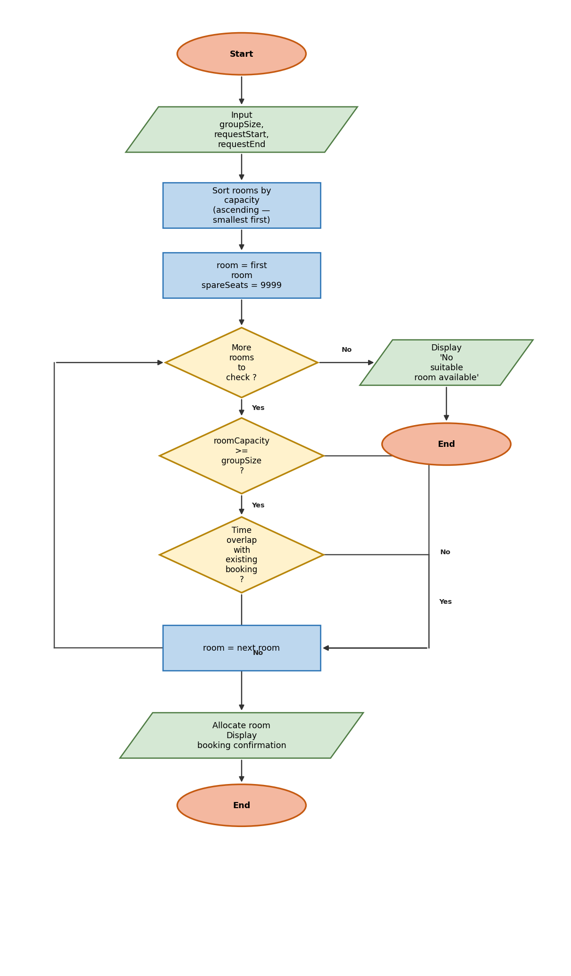

Written Explanation
The algorithm begins by collecting the group size and requested time window. Rooms are sorted by capacity in ascending order so that the smallest suitable room is always encountered first, minimising wasted seats. The algorithm then loops through each room, testing two conditions: the room's capacity must be at least as large as the group size, and no existing booking may overlap the requested window (an overlap exists when an existing booking starts before requestEnd and ends after requestStart).
The first room that passes both checks is immediately allocated. Because the ascending sort guarantees this is the room with the least spare capacity that still fits, no further comparison is needed — the best-fit result is obtained naturally without inspecting all rooms after the fact. If every room fails at least one check, the system reports that no suitable room is available for the requested time.
The time-overlap test is the critical safeguard against double-bookings. By comparing requestStart and requestEnd against every existing booking before confirming an allocation, the system enforces the rule that two bookings cannot share the same room and the same time window, which eliminates the paper-sheet errors currently experienced by staff.

Scenario 2 – Community Sports Hall Court Allocation
A sports centre with movable dividers needs to allocate the minimum number of consecutive court sections for each activity, based on the area the activity requires, while preventing section clashes.

MoSCoW Requirement Analysis
Must Have | Should Have | Could Have | Won't Have
Calculate sections needed from activity area requirement | Validate that sections are consecutive (contiguous layout) | Track which court markings (badminton/netball) are in each section | Manage physical deployment of movable dividers
Check that all required sections are free at requested time | Display allocated section numbers and booking confirmation | Allow section-type filtering by activity type in future | Handle equipment hire (separate system)
Allocate the minimum number of sections (no waste)

Identified Variables
Variable | Type | Description
activityArea | Number | Floor area required by the activity (square metres)
sectionSize | Number | Fixed area of one court section (constant, sq metres)
sectionsNeeded | Integer | ceil(activityArea ÷ sectionSize) — minimum sections required
startTime | Time | Booking start time
endTime | Time | Booking end time
sectionBooked | Boolean | TRUE if this section has an overlapping booking

Flowchart
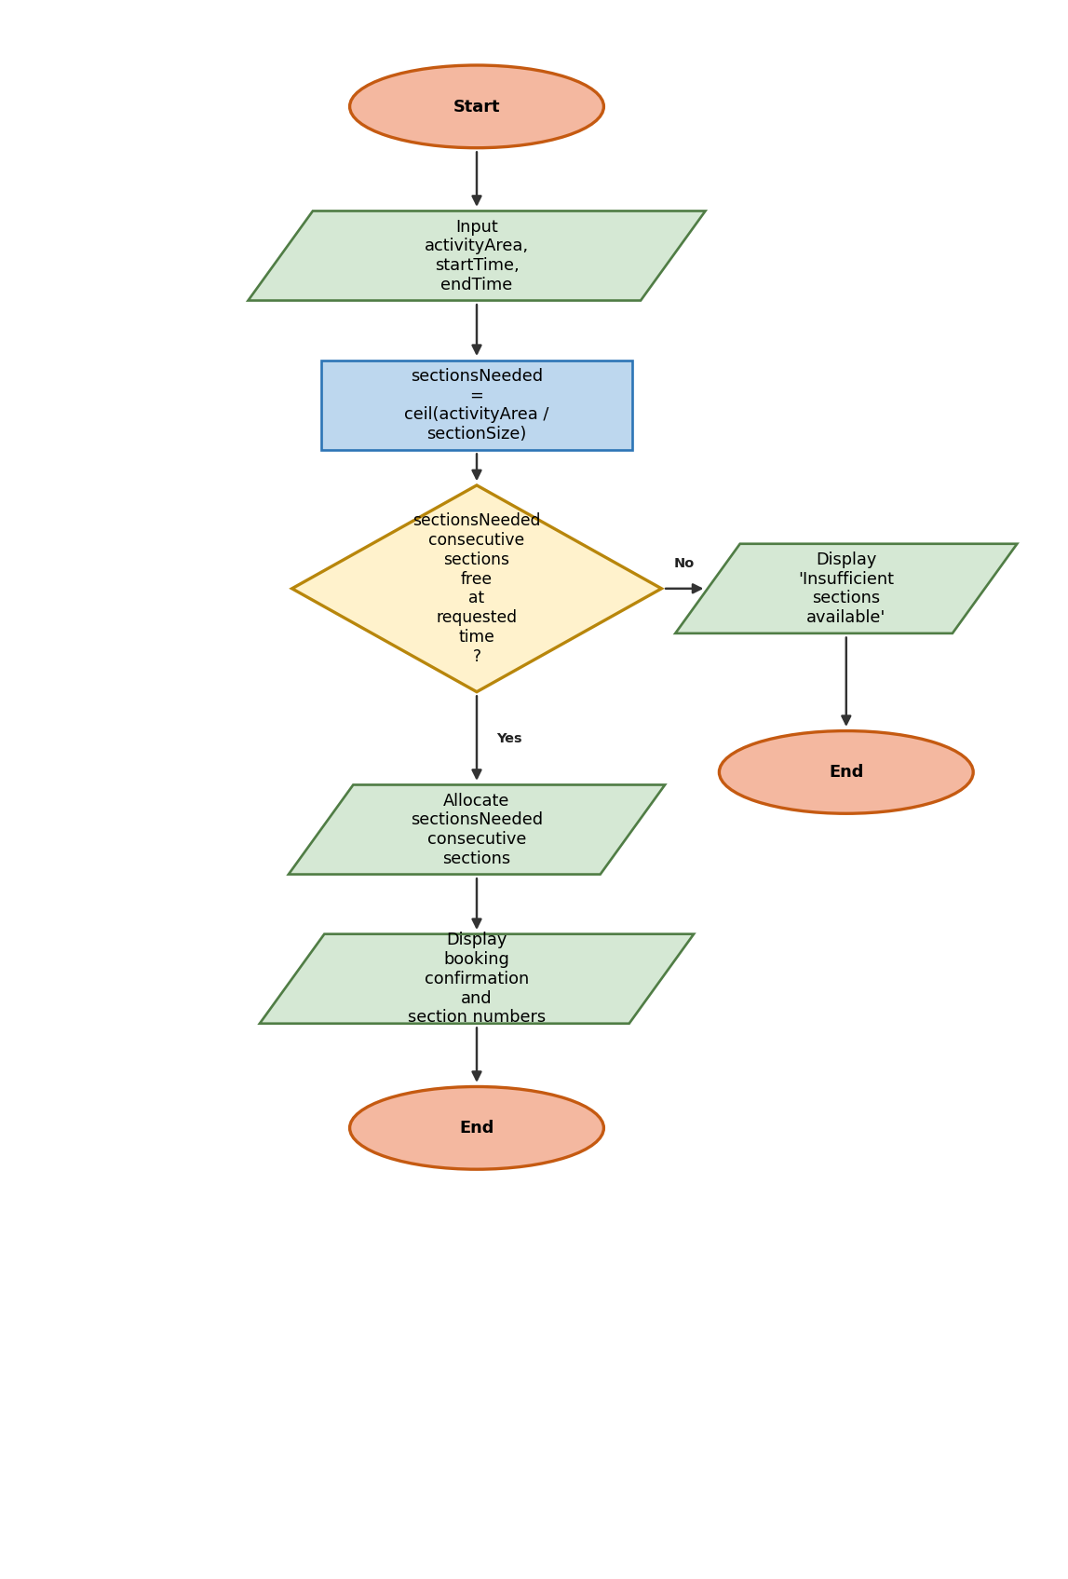

Written Explanation
The algorithm first calculates the number of court sections required by dividing the activity's floor area by the fixed size of a single section, rounding up to ensure sufficient space is always provided. This derived value — sectionsNeeded — drives the rest of the process and prevents staff from guessing how much space an activity needs.
The algorithm then checks whether sectionsNeeded consecutive sections are all free during the requested window. Consecutive sections are required because activities must occupy a contiguous area of the hall; non-adjacent sections would create unusable gaps and make the court layout impractical for participants.
If consecutive sections are available, the booking is confirmed and the section numbers are recorded. If not, the booking is rejected with an appropriate message. This approach prevents two common problems simultaneously: assigning too many sections (wasted space) and assigning sections that are already taken (clash).

Scenario 3 – IT Suite Computer Booking
An adult learning centre has three IT suites of different specifications. The system must place classes in standard suites first and only use the specialist suite when a class genuinely needs its capabilities.

MoSCoW Requirement Analysis
Must Have | Should Have | Could Have | Won't Have
Check suite capacity ≥ class size | Reserve specialist suites only for classes that need them | Notify IT staff before a specialist suite booking | Install software on demand
Verify required software is installed in the suite | Display which suite was allocated and the reason | Track software licence usage per suite per week | Manage student accounts or remote desktop access
Check graphics score meets class requirement
Prevent timetable clashes
Try standard suites before specialist ones

Identified Variables
Variable | Type | Description
classSize | Integer | Number of students in the class
softwareRequired | String | Name of the software the class needs
graphicsRequired | Integer | Minimum graphics performance score required
startTime | Time | Session start time
endTime | Time | Session end time
suiteCapacity | Integer | Number of workstations in the suite
softwareInstalled | Boolean | TRUE if the required software is installed in this suite
graphicsScore | Integer | Graphics performance score of the suite
suiteBooked | Boolean | TRUE if suite has a conflicting booking at the requested time

Flowchart
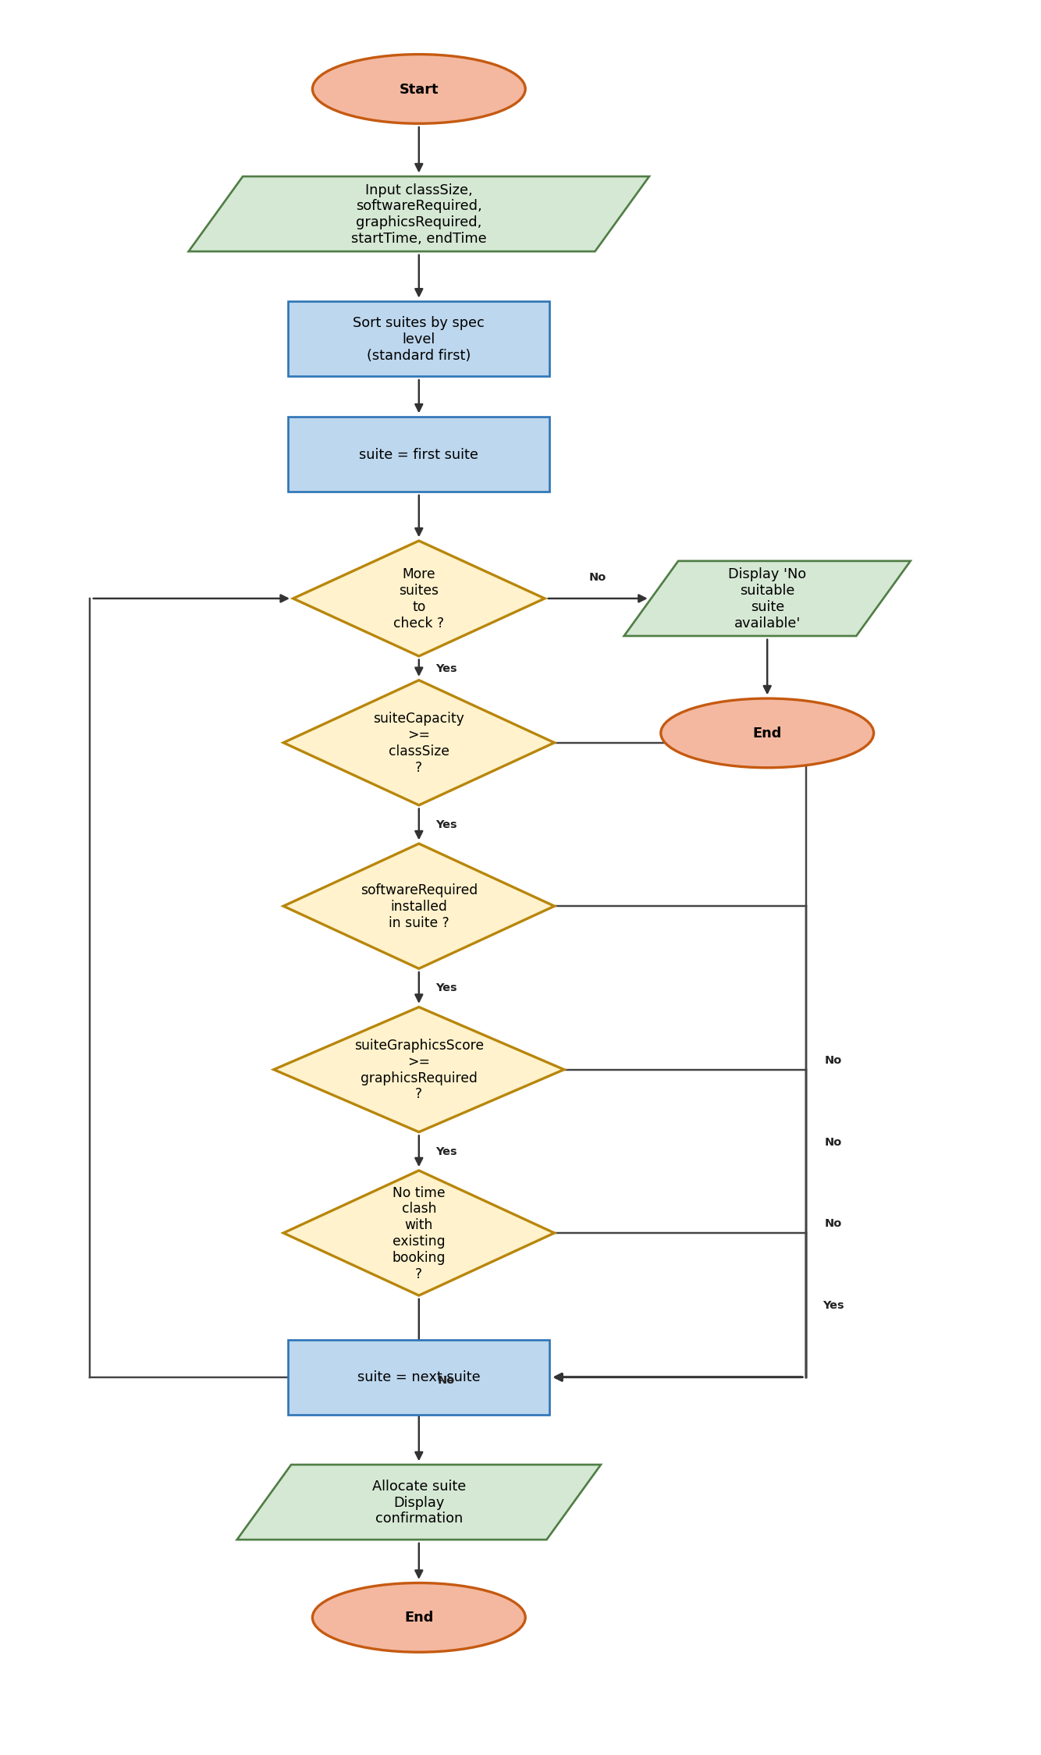

Written Explanation
The algorithm orders suites from lowest to highest specification before beginning its search, ensuring a standard suite is always evaluated before the specialist one. For each suite in turn, four conditions must all be satisfied: the suite must have enough workstations for the class size; the required software must be installed; the suite's graphics score must meet or exceed the class requirement; and the suite must be free at the requested time.
Checking software and graphics requirements before confirming an allocation is the mechanism that reserves specialist rooms for classes that genuinely need them. A class requiring only standard software will pass the software and graphics tests in the first available standard suite and be allocated there immediately, never triggering evaluation of the specialist suite. Only when no standard suite qualifies will the algorithm evaluate the specialist suite, applying the same four-condition test.
If no suite satisfies all four conditions, the system reports that no suitable suite is available. This prompts staff to investigate whether the class could be rescheduled, whether a software requirement is genuinely necessary, or whether a class could be split across two standard suites.

Scenario 4 – School Minibus Trip Scheduling
A school with two minibuses and several drivers needs a process that selects the smallest vehicle with enough seats and simultaneously finds an available driver, while enforcing a buffer time between consecutive trips.

MoSCoW Requirement Analysis
Must Have | Should Have | Could Have | Won't Have
Check vehicle seats ≥ passenger count | Select the smallest suitable vehicle (best-fit) | Notify driver automatically via app or email | Plan the route or estimate journey time
Detect vehicle time clash including buffer after previous trip | Display vehicle, driver, trip details in confirmation | Log trip for mileage and vehicle maintenance records | Handle fuel cost calculations or approval workflow
Find an available driver with no schedule conflict
Allocate vehicle and driver together as a pair

Identified Variables
Variable | Type | Description
passengerCount | Integer | Number of passengers for the trip
tripStart | Time | Planned departure time
tripEnd | Time | Planned return time
bufferTime | Duration | Minimum gap required after a trip before the vehicle can be reused
vehicleSeats | Integer | Seat capacity of the vehicle being evaluated
vehicleBooked | Boolean | TRUE if vehicle has a conflict including the buffer period
driverAvailable | Boolean | TRUE if driver has no conflicting commitment during the trip

Flowchart
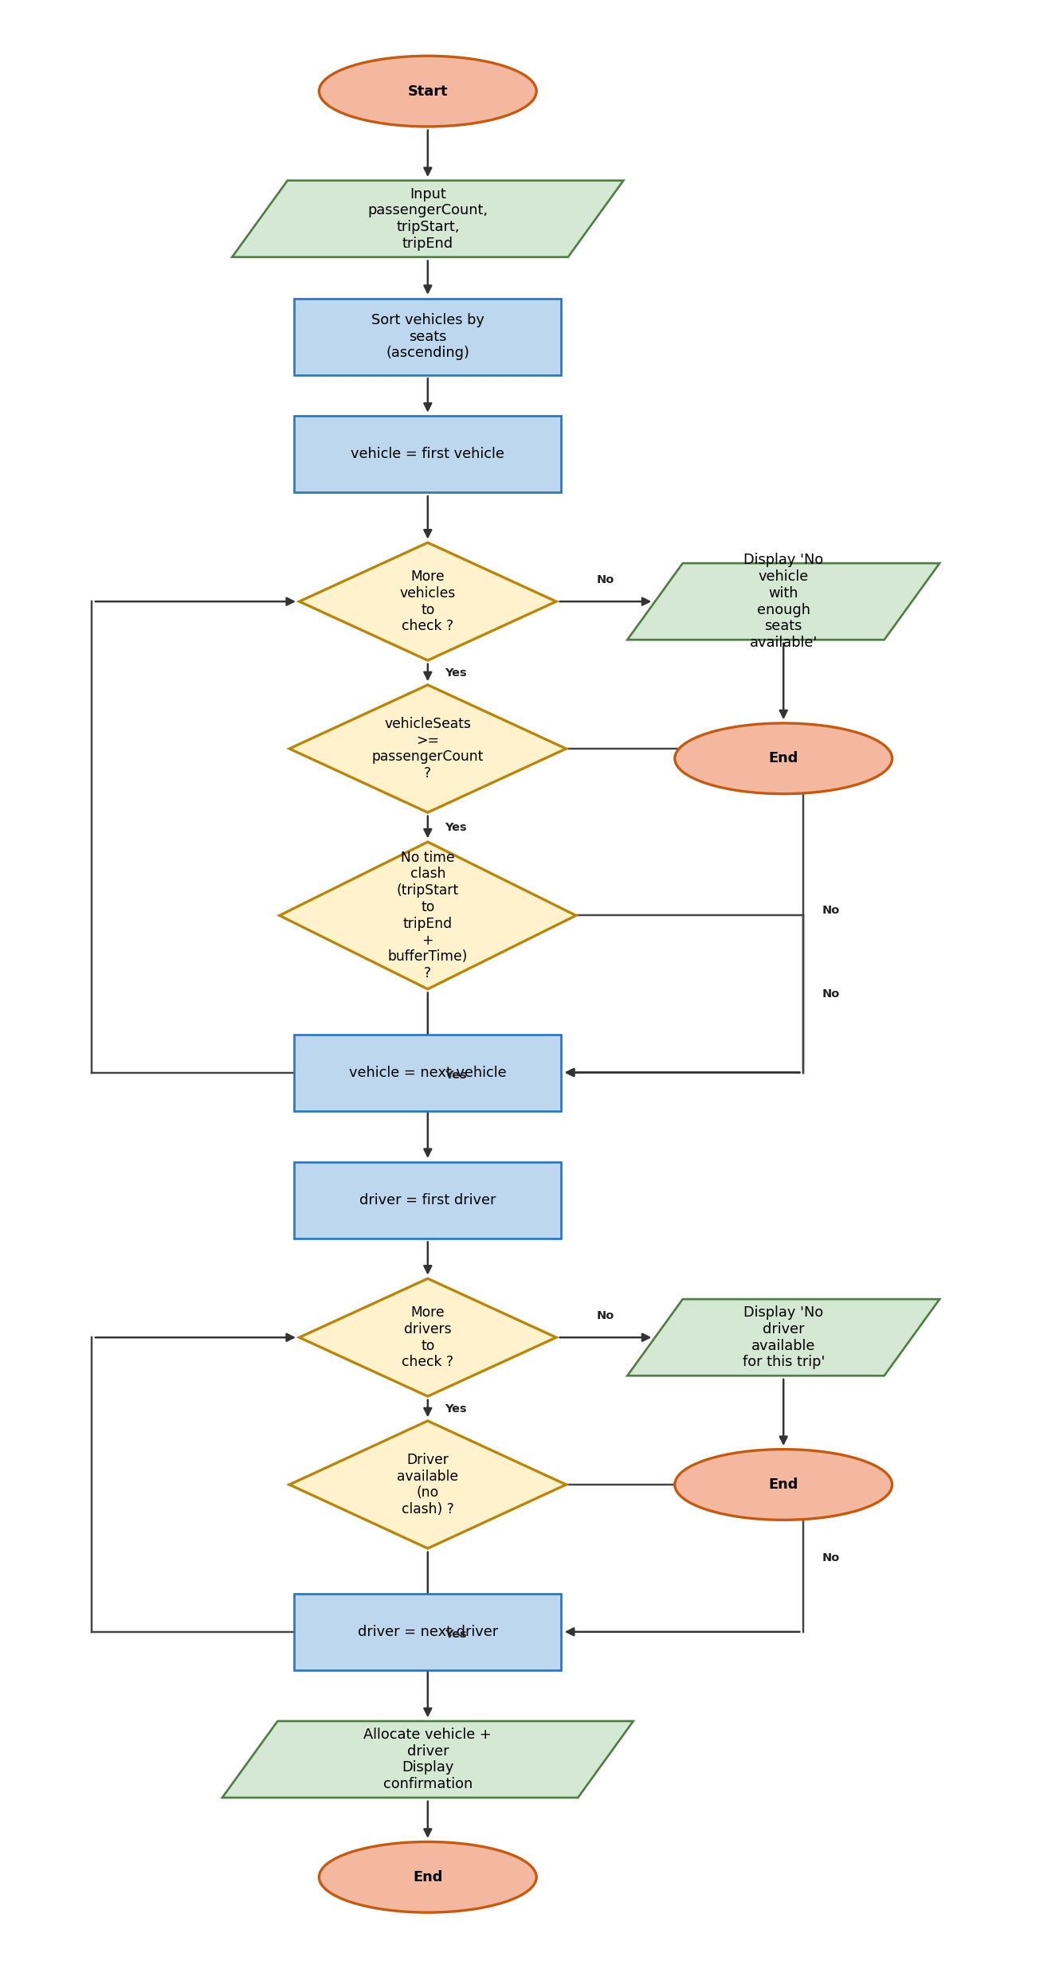

Written Explanation
The algorithm separates the vehicle and driver searches into two sequential loops. First, vehicles are sorted by seat count in ascending order. Each vehicle is tested against two conditions: it must have at least as many seats as the passenger count, and it must have no existing booking whose window overlaps the requested trip time extended by the buffer. The buffer is added to the end of every trip before checking for overlaps, so the system automatically enforces the required turnaround gap without requiring staff to calculate it themselves.
Once a valid vehicle is found, the algorithm begins the second loop to find a driver with no conflicting commitment during the trip window. Both loops must succeed for the booking to be confirmed. If a vehicle is found but no driver is available, the system returns a specific message indicating that the vehicle shortage is not the problem, giving staff precise information about where the bottleneck lies.
This two-step structure mirrors the operational reality: vehicles and drivers are independent resources that must both be free simultaneously. Treating them as separate loops makes the logic clear and makes it straightforward to extend the system later, for example to check that a driver holds the correct licence category for the vehicle selected.

Scenario 5 – Training Room Allocation in a Small Business
A company uses four training rooms for inductions, workshops, and client demonstrations. The system assigns a priority score to each session type so that client-facing sessions are protected when demand is high, while always selecting the best-fit room.

MoSCoW Requirement Analysis
Must Have | Should Have | Could Have | Won't Have
Check room capacity ≥ attendee count | Favour client sessions when room supply is limited | Automatically waitlist lower-priority sessions | Manage AV setup or catering (separate checklists)
Prevent booking clashes | Display confirmation with room details and spare seat count | Generate a daily room utilisation report | Integrate with external CRM for client contact details
Assign a priority score based on session type
Select the best-fit room (smallest valid surplus)

Identified Variables
Variable | Type | Description
attendeeCount | Integer | Number of people attending the session
sessionType | String | Session type: 'client', 'workshop', or 'induction'
startTime | Time | Session start time
endTime | Time | Session end time
priorityScore | Integer | Calculated score: client=3, workshop=2, induction=1
roomCapacity | Integer | Maximum occupancy of the training room
roomAvailable | Boolean | TRUE if room has no overlapping booking
spareSeats | Integer | roomCapacity − attendeeCount for a given room
bestRoom | String | Room ID with the smallest valid spare seat count so far
bestFit | Integer | Smallest spareSeats value seen so far (initialised to 9999)

Flowchart
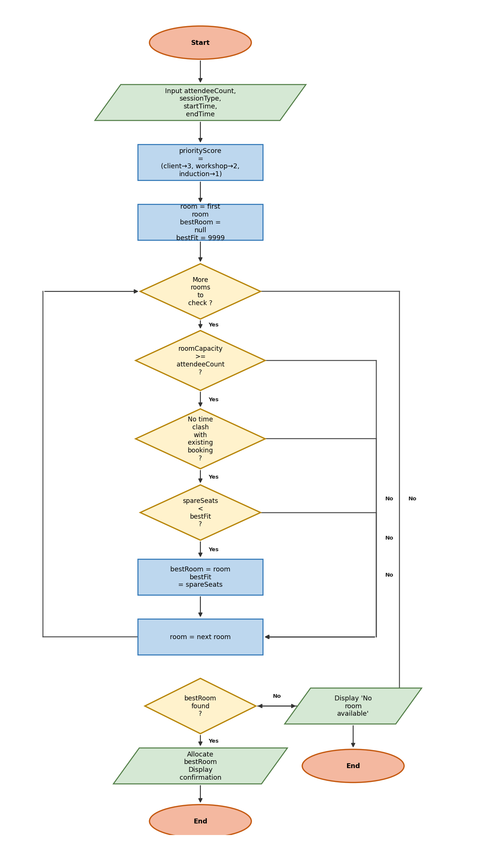

Written Explanation
The algorithm begins by translating the session type into a numeric priority score. This score is stored alongside the booking request and can be used in future extensions — for example, to automatically bump a lower-priority session from a room when a higher-priority booking arrives and no other room is available.
The room search applies a best-fit strategy. For every room that has enough capacity and no time clash, the algorithm calculates spare seats and compares this to the current bestFit value. If fewer spare seats are wasted in this room than in any room found so far, bestFit and bestRoom are updated. After all rooms have been evaluated, the algorithm allocates whichever room was found to produce the smallest valid surplus.
This approach differs from the first-match strategies in earlier scenarios because it requires evaluating all candidate rooms before making a decision. The trade-off is a slightly longer search, but the result is always the most space-efficient allocation available. If no room passes both the capacity and availability checks, the system reports that no room is available, and staff can consider rescheduling lower-priority bookings to free a room for the incoming request.

Scenario 6 – Hospital Clinic Room and Equipment Scheduling
An outpatient clinic must find a valid room, equipment, and clinician combination for every appointment while also reducing the walking distance between consecutive appointments to save staff time.

MoSCoW Requirement Analysis
Must Have | Should Have | Could Have | Won't Have
Check wheelchair accessibility if patient requires it | Select combination with shortest clinician walking distance | Auto-reschedule if a conflict appears after initial booking | Process billing or insurance claims
Verify room is free at appointment time | Display allocated room, equipment, clinician and distance | Send patient reminder message with room number | Access or modify patient medical records
Check required equipment is available
Confirm clinician has no overlapping appointment
Prevent any resource (room, equipment, clinician) clash

Identified Variables
Variable | Type | Description
wheelchairNeeded | Boolean | TRUE if patient requires a wheelchair-accessible room
equipmentNeeded | String | Equipment required for the appointment (or 'none')
clinician | String | ID of the clinician assigned to the appointment
startTime | Time | Appointment start time
endTime | Time | Appointment end time
roomAccessible | Boolean | TRUE if the room has wheelchair access
roomAvailable | Boolean | TRUE if room has no conflicting appointment
equipmentAvailable | Boolean | TRUE if required equipment has no conflicting booking
clinicianAvailable | Boolean | TRUE if clinician has no overlapping appointment
walkingDistance | Integer | Walking distance in metres between this room and the clinician's previous room
minDist | Integer | Smallest walkingDistance found among valid combinations so far
bestRoom | String | Room ID of the valid combination with the shortest walking distance

Flowchart
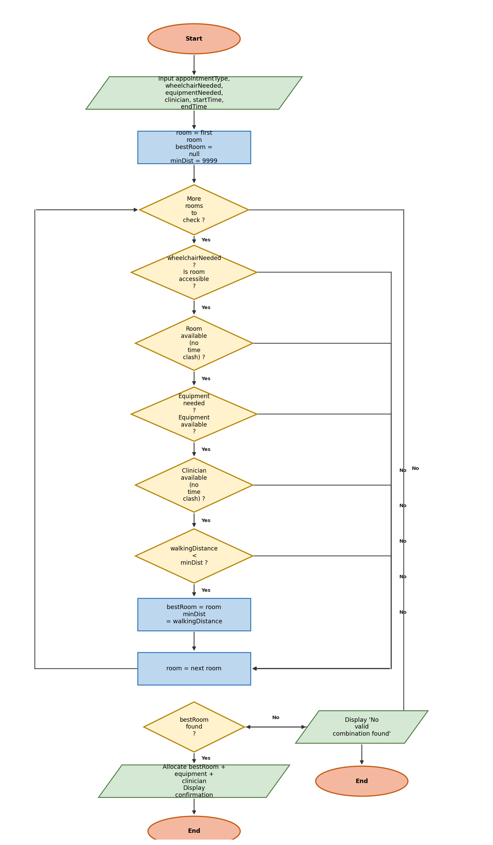

Written Explanation
The algorithm evaluates every room in the clinic against five conditions. Each condition that fails causes the algorithm to skip to the next room immediately, so only rooms that pass all five tests are considered as candidates. The five conditions are: the room must be wheelchair accessible if needed; the room must be free at the appointment time; the required equipment (if any) must be available at the same time; the assigned clinician must have no overlapping appointment; and the walking distance from this room to the clinician's previous appointment must be less than the shortest distance found so far.
The fifth condition is the optimisation step. Rather than simply finding the first room that satisfies the first four conditions, the algorithm continues evaluating all rooms and keeps track of the valid option that produces the shortest walking distance. Because clinicians often have several appointments in succession, minimising movement between rooms reduces both fatigue and the risk of running late.
If no room satisfies all five conditions, the system displays a clear rejection message identifying that no valid combination was found. This prompts clinic coordinators to check whether the clinician's schedule can be adjusted, whether a different equipment unit is available, or whether the patient should be offered an alternative appointment time.

Scenario 7 – University Exam Venue Allocation
A university must seat all students for an exam across one or more rooms of the correct type, with an available invigilator for each room, while also supporting access arrangements for students who need them.

MoSCoW Requirement Analysis
Must Have | Should Have | Could Have | Won't Have
Provide enough seats for all students (may need multiple rooms) | Minimise the total number of rooms allocated | Automatically assign invigilators to rooms from a rota | Mark or grade examination papers
Match room type to exam type (paper/computer/access) | Confirm and display the full room list with invigilators | Send venue notification to students and invigilators | Handle student identity verification at entry
Check invigilator availability for each room used
Support access arrangements (extra time, separate room)

Identified Variables
Variable | Type | Description
studentCount | Integer | Total number of students sitting the exam
examType | String | 'paper', 'computer', or 'access' — determines room type required
accessArrangements | Boolean | TRUE if any students need extra time or a separate room
startTime | Time | Exam start time
endTime | Time | Exam end time
seatsRemaining | Integer | Students not yet allocated to a room (starts equal to studentCount)
roomCapacity | Integer | Number of seats in the current candidate room
roomType | String | The category/type of the candidate room
invigilatorAvailable | Boolean | TRUE if an invigilator is free for this room and time
roomsAllocated | Integer | Number of rooms added to the allocation list so far

Flowchart
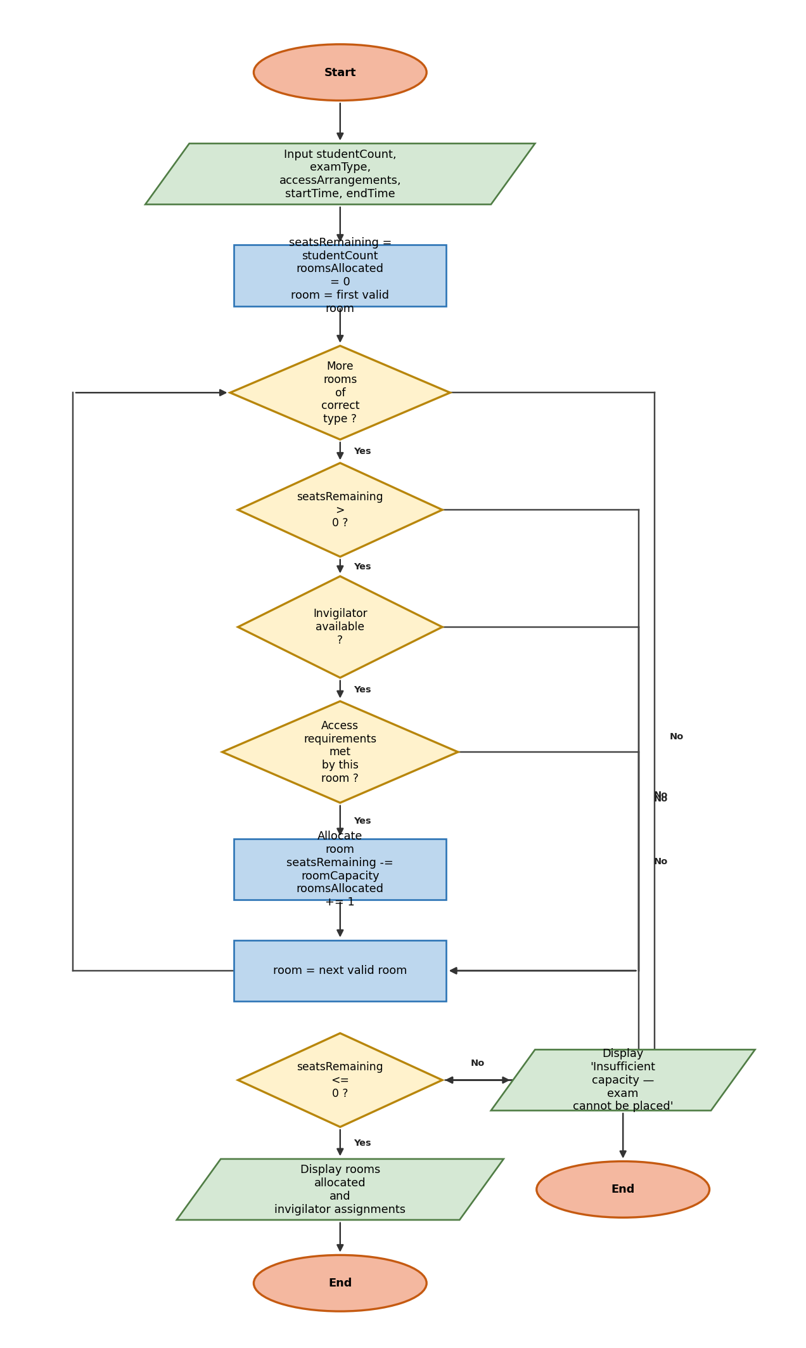

Written Explanation
Unlike single-room booking scenarios, the exam algorithm may need to allocate several rooms to seat an entire cohort. The algorithm initialises a seatsRemaining counter equal to the total student count, then iterates through rooms of the correct type. For each candidate room it checks two conditions: an invigilator must be available for the room's time slot, and the room must support any access arrangements needed. Rooms that fail either check are skipped.
When a valid room is found, its capacity is subtracted from seatsRemaining and the room is added to the allocation list. The outer loop continues until seatsRemaining drops to zero or below, meaning all students have been seated, or until there are no more rooms of the correct type to evaluate. This progressive accumulation approach handles cohorts of any size without needing to calculate in advance how many rooms will be needed.
If the algorithm exhausts all valid rooms before seatsRemaining reaches zero, it reports insufficient capacity. This allows the exams office to consider alternative approaches: using a different combination of room types, splitting the cohort across two sittings, or negotiating additional venue space. The roomsAllocated counter gives staff a clear picture of how many rooms were successfully assigned before the shortfall was detected.

Scenario 8 – Warehouse Loading Bay Scheduling
A warehouse must assign lorries to loading bays that match the vehicle's requirements, while also ensuring that forklifts and staff teams are available — and selecting the bay that minimises lorry waiting time.

MoSCoW Requirement Analysis
Must Have | Should Have | Could Have | Won't Have
Match bay type to vehicle requirements (refrigerated if needed) | Select the bay with the shortest valid waiting time | Alert manager when waiting time exceeds a threshold | Plan lorry delivery routes to the warehouse
Check bay is free during the service window | Display allocated bay, forklift, team, and expected service start | Generate a daily loading schedule report for planning | Manage warehouse inventory or stock levels
Verify forklift availability if required for the load
Confirm staff team is available
Minimise lorry waiting time from planned arrival

Identified Variables
Variable | Type | Description
vehicleType | String | Type of lorry: standard, refrigerated, or flatbed
refrigerated | Boolean | TRUE if load requires a refrigerated loading bay
forkliftNeeded | Boolean | TRUE if load requires a forklift for unloading
plannedArrival | Time | Scheduled arrival time of the lorry
duration | Duration | Estimated time to complete the loading or unloading job
bayType | String | Type category of the loading bay being evaluated
serviceStart | Time | Earliest time the current bay becomes free
waitTime | Integer | max(0, serviceStart − plannedArrival) in minutes
forkliftAvailable | Boolean | TRUE if a forklift is free for the required service window
staffTeamAvailable | Boolean | TRUE if a staff team is free for the required service window
bestBay | String | Bay ID with the minimum waiting time found so far
minWait | Integer | Smallest waitTime seen so far (initialised to 9999)

Flowchart
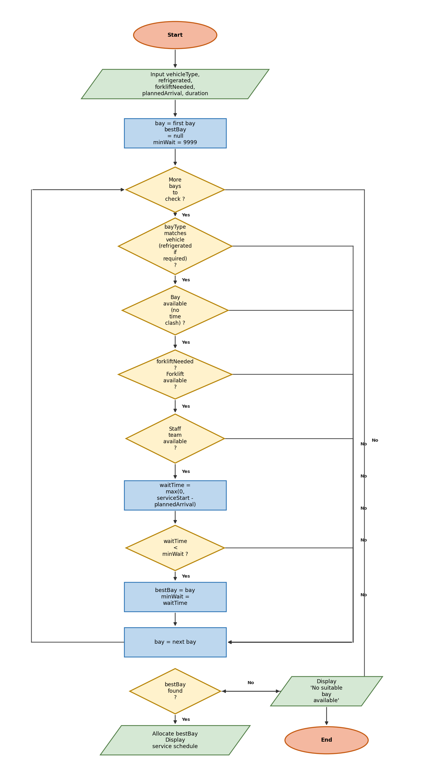

Written Explanation
The algorithm evaluates every loading bay to find the option that minimises waiting time while satisfying all operational requirements. For each bay, four conditions are checked in sequence: the bay type must match the vehicle (refrigerated if the load needs cold storage); the bay must not have a conflicting booking during the service window; if a forklift is required, one must be free; and a staff team must be available. Any condition that fails causes the algorithm to skip to the next bay.
For bays that pass all four checks, the algorithm calculates waitTime as the difference between when the bay becomes free and the lorry's planned arrival. Using max(0, ...) ensures that a bay already available at arrival time is recorded as zero wait, not a negative value. If this waitTime is smaller than minWait, bestBay and minWait are updated. The algorithm continues until all bays have been evaluated, then allocates the bay stored in bestBay.
The key benefit of finding the minimum-wait bay rather than simply the first valid bay is that it reduces idle time and congestion at the warehouse entrance. Lorries that wait unnecessarily at the gates increase operating costs and can create safety hazards. By systematically comparing all valid options before committing, the algorithm consistently produces a better outcome than a first-match approach would.

Scenario 9 – Conference Session and Room Scheduling
A conference organiser must place sessions into rooms and time slots, preventing speaker clashes and reducing audience overlap between sessions aimed at the same group, using a scoring system to select the best available slot.

MoSCoW Requirement Analysis
Must Have | Should Have | Could Have | Won't Have
Check room capacity meets session attendance | Score each valid slot and select the one with the lowest score | Publish the full programme automatically once all sessions are placed | Manage live streaming or session recording
Verify AV equipment is available if session needs it | Display allocated room, time slot, and overlap score | Allow attendee preferences to influence slot scoring | Handle speaker travel or accommodation arrangements
Prevent speaker appearing in two sessions at the same time
Reduce audience overlap between same-audience sessions

Identified Variables
Variable | Type | Description
sessionCapacity | Integer | Expected attendance for the session
avRequired | Boolean | TRUE if the session needs AV equipment
speakerID | String | Identifier for the session's speaker
audienceType | String | Target audience group (e.g. 'research', 'industry', 'students')
roomCapacity | Integer | Seating capacity of the room being evaluated
avAvailable | Boolean | TRUE if the room has AV and it is free in this time slot
speakerAvailable | Boolean | TRUE if the speaker is not already placed in this time slot
overlapScore | Integer | Count of other sessions targeting the same audienceType in this slot
capacityFit | Integer | roomCapacity − sessionCapacity (lower value = better fit)
score | Integer | overlapScore + capacityFit — combined slot quality score (lower = better)
bestSlot | String | Room-time combination with the lowest score found so far
bestScore | Integer | Lowest score encountered so far (initialised to 9999)

Flowchart
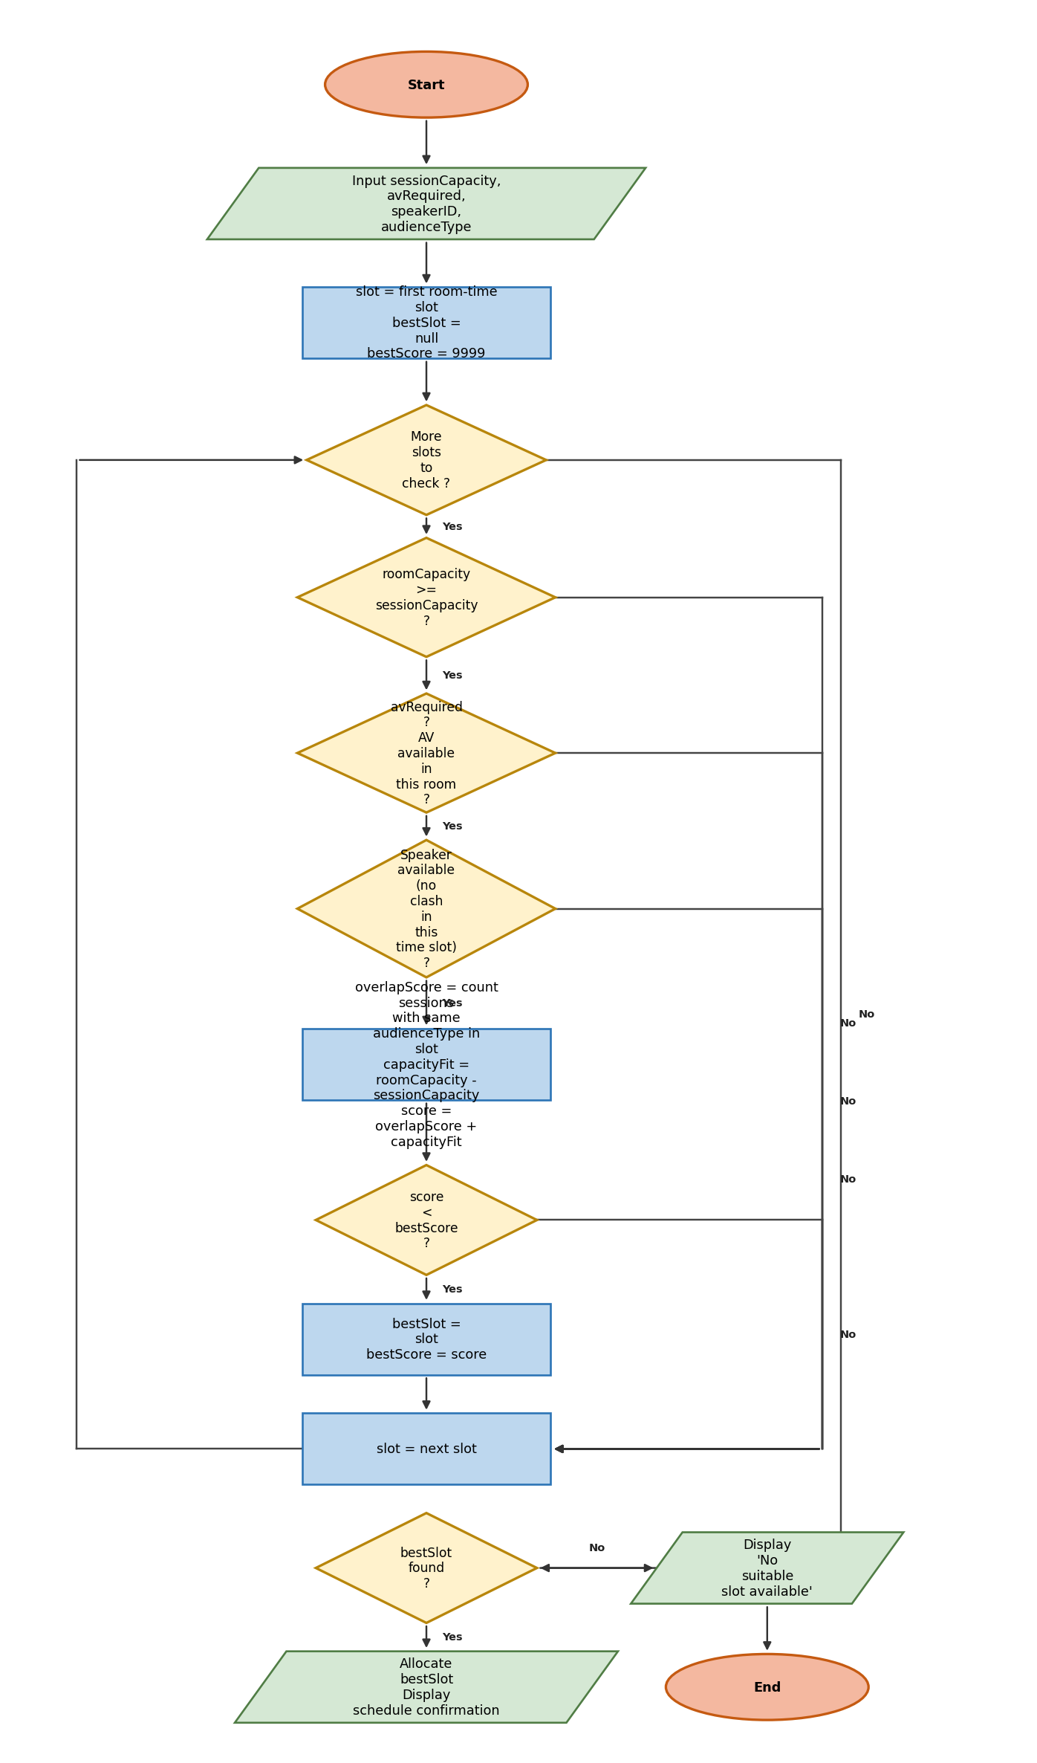

Written Explanation
The algorithm evaluates all room-time slot combinations and scores each valid option. A slot is valid only if three conditions hold: the room must have enough seats for the expected attendance; the AV equipment must be available if the session requires it; and the speaker must not already be committed to another session in the same time slot. Slots that fail any of these conditions are skipped without scoring.
Valid slots are scored by combining two components. The overlapScore counts how many other sessions in the same time slot target the same audience type — a high score means many attendees will face competing demands and may miss the session. The capacityFit measures how closely the room's seating matches the expected attendance — a lower value means fewer empty seats. By summing these two components, the score balances audience reach against room efficiency. The slot with the lowest combined score is the best placement.
When placing multiple sessions across a two-day programme, this algorithm is called once per session. As each session is placed and its time slot is filled, the overlapScore for remaining sessions updates dynamically, gradually resolving conflicts as the schedule is built. Speaker availability also narrows as sessions are placed, so earlier sessions in the placement order have more choices available.

Scenario 10 – Airline Gate Allocation at a Regional Airport
A regional airport must assign aircraft to gates, matching aircraft size and international requirements while preventing gate overlaps — and, where possible, minimising the walking distance for connecting passengers.

MoSCoW Requirement Analysis
Must Have | Should Have | Could Have | Won't Have
Check gate size can accommodate the aircraft | Display allocated gate, turnaround buffer, and walking distance | Notify passengers of gate assignment via departure board | Process immigration or customs on behalf of border authorities
Verify gate has international processing if flight requires it | Log gate allocation for operational records | Flag gates with scheduled maintenance to avoid selection | Schedule aircraft maintenance or fuelling (separate system)
Prevent overlapping gate use including turnaround buffer time
Select the gate with the minimum connecting passenger walking distance

Identified Variables
Variable | Type | Description
aircraftSize | String | Size category of aircraft: small, medium, or large
gateSize | String | Maximum aircraft size the gate can handle
internationalRequired | Boolean | TRUE if the flight requires international processing facilities
arrivalTime | Time | Scheduled aircraft arrival at the gate
departureTime | Time | Scheduled aircraft departure
turnaroundBuffer | Duration | Minimum gap required after departure before gate can be reused
connectingGate | String | Gate ID where connecting passengers are arriving from
walkingDistance | Integer | Distance in metres from connectingGate to this gate
minDist | Integer | Smallest walkingDistance found among valid gates so far
bestGate | String | Gate ID with the minimum walking distance found so far

Flowchart
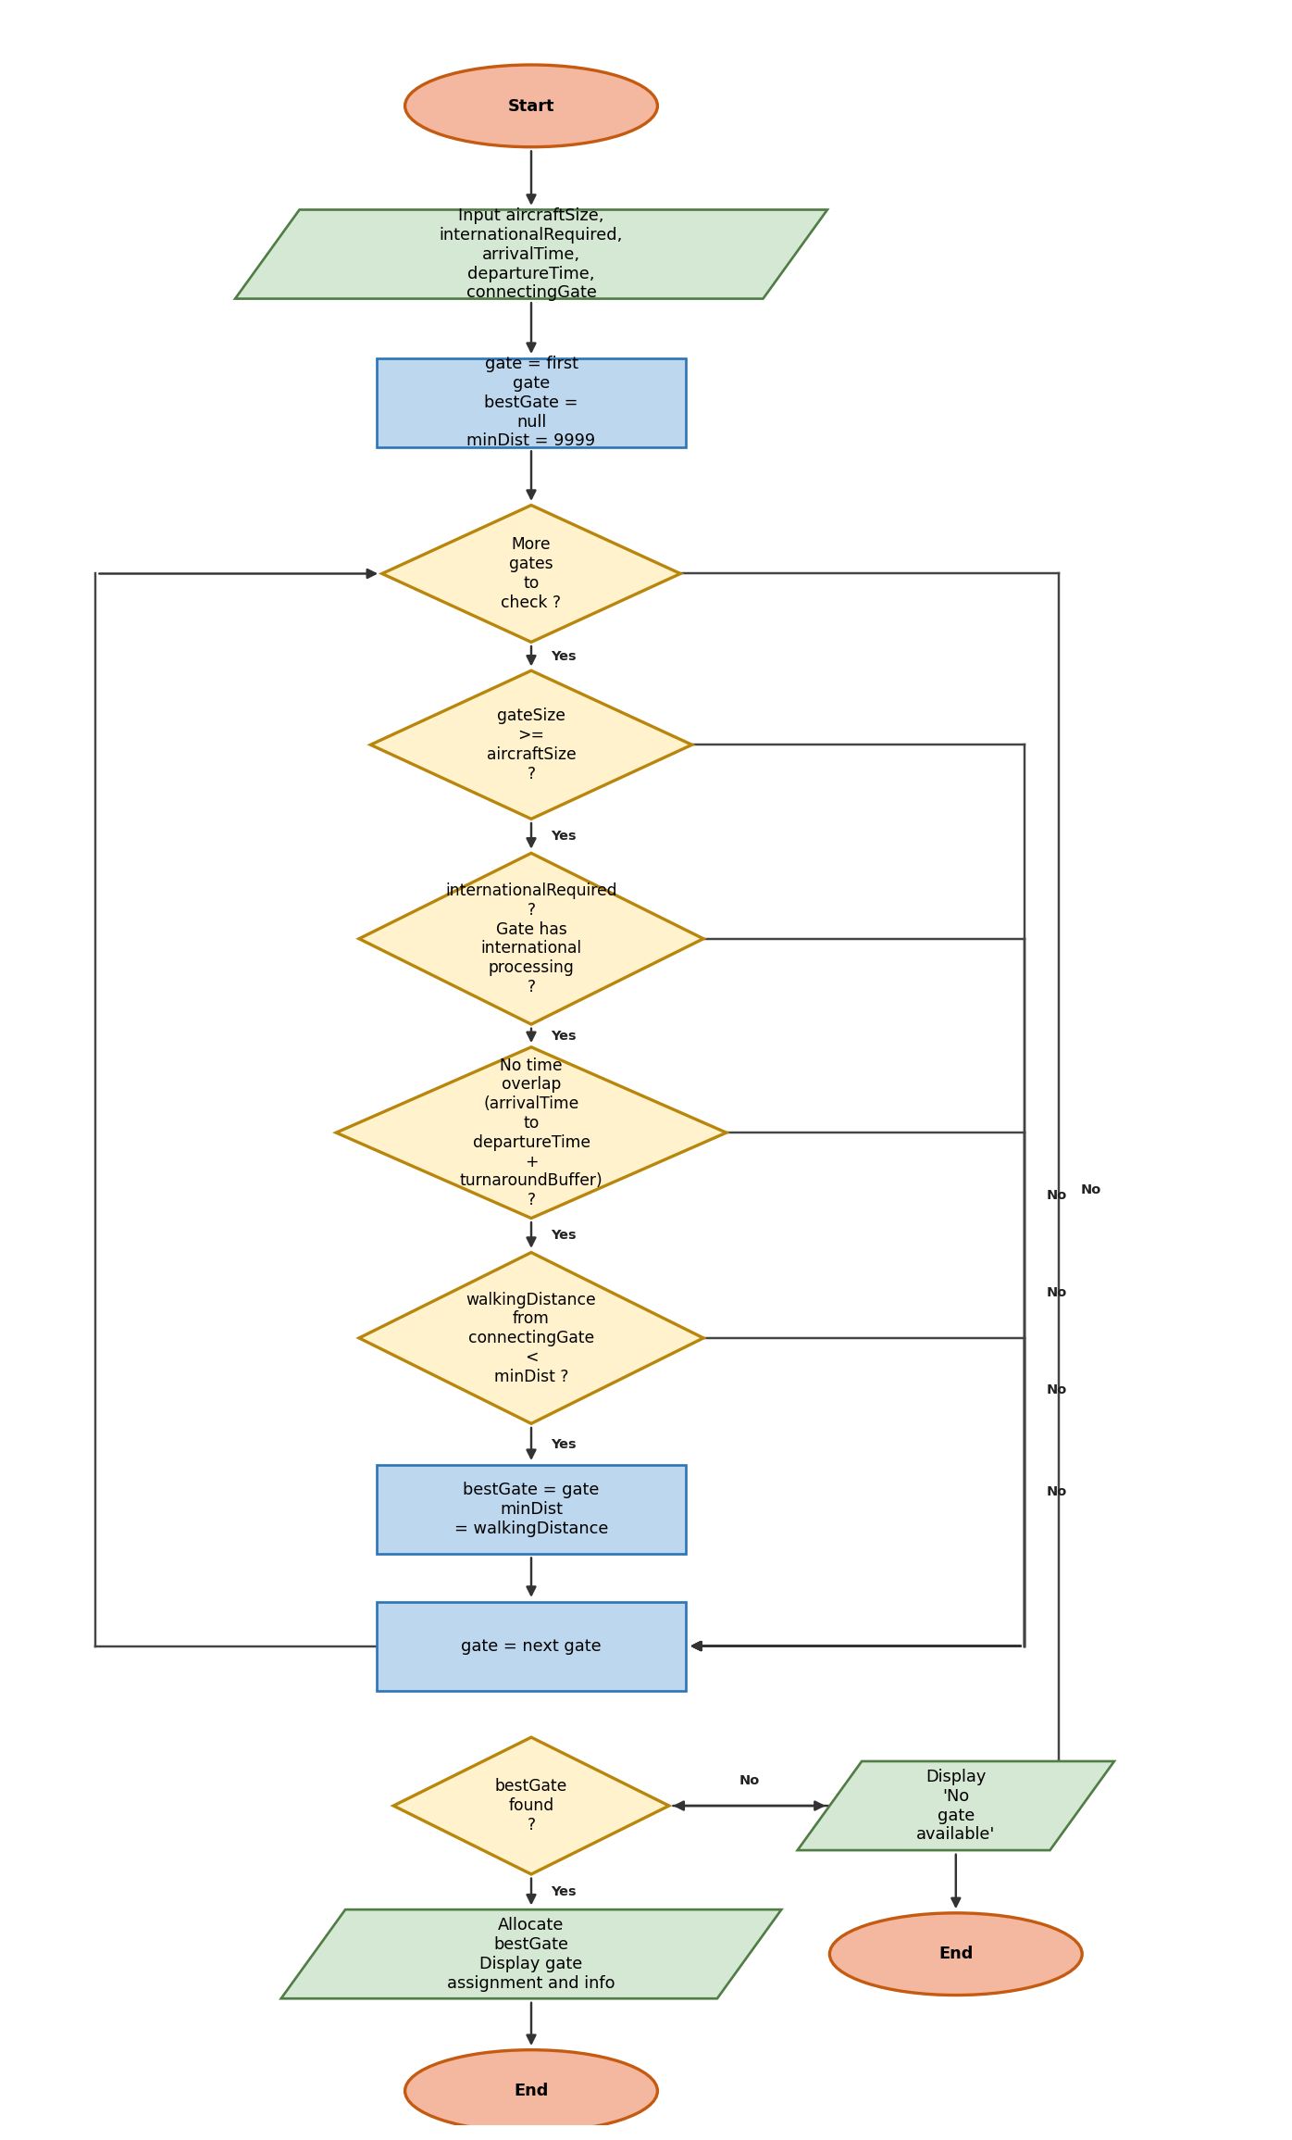

Written Explanation
The algorithm evaluates every gate at the airport against three eligibility conditions. The gate must be large enough for the arriving aircraft — using gateSize to compare against aircraftSize. If the flight carries international passengers, the gate must have the necessary processing facilities. Finally, the gate must be free for the complete window from arrivalTime to departureTime plus the turnaroundBuffer; the buffer is added to the departure time so that cleaning and servicing time is protected before the next aircraft can use the gate.
Among all valid gates, the algorithm selects the one that minimises the walking distance from the connecting passengers' incoming gate. Connecting passengers are time-pressured and have no flexibility about when they need to travel between gates. A shorter connection walk reduces the probability of missed connections and improves the experience of the airport's most vulnerable users. The algorithm tracks the best gate found (bestGate) and the corresponding distance (minDist) as it loops through all options, committing to the final selection only after all gates have been assessed.
If no gate satisfies all three conditions, the system reports that no gate is available. Operations staff can then investigate whether an aircraft could be held slightly longer at its previous position, whether the turnaround buffer for an adjacent gate could be shortened safely, or whether a remote stand with a bus transfer could serve the flight. The structured rejection message helps staff understand exactly why no gate was found rather than leaving them to check manually.

