Network and Cyber Security Essentials

[Date]
Network and Cyber Security Essentials


Lecturer’s Name: Dr Kwame Assa-Agyei
Student Name: Adiam mokonen
Student Number:2422051

Cybersecurity Policy Development for Vigilant Trust and Asset Management

Abstract
Cybersecurity threats are increasing every year and they are becoming more advanced especially for financial companies. Vigilant Trust and Asset Management which is a medium sized financial organisation recently experienced a phishing attack that was not detected by email security systems. The company also faced a ransomware attempt that almost caused serious data loss. These incidents clearly show that VTAM needs a stronger and more modern security approach. This report presents a complete cybersecurity strategy that is based on the Zero Trust model and supported by well-known standards such as NIST CSF 2.0 NIST SP 800 207 ISO IEC 27001 2022 and guidance from trusted organisations like CISA. The report explains current cybersecurity threats and describes updated security policies that the organisation can follow. It also explains technical security solutions that VTAM can apply in a practical way. In addition the report presents a plan for continuous system monitoring incident response and employee security training. Simple diagrams are included to help explain how the Zero Trust system and monitoring process work. The main aim of this report is to provide VTAM with clear and realistic steps to improve cybersecurity and build a stronger and safer security environment.

Introduction
As more businesses move their systems to cloud platforms and allow employees to work both from the office and from home computer networks are becoming more open and difficult to protect. This new way of working has created more chances for cybercriminals to attack organisations. Hackers now use automation artificial intelligence and advanced malware to gain access to systems steal money and cause serious long term damage. Financial organisations like VTAM face even greater risks because they store very sensitive information such as client financial records investment details and personal data. If a cyber-attack is successful it can lead to financial losses data breaches damage to the company reputation and heavy penalties from regulators. Due to these growing risks the VTAM board has decided to improve the company cybersecurity framework. The organisation plans to follow the Zero Trust model which means no user device or system is trusted without continuous checks. This report supports that decision and provides a clear plan based on recognised security standards.

Identification of Modern Threats
VTAM is exposed to many modern cybersecurity threats that come from both external sources and internal activities within the organization. [1]One of the most serious external threats is the rapid increase of Ransomware as a Service. In earlier years ransomware attacks were mainly carried out by highly skilled hackers. Today even criminals with little technical knowledge can easily buy or rent advanced ransomware tools through online platforms. These ransomware attacks usually involve several stages including stealing sensitive files locking company systems and threatening to release stolen information if the organization refuses to pay the ransom. Financial organizations are often targeted because they store valuable data and cannot afford long periods of system downtime.
[2]Another major threat faced by VTAM is AI powered social engineering. Attackers now use artificial intelligence to create very realistic phishing emails and messages that closely resemble legitimate communication. Artificial intelligence allows attackers to study publicly available information and create messages that appear personal and trustworthy. In addition criminals can generate fake voice calls that sound like real company executives. This makes vishing attacks extremely difficult for employees to recognize and stop.
The use of cloud services also introduces new cybersecurity risks. VTAM relies on platforms such as Microsoft 365 financial applications and other online systems to support daily operations. If these cloud environments are not configured correctly they can unintentionally expose sensitive information to the public. Attackers often attempt to steal API keys OAuth tokens or cloud login credentials to gain access without raising security alerts. Because cloud systems are complex and spread across different environments it can be harder to detect attacks compared to traditional on premises systems.
Supply chain attacks are another growing concern for VTAM. Instead of attacking the organization directly cybercriminals may target software vendors service providers or business partners. Once a trusted third party is compromised attackers can inject malicious code into software updates or use partner networks as hidden entry points. Past incidents such as the Solar Winds attack have shown that even organizations with strong security controls can be affected if one of their suppliers is breached.
Internal threats must also be considered as part of the modern threat landscape. Some insiders may intentionally attempt to steal data or misuse access for personal gain. However many internal incidents occur because of human error. Employees may click on malicious links reuse weak passwords or use personal devices that lack proper security controls. Remote working increases these risks because home networks and personal laptops are often less secure than company managed systems. Shadow IT also creates additional challenges when employees use unapproved applications or cloud services that are not monitored by the security team.

Modern Security Policies
[3]To protect the organization properly VTAM must update its security policies so they match modern cyber threats and current best practices. The most important policy should be based on the Zero Trust model described in NIST SP 800 207. This means the organization must no longer assume that users or devices are safe simply because they are connected to the internal network. Instead every access request must be verified continuously. Access decisions should be based on user identity device condition behavior and overall risk level. All access requests whether they come from inside or outside the organization must pass through strict security checks.
The access control policy used by VTAM should follow the guidance provided by NIST CSF and ISO 27001. Each employee should only be given access to the systems and data needed to perform their job duties. Special access rights must be tightly controlled and reviewed on a regular basis. High level accounts such as system administrators must follow stronger security requirements and their activities should be monitored closely to reduce the risk of misuse.
VTAM also requires a strong endpoint security policy. Every device used for work including laptops desktop computers and mobile phones must be properly managed and protected. All devices should have updated security software enabled disk encryption and strong authentication methods. Mobile devices should be managed through a mobile device management system that can enforce security settings and allow remote wiping if a device is lost or stolen.
Cloud security is another important policy area. VTAM must clearly define how cloud systems are set up monitored and protected. Cloud platforms should record all user activity and any sensitive data stored in the cloud must be encrypted. Before using any new third party software or cloud service the organization should assess potential security risks.
An incident response policy is essential to ensure the organization is prepared for cyber incidents. This policy should explain the actions taken when a security incident is detected. It should clearly define roles communication methods and notification requirements for authorities or clients. By following NIST SP 800 61 VTAM can respond to incidents in a structured and organized way.
Finally VTAM must enforce an acceptable use policy. This policy explains how employees are allowed to use company systems and data. It covers personal device use remote working email usage and cloud storage. Clear rules help employees understand their responsibilities and reduce the risk of security incidents.

Technical Mitigation Measures
Updating security policies alone is not enough to protect the organization from modern cyber threats. VTAM must also apply strong technical security controls to protect systems data and users. One of the most important technical measures is multi factor authentication. MFA should be required on all important systems including cloud platforms remote access services email accounts and administrator systems. Multi factor authentication improves security by requiring more than one method to verify a user identity. Stronger options such as hardware security keys or biometric authentication provide better protection against phishing attacks that can bypass simple login details.
[4]Privileged Access Management systems are also essential for protecting accounts with high level access. These systems store administrator passwords in secure vaults and limit how long privileged users can access sensitive systems. PAM solutions also record activity during privileged sessions which allows security teams to review actions and detect misuse. This reduces the risk of attackers using stolen administrator credentials to move through the network.
Network security should be improved through micro segmentation. This approach divides the network into smaller areas to prevent attackers from moving freely between systems. Zero Trust Network Access should replace traditional VPN solutions. ZTNA allows users to access only the specific applications they need rather than the entire network.
Endpoint detection and response tools should be installed on all company devices. These tools monitor devices for suspicious behavior block threats and isolate infected systems. Cloud security posture management tools help identify weaknesses such as open storage and incorrect permissions. Advanced email security systems should also be used to scan links and attachments and prevent email impersonation attacks.

Proactive Monitoring and Incident Response
A strong cybersecurity programmer requires continuous monitoring of systems and user activity. VTAM should operate a monitoring system that works twenty four hours a day and seven days a week. This system should collect and analyses security information from across the organization. A Security Information and Event Management system can be used to gather log data from cloud services firewalls email platforms servers and employee workstations. The system analyses this information to identify suspicious behavior. Examples include login attempts from unusual locations repeated failed login attempts and unexpected access to sensitive systems.
To improve response speed the Security Information and Event Management system should be connected to a Security Orchestration Automation and Response system. This integration allows specific actions to occur automatically when a threat is detected. For example a compromised user account can be disabled or an infected device can be isolated from the network. Automating these actions reduces the time attackers have to spread across systems or cause further damage.
The incident response process begins with the detection and analysis of a security event. The next stage involves containing the threat and removing any malicious activity. Once the threat has been eliminated systems are restored to normal operation. After each incident VTAM should conduct a review to understand what happened and identify weaknesses. This helps the organization improve security controls and prevent similar incidents in the future.
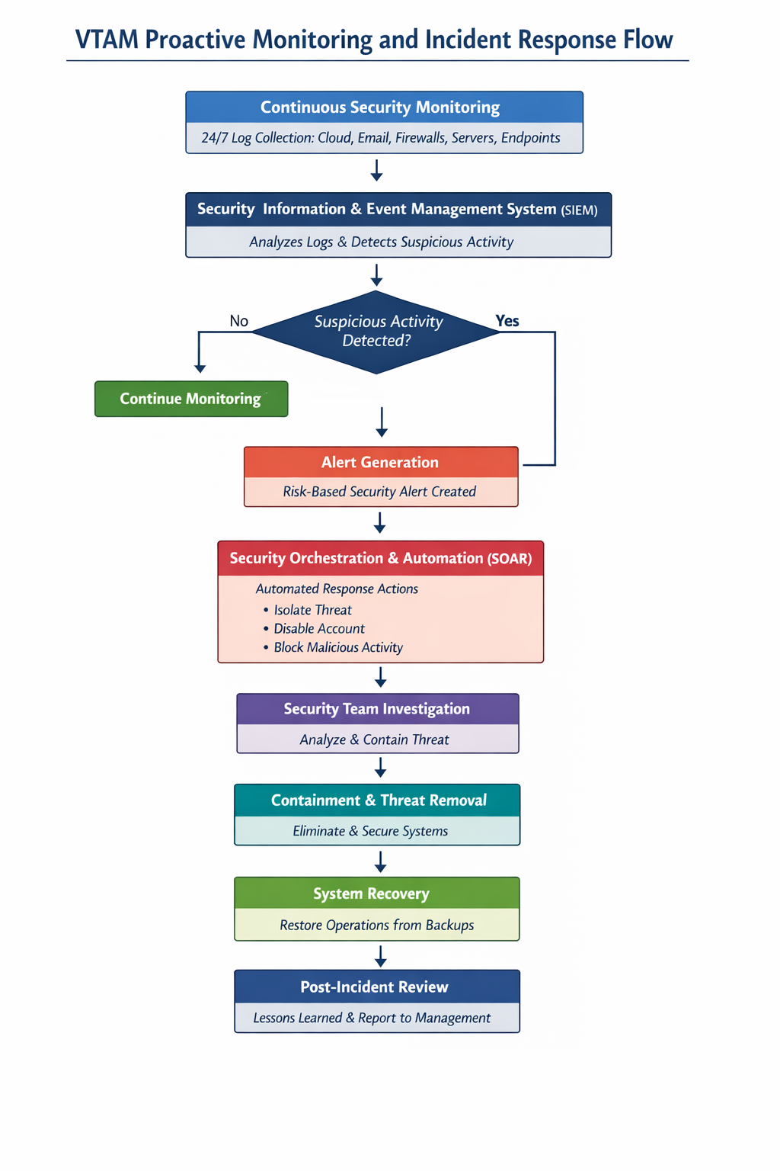

Continuous Training and Awareness
Technology alone cannot fully protect the organization if employees are not trained to recognize and avoid security threats. VTAM must implement a continuous training programmer that helps staff understand how to identify phishing emails fraudulent phone calls and other social engineering attacks. Regular phishing simulations allow employees to practice spotting fake messages in a safe learning environment. Voice phishing simulations help staff learn how to question suspicious phone calls even when the voice sounds real or familiar.
Training sessions should be short simple and easy to complete. This helps employees stay engaged and reduces disruption to daily work. Training topics should include safe password practices secure use of cloud applications protection of sensitive information and clear steps for reporting suspicious activity. Adding simple game style features such as point’s progress tracking or small challenges can increase motivation and participation.
Employees working in high risk roles require additional training. Executive’s financial staff and system administrators are often targeted by attackers and should receive advanced awareness training. This training should explain how attackers may target them and highlight the importance of secure communication and strong authentication.

Conclusion
The cybersecurity challenges facing financial institutions continue to grow, especially as attackers use new technologies to create more effective and complex attacks. VTAM must respond by adopting a modern and comprehensive cybersecurity framework based on Zero Trust principles and supported by widely recognised standards such as NIST CSF and ISO 27001. This report has outlined the main threats VTAM faces today, proposed updated and practical security policies, described technical measures that strengthen protection, and explained how to create an effective monitoring and incident response structure. It also emphasised the importance of continuous employee training, since humans play a major role in preventing breaches. By following the strategies presented here, VTAM can greatly improve its cybersecurity readiness and be better prepared to defend against current and future threats.

References
[1] M. Martin, “A Practical Guide to Continuous Cyber Security Monitoring,” Atlas Systems Blog, Dec. 3, 2025.
[2] N. Ebert, T. Schaltegger, B. Ambuehl, T. Geppert, A. Trammell, M. Knieps, and V. Zimmermann, “Learning from safety science: designing incident reporting systems in cybersecurity,” Journal of Cybersecurity, vol. 11, no. 1, Aug. 2025
3] T. Singh, Cybersecurity Tooling: SIEM, SOAR, and XDR, in Digital Resilience, Cybersecurity and Supply Chains, London, U.K.: Routledge, 2025.
[4] IBM Security Team, “What is SOAR (security orchestration, automation and response)?,” IBM, 2025.

Appendix A: Screenshot of the Board of Directors PowerPoint presentation
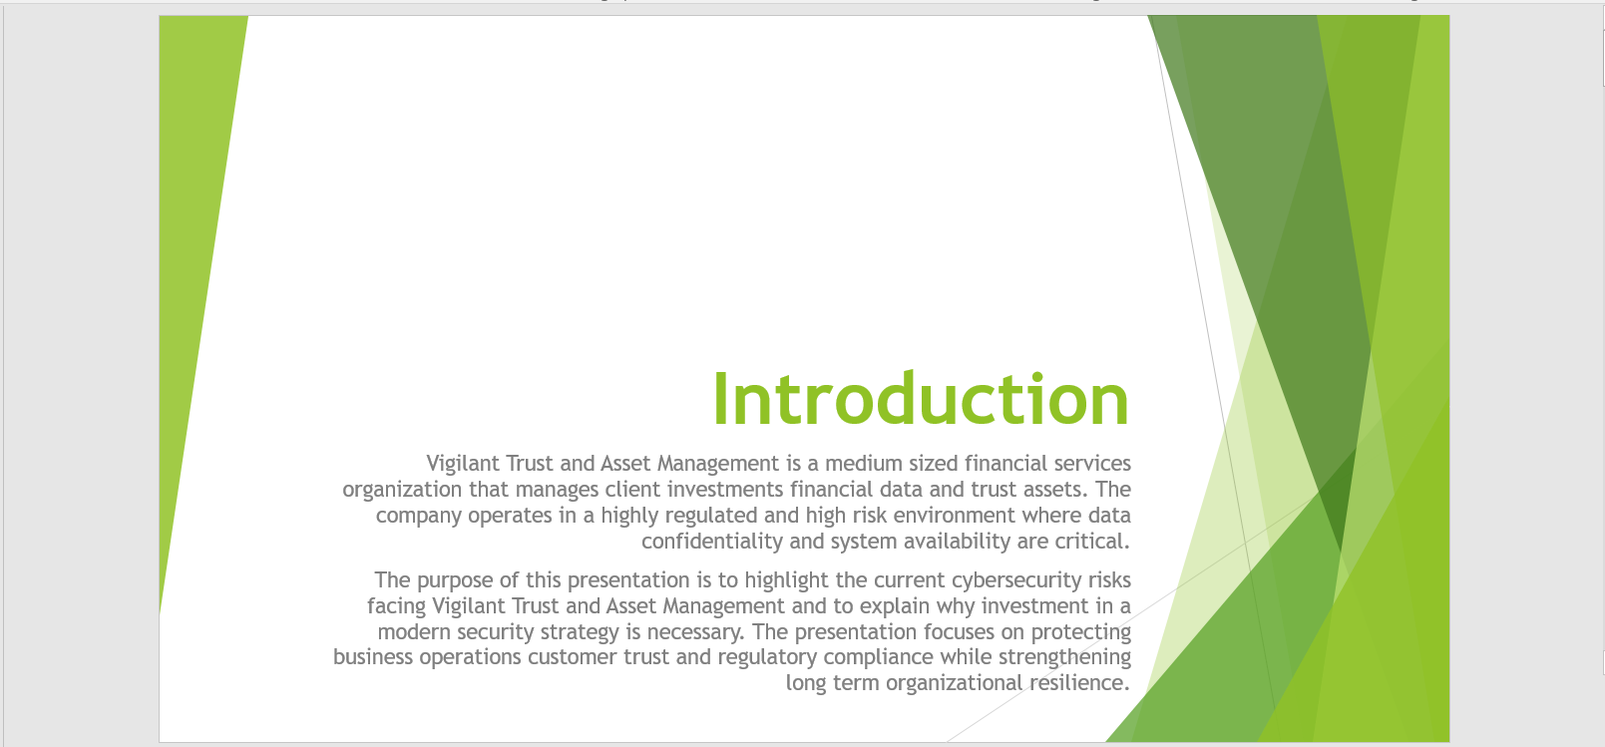
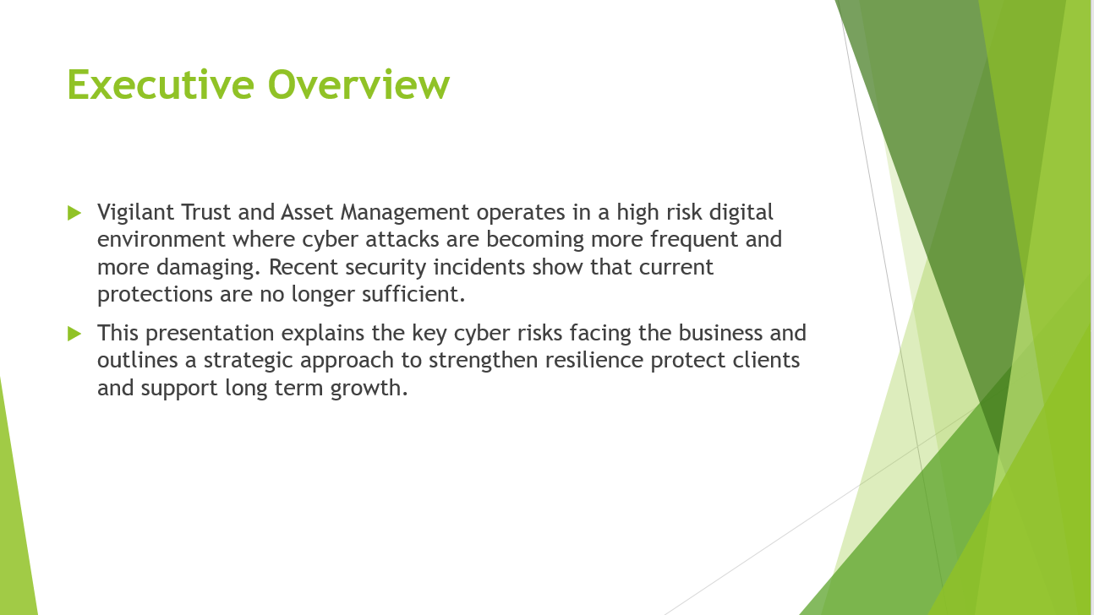
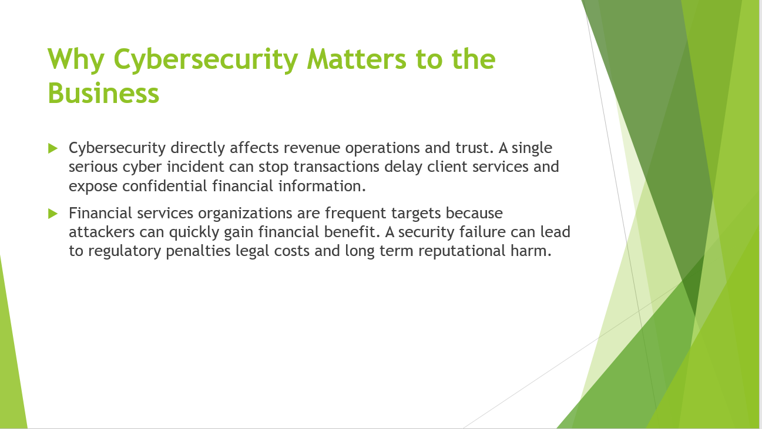
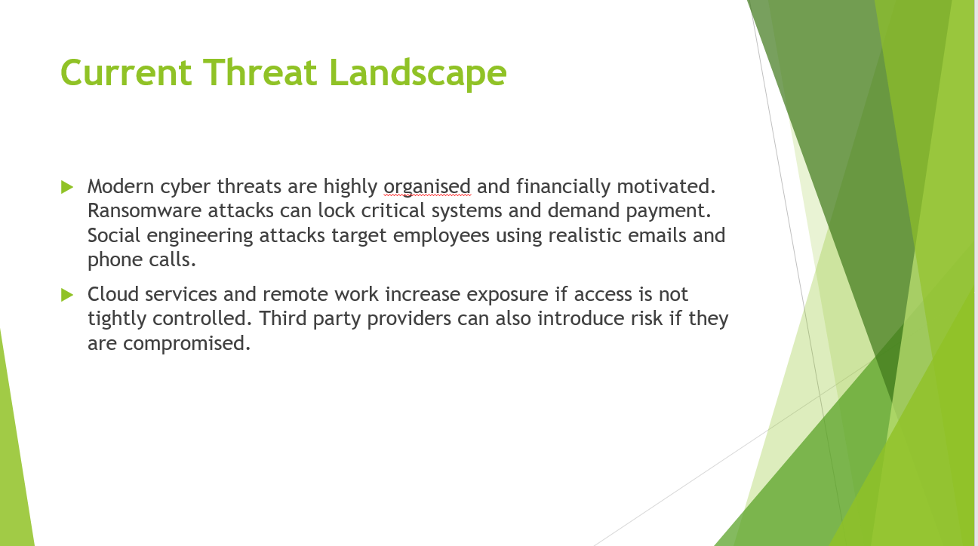
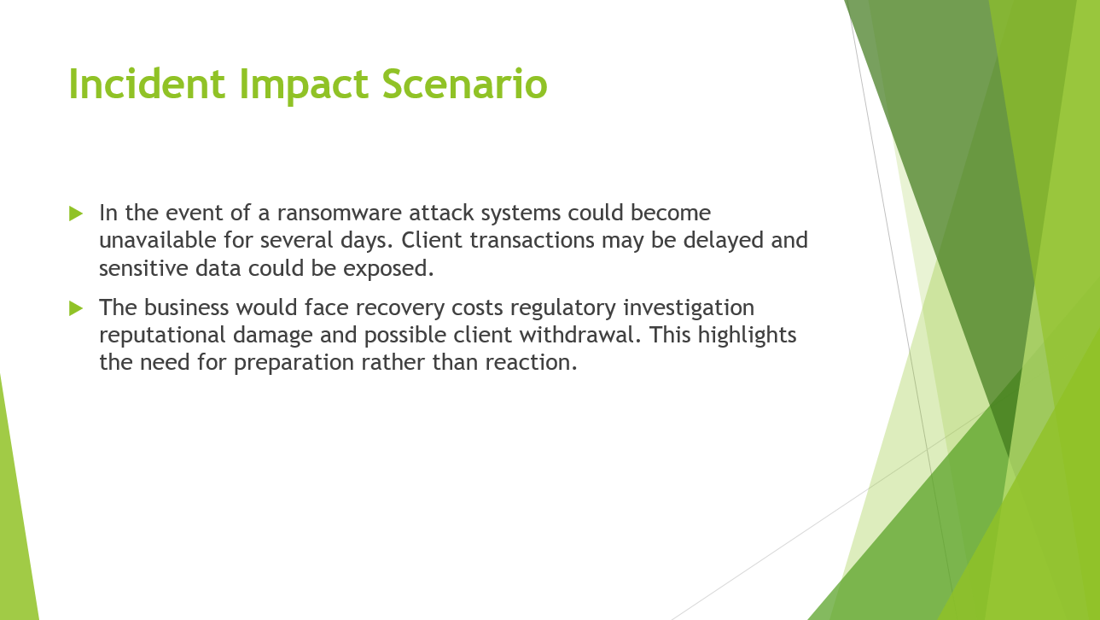
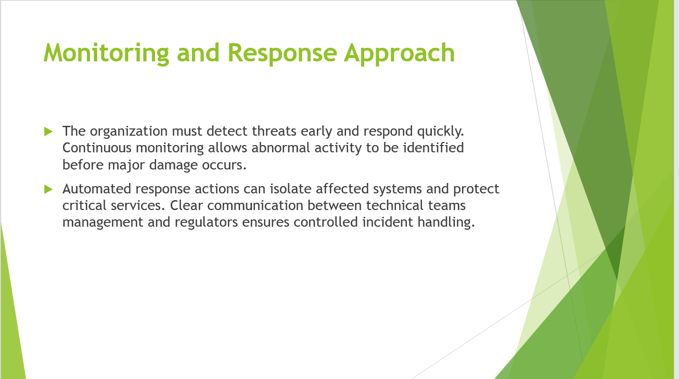
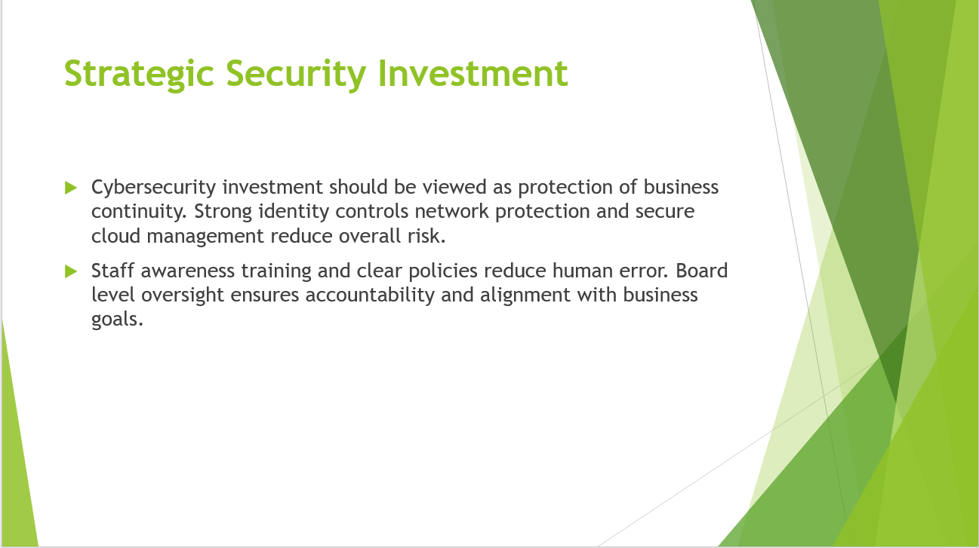
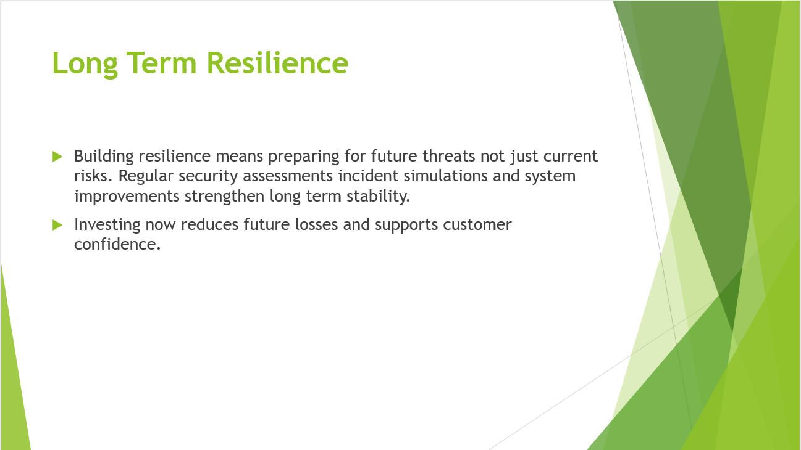
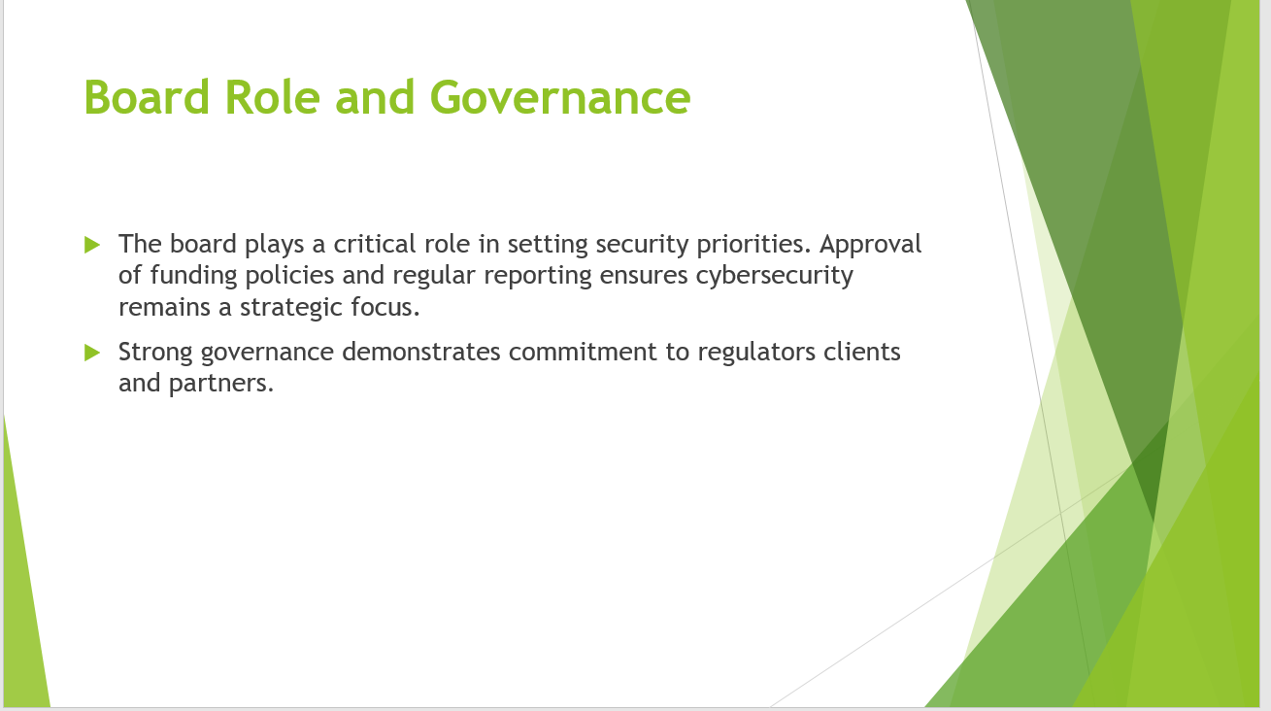
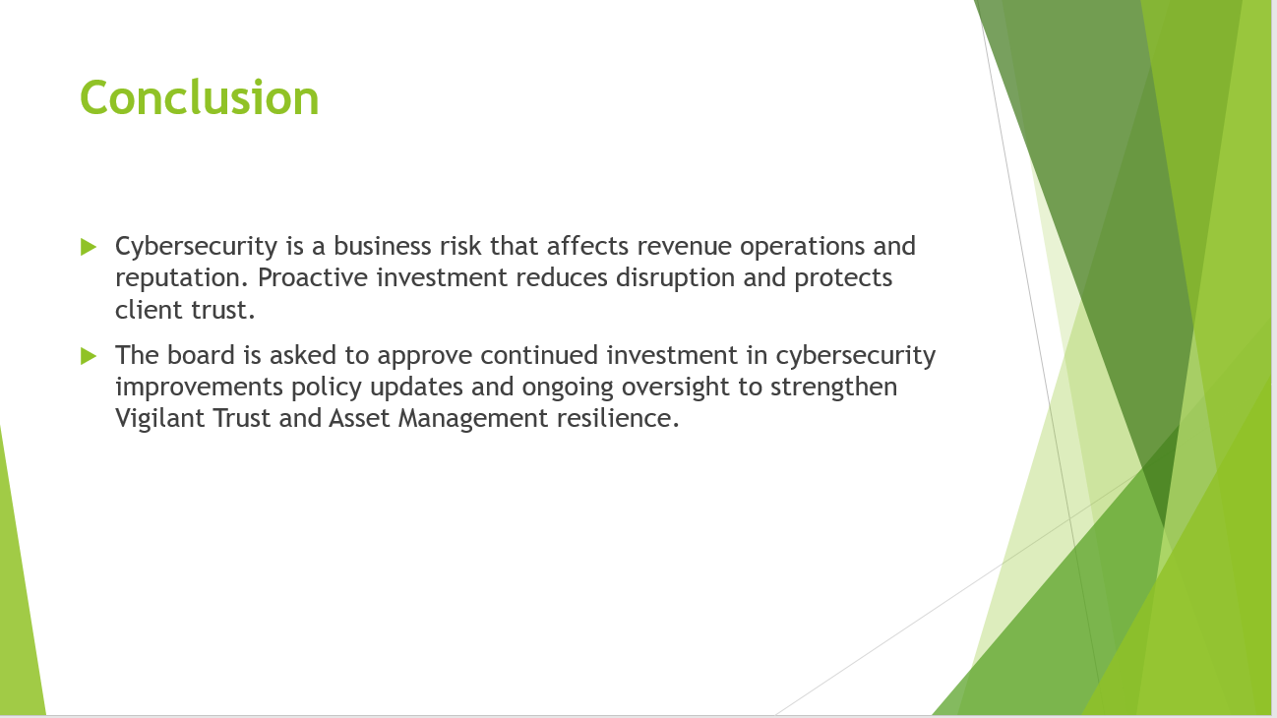

Appendix B: Screenshot of the Badge


