

An investigation into the prevalence of knife crime: what atrategies, policies and intervention schemes are in place to deter young people away from knife crime and how effective is police officer training regarding knife crime involving young people?

Elinor Green
2134411

Professional Policing

Acknowledgements

I'm extremely thankful for the staff at the University of Wales Trinity Saint David, especially Michelle Hill who is my policing project supervisor, who provided me with feedback on my dissertation throughout and whose guidance allowed me to complete my dissertation.

I would like to express my gratitude to my family who have supported me and encouraged me throughout the entire process.

This research would not have been possible if it weren't for my amazing colleagues at Gwent Police who generously gave their time to complete my questionnaire but who have also consistently supported me.

Declaration

Declaration - This work has not previously been accepted in substance for any degree and is not being concurrently submitted in candidature for any degree. Signed: Elinor Green Date: 04/04/2025
Statement 1 - This dissertation is being submitted in partial fulfilment of the requirements for the degree of BSc. Signed: Elinor Green Date: 04/04/2025
Statement 2 - This dissertation is the result of my own independent work/investigation, except where otherwise stated. Other sources are acknowledged by footnotes giving explicit references. A bibliography is appended. Signed: Elinor Green Date: 04/04/2025
Statement 3 - I hereby give consent for my dissertation, if accepted, to be available for photocopying and for interlibrary loan, and for the title and summary to be made available to outside organisations. Signed: Elinor Green Date: 04/04/2025
Statement 4 - I hereby give consent for my dissertation, if accepted, to be available on the university’s IT system to those who have consent to use the system. Signed: Elinor Green Date: 04/04/2025

Abstract

Knife crime is unfortunately a frequent topic that covers the UK media and it's concerning that it has become rife amongst young people.

This dissertation examines strategies, policies and intervention schemes that are in place to deter young people away from knife crime. It also explores the current literature that is available on the training that police officers receive regarding young people involved in knife crime and also if they are aware of the current strategies in place to deter them away from knife crime.

In order to gain further information on this topic, a questionnaire was disseminated to current serving police officers in Gwent Police. The officers were questioned on what strategies, policies and intervention schemes they were aware of and how often they personally utilise them. They were also asked about the training they personally received regarding young people involved in knife crime.

The results have shown that serving police officers were unaware of the strategies to deter young people away from knife crime and felt that they had not received sufficient training on the subject however were open to learning more about the topic and interested in receiving more specific training.

Table of Contents
Chapter 1 – Introduction…………………………………………………………………………………………………..8
1.1 Background…………………………………………………………………………………………………………8
1.2 Research Rationale……………………………………………………………………………………………..9
1.3 Aims and Objectives……………………………………………………………………………………………9
1.4 Conclusion…………………………………………………………………………………………………..……10

Chapter 2 – Literature Review…………………………………………………………………………………………11
2.1 Introduction………………………………………………………………………………………………………11
2.2 Current policies, strategies and intervention schemes in place to intervene or to persuade young people from carrying knives or knife crime……………………..……11
2.3 To explore if police officers are aware of strategies, policies and interventions for young people who are at risk of knife crime……………………………………………………..13
2.4 Identify areas of learning for response officers…………………………………………………13
2.5 What current training do response police officers receive regarding knife crime involving young people and is this training effective?......................................14
2.6 Conclusion…………………………………………………………………………………………………………16

Chapter 3 – Methodology…………………………………………………………………………………….…………17
3.1 Introduction………………………………………………………………………………………………………17
3.2 Ethical Practice……………………………………………………………………………………………….…17
3.3 Informed Consent…………………………………………………………………………………………..…17
3.4 Data Collection Method…………………………………………………………………………….………18
3.5 Sampling……………………………………………………………………………………………………………18
3.6 Limitations…………………………………………………………………………………………………..……19
3.7 Conclusion…………………………………………………………………………………………………………18
Chapter 4 – Analysis of Results……………………………………………………………………………….………20
4.1 Introduction………………………………………………………………………………………………………20
4.2 Participant Demographic……………………………………………………………………………..……20
4.3 Participant experience with knife crime………………………………………………….…………21
4.4 Participant Knowledge and training……………………………………………………………..……22
4.5 Area of Learning for Participants……………………………………………………………….………29
4.6 Conclusion…………………………………………………………………………………………………………30

Chapter 5 – Conclusion and Recommendations………………………………………………………………31
5.1 Introduction………………………………………………………………………………………………………31
5.2 To explore current policies, strategies and intervention schemes that are in place to intervene or to persuade young people from carrying knives or knife crime……………………………………………………………………………………….………31
5.3 To explore if police officers are aware of strategies, policies and interventions for young people who are at risk of knife crime…………………………………………………..….……31
5.4 Identify areas of learning for response officers………………………………………….………31
5.5 What current training do response police officers receive regarding knife crime involving young people and is this training effective?................................................32
5.6 Recommendations…………………………………………………………………………………….………33
5.7 Final thoughts……………………………………………………………………………………………………34

Chapter 6 -Bibliography…………………………………………………………….……………………………………35

Chapter 7 - Appendices………………………………………………………………………………..…………………40
7.1 Copy of Questionnaire……………………………………………………………………………………...40
7.2 Questionnaire answers…………………………………………………………………………………..…45
7.3 Answers to question 5…………………………………………………………………….…………………50
7.4 Answers to question 7……………………………………………………………………………….……..53
7.5 Answers to question 14…………………………………………………………………………………….55
7.6 Answers to question 15…………………………………………………………………………………….57
7.7 Answers to question 17…………………………………………………………………………………….59
7.8 Answers to question 19……………………………………………………………………………….……61

Chapter 1: Introduction
This dissertation will delve into the strategies, policies and intervention schemes in place that are designed to educate young people on the effects of knife crime and deter them away from the offences involved. It will also focus on what training police officers receive regarding young people being involved in knife crime and how effective that training is. This introduction chapter of the dissertation will provide the background on the topic of knife crime involving young people, the aim and objectives of the dissertation and the reason why the topic of knife crime is so significant.

1.1 Background
Knife crime can be defined as any crime involving knives or other bladed or pointed articles (Sidebottom, 2021) meaning these offences can include possession of a bladed article in a public place, threatening someone with a knife or fatally wounding someone with a knife (Leicester Police, 2025). Knife crimes can be and are committed by persons of any age however this dissertation will focus specifically on young people.
Out of the various offences that can be classed as knife crimes, 99.7% of the knife offences committed by young people in the last year were possession offences (Youth Justice Board for England and Wales, 2025). Nacro, who are a national social justice charity based in England and Wales, were told by young people that fear played a huge part in the reason they may carry knives but they also said that they felt that the police did not protect them. Nacro published that they believe that the police, community organisations, local authorities and education providers need to work together to improve the relationship between the police and young people (Coady, 2023).
Strategies, policies and intervention schemes to deter young people away from knife crime can involve educating the young person on the legal consequences, physical harm and emotional impacts that can come from involving themselves in knife crime (Youth Endowment Fund, 2025). This dissertation will delve into what interventions are in place to deter young people from knife crime and if current serving police officers are aware of them.
Training to become a police officer will vary depending on what entry route an officer has joined through as well as what force they are training with (College of Policing, 2025). However, every police officer will complete extensive training which is classroom-based as well as practical (Join the Police, n.d). This dissertation will examine what training police officers receive regarding young people involved in knife crime and whether or not that training is effective.

1.2 Research Rationale
The researcher’s rationale for this project is due to the prevalence of knife crime amongst children and young people in the UK. It is a subject that doesn’t just affect certain individuals or groups, but the entire UK population as a whole. It has become increasingly common to see the media covering stories where a child or young person has been either a victim or suspect in a knife crime. For instance, the murder of Olly Stephens, a thirteen year old boy, in 2021 where he was stabbed to death in Reading by two boys who were also teenagers (Mitchell, 2022).
More recently, in July 2024, seventeen year old Axel Rudakubana carried a kitchen knife into a children’s dance class in Southport and stabbed eleven children which resulted in the death of three children (Crown Prosecution Service, 2025). This specific case horrified the entirety of Britain and riots erupted in the town of Southport the day after the attack (Coffey, 2025). What the researcher has noted about this case is that two years prior, Lancashire police officers located Axel Rudakubana in possession of a knife on a bus. Not only this, but there were multiple Prevent referrals submitted from Axel Rudakubana’s school which were closed on each occasion (Coffey, 2025). The Home Secretary has pointed out that despite Axel Rudakubana’s multiple interactions and referrals to the police and partner agencies; they failed to act on the warning signs (Home Office, 2025).
This then raises the question if police have learned from incidences such as these, and if adequate training has been put in place to educate officers on how to deter young people from committing knife crime and following the appropriate policies and procedures. On completion of the research, it should be evident whether or not police receive vital training on how to tackle the prevalent issue of young people committing knife crime and if that training is effective.

1.3 Aims and Objectives
The aim of this dissertation is to examine what strategies, policies and intervention schemes are in place to deter young people away from knife crime. It also aims to inspect if police officers are aware of these intervention schemes, identify areas of learning if police aren’t aware and to analyse how effective police officer training is regarding this topic.
- To explore current policies, strategies and intervention schemes that are in place to intervene or to persuade young people from carrying knives or knife crime.
- To explore if police officers are aware of strategies, policies and interventions for young people who are at risk of knife crime.
- Identify areas of learning for response officers.
- What current training do response police officers receive regarding knife crime involving young people and is this training effective?
1.4 Conclusion
This first chapter has introduced the research of the dissertation, identified the aims and objectives of the research and the reasons why it is vital that more research is completed on this topic. The next chapter will present the available literature on each of the aims and objectives listed in this chapter.

Chapter 2: Literature Review

2.1 Introduction
This chapter will provide a brief overview of the current research into the prevalence of knife crime, looking specifically into youth offending. It will then go on to each objective and explore what literature is available and where the gaps are.
This dissertation has the following objectives:
- To explore current policies, strategies and intervention schemes that are in place to intervene or to persuade young people from carrying knives or knife crime.
- To explore if police officers are aware of strategies, policies and interventions for young people who are at risk of knife crime.
- Identify areas of learning for response officers.
- What current training do response police officers receive regarding knife crime involving young people and is this training effective?

2.2 Current policies, strategies and intervention schemes in place to intervene or to persuade young people from carrying knives or knife crime.
Phillips (2022) in their study, ‘Promising Approaches to Knife Crime’, describe knife crime committed by children is driven by a collection of “poverty, marginalisation, adverse childhood experiences, trauma, fear and victimisation.” They interviewed YOT (Youth Offending Team) staff members to find out what interventions are being implemented. As a result of their research they found four different categories of interventions; diversionary activities, strength-based approaches, programmes and other interventions.
The diversionary activities were found to be effective methods of keeping young people involved in positive, educational activities and away from the risks of knife crime. It was found that young people who aren’t provided with these diversionary activities were more at risk of harmful behaviour and showed signs of little self-esteem and confidence.
‘Promising Approaches to Knife Crime’ (2022) also found that mentoring is an effective intervention that is used to deter young people away from offending. Mentors are role models that may share similar experiences and interests with a young person are more likely to have “shared backgrounds” with the children in comparison to youth offending team workers. The College of Policing (2016a) also shares the same opinion when it comes to mentoring. It defines mentoring as an interaction of two individuals over an extended period of time where the mentee is in a position to imitate and benefit from the knowledge, skill, ability or experience of the mentor. The College sees mentors as maintaining healthy development with the young person and diverting them away from offending.
The research carried out also found that one of the strategies in place by the youth offending team was programmes based on the ‘Youth Justice Boards Knife Crime Prevention Programme.’ These were educational programmes aimed to inform children of the risks and impacts of knife crime. These programmes help the children think about the consequences of their own actions. Furthermore, these programmes include involvement from external organisation such as the ambulance service to describe to the children the impact that knife crime has on the health service, for example, cost of an ambulance or implications for other people who are in need of an ambulance. Aftermath interventions, also outlined in ‘Promising Approaches to Knife Crime’ (2022), are other agencies such as the St Giles Trust who facilitate the youth offending team access to children “in the almost immediate aftermath of being either the perpetrator or victim of knife crime.”
Applied Quantitative Methods Network Research Briefing (2019), state that Scotland’s introduction of interventions strategies for knife crime has caused a reduction in homicide and violence. They specifically mention the ‘Violence Reduction Unit’ and the ‘No Knives Better Lives’ campaign which is specifically aimed at reducing “street-based gang violence and knife crime” in young men. The ‘No Knives Better Lives’ campaign is an educational workshop for young people where practitioners strive to make young people aware of the consequences of youth violence. They do this by means of empowering young people and supporting them to take control and make reasoned decisions (No Knives Better Lives, 2025).
In 2018, the UK Government introduced the Serious Violence Strategy. One of the main focuses of the Serious Violence Strategy is ‘early intervention and prevention’ (HM Government, 2018). One of the schemes this strategy allows is for young people who are most “at risk of being involved in gangs or serious violence” will be eligible for early access to the Work and Health Programme. The Work and Health Programme gives personal support to those eligible with assisting them with finding work (Department for work and pensions, n.d.). Although this strategy seems that it should allow a pathway for young people most at risk of being involved in serious violence, it was discovered that 88% of the overall participants of this programme in 2018 did not achieve a job outcome within a year of starting the programme (Disability Rights UK, 2025).
Another preventative measure that was put in place to prevent young people from committing knife crime was the introduction of Knife Crime Prevention Orders (KCPO) (Hendry, 2022). The court may issue a young person with a Knife Crime Prevention Order if they are ‘satisfied’ that the defendant has committed an offence “involving violence or where a bladed article was used or carried by the defendant or any other person in the commission of the offence.” The application for a Knife Crime Prevention Order is made by chief police officers and they must consult with the Youth Offending Team beforehand. “Positive Requirements” are put in place for the defendants who will then, based on their individual circumstances, be required to attend educational courses, targeted intervention programmes or receive mentoring (Home Office, 2021).
McNeill & Wheller (2019) suggests that early intervention and prevention programmes have shown to be effective in tackling knife crime in young people and are of the belief that knife crime cannot be resolved using solely the criminal justice system. One of the programmes they list as being promising is child skills training which is used to reduce anti-social behaviour and targeted towards children who have been identified of at risk of committing that anti-social behaviour. This training focuses on self-control, anger management and victim empathy (College of Policing, 2016b).
Finally, Operation Sceptre is a national campaign which takes place twice a year where police officers work with young people to educate them on the dangers of carrying knives. This is done by engaging young people in a range of activities but also allowing them to take part in targeted operations (Surrey Police, 2024). A part of this campaign is test purchasing where police work with local retailers to ensure that young people are not buying knives. The retailers that fail the test purchasing are reported to Trading Standards and offered advice to prevent young people from getting their hands on knives (Wiltshire Police, 2021).

2.3 To explore if police officers are aware of strategies, policies and interventions for young people who are at risk of knife crime
2.4 Identify areas of learning for response officers
For these objectives the aim was to ascertain how competent police officers are when it comes to deterring young people away from knife crime. It’s obvious from the literature above that there are plentiful strategies, policies and interventions to persuade young people away from knife crime and to prevent them from committing any knife crime, but are these being utilised by police? The two objectives have been combined as the second objective will help to identify what areas police officers may need more training in based on what policies, strategies and interventions they are not aware of.
Police officers have the power to stop and search persons under section 1 of the Police and Criminal Evidence Act 1984. This power allows police officers to stop and search “any person, any vehicle, or anything which is in or on a vehicle, for stolen or prohibited articles, points and blades” (College of Policing, 2023). The Home Office (2023a) stated that since 2019, 100,000 weapons were taken from the streets of Britain through a range of tactics – half of which were seized in stop searches. While this shows that officers are making use of their stop search powers to tackle knife crime, His Majesty’s Inspectorate of Constabulary and Fire and Rescue Services (2023a) found that “police didn’t make full use of other relevant powers.”
The Police also have the power under section 34 of the Policing and Crime Act 2009 to apply to the courts for gang injunctions. These injunctions prohibit a person from engaging in activities and behaviours related to gang related violence (Home Office, 2013). Going back to the findings of His Majesty’s Inspectorate of Constabulary and Fire and Rescue Services (2023a), they’ve suggested that police forces do not utilise these injunctions as they are too “time-consuming, bureaucratic and expensive” even when it has been evidenced that they can reduce offending.
Furthermore, there seems to be a lack of knowledge around ‘outcome 22’ within the police (His Majesty’s Inspectorate of Constabulary and Fire and Rescue Services, 2023a. ‘Outcome 22’ is more of an educational and rehabilitating outcome rather than one that focuses on solely punishment (Home Office, 2023b). The purpose of this outcome is to ensure there have been efforts made to change the behaviour of the individual by addressing the direct cause of the offending (Youth Justice Legal Centre, 2022). HMICFRS (2023a) found that police officers had a “flawed understanding of it” meaning that it wasn’t as effective as it could have been if police officers had the appropriate training.
The researcher acknowledges that this literature identifies that police officers have a significant lack of knowledge surrounding strategies, policies and intervention schemes to deter young people away from knife crime. However, there is a lack of available literature detailing the reasons why officers have such a lack of understanding on strategies, policies and intervention schemes to deter young people away from knife crime. Furthermore, it should be noted that, although these injunctions have been seen to be effective in reducing offending, there is a lack of reason as to why young people are not being referred. The researcher identified that the literature was lacking the direct perspectives from police officers which has the potential to show what areas of learning can be fulfilled.
2.5 What current training do response police officers receive regarding knife crime involving young people and is this training effective?
For this objective, the aim was to find out what training police officers have around safeguarding young people when they are identified in being involved in knife crime and how effective that training is.
Gray (2021) state that adverse childhood experiences are strongly associated with a range of problematic behaviours including aggression, violence and criminal behaviour. Adverse childhood experiences can be defined as “highly stressful, and potentially traumatic, events or situations that occur during childhood and/or adolescence.” They can significantly increase the risk of an individual adopting health-harming behaviours as well as increasing the risk of suffering from poor mental health (Young Minds, 2018). UK police forces understand that children are vulnerable persons and so use alternative outcomes that do their best to keep children and young people out of the criminal justice system. It is no question that police officers have a huge role in protecting young people from abuse and have a duty of care to them (Home Office, 2016). However, it is also expected that front line police officers are able to identify young people who are at risk of engaging in violent crime and are able to spot the early signs of knife crime in children.
The college of policing (2021a) provide guidelines to police officers which contain practical support to help officers recognise individuals who are at risk of harm and encourage officers to seek more information about a vulnerable person’s situation. These guidelines specifically outline that police officers should be aware of the signs of vulnerability-related risk and should have the communications skills to develop trust with that individual in order to gain as much information as possible (College of Policing, 2021b). The college of Policing recognises that police officers will very often have to interact with partner agencies so referrals can be made.
It is clear that police officers are trained to use their powers of stop and search under section 1 of the police and criminal evidence act 1984 to search for “pointed or bladed articles” (College of Policing, 2023). However, if a knife is found on a child, are police officers trained in how to appropriately safeguard that child? If a child is found to have been involved in an incident relating to knife or weapon possession/offences, then a Public Protection Notice is to be sent from the police onto the relevant Youth Justice Service (Nottinghamshire County Council, 2022). A Public Protection Notice is “an information sharing document that records safeguarding concerns about an adult or child” which is shared with partner agencies to provide as much support to that individual as possible. (His Majesty’s Inspectorate of Constabulary and Fire and Rescue Services, 2023b). The Royal Society for Public Health (2020) have stated that Public Protection Notification workshops have been rolled out to police officers in Gwent which have shown to have a “significant improvement” of the quality of information sent to social services. These workshops have shown to be effective training for police officers as Blaenau Gwent Families First Team have stated that as a result of the better quality Public Protection Notifications being sent to them, they have a “much deeper understanding of the situation” and enables them to “respond more efficiently and proportionately (Royal Society for Public Health, 2020).
On the other hand, according to the Vulnerability Knowledge and Practice Programme (2020), they describe police as not fully understanding the referral process to social services or multi-agencies and having a lack of understanding around vulnerability. This emphasises that there is a need to further explore police officers’ understanding and training regarding making referrals and subsequently identify areas of learning. They also go on to mention that “police rely on partners to share information with the relevant agencies, instead of sharing themselves” which results in relevant information not being shared. This could possibly be improved with public protection notification workshops similarly to what was implemented in Gwent Police.
Again, the researcher notes that there is a lack of direct perspectives from police officers regarding what training they receive. It would be beneficial if the views of police officers were obtained to investigate if they recall any specific training relating to young people committing knife crime. It would be of value to gather police officers’ opinions on whether they feel they have received the necessary training to safeguard young people, but also what further training they believe may be worthwhile as they are the individuals who will know what will work best for them or what doesn’t work best for them.
2.6 Conclusion
The topic of knife crime is extremely broad in today’s society and there is a large amount of literature available surrounding the subject. From the research shown in the literature review, it’s evident that there is an abundance of intervention schemes, policies and strategies available to deter young people away from knife crime. However, the identified gap in the literature is the lack of research that has been undertaken to find out if these strategies are known to police officers who also deal with young people at risk of knife crime. There is also a lack of information available regarding what training police officers have around knife crime specifically in young people and if their current training is effective. The researcher has identified that the gap in the available literature is gathering the perspectives of police officers. In doing so, it is likely that the aims and objectives of the dissertation will be met.

Chapter 3: Methodology

3.1 Introduction
This chapter will discuss the methods used to conduct research regarding response constables’ knowledge and understanding of their responsibilities when they have contact or interact with a young person who is at risk of being involved in knife crime. It will discern the methods and approaches used to find out the training these officers received on how to safeguard these young people and what they know of their duties. This will then identify what areas of learning are needed as well as any further training required.

3.2 Ethical Practice
Prior to undertaking any research for a dissertation, it is a requirement that the research will be completed to an ethical standard which is defined as “the standards of behaviour that guide your conduct in relation to the rights of those who become the subject of your work, or are affected by it” (University of Westminster, n.d). Prior to starting any research regarding a dissertation, one must complete and submit an ethical consent form. This form consists of a summary of what will be investigated, the objectives and aims of the research, the proposed methods to conduct the research and anticipated risks of the research.
It is imperative that researchers obtain consent from any participants of the research to reduce to risk of any harm. They must also give consent if they are to be identified or if they wish to remain anonymous as a participant (Lund Research, 2012).
The data protection Act 1998 was introduced to protect people’s fundamental rights and their right to privacy. Specifically, data may only be used for the purpose of which it has been collected and it must not be disclosed to other parties without the consent of the individual whom it is about. Data that is collected for the purpose of research must be stored securely and can only be stored for the time that it is needed (Miller, 2013).

3.3 Informed Consent
Informed consent is an imperative part of a researcher’s dissertation and every participant must understand what research they are partaking in and, most importantly, give documented consent to be a part of it (Loughborough University, 2024).

For the research in this dissertation, it will be ensured that participants have been given informed consent by putting a disclaimer at the start of the questionnaire which will inform the participants what the study is about and what will happen with the information that they provide on the questionnaire as well as how their information will be protected. Furthermore, before the participant ‘submits’ their questionnaire answers, another disclaimer will show informing the participant that submitting their answers will constitute consent (University of St Andrews, 2024)

3.4 Data Collection Method
Qualitative research is a type of research that “gathers participants’ experiences, perceptions and behaviour. It answers the hows and whys instead of how many and how much” (Tenny, 2022), whereas, quantitative research measures the relationship between variables and defines trends (Barroga, 2022).

The secondary research will consist of obtaining information from participants by means of a questionnaire. This questionnaire will be completed by anonymous response constables across Gwent Police. It was decided to make the questionnaire anonymous as evidence has shown that participants tend to answer more honestly and are more likely to disclose sensitive information when they know that their identify will have no link with their answers (Murdoch, 2014). Furthermore, questionnaires allow for a large number of responses within a short period of time which is more advantageous than collecting data by means of interviewing participants (Pozzo, 2019). A questionnaire would provide the researcher with quantitative data.

Nonetheless, it can be considered to interview officers as this would enable the researcher to gain further explanation and understanding behind closed questions that they would have on a questionnaire (Espedal, 2022). The principal reason not to conduct interviews is because it would be very time consuming compared to a questionnaire which participants can complete without the researcher being present. Interviews would provide qualitative data.

To obtain both quantitative and qualitative data, closed questions will be asked in the questionnaire however also add text boxes where participants can share their explanations and thoughts for their answers. Open ended questions, such as ones which include a text box for the participant to write their answers in, are useful when conducting this type of research as they allow for a wide range of answers that closed questions do not and they also allow for in-depth responses (Hyman, 2016).

3.5 Sampling
Response constables were chosen to be the participants as they will have daily contact and interaction with young people at risk of criminal exploitation and knife crime. Response constables will have first contact with these young people at risk and have a duty to submit Public Protection Notifications on behalf of that child and are responsible for that PPN to be shared to social services.

These officers will be enlisted by advertising the questionnaire on the Gwent Police intranet where all response officers have access to and will be able to see. This is the best way to reach every response constable across the force. The downside of this is that the questionnaire will be accessible to all police officers and staff and not only response constables so there is a risk of it being completed by someone who is not the targeted participant and could therefore effect the results of the data.

3.6 Limitations
One limitation of this study that has been identified is the amount of time that the researcher had to gather participants’ answers from the questionnaire. Due to time constraints, the questionnaire was only answered by 43 individuals. If the questionnaire had longer time to be answered, it may have provided the researcher with a more representative sample.

Another limitation is that the researcher meant for only response police officers to answer the questionnaire. However, the easiest and quickest method to disseminate the questionnaire to all response police officers was to advertise it on the Gwent Police intranet which is accessible to all departments and staff members. This means that the questionnaire may have been completed by non-response officers who weren’t the target participant.

3.7 Conclusion

This chapter has outlined the research methodology of the dissertation. The research will be achieved by means of a questionnaire through open and closed questions. The next chapter will provide an analysis of the results obtained from the questionnaire.

Chapter 4: Analysis of Results

4.1 Introduction
This chapter will consist of the analysis of the results from the research. A total of 43 participants took part in the questionnaire. The aim of this questionnaire was to explore police officers’ knowledge around the strategies and interventions regarding knife crime involving young people and how effective their training is. This research was conducted to meet three of the main objectives for this dissertation.
2. To explore if police officers are aware of strategies, policies and interventions for young people who are at risk of knife crime.
3. Identify areas of learning for response officers.
4. What current training do response police officers receive regarding knife crime involving young people and is this training effective?

4.2 Participant Demographic
Question 1 – What is your gender?
Question 2 – What age group are you in?
Question 3 – What is your length of service as a police officer?
To begin the questionnaire, the researcher asked the participants what their gender was, what age group there were in and what their length of service was as a police officer. The researcher asked these three questions so that it could be seen if the questionnaire provided a representative sample of officers (Rahman, 2022). The questionnaire received a more or less equal amount of male and female officers which is a good representative sample, however there was less representation amongst age groups with the 25-34 and 35-44 brackets being the most prominent. There was an even lesser equal representation amongst participants’ length of service with officers with 2-5 years of service dominating the overall sample. This should be considered when reviewing the results of participants’ knowledge and training as it would be expected that officers with less service would have less experience and knowledge regarding strategies, policies and intervention schemes regarding knife crime than those with more service.





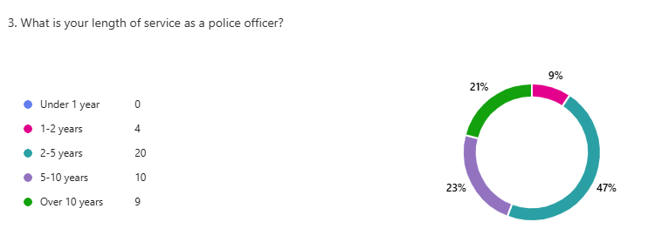

4.3 Participant experience with knife crime
Question 4 – How often do you have involvement with young people carrying knives?
The questionnaire then went on the get an insight into the participants’ experience with young people carrying knives as this was identified as the most common knife offence committed by young people. There were mixed responses however the most common answer was “rarely” closely followed by “monthly”. Participants were then asked what type of involvement they had in the following question.



Question 5 – Please describe what type of involvement you have.
This was an open question and there were many different experiences shared by the participants. A common answer to this question was locating knives on a young person as a result of a stop search. Linking this back to the literature review, this supports the findings of The Home Office (2023a) whereby their findings also showed that officers were making use of their stop search powers. Another common answer to this question consisted of intelligence submission. Participants made reference to conducting stop searches as a result of intelligence submissions made by partner agencies. This provides more information than the literature review as it shows that partner agencies are communicating effectively to the police and subsequently police are submitting the relevant intelligence onto police systems which has resulted in information that can be used by police as ground to conduct a stop search and effectively seize knives and bladed articles from the streets.

4.4 Participant Knowledge and training
Question 6 – Are you aware of any policies, strategies or intervention schemes that have been put in place to intervene or to persuade young people from carrying knives?
Question 7 – If yes, please specify.
Participants were asked this question to directly answer objective 2 of this dissertation. 44% of participants stated there were not aware of any policies, strategies or intervention schemes however those who stated they were aware were asked what they know of in question 7.
The most popular answers to question 7 were, “Knife amnesty” and “op sceptre” however there was a severe lack of explanation to accompany these answers so the extent to which the participants understand these terms cannot be ascertained. This could potentially back the findings of HMICFRS (2023a) where they stated that officers can have a “flawed understanding” of outcome 22. A few participants mentioned the Youth Offending Team/Service however again there wasn’t any explanation to accompany these answers but this shows that the participants are aware that working with partner agencies is a strategy to intervene young people from carrying knives. Interestingly, one participant stated that they had run a program to dissuade youths from carrying knives which shows that some officers are going above and beyond by running their own intervention schemes to deter young people from knife crime.
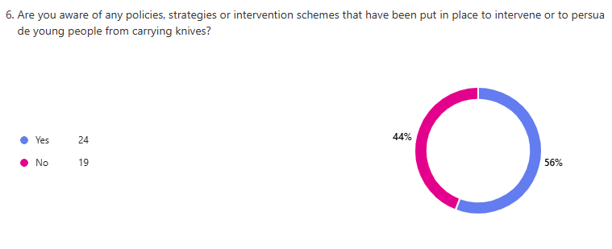

Question 8 – How often do you utilise Section 1 of the Police and Criminal Evidence Act 1984 'Stop and Search' regarding pointed and bladed articles?
From the primary research, it was evident that police officers do make use of their powers of stop and search (Home Office, 2023(a)) however the researcher has asked this question to see how often this was utilised amongst the participants and if the results support the primary findings. The most common answers were “monthly” and “regularly” making up a combined 88% of the overall responses. This doesn’t support the primary findings as the results show that the power of stop search is not being utilised often at all. Unfortunately, the questionnaire doesn’t detail why the participants “rarely” utilise their power of stop search and this would be interesting to know if it is due to a lack of training or perhaps something else.
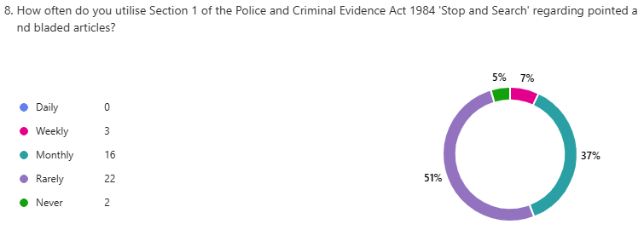

Question 9 – Are you aware of Section 43 of the Police and Crime Act 2009 regarding applying to the courts for gang injunctions?
Participants were asked this question to directly address the findings of HMICFRS (2023a) as they have stated that police forces do not use these injunctions as they are too “time-consuming, bureaucratic and expensive.” From the findings, 70% of participants said they were not aware. Although this may corroborate that police forces do not use the injunctions, it doesn’t support the fact they do not use them because they are too “time-consuming, bureaucratic and expensive” but it seems to be because officers simply do not know of this strategy. This could indicate a lack of training but it certainly identifies an area of learning for police officers.


Question 10 – Are you aware of 'Outcome 22' regarding intervention and diversionary activities?
Similarly to the previous question, participants were asked if they knew of this particular intervention scheme as HMICFRS (2023a) stated that officers had a “flawed understanding” of it.. 49% of officers stated that they were not aware of it which corroborates the findings of HMICFRS (2023a).


Question 11 – How often do you complete a 'Child at Risk' Public Protection Notification?
Question 12 – How often do you complete a 'Child at Risk' Public Protection Notification regarding a young person who has or is at risk of committing knife crime?

Participants were asked these two questions so that the researcher could compare the two results. The charts below show that despite most officers stating that they complete a ‘Child at Risk’ Public Protection Notifications “Daily” or “Weekly”, the majority of officers stated they “Rarely” complete a ‘Child at Risk’ PPN regarding a young person who has or is at risk of committing knife crime. The reasons for this are unknown however the results from question 4 may be the reason for this. However, the results from question 11 reflect upon the literature findings that Public Protection Notification workshops were rolled out to officers in Gwent and have shown “significant improvement” to the quality of them. Officers may be routinely completing ‘Child at Risk’ Public Protection Notifications as they have recently received enhanced training on how to complete them (The Royal Society for Public Health, 2020).
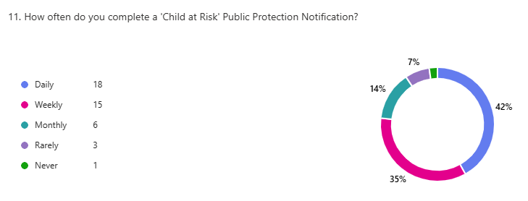

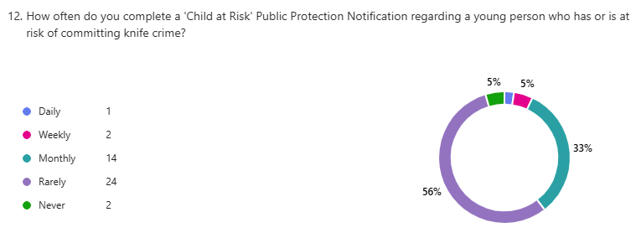

Question 13 – Do you always send that Public Protection Notification onto partner agencies?
From the primary research, the Vulnerability Knowledge and Practice Programme (2020) suggested that officers are not sharing information with the relevant agencies. However, from the secondary research it is clear that 93% of participants state that they always send their completed Public Protection Notifications onto partner agencies. This suggests that since 2020, there has been a significant improvement in officers’ training regarding these PPNs.


Question 14 – What partner agencies do you send them to?
With this question, the researcher aimed to find out specifically what agencies officers sent these PPNs on to. 35 out of 42 participants stated only social services. These findings corroborate the Vulnerability Knowledge and Practice Programme (2020) when they say that officers rely on partner agencies to share relevant information rather than doing it themselves. This shows that there could be further guidance for police officers for more specific agencies they can send their PPNs onto so that it reaches the most relevant agencies for the specific needs of the child.

Question 15 – What training have you received regarding knife crime, specifically involving young people?
The researcher asked this question to directly address objective 4 of the dissertation. 19 participants out of 40 stated that they hadn’t received any training in knife crime specifically involving young people which is a huge gap in officers’ training. One of the participants stated “None, which should change considering how prevalent it has become.” The other 21 participants didn’t give varying answers, mainly stop search training and taser training.

Question 16 – On a scale from 1 to 10, how effective would you say that training is, with 1 being the least effective and 10 being the most effective?
Participants were asked this question to gain insight into their view of how they felt about the training they received regarding knife crime committed by young people. The majority of participants ranked their training between 1 and 5 which is to be expected due to the results of the previous question where almost half of the participants said they hadn’t received any training.


Question 17 – Please give a reason as to why you think that training is/isn't effective.
18 out of 34 participants answered this question with either stating they hadn’t received any training or they cannot remember having any training on this topic. However, a few participants made comments about stop searches such as “there is larger focus on stop search and locating knives on persons than how to deal with the offences afterwards.” The primary research and secondary research shows that officers are trained to utilise stop search powers however this still shows a gap in training with how to safeguard these children who are found possessing a bladed article. It seems that police officers are being trained in how to locate knives and identify knife offences, but nothing on how to prevent it.

Question 18 – When was the last training you received regarding knife crime, specifically involving young people?
Participants were asked this question to calculate if the frequency of training could be a considering factor when determining areas of learning for police officers. 22 out of 43 participants selected “None/Don’t know” again showing a lack of training in knife crime, specifically involving young people.

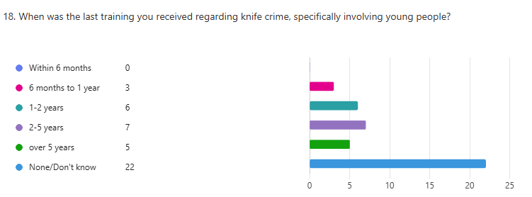
4.5 Area of Learning for Participants
Question 19 – Is there any training you would like to be introduced to response officers regarding knife crime involving young people?
There were various answers from participants for this question. One participant answered “sessions run by reformed young adults and what impact it had on them and what changed for them to change their initial behaviour.” Another participant wanted “training to deal with incident and outcomes – e.g. CR, young offender referral, VA, arrest, etc.” This shows that officers are willing to learn how to deal with young people committing knife crime.

Question 20 – How would you prefer that training be carried out?
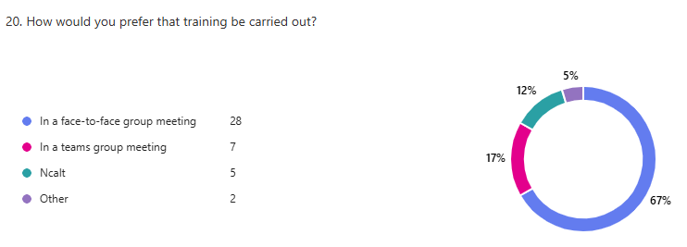
Participants were asked this question so as to identify what methods of training would be the most effective in expanding officers’ knowledge of how to prevent and deter knife crime in young people.
Question 21 – If other, please specify.
Only 8 out of 42 officers answered thisquestion. Those who answered suggested that training around this topic could be introduced during officer safety training and taser courses.

4.6 Conclusion
This chapter has analysed the findings of the questionnaire that was disseminated to police officers in order to meet three of the four main objectives of the dissertation:
2. To explore if police officers are aware of strategies, policies and interventions for young people who are at risk of knife crime.
3. Identify areas of learning for response officers.
4. What current training do response police officers receive regarding knife crime involving young people and is this training effective?

In conclusion, from the answers provided by the participants, a large number of police officers aren’t aware of strategies, policies and interventions for young people who are at risk of knife crime. It is clear from the questionnaire results that police officers receive basic training such as stop searches which may play a part in preventing young people from committing knife crime however this training is not specific to young people.
Participants have stated that they would like to receive training on how to deal with outcomes such as using community resolutions and young offender referrals and that they are interested in learning more about the topic.

Chapter 5: Conclusion and Recommendations
5.1 Introduction
This chapter will provide a summary of the main findings and recommendations of the primary and secondary research carried out. It will reflect on the dissertation objectives:
- To explore current policies, strategies and intervention schemes that are in place to intervene or to persuade young people from carrying knives or knife crime.
- To explore if police officers are aware of strategies, policies and interventions for young people who are at risk of knife crime.
- What current training do response police officers receive regarding knife crime involving young people and is this training effective?
- Identify areas of learning for response officers.

5.2 To explore current policies, strategies and intervention schemes that are in place to intervene or to persuade young people from carrying knives or knife crime

Primary research was conducted to complete this objective. From the research, it was discovered that there were multiple different policies, strategies and interventions in place to intervene or to persuade young people from carrying knives. A common factor amongst these interventions was to make every effort to keep young people out of the criminal justice system and to focus on rehabilitation rather than punishment.

5.3 To explore if police officers are aware of strategies, policies and interventions for young people who are at risk of knife crime
5.4 Identify areas of learning for response officers

To achieve these objectives, a questionnaire was disseminated to police officers. Just over half of the number of participants stated that they did know of strategies, policies and interventions for young people who are at risk of knife crime. When asked what specific interventions they are aware of, the most common answers were “knife amnesty” and “op sceptre.” However, some participants did mention the youth offending team/service as a strategy for young people who are at risk.
Despite The Home Office (2023)(a) stating that since 2019, 50,000 weapons were taken off the street after being seized as a result of stop searches, only two participants mentioned that the police power of stop searches as a strategy to intervene young people from knife crime. Furthermore, when the participants were asked how often they utilise their power of stop search, the majority of them answered “rarely.” This contradicts the findings from the Home Office as one would assume that officers are regularly performing stop searches for knives/bladed articles based off of their statistics.
His Majesty’s Inspectorate of Constabulary and Fire and Rescue Services (2023)(a) found that “police didn’t make full use of other relevant powers.” Specifically, the power to apply to the courts for gang injunctions. 70% of participants of the questionnaire stated that they weren’t aware of this power so this could mean that it’s not the simple fact of police not making full use of their powers because it’s too “time-consuming, bureaucratic and expensive” but that there is a lack of training in this area.
Furthermore on the subject of lack of training, it was found in the primary research that officers had a “lack of understanding” of ‘outcome 22’ (His Majesty’s Inspectorate of Constabulary and Fire and Rescue Services (2023)(a)). However, 51% of participants said that they were aware of ‘outcome 22’ regarding intervention and diversionary activities which doesn’t exactly corroborate the primary findings.

5.5 What current training do response police officers receive regarding knife crime involving young people and is this training effective?

From the literature review, it was discovered that if a child is found in possession of a knife or a weapon then the police have a duty to send a public protection notification to social services (Nottinghamshire County Council, 2022). It was clear from the questionnaire that participants were accustomed to completing child at risk referrals in their daily work. However, when asked how often they submit a PPN regarding a young person who has or is at risk of committing knife crime, the majority of participants answered either ‘monthly’ or ‘rarely’.
From the primary research, it was found that workshops on completing referrals to social services were rolled out to police officers in Gwent which have been viewed as having a significant impact on the quality of the referrals sent to social services (The Royal Society for Public Health (2020)). However, a problem was also found that social services were having with referrals received from police officers. The Vulnerability Knowledge and Practice Programme (2020) stated that police do not fully understand the referral process and that they rely on others to share information for them. So, in the questionnaire, it was asked to officers who they send their PPNs onto. 80% of the participants answered only social services and no particular partner agency. One participant even answered “not sure”. Therefore, it is clear that officers know how to complete PPNs but it could be suggested that there is room for training regarding who they should be sending the PPNs onto depending on the specific needs of that child.
Furthermore, participants were asked what training they could think that they had received regarding knife crime, specifically involving young people. An overwhelming amount of participants stated that they hadn’t received any training specifically involving young people, and therefore answered the following question stating that their training wasn’t effective/had little effect.
Opinions of the participants were obtained on what training they thought they might benefit from regarding knife crime involving young people. There were many different recommendations and some ideas reflected on the lack of knowledge already identified throughout the questionnaire. For example, one participant said they think officers would benefit from training around policies and interventions and learning how partner agencies can intervene. Another participant recommended sessions run by reformed young adults telling other young people what impact knife crime had on them and what helped them change their behaviour. The common theme around these answers were that participants wanted more training on how to deal with the long term issues of knife crime rather than the initial police response to knife crime.
Participants were also given the opportunity to voice how they would prefer their training on this subject be carried out. 67% of participants stated that they would prefer it to be carried out face-to-face and one participant suggested that training in this subject could be carried out in officer safety training refreshers.

5.6 Recommendations
Upon completing the research and dissertation, the following recommendations for further research have been made:
- It is recommended that the secondary research be completed with a larger sample size which would consist of an equal number of officers in each age bracket, gender and length of service as a police officer. This would allow the results to be more representative of the entirety of police officers.

- It is also recommended that the secondary research be completed using a range of research methods such as interviews. Interviews with officers would allow the researcher to obtain a better understanding of the officers’ answers as they would be able to ask them to explain their answers further and ask different questions that would be more specific to that officer.

- It could be recommended that research be carried out by interviewing police officer trainers to receive a different perspective on police officer training with knife crime. It would be interesting to find out if they have a different view on this topic than police officers or if their opinions are similar.

5.7 Final thoughts
It is evident from the research presented that knife crime has become an increasingly prevalent issue in young people in today’s society. In recent years, we have seen an increase in different strategies, policies and interventions to try and deter young people away from knife crime and, in different ways, rehabilitate these young people so that they can stay out of the criminal justice system in the future. There does seem to be a missing link between these intervention strategies and the police service, which has been shown in this research to be the result of a lack of internal informative training and communication between the police force and partner agencies. It is clear that deterring young people away from knife crime is a challenge, however it is only when the police service introduces new training methods informing their officers of these strategies, policies and interventions offered by partner agencies will the officers on the beat be fluent in how to tackle knife crime in young people.

Chapter 6: Bibliography
Barroga. E, et al (2022) ‘A practical guide to writing quantitative and qualitative research questions and hypothesis in scholarly articles’ J Korean Medical Science
Coady. A (2023) ‘Lives not Knives’ (PDF) Available at: https://www.nacro.org.uk/wp-content/uploads/2023/01/Lives-Not-Knives_-young-peoples-perspective-on-knife-crime.pdf (Accessed: 06/04/2025)
Coffey. J, et al (2025) ‘Inadequate information released after Southport attack by authorities, says terror law reviewer’ BBC News Available at: https://www.bbc.co.uk/news/articles/cvg1w29n0l7o (Accessed: 06/04/2025)
College of Policing (2025) ‘Joining the police as a new police constable (PC)’ Available at: https://www.college.police.uk/career-learning/joining-police/joining-new-pc (Accessed: 06/04/2025)
College of Policing (2023) ‘Legal Basis’ College of Policing. Available at: https://www.college.police.uk/app/stop-and-search/legal/legal-basis (Accessed: 07/04/2025)
College of Policing (2016a) ‘Mentoring’ College of Policing. Available at: https://www.college.police.uk/career-learning/support-for-career-development/mentoring (Accessed:07/04/2025)
College of Policing (2021b) ‘recognising and responding to vulnerability-related risks’ College of Policing (PDF) Available at: https://assets.college.police.uk/s3fs-public/2021-11/Recognising-responding-vulnerability-related-risks-guidelines.pdf (Accessed: 07/04/2025)
College of Policing (2016b) ‘Social skills training for children’ College of Policing. Available at: https://www.college.police.uk/research/crime-reduction-toolkit/social-skills-children (Accessed: 07/04/2025)
College of Policing (2021a) ‘Vulnerability-related risks’ College of Policing. Available at: https://www.college.police.uk/guidance/vulnerability-related-risks (Accessed: 07/04/2025)

Crown Prosecution Service (2025) ‘Teenager jailed for killing three children at a dance class and trying to kill ten others’ Available at: https://www.cps.gov.uk/mersey-cheshire/news/teenager-jailed-killing-three-children-dance-class-and-trying-kill-ten (Accessed: 06/04/2025)
Department for Work and Pensions (n.d.) ‘Work and Health Programme’ UK Government, Available at: https://www.gov.uk/work-health-programme (Accessed: 17/10/2024)
Disability Rights UK (2025) ‘9 out of 10 of Work and Health Programme participants do not have a job outcome’ Available at: https://www.disabilityrightsuk.org/news/2019/may/9 out-10-work-and-health-programme-participants-do-not-have-job-outcome?srsltid=AfmBOopLUrY1dkshjSIaEmBvMZ0V2ASY8AJ9_4Z9m7cbS4ipQC3yK9dZ (Accessed: 07/04/2025)
Espedal. G (2022) ‘Research Interviews to Investigate and Co-create Values’
Gray. P, et. Al (2021) ‘Serious Youth Violence and it’s relationship with adverse childhood experiences’ Manchester Metropolitan University
Hendry. J (2022) ‘The Usual Suspects: Knife Crime Prevention Orders and the Difficult Regulatory Subject’ The British Journal of Criminology, Volume 62, Issue 2
His Majesty’s Inspectorate of Constabulary and Fire and Rescue Services (2023a) ‘An inspection of how well police tackle serious youth violence’ Available at: https://hmicfrs.justiceinspectorates.gov.uk/publication-html/inspection-of-how-well-the-police-tackle-serious-youth-violence/ (Accessed: 17/10/2024)
His Majesty’s Inspectorate of Constabulary and Fire and Rescue Services (2023b) ‘Public Protection Notice’ Available at: https:// hmicfrs.justiceinspectorates.gov.uk/glossary/public-protection-notice/#:~:text=A%20PPN%20is%20an%20information,Last%20updated%3A%2029%20March%202023 (Accessed: 29/10/2024)
HM Government (2018) ‘Serious Violence Strategy’ Home Office (PDF) Available at: https://assets.publishing.service.gov.uk/media/5acb21d140f0b64fed0afd55/serious-violence-strategy.pdf (Accessed: 07/04/2025)
Home Office (2023b) ‘Crime outcomes in England and Wales: Technical Annex’ Home Office. Available at: https://www.gov.uk/government/statistics/crime-outcomes-in-england-and-wales-2023-to-2024/crime-outcomes-in-england-and-wales-technical-annex (Accessed: 07/04/2025)
Home Office (2016) ‘Have you got what it takes?” Home Office. Available at: https:// assets.publishing.service.gov.uk/government/uploads/system/uploads/attachment_data/file/512201/safeguarding-childrenarchive.pdf#:~:text=Dedicated%20child-protection%20oficers%20receive%20specialist%20training%20in%20investigating,role%20to%20play%20in%20identifying%20and%20protecting%20children. (Accessed: 29/10/2024)
Home Office (2013) ‘Injunctions to prevent gang-related violence and rehabilitate gang members’ Home Office. Available at: https://www.gov.uk/guidance/injunctions-to-prevent-gang-related-violence. (Accessed: 07/04/2025)
Home Office (2021) ‘Knife Crime Prevention Orders’ Home Office. Available at: https://www.gov.uk/government/publications/knife-crime-prevention-orders-kcpos (Accessed: 07/04/2025)
Home Office (2023a) ‘Police urged to use stop and search to save more lives’ Home Office. Available at: https://www.gov.uk/government/news/police-urged-to-use-stop-and-search-to-save-more-lives (Accessed: 07/04/2025)

Home Office (2025) ‘Southport perpetrator Prevent learning review.’ Available at: https://www.gov.uk/government/speeches/southport-perpetrator-prevent-learning-review (Accessed: 06/04/2025)
Hyman. M, Sierra. J (2016) ‘Open versus close-ended survey questions’ NM State University. Volume 14, issue 2.
Join the police (n.d) ‘Training and Progression’ Available at: https:// www.joiningthepolice.co.uk/training-progression/training#:~:text=While%20each%20force%20manages%20its%20own%20training%20programme%2C,you%20need%20to%20do%20your%20job.%20More%20items (Accessed: 29/10/2024)
Leicester Police (2025) ‘What is knife crime?’ Available at: https://www.leics.police.uk/police-forces/leicestershire-police/areas/leicestershire-force-content/c/campaigns/2019/knife-crime/what-is-knife-crime/ (Accessed: 06/04/2025)
Loughborough University (2024) ‘Research Ethics and Integrity’ Available at: https://www.lboro.ac.uk/internal/research-ethics-integrity/research-ethics/guidance-investigators/informed_consent/#:~:text=Informed%20consent%20is%20one%20of,without%20explicit%20or%20implicit%20coercion. (Accessed: 08/12/2024)
Lund Research (2012) ‘Principles of research ethics’ Available at: https://dissertation.laerd.com/principles-of-research-ethics.php#:~:text=In%20practice%2C%20these%20ethical%20principles,give%20participants%20the%20right%20to (Accessed: 01/12/2024)
McNeill. A, Wheller. L (2019) ‘Interventions to Reduce Knife Crime’ College of Policing. Available at: https://www.college.police.uk/guidance/knife-crime-evidence-briefing/interventions-reduce-knife-crime (Accessed: 07/04/2025)
Miller, R.L (2013) ‘Ethical issues in supervising undergraduate dissertations. Supervising and Writing a Good Undergraduate Dissertation.’ Bentham Science Publishers, pp.78-108
Mitchell. N (2022) ‘Olly Stephens: concerns about killer’s violent nature raised before killing’ BBC News Available at: https://www.bbc.co.uk/news/uk-england-berkshire-64045457 (Accessed: 06/04/2025)
Murdoch. M, et al (2014) ‘Impact of different privacy conditions and incentives on survey response rate, participant representativeness, and disclosure of sensitive information: a randomized controlled trial’
No Knives Better Lives (2025) ‘About us’ Available at: https://www.noknivesbetterlives.com/about-nkbl/ (Accessed: 07/04/2025)
Nottinghamshire County Council (2022) ‘Public Protection Notification Practice Guidance’ Available at: https:// trixcms.trixonline.co.uk/api/assets/nottinghamshirecs/844f19ed-cda7-4a91-8926-6f68b9f58fcf/public-protc-notification-prac-guid.pdf (Accessed: 29/10/2024)
Phillips. J, et. Al (2022) ‘Promising Approaches to Knife Crime: An Exploratory Study’ Her Majesty’s Inspectorate of Probation. (PDF) Available at: https://shura.shu.ac.uk/30260/1/RAB-2022-03-Promising-approaches-to-knife-crime-v1.1.pdf (Accessed: 07/04/2025)
Pozzo. M, et al (2019) ‘Using questionnaires in research on universities: analysis of experiences from a situated perspective’
Rahman. M, et al (2022) ‘Sampling techniques (probability) for quantitative social science researchers: a conceptual guidelines with examples’ (PDF) SEEU Review. Volume 17, issue 1. Available at: https://www.researchgate.net/publication/361694902_Sampling_Techniques_Probability_for_Quantitative_Social_Science_Researchers_A_Conceptual_Guidelines_with_Examples (Accessed: 02/02/2025)
Sidebottom A, Brennan I, Agar I, Ashby M, Bullock K, Hales G and Tilley N. (2021). ‘Knife crime: A problem solving guide’. College of Policing. (PDF) Available at: https://assets.college.police.uk/s3fs-public/2021-11/Knife-crime-a-problem-solving-guide.pdf (Accessed: 07/04/2025)
Skott. S, McVie. S (2019) ‘Reduction in homicide and violence in Scotland is largely explained by fewer gangs and less knife crime.’ Applied Quantitative Methods Network Research Briefing, 13, pp.1-5.
Surrey Police (2024) ‘Op Sceptre’ Available at: www.surrey.police.uk/police-forces/surrey-police/areas/campaigns/campaigns/20202/operation-sceptre/ (Accessed: 29/10/2024)
Tenny. S, et al (2022) ‘Qualitative Study’ StatPearls Publishing
The Royal Society for Public Health (2020) ‘Gwent police roll out PPN workshops’ Available at: www.rsph.org.uk/about-us/news/gwent-police-roll-out-ppn-workshops.html (Accessed: 29/10/2024)
Vulnerability Knowledge and Practice Programme (2020) ‘Learning for the police from safeguarding adult reviews – January 2020’ Available at: www.vkpp.org.uk/assets/Files/Publications/VKPP-SAR-Briefing-Jan-2020.pdf (Accessed: 29/10/2024)
Wiltshire Police (2021) ‘Op Sceptre – shops caught out in knife test purchases’ Available at: www.wiltshire.police.uk/news/wiltshire/news/2021/november-2021/op-sceptre---shops-caught-out-in-knife-test-purchases/ (Accessed: 29/10/2024)
Young Minds (2018) ‘Addressing childhood adversity and trauma’ NHS. Available at: www.youngminds.org.uk/media/ojpon1ut/addressing-adversity-infographic-poster.pdf (Accessed: 29/10/2024)
Youth Endowment Fund (2025) ‘Knife crime education programmes’ Available at: https://youthendowmentfund.org.uk/toolkit/knife-crime-education-programmes/#:~:text=Knife%20crime%20education%20programmes%20aim,education%20programmes%20may%20reduce%20violence. (Accessed: 06/04/2025)

Youth Justice Board for England and Wales (2025) ‘Youth Justice Board publishes knife crime insights pack’ Available at: https://www.gov.uk/government/news/youth-justice-board-publishes-knife-crime-insights-pack#:~:text=In%20the%20latest%20year%2C%20the%20vast%20majority,of%20resolving%20an%20investigation%20outside%20of%20court. (Accessed: 06/04/2025)

Youth Justice Legal Centre (2022) ‘NPCC Guidance on Outcome 22 – an alternative to a Out of Court Disposal’ Available at: https://yjlc.uk/resources/legal-updates/npcc-guidance-outcome-22-alternative-out-court-disposal (Accessed: 25/10/2024)

Chapter 7: Appendices
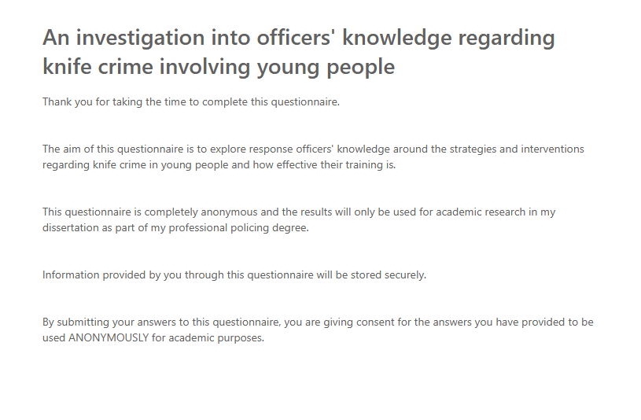
7.1: Copy of questionnaire
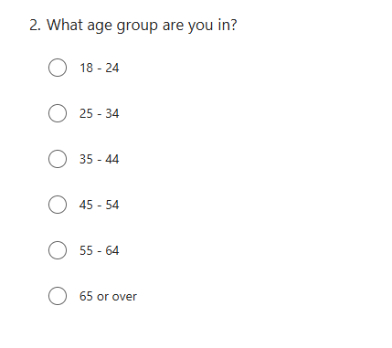
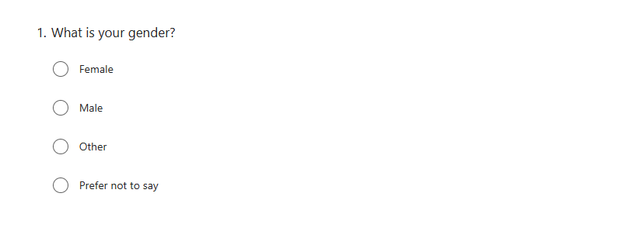

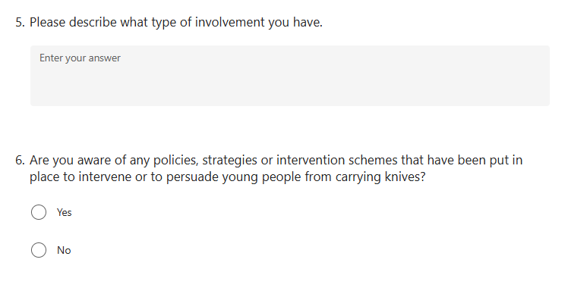
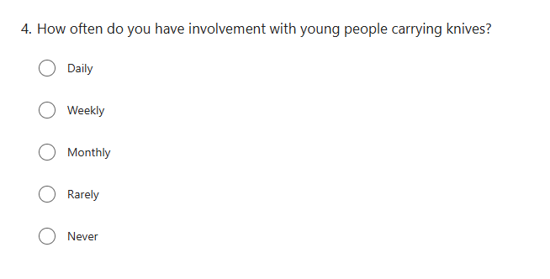
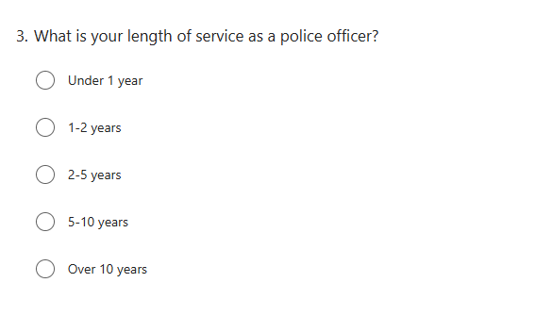

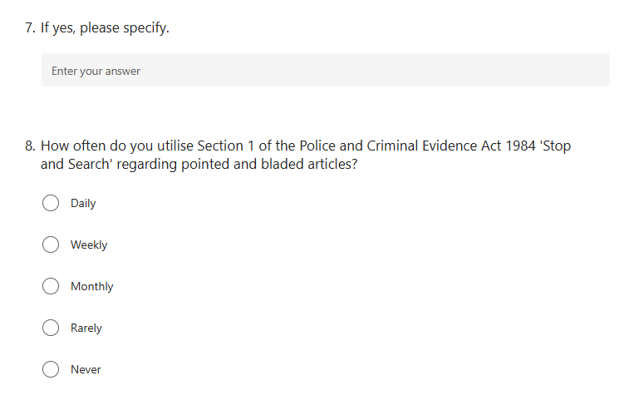

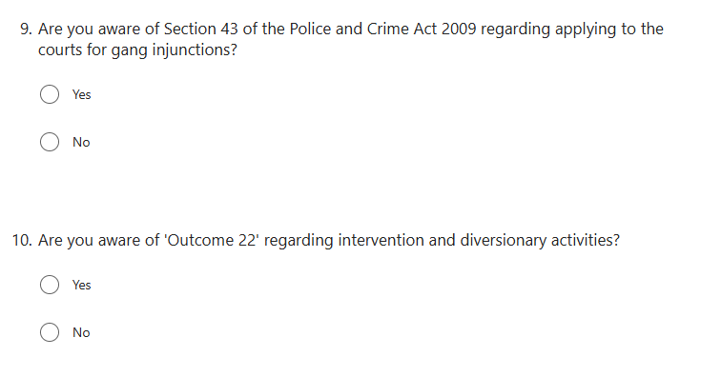

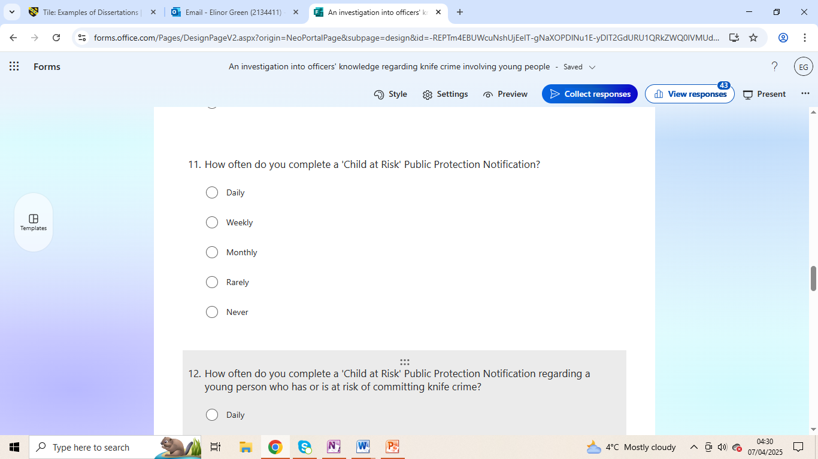

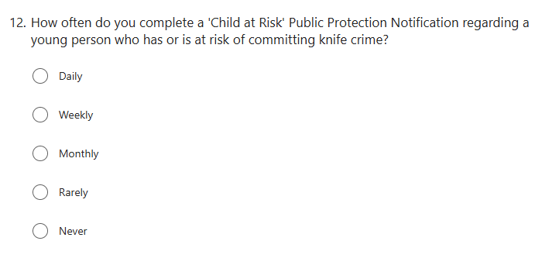

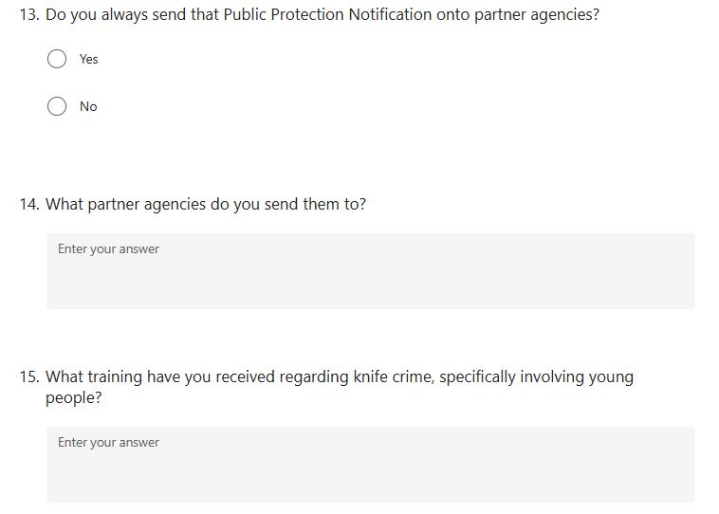

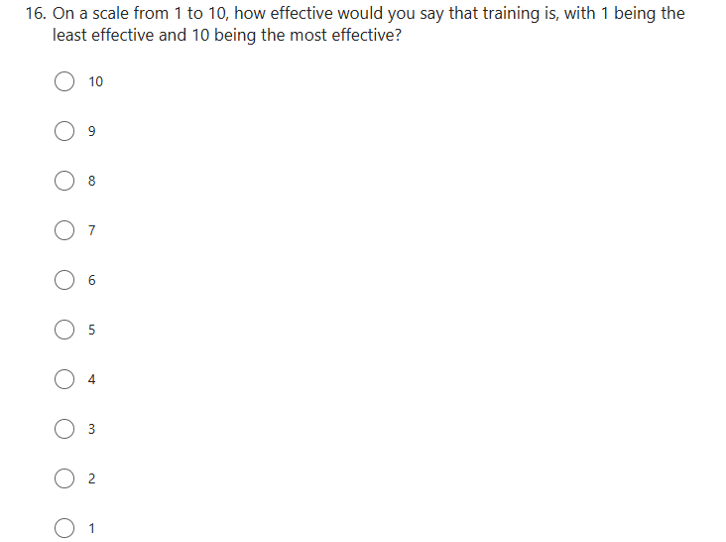

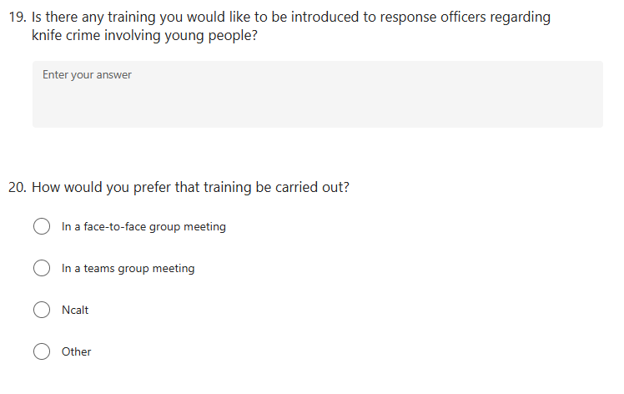
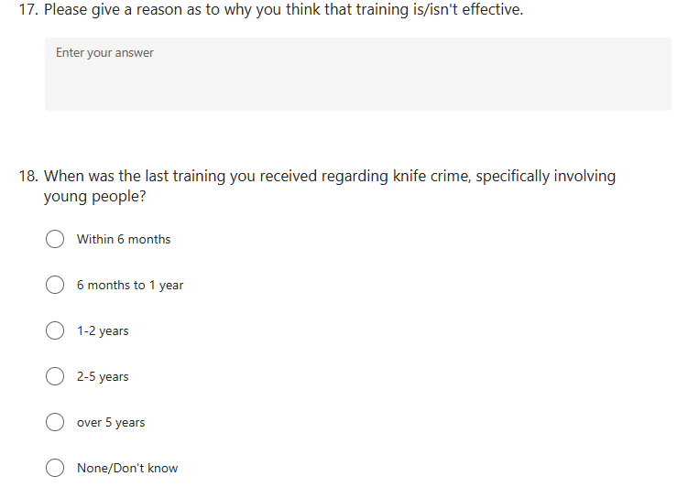



7.2: Questionnaire Answers

7.3: Answers to question 5
1 | anonymous | Never witnessed or searched any youth found to be carrying a knife in the area I police
2 | anonymous | Young people in possession of knives
3 | anonymous | Young persons being threatened with a knife or told that they would be threatened with one. Snap chat/ social media posts of threats. Youths “showcasing” their knives.
4 | anonymous | Seizing knives from youths carrying them or when found in their bedrooms at the home address.
5 | anonymous | I've fortunately had very little involvement but had many handovers whereby I have had to deal with people for having knives on their person
6 | anonymous | locating a knife on a person following arrest, attending calls involving knives as taser officer
7 | anonymous | Intelligence submitted by other agencies relating to youths carrying knifes and also stop searches of youths with knifes.
8 | anonymous | I am a response officer.
9 | anonymous | previously in the arrest and investigation of offences, now in administration of them
10 | anonymous | few calls - intel for stop searches which have been negative
11 | anonymous | Generally youths with markers for carrying weapons.
12 | anonymous | Self harm usually but recently stop searched person with knife down trousers
13 | anonymous | Deployment as a taser officer, stop searches,
14 | anonymous | Majority is reports from members of the public where they report either seeing or being threatened by a knife.
15 | anonymous | Generally for them being involved in robberies, assaults and other violent crime including attempt murder.
16 | anonymous | Responding to emergency calls
17 | anonymous | Custody officer so after arrest
18 | anonymous | Response officer, responding to calls with information people are / having intel for carrying knives and dealing with this threat or potential threat.
19 | anonymous | As a supervisor, I rarely go to the incidents. However I review all incidents and is it likely that a PPN will be submitted for the young person which ensures I am aware of the incident.
20 | anonymous | coming across people when on foot with known intelligence, emergency calls where knives have been seen
21 | anonymous | work within CID as a supervisor, so rarely have involvement with such incidents, I do however pass information to social services if we are aware of markers on a person who carries weapons to ensure they are aware of a potential risk.
22 | anonymous | Within the control room, Op lumley and working out on response when required
23 | anonymous | Attend emergency calls as a TASER trained officer
24 | anonymous | Youths involved in ASB, making threats to each other
25 | anonymous | arresting, stop search
26 | anonymous | Responding to 999
27 | anonymous | arresting officer. intelligence submissions. giving words of advice to subjects, victims and family. Attending schools to speak with persons involved attending incidents as a taser carrier interviewing officer OIC
28 | anonymous | young people suspected to having knifes.
29 | anonymous | Im a Police officer so deal with incidents regarding knives often
30 | anonymous | A lot of calls that we deal with involve children (under 18) who are being exploited by organised crime groups. They unfortunately feel the need to carry knives and other weapons as they are influenced by others.
31 | anonymous | N/A
32 | anonymous | Usually knives located after arrest or in the process of a stop search
33 | anonymous | It is beocming a more regular occurrence. Usually it is a report of a person with a knife/threatening with a knife. Upon engaging with the person a knife is usually not found
34 | anonymous | Due to working on response there is potential for me to deal with young people with knives. There are numerous children within the area I work that have warning markers for knives.
35 | anonymous | stopsearch usually
36 | anonymous | As a dog handler I get sent to most bladed weapon calls, to either assist in locating the subject or as a tactical option to deal with them.
37 | anonymous | As a firearms officer our tasking is directly related to threat risk harm and will often involve subjects known to carry weapons or have been witnessed in possession of a weapon/knife
38 | anonymous | Stop search on intel
39 | anonymous | Responding to emergency calls involving reports of people with knives, submitting intel, interviewing subjects who have been arrested for weapons offences

7.4: Answers to question 7
1 | anonymous | Youth offending team
2 | anonymous | LiveFearFree and also the knife amnesty bins every year
3 | anonymous | Knife amnesty boxes at police stations
4 | anonymous | When you can hand the weapons in with no questions.
5 | anonymous | knives over lives, op sceptre
6 | anonymous | Op Sceptre, Lives not knives, and College of Policing have toolkits to reduce knife crime.
7 | anonymous | Knife amnesties, YOS,
8 | anonymous | Knife amnesty bins
9 | anonymous | Operation Sceptre
10 | anonymous | Operation Sceptre / diversion schemes on dealing with young people in custody such as YOS or 18-25 diversion for education courses
11 | anonymous | Knife boxes
12 | anonymous | In Caerphilly, we use the REACH referral process.
13 | anonymous | knives amnesty at newport central
14 | anonymous | Nation wide weapon surrender schemes
15 | anonymous | OP SCEPTRE, Knife amnesty's, Knife crime toolkit to assist officers, NPT and partnership working with youths aorund carrying knives
16 | anonymous | Op Sceptre
17 | anonymous | NA
18 | anonymous | op sceptre
19 | anonymous | N/A
20 | anonymous | N/A
21 | anonymous | Knife amnesty, posters about knife crime,
22 | anonymous | Stop search
23 | anonymous | i ran aprogram for 18 months at Alway community centre to direct youths and diswade from carrying knives in the area
24 | anonymous | Aware of local initiatives in Newport area around knife crime and trying to tackle it in the Pill area.
25 | anonymous | Stop search

7.5 Answers to question 14
1 | anonymous | Social services
2 | anonymous | Social services
3 | anonymous | Social Services
4 | anonymous | Relevant social services depending on where that child resides
5 | anonymous | I only send it to social services and may submit intelligence, inform neighbourhood teams.
6 | anonymous | Social Services.
7 | anonymous | The local one for my policing area
8 | anonymous | Social services
9 | anonymous | Social Services.
10 | anonymous | NEWPORT CHILD SOCIAL SERVICES
11 | anonymous | Social services, YOS
12 | anonymous | social services
13 | anonymous | Social services
14 | anonymous | Torfaen children social services
15 | anonymous | social services.
16 | anonymous | Social services
17 | anonymous | Social services
18 | anonymous | social services
19 | anonymous | Social services
20 | anonymous | Social services, GP, Schools - Operation encompass
21 | anonymous | Social Services
22 | anonymous | children social services
23 | anonymous | All 5 of the social service areas within Gwent, also have sent to external social services outside of Gwent too if the person is living in that area (but the offence occurred in Gwent)
24 | anonymous | Children SS, sometimes when required inof contained within those PPN's to partnership agencies such a housing association if required
25 | anonymous | Social Services
26 | anonymous | Social Services
27 | anonymous | The relevant area social services
28 | anonymous | Social services
29 | anonymous | SS
30 | anonymous | social services - i am not aware of any other partner agencies that are in receipt of GWP PPNs
31 | anonymous | BG social services.
32 | anonymous | Social Services
33 | anonymous | relevant local authority email for Newport
34 | anonymous | Social Services
35 | anonymous | Social Services
36 | anonymous | Social services
37 | anonymous | Social services
38 | anonymous | Social services
39 | anonymous | na
40 | anonymous | Social Services / Internal PPU / Quartz
41 | anonymous | Unsure
42 | anonymous | Social services

7.6: Answers to question 15
1 | anonymous | None
2 | anonymous | Nothing specific
3 | anonymous | None
4 | anonymous | Searching and seizing powers
5 | anonymous | None
6 | anonymous | General PPST training
7 | anonymous | none
8 | anonymous | Nothing directly. Learnt on the job and some NCALT packages.
9 | anonymous | None.
10 | anonymous | none
11 | anonymous | sec 1 stop search
12 | anonymous | Initial training inputs Taser Training Stay Safe Principles
13 | anonymous | I am taser trained
14 | anonymous | initial training on SS, and case law. Further CPD with Sergeant exam
15 | anonymous | none specifically around knife crime and young people other than informed on a training day of the higher statistics for younger people carrying knives. Main knowledge is self taught.
16 | anonymous | not much besides training from training school
17 | anonymous | None specific - just OST
18 | anonymous | Officer safety training but little other training/awareness
19 | anonymous | Nothing specific to young persons.
20 | anonymous | stop and search
21 | anonymous | Within force training days, and from my previous force also (I am a transferee)
22 | anonymous | OST, Probationer training, Through NPT role.
23 | anonymous | None to my knowledge Mentioned in TASER training
24 | anonymous | Not much training really, stop search powers
25 | anonymous | None really just normal ASB training nothing really around knife crime
26 | anonymous | NCALT
27 | anonymous | None
28 | anonymous | no specific training regarding knife crime.
29 | anonymous | only what is provided in basic training.
30 | anonymous | None
31 | anonymous | None, this should change considering how prevalent it has become.
32 | anonymous | Input from YOS, Youth Service
33 | anonymous | Only taser trainer nothing else
34 | anonymous | nothing in relation to young person
35 | anonymous | None that I can recall
36 | anonymous | none
37 | anonymous | nil
38 | anonymous | taser related but nothing else specific
39 | anonymous | None
40 | anonymous | Can't think of anything specific

7.7: Answers to question 17
1 | anonymous | Don't get trained in youths carrying knives
2 | anonymous | N/A
3 | anonymous | Questions that I need know it
4 | anonymous | I have yet to receive any training in relation to this
5 | anonymous | Just lack of general safety equipment. The only thing that is covered by a stab vest is your torso. Your arms, legs and face are completely visible.
6 | anonymous | training is not tailored toward young persons
7 | anonymous | Lack of training by Gwent Police.
8 | anonymous | not many alternative ways of dealing with / intervention
9 | anonymous | N/A
10 | anonymous | All times I have had to use my taser against knife users have been effective
11 | anonymous | There is a larger focus on stop search and locating knives on persons than how to deal with the offences afterwards.
12 | anonymous | lack of training. There has been recent training on a FTD of stop search but nothing specific regarding knife crime and young people
13 | anonymous | Often too much information is given, and the trainers have never been on response or were on response years ago. times have changed
14 | anonymous | Nonspecific training
15 | anonymous | We know how to manage threat posed to us but not how we can assist the offender
16 | anonymous | because not always does the young person has a nkife in the possession
17 | anonymous | We should widely publicise the concerns and risks to officers more often
18 | anonymous | Cant recall having any
19 | anonymous | There is not enough training
20 | anonymous | online and not interactive
21 | anonymous | No training
22 | anonymous | there is no specific training beyond stop searches, identification of offences, use of force and investigations
23 | anonymous | it is effective as it provides a knowledge base.
24 | anonymous | No real training around young people carrying knives
25 | anonymous | Training received by officers are in the form of PPST, this covers all aspects of police safety and tactics. however, In a real world situation, dealing with a persons with a knife will be completely different that anything taught. Furthermore, I have not received any training in relation to prevention/referral for knife crime involving young persons and would generally only put a PPN in. I am not aware of any intervention methods.
26 | anonymous | Its a hard issue to tackle, when Officers execute stop search they are accused of being racist/racially profiling, it appears to be more talk than action by MP's/Government
27 | anonymous | Taser training is effective when dealing with knives, however there is no generic training
28 | anonymous | cant recall having it
29 | anonymous | Can't recall any training
30 | anonymous | na
31 | anonymous | Training if i had received it would be helpful.
32 | anonymous | Scenario testing is excellent if the role players are genuine and the feedback can be honest and constructive. When we are too scared to tell someone their actions led to an injury/death in a scenario and there is a need to reflect/consider/additional training because of fear of complaints relating to "criticising and bullying" the training becomes almost pointless
33 | anonymous | There hasn’t been any
34 | anonymous | I don't think I've had any

7.8: Answers to question 19
1 | anonymous | Yes, maybe introduce a scenario with ppst
2 | anonymous | Just surrounding organisations that we can refer to following arrest, etc
3 | anonymous | Sessions run by reformed young adults and what impact it had on them and what changed for them to change their initial behaviour. I believe that it is key to understand the bigger picture when dealing with such a sensitive issue.
4 | anonymous | Training in and around knife crime specifically within youths.
5 | anonymous | Awareness of it and why it occurs, and signs to look for.
6 | anonymous | intervention / arranging amnesties
7 | anonymous | N/A
8 | anonymous | I don't think any training other than taser use and stay safe principles are necessary for knife calls
9 | anonymous | All response officers to carry taser
10 | anonymous | Would be good to discuss powers and policies and interventions for officer awareness but also discussion on how partner agencies can intervene / NPT for example to tackle the wider issue.
11 | anonymous | Training on how to deal with incident and outcomes - e.g. CR, young offender referral, VA. arrest etc.
12 | anonymous | Restorative justice approach options (not just YOS but more specific)
13 | anonymous | I do think that different diversion and intervention schemes should be advertised and officers made aware of them.
14 | anonymous | yes
15 | anonymous | Just refreshers - potentially during OST training - to reiterate discuss risks to officers
16 | anonymous | A more specific training focused on Knife crimw
17 | anonymous | Beyond training of educational inputs i cannot think of any training of use that centres around young people and knife crime
18 | anonymous | to identify if it is a supporting crime to another offence.
19 | anonymous | Training regarding all legislation available
20 | anonymous | Dont know
21 | anonymous | n/a
22 | anonymous | Yes
23 | anonymous | na
24 | anonymous | that taser isnt always the answer
25 | anonymous | Any right now would be better

7.8: Answers to question 21

1 | anonymous | N/A
2 | anonymous | .
3 | anonymous | Formal taser courses and refreshers
4 | anonymous | During OST refreshers would be a good idea
5 | anonymous | NA
6 | anonymous | N/A
7 | anonymous | face to face meetings about interventions, services that deal with knife crime and what officers can do better.
8 | anonymous | Ncalt is not training!

