How I and others learn about business
Alex Bell | Learning and collaboration for global citizenship
BMSP4003
Elizabeth King (1907567)

How I and others learn about business.
Introduction
In this paper I am going to be looking at collaborative learning and individual learning. And looking into how I and others have learnt about business, and how we have got to where we are. I will be writing about my own learning experience as well as others and comparing. Seeing the way, we have all reacted to different learning environments and the different tools available to us.
Main Body
Since starting university, I have experienced collaborative learning and individual learning.
Being in the classroom I found to be helpful, as there were always discussions which I found useful. Everyone had their own way of looking at something which opens your eyes to new ways, which also helps with different ways of learning and interpretation. I also found these discussions helpful if I didn’t understand something. The atmosphere in the classroom is enjoyable with discussions and debates which can be interesting. The support network in a classroom is great and really helps a lot, which settles any fears you might be feeling. I found when I first started that I didn’t know or understand much and having people around helped a lot and gradually my confidence grew along with my ability to learn. But I did find that at that start having everyone contributing to the lectures I was able to sit there and listen instead of participating. I used to look forward to the classroom lectures and the atmosphere that comes with it but missed while doing the online learning. The discussions and debates are also something that I missed while participating in the online learning.
When experiencing the online learning I was curious and anxious as I would be on my own without the classroom support, interaction and discussions which was scary. At first, I couldn’t get to grips with it all. I struggled to understand what needed to be done. But in time I got there and started understanding more which a big confidence boost was knowing that I could do it. Being able to fit my learning in around my family life was a big advantage to me, but I found myself struggling to find time to do my work as there was always something that needed doing.
Being in a classroom has no distractions which for me would work better.
While being online I found a few others also said they struggled to find time to fit their work in around their home life and they to miss the classroom environment and the interaction that comes with it.(Clark,Jennifer,2020). It seems that technology is playing a big part in learning, but we still find that face to face interaction is more suitable for our learning. I enjoyed the experience of online learning and will remember the experience. It has boosted my confidence as I realised, I knew more than what I gave myself credit for.
While looking into learning I found VARK which are four learning styles, Visual learning, Auditory learning, Reading/Writing preference and Kinesthetic learning. This shows how students learn in different ways and to allow them to learn to the best of their ability while processing information and retaining it in a way that suits them (blog.advancementcourses,2017). It was interesting to see that the most common type of learner is the visual learner with around 65% of the population (google,2020).
Visual Learners relate best to arrows, charts, diagrams, and other visualization of information. But maybe not so much to photographs and videos.
Auditory learners prefer to hear the information and may find it beneficial to take notes. This may find them less engaged. They find reading their written work beneficial and find themselves participating in group activities successful.
Reading/Writing learners should be encouraged to make notes. They show strong learning in the written word.
Kinesthetic Learners are more hands on. And to do their best they need to take more of a physical role. They tend to engage all their senses equally (educationonline,2019).
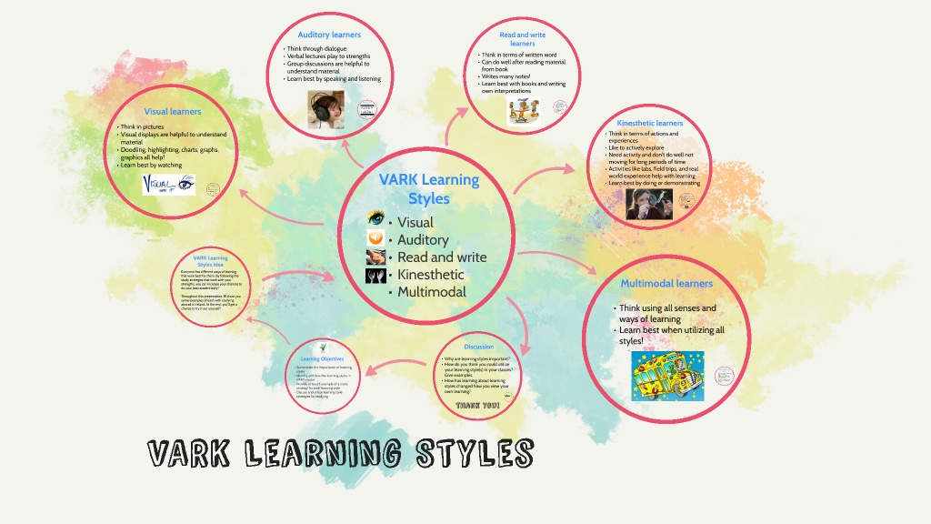
(prezi,2020).
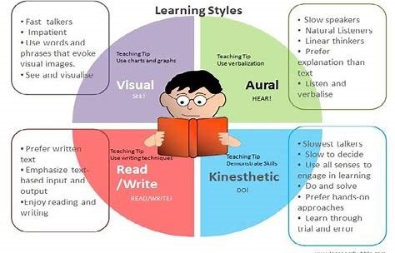
(blogspot,2020).
I find when I look at myself I feel that I come under the reading/writing learner, whether this is because of my age and the way I was brought up and taught in school that this is a more comfortable way of learning for me. In 1987 a model was created to learn more about students individual learning methods. It was created by Fleming. In this model learners are seen by the way they prefer to learn. Whether it’s visual learning, auditory learning, reading, and writing or kinesthetic learning. To identify which type of learner people are, Fleming developed a self-report inventory. A lot of critics have criticised this model over the years, saying that students shouldn’t be labelled for having one learning style as it could be a hindrance to learning. But despite this the VARK model remains popular. (verywellmind,2020).
Since starting university my use of tools for learning has improved a lot. There have been several tools that I had never heard of before. Trying something new has always been difficult for me as I don’t have much confidence, so I tend to stick to what I no. And going back to education and having to try new things has been way out of my comfort zone, but I have surprised myself at how far I have come and the new skills I have developed. During our online learning when we were asked to do our own PLE diagram I thought mine would be very basic and empty, but once I got started I realised my use of tools and technology and my understanding was greater than I thought. I f I look deeper there are probably a lot more tools that I use without realising or haven’t thought relates.
As you can see in the diagram below, I use a variety of tools.

Facebook Twitter Banking App

Messenger
My PLE
What’s App

Microsoft Outlook UWTSD YouTube
Spotify Google PowerPoint
When looking at other students PLE diagrams they were all similar which was interesting. We are a mixture of age groups with different strength and weaknesses, but all having similar technology tool usage. Being able to see other people’s usage of applications and tools was helpful as there were a few I hadn’t heard of before and therefore I was able to look them up and see if they were helpful to me or not. Everyone has their own way of doing things. Not every tool suit everyone.
I find that while learning my use of technology has increased. I still have so much to learn but as I’m learning new things my confidence has grown too. As my use of technology is still very limited, I have struggled with some learning activities and asking for help has helped me to understand. Being given some tools to help with learning has been very helpful and given tools that I wouldn’t of thought of has been a good experience too. With some learning using tools such as YouTube, Google and UWTSD Library has helped a great deal and has contributed towards my learning experience.
When I started university on this course, I didn’t know what to expect. I have thoroughly enjoyed my experience but having some idea about what was expected would have helped a lot. To anyone who is going to do this course I would recommend having an open mind and don’t expect to know everything or expect everything to be easy. At times it might be hard but stick with it and eventually it will all come together. Find out what help is out there, what tools are available, talk to other students and your lecturers and make full use of all that’s available to you. But most importantly enjoy yourself and the experience.
Talking to other students about work and the different approaches has helped me. Some things may work for other students and not you. You must try everything until you find a way that works for you. When I realised that there were a lot of f learning tools and sites out there that I didn’t know and started to use them I found things got a little bit easier and have really enjoyed my learning experiences. Also looking at my own PLE diagram helped to see what I was making full use of and seeing what others used helped give a few more ideas about what was out there and what could be helpful to me.

Conclusion
The experience of collaborative learning and individual learning has been a positive experience for me. Although I prefer the classroom learning I thoroughly enjoyed the experience of online learning, which has helped me develop new skills, whether small or big. The atmosphere and participation of classroom activities was a big help with learning and that’s the bit that I missed when participating with online learning. Having the support is needed when learning and there is more support in my view in the classroom rather than online. And looking at other students on the online forum they too struggled with online learning, struggling to fit their work in around family life, and missing the classroom interaction. As with other students I think they found it a positive experience and preferred it to the classroom. Noticing how far I have come and looking overall at where I was and are now was also a good experience for me. And finding tools out there to help with learning has also been a good experience. And trying new ones to see what is good for me and what’s not has also been a good due to the fact it has helped contribute to my learning experience. If I’d known at the start of this course what to expect maybe I would have been more prepared for what I was going to experience. But maybe not knowing has been an advantage as it has given me the chance to explore new ways of learning, new tools, and work on the very little I did know. As I have noticed with doing this assignment everybody is different, we all learn at different speeds, use different tools, some prefer classroom learning others prefer online learning but we all have the same end goal to succeed and complete this course to the best of our ability. And finding VARK in my research for this assignment was interesting for me. Seeing the four learning styles and trying to put myself into one of the groups was interesting. Seeing the different ways students learn and process things has never been considered by myself before. And knowing that the most common learner was a visual learner was an interesting fact to learn.

REFERENCES
- educationonline. (2019). vark. Available: https://educationonline.ku.edu. Last accessed 13/04/20
- google. (2020). vark. Available: https://sites.google.com. Last accessed 13/04/20.
- advancementcourses. (2017). vark. Available: https://blog.advancementcorses.com. Last accessed 13/04/20.
- blogspot. (2020). vark. Available: https://www.blogspot.com. Last accessed 13/04/20.
- prezi. (2020). vark. Available: https://www.prezi.com. Last accessed 13/04/20.
- Clark,Jennifer,otherstudent,2020
- verywellmind. (2020). vark. Available: https://www.verywellmind.com. Last accessed 13/04/20.

