

Programme Name: Master of Business Administration
Module Name: Marketing Management
Module Code: LCMB7024
Title of Submission: Assessment Component 1: Marketing Environment Analysis
Lecturer’s Name: Taonga Kaonga Sobere - Snithers
Student Name: Azbabanu Mohmmadanish Malek
Student ID: 2610331
Word Count: 2,500
Submission Date: 22nd October

Table of Contents
Introduction…………………………………………………………………………………….3
Task A Marketing environment analysis………………………………………………….4
A.1 Environment Actor……………………………………………………………………4
A.2 Political Actor…………………………………………………………………………5
A.3 Economic Actor……………………………………………………………………....6
A.4 Critical Evaluation of Codelco’s External Actors………………………………….7
Task B Strategic growth and competitive positioning………………………………….8
B.1 Market penetration…………………………………………………………………....8
B.2 Market development………………………………………………………………….8
B.3 Product development…………………………………………………………………9
B.4 Diversification…………………………………………………………………………10
B.5 Competitive advantage while transitioning to lower carbon…………………….10
Task C Managerial and Professional reflection……………………………………….11
C.1 Rationale for company and actor selection……………………………………....11
C.2 Reflection on growth strategies……………………………………………………12
C.3 Limitations and recommendations…………………………………………………12
C.4 Conclusion………………………………………………………………………….13
References……………………………………………………………………………….14

Introduction
Codelco, also known as the National Copper Corporation of Chile, is a state-owned company that operates in the global copper mining industry. Its main activities include exploring, developing and extracting mineral resources, processing copper and selling its products to customers worldwide (Codelco, n.d.-a). The company has an important position in Chile’s mining industry and contributes to the country’s economic development. Copper is also an important resource for electrical networks, renewable energy technologies and electric vehicles. As the world moves towards a low-carbon economy, the demand for copper creates opportunities for mining companies such as Codelco.
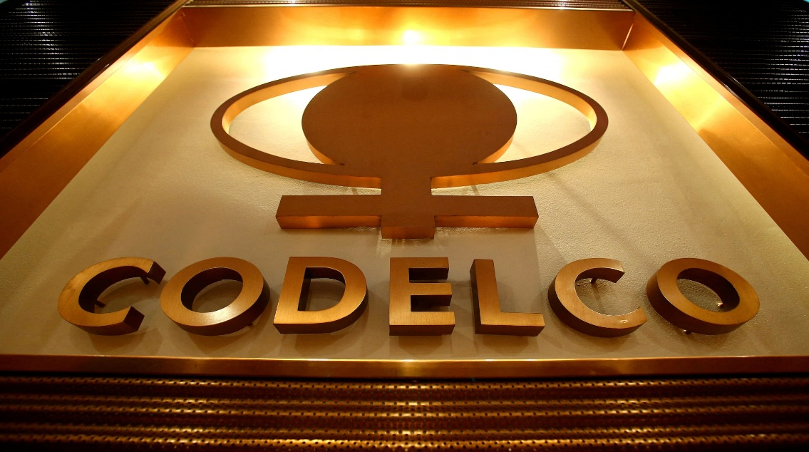
(Figure 1: Logo Symbolism)
(Source: Company’s official website)
However, Codelco operates in a changing external marketing environment that presents both opportunities and challenges. Environmental sustainability, government regulations, technological developments and changing market conditions can influence the company’s operations and future growth. Codelco’s history reflects the importance of copper mining to Chile, with the company’s current structure formally established in 1976 following the nationalisation of the country’s copper industry (Codelco, n.d.-b). Therefore, this report will analyse three external marketing environment factors affecting Codelco’s transition towards lower-carbon products, focusing particularly on the environmental factor and another relevant external factor. It will also apply the Ansoff Matrix to evaluate potential growth strategies and conclude with a managerial reflection on the key learning gained from the assessment.
Task A: Marketing Environment Analysis (PESTLE ANALYSIS)
A.1: Environment Actor
Environmental sustainability is an important external factor that affects the mining industry. Mining activities can have negative effects on natural resources, water quality, land and surrounding communities. Therefore, mining companies need to manage their environmental impacts and follow sustainable practices. (Virgone et al. 2018) discuss the importance of using effective frameworks to assess sustainability in mining. This highlights the need for mining companies to consider environmental, social and economic impacts when making business decisions.
This factor is important for Codelco because it is a major copper producer in Chile. Copper is widely used in renewable energy systems, electric vehicles and electrical networks. As countries move towards a low-carbon economy, demand for copper may increase. However, copper extraction and processing can create environmental challenges, including high energy and water use, waste generation and land disturbance. These issues may increase operating costs and affect the company’s reputation if they are not managed properly. Customers, governments and communities may also expect mining companies to demonstrate greater environmental responsibility.
To respond to these challenges, Codelco needs to improve resource efficiency, manage mining waste responsibly and explore ways to reduce emissions and water consumption. These actions could help the company reduce environmental risks and support more sustainable copper production. Overall, environmental sustainability creates both challenges and opportunities for Codelco. By improving its environmental performance, the company can support the transition to low-carbon technologies while protecting its reputation and long-term business performance.
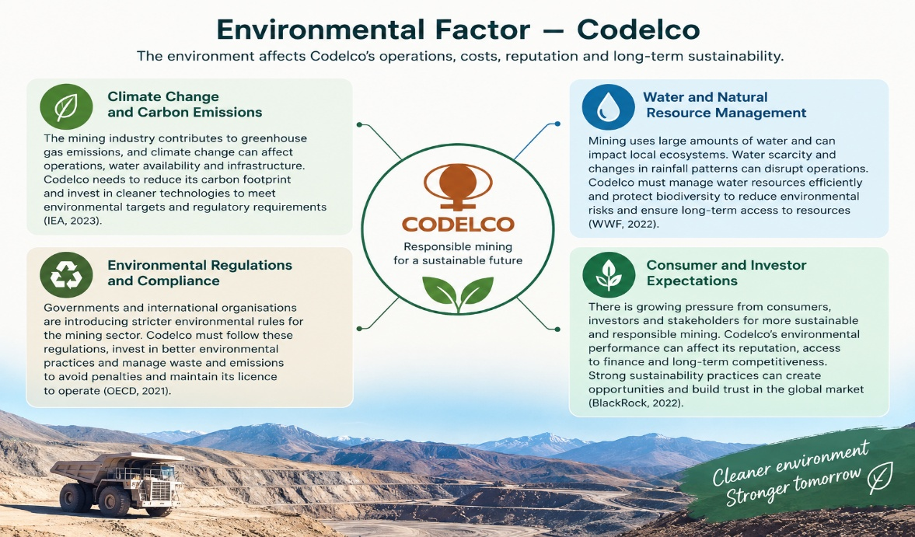
(Figure:2 Environmental factors)
(Source: Self-made)
A.2: Political Actor
Political factors play an important role in the mining industry because government policies and political decisions can influence business operations, investment and future growth. Nem Singh (2010) examines the political economy of Chilean mining policy and discusses how government policies and the relationship between the state and the mining industry can influence the development of the mining sector. This is important for Codelco because it is a state-owned copper mining company in Chile. Government priorities can influence its strategic direction, investment decisions and plans for future production. For example, decisions about mining policies, taxation and the management of natural resources may affect the company's operating costs and investment in new mining projects. Therefore, Codelco needs to consider government priorities and political developments when making long-term business decisions.
Furthermore, government policies supporting renewable energy and the transition towards a low-carbon economy may create opportunities for Codelco. Copper is widely used in electric vehicles, renewable energy systems and electricity networks, which are important for reducing carbon emissions. Policies that encourage these technologies may increase demand for copper and create opportunities for Codelco to strengthen its position in the global market. However, changes in government priorities, mining policies or regulations may create uncertainty and affect investment decisions. Political uncertainty can also make it more difficult for mining companies to plan large projects that require significant investment over several years. Codelco should therefore monitor political developments and adapt its business strategies to changes in the external environment. Overall, political factors can create both opportunities and challenges for Codelco by influencing its investment, production plans and long-term competitiveness.
A.3: Economic Actor
Economic factors play an important role in the mining industry because changes in copper prices, global demand and production costs can affect business performance. Guo and Cao (2024) examine factors influencing copper consumption in major countries and explain how economic development can affect copper demand. This is important for Codelco because changes in global copper consumption can influence its sales revenue, profitability and future investment decisions.
Furthermore, the transition towards renewable energy and low-carbon technologies may create economic opportunities for Codelco. Copper is widely used in electric vehicles, renewable energy systems and electricity networks. The growth of these technologies may increase demand for copper and create opportunities for Chilean copper exporters. However, Codelco may also face challenges when international copper prices fall, or production costs increase. Higher energy, labour and equipment costs can reduce profit margins and make mining projects more expensive. Therefore, Codelco needs to monitor international market trends and manage its costs carefully to remain competitive.
In addition, improving mining productivity can help Codelco manage economic pressures and use its resources more efficiently. Research on mining productivity highlights the importance of effective planning, scheduling and operational control Ramírez-Olivares et al., (2026). By improving operational efficiency and carefully planning investments, Codelco may reduce unnecessary costs and strengthen its long-term performance. Overall, economic factors create both opportunities and risks for Codelco. Monitoring copper demand, managing production costs and improving productivity can help the company respond to market changes and maintain its position in the global copper industry.
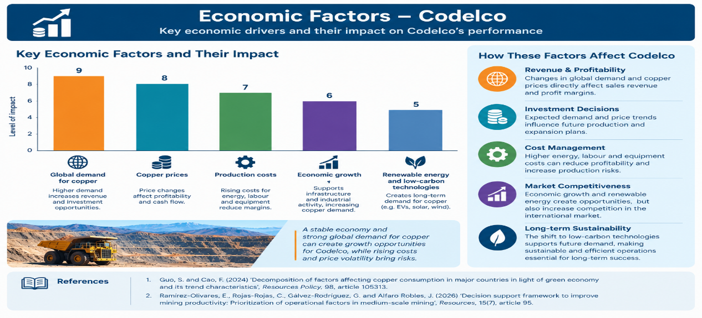
(Figure: 3 Economic factors)
(Source: Self-made)
A.4: Critical Evaluation of Codelco’s External Factors
A critical evaluation shows that political, economic and environmental factors are closely connected at Codelco. The company’s copper production increased by only 0.3% in 2024, while direct production costs decreased by 2% (Codelco, 2025). However, declining ore grades and ageing mines may make future production more expensive and difficult. This creates a challenge because Chile needs copper revenue, while Codelco must also meet environmental responsibilities. Research suggests that renewable energy can reduce some environmental impacts, but declining ore grades may increase energy requirements Cepeda-Kato, Zhang and Matsubae, (2026). Therefore, Codelco should focus not only on increasing production but also on improving long-term efficiency.
Another challenge is ensuring that environmental commitments lead to measurable results. Codelco aims to achieve carbon neutrality by 2050 and use renewable electricity across its operations by 2030 (Codelco, 2025). However, these targets may require significant investment and do not automatically guarantee lower environmental impacts. As a state-owned company, Codelco must balance financial performance with its responsibilities to the public and the environment. Furthermore, because its sustainability report is company-produced, independent assessments are important for checking progress. Codelco should therefore measure its environmental performance alongside production costs and financial results to support long-term competitiveness and stakeholder trust.
Task B: Strategic Growth and Competitive Positioning
B.1 Market Penetration – Existing Product, Existing Market
Market penetration is defined as an effort to increase company sales without departing from an original product-market strategy (Ansoff, 1957). For Codelco, this strategy would involve increasing sales of its existing copper cathodes to its current customers in established markets such as China, USA and Europe by improving operational efficiency and sustainability communication. Codelco reported a production increase of only 0.3% in 2024 with direct costs reduced by 2% (Codelco, 2025), which suggests limited growth through penetration alone. This strategy is low risk but insufficient for long-term competitive advantage because environmental pressures regarding energy and water consumption continue to increase operating costs (Virgone et al., 2018) and declining ore grades may require more energy for extraction (Cepeda et al., 2026).
B.2 Market Development – Existing Product, New Market
Market development is a strategy in which the company attempts to adapt its present product line to new missions (Ansoff, 1957, p.114). In the context of Codelco, this means targeting new markets and new applications for its existing copper, such as electric vehicle manufacturers, renewable energy systems and green infrastructure projects that are expanding under government decarbonisation policies. This is supported by the political economy of Chilean mining, where state policy strongly influences sector development (Nem Singh, 2010), and by evidence that economic development drives copper demand in major countries (Guo and Cao, 2024). Furthermore, copper is critical for electrical networks and low-carbon technologies, which creates opportunities for Chilean exporters. However, success depends on managing copper price volatility and production costs effectively (Ramírez-Olivares et al., 2026).
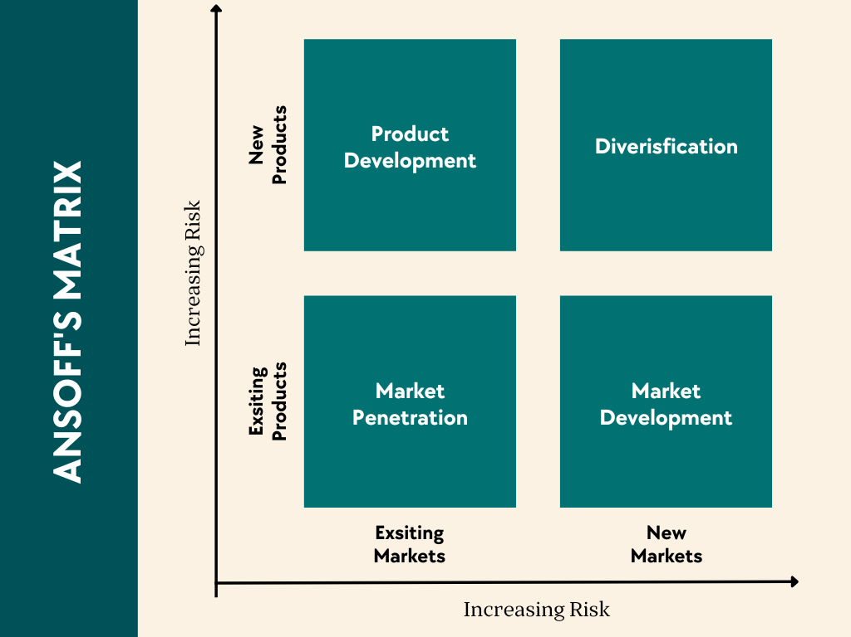
(Figure 4: Ansoff’s Matrix)
(Source: Self-made)
B.3 Product Development – New Product, Existing Market
Product development retains the present mission and develops products with new and different characteristics to improve performance (Ansoff, 1957). This is the most appropriate growth path for Codelco, as you explained in your recordings. Codelco should develop lower-carbon copper products, including green copper certified with renewable electricity and reduced carbon footprint, aligning with its corporate targets of 100% renewable electricity by 2030 and carbon neutrality by 2050 (Codelco, 2025). This approach directly addresses the environmental actor identified in Task A and supports the transition to a circular supply chain that emphasises resource use efficiency, recycling and environmental responsibility (Chen et al., 2025). From a competitive positioning perspective, this enables Codelco to pursue a differentiation strategy by offering a product with superior environmental credentials (Porter, 1980; Porter, 1985), rather than competing solely on cost. This can strengthen stakeholder trust and long-term competitiveness.

B.4 Diversification – New Product, New Market
Diversification involves moving beyond the current product line and market structure and is considered the riskiest growth option (Ansoff, 1957; Loredana, 2017). For Codelco, this could involve diversifying into lithium, hydrogen or circular economy services such as recycling copper waste and processing production residues into raw materials for other industries (Chen et al., 2025). While this could create new revenue streams, lateral diversification is open-ended and requires significant investment in ideological and infrastructural restructuring (Ansoff, 1957; Kozitska, 2020). Given Codelco’s role as a state-owned company contributing to Chile’s economic development, diversification should only be considered as a long-term option after establishing credibility through product development.
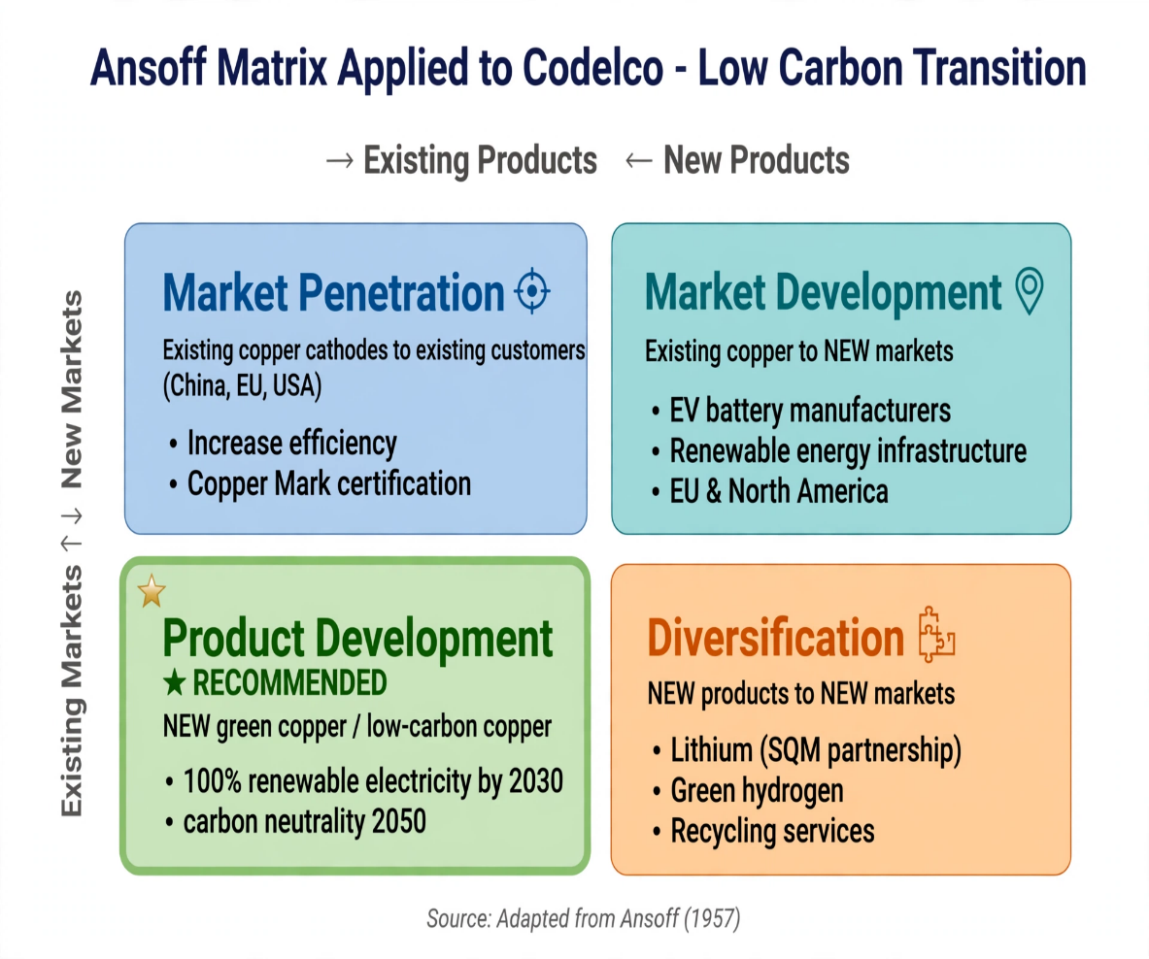
B.5 Competitive Advantage While Transitioning to Lower-Carbon Business Model – Codelco
To achieve competitive advantage while transitioning to a lower-carbon business model, Codelco must move beyond cost-based competition and pursue a differentiation strategy (Porter, 1980) through product development (Ansoff, 1957). As the world’s largest copper producer responsible for significant emissions, Codelco’s transition is driven by stakeholder pressure and global sustainability expectations (Kotler et al., 2024). Codelco can achieve advantage by developing a differentiated low-carbon product portfolio, specifically green copper produced with 100% clean electricity and electric underground equipment, in line with its commitment to reduce GHG emissions by 70% and achieve 100% renewable energy by 2030 (Codelco, 2025).
This is supported by its recent progress, including The Copper Mark certification across all divisions and the largest electric fleet in Chilean mining with 271 electric buses (Codelco, 2025). This differentiation is further strengthened by adopting circular supply chain principles that improve resource use efficiency and reduce operational costs (Chen et al., 2025), addressing the challenge of declining ore grades that increase energy consumption (Cepeda et al., 2026). By communicating its environmental strategy transparently through its 2024 Sustainability Report (Codelco, 2024), Codelco can build stakeholder trust, command a premium price from EV and renewable energy customers, and secure long-term competitive advantage in the low-carbon economy.
Task C: Managerial and Professional Reflection
C.1 Rationale for company and Actor Selection
CODELCO (Corporación Nacional del Cobre de Chile) was selected as it is the world’s largest copper mining company and a 100% state-owned enterprise managed by the Chilean government, headquartered in Santiago, operating major divisions including Chuquicamata, Radomiro Tomic and El Teniente and producing around 1.33Mt in 2025 (Codelco, 2025; Reuters, 2026; Wikipedia, 2026). Its core products are copper cathodes and concentrates critical for the energy transition, and since 2024 it has expanded into lithium through the partnership with SQM in the Salar de Atacama, agreement signed 31 May 2024 and JV NovaAndino Litio launched December 2025 until 2060 with Codelco holding 51% (Latin Business Daily, 2025; TechXplore, 2024). The rationale is its unique position at green demand versus financial crisis – despite copper at $6 per pound (Plusmining, 2026), it faces declining ore grades and net debt rising from $14bn to $25.1bn in 2025, leading Chile to reinvest 100% of its $2.4bn 2025 profits for the first time in history (Reuters, 2026; Kitco, 2026).
Three actors were selected. Environment actor was selected because CODELCO’s aging mines require processing more rock for less copper, increasing energy, water use and emissions, and its 2030 commitments to cut GHG by 70% and achieve 100% clean electricity directly impact its low-carbon model (Codelco, 2024; Codelco, 2025). Political actor – Chilean Government – was selected because as 100% owner it controls strategy through the National Lithium Strategy requiring state participation in Atacama and through the 100% profit reinvestment policy to support recovery (Kitco, 2026; Latin Business Daily, 2025). Economic actor was selected because global demand for low-carbon copper for EVs and renewables drives price and green premium opportunity, with stakeholder expectations for sustainability now a purchase driver (Kotler et al., 2024), while high operational costs from lower grades and $25.1bn debt pressure (Plusmining, 2026) force CODELCO to pursue differentiation via certified green copper.
C.2 Reflection on Growth Strategies
From an academic perspective, the analysis of CODELCO highlights that growth strategies are rarely applied in isolation. According to Ansoff (1957), firms can pursue market penetration, market development, product development or diversification. In the case of CODELCO, market penetration is evident through continued capital investment to sustain copper output despite declining ore grades, while diversification is demonstrated through the strategic entry into lithium via the SQM partnership (Latin Business Daily, 2025). This indicates that in capital-intensive and state-owned industries, growth strategies are interdependent and often defensive, aiming to secure long-term viability rather than short-term expansion, a nuance that is underdeveloped in traditional growth models.
C.3 Limitations and Recommendations
Limitations: CODELCO faces operational limitations from aging mines with declining ore grades (Reuters, 2026), financial limitations with net debt rising to $25.1bn in 2025 (Plusmining, 2026) and annual $5bn investment needs, political limitations due to 100% state ownership under National Lithium Strategy controlling its lithium JV with SQM until 2060 (Latin Business Daily, 2025), and environmental limitations from its 2030 commitment to cut GHG by 70% and achieve 100% clean electricity (Codelco, 2024) amid volatile copper prices.
Recommendations: It is recommended that CODELCO accelerates certified low-carbon copper for green premium pricing (Kotler et al., 2024), strengthens governance and environmental safeguards in the NovaAndino Litio JV, and maintains the 100% profit reinvestment policy of $2.4bn seen in 2025 (Kitco, 2026) to reduce debt and improve productivity in existing mines rather than aggressive expansion.
C.4 CONCLUSION
CODELCO illustrates that even the world’s largest copper producer faces limits to growth from ageing assets, high debt and political control. Its future depends not on producing more copper alone, but on making smarter choices – maintaining existing mines efficiently, reducing debt through profit reinvestment, and securing a position in lithium for energy transition. This shows that sustainable growth is achieved when operational, financial and environmental strategies are aligned.

REFRENCES
Codelco (n.d.-b) Historia. Available at: Codelco official history page (Accessed: 20 October 2026).
Virgone, K.M., Ramirez-Andreotta, M., Mainhagu, J. and Brusseau, M.L. (2018) ‘Effective integrated frameworks for assessing mining sustainability’, Environmental Geochemistry and Health, 40(6), pp. 2635-2655.https://librarysearch.uwtsd.ac.uk/permalink/44WHELF_UWTSD/1bmis16/cdi_hal_primary_oai_HAL_halshs_02391731v1
Nem Singh, J.T. (2010) ‘Reconstituting the neostructuralist state: the political economy of continuity and change in Chilean mining policy’, Third World Quarterly, 31(8), pp. 1413–1433. doi: 10.1080/01436597.2010.538240. https://doi.org/10.1080/01436597.2010.538240
Corporación Nacional del Cobre de Chile (Codelco) (2024) Annual Report 2024. Santiago, Chile: Codelco. Available at: Codelco official website.
Guo, S. and Cao, F. (2024) ‘Decomposition of factors affecting copper consumption in major countries in light of green economy and its trend characteristics’, Resources Policy, 98, article 105313. 10.1016/j.resourpol.2024.105313
Ramírez-Olivares, E., Rojas-Rojas, C., Gálvez-Rodríguez, G. and Alfaro Robles, J. (2026) ‘Decision support framework to improve mining productivity: Prioritization of operational factors in medium-scale mining’, Resources, 15(7), article 95. https://librarysearch.uwtsd.ac.uk/permalink/44WHELF_UWTSD/1bmis16/cdi_crossref_primary_10_3390_resources15070095
Codelco (2025) Sustainability Report 2024. Available at: Codelco Sustainability Reports (Accessed: 21 October 2026).
Cepeda-Kato, J., Zhang, Z. and Matsubae, K. (2026) ‘Environmental trade-offs from renewable energy adoption in Chile’s copper production: a life cycle assessment’, Journal of Industrial Ecology, 30, pp. 283–296.
Ansoff, H.I. (1957) Strategies for diversification’, Harvard Business Review, 35(5), pp.113-124. Available at: https://archive.org/details/strategiesfordiversificationansoff1957hbr [Accessed: 21 Oct 2026].
Codelco (2024) December 2024 Results - Operational and Financial Results. Available at: https://www.codelco.com/prontus_codelco/site/edic/base/port/inversiones.html [Production data:
Codelco (2025) Codelco launches its 2024 Sustainability Report. Available at: https://www.codelco.com/prontus_codelco/site/artic/20250612/pags/20250612101520.php
Full Report PDF: https://www.codelco.com/prontus_codelco/site/docs/20250610/20250610162815/2025_06_11_reporte_de_sustentabilidad_2024_versionfinal.pdf eiti. orgCodelco (2030 Commitments) Sustainability Commitments by 2030. Available at: https://www.codelco.com/sustainability-commitments-by-2030 codelco.com
Chen, M., Wang, T., Zhao, Q. and Hu, Y. (2025) ‘Research on the Construction Path of Circular Supply Chain with Multiple Subjects’, Systems, 13(5), 365. Available at: https://doi.org/10.3390/systems13050365 mdpi.com
Porter, M.E. (1980) Competitive Strategy: Techniques for Analyzing Industries and Competitors. New York: Free Press. Available at: https://www.hbs.edu/faculty/Pages/item.aspx?num=195 referenceforbusiness.com
Porter, M.E. (1985) Competitive Advantage: Creating and Sustaining Superior Performance. New York: Free Press.
Loredana, E.M. (2017) The use of Ansoff matrix in the field of business’, Annals of Constantin Brancusi University.
Kozitska, K. (2020) Marketing as growth strategy: case Helitene. University of Aveiro.
Virgone et al. (2018), Guo and Cao (2024), Nem Singh (2010), Cepeda et al. (2026) - as cited in your original Task A draft and Systems paper you uploaded [systems-13-00365.pdf].
Kitco (2026) https://www.kitco.com/news/2026-03-10/chile-reinvest-all-codelcos-2025-profits-debt-laden-copper-miner.html
TechXplore (2024) https://techxplore.com/news/2024-05-giant-lithium-partnership-chile.html
Reuters (2026) https://www.mining.com/web/codelco-to-produce-1-344mt-of-copper-in-2026-chairman-says/

