
DATA HANDLING AND BUSINESS INTELLIGENCE
Assessment 1

MODULE CODE: LCBB5000
STUDENT NAME: ELENA ALINA GRIGORAS
STUDENT ID: 2112864
LECTURER NAME: DR XAVIER MATIENI

EXECUTIVE SUMMARY
The report sheds light on the essence and value of business intelligence and the different types of its trends. In this case, the five most vital trends namely artificial intelligence, mobile business intelligence, self-service BI, data automation and lastly data security is discussed below. In addition to this, the report also gives a brief introduction to business intelligence and its importance in making businesses a huge success. As a consequence, some solid reasons for businesses to implement these trends are also elaborated on in the report below.

TABLE OF CONTENTS
Introduction 4
Definition of Business Intelligence 4
Types of BI trends 4
Importance of implementing BI Trends 6
Conclusion 8
References 9

INTRODUCTION
The report will be briefing all the major details regarding business intelligence and its initiation in many businesses. In this day and age, many entrepreneurs are trying to analyze its significance in making their businesses a great deal of opportunity to flourish. This is the reason; the report will be encompassing some most commonly used types of business intelligence trends. However, it will not be wrong to say that every businessman, CEO or entrepreneur must conduct thorough research on each trend before incorporating them into their business. On the other hand, the report will also give know-how of the reasons behind the business’s urge for the implementation of these trends.

DEFINITION OF BUSINESS INTELLIGENCE
Business intelligence is referred to as a term that aligns with carrying out detailed research on historical data and the advanced technologies that need to improve the processing of a business. This strategy not only helps in the decision-making process but also yields a competitive advantage for a business. To put it in another way, BI systems are used by the enterprise for turning complex data into useful information, which further leads to generating more valuable insights (Loureiro, Guerreiro, and Tussyadiah, 2021). Further to this, a business intelligence system owns a variety of processes, techniques, procedures and technical frameworks to provoke ideas regarding internal as well as a piece of external business information. This approach proves to be highly effective in bringing about powerful outcomes. Moreover, future events are also predicted after the stats obtained by business intelligence technologies. Business intelligence is a miscellaneous cycle that allows continuous data sharing and access.

TYPES OF BI TRENDS
There are a large number of business intelligence trends but some of the most common are detailed below.
Artificial intelligence
Artificial intelligence is one of the most widely known terms related to business intelligence. The new technologies concerned with artificial intelligence include engineering, security threats and hyper-automation. In this way, artificial intelligence risks or threats are advancing sites of attack (Kristoffersen et al. 2021). Artificial intelligence is generally a discipline seeking to enable machines for executing the operations that can usually be performed by complicated human intelligence. In other words, artificial intelligence can also be regarded as a human’s foe-friend usually shown in movies. AI is not aiming to destroy humans, despite the legal threats stated by well-known scientists and executives.
Mobile business intelligence
Mobile business intelligence is one of the recently launched terms of business intelligence that deals with introducing users’ data and control panels into mobile phones and tablets. This evolution is encouraging the designers to re-examine the user’s encounter named UX (Hmoud, and Laszlo, 2019). This UX further helps in recreating the same pertinent content that is normally shown on desktop computers on mobile phones. The best example in this case is Blackberry and iPhones. On top of that, with the extensive use of technology and mobile devices, many businesses have gained a great set of benefits from its launch.
Self-service BI
Self-service business intelligence is a framework that allows business individuals to analyze and advance data sets even without their background in data mining and business intelligence. The tools of self-service business intelligence enable users to process, type and explore data without the presence of a company’s IT teams.

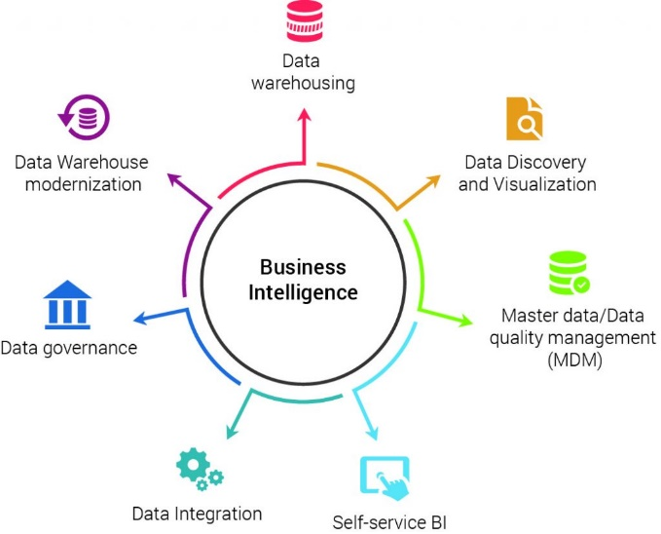

Fig. no 1: Types of Business Intelligence
(Source: Hmoud, and Laszlo, 2019)
Data automation
The term business intelligence cannot be justified without adding data automation to it. In other words, data automation is a key factor in the inauguration of business intelligence. Data automation has helped businesses in collecting a massive amount of information (Passlick et al. 2023). As per the forecasts generated regarding business intelligence, it has been stated that data automation would deal with all the data science tasks in the coming years.
Data security
The advanced AI trends and information handling & security have been on everyone’s minds since its huge fame in the year 2022. The advanced practice of privacy regulations namely the GDPR in the European Union has eased the process of controlling the customer’s security and personal data. Additionally, it is expected to experience a more advanced term named Zero trust (Conboy et al. 2020). The term zero trust is related to data security that will allow businesses to remove the hinted trust from all the operating devices. This action would be progressed by verifying all the processes of a device’s interaction with the user, no matter what the site is.

IMPORTANCE OF IMPLEMENTING BI TRENDS
Understandably, the main task of business intelligence is to make the process smooth by allowing quick measures aimed to create faster decisions. In this manner, a business must focus on data designs, analyze those designs and come up with new marketing trends to yield better decision-making with the help of business intelligence tools. For that reason, companies that keep an eye on the advanced trends of business intelligence led to greater control and clarity of their operations (Ajah, and Nweke, 2019). It also proves to be a complete guide for entrepreneurs to eradicate and correct the errors and inefficiencies in previously made decisions. Furthermore, it also enables those businesses to predict unanticipated challenges and take all the measures accordingly. Business intelligence trends also benefit organizations in generating actionable insights. This is because the BI gives proper access to all the data that leads to generating useful insights and smooth decisions. For example, the information about the percentage of consumers gives an idea about where the consumers are dropping. This action results in allowing businesses to take the required measures to reduce cart discontinuation rates. In addition to this, the business intelligence approach leads to improved efficiency. With the presence of an accurate business intelligence solution, business owners rush toward boosting the efficiency of their business operations by quickly upgrading the complete performance and thus resulting in growing revenues (Lennerholt, Van Laere, and Söderström, 2021). The availability of the data across all areas reduces a lot of extra time and hence increases the productivity of all the employees by using the self-service business intelligence trends. When data is always available to all the team members, it makes them stay alert and informed. This further helps the team members in making better and faster data-driven decisions (Choi et al. 2020). Moreover, a business intelligence framework also provides a proper solution with the help of enabling access to real-time data that further combat the risks of the occurrence of possible errors when designing reports. It also benefits in managing the organization’s health, encountering operational inefficiencies, following short-term market variations, and improving customer experience (Sestino, and De Mauro, 2022). On the other side, business intelligence also gives rise to launching promotional or marketing campaigns that improve the business’ ROI. The money generated through the clicks leads to generating huge revenue. It makes it easier for the business to understand the reasons behind the profit margins, worker productivity, sales, profits, losses and revenue. It may also help the businesses in their growth by only setting up the alarms for tracking the major metrics that prove to be essential for their business success. Thus, it can be concluded that companies need to leverage the importance of business intelligence for the growth of their business.
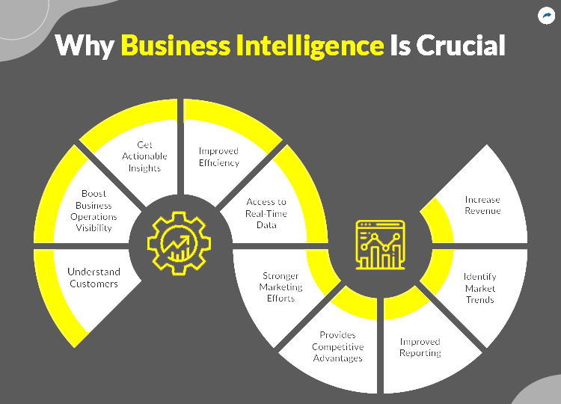
Fig. no 2: Importance of Business Intelligence
(Source: Ajah, and Nweke, 2019)

CONCLUSION
The report tries to narrate every other aspect that has been ever related to the most widely used term business intelligence. The term business intelligence has experienced immense recognition in the past few years. This is because many businesses started to explore new techniques and technical architects with the help of its revolution. Additionally, from the above discussion, it can be seen that business intelligence is really a vast category that involves so many significant trends. This is the reason; it is also essential for business entrepreneurs to carefully dive into doing meaningful research on various business intelligence trends. The above report gives a little introduction to the term business intelligence. It also focuses on the highly known terms aligned with business intelligence such as artificial intelligence, mobile business intelligence, self-service BI, data automation and lastly data security. It is easier to conclude that all these trends are equally important for a business entrepreneur to learn and implement them for the development of his business.

REFERENCES
1. Ajah, I.A. and Nweke, H.F., 2019. Big data and business analytics: Trends, platforms, success factors and applications. Big Data and Cognitive Computing, 3(2), p.32.
2. Choi, J., Yoon, J., Chung, J., Coh, B.Y. and Lee, J.M., 2020. Social media analytics and business intelligence research: A systematic review. Information Processing & Management, 57(6), p.102279.
3. Conboy, K., Mikalef, P., Dennehy, D. and Krogstie, J., 2020. Using business analytics to enhance dynamic capabilities in operations research: A case analysis and research agenda. European Journal of Operational Research, 281(3), pp.656-672.
4. Hmoud, B. and Laszlo, V., 2019. Will artificial intelligence take over human resources recruitment and selection? Network Intelligence Studies, 7(13), pp.21-30.
5. Kristoffersen, E., Mikalef, P., Blomsma, F. and Li, J., 2021. The effects of business analytics capability on circular economy implementation, resource orchestration capability, and firm performance. International Journal of Production Economics, 239, p.108205.
6. Lennerholt, C., Van Laere, J. and Söderström, E., 2021. User-related challenges of self-service business intelligence. Information Systems Management, 38(4), pp.309-323.
7. Loureiro, S.M.C., Guerreiro, J. and Tussyadiah, I., 2021. Artificial intelligence in business: State of the art and future research agenda. Journal of business research, 129, pp.911-926.
8. Passlick, J., Grützner, L., Schulz, M. and Breitner, M.H., 2023. Self-service business intelligence and analytics application scenarios: A taxonomy for differentiation. Information Systems and e-Business Management, 21(1), pp.159-191.
9. Sestino, A. and De Mauro, A., 2022. Leveraging artificial intelligence in business: Implications, applications and methods. Technology Analysis & Strategic Management, 34(1), pp.16-29.

