Effective Team Working and Communication

- Student Name. Marius Viorel Grama
- Student Number. 2018945
- Module Name. Effective Team Working and Communication
- Module Number. BMSW4002
- Lecturer. Timothy Hopkins
Table of Contents
Introduction 3
Overview of Communication 3
Models of Communication 3
Communicational Skills 7
Poor Communication 9
Conclusion 10
References 11

Introduction
Communication is the act of delivering, receiving, and sharing information - or, to put it another way, talk or write, and listen or read. Great communicators pay attention to what they are saying, speak or write clearly, and consider various emotions (Sillars and Vangelisti, 2018). This report will discuss the understanding of communication models and communicational skills, referring to case studies. Examples of poor communication in a workplace setting would also be stated, aligned with the case study, and recommendations will also be given on how it could be improved using the published literature.

Overview of Communication
Many theories have been suggested to describe, predict, and comprehend the activities and miracles that connection entails. When it comes to business discussions, we are often more interested in ensuring that our communications provide the best results. Be that as it may, to accomplish results, it very well may be essential to get what correspondence is and how it functions. Several ideas have been presented to depict, foresee, and comprehend the activities and wonders that correspondence entails (Mikkola and Valo, 2019).

Models of Communication
Shannon and Weaver
The Shannon-Weaver communication model was created to find the quickest and best communication technique between two points. It includes eight factors: the source, encoder, message, channel, decoder, collector, commotion and criticism (Mishra, 2017).

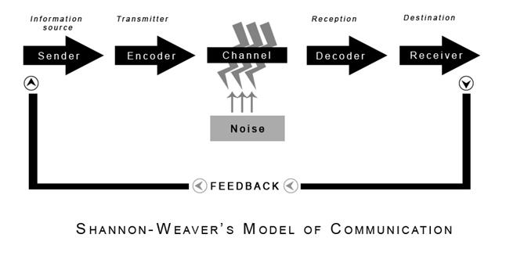
Figure 1. “Shannon and Weaver Model of Communication”
(Source: Mishra, 2017)

According to the model, the communication interactions begin with the source, which is the location where the initial message gets constructed. The source can be an individual or a group to pass on information to another person or group. According to Kubota (2019), After the source of communication has been chosen, the encoder's role is to convert the source's idea into an arrangement that will contact the person or group that needs to decode it. The data sent from the transmitter to the recipient is referred to as the message. The channel is a means of transmitting data from the transmitter to the receiver. It is critical to select a legitimate means of transmission before sending a message. The message path to the receiver might be verbal, written, digital or other formats. As the communication travels down the channel, commotion becomes the most crucial factor, an impedance or mutilation that can alter the message given by the transmitter or sender, causing it to be mis constructed.
Furthermore, clamour might be physical, semantic, mental or a method of speaking. Before the communication reaches its intended recipient, it must be decoded into a format that the receiver understands. When the transmitter encodes the notion that the person in question needs to send, it is the opposite side of the succession (Mishra, 2017). The recipient is the person who receives the communication sent by the sender. The point at which the recipient informs the transmitter that they have received and interpreted a message accurately is called input.

Berlo SMCR model of communication
The SMCR model by David Berlo expands Shannon and Weaver's 1948 straight correspondence model. This model is not particular to any type of connection, but it may be applied to any specialised strategy, including second language correspondence (Alshanqiti, A.M. and Khozium, 2021). The source, message, channel, and recipient are all considered in this communication model, as is the importance of the mental view in the correspondence model. Berlo's model is divided into four zones, each with its own set of essential components.

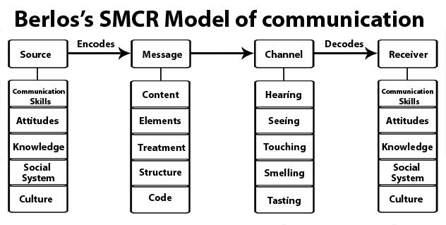
Figure 2. “Berlo’s SMCR Model of Communication”
(Source: Kuznar and Yager, 2020)

According to Berlo, this model includes a detailed examination of each component of the open interaction. The model’s source and collector are investigated in terms of relationships, capacities, information, socio alliance, social qualities, social viewpoints, articles, and conditions. The message was examined in its components and construction and content and coding strategy (Kuznar and Yager, 2020). Also, According to Berlo, the correspondence channels are the five detects that receive the data. This model is perhaps the simplest and most helpful in examining the components of a specific communication measure, to be regarded as essential in consideration of the individual components of the corresponding interaction. However, it has several drawbacks, it is monologue and unidirectional, and it cannot be deemed complete without considering the consequences of communication and input.

According to the SMCR model of communication, the communication recipient should understand that he has received a message and who sent it. As a result, this infers the sender’s dependability, the degree of which influences how much weight will be given to the message (Kuznar and Yager, 2020). If the sender’s certainty is high, the recipients will pay attention to the message and accept the data. The overall scenario, the message’s theme, the hour of its distribution, and the style for portraying the message are all important factors affecting the communication measures, determining the effect of the message on the population and its translation.

Schramm model of communication
As proposed by Schramm, this model suggests that communication is a two-way process, with the message going back and forth between the sender and the recipient. The purpose of this model is to ensure that both the sender and the recipient understand the message.

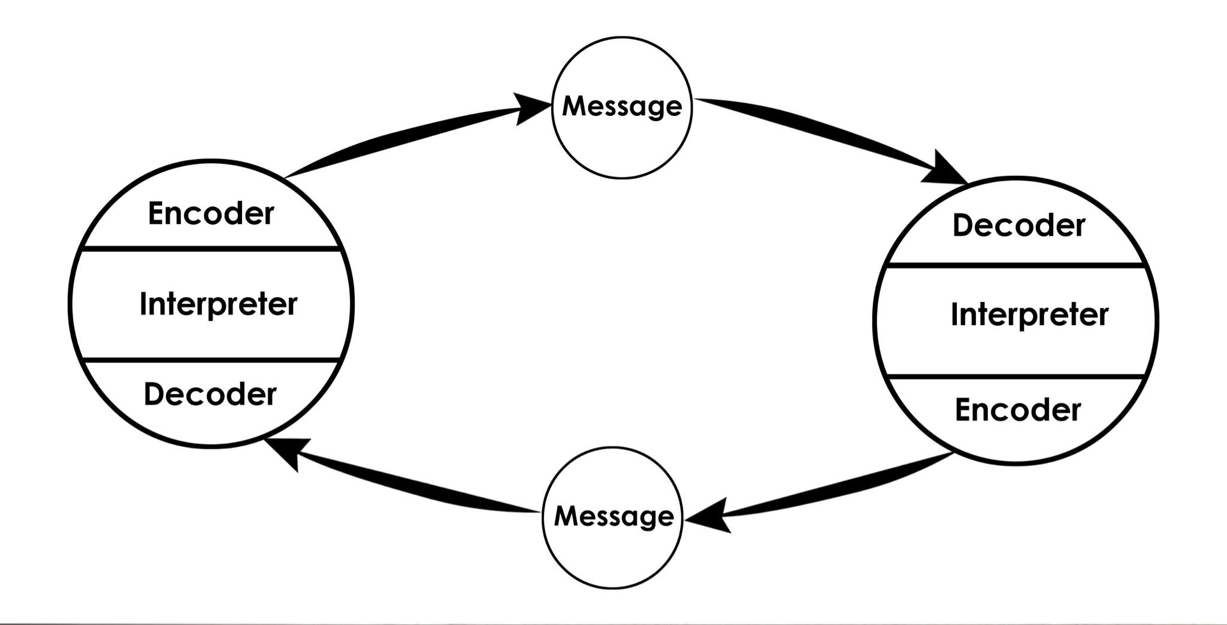
Figure 3. “Schramm’s Model of Communication”
(Source: Elleström, 2018)

The Schramm Communication Model is based on Sender, Encoder, Decoder, Receiver and the message itself. This model depicts communication as a two-way highway, implying that data is exchanged between the sender and the recipient (Elleström, 2018). Beginning process of this model is that the message travels from the sender to the receiver. However, that part inversion occurs when the receiver communicates back to the sender. The sender transforms into the recipient, and vice versa. This model states that two components are required to communicate: the sender and the recipient, both of whom must encrypt and decrypt the message. This is crucial for the message’s appropriateness and accurate translation. When a message reaches its intended recipient, they usually appreciate what the sender is seeking to convey. If the recipient cannot comprehend or interpret the message, the entire communication is rendered useless. As a result, decoding and encoding should be seen as two critical barriers to effective communication.

The concept of this model emphasises that communication is not complete until the sender receives feedback from the recipient. When the data was transferred off the recipient, the primary communication came to an end. They proceeded in a single-direction communication (Dissanayake, 2018). However, this paradigm is based on a bidirectional communication process where the sender and recipient trade jobs. There is no fourth component in this model, unlike “Berlo’s communication model”. Simply, the message starts with the sender, is encoded, and then delivered to the recipient. This recipient decodes the message and comprehends it. The receiver then encodes an acceptable response, which is then given back to the sender, who now becomes the receiver.

Communicational Skills
The skills a person employs when sending and receiving various forms of info are known as relational abilities. Talking, noticing, and identifying are all relational abilities. It is also helpful to understand the differences between face-to-face collaborations, phone conversations, and computerised exchanges like email and web-based media. One may learn and practise various relational abilities to help one become a more effective communicator (Dolan, 2017). Because so many of these skills interact, it is critical to practise relationship skills in various settings as soon as possible.

Active Listening skill is about giving undivided attention means paying careful attention to the person who is speaking. Because of the concern and regard, they show others. Their peers highly appreciate attentive people. While it may appear simple, this is a skill that can be tough to develop and master. One can be more attentive by focusing on the speaker, avoiding distractions such as PDAs, PCs, or other tasks, and preparing questions, remarks, or thoughts to respond appropriately (Spataro and Bloch, 2018).

Communication style adaptation is about changing the communication type based on the scenario. In certain situations, different types of correspondence are appropriate (Nolt, 2017). Consider the best way to communicate with them to make the most of their relational abilities. If a person is communicating with a potential supervisor, it is better to write a traditional email or call them on the phone. Depending on the situation, one may be required to send a formal, written letter rather than other forms of correspondence. In the workplace, it could be believed that communicating brutal information face to face or over a video conference is more accessible than sending a long, dense email.

Confidence is the crucial skill required for proper and effective communication. Individuals in the workplace are compelled to react to notions that are given assurance. Confident communication is helpful at work as well as during the interview process for a new employee.

With communication, Friendliness is also an exceptional skill that could improve the overall communication efficiency. Having a friendly tone will encourage other people to initiate and talk. This promotes communication and contributes to a more robust understanding, which could be very important in a teamwork scenario.

Other than these, Empathy skill means the ability to understand and share the sentiments of others. In both group and one-on-one contexts, this correspondence expertise is crucial. In all circumstances, one must understand the feelings of others and choose an appropriate response.

Respectful communication is about knowing when to start correspondence and react is a critical component of regard. Allowing others to speak freely in a group or social setting is regarded as a critical correspondence skill. Solid communicators can accept essential criticism and contribute constructively to others (Hardjati and Febrianita, 2019). Input should answer inquiries, make plans, or help strengthen the project or a nearby point.

One must also have cohesion and clarity in their communication. This is a necessary skill for a person to speak in a clear and understanding way. Especially in business communication, it is imperative to communicate concisely and clearly, without which certain misunderstandings could be born and create conflicts and therefore reduce workability.

Communication is the core that holds a team or a company together. Suppose people do not clearly understand the organization's vision and need if there is no viable contact. Therefore, to improve communication abilities and secure an excellent communicative habit, one must ensure the skills. The skills are the root of good communication.

Poor Communication
“Why do you think Pedro misunderstood Maria?”
From the case study of Maria and Pedro, it was found out that Pedro misunderstood Maria because of semantic noise. The noise could have interfered with the message, as the verbal and electronic mode of communication in this scenario. Pedro works in a building site known for generating noise. Semantic noise can weaken the message while also causing the importance of the message to shift. Due to this noise, the message was misinterpreted on the receiver's end, and therefore Pedro misunderstood Maria.

“Whose Model of Communication explains this confusion and why?”
Shannon and Weaver model of communication explained this confusion in-depth, and this phenomenon in the model is referred to as noise. The model explains this confusion because it has become a critical factor influencing how people communicate. According to the model, noise is interruptions that are caused in the process of communication. The noise disrupts the message, failing the message, and the communication process. For communication to be successful, it is important to consider noise as an element, and one must consider it to have a successful communication process.

“How could this have been prevented?”
This misinterpretation of the message could have been prevented if Pedro delivered an acknowledgement message to Maria. That way, the communication process would have become a two-way correspondence, and Maria could have got the assurance that the message was successfully delivered and not misunderstood by Pedro.

“Whose Model of Communication explains how it could have been avoided?”
Schramm's communication model explains how this single-directional communication could be avoided and prefers the bidirectional correspondence process to avoid such issues. According to the model, communication is referred to as a two-way process. The communication process of the Schramm model ensures that the receiver communicates back to the sender to assure the integrity of the message is maintained.

Example of poor communication in the workplace
Taking an example of poor communication in the workplace of Cafe Candon, where I am a chef. There was an instance where I asked my fellow worker to put up a candle on the cake ordered from table three. The worker went to the kitchen, put up the candle on the cake, went to table three, and wished the couple a happy anniversary. However, it was not an anniversary; instead, it was a birthday. Therefore, this created an awkward moment for both the communicators, the worker and the people on table three.
The Shannon Weaver Model can be used to communicate effectively. This model assumes that the sender sends messages to a recipient using any form of communication, such as telephone, transmit, mail, or face-to-face. There must be feedback for better correspondence framed by maintaining this route and cycle of communication. The worker could have asked the chef for more information. Also, the chef had a responsibility to communicate briefly.

Conclusion
In Conclusion, this report has covered the most widely known communication models. Furthermore, it has also covered up the relevant skills and abilities required for good communication ability. Also, the Marshfield Bakery was considered the case study. Two of the issues presented were discussed, following with the models and skills that could be implemented in the workplace to mitigate the same were recommended. Overall, this report investigates and shows the importance of communication, especially in a workplace environment.

References
Alshanqiti, A.M. and Khozium, M.O., 2021. Communication Models Comparisons: Tackling Approach for Corporate Communication. Psychology and Education Journal, 58(4), pp.4075-4079.
Dissanayake, W., 2018. Language and communication. World Englishes, 37(3), pp.461-463.
Dolan, R., 2017. Branding yourself effective communication skills. FEMS microbiology letters, 364(2).
Eads, D., 2017. Changing the Climate: Staff Development Activities that Address the Real Issues, Communication in the Workplace. North Carolina Libraries, 75(1).
Elleström, L., 2018. A medium-centered model of communication. Semiotica, 2018(224), pp.269-293.
Hardjati, S. and Febrianita, R., 2019. The power of interpersonal communication skill in enhancing service provision. Journal of Social Science Research, 14, pp.3192-3199.
Itzchakov, G. and Kluger, A.N., 2017. The listening circle: a simple tool to enhance listening and reduce extremism among employees. Organizational Dynamics, 46(4), pp.220-226.
Kubota, M., 2019. What is “Communication”?―Beyond the Shannon & Weaver’s Model―. International Journal, 13(1), pp.54-65.
Kuznar, L.A. and Yager, M., 2020. The Development of Communication Models, Quick Look. Joint Staff J39, Strategic Multi-layer Assessment Washington, DC United States.
Kuznar, L.A. and Yager, M., 2020. The Development of Communication Models, Quick Look. Joint Staff J39, Strategic Multi-layer Assessment Washington, DC United States.
Lovitt, C.R., 2020. Introduction Rethinking the Role of Culture in International Professional Communication. In Exploring the rhetoric of international professional communication (pp. 1-13). Routledge.
Mikkola, L. and Valo, M. eds., 2019. Workplace communication. Routledge.
Mishra, S., 2017. Shannon and Weaver model of communication.
Nolt, K.L., 2017. Communication Style. In Applied Exercise Psychology (pp. 275-288). Routledge.
Sillars, A.L. and Vangelisti, A.L., 2018. Communication: Basic properties and their relevance to relationship research.
Spataro, S.E. and Bloch, J., 2018. “Can you repeat that?” Teaching active listening in management education. Journal of Management Education, 42(2), pp.168-198.
Weaver, W., 2017. The mathematics of communication. In Communication theory (pp. 27-38). Routledge.
Yusof, A.N.A.M. and Rahmat, N.H., 2020. Communication Barriers at the Workplace: A Case Study. European Journal of Education Studies, 7(10).

