JAHPER MOTOR COMPANY


May 15

Marin Zaharidov
Module Code: ACC05
Module Name: Project Management
Module Tutor: Anupam Mazumdar



Title: Auto Mobile Integrated System

Project PLAN

TABLE OF CONTENT:
- Rapid Prototyping Methodology – by design a new prototype management system;
- Detailed Project Plan;
- WBS;
- Comunication Plan;
- Stakeholder Management Plan;
- Ghant chart;
  - Training for users;
  - Data Migration;
  - System Launch;
  - Assessment Plan;


PROJECT PLAN

Before I start I have to say what is Project Plan?
The project plan is a document that show what is the steps in the project. Time frame for any project plan is essential and important.
For start I need to know: why this project is necessary for this business, what are the main deliverable products, who will be part of the project and when exactly the project must be completed.
This steps are very import if I need to deliver my project on time and to be successful.

For this project I need to present a prototype. Rapid prototyping is a powerful tool that can give to my client answer how this project going to work. What is the prototyping – its how the program or the software should work when is done, it is made for testing, and allow to add more features after. There is many different shapes and sizes for the prototypes. The idea before you build the product where demonstration is light is a proof of concept. A lightweight version of the program itself is called rapid prototype. And the first quality – product version is Minimum Viable Product or known as MVP.
If you release a new product or program the idea of it must be risky and then you should spend more time to build right. To ensure your idea is the right one you need a proper feedback. Doing some researches also will help to build the right prototype.

There is some principles if you manage a rapid prototype. Instead of talking better draw some ideas, make a sketch, maybe a model or even a diagram. For the project manager and the team is very important to understand deeply the idea of the project, so that they can make right decisions. Always show support to the whole team working on this project, encourage even small ideas. To provide transparency I am going to use physical process. Supportive and safe environment is part of success. For any project the most valuable thing is the time, so it is important the team to be peaceful by creating minimum distraction. “This new approach to working I found immensely satisfying, often it felt chaotic, messy and out of control. Where and how much you should deviate from your current process is hard to know but I would encourage you to experiment, fail quickly and be open to what you need from them with my team.” (Davis, 2016)

WORK BREAKDOWN STRUCTURE

A key to organize the team work is a Work Breakdown Structure or WBS. The WBS visually defines the project scope into small parts that the project team can understand easily. It is like a map of the project. The main products and sub-products of this project are combined in different levels. The structure appear to be a tree diagram.
And why I need Work Breakdown Structure?
It has many benefits. Let’s start with the budget. A project budget should be allocated to the top levels of the work breakdown system, and the budgets of the departments should be determined easily based on the work breakdown system of each project. (Clayton, 2019)
A project plan and budget can be easily established by allocating
time- and expense estimates to different parts of the WBS.
As the project executes it is possible to track specific sections of the WBS to identify project costs.
WBS may also be used to define possible threats within a given project. If a framework for work breakdown has a chain that is not
well defined then it poses a danger for the interpretation of scope.
These risks should be tracked in a project log and checked while the project is implementing. By combining WBS with an organisational process, the project manager will also be able to define contact points and create a communication strategy around the organisation.
For referring the different levels of the project we can use some colours. Assigning colours of red for late, at risk we can use yellow, on time green, and blue for completed tasks. Is an efficient
way to create a project progress map and attract management's attention to key areas which need to be done. How look the structure:
            - Top level is the final project;
            - Sub – levels contain work case assigned to different teams;
            - Work packet define the job, time and the price for the tasks;
            - Work packet should be independent and unique;

Work Breakdown Structure tools.
One successful strategy is holding a brainstorming session with the
various departments that are going to be involved with the project.
Low-tech devices such as a white board, index cards or sticky index pads may be used by project managers to define main levels, sub-levels, and unique work packets. Such cards can be stuck onto a wall and reorganised.

Next step in the Project Plan is Communication Plan.

Sometimes communication is hard, so if I have to make it clear I need Project Communication Plan. Why this plan is important?
Just like project planning, expectations have to be set and both the project team and client stakeholders have to fulfil their responsibilities to ensure smooth communication.
Although a project should not start without a project plan in place, it
is not as readily addressed as a project communication plan — but should be. A communication plan sets out how important information
should be transmitted during the project, through who, and at what level. Communication plans have to be put in perspective, but they have to be made. When you implement the coordination process within a project, you take steps to make the project a success.
Start with a vision for the project and its goals.
Most of the time the communication is simple, using an emails or chat meetings and other applications. There is always some strength and weaknesses in the communication. The chance to enhance to better communication is to record all the strengths and even the risks.
Relevance is definitive. Don't presume everybody needs the same amount of data distributed in the same manner, but most members or even sutomers want their data reliably delivered on time. Always try to be S.M.A.R.T – Specific, Measurable, Actionable, Relevant, Timely.
For best communication results we have to make meetings. They are a powerful system of communication, and should be included for each and every communication strategy for a project. But meetings can be waste of time. That is why you want policies and procedures to ensure that your meeting gets the right information to the right members.

Stakeholders and Stakeholder Management Plan.

Stakeholders are the individuals, associations or organisations who have a crucial interest in a project's outcome.
Which can include heads of companies, investors , suppliers, major shareholders and therefore only department heads. Usually, they are active in the approval process and can always try making a project complicated or incredibly easily understandable – depending on where and how successfully they are organized in a management strategy with stakeholders.

It's time to assess the amount of control they have
over the project once all the project stakeholders have been identified. And when everybody has their own concept of success, there's no other choice but to rely on you and the judgement of your team to distinguish leaders from supporters.
For every stakeholders in your project is important to choose the right one by asking some question about the project. For example :

- What is their interest about the project itself?
- What is success?
- What is most important in the project?
Very important step in any project come to create the stakeholder communication plan. You don’t want specific information about the project to be given on all members and stakeholders . Imagine Overflowing them with all the information of the project in the hope of
keeping whatever they want, and throwing away the rest, is a big pattern. Someone should not be given access to those information.
To prevent all this the manager needs this plan to be sure that everything about the communication is clear. By contributing funds, money, supplies , equipment, skills and
more, the stakeholders help make it an extremely simple operation.
But they can also make it an incredibly confusing procedure
with lots of chaotic paperwork along the way, without appropriate planning.
Several stakeholders want to be notified at the completion of the project, while others need to be handheld at any possible phase, due to their low risks. The Management plans for stakeholders are
also essential from a PR perspective. Remember this — stakeholders don't operate alone; they learn about the success of the project from other participating partners and stakeholders. It 's important that their values stay strong, and that you just don't find yourself confronting a disappointed stakeholder's pained expression that has received a disappointing news. Because stakeholders typically include multiple main contacts through several different channels, effective and efficient communication with them is important. Before interviewing them in advance or evaluating their priority or interest, you may end up spinning your wheels trying to justify a low priority and low interest stakeholder 's criteria leaving those with a high
priority at the end feeling disappointed.

GANNT CHART

To successfully execute a project, you need to manage a large
number of tasks, and make sure they are finished on time.
Whether you miss a timetable or execute a task out of order, the remainder of the project may have knock-on consequences. As a result, it could experience delays, and cost significantly more.

In setting up a Gantt chart, you need to go about all the activities that are involved in the project. You must figure out who will be responsible for each task as part of this process, how longer every task would take, and what issues the team will experience.
They as well help you figure out realistic elements of a project, such as the lowest length of time needed to deliver, and also which activities have to be executed before others can proceed. Additionally, you can use them to define the project scope — the series of activities that have to be performed individually on time if the whole project is to perform on time.

PROJECT DELIVERABLES

These are the main results of the project itself. It can also a product or service, documents or papers which are part when you close the project. Example for this type of documents are contracts or reports. Deliverables can differ according to specifications of the project and requirements of the stakeholders. But all customers and stakeholders want deliverables that wrap the project thoroughly at its closing and track progress against requirements during the whole project. (Newton, 2017)

Training and why is important.
Training is vital to the growth and performance of the organisation. It is beneficial for an organisation's workers as well as employees.
If a member of the team is educated properly, he can become more effective and competitive. Training is offered to new candidates joining an organisation.
This training prepares them with the mission, vision, regulations and standards or workplace conditions of the organization or company. Current staff are qualified to update their skills and to improve it. If any technical improvements and modifications take place, preparation is given to deal with those changes. For example purchasing a new machine, manufacturing process upgrades, device installation. Staff must be trained to use modern techniques. During making the project training offered to employees and members inside daily work tasks. It is a easy form of training which is cost-effective. The staff and members of the team are being educated in actual job situation.

Data Migration.

This is a difficult process procedure that includes a robust methodology. Each mechanism in this framework for data migration planning should help reduce the risks involved in a data migration. As described earlier, initiatives related to data migration seldom stand alone. They are usually part of a broader business effort to upgrade essential airline systems and take on new job processes. This makes the customers just as important as the data itself. The key problem is that each technology renders data management more difficult by adding technology logic elements into the data management layer, and each is resistant to the next data use case. There is 3 types data migration: storage migration – moving data into modern systems, cloud migration – moving information from or to a cloud, application migration – moving to new form application. Main steps of data migration are: extract, transform and load.

System Launch.

Your project manager will control the internal resources and cooperation to ensure that non-opening pieces of the project, such as data transfer to user training, are properly handled and prepared. Having your direct and indirect team members resourced and
performing properly will help you optimally launch your project.
Even though a software system is a big project with many uncertainties, a significant early factor in its performance is the proper structure and management of the team resources.

Assessment Plan

Assessment plans are a very important aspect of skills development, used to ensure that these skills are followed by presenting examples of workplace assignments and activities. Assessment plan is unique to the project or the daily activities you are involved.

In my Project Plan I have to make a software for a Mobile Service.
The project is made with Microsoft Access.
There is some benefits pf MS Access. It has automatic repetitive tasks and can manage a large amounts of data. Find information fast and extracted. Ability to import and export from others sources. In access we start with the database. Main components are tables, queries , forms and reports. The form you can add or update some of information, create a buttons open another forms and many others. In queries you can display only the fields you need. (Kaceli, 2017)
Start with creating the tables for our project. Include all the information and creating our relationships.
Creating a prototype is one of the steps.

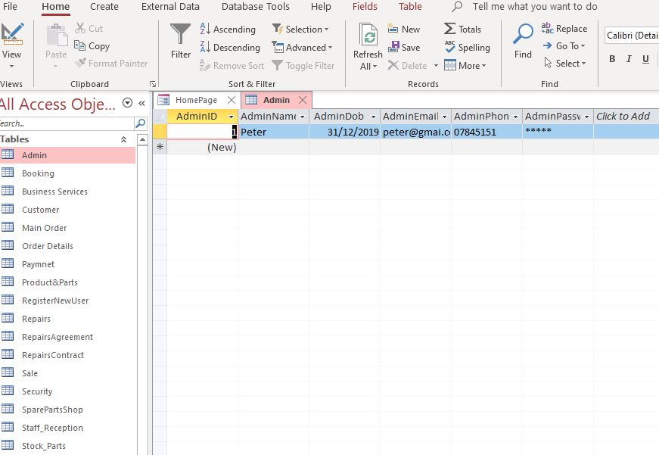

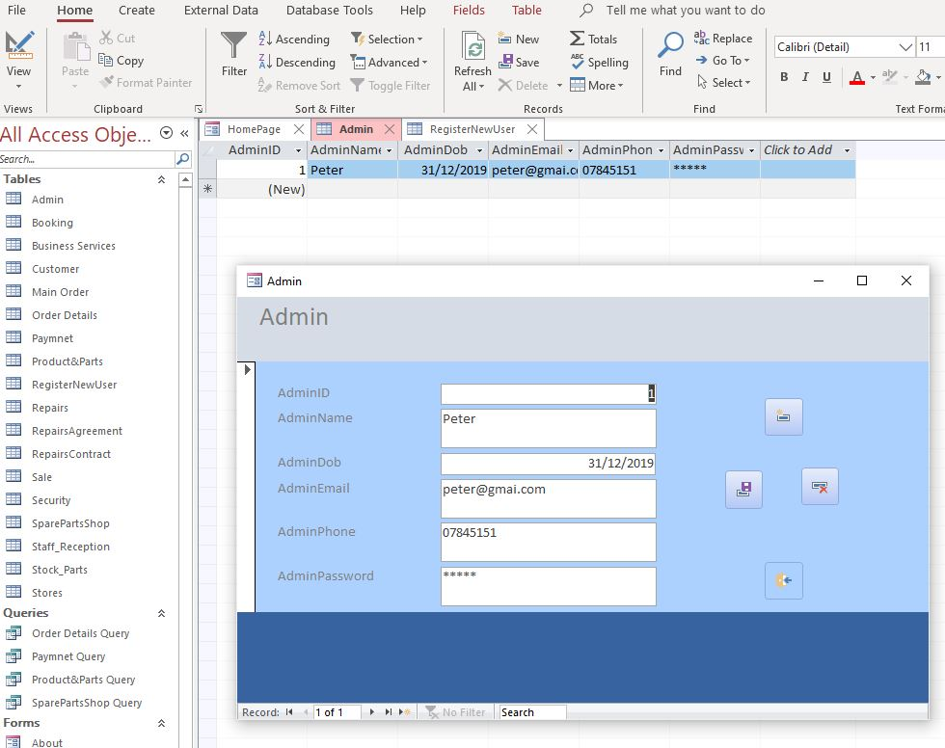
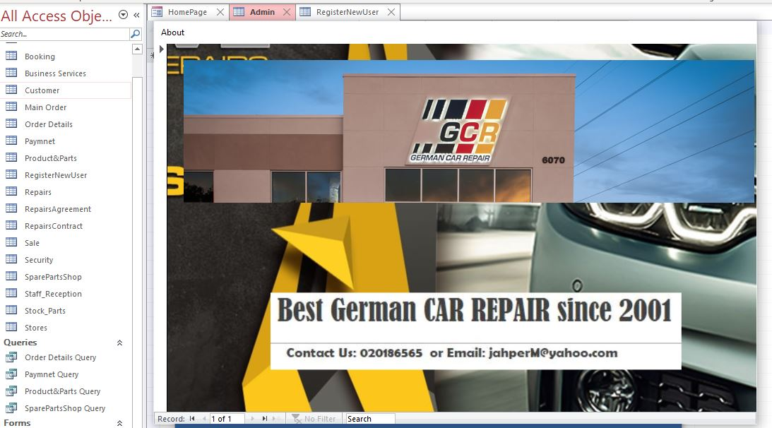

Work Breakdown Structure and Gannt Chart are the nest step in the project.
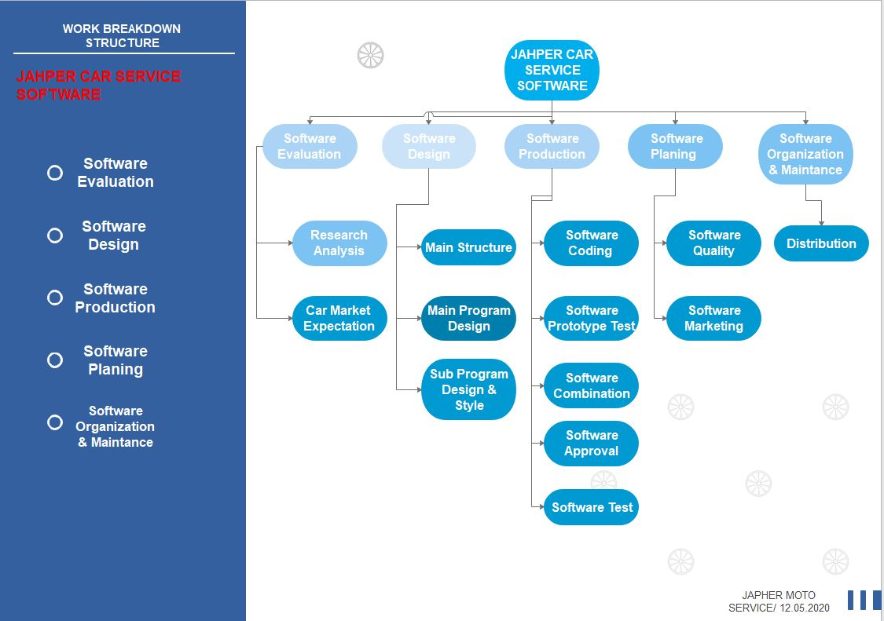

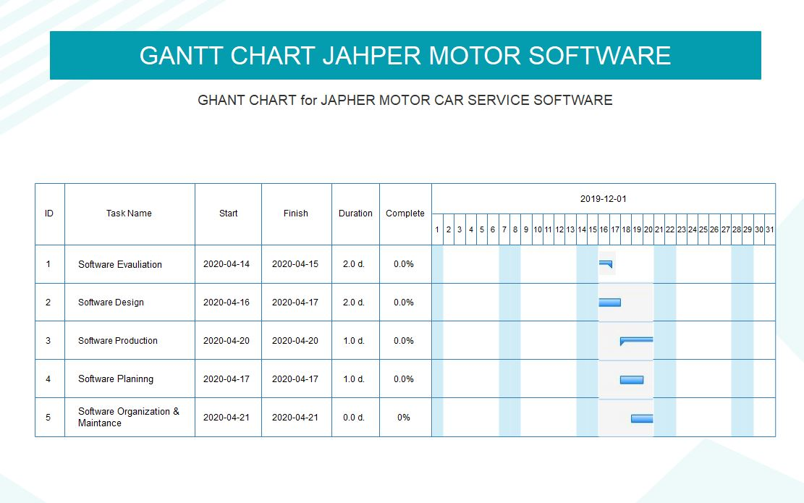

Stakeholder Plan and Communication Plan also take place in the project .

Stakeholder  Risk  Influence  Interest |  |  |  | Project Phases
 |  |  |  | Initiation | Planning | Execution | Close
Rick Dodd | Low | High  level | Medium level | Responsible | Consulted | Informed | Consulted
J. Michael | Medium | Low | Medium  level | Informed | Consulted | Informed | Responsible
Ren Gold | Medium | Low | High level | Consulted | None | Informed | Responsible

Communication Plan:

 | Communication | Medium | Delivery Date | Frequency
1 | Project Team | Meeting | Ongoing | Daily
2 | Executive Stakeholder Comm | Meeting | Ongoing | Weekly
3 | Design Depart. | Email | 20.04.2020 | One - time
4 | Faculty Members | Letter | 20.04.2020 | One- time
5 | Distributors | N/A | 20.04.2020 | One - time

Risk Management in the Project.

Project risk management is the process of detecting, evaluating, and then reacting to any danger that occurs during a project's life cycle to help the project remain on track and achieve its objective.
Risk management is not only reactive, it should be part of the implementation to determine the risk that could occur in the project and how to manage the risk if it actually occurs. Risk management on various projects can mean different things. Risk reduction approaches on large-scale projects should require comprehensive thorough preparation for increasing risk to ensure management plan are in place if issues occur.

Risk Matrix.
The Risk Matrix is also identified as the Probability Matrix effect. It is an important method that assists in risk evaluation by assessing
the possibility or probability of intensity involved with a project's potential risks.
 | Risk Matrix | Minor | Moderate | major Critical
1 | 75-100% | 0 | 0 | 1 2
2 | 40-74% | 1 | 8 | 5 1
3 | 25-39% | 1 | 2 | 2 2
4 | 0-24% | 10 | 2 | 3 0

We define different types of risk priority.
- Critical – high priority or extreme risk;
- Major – important almost high level ;
- Medium level of risk – moderate;
- Low level – minor risksl;
Building a risk evaluation framework and integrating it into the company's project is necessary. When you define risk, you'll want to make sure you 're not filling your danger register with risks that are just outliers and not risks at all. It is best that everyone understands what's happening on in the project, so they know what to look for and support the work process.

Quality Assurance
We use the quality assurance to be sure that our project does not have any mistakes. It is the aspect of quality management that focuses on protecting product or service credibility, giving stakeholders the trust that their quality requirements will be met. But it is a basic aspect of project management.
There is two aspect on the quality assurance. First one is “fit for purpose”,
And the second is “right first time”.
With these aspects is very easy to create the product and work without any mistakes delivering the right project.

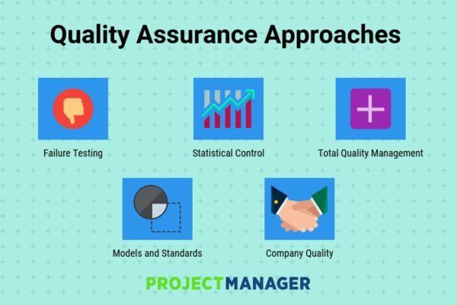

The major difference between quality assurance and testing is that quality assurance is about the measures taken to ensure
that the project conforms to stakeholders' standards, while testing is a method of discovering a process for assessing faults. Testing focuses on device testing and faults-finding.

Conclusion:

Main role of the project is to create a better software and to be easily managed, not very expensive and friendly. In this scenario, PM's overall role is to harmonise the functions of planning, communicating, monitoring and controlling the working process to meet the overall objectives of this project. The focus of this project was on improving J. Motor Company for better coordination and documentation, storing bookings and payments. Our client receive test version to see how the system is going to work. The final product was ready in time frame.
This days Project Management is important part of almost every business an if you want to be successful Project Manager you need to have the right skills. Learn the process of project management system and become absolute professional manager.

References
Clayton, M. (2019, 02 14). Online PM Courses - Mike Clayton. Retrieved from youtube: https://www.youtube.com/watch?v=akO2Lf1fHmM
Davis, H. (2016, 10 10). How to run a rapid prototyping project. Retrieved from dpm: https://thedigitalprojectmanager.com/how-to-run-a-rapid-prototyping-project/
Kaceli, S. (2017, Mar 4). Access Tutorial. Retrieved from Microsoft Access Tutorial: www.youtube.com
Newton, R. (2017). Project management step by step : how to plan and manage a highly successful project. In R. Newton, Project management step by step : how to plan and manage a highly successful project.

