Student Name; Tracey Anderson
Student number; 2314117
Module; BMHP3003
Module name; Care in the Communication

A Reflective Write-up

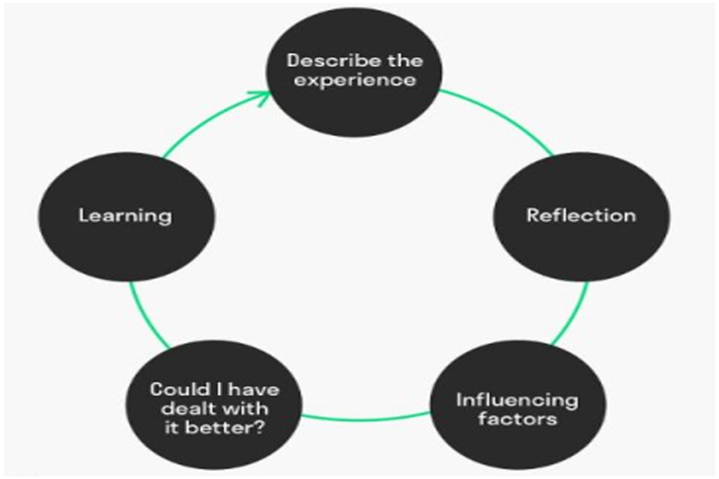
Introduction
This work will discuss a roleplay exercise that was carried out in class for a positive communication roleplay exercise (Altun, 2015.) The write-up will be addresses using Johns reflective model which helps you to determine what you have undertaken within a reflective action. Johns model uses key questions to ascertain how you have carried out a particular action or thing reflectively as per the diagram above. In university today I had to discus and do a role play exercise, the role play had to be three minutes long and I had to interact with my fellow student Tiffany, throughout my reflected write up. Tiff and I did our presentation in a large classroom. In my reflected write up I will be playing a negative and positive service user and a resident.

DESCRIPTION OF THE EVIDENCE
I had to write a role play with my student friend Tiffany, in my role play I am an older elderly person who needs help in her home. I cannot walk and I am deaf (Hampton, et al, 2024). I’m very fragile and I get scared of new carers coming to my home. I played the part of the positive in this role, while Tiffany was the negative. There was no empathy with Tiffany in her role, which made me more afraid of the scenario (Seonyeong 2025). I needed help to dress, wash and I had wet my bed. Tiffany left me feeling very uncomfortable in bed and wouldn’t listen to me, she just kept shouting and saying, “I was a nuisance to her’, not addressing personal needs can lead to future bed sores (Yoshiyuki et al 2025). We played this role in a classroom with our fellow students watching, the lecturers were there to. I had three minutes to perform it.

REFLECTION
The role play I had to produce in front of my colleagues was a scenario of me playing a positive person, I think Tiffany who played the negative person could have been more friendlier with me and she could have changed her attitude towards me, Tiffany could have showed me a bit of empathy and could have been kind and considerate and her communication skills was badly presented ( Feier, et al,1981.) She should have left her private family issues at home as this is clearly bad of her job role and affects the service user’s care (Tozoglu et al 2025). In my character I felt very small, fragile and weak because of Tiffanys communication skills with me. Tiffany was shouting at me with her negative attitude, and it scared me. In the role I mentioned I normally have a lady called Jade so when Tiffany appeared not introducing herself, I was nervous, this meant that I had no confidence with Tiffany dealing with my care needs (Marston 1968).

Influencing Factors
On the day of my role play I was excited and nervous at the same time (Grieve, et al 2021). I had prepared beforehand, which gave me the confidence and knowledge to play out the role play effectively (Marchetti, et al 2021). I had a good night’s sleep and had eaten breakfast beforehand (Rani, 2021) This made me have a more focused approach due to my mind and body working in conjunction with each other (Afzal et al 2025). I had also carried out the roleplay on quite a few occasions with Tiff to prepare. I did my role play in front of my lecturers. I wanted to show them I had good knowledge of what I was going to deliver in my role play exercise. I did the role play to the best of my abilities and showed the lecturer’s I had good communication skills in the three minutes that I had to perform. I spoke clearly and I was confident, and I showed good examples of communicated skills (Cortes 2022). This was in the format of making sure that I could identify any hearing problems (Davis, et al 2020) verbal issues and language skills.

Could I have dealt with it better.
During my role play exercise I had a positive communication experience, and my partner Tiffany had a negative experience. I think going forward she could have had adopted a more empathetic attitude towards the service user (Treharne, 1990.) She also should have introduced herself to make the service user feel more at ease and communicated in a more friendly, clear way, and reiterated to the service user to make sure that they understood what she was asking them(Sharkiya 2023) This would show that the service user could firstly hear them, secondly, understand her and thirdly reiterate back to Tiffany her choices (Plack, et al 2006).

Learning
In my role play I learnt that two people are not the same, one could show empathy (Riess, 2017) and the other could show no remorse at all. I have experienced different ways to communicate with people, you do not just have to talk, you can use, writing, pictures, books. Face gestures, body language, facial expressions, eye contact and movement. I have also learnt that keeping a socially acceptant space from the service user whilst speaking to them can make them feel more comfortable (Scott 1988).

Feedback slot one
My feedback for my interactive role plays from my tutor was very positive, I had excellence for my presentation. I had clear speech, and my gestures were good. My interaction with Tiffany was a positive role play and my interaction with her was great. I made my intension clear; I introduced myself and I was attentive. My discussion flow with Tiffany went well and I had excellence awareness (Nestel et al 2007). I gave verbal and non-verbal suggestions that worked well in my roleplay. Overall, I was very pleased with my mark, and I enjoyed interacting with my fellow colleagues, it can be daunting, and some students can be a little nervous, but I think I enjoyed this a lot, My fellow students feedback was I was clear in what my roleplay was, and they understood the situation that I was doing as a service user. They loved the performance.

References
Afzal MA, N Shahzadi, Z Ahmed, A Hyder, H Saleem, A Zahra, MN Zafar & E Mukhtar (2025). Breakfast; the most important meal of the day or a myth? Biological Times’, 4(2), pp 20-24.
Altun, M. (2015). Using Role-Play Activities to Develop Speaking Skills: A Case Study in the Language Classroom. International Journal of Social Sciences & Educational Studies, 1(4), 27-3329
Claudette D. Feier, Gilbert Leight, A Communication-Cognition Program for Elderly Nursing Home Residents, The Gerontologist, Volume 21, Issue 4, August 1981, Pages 408–416
Cortés-Rodríguez, A.E.; Roman, P.; López-Rodríguez, M.M.; Fernández-Medina, I.M.; Fernández-Sola, C.; Hernández-Padilla, J.M. (2022) Role-Play versus Standardised Patient Simulation for Teaching Interprofessional Communication in Care of the Elderly for Nursing Students. Healthcare 10, (1), pp 46.
Davis, H., Schlundt, D., Bonnet, K., Camarata, S., Bess, F. H., & Hornsby, B. (2020). Understanding Listening-Related Fatigue: Perspectives of Adults with Hearing Loss. International Journal of Audiology, 60(6), 458–468.
Grieve, R., Woodley, J., Hunt, S. E., & McKay, A. (2021). Student fears of oral presentations and public speaking in higher education: a qualitative survey. Journal of Further and Higher Education, 45(9), 1281–1
Gwyneth Treharne BSc (Hons) RGN. (1990) ‘Attitudes towards the care of elderly people: are they getting better?’ 15, (7 ) ,Pp 777-78
Hampton, T Loureiro, M Mortimer, K and Nyirenda, N (2024) Experience of conductive hearing loss and impacts of hearing aid use throughout life. Front. Rehabil. Sci. 5:1491473.
Marchetti, E. (2021). Exceeding and digital materiality in the classroom - a student’s perspective on roleplay in higher education. Journal of Play in Adulthood, 3(2), [113]-130.
Marston 1, A. R. (1968). DEALING WITH LOW SELF‐CONFIDENCE. Educational Research, 10(2), 134–138.
Nestel, D., Tierney, T. (2007) Role-play for medical students learning about communication: Guidelines for maximising benefits. BMC Med Educ 7, (3) pp 55-66.
Özcan Tozoğlu E, Gürbüzer N (January 04, 2025) The Effect of Self-Esteem on Attitudes Toward Aging in the Elderly. Cureus 17(1)
Plack, Margaret M PT, EdD. The Development of Communication Skills, Interpersonal Skills, and a Professional Identity Within a Community of Practice. Journal of Physical Therapy Education 20(1): pp 37-46, Spring 2006.
Rekha Rani Chetan N Dharaiya, Bhopal Singh, Importance of not skipping breakfast: a review, International Journal of Food Science and Technology, Volume 56, Issue 1, January 2021, Pages 28–38,
Riess H. The Science of Empathy. Journal of Patient Experience. 2017;4(2):74-77. Dement Neurocogn Discord
Scott AL. HUMAN INTERACTION AND PERSONAL BOUNDARIES. Journal of Psychosocial Nursing and Mental Health Services. 1988;26(8):23-27.
Seonyeong Yang ¹, Sun Hwa Lee ², Jaeho Kim ², Soo-Jin Cho ², Yeonwook Kang (2025) Dement Neurocogn Discord Effects of cognitive and depression status on empathy in Health Elderly, Amnestic MCI ,and Dementia of the Alzheimer’s type’, (1) , pp 54-68.
Sharkiya, S.H. (2023) Quality communication can improve patient-centred health outcomes among older patients: a rapid review. BMC Health Serv Res (23), pp 886.
Yoshiyuki Yoshikawa, Noriaki Maeshige Masayuki Tanaka ,Mikiko Uemura Terutaka Hiramatsu ,Hidemi Fujino ,Masaharu Sugimoto (2024) Relationship between cleaning frequency and pressure ulcer healing time in older people receiving home care, Journal of Wound care , 33(6) pp 106-111.

