Therapy Assistant Practitioner:
Demonstrating Practice Logbook

Name: Gerallt Wyn Elias
Supervising Therapist/ Mentor: Tom Cooze
Date commenced: 06/01/2025

The content page includes a check list of evidence to be collected with columns to help correspond the continents.

Contents | Pages | Appendix
1 Log of supporting documents from mentor: | 3
- Log of assessments and goal setting. | 4
- Log of a wide range of assessments. | 5-11
- Log of clinical interventions within scope of practice. | 12-13
- Log of risk a risk assessment and how it informs practice. | 14-20 | 1
- Report on learner’s time and workload management. | 21
- Log of compliance with mandatory training. | 22
- Copy of a recent Personal Development Appraisal Review (PDAR). | 23-26
- Copy of recent supervision records (at least two). | 27
- Completed peer review sheet. | 28-33

The Therapy Assistant Practitioner (TAP) demonstration of competencies in the following areas:
- Log of supporting documents from mentor: | Details to include: | Date of completion: | Mentors signature:
- Log of assessments and goal setting. | A completed initial assessment or detailed screening form, including evidence of patient centred goal document. | 06/01/2025 | T.L.Cooze
- Log of a wide range of assessments. | A minimum of three assessments completed, demonstrating a range of skills and tools. | 06/01/2025 | T.L.Cooze
- Log of clinical interventions within scope of practice. | A minimum of three interventions completed, demonstrating a range of skills within scope of practice. | 06/01/2025 | T.L.Cooze
- Log of a risk assessment and how it informs practice. | A completed risk assessment within the workplace, which can include clinical practice or department procedure. This can include case notes, reports, DATIX or professional discussion, which consists of risk identified, how the learner managed the risk and informed progress. | 06/01/2025 | T.L.Cooze
- Report on learner’s time and workload management. | A completed report with mentor’s feedback of the learner’s time and workload management. The report can be completed on a word document and will need to be signed and dated. The report will need to include an example of how the learner demonstrates good time and workload management. | 06/01/2025 | T.L.Cooze
- Log of compliance with mandatory training. | A copy of the learner’s compliance with mandatory training. Compliance is required to be 80% or above. | 06/01/2025 | T.L.Cooze
- Copy of a recent Personal Development Appraisal Review (PDAR). | A copy of the most recent PDAR document completed with supervisor / mentor. | 06/01/2025 | T.L.Cooze
- Copy of recent supervision records. | A minimum of two supervision records, demonstrating attendance and contribution to supervision and agreement to actions. | 06/01/2025 | T.L.Cooze
- Copy of peer review document. | An attached copy of the peer review document completed following observations of others presentations.
This logbook was completed by:
Mentor’s name: T.L.Cooze Mentor’s signature: T.L.Cooze Date: 30/01/25

Learner’s name: Gerallt Wyn Elias Learners’ signature: G.W.Elias Date: 22/01/2025

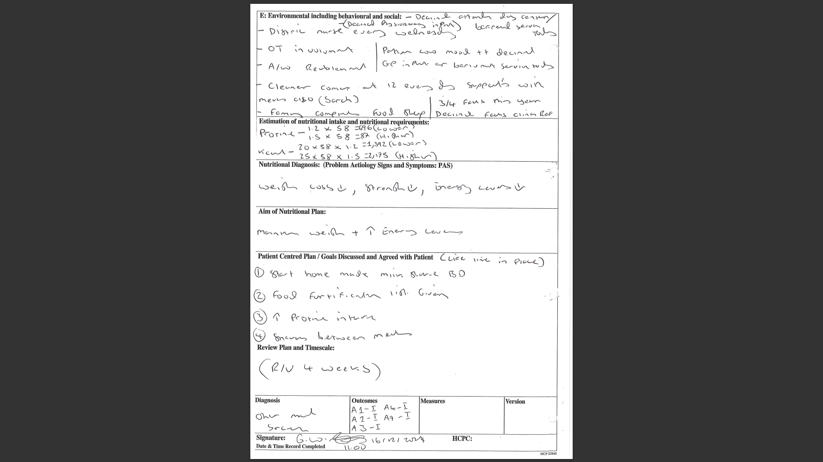
- A - A completed initial assessment or detailed screening form, including evidence of patient centred goal document.

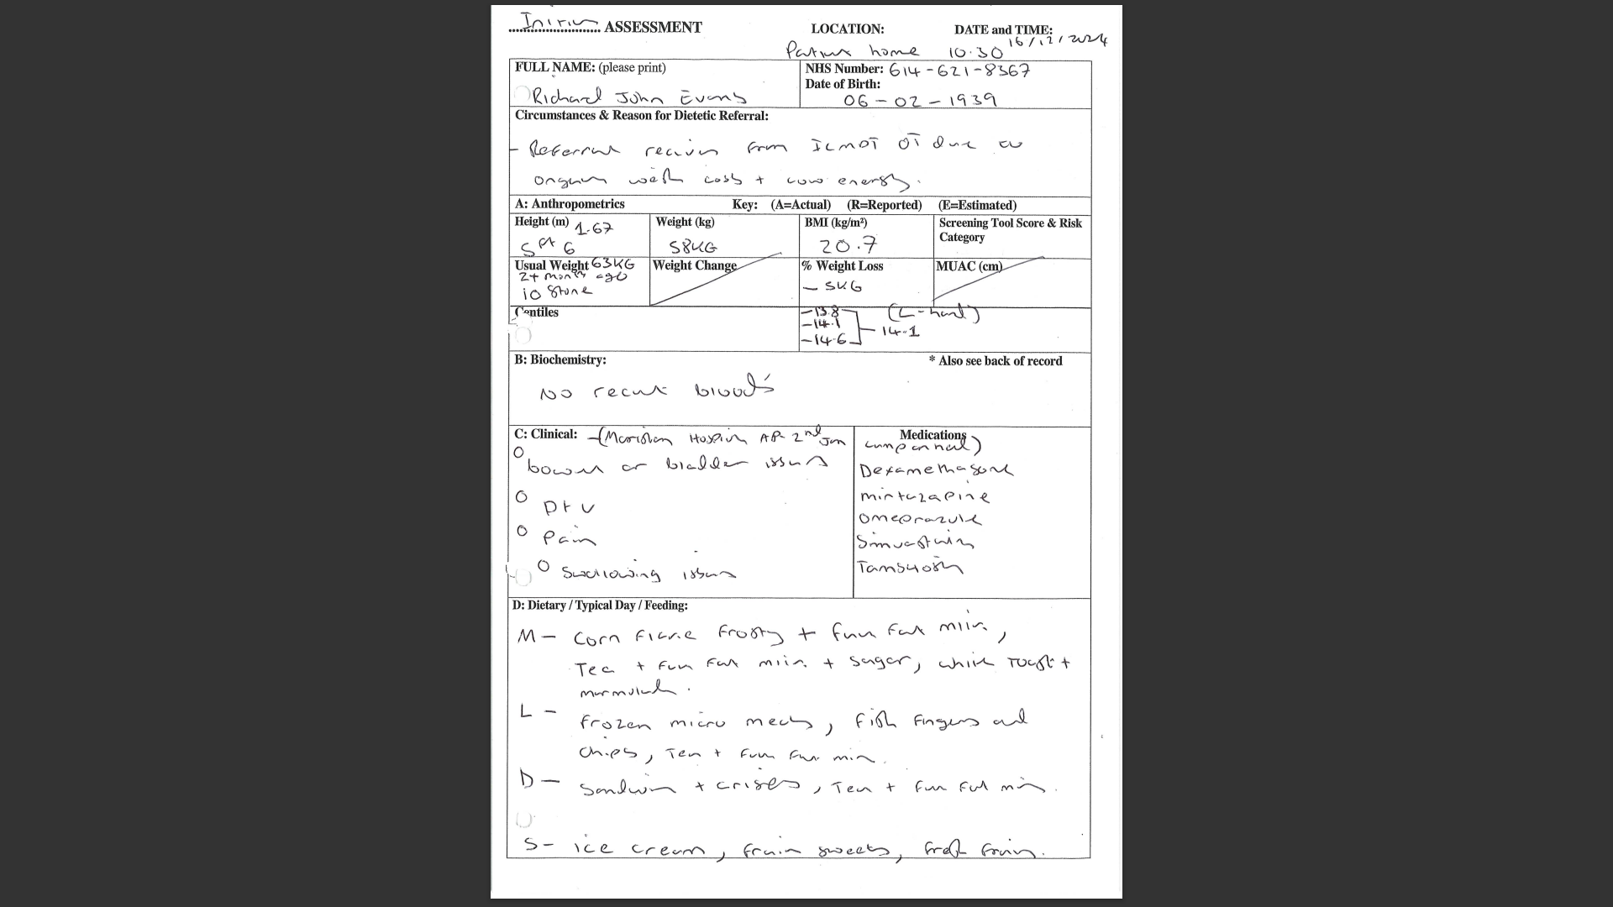

- 1 B - A minimum of three assessments completed, demonstrating a range of skills and tools.
Assessment 1
This is a copy of my casenote entry demonstrating my assessments and goal setting.

“Gerallt Wyn Elias Therapy Assistant Practitioner ICMDT
Verbal consent gained to enter the property; home visit booked via phone call on Friday last week. MR Evans has given consent for myself to complete the dietetic assessment that I have documented on a separate entry. MR Evans was sat on the raise recliner on arrival to the property.
MR Evans has declined physiotherapy input today and expressed that he has exercises that were given in a paper copy by the CRT physiotherapy team, he has expressed that he has no intention to complete this. MR Evans has expressed that he has had 4 falls in the last 12 months and has also expressed that he has ongoing depression / low mood since the passing of his wife.
The following services have been offered to MR Evans listed below:
- Referral to falls service declined
- Referral to balance class declined
- Referral to social proscribing declined
- Referral to the day centre in Ammanford declined
- Referral to befriending services declined
- Referral to Jack Lewis foundation for potential counselling due to bereavement of wife declined
- Declined for myself to speak to the GP on his behalf as he has expressed that he is feeling really low in mood and depressed.
Patient has expressed current function/ support and equipment that is in place listed below:
- Perching stool in the upstairs bathroom that patient completes washing, patient has a level access shower down stairs but does not use due to having dressings due to bi-lateral nephrostomy.
- Stair lift using independently
- Zimmer Frame upstairs– uses independently
- Rollator Zimmer Frame downstairs- uses independently
- Kitchen trolley in place to support with transporting meals- advised to use the Rollator Zimmer Frame when mobilising from point A – B without meals due to ongoing lower limb weakness to reduce the falls risk due to the kitchen trolley being on 4 wheels.
- Static commode in bedroom against the wall- does not use but wishes to keep in place.
- Free standing toilet frame in upstairs toilet with raised toilet seat uses independently.
- Bed has an electrical motor to position the head of the bed and a bed leaver also in place- completes transfers independently.
- Downstairs toilet has a free-standing toilet frame and raised toilet seat- Self toileting and emptying bilateral kidney drains and placing overnight bags on independently.
- District nurses complete dressing once a week to back due to the bi-lateral nephrostomy.
- Shower chair in place in the downstairs level access shower but not in use.
- Raise recliner in place stands from independently without using the remote control.
- Lifeline in place.
- Cleaner that attends to the property 12 o clock every day except from the weekend, cleaner also supports with making lunch for MR Evans.
- Patient takes own medication prescription box in place- taking medications independently.
- All transfers are being completed independently.
Patient has expressed that he is only having difficulty putting his socks on, due to this he has expressed that he wears slippers instead. Expressed regarding purchasing a sock aid this was declined. MR Evans has expressed I am managing okay at home, MR Evans has expressed that he is happy for the reablement service to start at home, I am aware that this service has been in place on two other occasions also. I am unsure what MR Evans will need support with as he is completing all tasks independently as documented above that MR Evans had stated today.
MR Evans has expressed that he has viewed a care home in Glanamman 3 weeks ago and had also attended a care home in Cross hands, MR Evans has expressed that he really liked the Gwenllwyn care home and was asked if he would like to stay there for up to one week. MR Evans went home later that day and made the decision to stay at home, MR Evans has expressed to myself ‘why would I want to lose my home to have a small bedroom and have to be around people every day, I like to have my own independency in my own home’.
I have expressed that if MR Evans does want physiotherapy input in the future to contact delta that will complete the referral when appropriate for MR Evans, no concerns have been raised regarding MR Evans capacity or any concerns raised regarding ongoing confusion. MR Evans has expressed that he has no concerns today and has expressed that the cleaner will be with himself today at lunch time and family member will be going to see him today also. MR Evans has expressed that his sister has been staying with him and that she has gone to visit family in Jersey.
P/ Discharged from ICMDT physiotherapy, dietetic review in 4 weeks patient has consented to this.”
Assessment 2
Gerallt Wyn Elias Therapy Assistant Practitioner ICMDT
S/ Attended to property, Joan has opened the front door while using the x2 walking sticks. Verbal consent gained to enter the property. Joan has expressed that she has showered herself this morning while sat on the bath board, Joan has expressed that she has continued to complete daily exercise and has also expressed that reablement have now finished today and that she has been completing the stairs every day to use the upstairs bathroom. (no concerns raised )
O/ Joan has expressed that she would like to go to the bathroom prior to completing therapy input, Joan has mobilised to the stairs with the x2 walking sticks then completed the stairs while holding onto the x2 bilateral rails and completed the x2 steps going into the bathroom while holding into the x2 grab rails (without supervision). Joan has grasped onto the x2 walking sticks in the bathroom then mobilised to use the toilet, Joan has expressed that she has completed own personal care and has sit to stand from the Mowbray independently with no concerns raised.
Joan has placed the x2 sticks against the wall while she has kept standing balance to wash her hands in the sink, Joan has then mobilised to the door of the bathroom and placed the x2 walking sticks against the wall. Joan has then completed the x2 steps down from the bathroom while holding onto the x2 grab rails then returned to mobilised down the stairs while holding onto the x2 bilateral rails.
Joan has then grasped onto the x2 walking sticks and mobilised to the conservatory, Joan had expressed that the chair is too low in the conservatory last week. I have now raised this by 2 inches equipment order number (116748), Joan has practiced a sit to stand from the single arm chair and completed this independently.
Joan has then mobilised to complete the step out of the front property with the x2 walking sticks to hand and has mobilised to the front gate and mobilised back to the property and completed the step while holding onto the x2 walking sticks, this has been completed to the door located to the rear of the property that was also completed independently while holding onto the x2 walking sticks then mobilised back to sit on the kitchen chair. (Advised for supervision regarding this)
A/ Current function-
- Mobilising indoors with x2 walking sticks independently.
- Transferring meals from point A to B with a Caddy on a Rollator Zimmer Frame- a kitchen trolley was declined.
- Stairs completing independently while holding onto x2 bilateral rails.
- Bed downstairs and upstairs, Joan has expressed that she prefers to use the downstairs bed. (Bed transfers independently).
- Static commode downstairs against the wall downstairs, family member supports with the commode liners.
- Perching stool in the kitchen and bathroom, sit to stand independently.
- Mowbray in place in bathroom upstairs, sit to stand independently.
- Completing micro meals and cooking meals in the oven independently.
- Washing and dressing independently.
- Showering while sat on the bath board independently.
- Sit to stand from kitchen chair, living room sofa and single armchair in the conservatory independently.
Discussion with Joan regarding attending a day community centre or myself referring for a social prescriber this has been declined, Joan has given consent for myself to complete a referral to care and repair regarding a grab rail to the front and rear door to minimise the risk of falls, Phone call completed to Joan's daughter while in the property expressing the outcome of today’s session. Joan's daughter has expressed her thanks for supporting mum back to being independent, I have expressed that the rails being fitted to the front and rear door may take up to 6 weeks.
P/
- Delta wellbeing phone number provided (lifeline in place)
- Equipment stores phone number provided- expressed that equipment is on loan and an information sheet has been given for all equipment that I have put in place.
- CRT refferal declined at present, Joan has expressed that she will contact Delta when she feels that she is ready to complete this.
- Discharged from ICMDT therapy.

Assessment 3
Gerallt Wyn Elias Therapy Assistant Practitioner ICMDT
S/ Verbal consent gained from Margaret; home visit booked via previous home visit. On Arrival at property Margaret was sat on the single armchair in the living room, consent gained to enter the back of the property. No concerns raised on arrival; Margaret has consented regarding taking part in physiotherapy input today. Reablement service has now stopped, and care and repair have now completed the x2 grab rails to the front door and x2 galvanised rails on the stairs.
O/ Margaret has mobilised to the kitchen with the x1 walking stick and has taken a seat on the kitchen chair with the table located in front of her complete upper limb exercise independently without prompts, Margaret has completed the following exercise's
- Polishing with a tea towel in the forward and backwards motion 15 times and completed side to side 15 times.
- Elbow flexion extension 15 times on left and support with right side.
- Scapular retractions 10 times.
- Shoulder rolls on both shoulders separately 15 times.
- Stood up independently from kitchen chair.
- Pendulum forward and back 15 times.
- Pendulum small circles 15 times.
Margaret has then mobilised with the x1 walking stick to the front door, Margaret has completed the first step over the door freehold with x1 walking stick and holding onto the grab rail. Margaret has then completed the one step while holding onto the x1 walking stick and the x1 grab rail, Margaret has completed the x2 steps while holding onto the x2 galvanised rails and mobilised with the one walking stick to the front gate then completed the same procedures going back into the property. Margaret has mobilised to the living room with the x1 walking stick then returned to sit on the single armchair, no concerns raised.
A/ Margaret has expressed that she has been going to the community centre with her daughter present and has also been going to the hairdressers with her friend that drives, Margaret shoulder movement has improved to the point of having FROM when completing exercise. I have explained to Margaret that I am hoping to complete a home visit next week to complete a dietetic assessment that she has given consent for, Margaret is aware to continue to complete shoulder exercise daily.
P/
- Continue therapy input.
- Patient to continue daily exercises as per exercise sheet given.
- Patient aware of the Delta wellbeing number for safety netting.

1 – C - A minimum of three interventions completed, demonstrating a range of skills within scope of practice.
Intervention 1, 2 & 3
- Exercises completed i.e Squats
- Practicing walking with stick for outdoor mobility
- Practice shower transfer
Gerallt Wyn Elias Therapy Assistant Practitioner ICMDT
S/ Verbal consent gained from Peter via phone call, visit booked on previous home visit. Phone call completed prior to visit to inform Peter that the HCSW will be attending the property at 14:30 today to take a blood sample that family and patient are aware of, no concerns raised via phone call. Attended the property and was greeted by daughter, consent gained to enter the property.
O/ Peter was sat on the raise recliner on arrival to the property, Peter has stood from the raise recliner independently to x1 walking stick. Peters had a bad posture when standing to the x1 walking stick due to this being adjusted to low, correct adjustment completed to the walking stick that has improved Peters posture.
Peter has mobilised to the kitchen to complete standing exercise with supervision, unable to complete calf raises due to both ankles have been fused as mentioned on previous notes. Peter has completed the following exercise while holding onto the kitchen work top, 10 mini squats, marching on the spot high knees for 15 seconds, Hip extensions and hip abductions on both legs 10 times. No pain / SOB or dizziness.
Peter has consented to complete outdoor mobility today; Peter has mobilised to the front door with the walking stick independently. Peter has completed the step over the door threshold and completed the new step while held onto the new grab rail while stick was also in other hand and completed this indepdnently, Peter has mobilised around the car port next to the house due to this being flat and walked from the start of the car port to then end and back to the property front door.
Peter has completed the step into the property holding onto the walking stick and the grab rail, Peter has consented to practice the shower transfer. Peter has mobilised up the stairs holding onto the x2 bilateral stair rails, advised peter to place left foot further on the step to minimise the risk of a fall, Peter has completed the step into the shower independently leading with the right leg while holding onto the grab rail in the shower then turned and sat on the corner shower seat.
Peter has the stood from the corner shower chair while holding onto the grab rail, Peter has completed a transfer out of the shower with left hand on the grab rail leading with the right leg out of the shower right hand rested on the sink then placed left foot out of the shower then held onto the walking stick.
Peter has then mobilised to the stairs and completed descending the stairs holding onto the x2 bilateral grab rails, reiterated previous advice regarding the left foot being placed further back onto the step. Peter had then mobilised to the raise recliner and sat down with no concerns or SOB.
A/ Asked Peter if he would like myself to complete a showering assessment or if he would like myself to ask the care staff if they can give supervision, Peter has expressed that he will manage this himself I have asked Peter if he does not want support as he may feel unconfutable but he has expressed this is not the case and that after practicing the shower transfer today he has gained confidence with completing this step.
Daughter that was present in the property has expressed that she will be present most of the day with dad as she is aware that he is having blood tests today at home and she has also expressed that she is going to be completing a shop today following the nutritional advice from Tom ICMDT dietitian.
Expresses to patient and daughter that my next home visit will be next Monday, both sisters with communicate regarding Peters progression today, Peter is really engaged with the advice that he has from professionals and has expressed that he is looking forward to returning outdoors and driving.

P/
- Complete outdoors mobility with x1 walking stick and supervision.
- further outdoor mobility distance and practice car transfers with therapy staff
- Delta number given on previous home visit.

1 D - Log of a risk assessment and how it informs practice.
These are the casenote, in chronological order that followed the risk assessment in appendix 1.
Part 1
Gerallt Wyn Elias Therapy Assistant Practitioner ICMDT
S/ Verbal consent gained from Marjorie, home visit booked via phone call. Arrived at the property was greeted by Marjorie at the front door, verbal consent gained to enter the property. Marjorie has expressed that she is happy to complete therapy input today, referral received due to Marjorie having difficulty with bed transfer and also general weakness affecting mobility.
O/ Marjorie has mobilised with the Rollator Zimmer Frame back to the living room and sat on the two seater sofa, when Marjorie sat down I have had a look at the Rollator Zimmer Frame to see if this is in working order. Rollator Zimmer Frame was bent and also the frame ferules were worn down to the metal and at incorrect height, verbal consent gained to remove the Rollator Zimmer Frame from the property and replaced with a new Rollator Zimmer Frame.
Marjorie has completed sit to stand to the Rollator Zimmer Frame and kept standing balance then sat back down while I completed an adjustment for the Rollator Zimmer Frame to be at the correct height, seated exercises demonstrated and supplied a photo copy of the exercises for Marjorie to complete daily as agreed. Marjorie has completed the following seated exercise marching on the spot for ten seconds, straight leg raise on both legs 10 times, calf raise 10 times, knee flexion on both legs 10 times and practiced 5 sit to stands from the recliner sofa to the Rollator Zimmer Frame. (no concerns / pain noted)
When standing Marjorie has mobilised with the Rollator Zimmer Frame independently with good foot clearance and balance to the bedroom, Marjorie has sat on the edge of the bed and expressed that she transfers out of the right side of the bed while pulling on the commode arm to support with this transfer. I have expressed to Marjorie the dangers of this, Marjorie has consented to completing bed transfers.
Marjorie has stood from the edge of the bed and mobilised while keeping balance with hand on window sill unaided due to there not being any room by the side of the bed, Marjorie has transferred on the bed with no concerns. Marjorie has attempted to transfer out of the bed without holding onto the arm of the commode 3 attempts and was unable to do this even with a leg lifter, re positioned pillows Marjorie was then able to complete the transfer but did take some time.
Asked Marjorie would she like to practice a transfer from that side with and without the leg lifted that she has agreed to, Marjorie found it more difficult to transfer out of the left side of the bed. Tried all options as I'm aware that Marjorie was not keen to have the bed leaver, I reiterated my concerns again regarding pulling on the commode to transfer out of bed at this point Marjorie has then agreed for the equipment to be put in place and fitted by equipment stores order number 116024, bed rails risk form also completed and attached to separate case note.
A walking stick has been provided and measured at the correct height to Marjorie located at the end of the bed so that Marjorie can use this to support with mobility from the bottom to the top of the bed to minimise the risk of falls due to the Rollator Zimmer Frame not being able to fit down the side of the bed that may cause an entrapment issue. This has also been practiced and Marjorie managed well will one hand on the window sill and one hand on the walking stick.
Phone call received from Marjorie's daughter expressing that Marjorie may need a step by the shower, I have expressed that we do not provided shower steps but I am happy to complete shower transfers today, Marjorie has mobilised from the bedroom with the Rollator Zimmer Frame to the shower area. Marjorie has completed transfers in and out of the shower with no concerns while holding onto the grab rails located on the outside and inside of the shower. The shower head has been adjusted so that Marjorie can now wash her hair while sat on the drop down shower chair, It is evident that if there was a step in place this would cause more of a hazard due to the shower being located near to the bedroom door way.
Asked Marjorie if she has any concerns regarding toilet transfers she replied this is becoming more difficult. On the review of the equipment the raised toilet seat was broken down the seem in half and the free standing toilet frame was corroded and not fit for purpose. Marjorie has mobilised to the living room with the Rollator Zimmer Frame and returned to sit back on the recliner sofa. I have asked Marjorie if I can remove the equipment from the property due to it being dangerous and that I will replace with a Mowbray instead that Marjorie has consented too.
Removal of equipment order completed-89092 ( Placed at the outside of the property for collection due to no room restriction in my vehicle)
Order for Mowbray completed - 116024 that will be replaced to GGH OT stock. (Equipment instruction form given)
Collected Equipment from GGH equipment room, returned back to property. Verbal consent gained to enter property from Marjorie, Marjorie has completed a sit to stand from the Mowbray with a little difficulty. Adjustment completed to Mowbray, then Marjorie practiced a sit to stand that she managed well with pushing down with both hands on the arms of the equipment as advised. Marjorie has thank myself for my input today and mobilised back to the living room with the Rollator Zimmer Frame.
A/ Marjorie has over all managed really well and engaged well in today home visit, Marjorie is aware to complete the daily seated exercises. She is also aware that I will be returning to complete a home visit next Friday in the hope that the bed leaver will be fitted, at this point we can practice the bed transfers. No concerns raised, reablement care has stopped today due to meeting all goals independently with the care staff, Marjorie has a life line in place and a supportive family.
P/ Continue therapy input.

Part 2
Gerallt Wyn Elias Therapy Assistant Practitioner ICMDT
Phone call completed to Marjorie's daughter expressing that the potential date for deliver and fitting of the bed leaver will be on the 14/11/2024, I have expressed that I will then complete the bed transfers on the home visit booked on Friday with the new equipment in place that stores would have supplied and fitted.
I have expressed that I had noticed that Marjorie has/ two mattresses on top of each over on her current bed, I have advised that one of the mattresses will need to be removed so that there is no danger of the mattress moving that may could cause an entrapment issue between the mattresses and the bed leaver. (NOK has agreed to completing the removal of one of the mattresses)
P/ Continue therapy input.
Part 3
Gerallt Wyn Elias Therapy Assistant Practitioner ICMDT
Please see attached bed rails risk form, equipment stores will be supplying and fitting.

1 – D - Log of a risk assessment and how it informs practice
This is another example of conducting my own risk assessment when seeing a patient. The following are three separate casenote entries in the chronological order that the events unfolded.
Part 1
Gerallt Wyn Elias Therapy Assistant Practitioner ICMDT
Referral received yesterday due to patient above struggling with bed transfers, due this the care providers have asked for an assessment to be completed in regarding of the patient receiving bed lever to support with the transfers in and out of the bed.
Phone call completed to patient's son yesterday (Howard) due to there no being an answer on the patient’s landline, patient's son has expressed that he will pass the message onto the patient that I am completing a home visit tomorrow to practice bed transfers to identify if there is a need for equipment. Attended to the property, knocked on the door. Patient has given me consent to enter the property, on arrival the patient was stood trying to push a 4-wheel walker and the kitchen trolley that has brakes at the same time.
It was evident on my arrival to the property that the patient was trying to mobilise with two walking aids and expressed ' I am getting ready to go to the airport', I had supported the patient to grasp onto the 4-wheel walker that she was thankful for. I had expressed to the patient regarding why I was completing a home visit today, patient has consented for myself to complete the assessment with the bed transfers. Patient has mobilised from the entrance door of the property to the bedroom with the 4-wheel walker independently, patient must mobilise from the bedroom door to the edge of the bed unaided holding onto the bedroom furniture due to there being limited space to mobilise this is due to the amount of bedroom furniture and as well as the bed being large.
I am concerned with the limited amount of movement the patient can complete in the bedroom due to the limited space, when patient sat on the edge of the bed the doorbell had rang that was the HCSW coming to complete taking a blood test. I had asked the HCSW when with patient’s leg dressings be completed next, she has expressed that this is booked for tomorrow, the patient had expressed to the HCSW ' are you coming to take measurements of my stomach'. The HSCW expressed that she has come to take bloods for the GP surgery that the patient consented too.
The patient had transferred on to the bed independently with multiple verbal prompts taking a total of 10 + minutes to transfer into the bed, patient had centred her bottom and limbs into the centre of the bed. The patient then expressed ' I bet you like getting the ladies into bed'. The patient shortly after transferred to the edge of the bed independently keeping sitting balance while the HCSW had taken a blood test. The bed and mattress seem to be high of the floor making the transfers difficult due to this, the patient expressed 'are you a midwife' to the HCSW, shortly after the HCSW had left the property.
Asked patient if she would like to practice the bed transfers again that she had consented to, the patient has stood up from the edge of the bed to complete the transfers again. The patient was trying to complete the bed transfer with her bottom halfway down the bed, I have advised the patient to shimmy her bottom up the bed that she had. The patient was then trying to place her feet in the bedroom furniture draw, I had expressed to the patient why was she trying to place her feet in the draws she had not replied to this and closed the draw.
The patient has placed a black foldable step placing this is such a way against the furniture to support with a halfway point to push her bottom further onto the bed then completed the bed transfer with verbal prompts, patient then transferred to the edge of the bed. I have supported the patient to put slippers on, patient has stood from the edge of the bed then mobilised holding onto the furniture until the point that she had reached to the door of the bedroom where the 4-wheel walkers were. The patient has then mobilised to the single armchair in the living room, patient has a lifeline in place.
The patient is receiving 3 calls a day from reablement and has been identified to have long term care needs, previous case not stated that family have been looking into placement options. I was aware that the care staff have been this morning as this is reflected in the reablement file stating from the care staff that the patient was really confused this morning, I had expressed to the patient have you had any care staff in today she stated, ' yes the midwifes have been this morning'. Asked patient if she would like myself to support her with anything prior to leaving she has expressed if I could complete her a cup of water, the patient expressed that the physiotherapist was with her yesterday this was also false information.
I have contacted Jamie band 5 rotational physiotherapist that works within ICMDT, Jamie has expressed that the patient is being treated with antibiotics due to a urine infection as I was aware of prior to attending to the property. Jamie has expressed that the patient has received a different antibiotic due to the ongoing confusion not improving, I have reiterated today’s assessment and Jamie has expressed that the patient’s cognition has worsen.
Informed my manager Emma ICMDT lead occupational therapist that has expressed that she is in training at present would it be possible for myself to contact one of the other lead band 7's within ICMDT that I have agreed too, I have contacted Leanne Murphy occupational therapist lead for bed-based care. I have expressed my concerns of supplying the bed leaver when the patient has ongoing confusion that may cause a danger and that this may also confuse the patient more as this will be an unfamiliar equipment that may harm, I have raised my concerns that I have listed above as well as the limited space in the bedroom placing the patient at a risk of falls.
The patient was able to complete the bed transfers but needed a lot of verbal prompts throughout, I feel that the patient cognition and confusion is placing her in danger in her own home preventing her to complete these tasks.
P/
Leanne has kindly asked for me to contact ICMDT triage team to relay the above information and concerns.
Part 2
Gerallt Wyn Elias Therapy Assistant Practitioner ICMDT
Contact made to ICMDT triage; it was highlighted by the ICMDT GP that the patient would benefit from a medical review. DR. Sioned has kindly expressed that she will contact the patients GP in regard to the patient’s worsening confusion.
P/
- Contact patients Son Howard NOK (07759112437)
- (Update) ICMDT GP feels that this should be a (999) emergency call that is currently being completed.
- Informed by triage team that reablement calls will continue until further notice.
- Inform patients son (Howard) NOK.
- Lifeline in place
- Wait for outcome, if admitted to hospital will be discharged from ICMDT therapy.
Part 3
Gerallt Wyn Elias Therapy Assistant Practitioner ICMDT

Phone call received from paramedic team expressing that the patient has been admitted to hospital and will be treated with antibiotics, contact received from social worker from Cadog ward expressing that the reablement team have now expressed that there is long term care needs and that the patient will be going into placement as agreed with family.

P/ Discharged from ICMDT therapy.

1-E - Report on learner’s time and workload management.

Mentor’s Feedback

Gerallt has consistently demonstrated excellent time management skills in the year that I have been his clinical supervisor. He is very punctual and shows up to work with a positive attitude. I have seen evidence in his diary that he books his patient visits in in a very timely manner which enables him to organise his workload effectively and provide additional time to respond to crisis calls as and when needed.
Gerallt further demonstrates his workload management by returning to the office at a reasonable time at the end of the day to ensure that he has sufficient time to write up his notes, send any letters and complete his expenses for the day to prevent his one day’s work interfering and spilling over to the following day.

Thomas Cooze 09/01/24
DT031770

- F - Log of compliance with mandatory training.

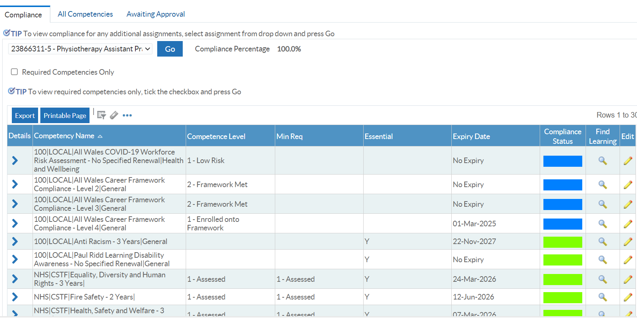

2 Copy of a recent Personal Development Appraisal Review (PDAR).
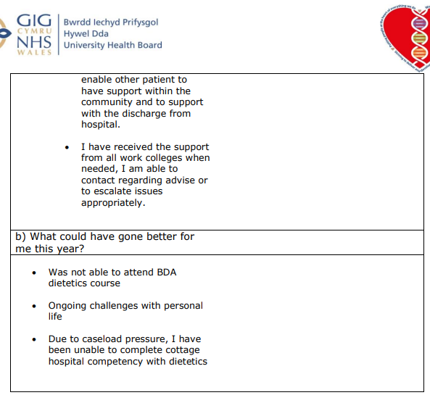
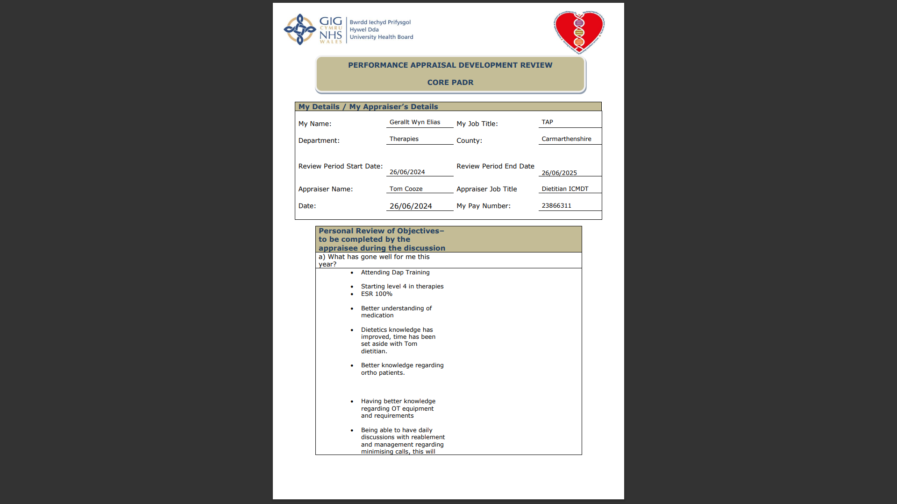

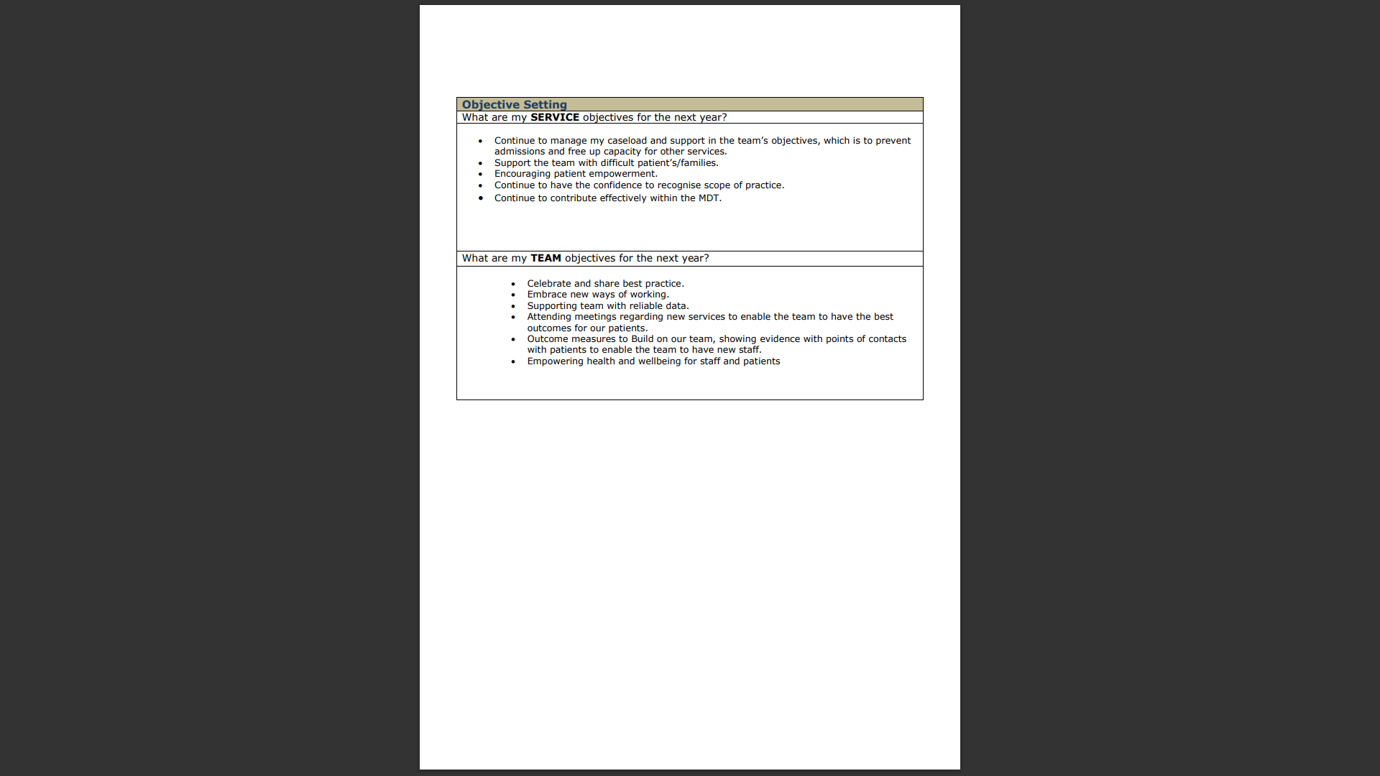
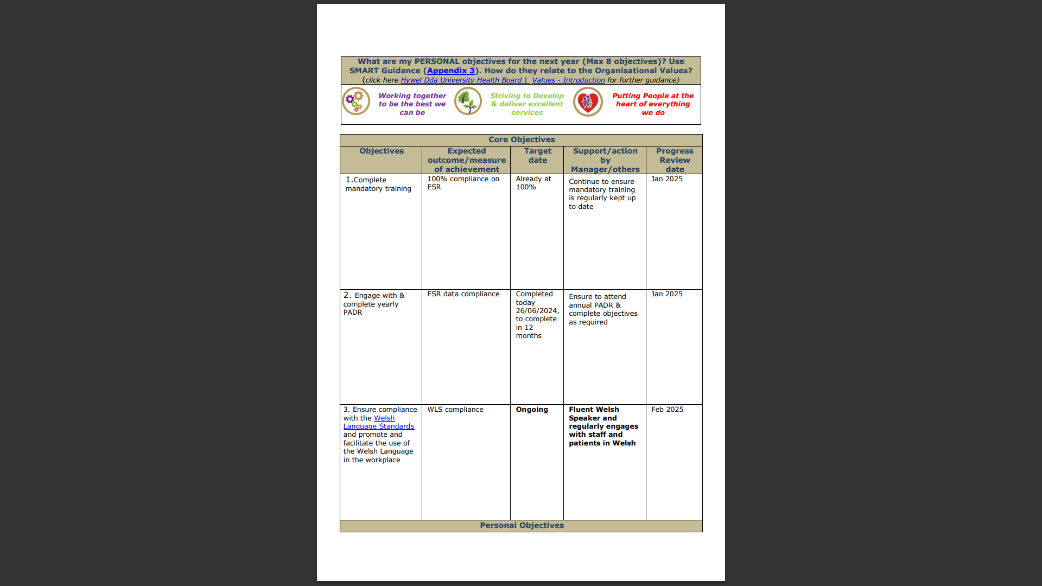

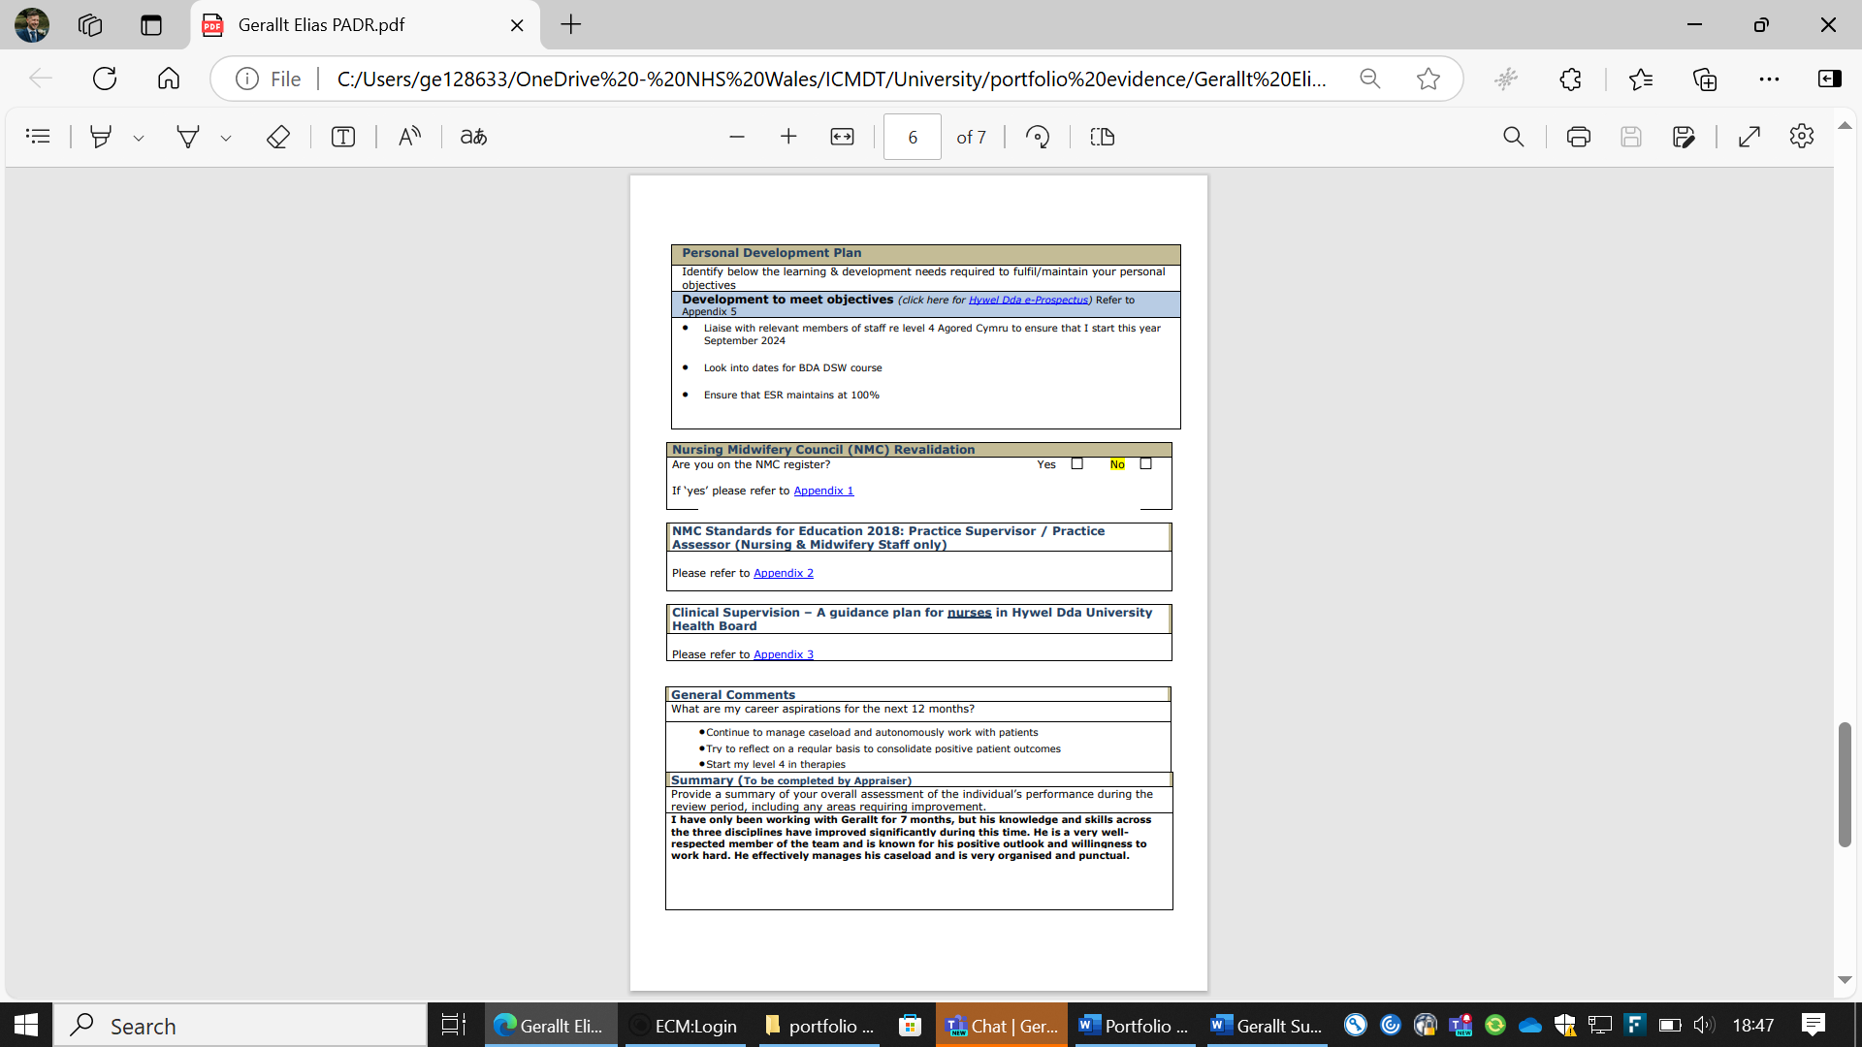
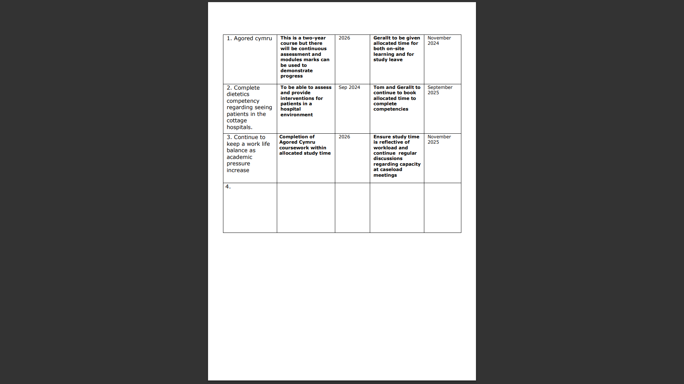

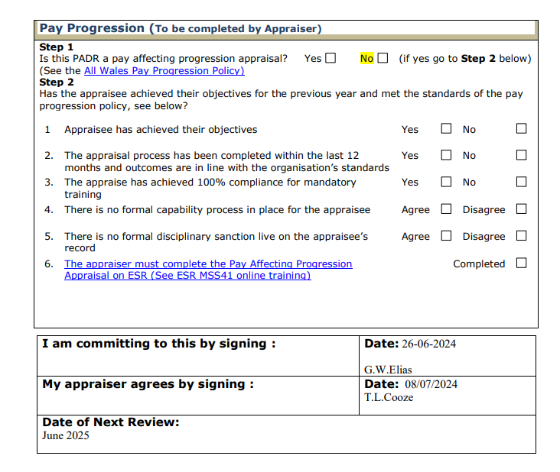

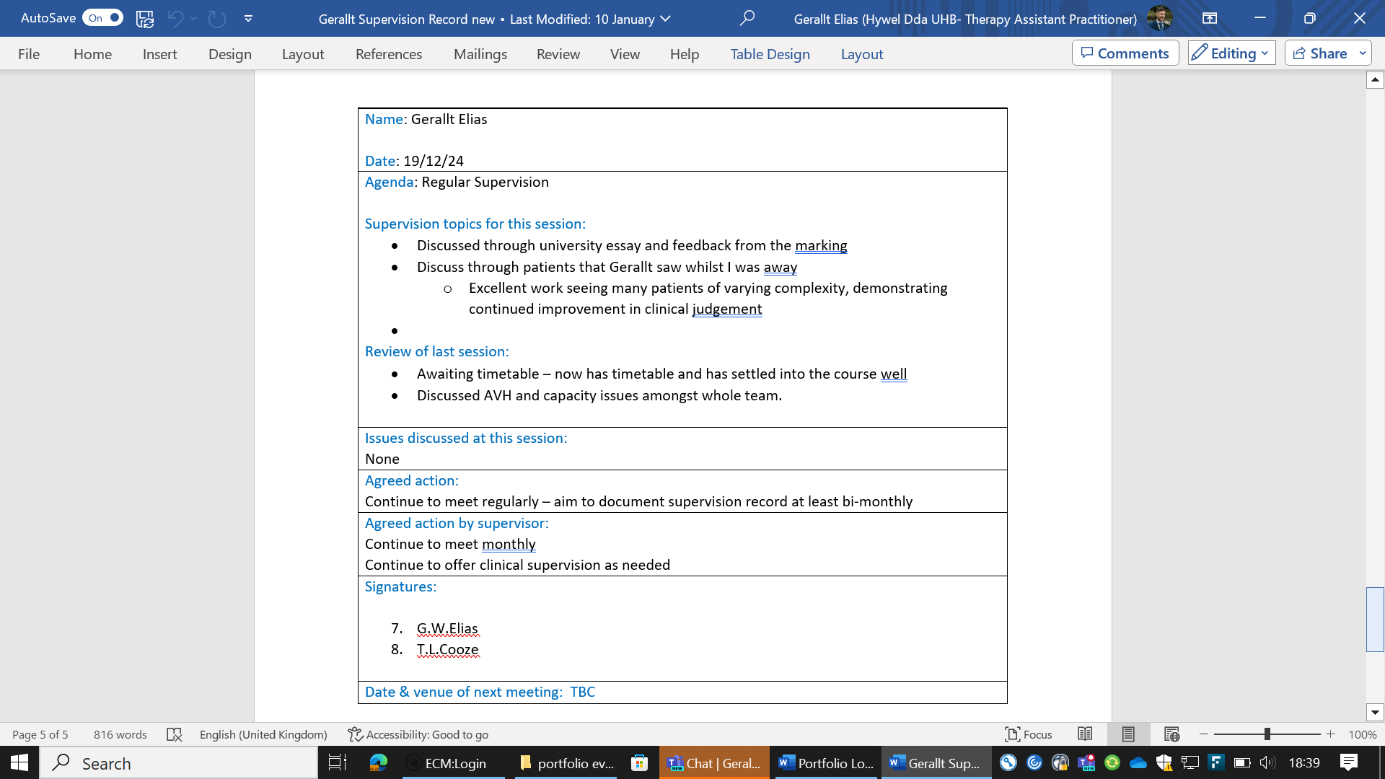
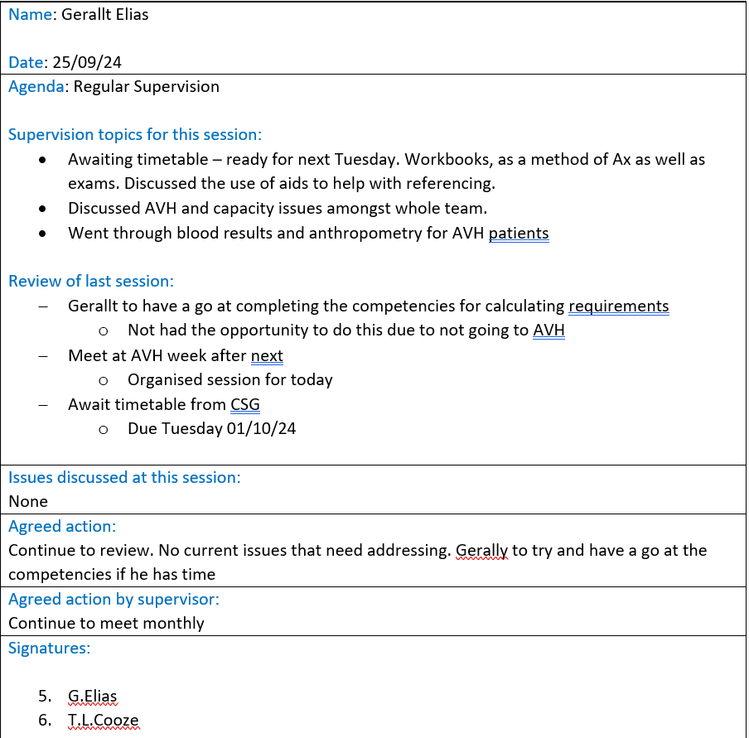
3 - Copy of recent supervision records (at least two).

4 - Copy of peer review document.

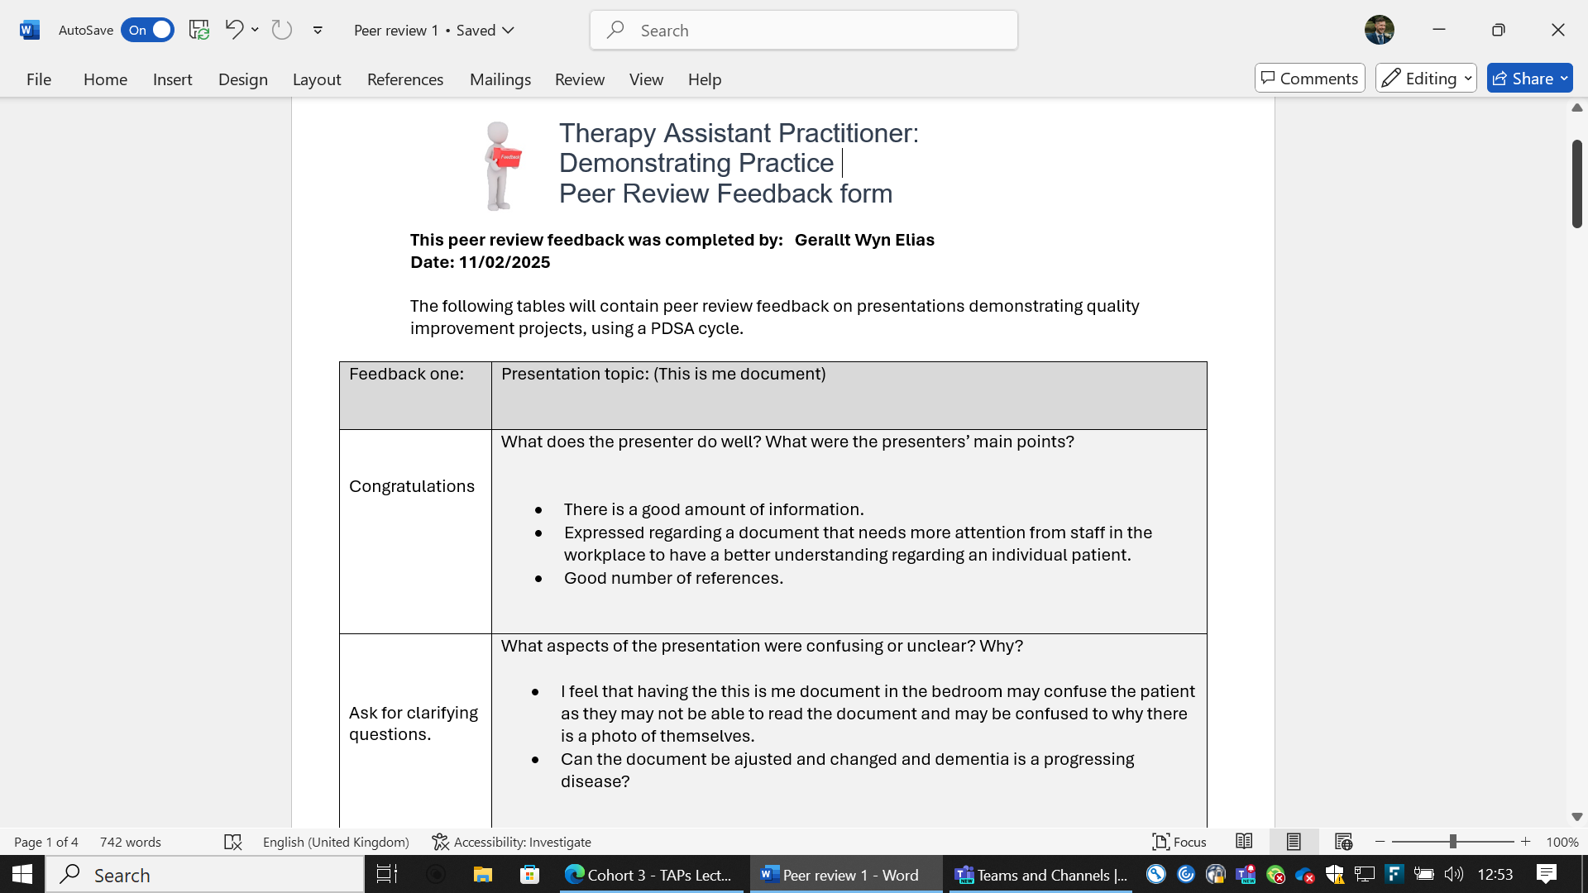
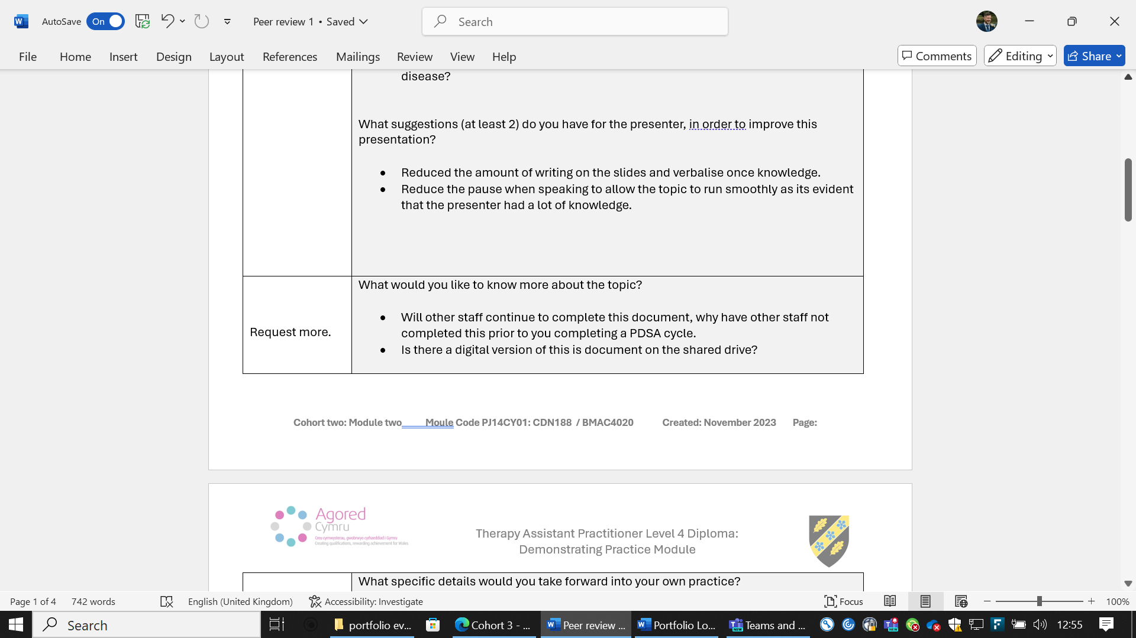
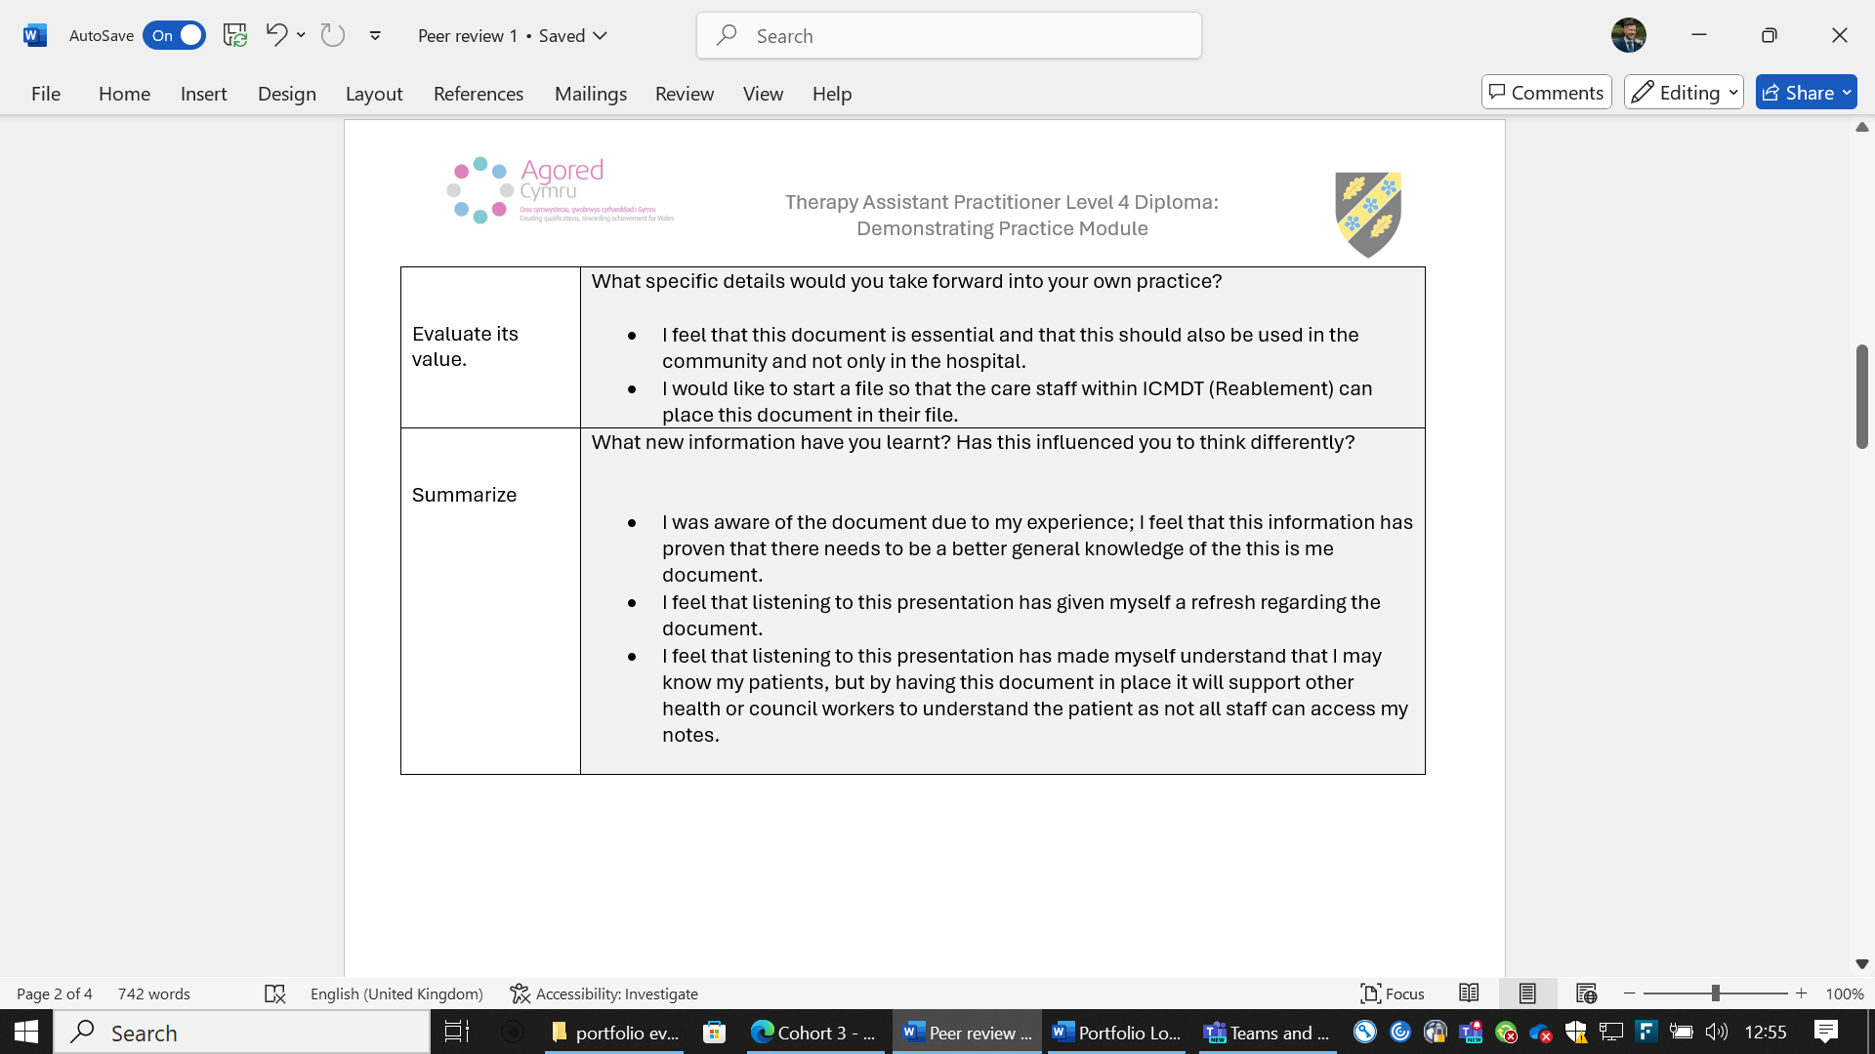
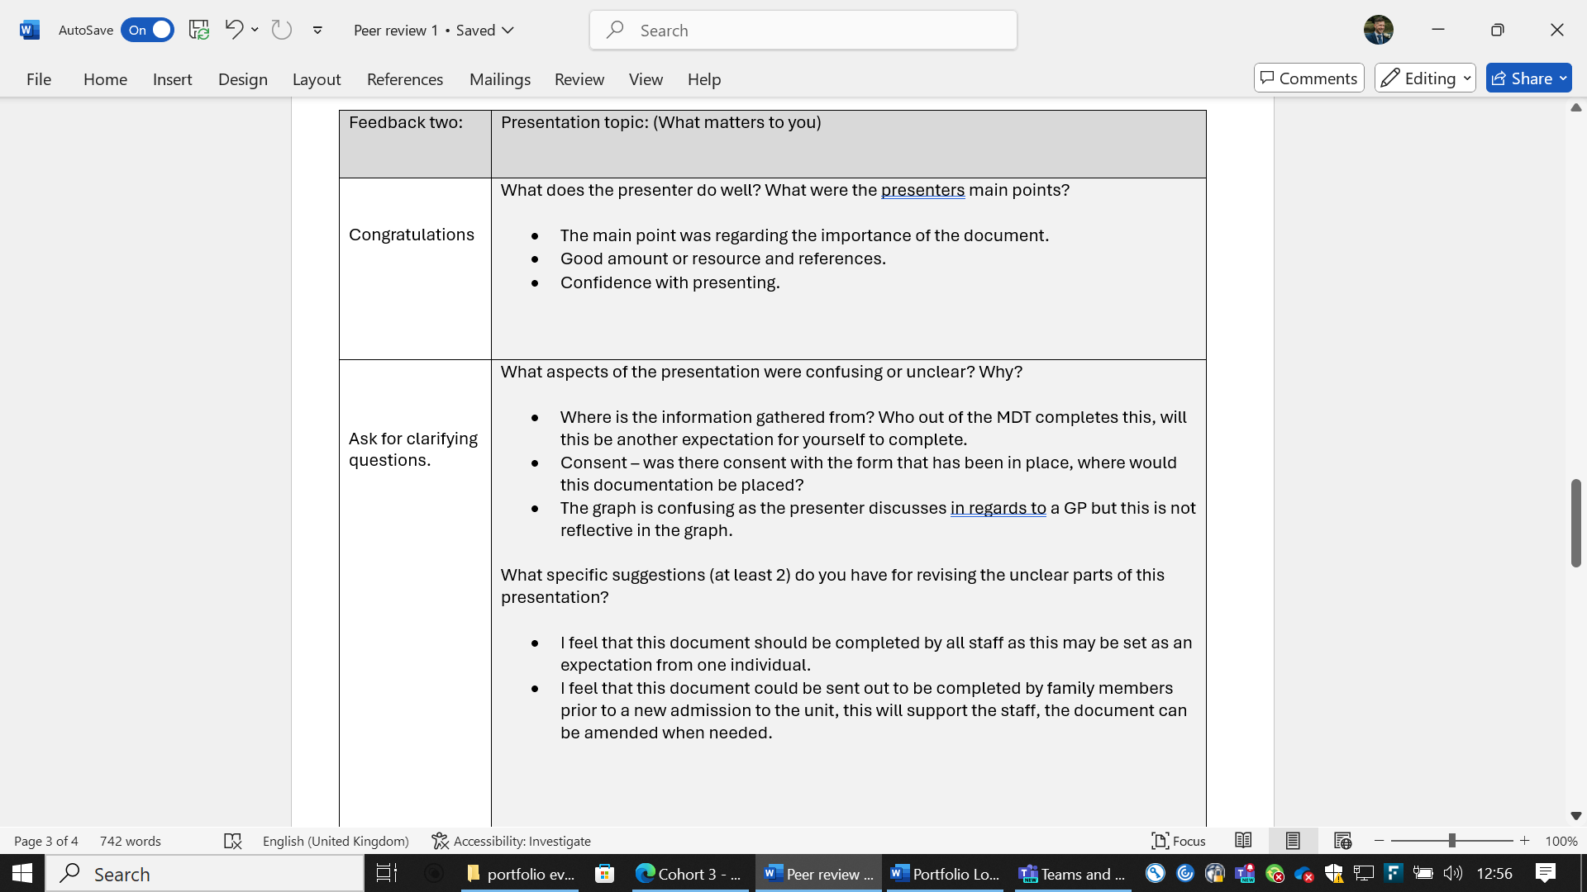

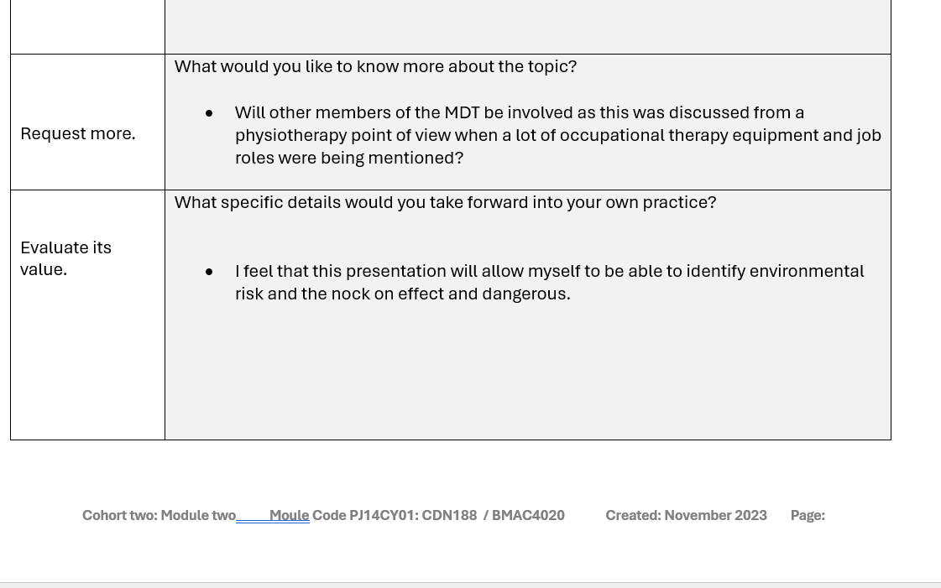

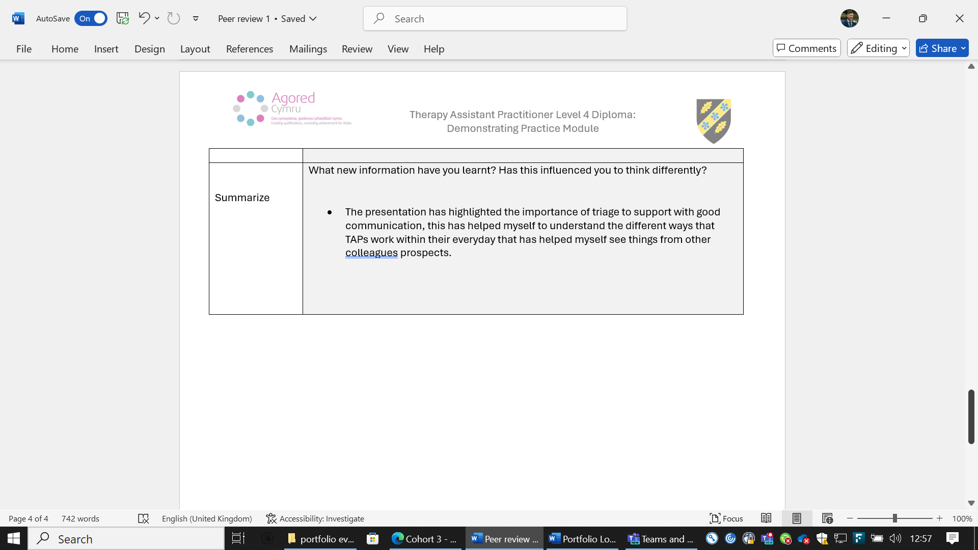

Appendix 1


