BMIH6007
International Meetings Management for the Hotel Industry

Planning and Delivering an International Meeting/Event

Name: Dobra Luciana
Student number:2019290@STUDENT.UWTSD.AC.UK
Lecturers name: Kathryn Finn

Executive Summary
The HospitalityTech Expo 2024 in London is predicted to revolutionise UK hospitality. By emphasising "Technology and Innovation," the conference intends to transform guest service, enhance productivity, and grow the hospitality industry. The event's major goals of stimulating business innovation and cooperation are examined in this report. Conceptualization, planning, promotion, execution, and assessment were carefully followed to ensure the event's success. The event's purpose is to showcase cutting-edge technology, share expertise, and foster networking. A complete itinerary shows the many lectures and activities organised to fulfil guests' interests and needs. The research also analyses industry trends, operational issues, and budgets using class theories and models. Overall, the HospitalityTech Expo 2024 is a great chance to shape UK hospitality tech.

Table of Contents
Executive Summary 2
Introduction 4
The Event Cycle 4
Event Concept 5
Aim and Objectives of the Meeting/Event 7
Event Operations 7
Event Budget 10
Incorporation of Theories and Models 11
Industry Trends/Issues/Impacts 12
Cultural and Situational Considerations 14
Conclusion 15
Reference 16

Introduction
HospitalityTech Expo 2024 will be the biggest event in the UK for hospitality technology. The event's theme, "Technology and Innovation," will transform hotel technology. In this age of computers and robots, the HospitalityTech Expo 2024 plans to change how guests feel, how efficiently firms run, and how the economy grows in the UK hospitality industry.
The HotelityTech Expo 2024 was selected since technological advancement encourages competitiveness and sustainability in the hotel industry. New technology help hospitality organisations satisfy consumer requirements and compete. Hospitality professionals collaborate and display cutting-edge technology at this event. This will help tech companies succeed. HospitalityTech Expo 2024's central London location is crucial. International talent, innovation, and cooperation thrive in London's dynamic climate. It serves as a centre for entrepreneurship and innovation worldwide. The rich past and varied people of the city make it an ideal location to study hospitality and technology and have fruitful conversations about them. For the UK hospitality sector, HotelTech Expo 2024 marks a turning point in the form of new technological advancements, expansion, and sustainability. The event connects leaders, technology suppliers, and industry professionals to influence hospitality. It make possible a digital revolution that will change how guests experience.

The Event Cycle
The event cycle is the set of actions taken in reaction to an occurrence. Event Cycle phases include planning, executing, and evaluating. Each phase is crucial to the event's success and efficacy.
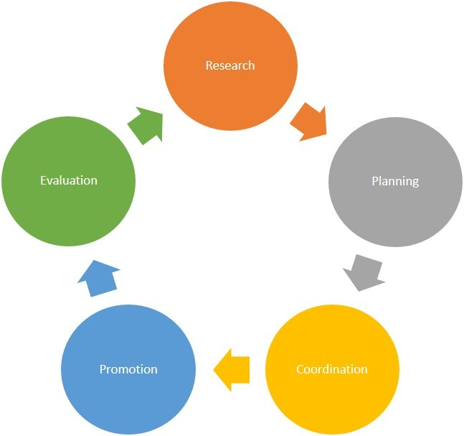
Source: https://www.meetingbox.com/
Application of the Event Cycle to the HospitalityTech Expo 2024:
Using this method makes sure that every part of the event is properly planned. we will choose Shone and Parry's (2004) Event Cycle model for HospitalityTech Expo 2024:
Conceptualization: This stage determine the event's objective. HospitalityTech Expo 2024 was created to exhibit advanced hospitality technologies and encourage innovation.
Planning: Planning involves creating thorough event strategies. Event logistics involve scheduling, budgeting, venue and supplier selection. HospitalityTech Expo 2024 venue, exhibitors, speakers, and advertising needed careful planning.
Promotion: Promotion is crucial for event awareness. This phase involves marketing across several platforms to attract the target demographic and boost attendance. HospitalityTech Expo 2024 attracted hospitality experts, technology providers, and industry participants using social media, email marketing, industry alliances, and targeted advertising.
Execution: All event aspects are controlled in real time and plans are executed. This function oversees event logistics, exhibitors, presenters, registration, and smooth operation. Organisers of HospitalityTech Expo 2024 worked hard to make participants happy.
Evaluation: Event Cycle evaluates event success against goals and KPIs. We will analyse event stats, obtain stakeholder, exhibitor, and audience feedback, and improve the event. HospitalityTech Expo 2024's extensive analysis appraised its value, suggested opportunities for future expansion, and quantified its influence on hospitality technology innovation (Frank et al., 2015).

Event Concept
The HospitalityTech Expo 2024 combines key players in the technology and hospitality sectors to network and engage concerning innovative concepts, developments, and opportunities that will influence their domains. Leveraging technology and innovation, the event seeks to enhance visitor service, operate more effectively, and expand sustainably.
HospitalityTech Expo 2024 combines technology and hospitality for an unforgettable experience. It aims to showcase hotel sector trends, ideas, and inventions. Innovation Showcase, a key feature of the event, presents cutting-edge innovations that improve operational efficiency, company growth, and visitor experiences. AI-powered chatbots and contactless payment systems are revolutionising hospitality at the Innovation Showcase. Hospitality technology professionals and thought leaders will explore how to keep up with rapid technological changes in the event's seminars, panel discussions, and keynote speeches. Guests may interact with innovators, investors, technology suppliers, and colleagues. Information sharing and collaboration will increase. Aspiring entrepreneurs can propose their ideas and get visibility at the event's. Education and inspiration inspire people to think and to transform hospitality (Ether, 2024).
Event Itinerary:
Time | Session | Description
9:00 AM - 12:00 PM | Registration and Welcome Reception | Attendees arrive and check-in for the event. Welcome reception provides an opportunity for networking and mingling with fellow attendees, exhibitors, and speakers.
 | Opening Keynote Address: "The Future of Hospitality Technology" | Keynote presentation by industry expert discussing emerging trends, challenges, and opportunities in hospitality technology.
 | Panel Discussion: "Trends and Opportunities in AI and Automation" | Panel of experts explore the latest advancements and applications of AI and automation in the hospitality industry.
 | Innovation Showcase: Product Demos and Exhibits | Attendees explore interactive exhibits and demonstrations featuring cutting-edge hospitality technologies, solutions, and innovations.
12:00 PM - 1:00 PM | Lunch Break | Networking lunch session allowing attendees to connect with industry peers, exhibitors, and speakers over lunch.
1:00 PM - 4:00 PM | Educational Workshops:
 | "Unlocking the Power of Data Analytics in Hospitality" | Workshop focusing on the role of data analytics in optimizing operations, enhancing guest experiences, and driving business growth in the hospitality sector.
 | "Enhancing Guest Experiences with IoT and Personalization" | Workshop exploring the potential of IoT (Internet of Things) and personalization technologies to create tailored and immersive guest experiences.
 | Pitch Competition: Startup Pitches and Judging | Aspiring entrepreneurs and startups pitch their innovative ideas and solutions to a panel of judges and potential investors.
 | Networking Reception: Cocktails and Networking | Attendees gather for a networking reception featuring cocktails and refreshments, providing opportunities for further discussions, connections, and collaborations.
4:00 PM - 5:00 PM | Awards Ceremony: Recognizing Innovation and Excellence | Recognition of outstanding achievements and innovations in the hospitality technology sector.
 | Closing Keynote: "Driving Innovation in the Digital Age" | Closing keynote address offering insights and inspiration for driving innovation and embracing digital transformation in the hospitality industry (Schultze, 2024).

Aim and Objectives of the Meeting/Event
Aim:
This event showcases and explores the latest hotel technology and innovation to promote information sharing, creativity, and strategic collaborations.
Objectives:
- Increase guests' understanding of new hotel technology and trends by 20% after the event with keynote speeches, panel discussions, and interactive exhibitions.
- The event's networking and collaboration opportunities between industry professionals, startups, investors, and technology vendors will lead to at least five new strategic collaborations.
- Give participants concrete insights and practical strategies for using new technology in hospitality operations to boost their confidence by 15%.

Event Operations
Event Management Team
Roles and Responsibilities
Delegates: Needs, Wants, and Experiences (Marketing Theory)
To succeed, HospitalityTech Expo 2024 must understand participants' needs, wants, and experiences. If the event meets expectations, delegates will return and tell others how much they enjoyed it.
Needs:
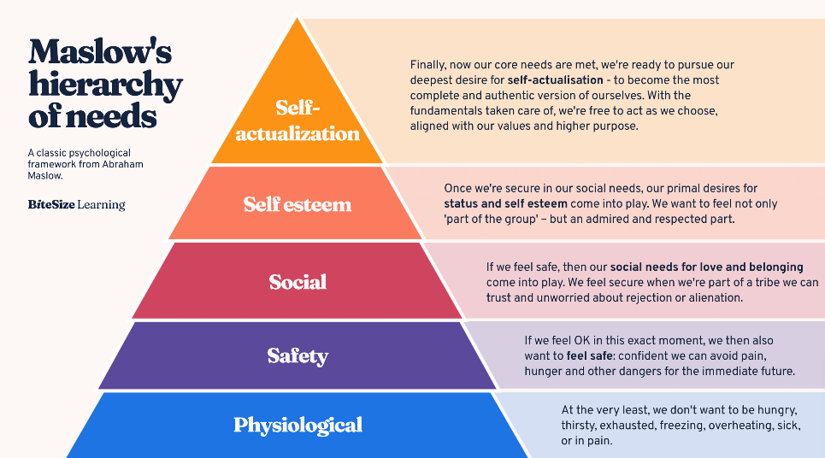
Source: https://www.bitesizelearning.co.uk/
Guests come to HospitalityTech Expo 2024 with goals both personal and professional. Within Maslow's Hierarchy of Needs, they are grouped into:
- Physiological Needs: Needs are for food, water, and shelter. These needs are satisfied by great catering and convenient access.
- Safety Needs: At the event, every delegates has to feel secure. This involves strict health and safety regulations, clearly defined emergency plans, and safe registration.
- Social Needs: Availability to networking functions is necessary. Priority one is to meet other guests, business leaders, and possible partners. Networking sessions and social events can satisfy these needs.
- Esteem Needs: It's important to show respect and appreciation. Guests' needs can be satisfied by panel discussions or speaking opportunities.
- Self-Actualization Needs: People there want to develop and learn. By offering pertinent, excellent information, workshops, seminars, and keynote speeches can satisfy this need.
Wants:
- Customization: Participants expect experiences that are specific to them. Customising their agendas allows attendees to choose courses and seminars that interest them.
- Innovation: Participants at the technology-focused expo want to see the newest innovations. Modern technical show and interactive displays fulfil this need.
- Convenience: Visitors want easy venue navigation and registration. Boost convenience by developing an intuitive mobile app with dynamic maps, real-time updates, and customised timetables.
Experiences:
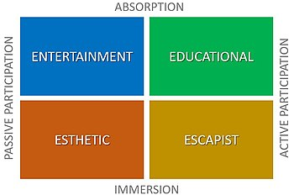
Source: en.wikipedia.org
An impression is important for success at HospitalityTech Expo 2024. Pine and Gilmore's Experience Economy says experiences matter.
- Immersive Experiences: VR and AR can give attendees engaging and educational experiences. Interactive lectures and hands-on tech demos improve event immersion.
- Engagement: Interactive activities are more fascinating than watching them. Gamification, live polling, and Q&A sessions can engage delegates.
- Feedback: Importantly, act on delegated work feedback. Delegate satisfaction and improvement areas can be better understood using post-event questionnaires and real-time feedback.
Marketing Theory Application:
Applying marketing theories such as the 4Ps (Product, Price, Place, Promotion) can help tailor the event to meet delegate needs and wants:
- Product: The event itself, including the sessions, workshops, and networking opportunities, should be designed to meet the specific needs and wants of the delegates.
- Price: If group pricing and early bird discounts are offered, more individuals can afford the event.
- Place: The event location should be central, accessible, and have all the necessary amenities.
- Promotion: Well-planned and executed marketing can attract the right people and make them excited for the event.

Event Budget
Expense Category | Cost (GBP) | Explanation
Venue Rental | £50,000 | The overall cost to hire the event facility, including all rooms and display area
Staffing | £20,000 | Cost of hiring event management, technical support, logistics, marketing, security, and other staff
Technology Equipment | £30,000 | Event technology demos, AV equipment rental, and IT infrastructure purchase
Marketing | £15,000 | Paid advertising, social media promotions, email blasts, and content generation
Catering | £10,000 | Cost of providing food and beverages for exhibitors, attendees, and event staff
Logistics | £8,000 | Logistics around transportation, signage, registration, and attendee management
Insurance | £5,000 | Event insurance premiums, including property, liability, and cancellation.
Miscellaneous | £7,000 | Contingency fund for unexpected expenses, emergency services, and incidentals

Total Expenses | £145,000
Revenue Source | Amount (GBP)
Registration Fees | £100,000
Sponsorships | £50,000
Exhibitor Fees | £40,000
Advertising Sales | £10,000
Partnerships | £15,000

Total Revenue | £215,000
Funding Sources
Sponsorships | £50,000
Grants | Find grants from numerous sources
Ticket Sales | £100,000
Partnerships | £15,000

Every anticipated cost and revenue item is listed in the HospitalityTech Expo 2024 budget. The budget covers staffing, technology, advertising, food, transportation, insurance, and a contingency fund in addition to venue rental. Venue logistics, technical assistance, marketing, participant housing, and event insurance are all necessary for event success.
Event revenue will come from registration, advertising, sponsorships, exhibitor fees, and collaborations. These revenue streams are essential for event funding. Event attendees pay registration and exhibitor fees, while corporate sponsorships, industry stakeholders, and technology vendors help fund the event.
Along with direct financing, the event may consider grants and cooperative projects. Government, nonprofit, and trade organisation funding can supplement the event budget or specific elements of it.

Incorporation of Theories and Models
According to GETZ (2007), event design is essential for memorable experiences. HospitalityTech Expo 2024 meticulously plans and executes every detail to give attendees an amazing experience. Every detail, from exhibit hall layout to interactive exhibits to keynote speeches, is meticulously studied to make attendees remember the event. HospitalityTech Expo 2024 is focused on uniqueness and innovation in event planning to engage and motivate attendees while creating an engaging environment for learning, networking, and collaboration.
BOWDIN et al. (2011) discuss the importance of well-planned events. The HospitalityTech Expo 2024 follows these criteria and uses a comprehensive preparation procedure. The event's smooth execution depends on strategic planning, which specifies goals, timeframes, resources, and hazards. HospitalityTech Expo 2024 may anticipate issues, capitalise on opportunities, and create an unforgettable event by being proactive.
EMBOK Model
The Event Management Body of Knowledge (EMBOK) model will be applied to ensure thorough planning and execution of HospitalityTech Expo 2024. It covers five areas:
- Administration: Budgeting, risk management, and stakeholder management
- Design: Event concept, theme, and content creation
- Marketing: Promotion, communication, and sponsorship
- Operations: Logistics, venue management, and technical support
- Risk: Health and safety, security, and contingency planning

Industry Trends/Issues/Impacts
PESTEL Analysis:
Political: Political regulations, laws, and stability affect the events industry. Government regulations may influence event organisation, safety, and licencing. Political instability in some locations could affect world events.
Economic: GDP growth, inflation, and currency exchange rates affect the events industry. Corporate events and leisure and entertainment spending can suffer in a recession. However, a strong economy may boost event investment, creating new growth opportunities.
Social:
Cultural choices, demographic shifts, and societal standards are social factors. The events people want to attend evolve with consumer behaviour and tastes. Health and wellness events may grow more popular as people become more health conscious.
Technological:
Technological advances have transformed the events industry, improving planning, execution, and attendee experience. AR/VR and mobile event apps have transformed event participation. Infrastructure and skills investments to incorporate these technologies may cause accessibility and data privacy difficulties (Parviainen et al., 2022).
Environmental:
The importance of sustainability and environmental preservation has increased, making environmental factors more important when planning events. Event organisers reduce waste, recycle, and use energy efficiently to reduce their environmental impact. Sustainable event planning enhances credibility and engagement among key audiences and helps firms achieve CSR goals (Jones, 2014).
Legal:
Legal issues including rules, statutes, and compliance affect all areas of event planning and implementation. Event planners must observe various rules, including health and safety, contract, permit, and intellectual property rights. Not obeying the guidelines might result in fines, legal issues, and reputation damage (Anand, 2015).
SWOT Analysis:
- Strengths: The event is successful due to a large network of partners and stakeholders and industry knowledge. Due to its innovative focus on technology and new ideas, it stands out from the competition and attracts a specialised clientele. Strong ties with hospitality and technology leaders improve the event's reputation and exposure. Strong promotion and marketing tactics include digital marketing, social media interaction, and targeted outreach to ensure widespread awareness and participation (Parviainen et al., 2022).
- Weaknesses: Lack of cash and resources affects venue selection, marketing, and operational issues. The event may attract top competitors with greater money and fame. Venues, transportation, and hotel may be unavailable, thus careful planning is needed. Overreliance on third-party vendors, sponsors, and suppliers raises concerns regarding dependability, quality control, and contractual duties.
- Opportunities: The event can capitalise on hospitality sector trends by meeting demand for technology-focused events. Virtual and hybrid event forms offer more opportunities than ever for participants to participate and enhance the event's effect. International expansion opens doors to strategic alliances, sponsorships, and partnerships with global businesses. The event's focus on technology and innovation may attract sponsors, exhibitors, and attendees seeking innovative solutions and networking possibilities (Anand, 2015).
- Threats: Due to market saturation and competition from other industry events, attendees may have limited time and resources to attend several events, limiting event performance. Economic issues including recessions, inflation, and currency changes can affect sponsorship budgets, attendance, and event revenue. Health and safety, event planning, licencing, and permit laws may cause legal liabilities and compliance issues. Pandemics, natural disasters, and political unrest can disrupt event operations and financial losses.

Cultural and Situational Considerations
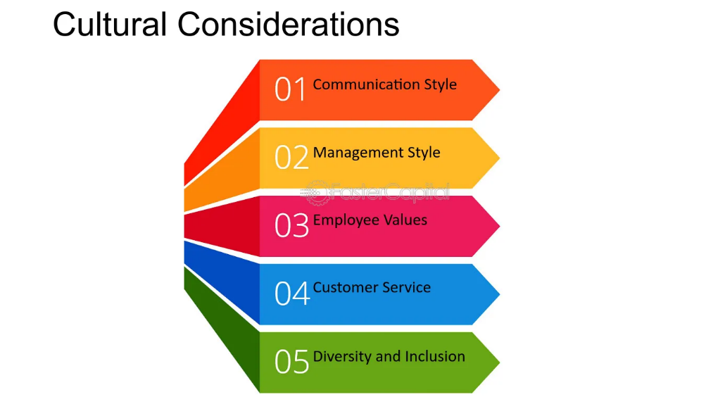
Source: https://fastercapital.com/
The intrinsic cultural variety of world events influences social mores, communication, and economic activity. Meeting planners must be mindful of cultural differences to be inclusive and thoughtful. Learning and respecting the host country's and participants' cultures makes an event welcome. Organisers that acknowledge and welcome a variety of cultural origins help to foster respect and appreciation among participants. International cooperation and communication are facilitated by this.
Barriers in language can make it hard for people who speak different languages to talk to each other. Regardless of language, multilingual assistance such as translation, interpretation, and bilingual signage facilitates participation by all. To increase accessibility and inclusiveness and show concern for the linguistic variation of the participants, use words and phrases that are appropriate for the culture. Overcoming language obstacles, organisers can make everyone feel at ease and enjoy oneself (indeed , 2024).
Religious festivals influence global gatherings' schedule, content, and food. Allowing prayer a while, fasting periods, and halal/kosher food restrictions shows respect for individuals' religious views and promotes inclusivity. Planners should consult local community members or religious leaders to ensure the event is suitable for all participants and meets their religious requirements. Allowing religious diversity can make everyone feel welcome.
Events worldwide have to emphasise gender diversity and inclusion. Gender balance and diversity can make events more inclusive and encouraging for audiences and presenters. Addressing gender bias, harassment, and discrimination requires safe spaces, diversity training for staff and volunteers, and inclusive policies. By promoting gender diversity and inclusivity, planners may stimulate creativity through collaboration and inclusivity.
Politics affect the viability and safety of international meetings and events in many countries. Risk management and contingency planning need evaluating the political environment and security of the host nation. To ensure participant safety, event planners must keep an eye on travel warnings, adhere to security regulations, and in an emergency, communicate with local authorities and security services. Organisations of events can guarantee joy by giving safety first priority (Brunt, 2017).

Conclusion
A successful international conference or event requires cultural, logistical, and operational knowledge, attention to detail, and strategic planning. Event planners can simplify the planning process and ensure everyone has fun by following event management guidelines and using theoretical models like the Event Cycle. Event planners can foster teamwork, creativity, and social good by following sustainability principles, embracing all attendees, and recognising cultural diversity. Bringing theoretical understanding and practical approaches to their design and implementation make international gatherings and events strong tools for good. Global growth, innovation, and meaningful engagement will result.

Reference
Anand, B. (2015) ‘Reverse globalization by internationalization of SME’s: Opportunities and challenges ahead’, Procedia - Social and Behavioral Sciences, 195, pp. 1003–1011. doi:10.1016/j.sbspro.2015.06.359.
Bladen, C. et al. (2022) Events management [Preprint]. doi:10.4324/9781003102878.
Brunt, P. (2017) Research methods in tourism, hospitality and events management, Google Books. Available at: https://books.google.com/books/about/Research_Methods_in_Tourism_Hospitality.html?id=6MA2DwAAQBAJ (Accessed: 06 May 2024).
Buhalis, D. et al. (2019) ‘Technological disruptions in services: Lessons from tourism and hospitality’, Journal of Service Management, 30(4), pp. 484–506. doi:10.1108/josm-12-2018-0398.
Dumas, M. et al. (2018) Fundamentals of Business Process Management [Preprint]. doi:10.1007/978-3-662-56509-4.
Dzhandzhugazova, E.A. et al. (2017) ‘Intellectual Resources used in developing tourism and Hospitality Industry’, Eurasian Journal of Analytical Chemistry, 12(5b), pp. 705–722. doi:10.12973/ejac.2017.00204a.
Ether, N. (2024) 20 creative corporate event ideas for 2023, Webex Events (formerly Socio). Available at: https://socio.events/blog/corporate-event-ideas (Accessed: 06 May 2024).
Frank, Dorothea et al. (2015) ‘Effects of climate extremes on the terrestrial carbon cycle: Concepts, processes and potential future impacts’, Global Change Biology, 21(8), pp. 2861–2880. doi:10.1111/gcb.12916.
indeed (2024) 4 examples of cultural differences for managers, indeed . Available at: https://www.indeed.com/hire/c/info/cultural-differences (Accessed: 06 May 2024).
Jones, M. (2014) Sustainable event management [Preprint]. doi:10.4324/9780203768723.
Kansakar, P., Munir, A. and Shabani, N. (2019) ‘Technology in the hospitality industry: Prospects and challenges’, IEEE Consumer Electronics Magazine, 8(3), pp. 60–65. doi:10.1109/mce.2019.2892245.
Kazandzhieva, V. and Filipova, H. (2019) ‘Customer attitudes toward robots in travel, tourism, and Hospitality: A conceptual framework’, Robots, Artificial Intelligence, and Service Automation in Travel, Tourism and Hospitality, pp. 79–92. doi:10.1108/978-1-78756-687-320191004.
Nexus, G. (2023) Building an effective event team: Roles and Responsibilities, LinkedIn. Available at: https://www.linkedin.com/pulse/building-effective-event-team-roles-responsibilities-global-nexus/ (Accessed: 06 May 2024).
Nikopoulou, M. et al. (2023) ‘Determinants of digital transformation in the hospitality industry: Technological, organizational, and environmental drivers’, Sustainability, 15(3), p. 2736. doi:10.3390/su15032736.
Parviainen, P. et al. (2022) ‘Tackling the digitalization challenge: How to benefit from digitalization in practice’, International Journal of Information Systems and Project Management, 5(1), pp. 63–77. doi:10.12821/ijispm050104.
Schultze, M. (2024) AI in business events: Where it is relevant and how organisations can get ai-ready, LinkedIn. Available at: https://www.linkedin.com/pulse/ai-business-events-where-relevant-how-organisations-can-schultze-radnc/ (Accessed: 06 May 2024).

