PROBLEM SOLVING AND DECISION MAKING

Bmsw 4004
Author Zerron Williams-Hankey
university of Wales trinity saint David’s
Ernest Ovia

Table of Contents
Introduction 3
Problem solving and decision making 3
What is Work-related stress? 3
Abstract 3
Alternative solutions 4
evaluation 5
success criteria 5
conclusion 5

Introduction

Problem solving and decision making
Humans must make multiple decisions daily from when they wake up to when you go back to sleep. He explains that the chooses a person makes can result in having sizeable consequences. Making important decisions can impact on our lives considerably, people need to improve their knowledge by learning new things like problem solving skills, applying critical thinking skills and analysing the problem, being aware of influencing factors related to the problem, showing the use of methods and theories like the SWOT and PESTEL analysis to recap and observe past behaviours to minimize negative outcomes. (Williams,2022)

What is Work-related stress?
Stress is a harmful reaction created from too much pressure in or out of the workplace. And its down to how much everyone can endure. Work related stress has risen rapidly over the years Since (2009-2012) to (2020-2021) the rate has risen enormously, (2009-2012) the rate of workers experiencing stress, depression and anxiety on the workplace has an estimated annual average of 1,400 per 100,000 people each year. (HSE)
we experienced a national emergency in 2020, where thousands of people had fallen ill due the hasty spread of the virus, known as coronavirus also known as COVID-19, statistics has been estimated to have 449,000 workers out of 822,000 workers to had reported that their symptoms have worsened due to the COVID-19 pandemic but the main issues still remains that is, work related stress generally comes from too much pressure, excessive workloads, intense working environments (HSE) .

Abstract

How wide is the problem?
Within a workplace stress can impact of staff members but also customers to like in a care setting like residential or hospital environments have several types of problems that are factors to work related stress, some will be based on the area of expertise as in a care home the stress is mainly psychological physical and social. The effects of this for staff would be overwhelming to deal with, causing more turnovers and adversely affects patient’s care.

Is the problem long or short-term?
The short effect of stress is necessary for a person to have have some pressure in their life in order to improve a person’s performance quality, it’s healthy and essential that a person experiences challenges in their life in order to progress and learn how to handle stress better but when the pressure becomes to excessive, deadlines and commitments can sometimes be overwhelming this causes the environment and atmosphere to become intense, statistically people work better when they have a flexible work pattern looking at a survey from 2018 more than 70% of employees preferred a job that offers a flexible schedule over jobs that did not

Who is affected by the problem? How are they affected (Financial; operational; social)
Both companies and employees are affected by different types of stress whether that be occupational personal, with family relationships, health concerns or financial stress, as many people whom have financial well-being they don’t experience as much financial stress as those whom are on lower income (1949).
As one study forum that people who have a higher education and not only secondary qualifications had a better chance and being more educated than those from a secondary school (Golubic et al.) this can cause a person to have more self-doubt and insecurities that will results in uncontrollable pressures due to lack of experience in job role, this is a concern as Piaget’s cognitive therapy theory suggests that a person’s understanding comes from process built up of neurological ions in the brain, that send signals to the nervous system to tell the body how to react to the changes happening within the body, all based on experiences from things a person will see in their life time, the traumas, and something called trial and error this method is used in cases where a person try’s something and fails but has the right motivation and determination to provide like when as work, people are faced with numerous amount of challenges though the day/week, and even when they cannot find a solution themselves, their support system like collages and other peers should be able to help the overcome the obstacle.

using the SWOT and PESTLE analysis

using the pestle analysis to understand the variety of contributing factors that come from all different areas in life, that can lead to financial difficulty, instability and unforeseen problems that arise that throughout time which are indicators of work-related stress, Johnson, S. paper explains how from 26 different occupational sectors the levels of stress are sometimes greater or lesser than another, they reported that six sectors are recording having worser than normal scores when it come to the psychological wellbeing and job satisfaction aspects

Alternative solutions
Companies trying to tackle the need for better psychological and cognitive support withing a workplace. The key objects would be to scope the problem and find the sequence of recurring events to start to set demands for a normal functioning system with better evaluative processes. When employers are advertising a job, they are requiring thinking positively and not allow anyone who is applying to feel discriminated this also applies within the workplace. It’s the employers and part employee’s responsibility to create a good friendly professional environment. Many of the stress related problems at work deprive from lack of resources and the importance of an individuals failing to cope with their workload, to help individuals have a better coping mechanism suggest that is crucial to increase personal resources of high importance for the ability to enhance self-efficiency, (Mackay et. all, 2004)

evaluation
looking at the alternative solution, trying to identify if this method is sustainable when it comes to tackling down the rate of stress in the workplace, as both indirect and direct adverse events happen in different social or technological systems but a humans is to blame at the end of the process, stressed by Reasons’s theory in order to have a worldwide understanding on the best ways to prevent interrelations among organizations , since health care services are mainly to provide an professional medical service but for this to happen staff need to be supported correctly. Reasons,1995)
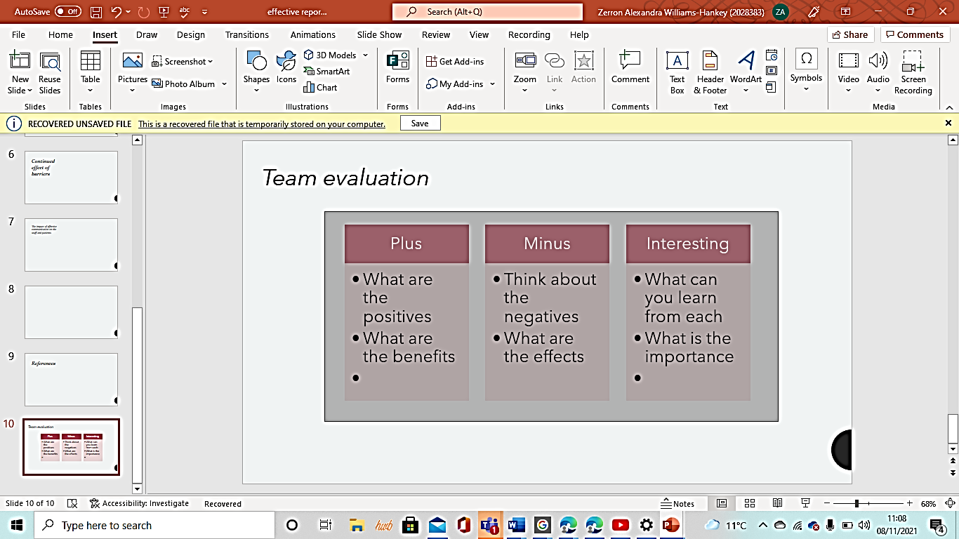
Using a method called PMI (plus, minus, interesting) this identifies the major problems that arise in the workplace and categorises them into groups so that the leaders of the organisation can single out the correlating major factors that are the reason for work related stress. The first would be creating a structured grid.
This system is used for brainstorming, decision making and critical thinking tool which can be helpful later when analysing complex problems making a more informed decision. The positives will outline the benefits, the minus with outline the negatives and the interesting will be extra information contributing to each point calculating to see which is more beneficial when coming to a decision.

success criteria
looking at the NHS’s advice and information the urgent need for better intervention and research methos to help the organizations across the health care sector to stop occupational and professional stress at this all comes from incapacity benefits and major concerns around the practicality to provide staff with better support systems such as psychological services, as one survey revealed they consider their main related problems tends to be musculoskeletal disorders depression or anxiety Griffiths. A (1998)

conclusion
overall the health care sector needs better practice methods In place in order to reduce the amount of people becoming stressed at work, trying to cope with excessive workloads massive amounts of pressure from organisations due to new regulated systems implemented by the government to help workplaces run smoother and that employees and employers feel better at ease when coming to work to reduce the turn over percentage to a good rate and also following (MacKay’s) findings things need to change to stop people taking sick absence, work related illnesses.

References
Williams, SW 2001, Making Better Business Decisions : Understanding and Improving Critical Thinking and Problem Solving Skills, SAGE Publications, Thousand Oaks. Available from: ProQuest Ebook Central. [7 March 2022].
Hse.gov.uk. 2021. Work-related stress, anxiety or depression statistics in Great Britain, 2021. [online] Available at: <https://www.hse.gov.uk/statistics/causdis/stress.pdf> [Accessed 7 March 2022].
(2019, March 27). New Research Shows That Flexible Working is Now a Top Consideration in the War for Talent. PRNewswire. https://www.prnewswire.com/news-releases/new-research-shows-that-flexible-working-is-now-a-top-consideration-in-the-war-for-talent-300818790.html

https://www.prnewswire.com/news-releases/new-research-shows-that-flexible-working-is-now-a-top-consideration-in-the-war-for-talent-300818790.html
Johnson, S., Cooper, C., Cartwright, S., Donald, I., Taylor, P. and Millet, C. (2005), "The experience of work‐related stress across occupations", Journal of Managerial Psychology, Vol. 20 No. 2, pp. 178-187.
Cousins *, R., MacKay, C., Clarke, S., Kelly, C., Kelly, P. and McCaig, R., 2004. ‘Management Standards’ work-related stress in the UK: practical development. Work & Stress, [online] 18(2), pp.113-136. Available at: <https://doi.org/10.1080/02678370410001727474>.
Golubic, R., Milosevic, M., Knezevic, B. and Mustajbegovic, J. (2009), Work-related stress, education and work ability among hospital nurses. Journal of Advanced Nursing, 65: 2056-2066. https://doi.org/10.1111/j.1365-2648.2009.05057.x
Reason Understanding adverse events: human factors.BMJ Quality & Safety 1995;4:80-89. http://dx.doi.org/10.1136/qshc.4.2.80
Amanda Griffiths (1998) Work-related illness in Great Britain, Work & Stress, 12:1, 1-5, DOI: 10.1080/02678379808256844

