Design and implementation of a Lego Mindstorms Solution to a series of problems

Computational Thinking

University of Wales Trinity Saint David

Jaromir Pauer (1801641)

23/01/2020

Contents
1. Main Use Case Diagram 4
2. Use Case documents for rectangle 5
2.1 Drawing a rectangle 5
2.2 Turns - rectangle 6
2.3 Check height/length and drawn and travelled - rectangle 8
2.4 Increasing sizes - rectangle 8
3 Use case documents for right-angle triangle 9
3.1 Drawing a right-angle triangle 10
3.2 Turns – right-angle triangle 11
3.3 Check hypotenuse/length/height – right-angle triangle 12
3.4 Increasing sizes – right-angle triangle 13
4 Use case documents for circle within a square 14
4.1 Drawing a circle within a square 14
4.2 Turns – circle within a square 15
4.3 Check length/height/circumference – Circle within a square 16
4.4 Increasing sizes – circle within a square 17
5 Use case documents for equilateral triangle (join symbol) 18
5.1 Drawing an equilateral triangle 18
5.2 Turns – equilateral triangle (join symbol) 19
5.3 Check length/height – equilateral triangle (join symbol) 20
5.4 Increasing sizes – equilateral triangle (join symbol) 21
6 Use case documents for detecting obstacles and the steps to deal with it 22
6.3 Using colour sensor detect obstacles along the way 22
6.4 Type of obstacle 23
6.5 Coloured electrical tape 24
6.6 Irremovable object 25
6.7 Steps to do for coloured electrical tape 26
6.8 Steps to do for irremovable object 27
7. BPMN Diagrams 28
7.1 BPMN Diagram for rectangle 28
7.2 BPMN Diagram for right-angle triangle 29
7.3 BPMN Diagram for circle within a square 30
7.4 BPMN Diagram for equilateral triangle 32
8. EV3 Screenshots of the code for my shape 35

Main Use Case Diagram

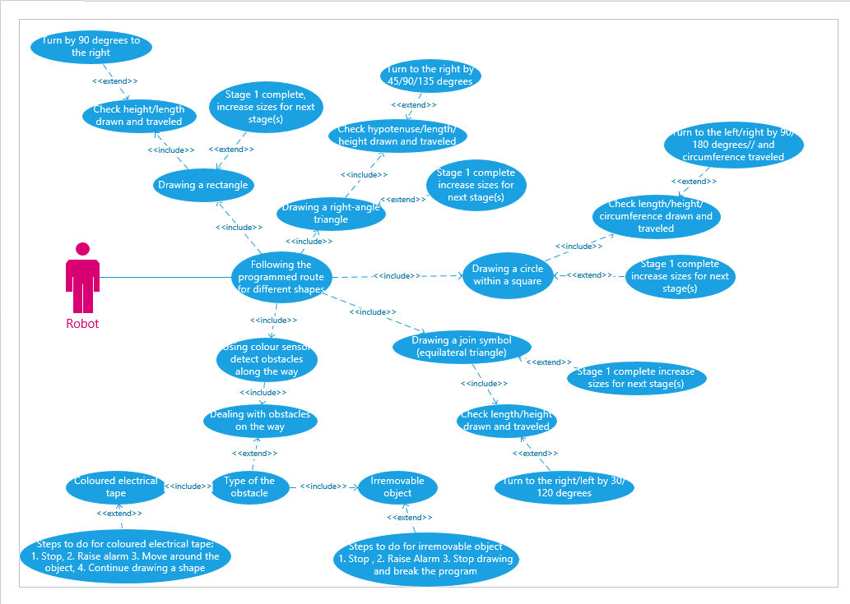

Use Case documents for rectangle

Drawing a rectangle

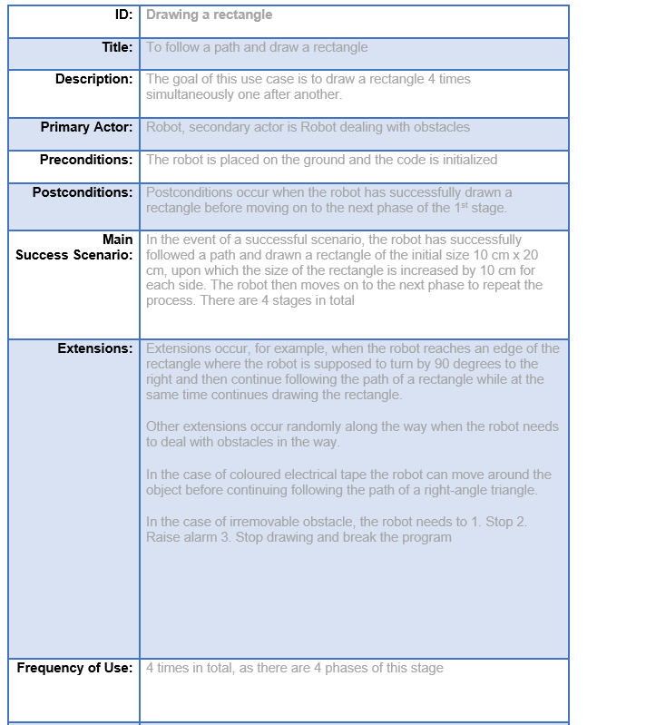

2.2 Turns - rectangle

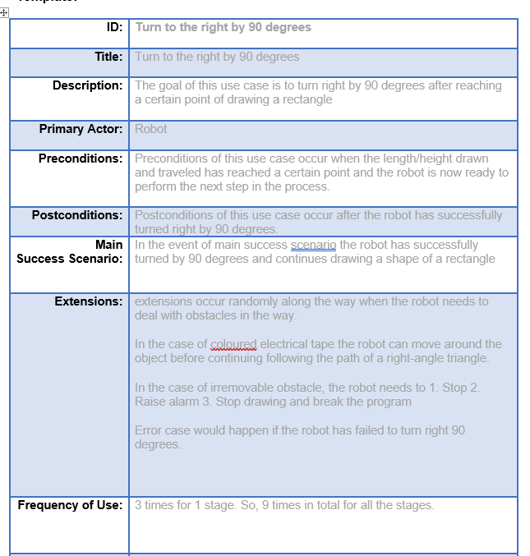

Check height/length and drawn and travelled – rectangle

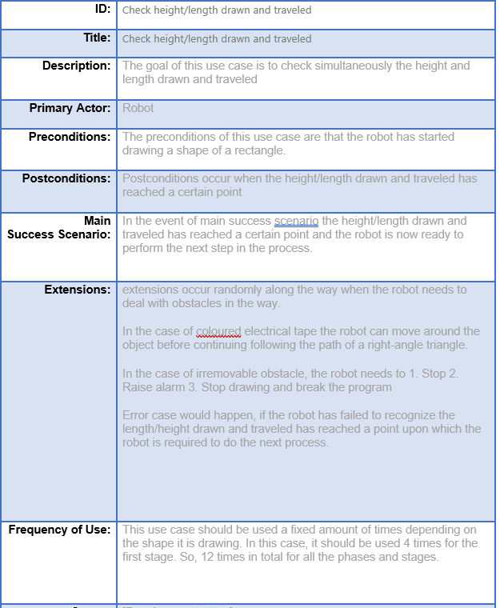

2.4 Increasing sizes - rectangle

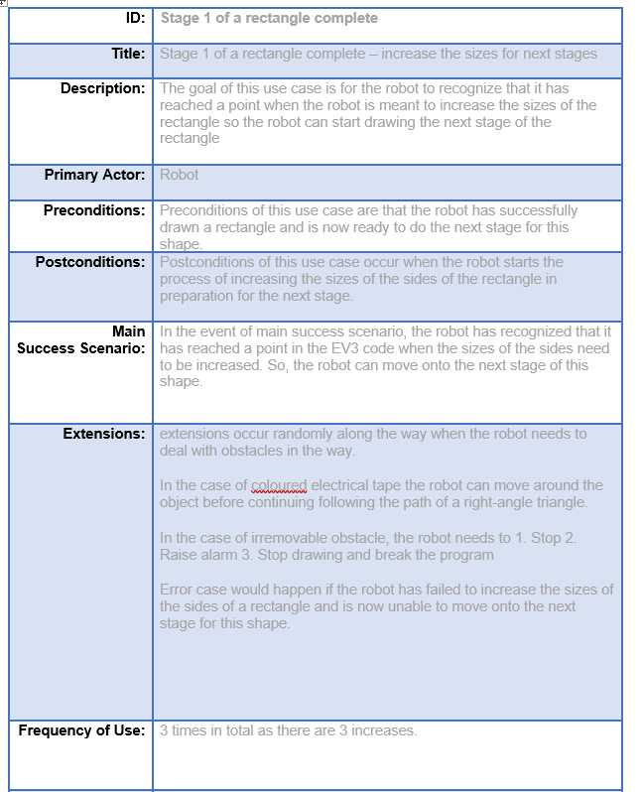

Use case documents for right-angle triangle

3.1 Drawing a right-angle triangle

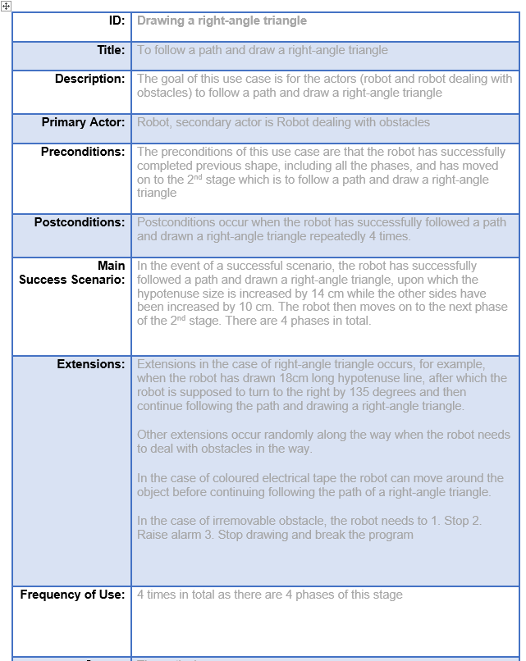

3.2 Turns – right-angle triangle
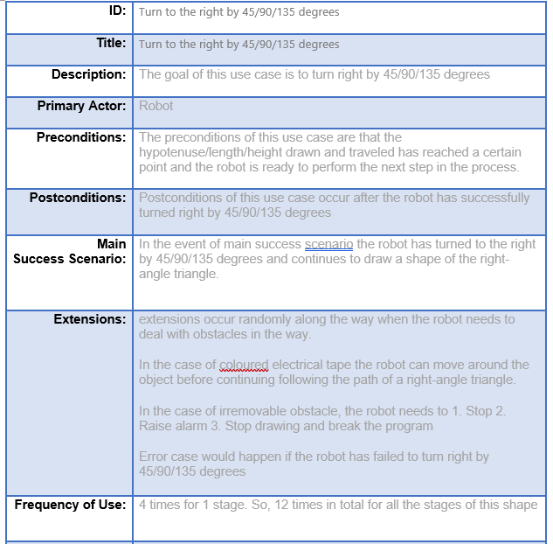

Check hypotenuse/length/height – right-angle triangle

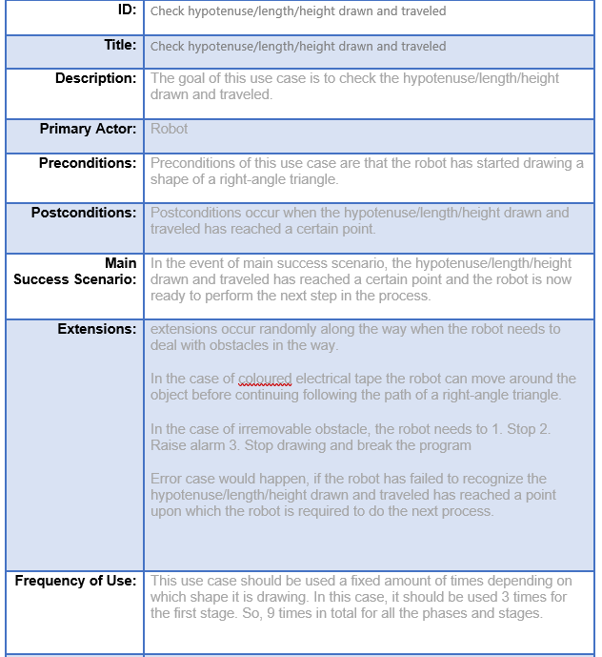

3.4 Increasing sizes – right-angle triangle
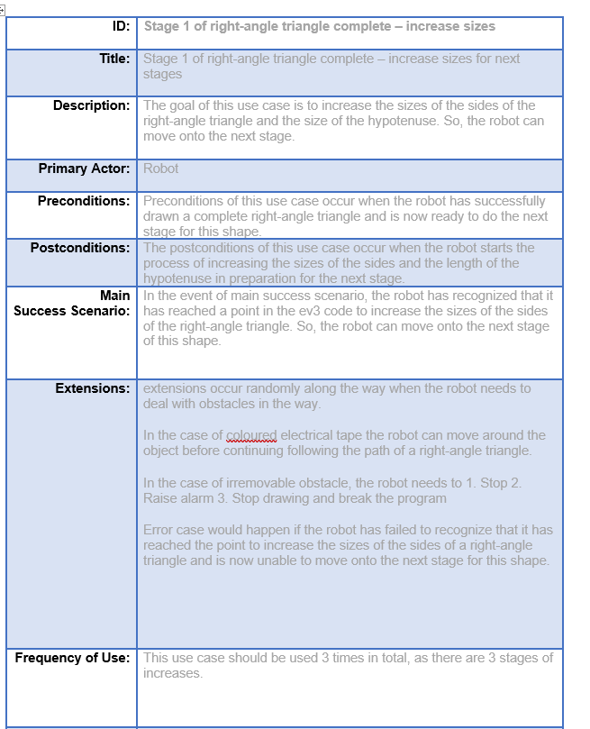

Use case documents for circle within a square

Drawing a circle within a square

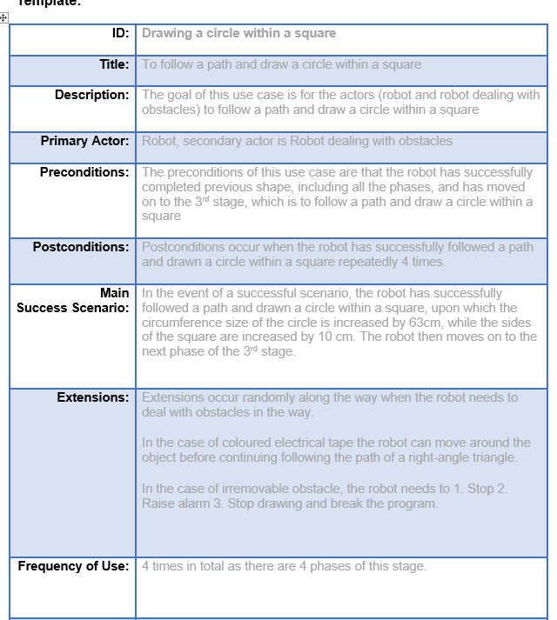

Turns – circle within a square

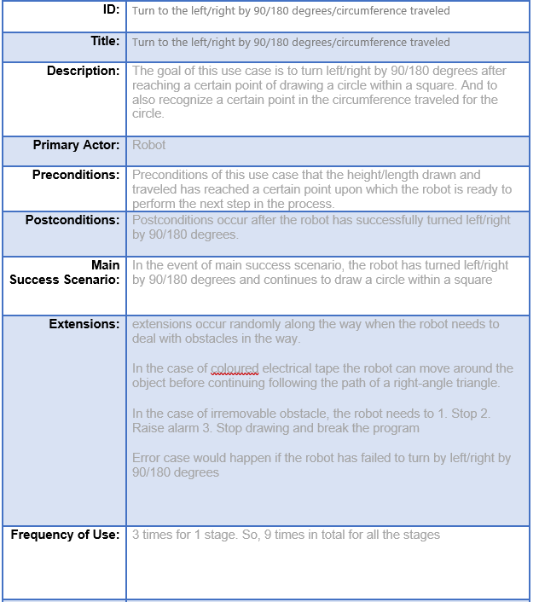

4.3 Check length/height/circumference – Circle within a square

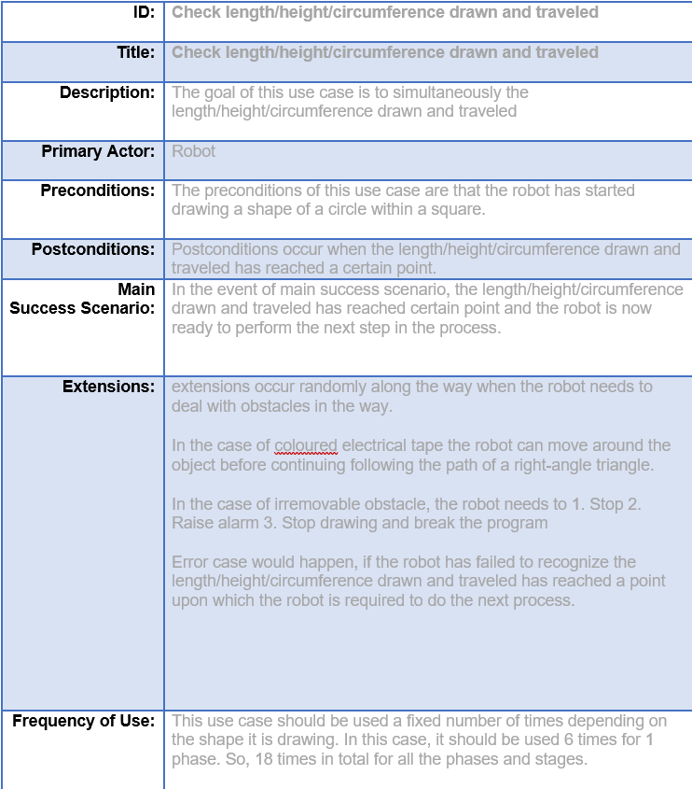

4.4 Increasing sizes – circle within a square

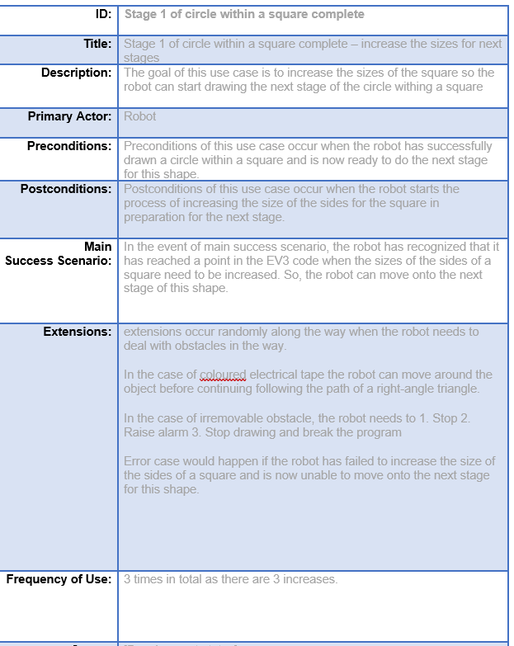

Use case documents for equilateral triangle (join symbol)

Drawing an equilateral triangle

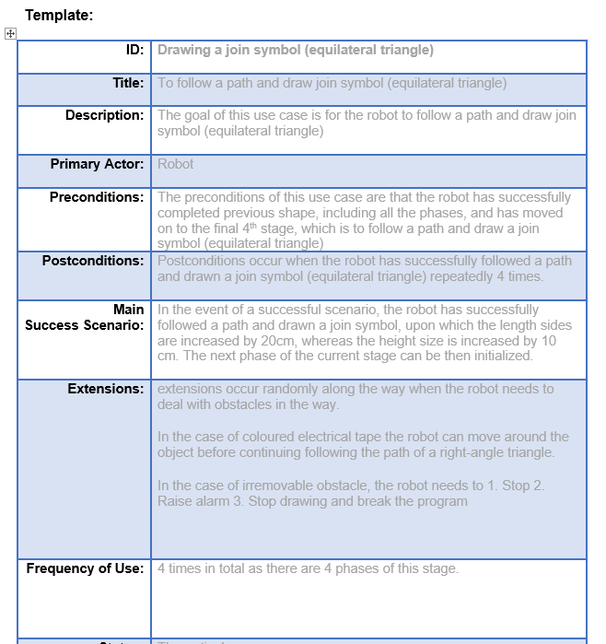

Turns – equilateral triangle (join symbol)

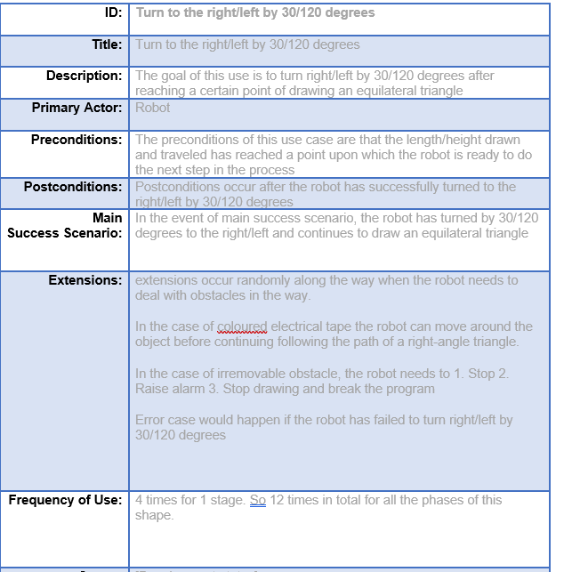

Check length/height – equilateral triangle (join symbol)

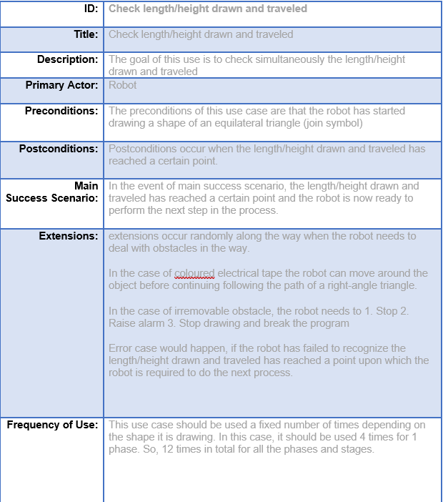

Increasing sizes – equilateral triangle (join symbol)
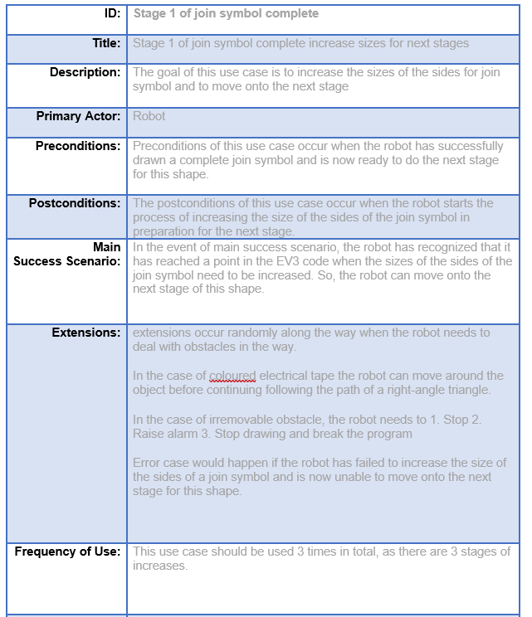

Use case documents for detecting obstacles and the steps to deal with it

Using colour sensor detect obstacles along the way

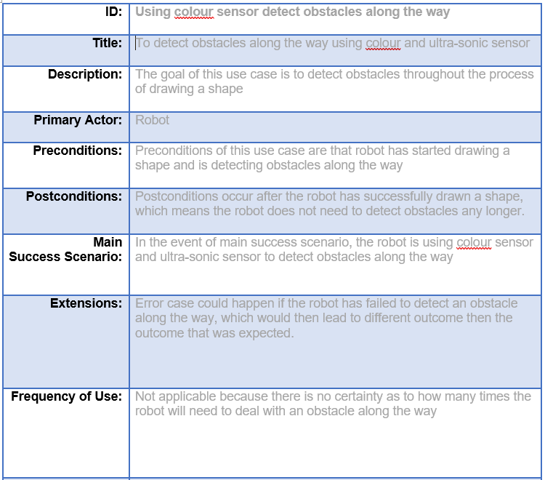

Type of obstacle
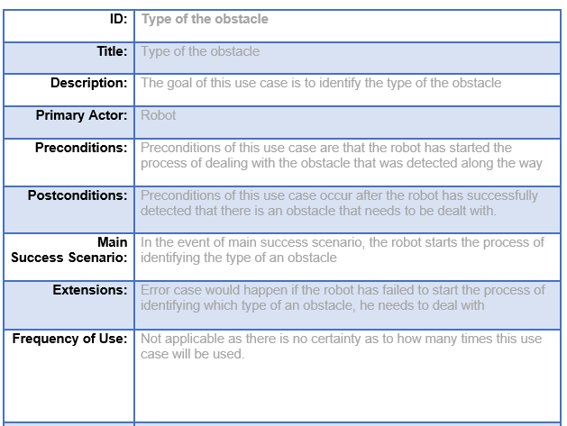

Coloured electrical tape
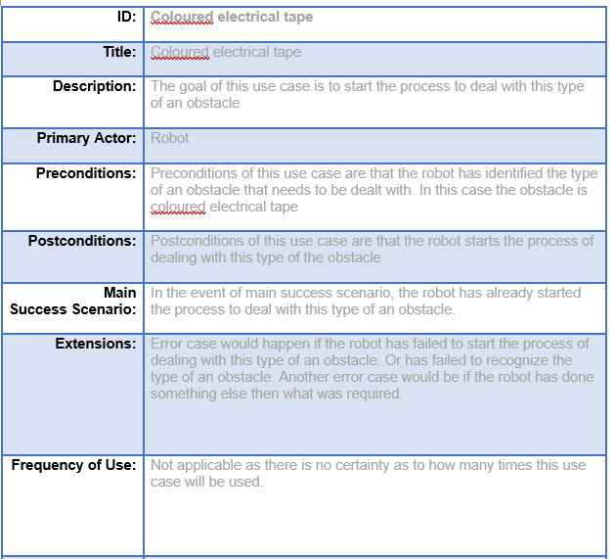

Irremovable object
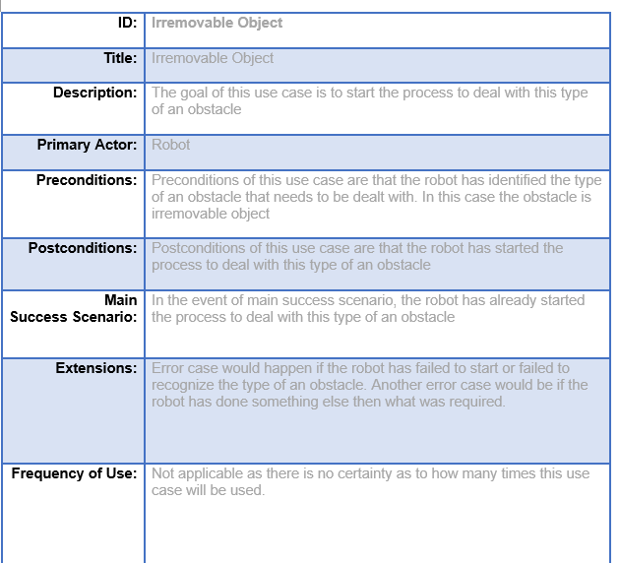

Steps to do for coloured electrical tape

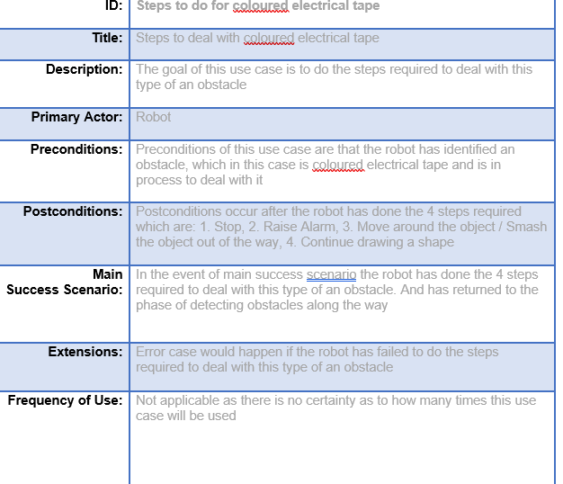

Steps to do for irremovable object

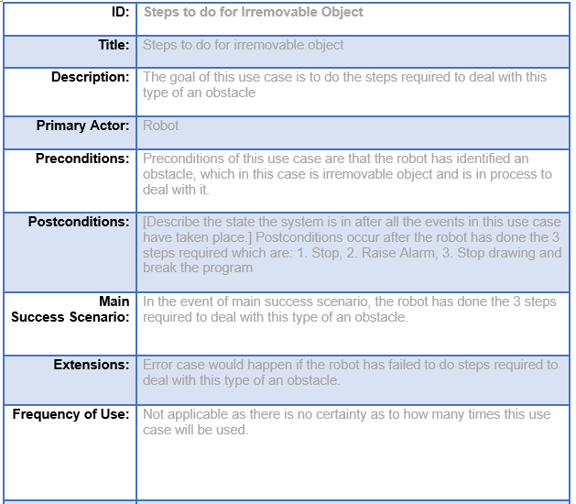

7. BPMN Diagrams

7.1 BPMN Diagram for rectangle

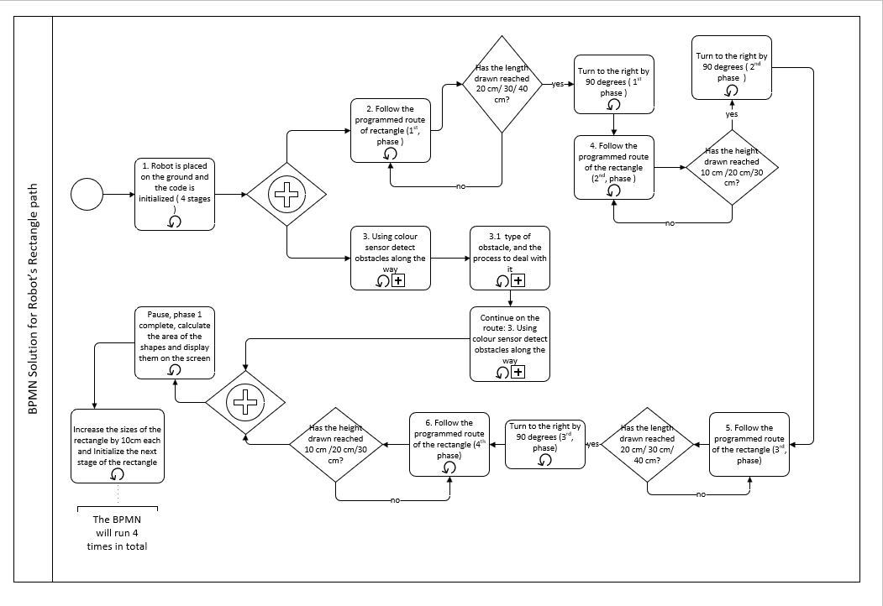

7.2 BPMN Diagram for right-angle triangle

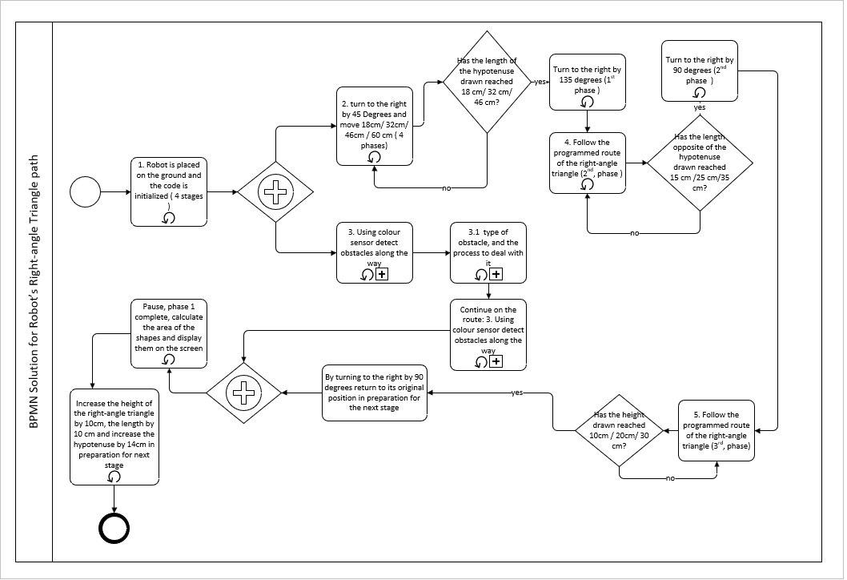

7.3 BPMN Diagram for circle within a square

Part 1
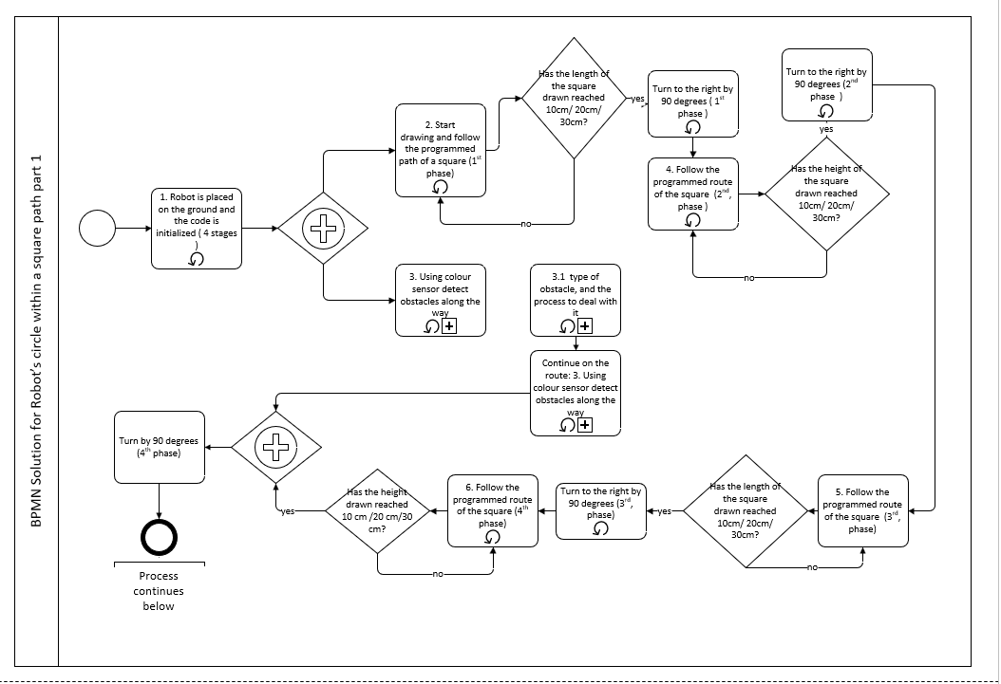

Part 2
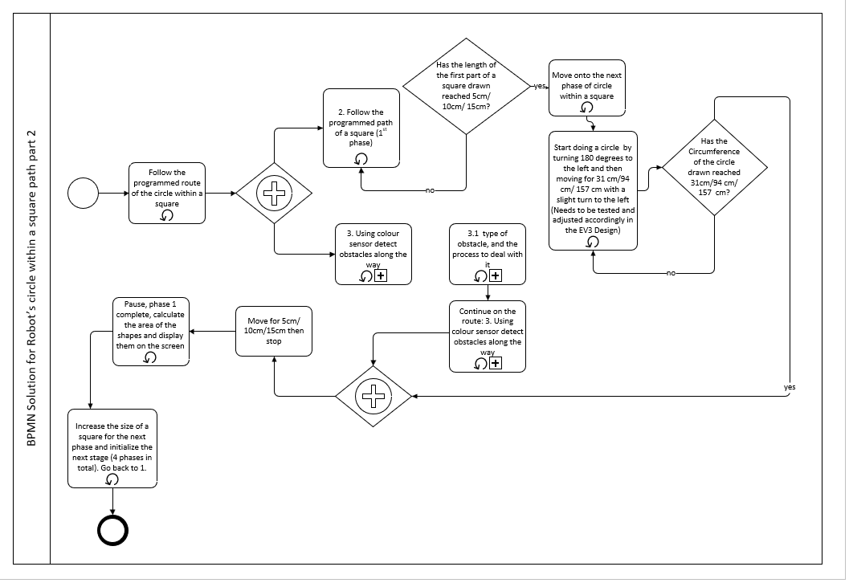

7.4 BPMN Diagram for equilateral triangle

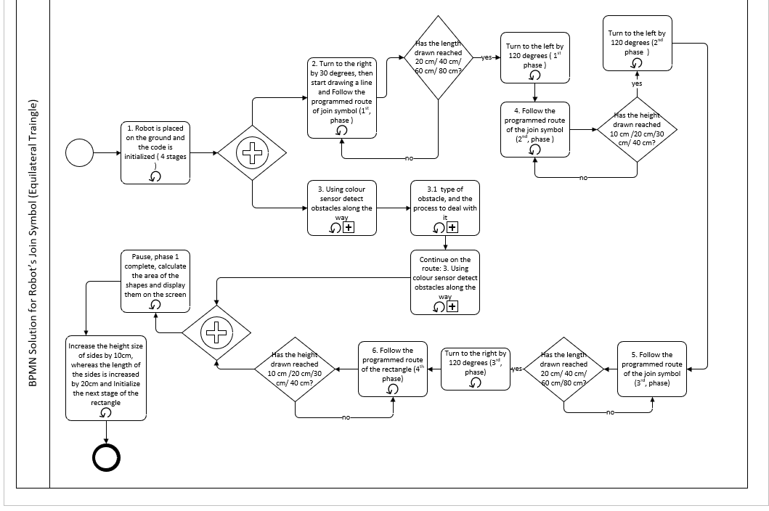

7.5 BPMN Sub Processes diagrams

Sub process 1
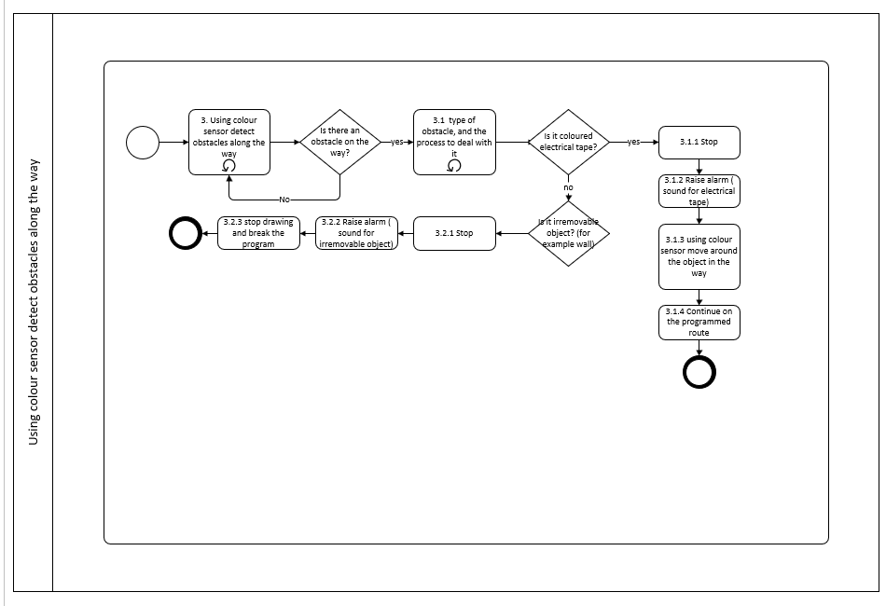

Sub process 2
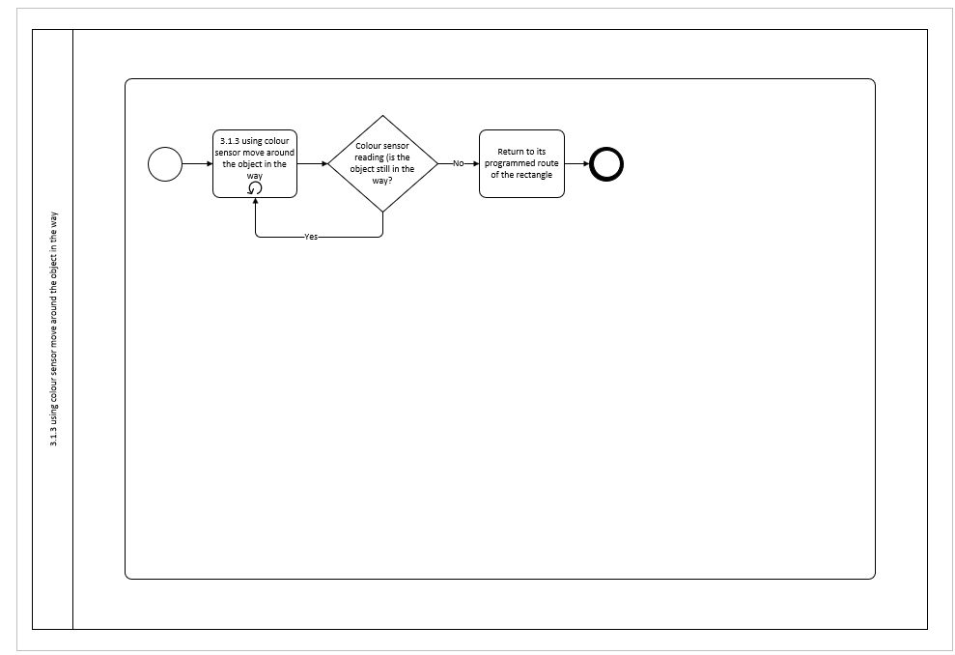

8. EV3 Screenshots of the code

8.1 Design of the robot

Design of the robot [1]:
Picture 1
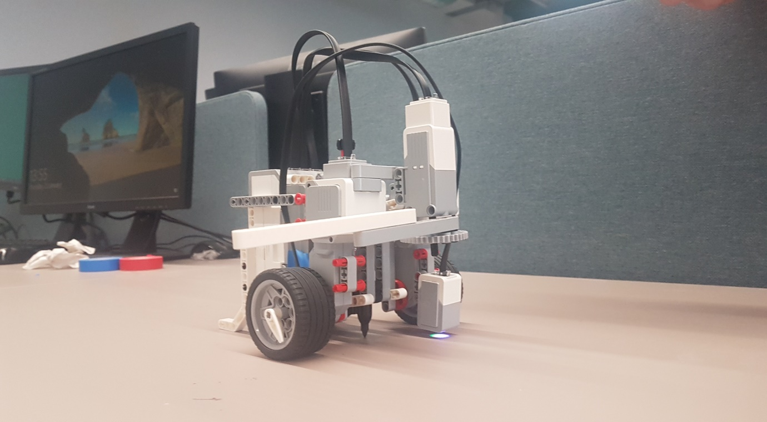

Picture 2
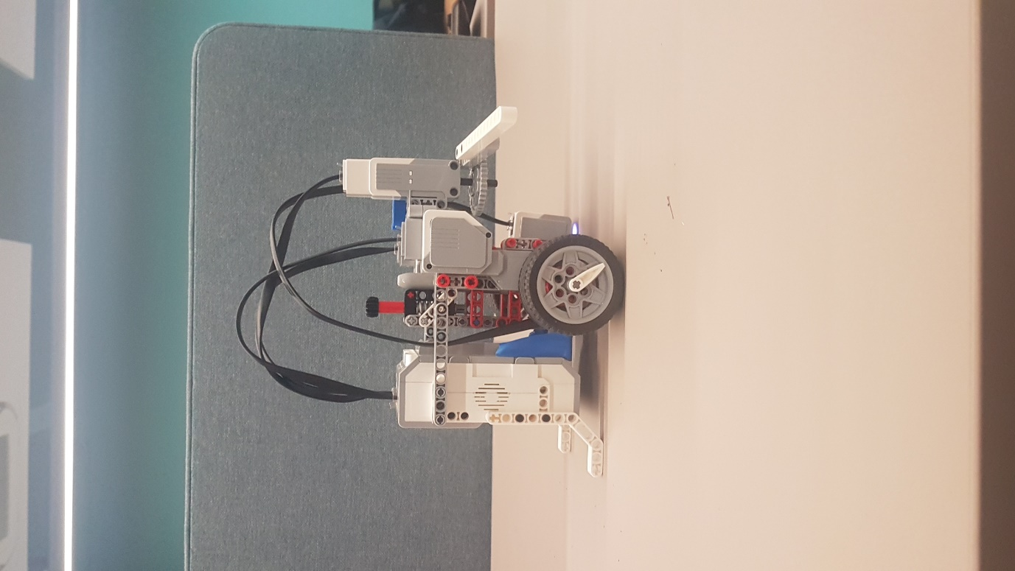

Picture 3
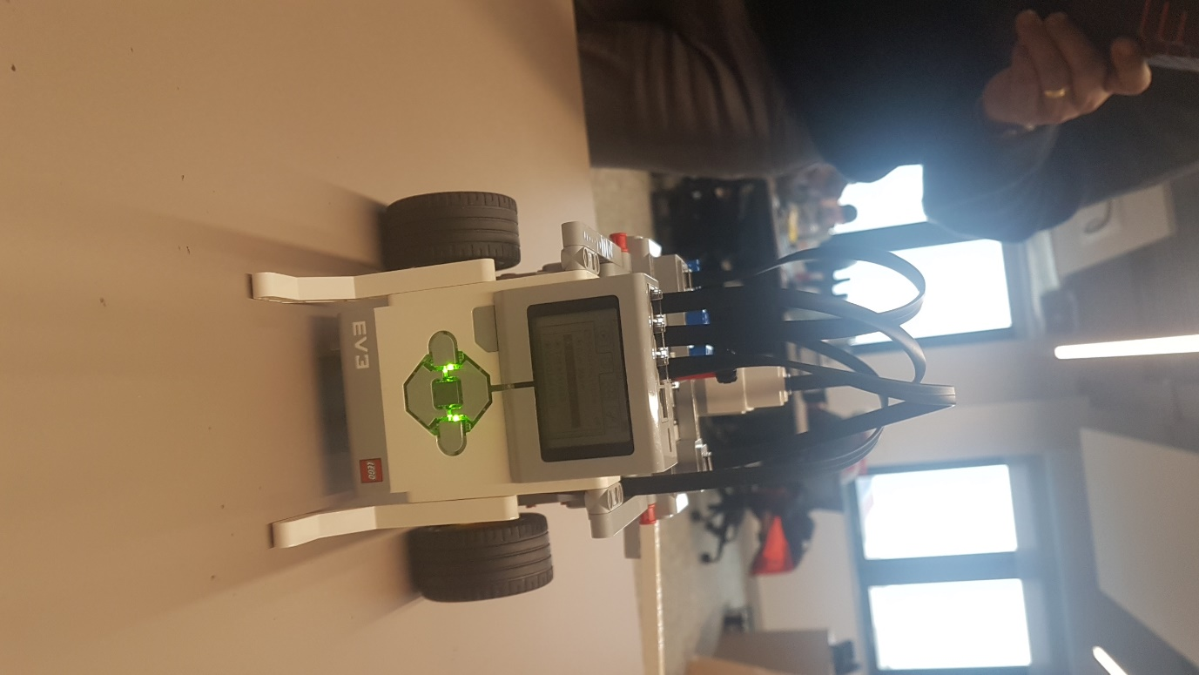

Picture 4
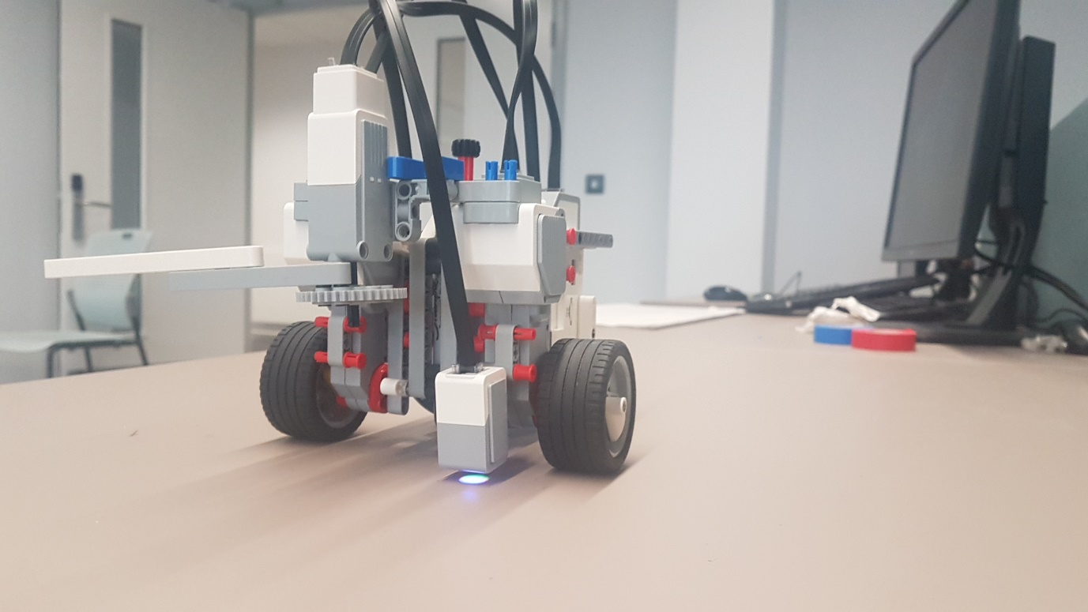

Picture 5
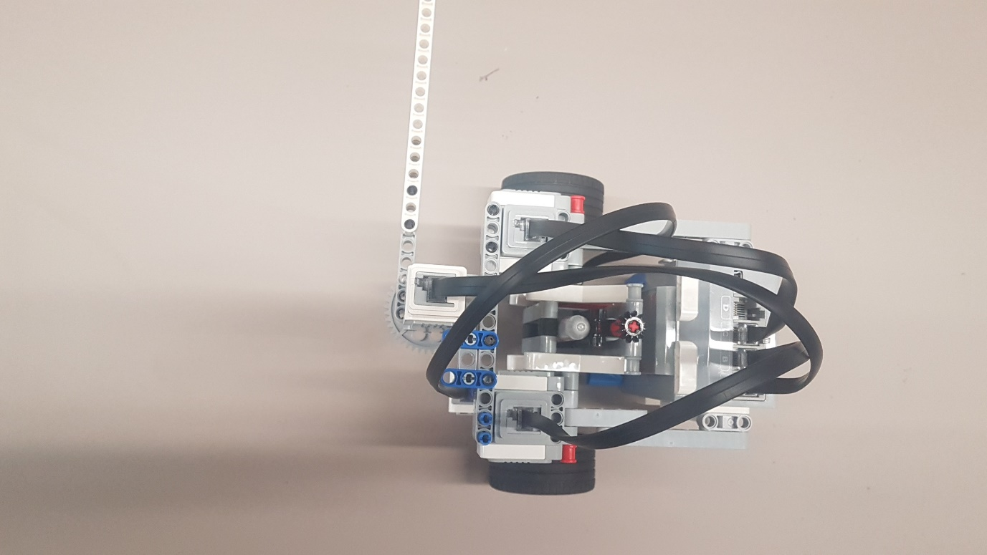

8.2 Rectangle

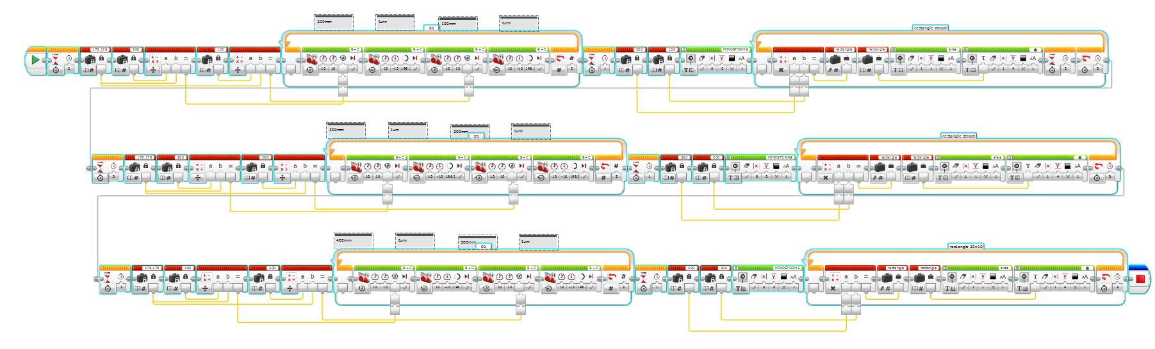

8.3 Right-angle triangle
Part 1
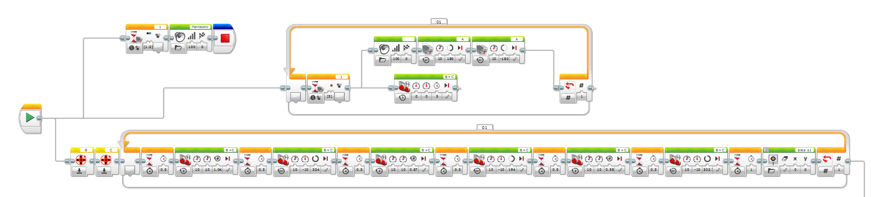

Part 2
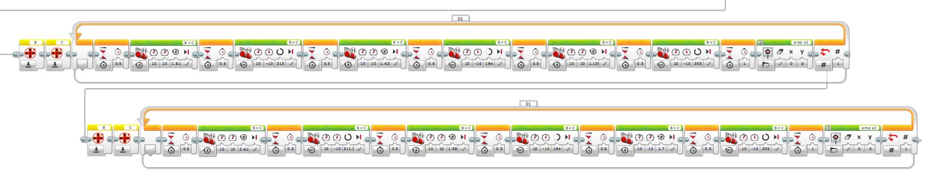

8.4 Circle within a square

Part 1
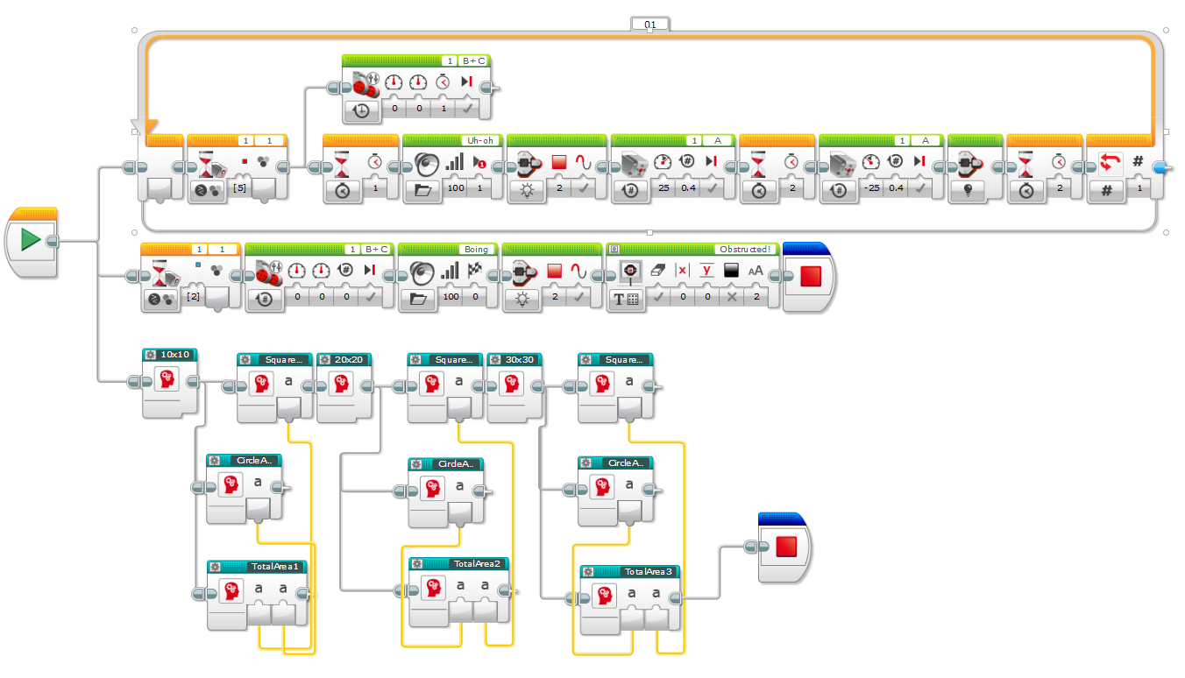

Part 2
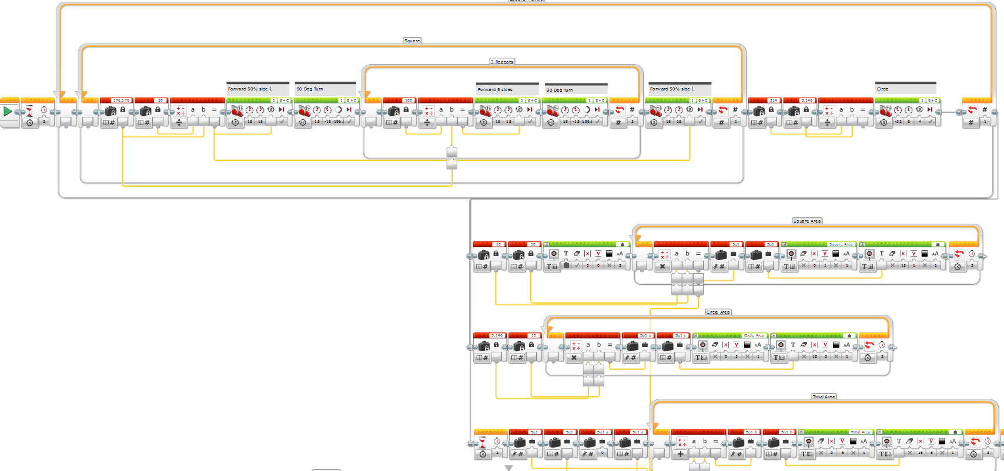

Part 3
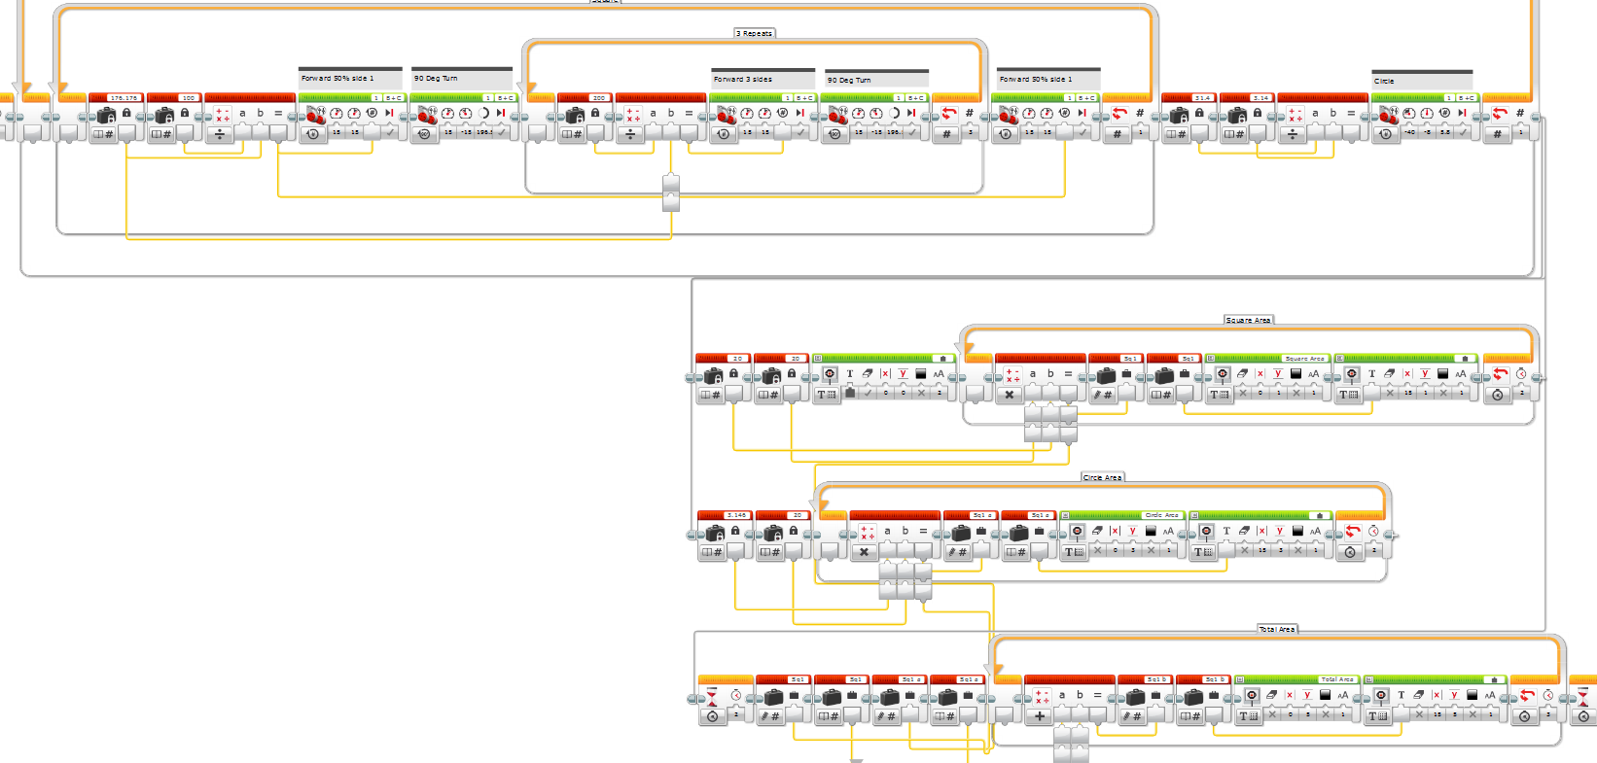

Part 4
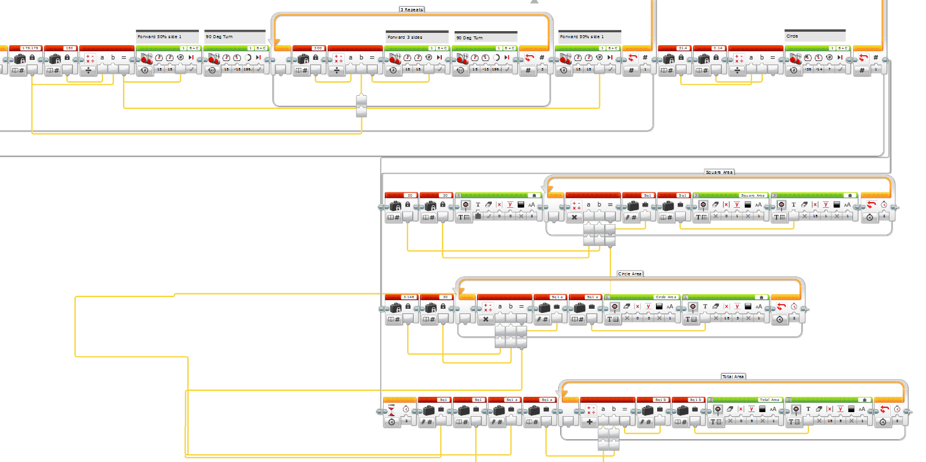

8.5 Equilateral Triangle (join symbol)

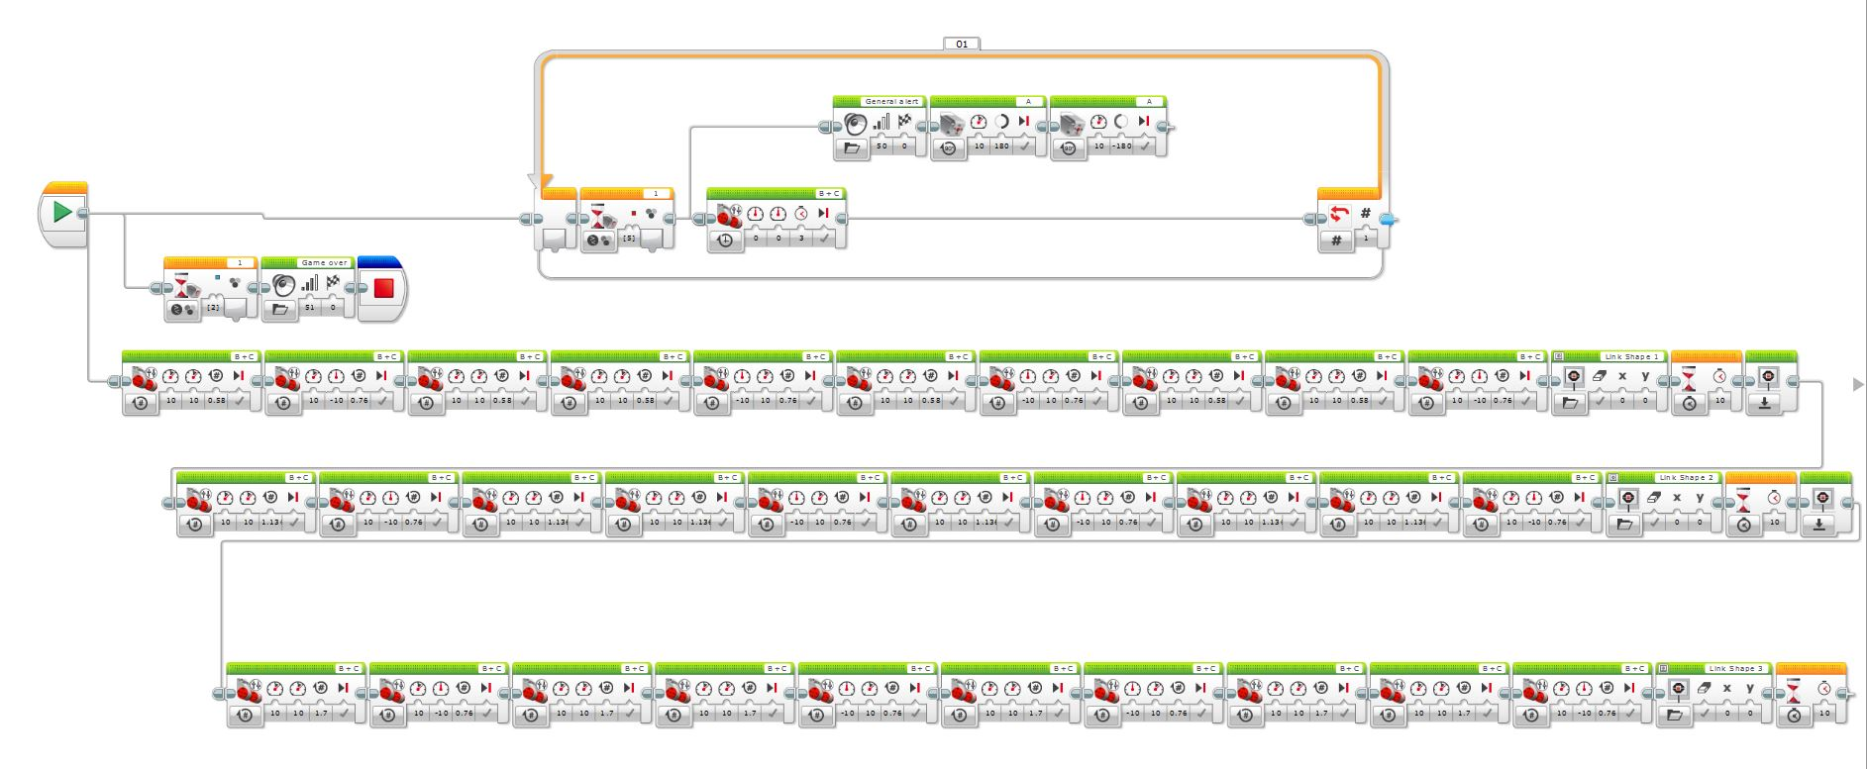

8.6 Screenshots of the shapes drawn.

Rectangle:

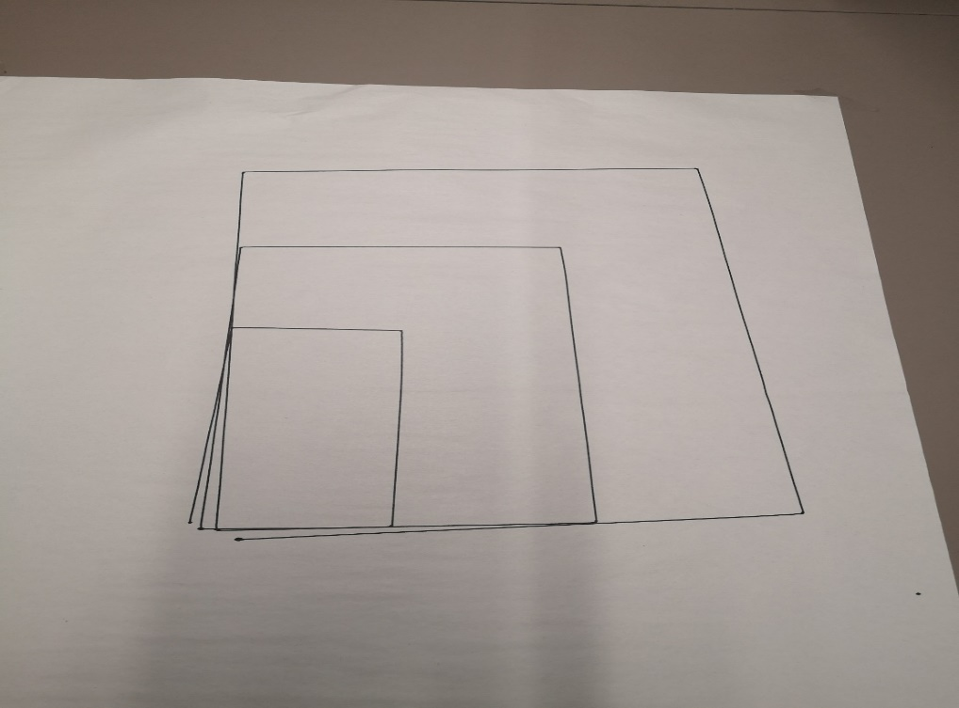

Right-angle triangle

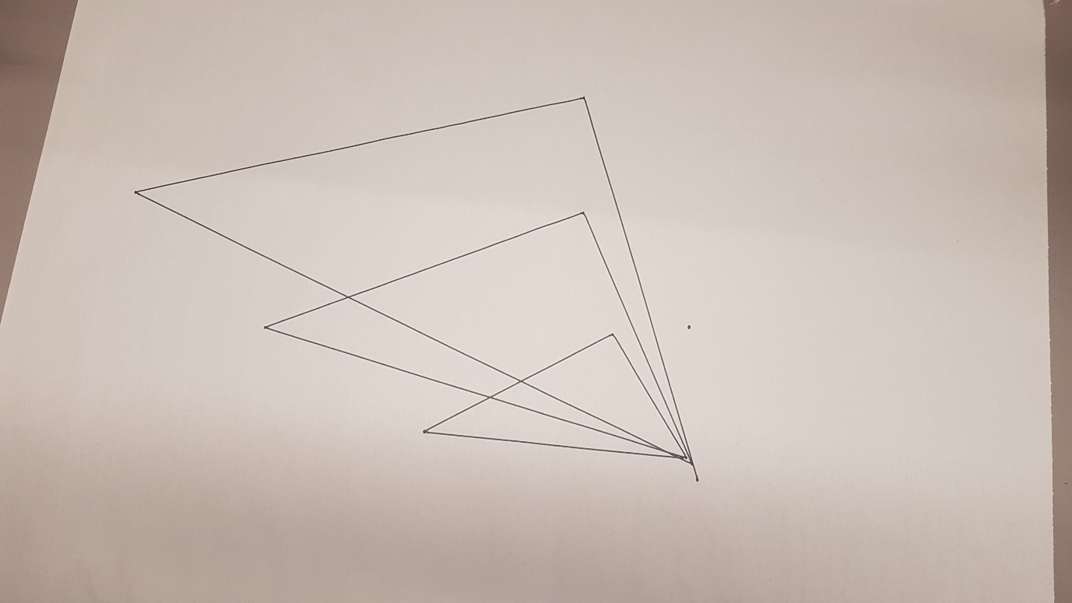

Circle within a square

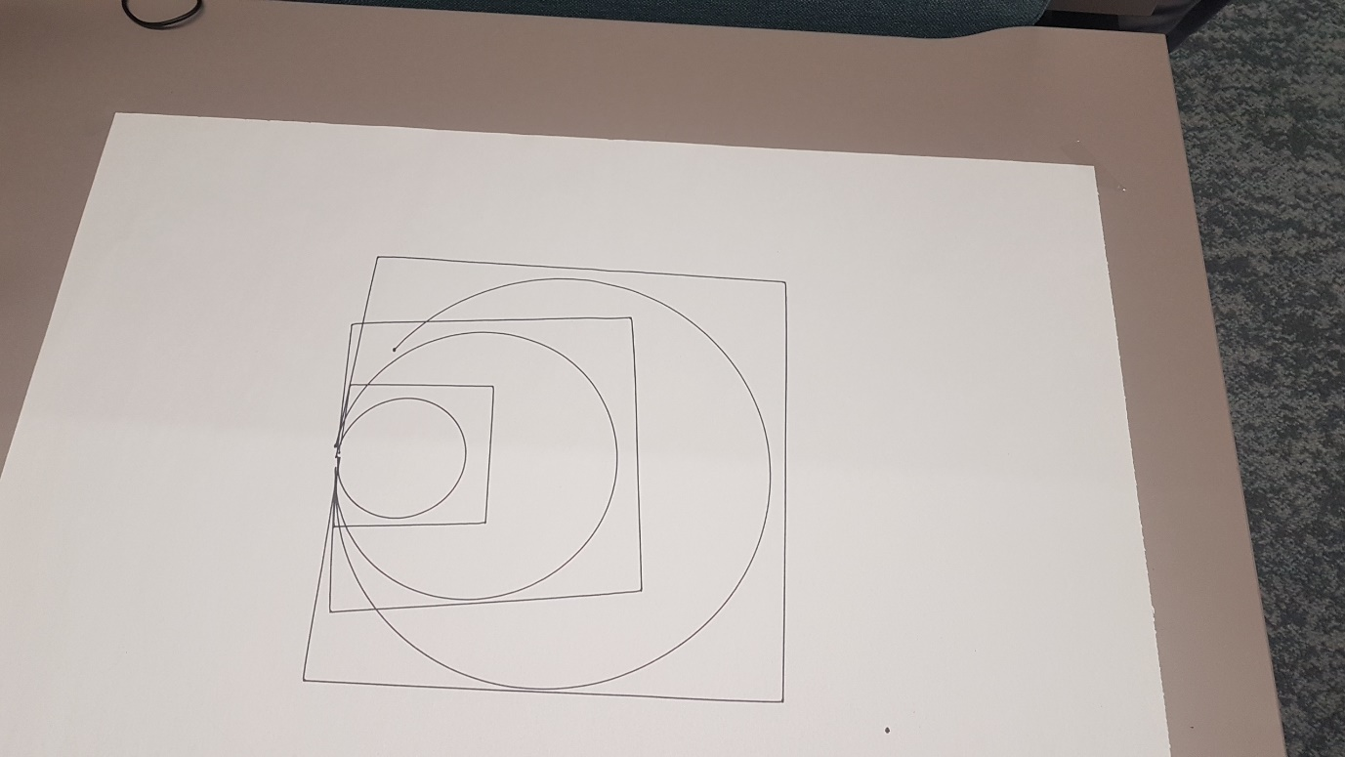

Equilateral triangle

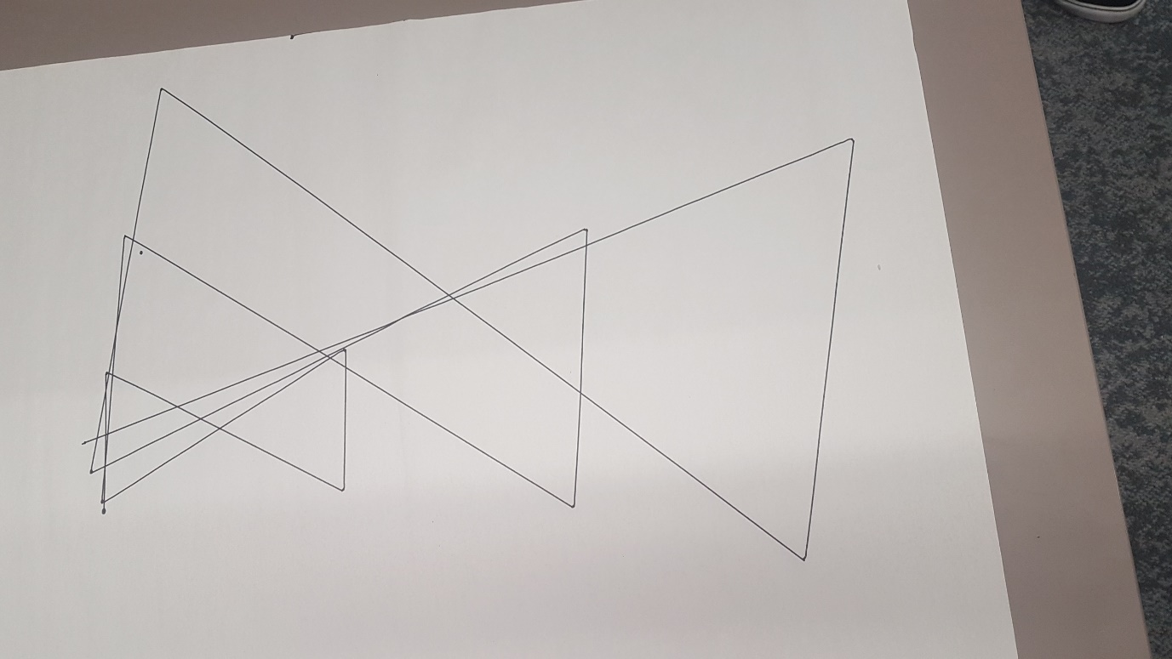

References

[1] | LEGO, “Make it Move in a Pattern,” Unknown. [Online]. Available: https://education.lego.com/en-us/lessons/ev3-dep/make-it-move-in-a-pattern.

