Electrical & Electronic Engineering

Using & programming the 7 segment display prototype circuit
Micros Peripherals and Interfaces
Rebecca Coles
2218001
Table of Contents
Abstract 2
Section 1 2
Section 2 4
Section 3 5
Conclusion 11
References 11

Abstract
In this assignment we were required to understand how to use and programme a 7 segment display circuit. This included finding out what components are used and identify how each one played a role in making the circuit work.
The assignment also required us to display the Hexadecimal characters 0-F on the 7 segment display using binary. Our final section of the assignment was to write a programme to enable all these functions to work. Functions such as displaying 0-F, pressing a button to display a number/letter on the 7 segment display, but also combining all this data together to allow our circuit to count up on one button and down on another.

The rest of this assignment will show in detail each task briefly described above.

Section 1
In this section of the task, it was required to produce a count project on Proteus, which we were able to simulate. It also involved us looking into detail and finding out what each component does in the count project. Refer to [Fig.1] of circuit produced on Proteus.

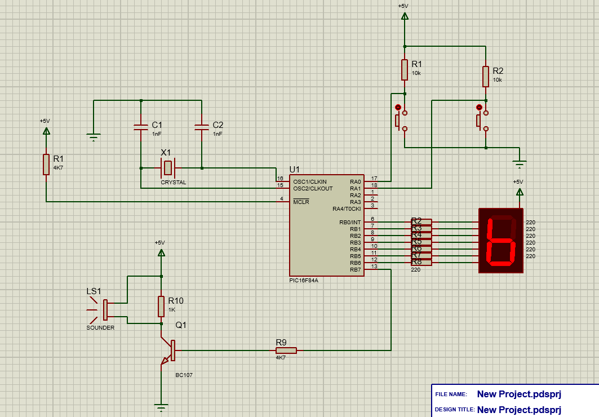

Fig.1 – Count project of 7 segment display on Proteus.

As shown above on Proteus and [Fig.1], there are several components used to ensure a count project on a 7 segment display simulates.

Firstly, this project runs on a PIC16F84 chip. A PIC16F84 chip is a microcontroller chip. It can be used to perform various tasks, including controlling a 7 segment display. It begins by receiving data/signals from other sources, such as buttons, sensors or sounder. Then the microcontroller processes the data according to its programme. For 7 segment this will involve converting it numerical/alphabetical onto the display. The microcontroller also controls each individual segment of LED on the display, desired for each character. It is also in is charge of the timing. Finally, the PIC16F84 microcontroller generates output signals to control the 7 segment display dependant on the programming. This can involve increments or decrement a counter depending on a button push or timer event.
All in all, the microcontroller acts as the brain in this instance. It receives data, processes it and outputs a signal to the 7 segment display.

Secondly buttons or other input components, these are used to control the counting process. An example of this maybe one button counts up whilst another counts down. This means when a button is pressed it generates a signal to the microcontroller, which then converts it and generates an output accordingly.

Then a 7 segment display is used to visually represent the count process. Each number/letter is displayed using one or more segments of the display (LED’s).
The microcontroller generates the signal and then allows the appropriate segment to represent on the display. This typical type of count involves binary coded decimals.

Next a suitable power supply is required to power the microcontroller, 7 segment display.

Furthermore, a crystal oscillator is used for timings. It is required for counting operations in a 7 segment circuit display. It ensures accurate counting sequencing, which makes it an essential component.

Finally depending on specific requirements, components such as resistors and capacitors are used. Resistors are used for protection and signal conditioning. They limit current, scale voltage, maintain signal and protect components from getting damaged. On the other hand, capacitors do not influence the operation of a 7 segment display, they do play a role in the circuit. This includes minimizing noise, voltage levels and improves the overall functionality of the system.

In summary of above, a count project using a 7 segment display involves a microcontroller to analyse the data, buttons for a user to input the data, a 7 segment display to visually represent the count, a crystal oscillator to control timings, a stable power supply and any additional resistors or capacitors for protection or desired features. [Fig.2] is a flowchart clearly describing the above sequence.

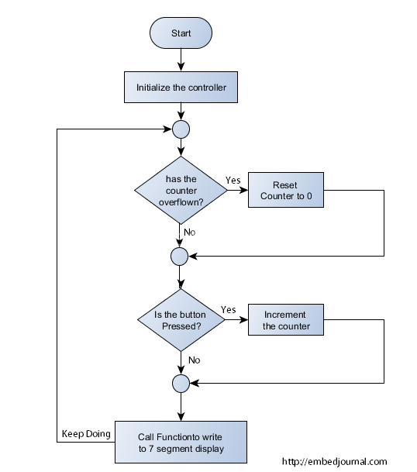

Fig.2 – Flow chart of how a PIC16F84 and 7 segment display work.

Section 2
In this section we were required to demonstrate how we would display Hexadecimal characters, 0-F on a 7 segment display. When displaying Hexadecimal characters, the use of a microcontroller would be used. A microcontroller would send an output to a specific segment of the display. Each hexadecimal digit corresponds to a specific combination of a segment.
Hexadecimal and binary are closely related, each hexadecimal digit corresponds to a unique combination of four binary digits. This makes is easier to represent hexadecimal digits using binary patterns.
To display hexadecimal characters, 0-F on a 7 segment display using binary, refer to [Table.1] below for binary to hexadecimal conversion.

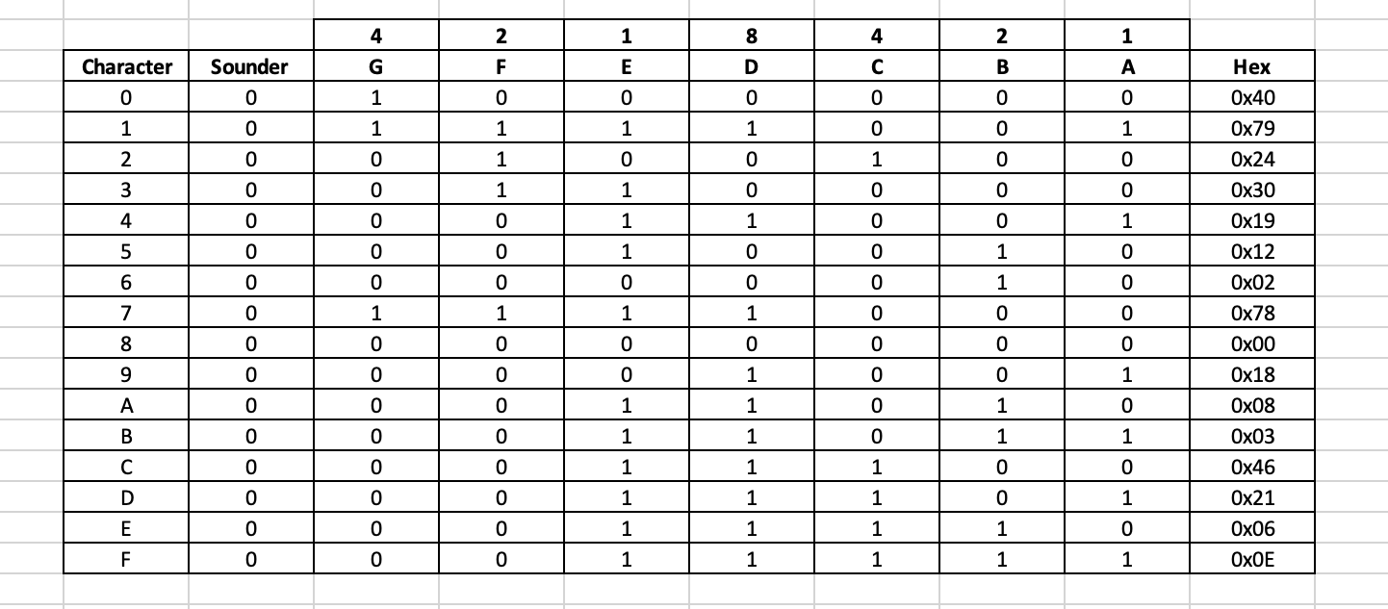

Table.1 – Binary to Hexadecimal correspondence chart.

As stated in table.1 above, a table would be needed to correspond to each letter/digit on the display, this will then determine what segment can have an output sent to it. Then the microcontroller would need to be programmed to convert an input from a user push, i.e., button to an output to the 7 segment display.
This communication would then be done using a code written by a user, specific to their job request and the hexadecimal characters from table.1 above. Each pin of the controller will give an output to the 7 segment display.

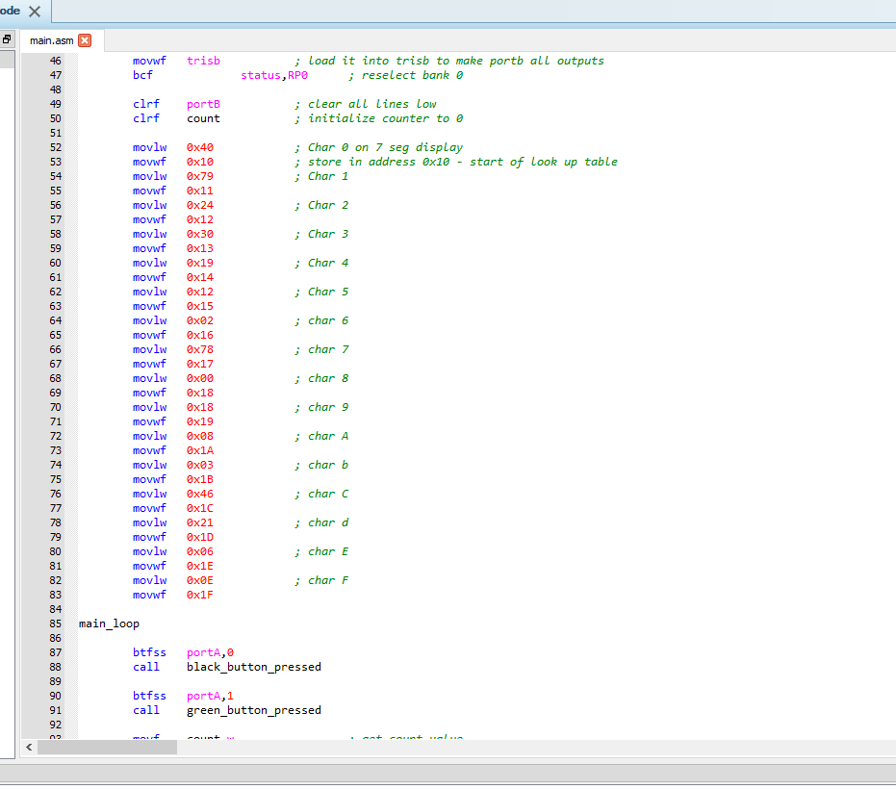

Fig.2 – Hexadecimal put into the code.

Section 3
- In the first part of this section, we were required to set our count project outputting to the 7 segment display to count in 0.5 seconds increments. This is done by setting a time variable on the crystal timer.
Below is a simple example of inputting 0.5 second increments in pseudocode.

Initialize count variable – to 0
Configure timer interrupt with 0.5 – seconds
Enable interrupts

Timer Interrupt:
Increment count variable
Update 7 segment display with new count value
Clear timer interrupt

Main:
Initialize microcontroller peripherals
Start timer
Loop identified

Set up any other parameters within the controller. Once steps above are complete, you are able to run the simulation and verify that the 7 segment display is updating to the correct 0.5 second increment set.

Below is also a basic set up by flow chart on how to set a timer for a 7 segment display on proteus. This is how to add a 0.5 second increment delay into the set up using the capabilities of the crystal delay timer. This can be altered depending on the delay set up in the code.

Start

Initialize timer

Enable timer Interrupt

Wait for interrupt

Update display

Reset timer

Return to wait

End

Included in Fig.3/Fig.4/Fig.5 of a proteus grab, it is clear to see in the code a delay inputted.
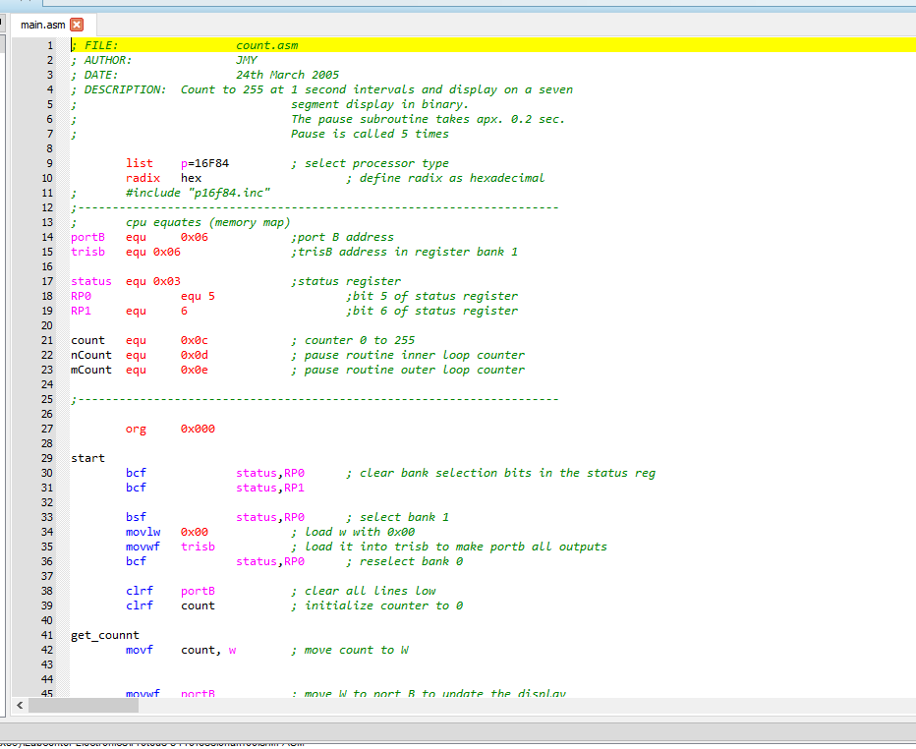
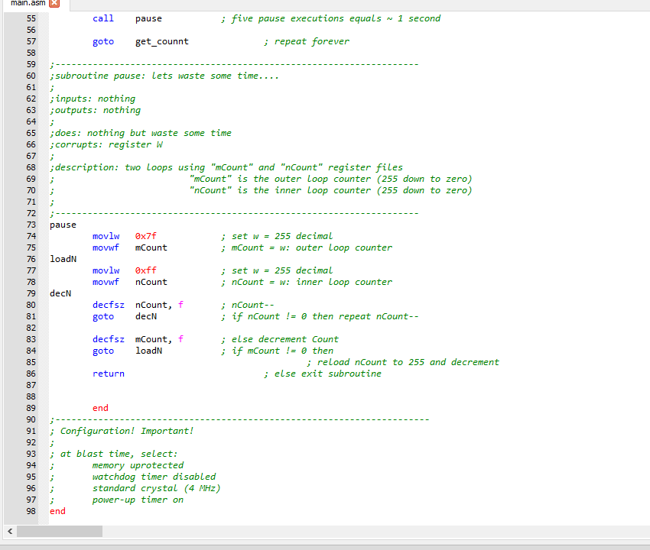

Fig.3 Fig.4 Fig.5

- In this part of the section, we were required to write a code, to allow both buttons to operate different functions. One being when pressed it would display ‘1’ and the other ‘2’.
As shown in Fig.3/4/5 above, you are able to see the code written again for different buttons engaged and what output is displayed.
Below is a basic pseudocode to explain how pressing each button gives a different output.

Loop:
If RB0 is pressed:
Display 1 on 7 segment display
Wait for button release (debounce)

Else if RB1 in pressed:
Display 2 on 7 segment display
Wait for button to be release (debounce)

This programme will continuously loop to check what states the button is in, whether they have been pressed or not.
A basic set up in the form of a flow chart of how it works when going through the sequence it shown below.

Start

Check button status

RB0 Pressed

Yes No

Display ‘1’ RB1 Pressed

Wait Yes No

Loop

Display ‘2’ Display previous state

Wait

Loop

End

- In the third part to the section, we were required to turn off the 7 segment display using the buttons. One would turn it on and the other would turn the display off.
As shown below is a basic pseudocode of this sequence.

Initialize display to_OFF

Loop:
If button 1 in pressed and display state is_OFF:
Turn display_ON
Set display state to_ON
Wait until button 1 is released (debounced)

Else if button 2 is pressed and display state in_ON
Turn off display
Set display state to_OFF
Wait until button 2 is released (debounced)

By using this type of sequence, it allows the display to be turned on/off without the need of a button being pressed. Button 1 pressed would allow it to go from off to on, button 2 pressed would allow from on off. This allows toggling between both buttons and not the need to be continuously pressed.

- The final part to this section involved us writing a code on proteus to count from 0-F on the display in hexadecimal.
Below is a basic pseudocode for this sequence in the code.

Initialize count to 0

Loop:
Display current count value on 7 segment display
If button 1 is pressed:
Increment count
If count exceeds F, reset to 0
Wait until up button is released (debounced)

If button 2 is pressed:
Decrements count
If count variable is less than 0, set it to F
Wait until button is released (debounced)

This loop will continue to cycle, as like the others until it sees a state to give an output too.

This same pseudocode can be seen in the code written on proteus for the 7 segment circuit for our project.
It can be clearly shown, once button 1 is pressed it will count up until it reaches F, then sets itself back to 0, and vies versus for when button 2 is pressed it will count back down, until it reaches 0, where it’ll set itself back to F. this programme will continuously loop.
Refer to Fig.6/7/8 for the code written for this set up on the simulation.
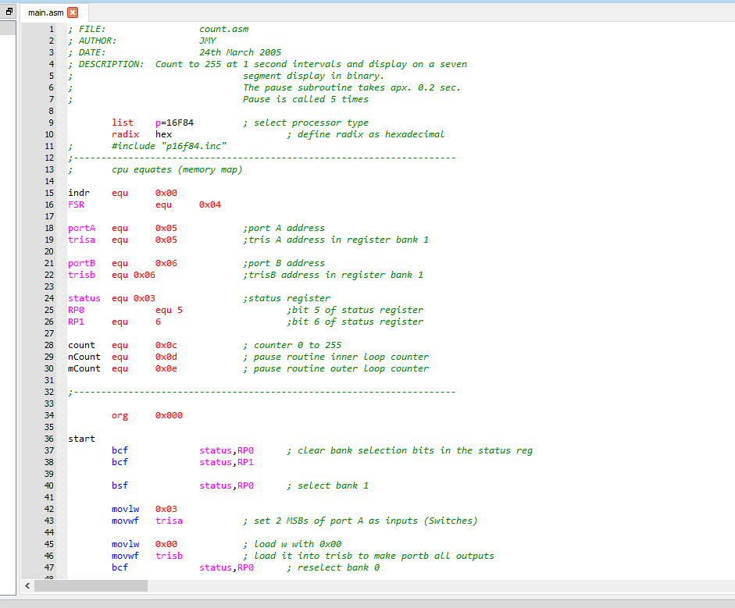
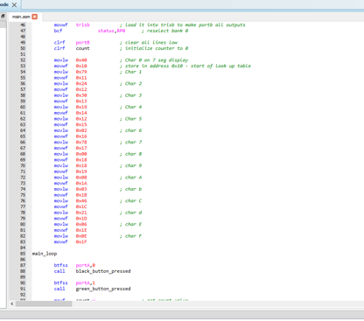
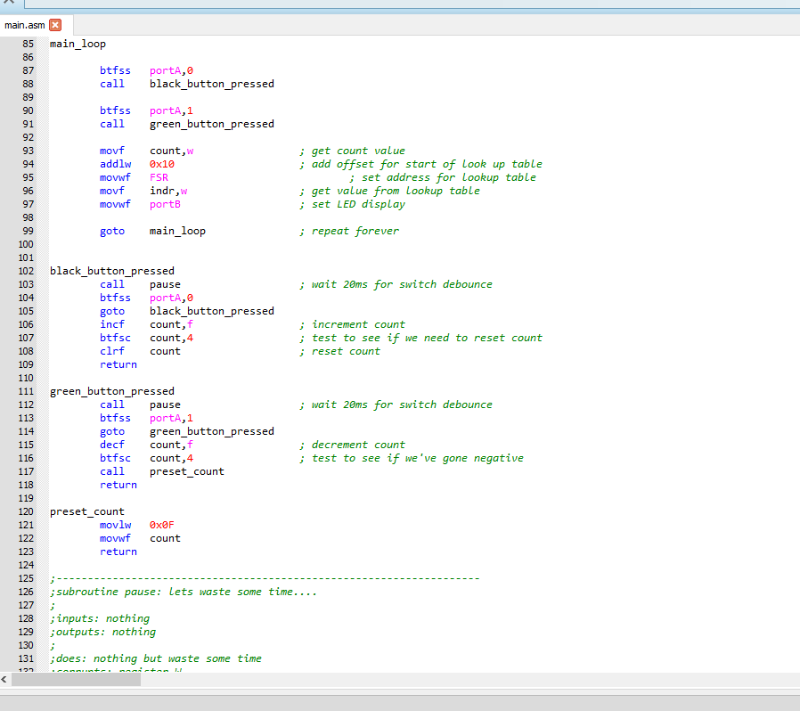
Fig.6 Fig.7 Fig.8

Below is a full sequence of the count project, counting from 0-F.
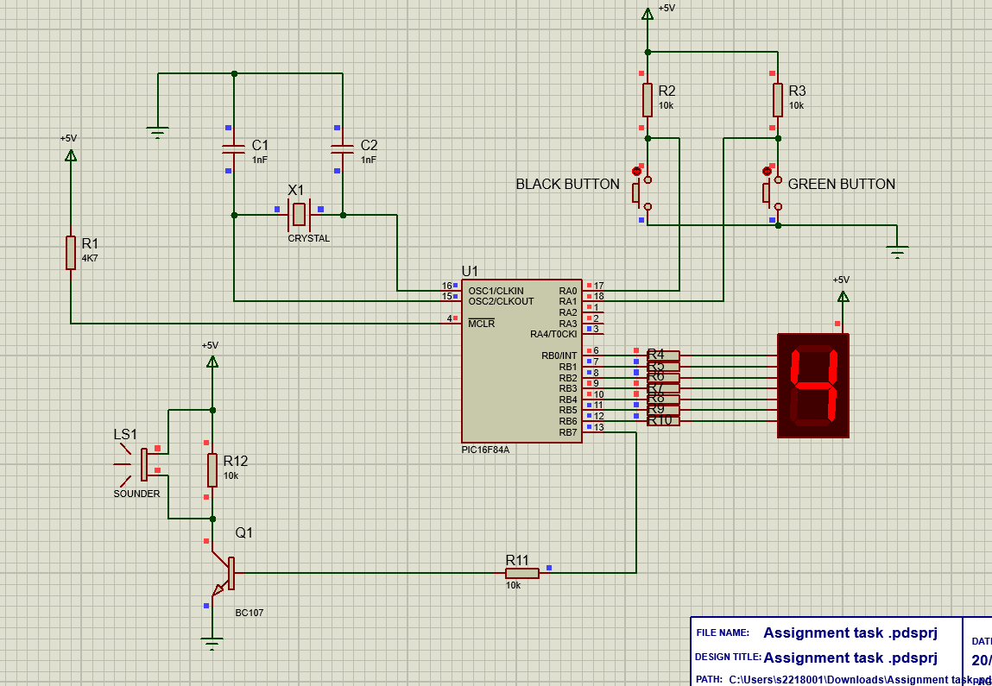
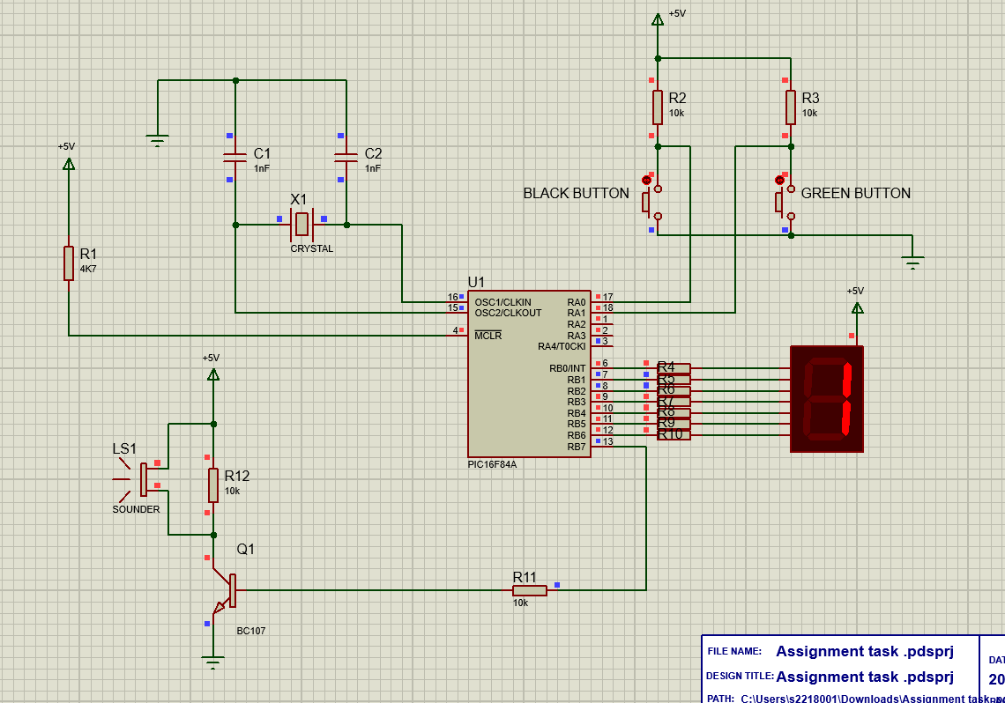
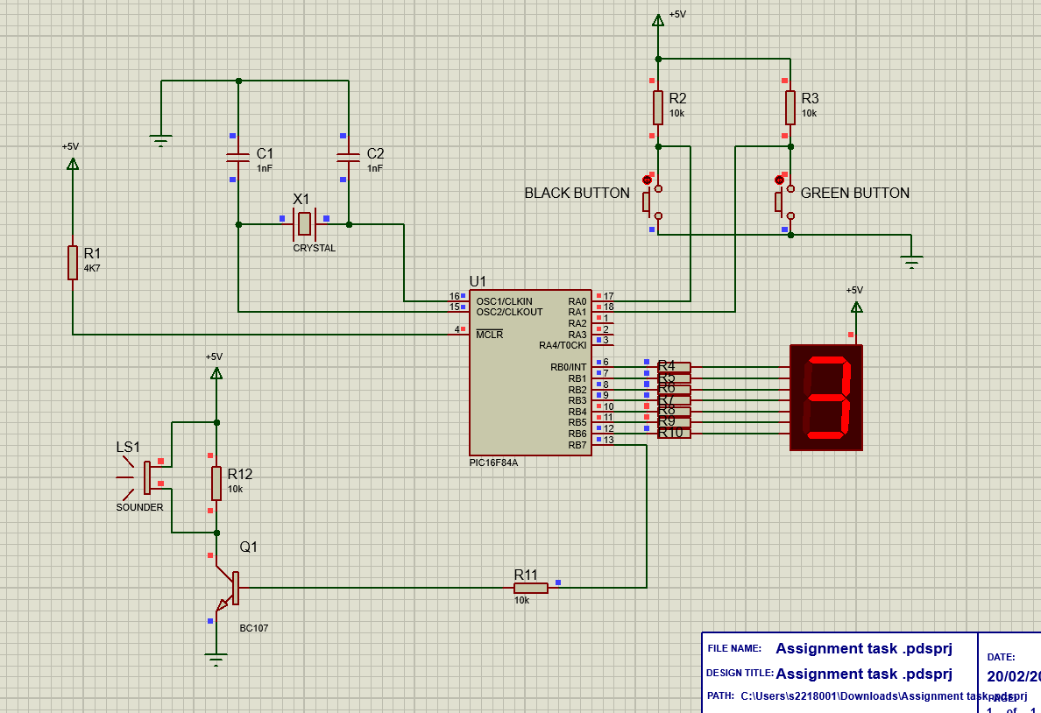
Refer to Figures below.
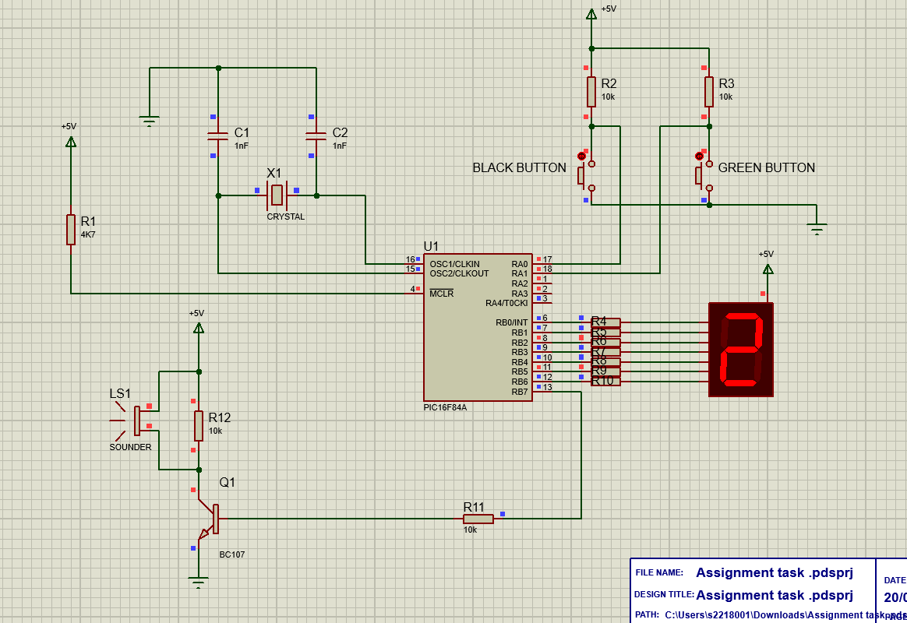
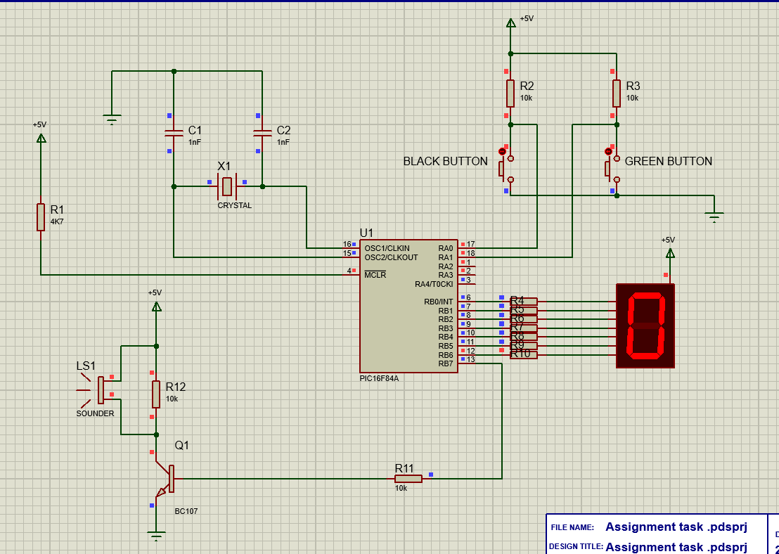
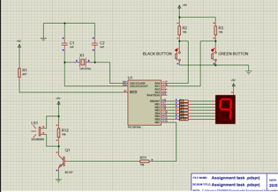
Fig.9 Fig.10 Fig.11 Fig.12 Fig.13
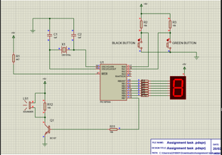
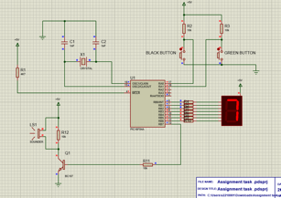
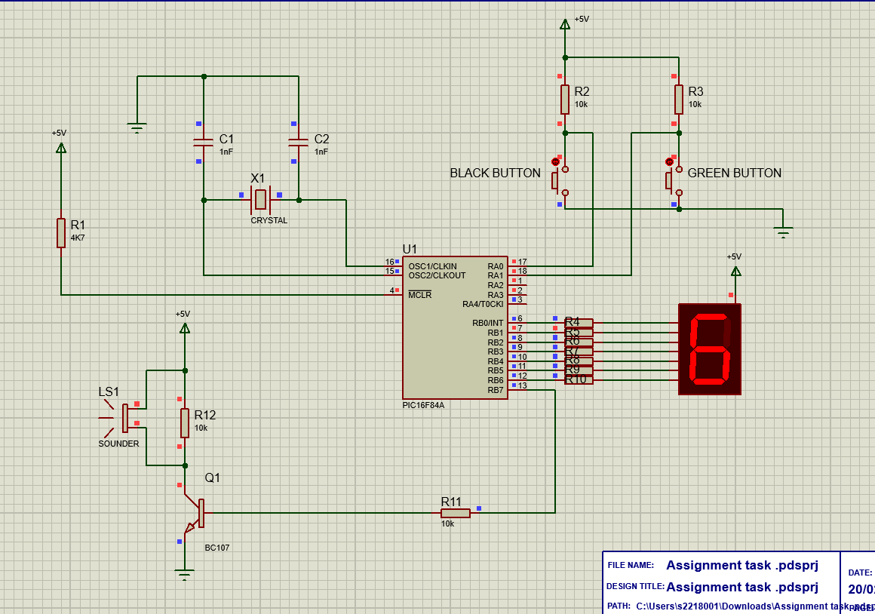
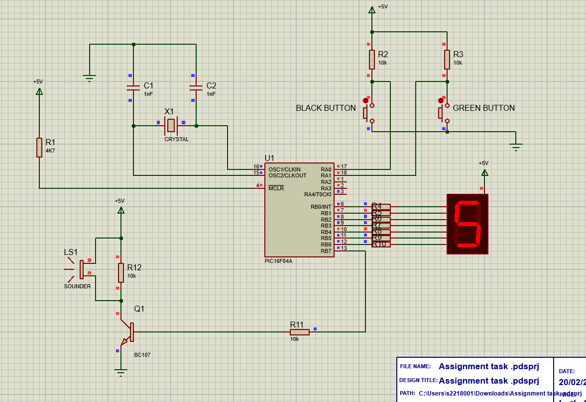
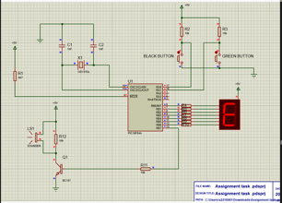
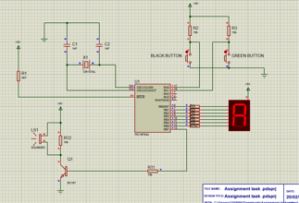
Fig.14 Fig.15 Fig.16 Fig.17 Fig.18
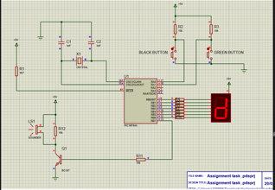
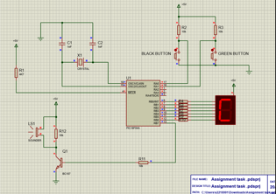
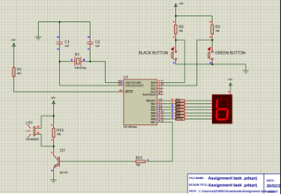
Fig.19 Fig.20 Fig.21 Fig.22 Fig.23
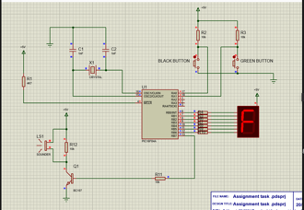

Fig.24

Conclusion
In conclusion, once simulating these set ups on proteus it is clear to understand what the function of them are and also what outcome it is trying to provide. Especially when referring them to the pseudocode or flowchart.
However, it is clear to understand that Proetus time and real-time are very different when setting up sequences.
Proteus is very reactive and sensitive when programming compared to a 7 segment display and PIC built on a PCB.
In addition, it also shows how useful and how frequently used a 7 segment display/any display and count system is used in day to day life. It also shows how many different codes can be input into the microcontroller to help make counting or turning electronics such as lights on and off.

References
[Fig.2] - https://embedjournal.com/external-event-counter-seven-segment-displays/
[1] Steve Mosey – Power Points

