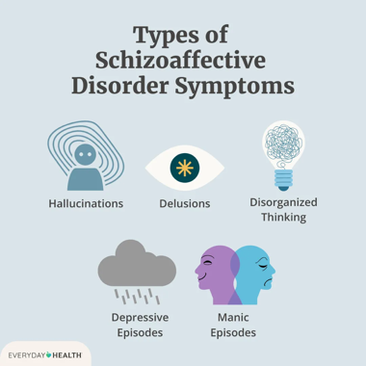
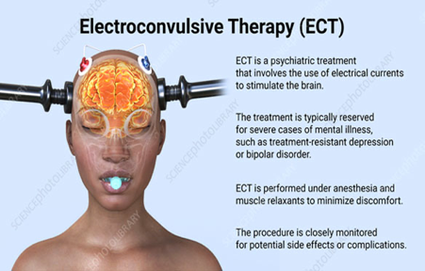
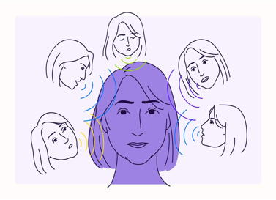
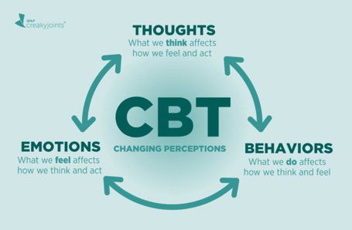
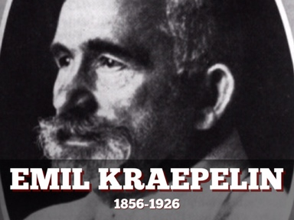

- Modern Understanding (ICD-11)
- Now the ICD-11 (World Health Organisation, 2022) associates' schizophrenia with other psychotic disorders such as schizoaffective and delusional disorders.
- Modern thinking has connected a mixture of psychological, biological, and social causes being the cause to this illness.
- The focus is no longer how to cure people but how to help them to live with the illness and move forward independently with a decent quality of life.

- Definition and Overview
- Schizophrenia and related psychotic disorders affect how people may feel, think, or understand reality.
- Symptoms include hearing or seeing things that are not there, strongly believing in something that is not true, and feeling isolated or withdrawn.
- Experiencing this can make a person’s life and daily activities much more difficult.
- The aim of this poster is to explore what schizophrenia is and what types of treatments have been available over time, ranging from early institutions to modern day care.

- Historical Context
- In the 1800s, people who had severe mental health issues were sent to asylums.
- In 1896 Emil Kraepelin first described a long-term illness as “dementia praecox”.
- Later, in 1911 Eugen Bleuler introduced the term “Schizophrenia” which means “split minds”.
- Earlier treatments used were ECT, insulin coma therapy, and lobotomy. These were seen as harsh.
- From 1950s onwards, new attitudes towards this encouraged new medicines which led to community-based care rather than institutions.

- Critical Reflection and Future Directions
- Shift in care: Treatments in the past only focused on containing the behaviour in institutions. Where as, modern care encourages independence, recovery and inclusion. However, services still have barriers such as underfunding and high demand.
- Ethical improvements: Progress is shown through patient choice and consent. But some practices are still risking free will, even under the required treatment laws.
- Need for cultural awareness: Services in the future need to take into account how culture, background and identity can affect diagnosing an illness and recovery.
- Empowerment and inclusion: Those who have lived and experienced the illness should have a strong say in how to shape the mental health care, where as education and intervening early can also help to improve the outcomes globally.
- Social, Cultural, and Political Factors
- People who suffer from schizophrenia often face stigma and discrimination (Thornicroft, 2006).
- In some cultures, if someone can hear voices it is seen as a spiritual cause instead of a medical cause.
- Some studies have shown that certain ethnic minorities have been detained or diagnosed more than others (Morgan et al, 2020).
- The Mental Health Act (1983, updated in 2007) aims to protect while keeping people safe.
- Treatment and Care
- Antipsychotics is the medicine prescribed to help reduce symptoms like hallucinations and delusions.
- Talking therapist such as CBT is used to help people manage their thoughts and feelings.
- Support from families and the community can also help with recovery and reduce relapsing.
- Policies (NICE, 2014; NHS, 2019) now encourage team-based care, intervening early and person-centred support.
References List
- Read, J. and Dillon, J. (eds.) (2013) Models of Madness: Psychological, Social and Biological Approaches to Psychosis. 2nd ed. London: Routledge.
- Thornicroft, G. (2006) Shunned: Discrimination Against People with Mental Illness. Oxford: Oxford University Press.
- Morgan, C., Knowles, G. and Hutchinson, G. (2020) ‘Social determinants of psychosis: reflections on emerging evidence for ethnic differences’, BJPsych Bulletin, 44(5), pp. 208–212.
- Lieberman, J.A., et al. (2018) ‘Antipsychotic drugs: History, pharmacology, and therapeutic use’, Journal of Clinical Psychiatry, 79(3), pp. 1–10.
- National Health Service (2019) The NHS Long Term Plan. London: Department of Health and Social Care.
- Pilgrim, D. and Rogers, A. (2010) A Sociology of Mental Health and Illness. 4th ed. Maidenhead: Open University Press.
- World Health Organization (2023) Mental Health Action Plan 2013–2030: Progress Update. Geneva: WHO.
- Sayce, L. (2016) From Psychiatric Patient to Citizen: Overcoming Discrimination and Social Exclusion. 2nd ed. London: Palgrave Macmillan.
- National Institute for Health and Care Excellence (2014) Psychosis and Schizophrenia in Adults: Prevention and Management (CG178). London: NICE.
- World Health Organisation (2022) International Classification of Diseases 11th Revision (ICD-11): Schizophrenia and Other Primary Psychotic Disorders. Geneva: WHO.

