Website Project Report
Website Title: Explore Cardiff, Wales City Guide
Student Name: Alina Firu
Student ID: 2323237
Module: Interactive Web Development (ACCA4023)
Submission Date: 19/12/2025

Table of Content:
1. Introduction 3
1.1 Abstract 4
2. Requirements 4
2.1 Purpose 4
2.2 Subject Matter 4
2.3 Target Audience 4
2.4 Success Criteria 5
3. Implementation 5
3.1 Site Organization and navigation. 5
3.2 Visual Design and Theme 5
3.3 Responsive Design Approach 5
3.4 Interactivity 5
3.5 Implementation Awareness of Accessibility. 6
4. Testing and Validation 6
4.1 Functional Testing 6
4.2 Website Page Screenshots 6
4.3 HTML Validation Home Page 10
4.4 CSS Validation 10
4.5 Mobile Responsive Evidence 10
5. Evaluation 12
5.1 Usability 12
5.1 Critique of this site 12
5.2 Accessibility (Research + Findings WCAG 2.1) 13
Accessibility tool evidence 13
5.3 Search engine optimisation (Research + Findings) 14
6. Comparative Appraisal 15
6.1 Chosen Websites 15
6.2 Comparison Criteria 15
6.3 Results Summary 15
6.3.1 Usability 15
6.3.2 Accessibility 16
6.3.3 SEO 17
6.3.4 Mobile friendliness 17
6.4 Overall comparison. 19
7. Conclusion 19
9. References 19
10. Appendices 20
Appendix A: HTML Code Listings 20

1. Introduction
This project includes a responsive multi page web site named Explore Cardiff Wales. The site is created as an effective city guide to tourists, students and newcomers. It gives the important details in six related pages namely Home Places to Visit Food and cafes getting around travel tips and contact. The design objective was to develop a modern and aesthetically appealing site that is easy to read, easy to navigate and can be used in the desktop and mobile screens.

1.1 Abstract
The site has been constructed in HTML5 and CSS3 with little use of JavaScript to switch the mobile navigation menu. The site has a consistent navigation layout on all pages and a consistent visual theme which has been determined with CSS variables. This report captures the documentation of the requirements of the site, the implementation selection, the evidence of the validation and the evaluation based on the principles of usability, accessibility and SEO. The report also entails a comparison on this site and two similar tourism sites in the real world.

2. Requirements

2.1 Purpose
The aim of the website is to offer a clear and structured guide of Cardiff. The site assists the user by aiding them in determining attractions and experiences in the city. The site is also friendly to the users as it proposes food and cafe options that suit the visitors. Also the site describes the transport methods to allow the user to know how to commute in Cardiff. The site also offers useful travelling tips such as how to budget and how to be safe. Lastly the site also allows a mode of contacting in case users would like to make suggestions on how to improve the site or recommend more places.

2.2 Subject Matter
The topic of discussion is Cardiff Wales and the theme dwells on information that is visitor friendly. It organizes the information in such a manner that a user does not spend a lot of time reading long paragraphs before getting answers.

2.3 Target Audience
The target market is mainly the tourists who are going to make a short trip to Cardiff. Students and visiting newcomers to Cardiff are also considered to be the main audience that seeks easy to follow advice. The site is also mobile friendly since it is arranged to suit short scannable content by mobile users. The secondary audience consists of the local residents who are interested in having a quick reference guide or even proposing other places.

2.4 Success Criteria
The site has been considered successful provided that there are a minimum of five related pages and that they have a clear internal navigation between the pages. The site is effective with the ability to be responsive and viewable on the usual screen sizes including the mobile screen. The success of the site is that it loads properly by opening index.html directly without the need of a development environment. The site will be successful in that the relative links are applied on all the pages and assets that they have as the site does not halt when it is unzipped. The success of the site is when it shows good practice in the following aspects; usability, accessibility and the basic on page SEO.

3. Implementation

3.1 Site Organization and navigation.
There are six pages within the site; the index.html places.html food.html transport.html tips.html as well as the contact.html. There is an available consistent navigation menu that appears on the top portion of every page to allow the user to navigate easily between pages. The navigation is simplified into a mobile menu on smaller screens that is operated by a menu toggle button and it makes the navigation look less cluttered and more usable by the mobile users.

3.2 Visual Design and Theme
The layout is in a contemporary guide like design which is more focused on legibility and uniformity. The pages are spaced uniformly and typed to ensure that they are readable. The information is arranged in card blocks in major sections so that one can scan suggestions within a short period of time. It is made with a strong first impression using a hero section and provides readable and structured text at the same time. CSS variables are used to implement the colour palette to emulate better maintainability and to make all pages look alike.

3.3 Responsive Design Approach
The responsiveness is enforced through the viewport meta tag in every page. The layout is constructed out of flexible sizing in such a way that the content will fit to various screens without overfilling. The images are processed with rules of responsiveness in order to size within their containers and not to ruin the layout on smaller screens. Media queries allow making layout and typography changes based on important breakpoints in order to make the experience comfortable on both phones, tablets and desktops.

3.4 Interactivity
The navigation mobile menu is supported using JavaScript. The navigation list can be opened and closed with the help of the script thus making it more user friendly on the small screens. JavaScript usage is also kept down to a minimum and only a single interactive feature and this contributes to the lightness and reliability of the web site.

3.5 Implementation Awareness of Accessibility.
The considerations made during implementation were accessibility driven. The level of semantic heading of the contents is such that the structure is easily understood by the sighted users as well as assistive technologies. The contact form has clear labels attached to the inputs so that they can be less confusing and enhance compatibility with the screen readers. Focus styles are applied in such a way that keyboard users can get a view on the element that is in use. Visual strain is also minimized using readable line height and width.
Another way of enhancing the site is by including a skip to content link on the top of every page. Mobile menu button could also be enhanced by introducing aria expanded and aria controls to notify the assistive technologies of the state changes. Colour contrast is also to be checked using contrast checker and recorded as a testimony in the evaluation section.

4. Testing and Validation

4.1 Functional Testing
The functionality of the site was tested manually to ensure that it is functioning appropriately. To make sure the site is running stand alone and everything (CSS and images) is loading correctly index.html was opened and launched. All links and buttons to navigation were clicked to make sure that they open the appropriate pages without any mistakes. Contact form was tested to ensure that the inputs work and basic validation produces as expected.

4.2 Website Page Screenshots
The following figures should be inserted as screenshots of each completed page.

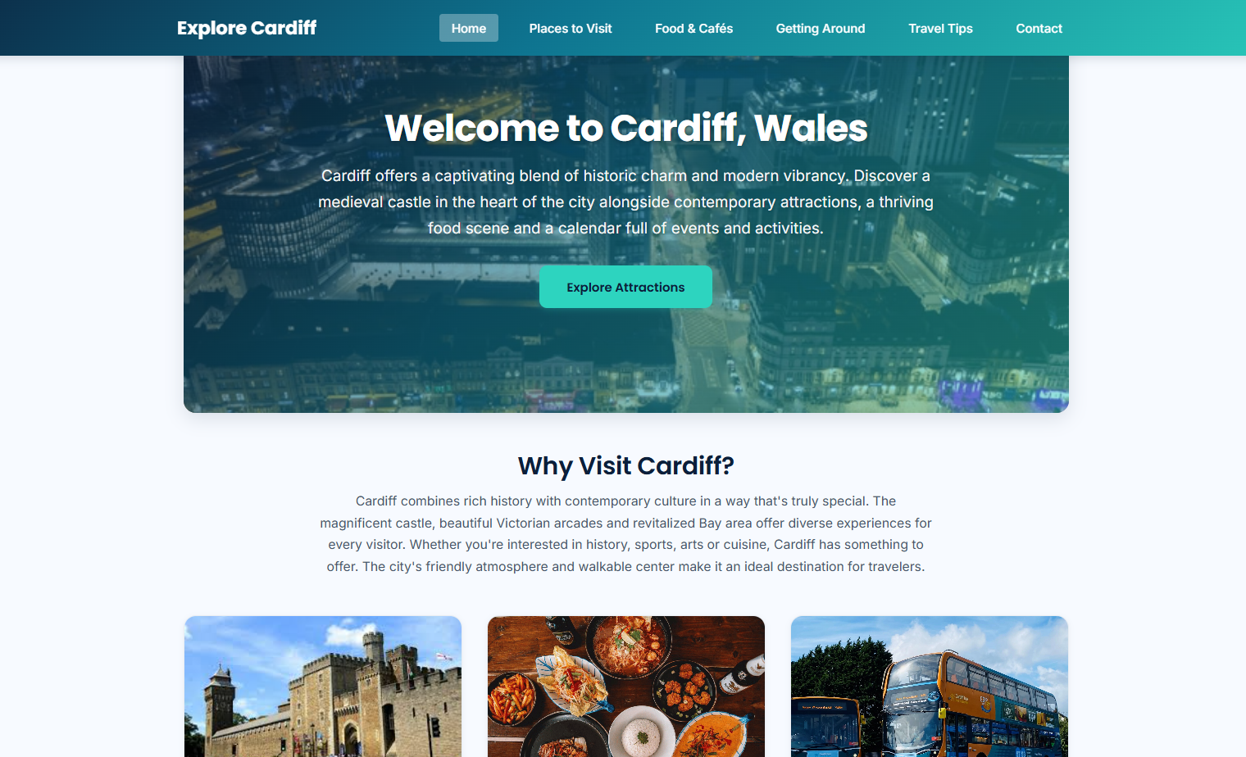
Figure S1: Home page (index.html)
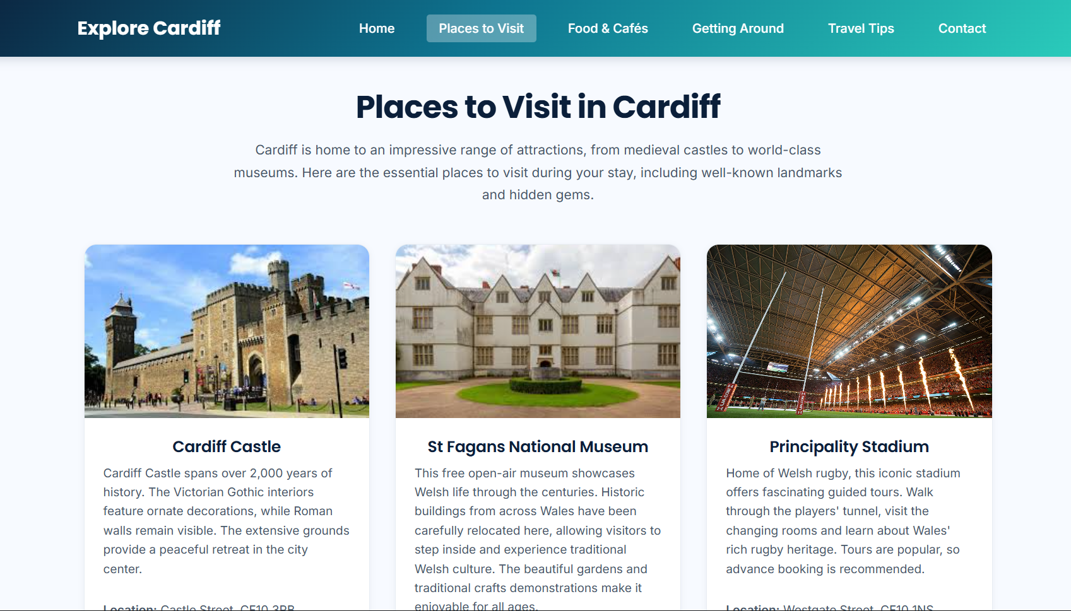
Figure S2: Places to Visit page (places.html)
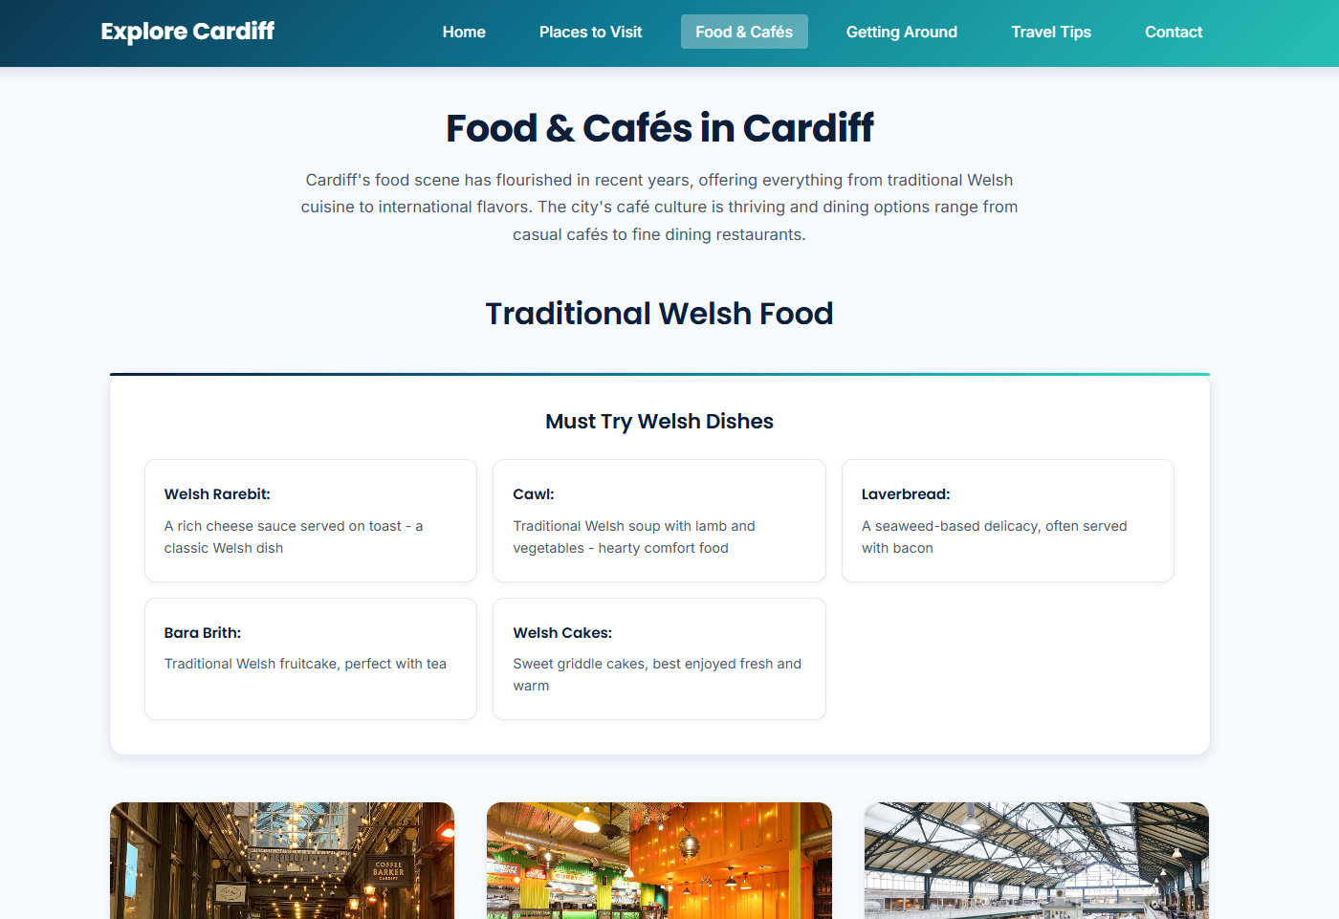
Figure S3: Food & Cafés page (food.html)
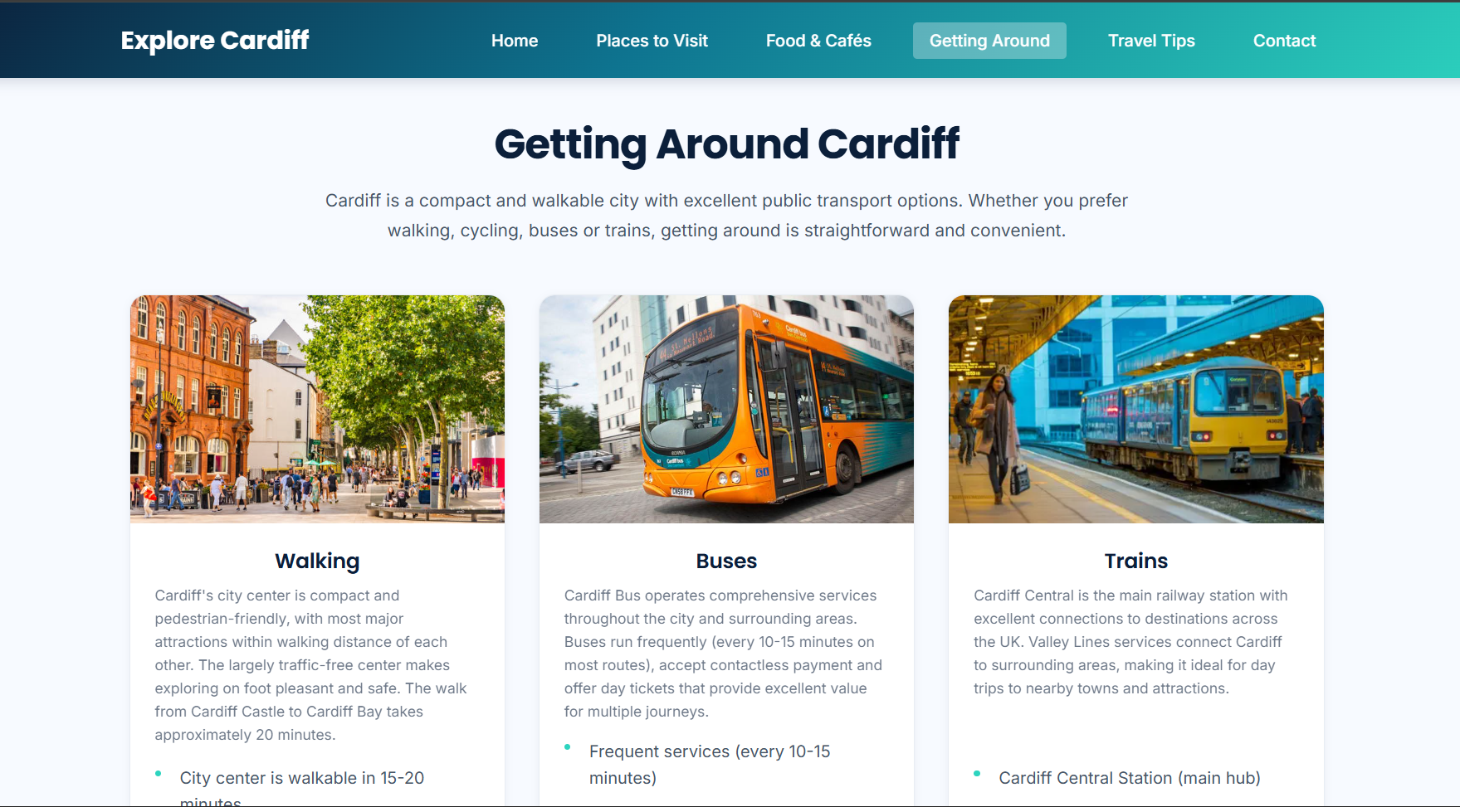
Figure S4: Getting Around page (transport.html)
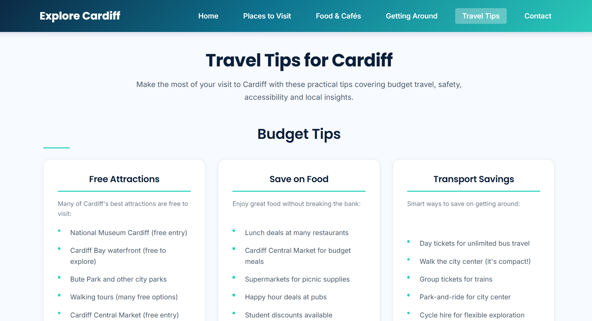
Figure S5: Travel Tips page (tips.html)

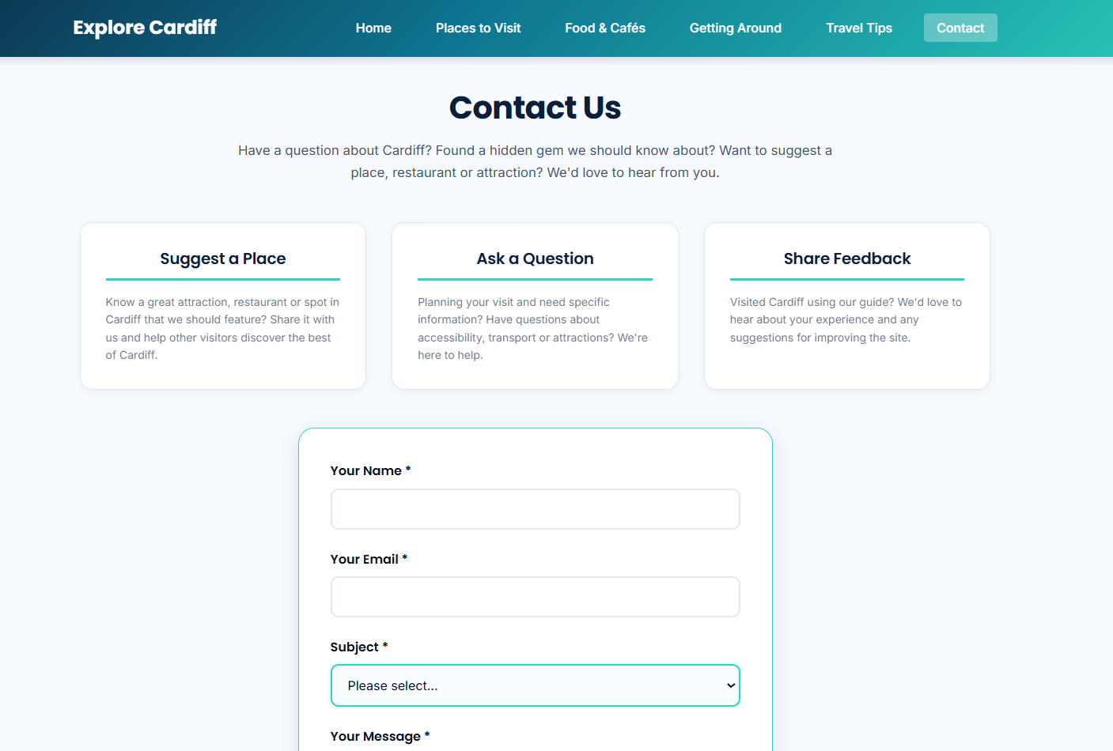
Figure S6: Contact page (contact.html)

4.3 HTML Validation Home Page
The home page was validated using the W3C HTML Validator (or an equivalent validator).
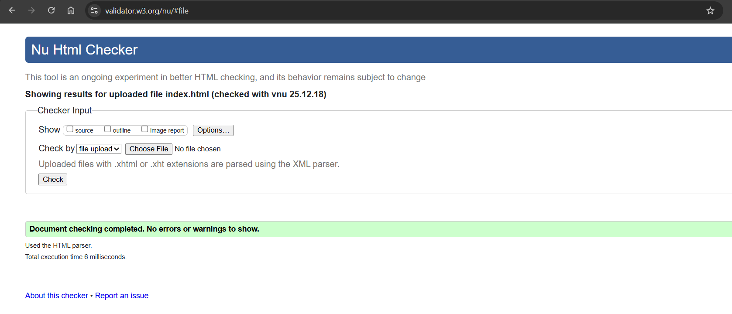
Figure V1: HTML validation results for index.html
The index.html home page was validated using the W3C HTML Validator (Nu HTML Checker). The validation completed successfully with no errors or warnings reported.

4.4 CSS Validation
The main stylesheet was validated using the W3C CSS Validator (or an equivalent validator).
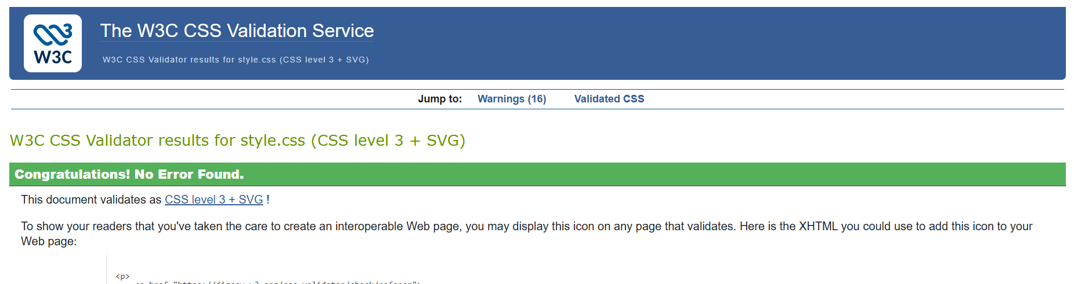
Figure V2: CSS validation results for style.css
The main stylesheet (style.css) was validated using the W3C CSS Validator. The validation reported no errors confirming the CSS is standards compliant.

4.5 Mobile Responsive Evidence
Responsive behaviour was checked using browser responsive tools such as Chrome DevTools device emulation.
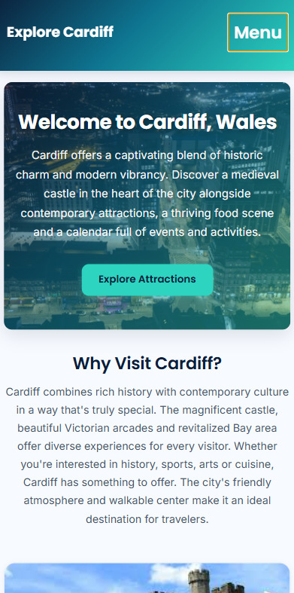
Figure M1: Home page at a mobile width
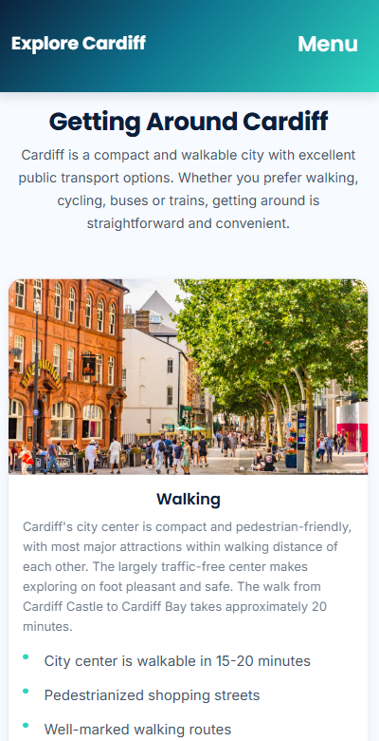
Figure M2: One content page (Places or Food) at a mobile width

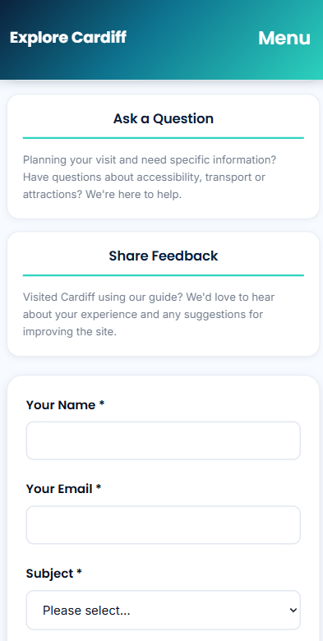
Figure M3: Contact page form layout at a mobile width

5. Evaluation

5.1 Usability
Usability refers to the efficiency and ease of accomplishment that users are able to achieve through using a system and their degree of satisfaction upon using it. Usability evaluation According to research on usability evaluation the structured methods of evaluation can be used to identify the problems of navigation undecipherability of the content and user unfriendly interface that decreases the success of the users.

5.1 Critique of this site
The site is good in terms of usability as the navigation is maintained throughout the site and there is less cognitive load to the user. The information is formatted in scannable parts which favour rapid reading. Task completion is also facilitated by the site as each page has a specific user target e.g. to select attractions to pick up a food or to get transport directions.
It is possible to add jump links or the anchors to the longer pages as they would enable the users to get to certain areas quicker. Top picks or featured items could also feature on more pages of the site as it would help make quick decisions among new people. Given more time to develop a basic filter or search option might have been given to lists which would enhance utility to users even more.

5.2 Accessibility (Research + Findings WCAG 2.1)
Accessibility is the capability of all the users and users with disabilities to perceive being able to operate, comprehend and in a dependable way access web materials. There are four principles: Perceivable Operable Understandable and Robust (POUR) of accessibility guidance in WCAG 2.1 groups.
The analysis of this site in terms of WCAG 2.1.
The Perceivable principle is supported on the site since information is arranged in headings and readable areas. The site must also make sure that every informative image has significant alternative texts and the informative images with decorative image have empty alt attributes to not distract users of a screen reader.
The Operable principle is supported by the site since the interactive components are supposed to be keyboard operational and the design has focus style. The site still needs some more enhancement because all links and buttons should have visible focus indicators.
The site complies with the principle of Understandable since it comprises straightforward language and regular patterns of layout of each page. The contact form enhances clarity as it has clear labels corresponding to each field of input.
The site also upholds the Robust principle as it has semantic HTML structures which enhance compatibility with the browsers and assistive technologies. Validation also helps in robustness by minimizing errors in markups that may lead to unpredictable behaviour

Accessibility tool evidence
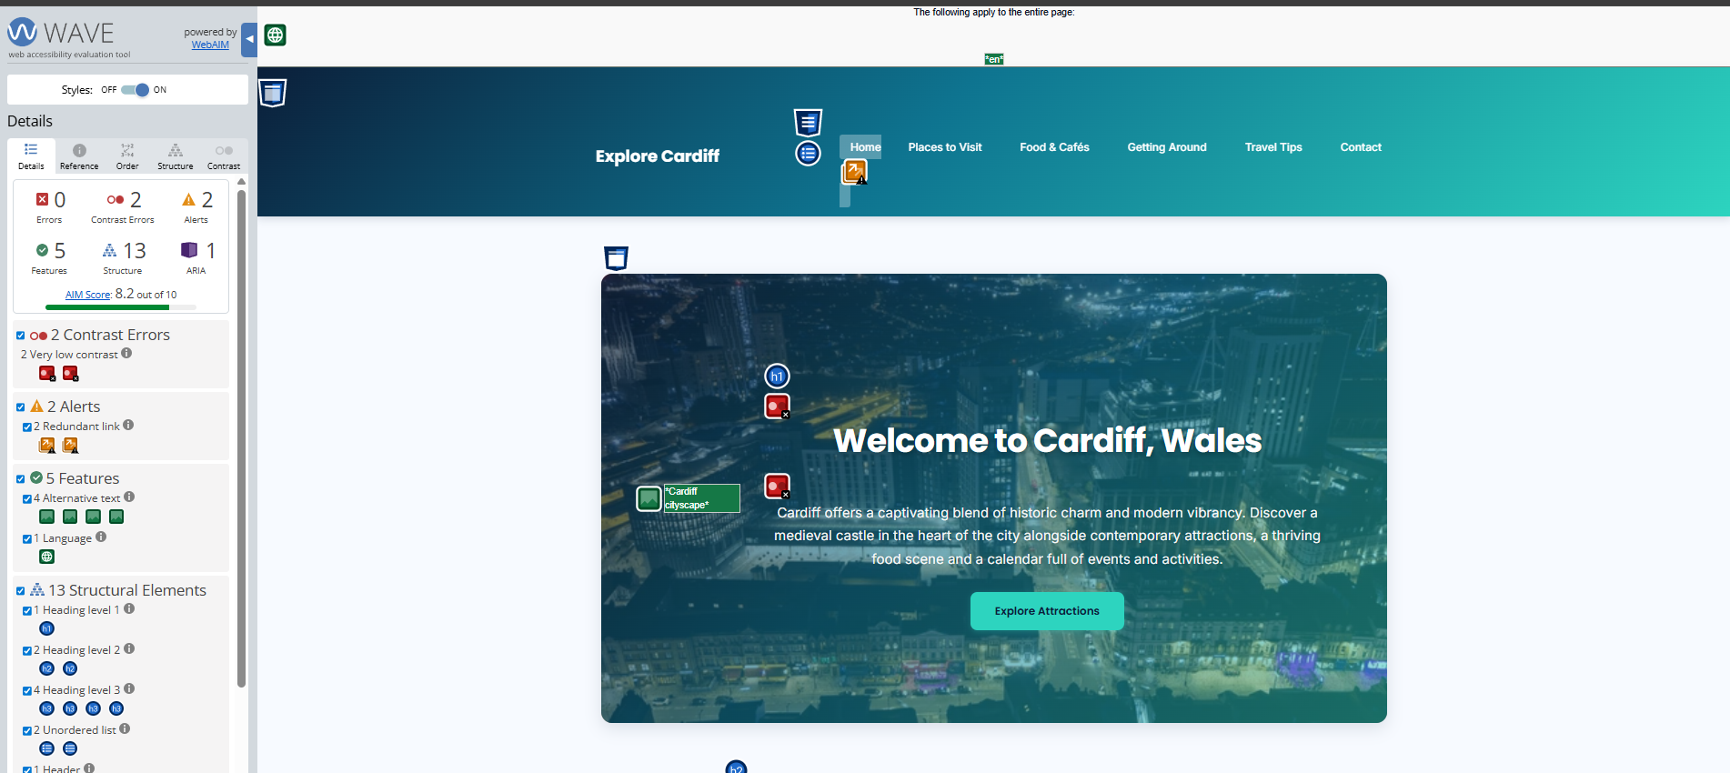
Figure A1: Accessibility scan results for your home page WAVE
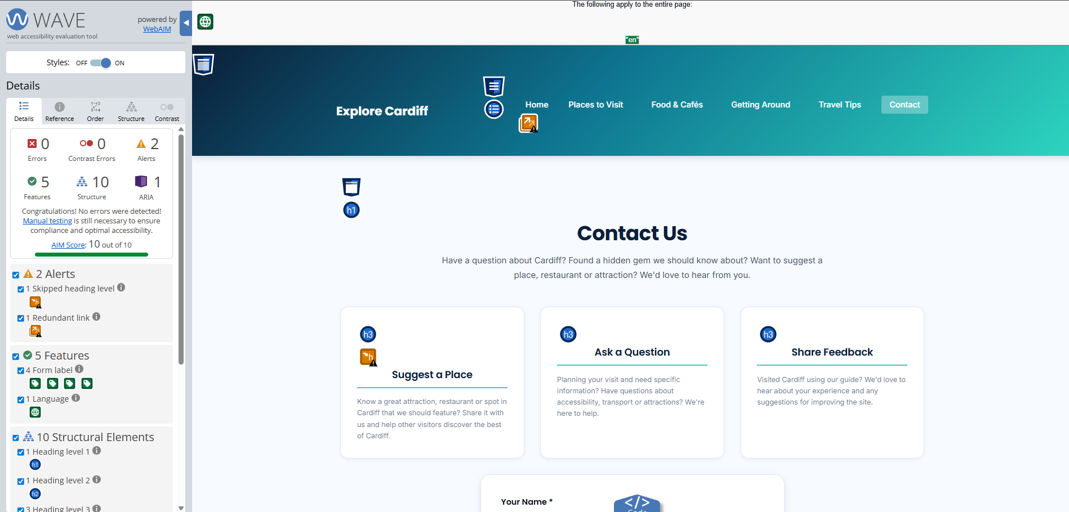
Figure A2: Accessibility scan results for your contact page
WAVE showed no errors severe enough in both pages and indicated the positive aspects on the page like there was a declaration of page language, proper hierarchy of headings and the appropriate names of form fields on the Contact page. Two contrast errors were displayed on the Home page and two alerts were displayed on the Contact page (a skipped heading level and redundant link). These are problems associated with WCAG 2.1 since low contrast is associated with the principle of Perceivable and heading/link structure is linked with Operable/Understandable navigation. I will correct this by enhancing colour contrast, fixing the order of headings, eliminating or renaming unnecessary links which will enhance accessibility outcomes.

5.3 Search engine optimisation (Research + Findings)
SEO has on page and technical activities that assist the search engines in knowing the topics of their pages and enabling users to access the relevant pages. On page SEO usually entails the provision of descriptive titles, meaningful headings and proper meta description that summarises page content.
An analysis of this site
The site employs the principles of on page SEO because it assigns each web page a distinctive title that aligns with the content of the web page. Meta descriptions are also included in the site and it summarises content and gives a clear preview of content in every page. The headings correspond to the central purpose of each page and they facilitate the readability and the search engine interpretation. Internal links are also regular and this is the result of the navigation supporting the crawlability and user flow.
Open Graph tags might be added to the site to ensure that the shared links have previews that can improve on social media. A simple sitemap file is also one of the best practices that the site might have. The content of the page could also be increased by adding more location specific phrases that are written normally in headings and introductory text but no key word stuffing was done.

6. Comparative Appraisal

6.1 Chosen Websites
Two comparable real life tourism websites were selected to be compared. The first site is Visit Cardiff which is the official tourism site of Cardiff. The second site is Visit Bristol which is an official Bristol tourism site.

6.2 Comparison Criteria
The usability, accessibility, SEO and mobile friendliness are the points of comparison. A comparison of usability is done by examining layout clarity of navigation readability and organisational of the content. It is compared to accessibility through the execution of the identical accessibility tool on both websites and correlating the results with principles of WCAG 2.1. The basic inspection of titles meta descriptions headings and image handling practices is used to compare SEO. Mobile friendliness is tested by running the websites at the mobile widths by using the browser responsiveness tools.

6.3 Results Summary

6.3.1 Usability
Visit Cardiff has good branding and provides a huge content which caters to the needs of many visitors. Nevertheless some pages may seem heavy because of the vast content to the new visitors. The Visit Bristol is well navigated and offers all the necessary information as well however the information architecture can be harder to get familiar with by the users who have not explored the site as much. Comparatively the coursework site is less complicated and easier to scan fast though the content is not as depth laden as the official pages.

6.3.2 Accessibility
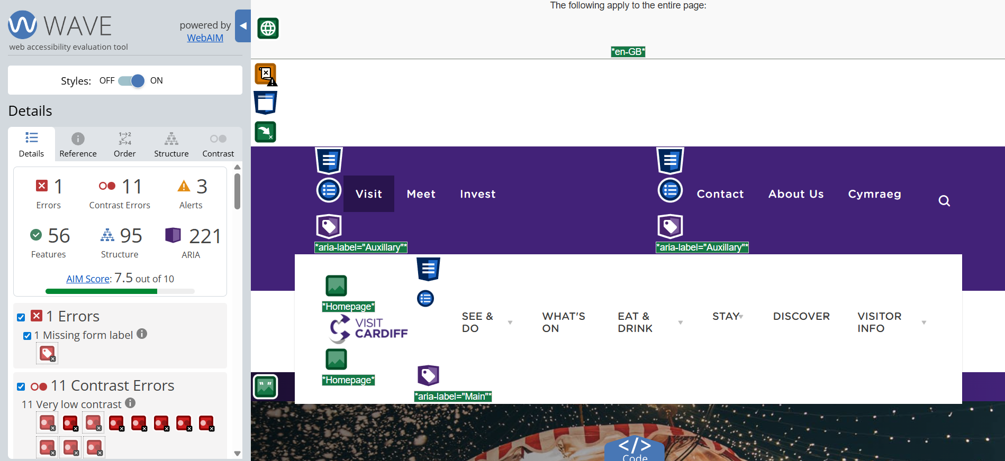
Figure C1: Accessibility scan of Visit Cardiff (home page)
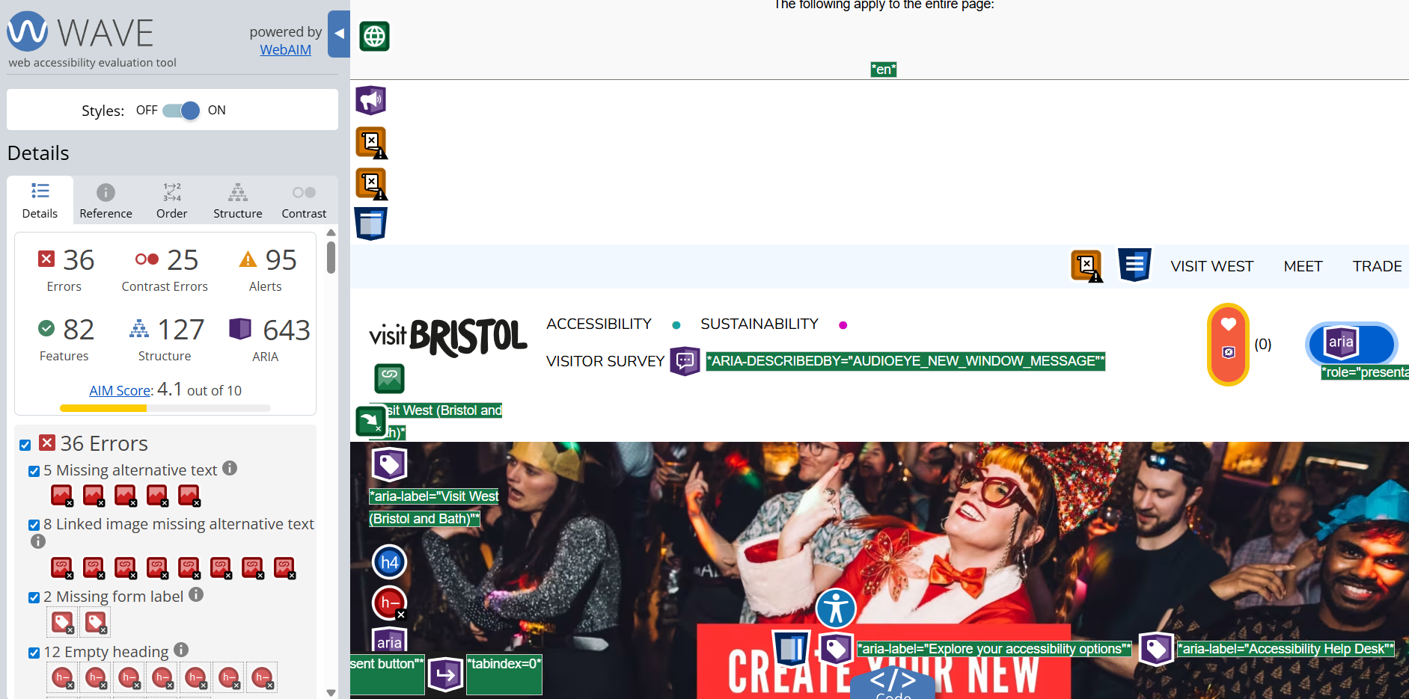
Figure C2: Accessibility scan of Visit Bristol (home page)
WAVE has indicated that Visit Cardiff has 1 error 11 contrast errors and 3 alerts and numerous elements that are related to accessibility. Low contrast was extremely low and the lack of a form label was the key issue and they are connected to WCAG 2.1 since the former impacts Perceivable and the latter is Operable/Understandable use by the screen reader users. WAVE showed that Visit Bristol contains 36 mistakes, 25 contrast mistakes and 95 warnings such as the lack of alt text form labels or empty headings that influence the structure of Perceivable and Understandable. In general the coursework site is more suitable in the aspects of simplicity of accessibility (less problems) whereas the official sites are more complicated and hence a greater number of the tool detected problems are indicated.

6.3.3 SEO
Visit Cardiff and Visit Bristol both have distinct branding structured navigation and description headings which assist search engines in the interpretation of page contents and enhances the crawling capability. The coursework site has good on page SEO (understandable titles/headings and straightforward inner connections) though the authority and the depth of the content are less effective due to the presence of multiple pages and the power of internal connections in the official sites.

6.3.4 Mobile friendliness

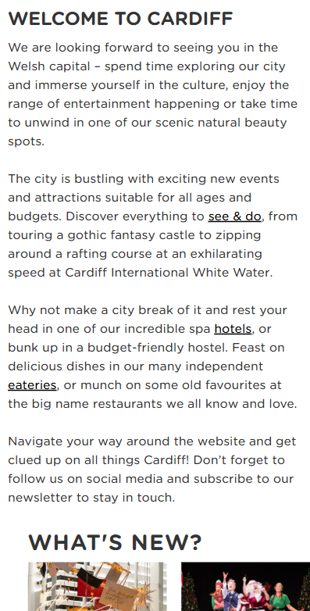
Figure C3: Visit Cardiff on mobile width
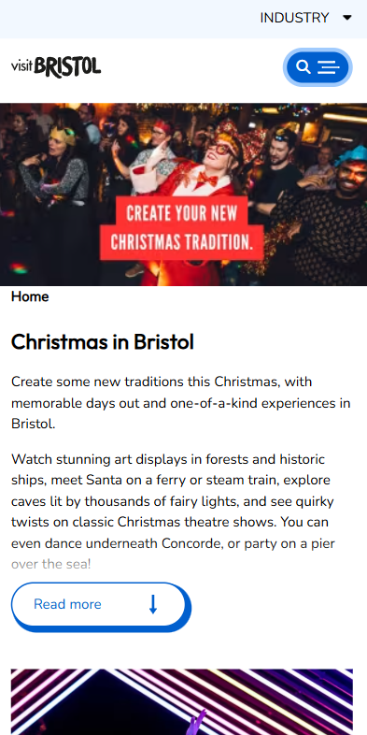
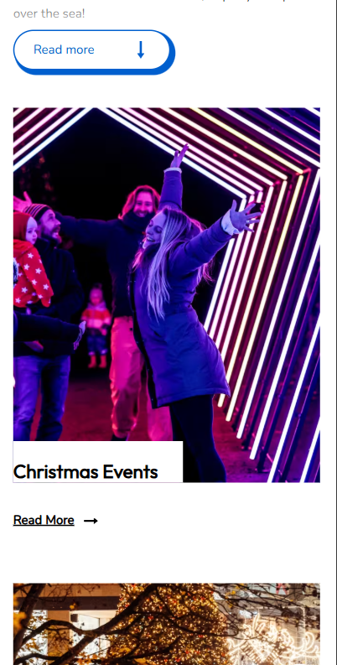
Figure C4: Visit Bristol on mobile width
Visit Cardiff and Visit Bristol have both adopted compact designs and vertically stacked layouts on their mobile apps which are well matched to the screen. Visit Cardiff is not visually cluttered and contains a lot of content and therefore the user might scroll further and Visit Bristol appears readable yet could look crowded with huge photos and numerous blocks of content. The coursework site is also easier to browse on the phone and scan the information in a few seconds and it can be refined further by maintaining a similar behaviour of the menu and making tap targets big enough.

6.4 Overall comparison.
Generally the official sites are very strong because of the richness of content and authority of the organisation. Nevertheless the coursework site is effective because of its plainness and easy to scan design. Coursework website can be brought a step closer to a professional tourism standard without becoming heavyweight by making changes to it: adding skip links, enhancing the mobile menu button with better ARIA support and adding richer content sections.

7. Conclusion
Explore Cardiff Wales site satisfies the target of producing a responsive multi page and standalone city guide. The site has a uniform design navigation and systematic content that facilitates usability. The implementation with awareness of accessibility is observable in the areas of semantic structure and labelling of forms and may be enhanced further by applying WCAG 2.1 advice and evidence provided by tools. The site uses the rules of on page SEO in the form of unique titles, meta descriptions and headings. Compared to other websites in tourism of the same kind the official sites are larger in terms of content and authority whereas the coursework site offers a more simplified and user friendly experience that can be refined further with a few improvements.

9. References
[1] R. Bastardo J. Pavão and N. P. Rocha “Methodological Quality of User Centered Usability Evaluation of Digital Applications to Promote Citizens’ Engagement and Participation in Public Governance: A Systematic Literature Review” Digital vol. 4 no. 3 pp. 740–761 2024 doi: 10.3390/digital4030038.

[2] J. Ara C. Sik Lányi and A. Kelemen “Accessibility engineering in web evaluation process: a systematic literature review” Universal Access in the Information Society vol. 23 no. 2 pp. 653–686 2024 doi: 10.1007/s10209 023 00967 2.

[3] W3C “Web Content Accessibility Guidelines (WCAG) 2.1” Jun. 2018. [Online]. Available: https://www.w3.org/TR/WCAG21/

[4] C. Álvarez García “Relevance of Meta Tags and Search Engine Optimisation (SEO) Strategies in Web Localisation” Íkala Revista de Lenguaje y Cultura vol. 30 no. 2 2025 doi: 10.17533/udea.ikala.356108.

[5] Google Search Central “Meta tags and attributes that Google supports.” [Online]. Available: https://developers.google.com/search/docs/crawling indexing/special tags

[6] Visit Cardiff “Visit Cardiff - Official tourist information site.” [Online]. Available: https://www.visitcardiff.com/

[7] Visit Bristol “Visit Bristol - Official tourist information site.” [Online]. Available: https://visitbristol.co.uk/

10. Appendices

Appendix A: HTML Code Listings
A1. index.html
<!DOCTYPE html>
<html lang="en">
<head>
<meta charset="UTF-8">
<meta name="viewport" content="width=device-width, initial-scale=1.0">
<meta name="description" content="Explore Cardiff, Wales - Your complete guide to attractions, food, transport and tips for visiting the capital city of Wales">
<title>Explore Cardiff, Wales - Your Complete City Guide</title>
<link rel="stylesheet" href="css/style.css">
</head>
<body>
<header>
<div class="header-container">
<a href="index.html" class="logo">Explore Cardiff</a>
<nav>
<button class="menu-toggle" aria-label="Toggle menu"></button>
<ul id="nav-menu">
<li><a href="index.html" class="active">Home</a></li>
<li><a href="places.html">Places to Visit</a></li>
<li><a href="food.html">Food & Cafés</a></li>
<li><a href="transport.html">Getting Around</a></li>
<li><a href="tips.html">Travel Tips</a></li>
<li><a href="contact.html">Contact</a></li>
</ul>
</nav>
</div>
</header>

<main>
<section class="hero">
<img src="images/cardiff-banner.jpg" alt="Cardiff cityscape" class="hero-image" onerror="this.style.display='none'">
<div class="hero-content">
<h1>Welcome to Cardiff, Wales</h1>
<p>Cardiff offers a captivating blend of historic charm and modern vibrancy. Discover a medieval castle in the heart of the city alongside contemporary attractions, a thriving food scene and a calendar full of events and activities.</p>
<a href="places.html" class="btn">Explore Attractions</a>
</div>
</section>

<section class="intro-section">
<h2>Why Visit Cardiff?</h2>
<p>Cardiff combines rich history with contemporary culture in a way that's truly special. The magnificent castle, beautiful Victorian arcades and revitalized Bay area offer diverse experiences for every visitor. Whether you're interested in history, sports, arts or cuisine, Cardiff has something to offer. The city's friendly atmosphere and walkable center make it an ideal destination for travelers.</p>
</section>

<div class="card-grid">
<article class="card">
<img src="images/cardiff-castle.jpg" alt="Cardiff Castle" onerror="this.style.display='none'">
<div class="card-content">
<h3>Historic Attractions</h3>
<p>Explore Cardiff Castle with its impressive Victorian interiors and Roman foundations or visit Castell Coch, a fairytale-like castle in the hills. The National Museum offers free entry and fascinating collections spanning art, history and natural sciences.</p>
<a href="places.html" class="btn btn-secondary">Discover More</a>
</div>
</article>

<article class="card">
<img src="images/cardiff-food.jpg" alt="Welsh cuisine" onerror="this.style.display='none'">
<div class="card-content">
<h3>Food & Drink</h3>
<p>Experience traditional Welsh cuisine, from Welsh rarebit to fresh local seafood. Cardiff's dining scene ranges from cozy cafés and traditional pubs to award-winning restaurants, offering something for every taste and budget.</p>
<a href="food.html" class="btn btn-secondary">Explore Food</a>
</div>
</article>

<article class="card">
<img src="images/cardiff-transport.jpg" alt="Cardiff transport" onerror="this.style.display='none'">
<div class="card-content">
<h3>Easy Transport</h3>
<p>Cardiff's compact city center is easily walkable, with excellent public transport options including buses and trains. Bike hire schemes are available and our transport guide will help you navigate the city efficiently.</p>
<a href="transport.html" class="btn btn-secondary">Transport Guide</a>
</div>
</article>
</div>

<section class="cta">
<h2>Planning Your Visit?</h2>
<p>Our travel tips section provides practical advice on budget travel, safety, accessibility and local insights to help you make the most of your Cardiff experience.</p>
<a href="tips.html" class="btn">View Travel Tips</a>
</section>

<section class="info-box">
<h3>Quick Facts About Cardiff</h3>
<ul class="features">
<li>Cardiff became the capital of Wales in 1955</li>
<li>Home to over 350,000 residents</li>
<li>Cardiff Castle dates back to Roman times</li>
<li>Famous for rugby, home to the Principality Stadium</li>
<li>Over 1,000 listed buildings throughout the city</li>
</ul>
</section>
</main>

<footer>
<p>&copy; 2024 Explore Cardiff, Wales. All rights reserved.</p>
<p>Have a suggestion? <a href="contact.html">Contact us</a> to share your favorite Cardiff spots!</p>
</footer>

<script>
const menuToggle = document.querySelector('.menu-toggle');
const navMenu = document.getElementById('nav-menu');

if (menuToggle) {
menuToggle.addEventListener('click', function() {
navMenu.classList.toggle('active');
});
}
</script>
</body>
</html>

A2. places.html
<!DOCTYPE html>
<html lang="en">
<head>
<meta charset="UTF-8">
<meta name="viewport" content="width=device-width, initial-scale=1.0">
<meta name="description" content="Discover the best places to visit in Cardiff, Wales - from historic castles to modern attractions">
<title>Places to Visit - Explore Cardiff, Wales</title>
<link rel="stylesheet" href="css/style.css">
</head>
<body>
<header>
<div class="header-container">
<a href="index.html" class="logo">Explore Cardiff</a>
<nav>
<button class="menu-toggle" aria-label="Toggle menu"></button>
<ul id="nav-menu">
<li><a href="index.html">Home</a></li>
<li><a href="places.html" class="active">Places to Visit</a></li>
<li><a href="food.html">Food & Cafés</a></li>
<li><a href="transport.html">Getting Around</a></li>
<li><a href="tips.html">Travel Tips</a></li>
<li><a href="contact.html">Contact</a></li>
</ul>
</nav>
</div>
</header>

<main>
<h1>Places to Visit in Cardiff</h1>
<p class="intro-section">Cardiff is home to an impressive range of attractions, from medieval castles to world-class museums. Here are the essential places to visit during your stay, including well-known landmarks and hidden gems.</p>

<div class="card-grid">
<article class="card">
<img src="images/cardiff-castle.jpg" alt="Cardiff Castle" onerror="this.style.display='none'">
<div class="card-content">
<h3>Cardiff Castle</h3>
<p>Cardiff Castle spans over 2,000 years of history. The Victorian Gothic interiors feature ornate decorations, while Roman walls remain visible. The extensive grounds provide a peaceful retreat in the city center.</p>
<p><strong>Location:</strong> Castle Street, CF10 3RB</p>
<p><strong>Opening Hours:</strong> Daily 9:00 AM - 6:00 PM</p>
</div>
</article>

<article class="card">
<img src="images/st-fagans.jpg" alt="St Fagans National Museum" onerror="this.style.display='none'">
<div class="card-content">
<h3>St Fagans National Museum</h3>
<p>This free open-air museum showcases Welsh life through the centuries. Historic buildings from across Wales have been carefully relocated here, allowing visitors to step inside and experience traditional Welsh culture. The beautiful gardens and traditional crafts demonstrations make it enjoyable for all ages.</p>
<p><strong>Location:</strong> St Fagans, CF5 6XB</p>
<p><strong>Opening Hours:</strong> Daily 10:00 AM - 5:00 PM</p>
</div>
</article>

<article class="card">
<img src="images/principality-stadium.jpg" alt="Principality Stadium" onerror="this.style.display='none'">
<div class="card-content">
<h3>Principality Stadium</h3>
<p>Home of Welsh rugby, this iconic stadium offers fascinating guided tours. Walk through the players' tunnel, visit the changing rooms and learn about Wales' rich rugby heritage. Tours are popular, so advance booking is recommended.</p>
<p><strong>Location:</strong> Westgate Street, CF10 1NS</p>
<p><strong>Tours:</strong> Available daily, book in advance</p>
</div>
</article>

<article class="card">
<img src="images/bay.jpg" alt="Cardiff Bay" onerror="this.style.display='none'">
<div class="card-content">
<h3>Cardiff Bay</h3>
<p>Once the world's largest coal-exporting port, Cardiff Bay has been transformed into a vibrant waterfront destination. The striking Wales Millennium Centre hosts world-class performances, while restaurants, bars and boat trips offer plenty of ways to enjoy this revitalized area.</p>
<p><strong>Location:</strong> Cardiff Bay, CF10 5AL</p>
<p><strong>Access:</strong> Free to explore, various attractions</p>
</div>
</article>

<article class="card">
<img src="images/national-museum.jpg" alt="National Museum Cardiff" onerror="this.style.display='none'">
<div class="card-content">
<h3>National Museum Cardiff</h3>
<p>This free museum houses impressive collections of art, natural history and archaeology. Highlights include an excellent Impressionist painting collection, dinosaur skeletons and engaging exhibitions on Welsh history and culture. Allow at least two hours to explore.</p>
<p><strong>Location:</strong> Cathays Park, CF10 3NP</p>
<p><strong>Opening Hours:</strong> Tuesday-Sunday 10:00 AM - 5:00 PM</p>
</div>
</article>

<article class="card">
<img src="images/arcades.jpg" alt="Cardiff Arcades" onerror="this.style.display='none'">
<div class="card-content">
<h3>Victorian Arcades</h3>
<p>Cardiff's Victorian and Edwardian shopping arcades feature stunning architecture with ornate glass roofs. These covered walkways house independent shops, charming cafés and unique boutiques, making them perfect for browsing and enjoying a coffee break.</p>
<p><strong>Location:</strong> City Centre (Castle Arcades, High Street Arcade, etc.)</p>
<p><strong>Access:</strong> Free, shops have individual hours</p>
</div>
</article>
</div>

<section class="cta">
<h2>Share Your Favorite Cardiff Spot</h2>
<p>Found a hidden gem we should know about? We'd love to hear from you and help other visitors discover the best of Cardiff.</p>
<a href="contact.html" class="btn">Suggest a Place</a>
</section>
</main>

<footer>
<p>&copy; 2024 Explore Cardiff, Wales. All rights reserved.</p>
<p>Have a suggestion? <a href="contact.html">Contact us</a> to share your favorite Cardiff spots!</p>
</footer>

<script>
const menuToggle = document.querySelector('.menu-toggle');
const navMenu = document.getElementById('nav-menu');

if (menuToggle) {
menuToggle.addEventListener('click', function() {
navMenu.classList.toggle('active');
});
}
</script>
</body>
</html>

A3. food.html
<!DOCTYPE html>
<html lang="en">
<head>
<meta charset="UTF-8">
<meta name="viewport" content="width=device-width, initial-scale=1.0">
<meta name="description" content="Discover the best food and cafés in Cardiff, Wales - from traditional Welsh cuisine to modern dining">
<title>Food & Cafés - Explore Cardiff, Wales</title>
<link rel="stylesheet" href="css/style.css">
</head>
<body>
<header>
<div class="header-container">
<a href="index.html" class="logo">Explore Cardiff</a>
<nav>
<button class="menu-toggle" aria-label="Toggle menu"></button>
<ul id="nav-menu">
<li><a href="index.html">Home</a></li>
<li><a href="places.html">Places to Visit</a></li>
<li><a href="food.html" class="active">Food & Cafés</a></li>
<li><a href="transport.html">Getting Around</a></li>
<li><a href="tips.html">Travel Tips</a></li>
<li><a href="contact.html">Contact</a></li>
</ul>
</nav>
</div>
</header>

<main>
<h1>Food & Cafés in Cardiff</h1>
<p class="intro-section">Cardiff's food scene has flourished in recent years, offering everything from traditional Welsh cuisine to international flavors. The city's café culture is thriving and dining options range from casual cafés to fine dining restaurants.</p>

<section>
<h2>Traditional Welsh Food</h2>
<div class="info-box">
<h3>Must Try Welsh Dishes</h3>
<ul class="features">
<li><strong>Welsh Rarebit:</strong> A rich cheese sauce served on toast - a classic Welsh dish</li>
<li><strong>Cawl:</strong> Traditional Welsh soup with lamb and vegetables - hearty comfort food</li>
<li><strong>Laverbread:</strong> A seaweed-based delicacy, often served with bacon</li>
<li><strong>Bara Brith:</strong> Traditional Welsh fruitcake, perfect with tea</li>
<li><strong>Welsh Cakes:</strong> Sweet griddle cakes, best enjoyed fresh and warm</li>
</ul>
</div>
</section>

<div class="card-grid">
<article class="card">
<img src="images/cafe.jpg" alt="Cardiff café" onerror="this.style.display='none'">
<div class="card-content">
<h3>City Centre Cafés</h3>
<p>Cardiff's arcades and city center are home to numerous excellent cafés, from traditional tea rooms to modern artisan coffee shops. Perfect for breakfast, lunch or a relaxing break, many serve traditional Welsh cakes and Bara Brith.</p>
<p><strong>Best Areas:</strong> The Arcades, High Street, Queen Street</p>
<p><strong>Must Try:</strong> Welsh cakes, Bara Brith, local coffee roasters</p>
</div>
</article>

<article class="card">
<img src="images/restaurant.jpg" alt="Cardiff restaurant" onerror="this.style.display='none'">
<div class="card-content">
<h3>Fine Dining</h3>
<p>Cardiff boasts several award-winning restaurants offering modern Welsh cuisine and international flavors. Many focus on locally-sourced ingredients and seasonal menus. Fresh Welsh lamb and local seafood are particular highlights.</p>
<p><strong>Best Areas:</strong> Cardiff Bay, Pontcanna, City Centre</p>
<p><strong>Must Try:</strong> Fresh Welsh lamb, local seafood, craft cocktails</p>
</div>
</article>

<article class="card">
<img src="images/market.jpg" alt="Cardiff Market" onerror="this.style.display='none'">
<div class="card-content">
<h3>Cardiff Central Market</h3>
<p>This Victorian indoor market offers an authentic Cardiff experience. Sample local produce, enjoy budget-friendly meals from food stalls serving everything from Welsh specialties to international cuisine and soak up the traditional market atmosphere. Note: closed on Sundays.</p>
<p><strong>Location:</strong> St Mary Street, CF10 1AU</p>
<p><strong>Opening Hours:</strong> Monday-Saturday 8:00 AM - 5:30 PM</p>
</div>
</article>

<article class="card">
<img src="images/pub.jpg" alt="Welsh pub" onerror="this.style.display='none'">
<div class="card-content">
<h3>Traditional Pubs</h3>
<p>Cardiff's traditional pubs offer hearty food, local Welsh ales and a warm, friendly atmosphere. Many serve traditional Welsh dishes alongside classic pub favorites and Sunday roasts are particularly popular.</p>
<p><strong>Best Areas:</strong> City Centre, Pontcanna, Roath</p>
<p><strong>Must Try:</strong> Local Welsh ales, Sunday roasts, pub classics</p>
</div>
</article>

<article class="card">
<img src="images/street-food.jpg" alt="Street food" onerror="this.style.display='none'">
<div class="card-content">
<h3>Street Food & Markets</h3>
<p>Cardiff's street food scene has grown significantly, with regular markets, food festivals and pop-up events throughout the city. You'll find diverse cuisines from around the world, from Asian fusion to gourmet burgers.</p>
<p><strong>Best Areas:</strong> Cardiff Bay, various pop-up locations</p>
<p><strong>Must Try:</strong> Food festivals, weekend markets, food trucks</p>
</div>
</article>

<article class="card">
<img src="images/vegetarian.jpg" alt="Vegetarian food" onerror="this.style.display='none'">
<div class="card-content">
<h3>Vegetarian & Vegan Options</h3>
<p>Cardiff is very vegetarian and vegan-friendly, with most restaurants offering excellent plant-based options. Dedicated vegetarian and vegan cafés can be found throughout the city and some establishments even offer plant-based versions of traditional Welsh dishes.</p>
<p><strong>Best Areas:</strong> City Centre, Pontcanna, Roath</p>
<p><strong>Must Try:</strong> Plant-based Welsh dishes, vegan cafés, veggie markets</p>
</div>
</article>
</div>

<section class="cta">
<h2>Share Your Favorite Cardiff Eatery</h2>
<p>Found an amazing restaurant or café? We'd love to hear about it and help other food lovers discover Cardiff's culinary gems.</p>
<a href="contact.html" class="btn">Suggest a Restaurant</a>
</section>
</main>

<footer>
<p>&copy; 2024 Explore Cardiff, Wales. All rights reserved.</p>
<p>Have a suggestion? <a href="contact.html">Contact us</a> to share your favorite Cardiff spots!</p>
</footer>

<script>
const menuToggle = document.querySelector('.menu-toggle');
const navMenu = document.getElementById('nav-menu');

if (menuToggle) {
menuToggle.addEventListener('click', function() {
navMenu.classList.toggle('active');
});
}
</script>
</body>
</html>

A4. transport.html
<!DOCTYPE html>
<html lang="en">
<head>
<meta charset="UTF-8">
<meta name="viewport" content="width=device-width, initial-scale=1.0">
<meta name="description" content="Complete guide to getting around Cardiff, Wales - public transport, walking, cycling and more">
<title>Getting Around - Explore Cardiff, Wales</title>
<link rel="stylesheet" href="css/style.css">
</head>
<body>
<header>
<div class="header-container">
<a href="index.html" class="logo">Explore Cardiff</a>
<nav>
<button class="menu-toggle" aria-label="Toggle menu"></button>
<ul id="nav-menu">
<li><a href="index.html">Home</a></li>
<li><a href="places.html">Places to Visit</a></li>
<li><a href="food.html">Food & Cafés</a></li>
<li><a href="transport.html" class="active">Getting Around</a></li>
<li><a href="tips.html">Travel Tips</a></li>
<li><a href="contact.html">Contact</a></li>
</ul>
</nav>
</div>
</header>

<main>
<h1>Getting Around Cardiff</h1>
<p class="intro-section">Cardiff is a compact and walkable city with excellent public transport options. Whether you prefer walking, cycling, buses or trains, getting around is straightforward and convenient.</p>

<div class="card-grid">
<article class="card">
<img src="images/walking.jpg" alt="Walking in Cardiff" onerror="this.style.display='none'">
<div class="card-content">
<h3>Walking</h3>
<p>Cardiff's city center is compact and pedestrian-friendly, with most major attractions within walking distance of each other. The largely traffic-free center makes exploring on foot pleasant and safe. The walk from Cardiff Castle to Cardiff Bay takes approximately 20 minutes.</p>
<ul class="features">
<li>City center is walkable in 15-20 minutes</li>
<li>Pedestrianized shopping streets</li>
<li>Well-marked walking routes</li>
<li>Free walking tours available</li>
</ul>
</div>
</article>

<article class="card">
<img src="images/bus.jpg" alt="Cardiff buses" onerror="this.style.display='none'">
<div class="card-content">
<h3>Buses</h3>
<p>Cardiff Bus operates comprehensive services throughout the city and surrounding areas. Buses run frequently (every 10-15 minutes on most routes), accept contactless payment and offer day tickets that provide excellent value for multiple journeys.</p>
<ul class="features">
<li>Frequent services (every 10-15 minutes)</li>
<li>Contactless payment accepted</li>
<li>Day tickets available</li>
<li>Routes to Cardiff Bay, suburbs and beyond</li>
</ul>
</div>
</article>

<article class="card">
<img src="images/train.jpg" alt="Cardiff trains" onerror="this.style.display='none'">
<div class="card-content">
<h3>Trains</h3>
<p>Cardiff Central is the main railway station with excellent connections to destinations across the UK. Valley Lines services connect Cardiff to surrounding areas, making it ideal for day trips to nearby towns and attractions.</p>
<ul class="features">
<li>Cardiff Central Station (main hub)</li>
<li>Valley Lines for local travel</li>
<li>Direct services to London, Bristol, Manchester</li>
<li>Cardiff Bay station for waterfront area</li>
</ul>
</div>
</article>

<article class="card">
<img src="images/cycling.jpg" alt="Cycling in Cardiff" onerror="this.style.display='none'">
<div class="card-content">
<h3>Cycling</h3>
<p>Cardiff is becoming increasingly cycle-friendly with dedicated cycle lanes and bike hire schemes such as Nextbike. Cycling is an excellent way to explore attractions slightly further out, including Cardiff Bay and St Fagans, with improving infrastructure making routes safer and more accessible.</p>
<ul class="features">
<li>Nextbike hire scheme available</li>
<li>Dedicated cycle paths</li>
<li>Bike-friendly routes to Cardiff Bay</li>
<li>Cycling maps available</li>
</ul>
</div>
</article>

<article class="card">
<img src="images/taxi.jpg" alt="Taxis in Cardiff" onerror="this.style.display='none'">
<div class="card-content">
<h3>Taxis & Ride-Sharing</h3>
<p>Taxis are readily available throughout Cardiff, particularly in the city center. You can hail them on the street, book by phone or use ride-sharing apps. Taxis are useful for late-night travel or when carrying luggage and accessible taxis are available for those who need them.</p>
<ul class="features">
<li>24/7 taxi services</li>
<li>Ride-sharing apps available</li>
<li>Fixed rates from airport</li>
<li>Accessible taxis available</li>
</ul>
</div>
</article>

<article class="card">
<img src="images/car.jpg" alt="Driving in Cardiff" onerror="this.style.display='none'">
<div class="card-content">
<h3>Driving</h3>
<p>While Cardiff is walkable, having a car can be useful for exploring beyond the city center. However, city center parking is limited and can be expensive. Park-and-ride services offer a convenient alternative for city center visits, while a car is ideal for day trips to surrounding areas.</p>
<ul class="features">
<li>Park-and-ride services available</li>
<li>City center parking restrictions</li>
<li>Good for day trips</li>
<li>Car hire available</li>
</ul>
</div>
</article>
</div>

<section class="info-box">
<h3>Transport Tips</h3>
<ul class="features">
<li><strong>Cardiff Bus Day Ticket:</strong> Unlimited travel for one day - excellent value if using buses multiple times</li>
<li><strong>Free City Center Shuttle:</strong> Free bus service connecting key areas (check current availability)</li>
<li><strong>Travel Cards:</strong> Multi-day passes available for longer stays</li>
<li><strong>Mobile Apps:</strong> Use transport apps for real-time information and route planning</li>
<li><strong>Accessibility:</strong> Most buses and trains are wheelchair accessible - contact operators in advance for specific needs</li>
</ul>
</section>

<section class="cta">
<h2>Plan Your Cardiff Journey</h2>
<p>For more information on accessibility, budget options and practical travel advice, visit our travel tips page.</p>
<a href="tips.html" class="btn">View Travel Tips</a>
</section>
</main>

<footer>
<p>&copy; 2024 Explore Cardiff, Wales. All rights reserved.</p>
<p>Have a suggestion? <a href="contact.html">Contact us</a> to share your favorite Cardiff spots!</p>
</footer>

<script>
const menuToggle = document.querySelector('.menu-toggle');
const navMenu = document.getElementById('nav-menu');

if (menuToggle) {
menuToggle.addEventListener('click', function() {
navMenu.classList.toggle('active');
});
}
</script>
</body>
</html>

A5. tips.html
<!DOCTYPE html>
<html lang="en">
<head>
<meta charset="UTF-8">
<meta name="viewport" content="width=device-width, initial-scale=1.0">
<meta name="description" content="Essential travel tips for visiting Cardiff, Wales - budget advice, safety tips and accessibility information">
<title>Travel Tips - Explore Cardiff, Wales</title>
<link rel="stylesheet" href="css/style.css">
</head>
<body>
<header>
<div class="header-container">
<a href="index.html" class="logo">Explore Cardiff</a>
<nav>
<button class="menu-toggle" aria-label="Toggle menu"></button>
<ul id="nav-menu">
<li><a href="index.html">Home</a></li>
<li><a href="places.html">Places to Visit</a></li>
<li><a href="food.html">Food & Cafés</a></li>
<li><a href="transport.html">Getting Around</a></li>
<li><a href="tips.html" class="active">Travel Tips</a></li>
<li><a href="contact.html">Contact</a></li>
</ul>
</nav>
</div>
</header>

<main>
<h1>Travel Tips for Cardiff</h1>
<p class="intro-section">Make the most of your visit to Cardiff with these practical tips covering budget travel, safety, accessibility and local insights.</p>

<section class="tips-section">
<h2>Budget Tips</h2>
<div class="card-grid">
<article class="card card-text-only">
<div class="card-content">
<h3>Free Attractions</h3>
<p>Many of Cardiff's best attractions are free to visit:</p>
<ul class="features">
<li>National Museum Cardiff (free entry)</li>
<li>Cardiff Bay waterfront (free to explore)</li>
<li>Bute Park and other city parks</li>
<li>Walking tours (many free options)</li>
<li>Cardiff Central Market (free entry)</li>
</ul>
</div>
</article>

<article class="card card-text-only">
<div class="card-content">
<h3>Save on Food</h3>
<p>Enjoy great food without breaking the bank:</p>
<ul class="features">
<li>Lunch deals at many restaurants</li>
<li>Cardiff Central Market for budget meals</li>
<li>Supermarkets for picnic supplies</li>
<li>Happy hour deals at pubs</li>
<li>Student discounts available</li>
</ul>
</div>
</article>

<article class="card card-text-only">
<div class="card-content">
<h3>Transport Savings</h3>
<p>Smart ways to save on getting around:</p>
<ul class="features">
<li>Day tickets for unlimited bus travel</li>
<li>Walk the city center (it's compact!)</li>
<li>Group tickets for trains</li>
<li>Park-and-ride for city center</li>
<li>Cycle hire for flexible exploration</li>
</ul>
</div>
</article>
</div>
</section>

<section class="tips-section">
<h2>Safety Tips</h2>
<div class="info-box">
<h3>Staying Safe in Cardiff</h3>
<ul class="features">
<li><strong>General Safety:</strong> Cardiff is generally a safe city, but use common sense - keep valuables secure, especially in crowded areas</li>
<li><strong>Night Safety:</strong> Stick to well-lit areas at night, travel in groups when possible and use licensed taxis</li>
<li><strong>Emergency Numbers:</strong> 999 for emergencies, 101 for non-emergency police</li>
<li><strong>Personal Belongings:</strong> Keep bags zipped and close to you, especially in markets and busy areas</li>
<li><strong>Weather:</strong> Wales is known for rain - always carry an umbrella or waterproof jacket</li>
</ul>
</div>
</section>

<section class="tips-section">
<h2>Accessibility</h2>
<div class="card-grid">
<article class="card card-text-only">
<div class="card-content">
<h3>Getting Around</h3>
<ul class="features">
<li>Most buses are accessible</li>
<li>Train stations usually have step-free access</li>
<li>City center's pretty flat, which helps</li>
<li>You can get accessible taxis if needed</li>
<li>Blue Badge parking available in the center</li>
</ul>
</div>
</article>

<article class="card card-text-only">
<div class="card-content">
<h3>Attractions</h3>
<ul class="features">
<li>Most places have accessibility info on their websites</li>
<li>Museums are usually pretty good for access</li>
<li>Worth ringing ahead if you've got specific needs</li>
<li>Some of the older buildings can be tricky</li>
<li>Accessible toilets are around, but check where they are</li>
</ul>
</div>
</article>

<article class="card card-text-only">
<div class="card-content">
<h3>Additional Support</h3>
<ul class="features">
<li>Tourist info centers have accessibility maps if you need them</li>
<li>Lots of places have hearing loops</li>
<li>Guide dogs are welcome pretty much everywhere</li>
<li>Some places do audio guides - ask when you book</li>
<li>Check venue websites for specific details</li>
</ul>
</div>
</article>
</div>
</section>

<section class="tips-section">
<h2>Local Tips</h2>
<div class="info-box">
<h3>Insider Knowledge</h3>
<ul class="features">
<li><strong>Weather:</strong> Pack layers - Welsh weather can change quickly. Always have a waterproof jacket</li>
<li><strong>Language:</strong> English is widely spoken, but you'll see Welsh language signs - it's the official language alongside English</li>
<li><strong>Tipping:</strong> 10-15% in restaurants is standard if service charge isn't included</li>
<li><strong>Opening Hours:</strong> Many shops close earlier on Sundays, some attractions have different winter hours</li>
<li><strong>Rugby:</strong> If visiting during rugby season, book accommodation early - the city gets very busy</li>
<li><strong>Markets:</strong> Cardiff Central Market is closed on Sundays, plan accordingly</li>
<li><strong>Student Discounts:</strong> Many attractions offer student discounts - always ask!</li>
</ul>
</div>
</section>

<section class="cta">
<h2>Have Questions?</h2>
<p>If you have specific questions about visiting Cardiff or need more detailed information, feel free to get in touch.</p>
<a href="contact.html" class="btn">Contact Us</a>
</section>
</main>

<footer>
<p>&copy; 2024 Explore Cardiff, Wales. All rights reserved.</p>
<p>Have a suggestion? <a href="contact.html">Contact us</a> to share your favorite Cardiff spots!</p>
</footer>

<script>
const menuToggle = document.querySelector('.menu-toggle');
const navMenu = document.getElementById('nav-menu');

if (menuToggle) {
menuToggle.addEventListener('click', function() {
navMenu.classList.toggle('active');
});
}
</script>
</body>
</html>

A6. contact.html

<!DOCTYPE html>
<html lang="en">
<head>
<meta charset="UTF-8">
<meta name="viewport" content="width=device-width, initial-scale=1.0">
<meta name="description" content="Contact us or suggest your favorite places in Cardiff, Wales">
<title>Contact - Explore Cardiff, Wales</title>
<link rel="stylesheet" href="css/style.css">
</head>
<body>
<header>
<div class="header-container">
<a href="index.html" class="logo">Explore Cardiff</a>
<nav>
<button class="menu-toggle" aria-label="Toggle menu"></button>
<ul id="nav-menu">
<li><a href="index.html">Home</a></li>
<li><a href="places.html">Places to Visit</a></li>
<li><a href="food.html">Food & Cafés</a></li>
<li><a href="transport.html">Getting Around</a></li>
<li><a href="tips.html">Travel Tips</a></li>
<li><a href="contact.html" class="active">Contact</a></li>
</ul>
</nav>
</div>
</header>

<main>
<h1>Contact Us</h1>
<p class="intro-section">Have a question about Cardiff? Found a hidden gem we should know about? Want to suggest a place, restaurant or attraction? We'd love to hear from you.</p>

<div>
<div class="card-grid">
<article class="card card-text-only">
<div class="card-content">
<h3>Suggest a Place</h3>
<p>Know a great attraction, restaurant or spot in Cardiff that we should feature? Share it with us and help other visitors discover the best of Cardiff.</p>
</div>
</article>

<article class="card card-text-only">
<div class="card-content">
<h3>Ask a Question</h3>
<p>Planning your visit and need specific information? Have questions about accessibility, transport or attractions? We're here to help.</p>
</div>
</article>

<article class="card card-text-only">
<div class="card-content">
<h3>Share Feedback</h3>
<p>Visited Cardiff using our guide? We'd love to hear about your experience and any suggestions for improving the site.</p>
</div>
</article>
</div>
</div>

<div>
<form action="#" method="post">
<div class="form-group">
<label for="name">Your Name *</label>
<input type="text" id="name" name="name" required>
</div>

<div class="form-group">
<label for="email">Your Email *</label>
<input type="email" id="email" name="email" required>
</div>

<div class="form-group">
<label for="subject">Subject *</label>
<select id="subject" name="subject" required>
<option value="">Please select...</option>
<option value="suggestion">Suggest a Place</option>
<option value="question">Ask a Question</option>
<option value="feedback">Share Feedback</option>
<option value="other">Other</option>
</select>
</div>

<div class="form-group">
<label for="message">Your Message *</label>
<textarea id="message" name="message" required placeholder="Tell us about the place you'd like to suggest, your question or your feedback..."></textarea>
</div>

<button type="submit" class="btn">Send Message</button>
</form>
</div>

<section class="cta">
<h2>Ready to Explore Cardiff?</h2>
<p>Now that you've got all the information you need, start planning your perfect Cardiff visit.</p>
<a href="index.html" class="btn">Back to Home</a>
</section>
</main>

<footer>
<p>&copy; 2024 Explore Cardiff, Wales. All rights reserved.</p>
<p>Have a suggestion? <a href="contact.html">Contact us</a> to share your favorite Cardiff spots!</p>
</footer>

<script>
const menuToggle = document.querySelector('.menu-toggle');
const navMenu = document.getElementById('nav-menu');

if (menuToggle) {
menuToggle.addEventListener('click', function() {
navMenu.classList.toggle('active');
});
}

const form = document.querySelector('form');
if (form) {
form.addEventListener('submit', function(e) {
e.preventDefault();
alert('Thank you for your message! We will get back to you soon.');
});
}
</script>
</body>
</html>

