Student Name: Ana Maria Stoica
Student Number: 2245028
Assignment Title: Assignment 2: Event Strategic Planning and Delivery Considerations for an International Meeting/Event
The module title: International Meetings Management BMIH6007
Lecturers: Kathryn Flynn(Module Lead),Kat Roberts

AI Declaration

Learner Declaration
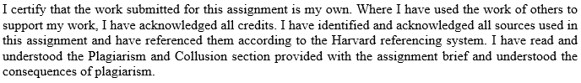
Signature: …………A.M.Stoica………… Date: ……...13.06.2025………

Table of Contents
1 Introduction 3
2 The Event Cycle 3
2.1 EMBOK Model 4
3 Three-Stage Event Design Model 4
4 Event Concept 5
5 Aim and Objectives of the Event 6
6 Event Management 7
7 Event Budget 8
7.1 Income and Expenditure 8
7.2 Funding Sources 9
7.3 Income Generation 9
8 Industry Trends / Issues / Impacts 10
8.1 Sustainability and Green Expectations 10
8.2 Virtual Events 10
8.3 Workforce Shortages and Skills Gaps 10
9 Situational and Cultural Considerations 10
9.1 Pestle Analysis 10
Political 10
9.2 SWOT Analysis 12
9.3 SOAR Analysis 12
10 Conclusion 13
11 References 14

Introduction
The main idea of the event is the EcoWales Summit 2025. Hence, this will promote sustainable tourism in the UK. This will take place in Wales to showcase the UK’s dedication to green travel and innovation. Hence, there will be sessions on eco-lodges, sustainability, and green energy. Therefore, there will be also an open competition in regard to the pitch green energy ideas. The summit will bring together leaders, entrepreneurs, and eco-tourism players with a platform to exchange ideas and innovations that result in the development of new sustainable tourism solutions. The tourist visitors will include tourism experts, innovators, and foreign visitors who are concerned with green tourism.

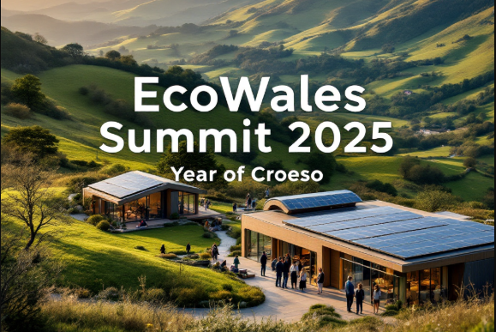
Figure 1: EcoWales Summit 2025

The Event Cycle
The chosen model for this event will be the EMBOK model. The EMBOK Model outlines key elements in event management, including planning, design, risk, and operations. It serves as a framework to guide professionals in organising successful events by addressing every phase and function, helping ensure consistency, safety, and a quality experience across different types of events (van Antwerpen, 2023).

EMBOK Model
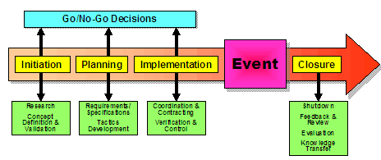
Figure 2: EMBOK Model
Embok, 2025

In the first phase, the purpose will be to establish Wales as a sustainable tourism pioneer. The organisers will focus on the target audience, which involves tourism professionals, green start-ups, and international tourists. When planning, some sessions regarding the event will be outlined. It will include arranging guided tours to green lodges, selecting carbon neutrality expert panellists, and arranging the green start-up pitch competition. Logistics, such as transportation to rural areas, technical requirements for presentations, and environmentally friendly catering (Dowson et al., 2022), will be taken care of.
In the implementation stage, these strategies will be put into action. Hence, it includes rolling out promotional messages, building exhibitor stands, and training staff on timelines. After the event occurs, staff will organise panels, guide visitors on green tours, and facilitate the live pitch competition. Live changes guarantee a smooth ride. Finally, in the closing phase, feedback from visitors will be collected, pitch event winners will be announced, and the results will be reviewed to gauge the influence of the summit on Wales' tourism strategy.

Three-Stage Event Design Model
Bladen's Three-Stage Event Design Model (2012) will effectively organise the EcoWales Summit 2025. At the Feasibility stage, organisers will consider the purpose of the event and feasibility. They will determine if it aligns with Wales' sustainable tourism goals, assess the available funding, and select initial target audiences, including eco-tourism professionals, businesspeople, and international visitors (Nicholls et al., 2021).
Then, during the Design stage, focus will be placed on designing the overall event experience. Organisers will organize eco-lodge tours, panel sessions featuring green expertise on topics such as carbon neutrality, and a green start-up pitch competition event. Visual branding, sustainability, and ambience that capture Welsh culture and natural surroundings (Walker, 2021) will be taken into account in the design process.
Finally, the Implementation phase will bring plans to fruition. Staff members would handle logistics, guests would be welcomed, sessions would be organised, and everything from site visits to competitions would be executed efficiently. This stage would be crucial in making the summit a seamless and successful one, with an undercurrent of sustainability and innovation.

Event Concept
An engaging, educational, and interactive trip will show how Wales showcases the best of sustainable tourism at the EcoWales Summit 2025. The agenda has been carefully curated to ensure a balance of learning, networking, and hands-on experiences, all within the stunning eco-friendly environment of the Centre for Alternative Technology (CAT) in Machynlleth.

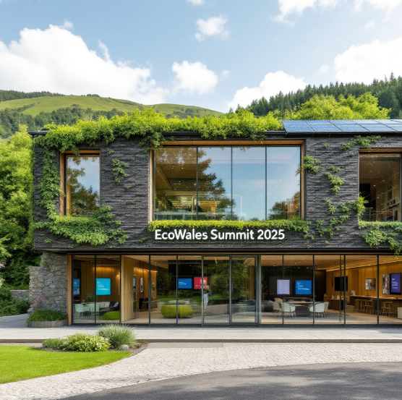
Figure 3: Event

Morning Session
Registration and a warm welcome start in the morning, and each attendee will receive some eco-focused items for the day. Delegates are welcome to enjoy some locally produced organic teas, coffees, and pastries. The summit begins in the morning, opening with a rousing speech from a highly respected industry expert who stresses the value of sustainable tourism and Wales's role in helping others adopt sustainable practices (Abdellatif et al., 2024). After that, a discussion with experts on carbon neutrality and green hospitality will discuss the challenges and benefits of eco-tourism.
Mid-Morning Activities
Delegates will divide into smaller groups to take tours of nearby eco-lodges and eco-clusters. Guided tours will enable participants to explore eco-friendly practices in hospitality that are implemented daily (Zhichao and Yash, 2024). Visits focus on teaching sustainability by exploring renewable energy, conserving water, and managing waste.
Lunch Break
Lunch will take place for all delegates at the Centre for Alternative Technologies (CAT) dining area. Welsh favourites will be offered, using local, fresh, and seasonal ingredients. This time gives everyone a relaxed moment to socialise and form connections for future projects.
Afternoon Session
In the afternoon, everyone pays attention to innovation by watching teams pitch their start-ups. Welsh eco-entrepreneurs will present their projects to a panel and an audience in the hopes of securing funding and attention. Panellists present fresh ideas from the region, which encourages everyone in the audience to engage.
Closing Ceremony
The day concludes with a closing ceremony, during which key points from the summit are shared. Before the event concludes, a major government official will outline why eco-tourism is important and how collaboration supports the aims of sustainability (García and López, 2025). At last, participants will leave with a wealth of knowledge, new connections, and the will to implement sustainable actions in their jobs.
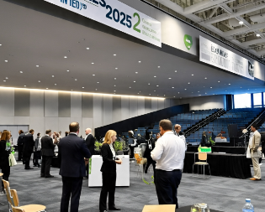
Figure 4: Event Day

. Aim and Objectives of the Event
The event primarily aims to showcase Wales as a global leader in sustainable tourism by introducing eco-friendly business solutions, partnering with others, and highlighting both the country's landscape and cultural heritage.
SMART Objectives
- To attract 150 delegates, including eco-tourism professionals, start-ups, and international attendees, by June 2025.
- To host at least three practical workshops and an eco-start-up pitch competition, engaging a minimum of 10 participants per session.

Event Management
Running the EcoWales Summit 2025 will depend on different abilities. Strong operational management depends on capable event planners handling set-up, scheduling, and managing all resources. They must organise all actions to enable smooth transitions between meetings and handle any unexpected challenges (Đorđević et al., 2024). In addition, organisations will rely on sustainability consultants to ensure eco-friendly strategies are used across all business functions. Qualified staff must monitor and maintain the audio-visual systems to ensure everything runs smoothly during presentations. The role of volunteers encompasses managing registration, assisting attendees at the event, and distributing materials (Fox, 2014). Staff who are qualified and experienced will prepare locally sourced meals and prioritise sustainability for the event.
To ensure the event starts correctly, attention will be given to aligning it with its main goals and objectives. A detailed timeline should be created in strategic planning to track key activities, such as booking the venue, finalising the speakers, and advertising the event. Sticking to the budget requires budget analysts to plan finances effectively and organise resources thoughtfully while maintaining high quality (Islam et al., 2025). Such specialists will advise the organisation on how to minimise the event's carbon footprint, and may suggest eco-friendly transportation options and efficient waste management. Risk management professionals study various problems, economic changes, and unpredictable weather, and plan steps to address them (Rogers and Wynn-Moylan, 2022). The project manager ensures that all tasks are organised and each component is delivered as scheduled.


Figure 5: Event

Attracting 150 delegates, including eco-tourism professionals, start-ups, and foreign participants, will be achieved mainly through marketing activities. Marketing professionals will develop and implement a global strategy for advertising, primarily utilising digital tools to connect with the target audience. Content creators will produce engaging videos, social media posts, and articles to emphasize the special facets of the event, including the start-up pitch session and tours of eco-lodges (Getz and Page, 2019). Public relations will organise everything needed to ensure that the event is featured in the media. Working together with eco-tourism organisations, local businesses, and the government will enable the event to be noticed by a wider audience.
Managing resources is important and requires close attention (O’Toole, 2011). At the event, signs, nametags, and programme information will be made from recyclable products and not printed on paper. The latest green technology will be used at the Centre for Alternative Technology, including energy-saving lights and environmentally friendly transportation options.
Caterers will take care to practise sustainability by providing packaging and food made from sustainable resources. Aligning these practices with the sustainability objectives will help establish a stronger and more trustworthy reputation for the event.
Ensuring there is adequate technical knowledge will be key to the event having a successful outcome. IT experts will oversee registration websites, ensuring everything is easy for participants. Providing real-time help and opportunities for virtual participants to engage will be crucial for reaching a global audience. Attendance information, feedback, and the level of attentiveness will enable analysts to estimate the event's performance (Islam et al., 2025). Those working in sustainability will assess whether the event contributes to reduced carbon emissions, thereby helping to fulfil the goals of eco-friendly tourism. Having this data will assist in planning for the event and landing valuable sponsorships or funding.

Event Budget

Income and Expenditure
Table 1: Expenditure
Expenditure | Estimated Cost (£)
Venue Hire (CAT for 3 days) | 4,500
Catering (for 150 delegates) | 3,000
Accommodation (subsidised for guests/speakers) | 4,000
Marketing & Promotion | 2,000
Speaker Fees and Travel Reimbursement | 3,500
Staff & Volunteers (T-shirts, food, travel) | 1,000
Conference Materials (print/digital packs) | 500
Transportation for Site Visits | 1,500
Audio-Visual Equipment & Technical Support | 1,000
Insurance and Contingency | 1,000
Total Expenditure | 22,000

Table 2: Income
Income | Estimated Revenue (£)
Delegate Fees (150 people @ £120) | 18,000
Sponsorship from eco-brands/organisations | 3,000
Exhibition Stall Bookings (10 @ £100) | 1,000
Government or Green Tourism Grant | 2,000
Startup Pitch Entry Fees (10 @ £100) | 1,000
Total Revenue | 25,000

Funding Sources
Table 3: Funding Sources
Source | Details
Delegate Fees | The main revenue stream will come from delegate fees, with tickets priced at £120 each for 150 attendees.
Sponsorships | Sponsorship income will be generated through partnerships with eco-tourism businesses, local enterprises, and green brands.
Grants | Grants will provide funding support from the Welsh Government, Visit Wales, or environmental charities.
Exhibitor Fees | Eco product vendors and startups will pay exhibitor fees to showcase their innovations.
Pitch Competition Entry Fees | Startups will pay to enter the pitch competition, gaining exposure and receiving prize support.

Income Generation
Income generation will rely on delegate fees, sponsorships, grants, exhibitor fees, and pitch competition entries, ensuring diverse revenue streams through partnerships, government support, and participation from startups and vendors.

Industry Trends / Issues / Impacts

Sustainability and Green Expectations
The sector is shifting towards low-carbon and more sustainable event formats. In 2025, the UK will see increased attention to renewable power, circular economy practices, and low-carbon transport, fueled by growing consumer pressure and government policy. The UK is determined to develop further applications of renewable materials, such as wind and solar, to support it in reaching its net-zero goals. There is greater focus on nature-based measures such as urban greens and biodiversity conservation, and a try to preserve and promote nature (Sustainable, 2025).

Virtual Events
Hybrid models mix physical and virtual experiences to expand global reach. The trend fits with low carbon emissions due to reduced long-distance travel requirements. For virtual events in the UK, there is a trend towards increased immersion and interactivity through technologies such as AR/VR and AI for personalization and concentration on sustainability and accessibility. Virtual events are being made accessible to all visitors regardless of capability and background (Carbon Click, 2025).

Workforce Shortages and Skills Gaps
Unpredictable climatic conditions as a result of climate change impact off-site and external events. Risk management planning is crucial to ensure safety and continuity assurance. Environmental and climate-related risks are increasing in the UK, with weather forecast estimates predicting increasingly severe weather, increased temperatures, and increased flooding on a larger scale in the events industry (Met Office, 2025).

Situational and Cultural Considerations

Pestle Analysis

Political
The Welsh government is also driving sustainable tourism to realize long-term benefits for both communities and the environment (Visit Wales, 2025). This is achieved through various methods that involve regulation, funding, and stakeholder engagement.
Plaid Cymru advocates for local levies on tourism, which equip local councils with the authority to spend and invest locally (Plaid Cymru, 2025). The strategies, such as "Welcome to Wales: Priorities for the Visitor Economy 2020-2025," is centered on sustainable tourism and minimizing the environmental impact of tourism.

Economic
Tourism is a prominent economic force in Wales, with sustainable tourism becoming more prevalent. Tourism industries have contributed 5.1% of Gross Value Added (GVA) in Wales in 2022, equivalent to £3.8 billion. Tourism also provided work for 11.8% in Wales, and directly supported jobs in 159,000 roles (Nicholls et al., 2020).

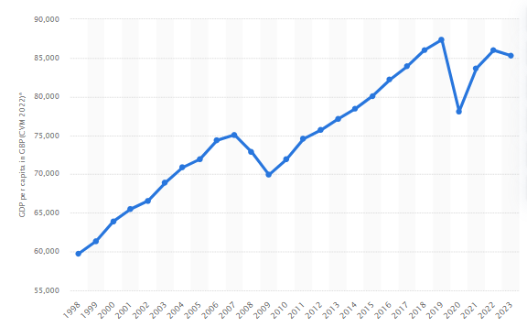
Figure 6GDP of Wales
Statista, 2023

Social
Tourism in Wales contributed 11.8% of all employment in 2022, at 159,000 jobs, a slight increase from 151,000 in 2020. Most of that work (77%) was in the hospitality sector. Though visitor numbers in 2023 were 13% down from 2019, spend was £458 million, a 16% increase on 2022, Visit Wales reported. This reflects a transition away from overnight stays and short, high-cost breaks (Visit Wales, 2023).
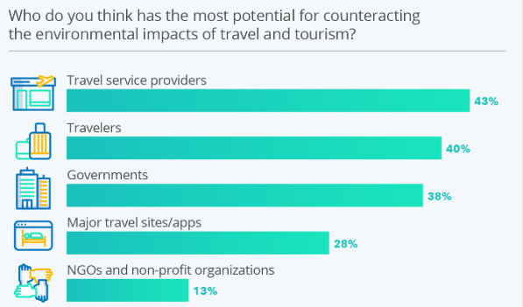
Figure 7Sustainable Tourism Industry of Wales
Statista, 2024

Technological
Wales is proactively encouraging the uptake of technology that will contribute to making the tourist industry more sustainable, tapping into renewable sources of energy, digital technologies, and data analysis to maximize the resource utilization and reduce harm to the environment. The aim is to develop sustainable tourist holiday experiences that are economical to the local economies and communities (Green Economy Wales, 2023).

Legal
A Senedd bill to prohibit various single-use plastics was passed in a bid to reduce litter and contamination (Gov Wales, 2025). The Environment (Wales) Act 2016 provides for the environmentally, socially, and economically advantageous management of natural resources (Cymru Welsh Government, 2025). Visit Wales works towards spreading responsible tourism messages through advertising and stakeholder engagement. It offers business resources and advice on how to undertake sustainable business policies, such as Green Key accreditation.
Environmental
Wales puts green tourism at the highest level by conserving natural surroundings, promoting low-impact tourism, conservation, and green-certified events that make people environmentally conscious and reduce damage to the environment (Giorgi, 2024).

SWOT Analysis
Table 4: Swot Analysis
Strengths | Weaknesses | Opportunities | Threats
The event has a unique focus on promoting sustainable tourism, specifically in Wales. | The event relies heavily on attracting a niche audience that is eco-conscious. | There is an increasing global demand for sustainable travel solutions, which presents a growth opportunity. | There is strong competition from other destinations that also promote sustainable tourism.
A strong and reputable venue, the Centre for Alternative Technology, is available for hosting the event. | The costs associated with organising the event could potentially be high, posing a financial challenge. | There is potential to form partnerships with eco-tourism innovators, as noted by Erdoğan et al. (2022). | Economic instability, as discussed by Đorđević et al. (2024), may affect attendance and funding.
The event benefits from collaboration with industry leaders and startups, as highlighted by Rogers Wynn-Moylan (2022). | There are limited resources available for large-scale promotional activities. | There is an opportunity to build Wales’ reputation as a leading destination in green tourism. | Achieving the carbon-neutral goals for the event may present significant challenges.

SOAR Analysis
Table 5: Soar Analysis
Strengths | Opportunities | Aspirations | Results
Wales stands out for its commitment to sustainable tourism, supported by its unique venues like the Centre for Alternative Technology and partnerships with eco-conscious startups. | The rising global interest in environmentally friendly travel offers Wales the chance to become a top destination. Collaborating with international eco-tourism innovators could boost outreach. | The aim is to make Wales a global leader in sustainable tourism, known for its innovation, eco-values, and authentic experiences that respect nature and local culture. | Progress will be evident through increased visitor numbers, enhanced global visibility, and tangible contributions to carbon reduction and sustainable development goals.

Conclusion
In conclusion, this report highlighted that the EcoWales Summit 2025 will inspire a greener tourism industry. This summit will encourage innovation in sustainable travel practices. Local communities will benefit through shared knowledge and increased eco-awareness. Workshops and discussions will help shape responsible policies across the UK. The summit promotes ethical travel choices and supports environmental preservation efforts. Attendees will leave empowered to drive change within their own sectors. Collaboration with stakeholders ensures long-term impact beyond the event itself.

References
Abdellatif, H., Hicham, B., and Karim, B. (2024). Responsible green tourism: A new path for eco-friendly tourism development. International Journal of Economic Perspectives, 18(2), 560-589.
Carbon click. (2023). The current state of Britain's environment. [online]. Available at: https://www.carbonclick.com/news-views/the-current-state-of-britains-environment [Accessed on June 7, 2025]
Đorđević, N., Milićević, S., and Lazović, S. (2024). Eco-friendly tourism destinations: Strategies for implementing sustainable tourism practices. Economics of Sustainable Development, 8(2), 21-33.
Đorđević, N., Milićević, S., anf Lazović, S. (2024). Eco-friendly tourism destinations: Strategies for implementing sustainable tourism practices. Economics of Sustainable Development, 8(2), pp. 21-33.
Dowson, R., Albert, B., and Lomax, D. (2022). Event planning and management: Principles, planning and practice. Kogan Page Publishers.
Embok. (2025). Phases. [online]. Available at: https://www.embok.org/index.php/embok-model/phases [Accessed on June 7, 2025]
Erdoğan, S., Gedikli, A., Cevik, E. I., and Erdoğan, F. (2022). Eco-friendly technologies, international tourism, and carbon emissions: Evidence from the most visited countries. Technological Forecasting and Social Change, 180, p. 121705
Fox, D. et al. (2014). Doing events research: from theory to practice. Routledge: Oxford
García, H., and López, J. (2025). Tourism Development in Fragile Ecosystems: Promoting Responsible Practices in Ecotourism. Journal of Tourism, Culture, and Management Studies, 2(1), 47-61.
Getz, D. and Page, S. (2019) Event studies: theory, research and policy for planned events. 3rd Edition. Routledge: Oxford
Giorgi, L. (2024). Scenarios for the future of nature tourism in Portugal–time horizon: 10 years. Traditional Tranquility (Master's thesis, Universidade NOVA de Lisboa (Portugal)).
Gov Wales. (2023). Written Statement: Responsible tourism. [online]. Available at: https://www.gov.wales/written-statement-responsible-tourism#:~:text=The%20Senedd%20has%20passed%20the,be%20happy%20to%20do%20so. [Accessed on June 7, 2025].
Gov Wales. (2025). Written Statement: Responsible tourism. [online]. Available at: https://www.gov.wales/sites/default/files/publications/2019-06/natural-resources-policy.pdf [Accessed on June 7, 2025].
Green Economy Wales. (2025). Tech Innovations: Harnessing Technology for Sustainable Travel Experiences. [online]. Available at: https://greeneconomy.wales/tech-innovations-harnessing-technology-for-sustainable-travel-experiences [Accessed on June 7, 2025].
Islam, M. A., Goldar, S. C., Al Imran, S. M., Halimuzzaman, M., and Hasan, S. (2025). AI- Driven green marketing strategies for eco-friendly tourism businesses. International Journal of Tourism and Hotel Management, 7(1), 31-42.
Met Office. (2025). Effects of climate change. [online]. Available at: https://weather.metoffice.gov.uk/climate-change/effects-of-climate-change#:~:text=Parts%20of%20the%20UK%20will,us%20to%20produce%20new%20ones. [Accessed on June 7, 2025]
Nicholls, S., Organ, K., and Cummings, B. (2021). Planning for sustainable tourism development in Wales: an analysis of destination management plans. Welsh Economic Review, 28, pp. 23-32.
Nicholls, S., Organ, K., and Cummings, B. (2021). Planning for sustainable tourism development in Wales: an analysis of destination management plans. Welsh Economic Review, 28, pp. 23-32.
O’Toole, W. (2011) Events feasibility and development: from strategy to operations. Elsevier: Oxford.
Plaid Cyrmu. (2025). Sustainable Tourism. [online]. Available at: https://www.partyof.wales/2022_twristiaeth_tourism [Accessed on June 7, 2025].
Rogers, T. Wynn-Moylan, P (2022) Conferences and conventions: a global industry. 4th Edition. Routledge: Oxford
Rogers, T. Wynn-Moylan, P (2022) Conferences and conventions: a global industry. 4th Edition. Routledge: Oxford
Statista. (2023). Gross domestic product of Wales from 1998 to 2023. [online]. Available at: https://www.statista.com/statistics/1004446/gdp-of-wales/ [Accessed on June 7, 2025].
Statista. (2024). Sustainable Tourism: Collective Responsibility of Providers, Travelers, and Governments. [online]. Available at: https://www.statista.com/chart/32241/collective-responsibility-of-sustainable-tourism/ [Accessed on June 7, 2025].
Sustainable. (2025). Sustainability Trends for 2025: What’s Next? [online]. Available at: https://www.sustainablex.co.uk/sustainability-trends-for-2025-whats-next/#:~:text=Circular%20Economy%20in%20Full%20Swing,rethink%20their%20product%20life%20cycles [Accessed on June 7, 2025]
Van Antwerpen, S. (2023). A proposed integration of the event and project management body of knowledge. International Journal of Applied Sciences in Tourism and Events, 7(2), pp. 107-119.
Visit Wales. (2023). Latest Annual Statistics: Wales in 2023. [online]. Available at: https://industry.visitwales.com/research-and-insights/overnight-visits-wales-gb-visitors [Accessed on June 7, 2025].
Visit Wales. (2025). “A small contribution that could make a big difference” – Legislation introduced to support a thriving, sustainable tourism industry in Wales. [online]. Available at: https://www.gov.wales/legislation-introduced-to-support-a-thriving-sustainable-tourism-industry-in-wales [Accessed on June 7, 2025].
Walker, S. (2021). The spirit of design: objects, environment and meaning. Routledge.
Zhichao, Y., and Yashu, Y. (2024). Promoting Environmental Sustainability through the Principles of Green, Eco-Friendly Tourism. Imras, 7(12), 63-74.

