

Student Name: Resvy Ahmed
Student ID: 2504376

Module Name: Marketing Management
Module Code: LCMB7024

Lecturer’s Name: Dr Laila Maazouz

Word Count: 2467

Table of Contents
1. Introduction 3
2. Macro Marketing Environment Critical Analysis 4
2.1. Macro Marketing Environment Overview 4
2.2. Technological Factor: E-commerce & Digital Transformation 5
2.3. Environmental Factor: Sustainability and Regulations 6
2.4. Overview of Macro Factors and their effect 8
3. Strategic Responses of Pioneering and Follower Organisations 9
3.1. Pioneering Organisation: ASOS 9
3.2. Follower Organisation: Marks and Spencer (M&S) 11
4. Conclusion 14
5. References 15

List of Figures
Figure 1: Fashion and Textile Industry’s Economic Impact (UKFT, 2023) 3
Figure 2: Global Growth in E-commerce Fashion: Penetration & Share (ECDB, 2024) 5
Figure 3: Share of ESG conversation per brand (Botha, 2023) 7
Figure 4: ESG Net Sentiment per fashion brand(Botha, 2023) 8
Figure 5: E-Commerce and AI Integration of ASOS (ASOS Annual Report, 2024) 9
Figure 6: Sustainability Initiatives of ASOS (ASOS Annual Report, 2024) 10
Figure 7: Technological Adaptation -E-commerce Growth of Marks & Spencer (M&S Annual Report, 2023) 11
Figure 8: Net Zero Transition Roadmap (Marks & Spencer, 2023) 12

Introduction
This report aims to analyse the macro marketing environment of the UK fashion and apparel industry and evaluate how the external factors influence the strategic practices of leader and follower organisations. It uses the example of ASOS, a major online retailer and Marks and Spencer (M&S), an old high street brand to demonstrate how each is changing to meet online retail trends and beyond, to technological and environmental pressures. The fashion sector of the national economy is a significant sector in the UK with over 1.3 million individuals working in it and contributing over £62 billion GVA (UKFT, 2023). The fast pace of development in the market, coupled with the change in technology, has been associated with threats and opportunities. The growth of e-commerce, the increased application of AI, and increasing expectations of sustainable and responsible business conduct due to legislation and consumer consciousness are some of the influential factors. ASOS was fast to embrace AI technologies and sustainability technology to cement its standing, and M&S has been striving to digitise its traditional physical retail business and increase investment in its sustainability promises. This report discusses the response of the two organisations to these macro factors and how they intend to maintain their growth and competitiveness.
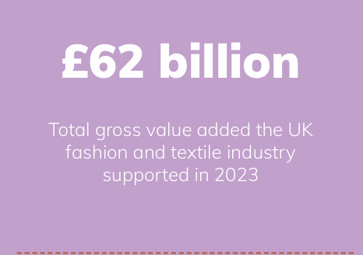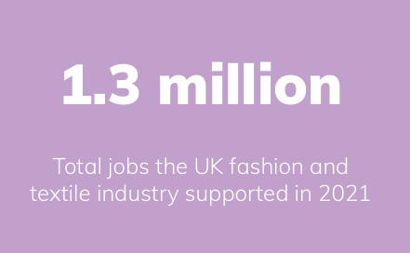
Figure 1: Fashion and Textile Industry’s Economic Impact (UKFT, 2023)

2. Macro Marketing Environment Critical Analysis

2.1. Macro Marketing Environment Overview
Macro marketing environment refers to external aspects that can affect business choices and consumer behaviour and they are generally evaluated by the framework of PESTEL (Political, Economic, Social, Technological, Environmental, and Legal factors). Technology and environment have emerged as important determinants of the dynamics in the UK fashion industry as a company (Johnsson and Kramer, 2023). As technology is continuously growing, particularly, the advent of e-commerce and artificial intelligence (AI), the manner in which fashion companies communicate with their customers and their business is changing radically. On the contrary, environmental sustainability has been cited as one of the key drivers since companies have been forced to comply with regulatory requirements and consumer demands to produce and adopt eco-friendly products and practices (Edyvean, 2025). Due to the growing concern of climate change in the global community, governments in the United Kingdom and the entire Europe are tightening the belt when it comes to legislation and regulations that are meant to enable business practices to be sustainable. The online fashion Industry is an innovative sector with both ASOS being an online organisation and Marks and Spencer (M&S) being a conservative retailer responding to these macro factors to stay ahead and relevant in the evolving market.

2.2. Technological Factor: E-commerce & Digital Transformation
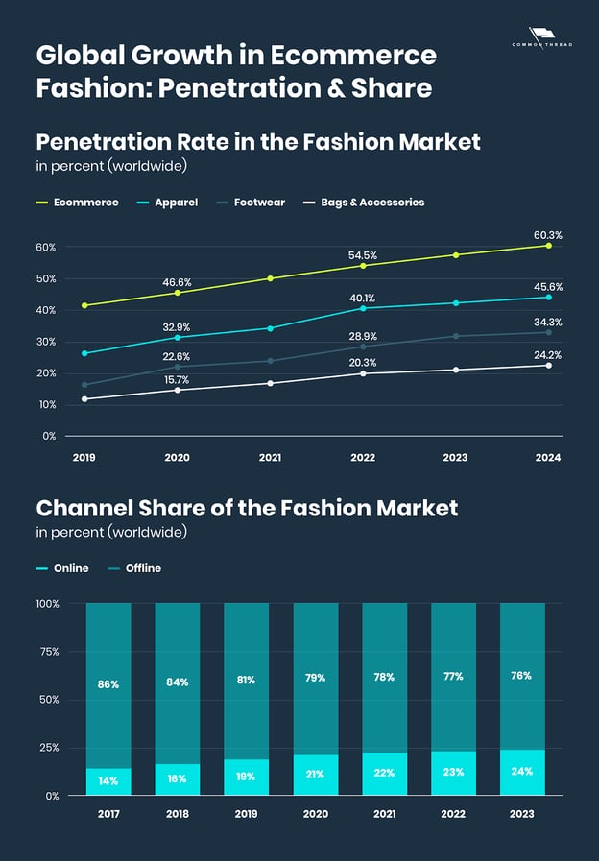
Figure 2: Global Growth in E-commerce Fashion: Penetration & Share (ECDB, 2024)
The UK fashion and clothing market is changing dramatically due to the fast development of e-commerce and the digitalisation of the fashion industry, which brings both opportunities and challenges to the brands. By 2024, online sales are predicted to constitute 31% of the fashion market in the UK, and the percentage is likely to grow since more consumers will prefer doing transactions online (ECDB, 2024). This trend underscores the fact that fashion companies should embrace powerful digital practices and technologies to remain competitive.
Being one of the pioneering online retailers, ASOS has invested so much in online shopping capabilities and has become a leader in the market. Its business model is online, and its application of artificial intelligence (AI) has also improved customer experience and interaction (Gallery & Conlon, 2024). The AI-based styling devices and custom suggestions are shaped around its fundamental demographic of 20-somethings, which boosts the levels of customer satisfaction and purchase rates. These and additional tools, along with a fact-based view on customer preferences, have assisted ASOS in accelerating retention and maintaining a high level of engagement as indicated in its 2024 Annual Report. Mobile commerce is also at the point of the ASOS strategy and mobile transactions made more than half of all sales in 2023 (ASOS Annual Report, 2024). The ASOS app has become easy to use, convenient and appealing in a mobile-first retail setting by supporting its features with features like one-click shopping, AI-generated product recommendations and in-stock view.
Contrastingly, Marks and Spencer (M&S), which is a long-established high-street retailer, has been struggling to adapt to digital retail. Despite the modernisation of its online store, the introduction of a better mobile application and the increase of online marketing efforts, M&S has lagged behind digital native brands, like ASOS. The percentage of online revenues also represents a lower percentage of total sales compared to the faster rate of digital adoption. However, M&S is currently making investments into AI-enhanced personalisation, click-and-collection services and wider online food and clothing delivery, which would enable it to increase its market presence amidst changing conditions (Rajput, 2025). Generally, ASOS has been at the forefront of digital innovation and M&S is still on a faster track toward the process of transformation so as to be competitive in the ever-growing online fashion world. These opposite strategies demonstrate the way digital preparedness and actionability determine performance in the fashion and apparel industry in the UK.

2.3. Environmental Factor: Sustainability and Regulations
Sustainability in fashion has become a trend that has gained relevance because consumers have become more demanding of products that are environmentally friendly and the growth of environmental laws. Since the UK government aims to transform the country into a net-zero climate by the year 2050, the fashion sector must do much to keep up with the pace. ASOS and Marks and Spencer (M&S) companies are addressing these changes differently.
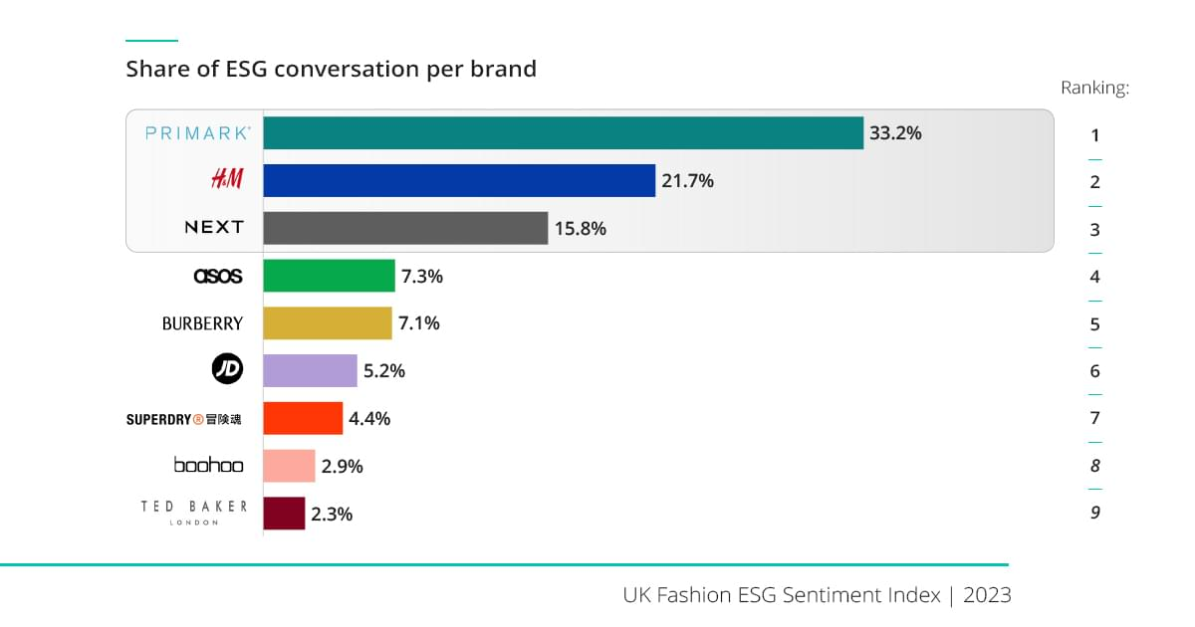
Figure 3: Share of ESG conversation per brand (Botha, 2023)
ASOS is an innovative organisation that has embraced the concept of sustainability as a business approach in the online fashion industry. The company has the Fashion with Integrity programme which promotes recycling of materials and ethically sourced materials. Reducing stock by 30 per cent to eliminate overproduction and waste is a great environmental initiative by ASOS (ASOS Annual Report, 2024). According to the UK Fashion ESG Sentiment Index (2023), ASOS has a positive impact on the global ESG discussion in the fashion industry helping produce 7.3%, which is its growing interest in environmental and social regulation (Botha, 2023). In addition, most consumers in the UK (65%) consider the issue of sustainability in their buying preferences (KenResearch, 2024), which positively contributes to the competitiveness of ASOS in the market because it matches the expectations of consumers. Its concern for carbon offsetting programmes and sustainable packaging further helps to mitigate the environmental footprint of the brand.
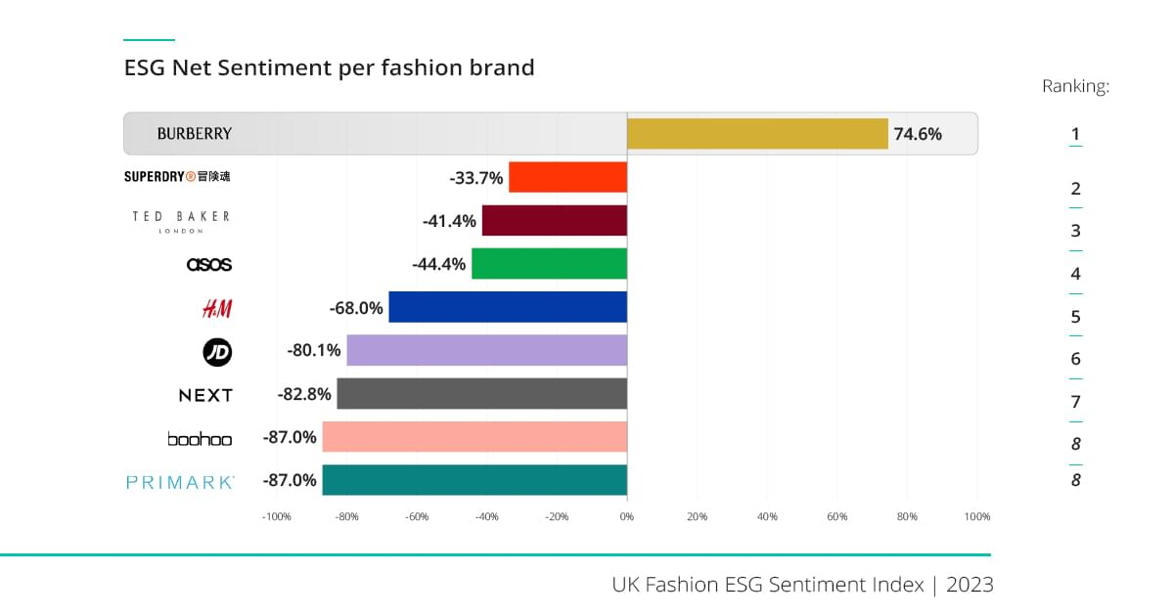
Figure 4: ESG Net Sentiment per fashion brand(Botha, 2023)
Quite on the contrary, Marks and Spencer (M&S) has been lagging in embracing the concept of sustainability. Although there have been certain improvements in the S Plan A programme, in which M&S plans to utilise sustainable cotton and decrease carbon emissions, the ESG Net Sentiment score is -68% (Botha, 2023), which means that people have a negative perception of its efforts in sustainability. Sustainability practices at M&S, including zero-waste, better supply chain transparency practices, have not kept up with ASOS. M&S is also responding to the Extended Producer Responsibility (EPR) legislation in its logistics in terms of energy consumption and recycling. In conclusion, ASOS has been leading the pack, in terms of sustainability and ESG initiatives, which gives it a competitive edge, and M&S is not a fully sustainable enterprise.

2.4. Overview of Macro Factors and their effect
All this has contributed to the overall strategic direction of both ASOS and M&S since, being the first to adopt the technologies, ASOS has been able to leverage the strength of e-commerce and AI to make the shopping experience a distinct and personalised one, and lead in terms of sustainability with its Fashion with Integrity campaign (Kesidou & Palm, 2025). Concurrently, in its quest to adopt digital transformation, M&S is gradually shifting to sustainable fashion and integrating the use of digital technologies to improve its services. These macro factors have to be maintained by the two organisations as they strive to gain competitive advantages in the evolving market environment.

3. Strategic Responses of Pioneering and Follower Organisations

3.1. Pioneering Organisation: ASOS
As an innovative organisation, ASOS has been in a position to adjust to changes in technology and the environment of the UK fashion industry by venturing into e-commerce and sustainability. ASOS is a digital-first company and it uses artificial intelligence (AI) and data analytics to enhance customer experiences and streamline business processes.
E-Commerce and AI Integration:
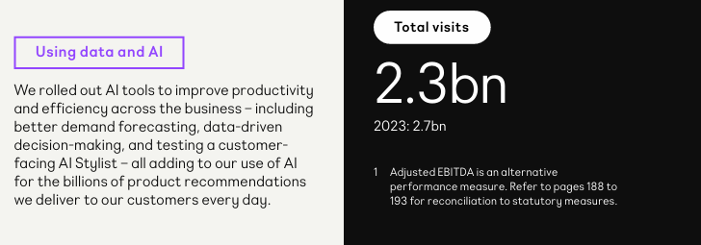
Figure 5: E-Commerce and AI Integration of ASOS (ASOS Annual Report, 2024)
ASOS has also taken advantage of the development of mobile commerce, and over half of the total revenue in 2023 is mobile sales (ASOS Annual Report, 2024). The substantial investments that the company has made in the artificial intelligence (AI) have enhanced the customer shopping experience, which provides personalised product recommendations and virtual styling tutorials. Another field that AI has been instrumental in improving efficiency in the running of ASOS is demand forecasting, since it makes sure that the correct products are at the right place and at the right time. Virtual try-ons and the AI Stylist feature have changed the experience of online shopping and helped reduce the number of returns and enhance customer interactions (Vitorino, 2021). All these inventions will be needed so that ASOS can remain competitive in a highly saturated market and develop relationships with customers, who in the long run will be loyal customers.

Sustainability Initiatives:
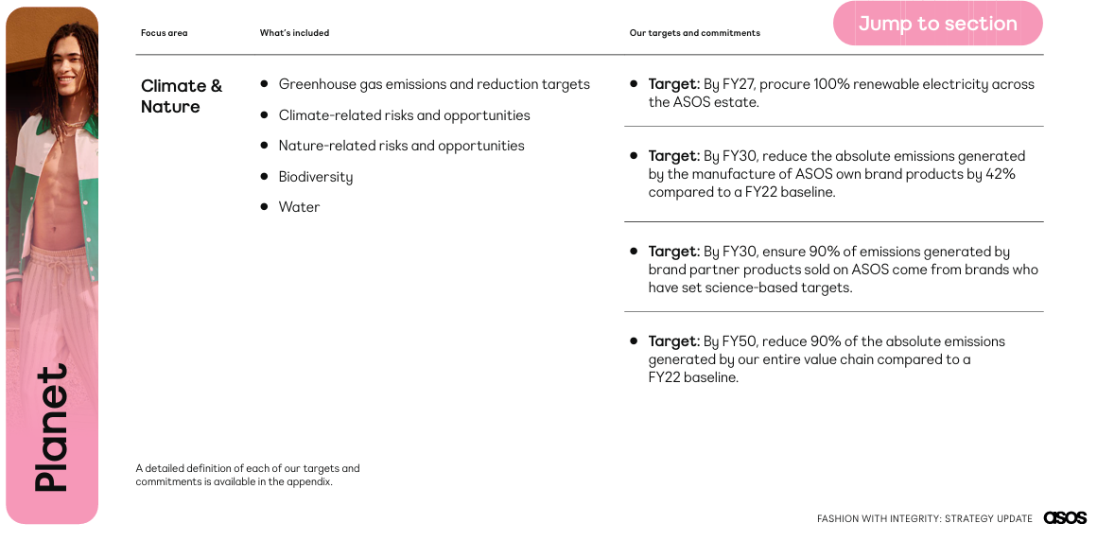
Figure 6: Sustainability Initiatives of ASOS (ASOS Annual Report, 2024)
The increasing consumer demand in the sustainability sector has compelled ASOS to incorporate environmental responsibility in its business model. The company has also made an obligation through its Fashion with Integrity programme to utilise recycled and ethically sourced materials. It has also minimised inventory by 30 per cent in order to curtail overproduction and waste so that it is able to match its products to customer demand (ASOS Annual Report, 2024). This has enhanced its competitiveness when 65% of UK consumers focus on environmentally friendly products (KenResearch, 2024). ASOS is also striving to reduce carbon emissions in its supply chain as well as introducing more sustainable packaging. These measures complement regulatory expectations and attract customers who are more attracted to the environmentally friendly brands and contribute to the creation of long-term loyalty.
Strategic Analysis Using Porter’s Generic Strategies:
ASOS focuses on differentiation and cost leadership to stay competitive. The company uses differentiation by offering a personalised shopping experience with the help of AI. Features like product recommendations, virtual styling, and demand forecasting make shopping easier and more engaging for customers. This helps ASOS stand out in the crowded fashion market.
At the same time, ASOS works on cost leadership by streamlining its operations. It reduces waste and overproduction through better inventory management, which keeps costs low. Sustainability efforts, like using eco-friendly materials, also help meet consumer demand while saving money. By balancing unique customer experiences with cost efficiency, ASOS maintains a strong position in the market.
Moreover, ASOS continuously improves its digital platforms and invests in advanced automation tools, allowing the company to respond faster to market trends while delivering consistent value that strengthens its overall competitive advantage.

3.2. Follower Organisation: Marks and Spencer (M&S)
Marks and Spencer (M&S) is an old organisation working in the fashion sector in the United Kingdom, and it has had to swiftly adjust to the new trend in online shopping and the increasing need to be sustainable. M&S is a follower organisation, and it has been trailing the digital-first brands like ASOS but it has been improving tremendously in the past few years.
Technological Adaptation -E-commerce Growth:
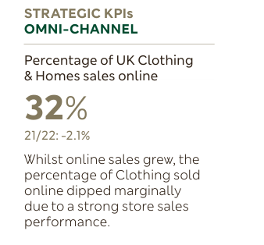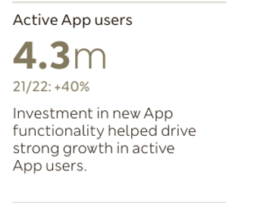
Figure 7: Technological Adaptation -E-commerce Growth of Marks & Spencer (M&S Annual Report, 2023)
In an effort to rival online-only retailers like ASOS, Marks and Spencer (M&S) has invested a lot of money in enhancing its online shopping system and the mobile application. Even though it makes 10% of its revenues in the UK Clothing and Home online sales, this number decreased by 2.1% compared to the last year indicating that digital expansion is limited (M&S Annual Report, 2023). Nevertheless, the brand has enhanced its mobile base, where the number of active users of apps has increased by 40% to 4.3 million. M&S has also begun incorporating AI-driven suggestions and customisation of shopping into its operations to enhance customer experience. But in comparison to ASOS, which is completely online, M&S continues to be unable to provide a smooth digital experience. It is important to work towards enhancing its presence online so that it can be competitive.
Sustainability Initiatives
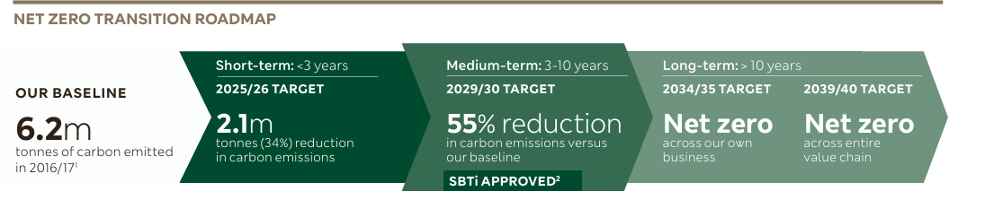
Figure 8: Net Zero Transition Roadmap (Marks & Spencer, 2023)
In contrast to the speed with which ASOS has integrated sustainability into their business, Marks and Spencer (M&S) as a follower organisation as a business has been slow in adopting such environmentally friendly initiatives. However, M&S has improved remarkably, and its Plan A sustainability strategy is aimed at decreasing carbon emissions, offering a better view of the supply chain, and using more recycled materials. As an example, one of the goals of the M&S is to decrease carbon emissions by 55% by 2029 compared to its 2016 level (M&S Net Zero Transition Roadmap). It is already a huge task, and ASOS has already started to apply carbon offset programmes and sustainable packaging in its business model (Marks and Spencer, 2023).
Despite the fact that ASOS is ahead of its rivals in terms of AI and recycled fabrics, M&S still lags behind its attempts to minimise the waste levels, striving to become a zero-waste company and use sustainable cotton in its collections. However, M&S has gone further to make its goal of achieving net-zero emissions in business by the year 2035 and even further to its entire value chain by 2040 (Mazhar and Molthan-Hill, 2023).
Strategic Analysis Using Porter’s Generic Strategies:
Marks & Spencer (M&S) uses differentiation and focus strategies to stay competitive. Although it has been slower than digital-first brands like ASOS, M&S has worked on improving its online shopping system and mobile app, which now sees a 40% increase in active users (M&S Annual Report, 2023). However, its online presence is still behind ASOS, limiting its digital growth.
In terms of focus strategy, M&S is targeting a specific market that values sustainability. The company has set ambitious goals to reduce carbon emissions and use recycled materials. While it lags behind ASOS in some areas, M&S’s commitment to achieving net-zero emissions by 2035 shows its focus on long-term sustainability and differentiating itself through eco-conscious practices.
In conclusion, e-commerce, AI, and sustainability have assisted ASOS to maintain a competitive edge in the fast-evolving fashion industry due to the fact that the organisation is an innovator. On the other hand, Marks & Spencer (M&S), being slower in its transformation but still, has achieved much in terms of embracing the digital change and sustainable business operations (Goworek et al., 2020). Nevertheless, M&S is progressing towards its sustainable goals and developing its online platform to maintain the pace with its competitors, including ASOS in the changing competitive environment.
Additionally, M&S continues to refine its customer engagement through improved digital tools, store redesigns, and targeted product ranges, enabling the brand to strengthens its market relevance while steadily enhancing both operational efficiency and consumer trust.

4. Conclusion
In conclusion, both ASOS and Marks and Spencer (M&S) have reacted to the technological and environmental forces that are transforming the UK fashion sector but in a different manner based on their market position. Being an innovative online retailer, ASOS has welcomed the development of online commerce and utilised AI greatly to add to the level of personalisation, provide virtual try-ons and create customer experience-enhancing tools. These inventions have enhanced its competitiveness and helped it stay in the online fashion environment as a leader. The sustainability of its products, backed by the Fashion with Integrity programme, the low level of stock and continuous attempts to minimise its carbon footprint also contribute to the requirements of the increasing consumer demands, as well as regulatory requirements. M&S, on the contrary, has been slower because of being a conventional retailer switching to digital retail. Though it has grown its online presence, developed its mobile application and artificial intelligence-based product recommendations, it continues to lag behind fully digital-first players such as ASOS. Nevertheless, its sustainability pledges and the growing popularity of recycled materials reflect a positive change and a definite turn towards more responsible behaviour. All in all, the two organisations still need to adjust to the changes in technology and environmental pressures to survive in a rapidly changing market.

5. References
Abbate, S., Centobelli, P., Cerchione, R., Nadeem, S.P. and Riccio, E., (2023). Sustainability trends and gaps in the textile, apparel and fashion industries. Environment, development and sustainability, p.1.
ASOS (2024) Fashion with Integrity: Strategy Update. [online] Available at: https://asos-12954-s3.s3.eu-west-2.amazonaws.com/files/7217/4651/9811/Fashion_with_Integrity_Strategy_Update.pdf [Accessed 12 Nov. 2025].
Botha, J. (2023) UK Fashion ESG Index – Is the fashion industry sustainable? [online] DataEQ. Available at: https://dataeq.com/resources/news/is-the-fashion-industry-sustainable [Accessed 14 Nov. 2025].
DataFeedWatch (2025) ‘An industry analysis of Fashion eCommerce’. [online] DataFeedWatch Blog. Available at: https://www.datafeedwatch.com/blog/fashion-industry-analysis [Accessed 16 Nov. 2025].
ECDB, 2024. Fashion Market: UK. [online] Available at: https://ecdb.com/resources/sample-data/market/gb/fashion [Accessed 15 Nov. 2025].
Edyvean, H., (2025). Macro-environment analysis and fashion lifestyle trends. In Fashion Trends and Forecasting (pp. 47-66). Routledge.
Gallery, C. and Conlon, J., (2024). Fashion Business and Digital Transformation: Technology and Innovation across the Fashion Industry. Routledge.
GlobalData, 2024. UK Apparel Market Analysis. [online] Available at: https://www.globaldata.com/store/report/uk-apparel-market-analysis/ [Accessed 13 Nov. 2025].
Goworek, H., Oxborrow, L., Claxton, S., McLaren, A., Cooper, T. and Hill, H., (2020). Managing sustainability in the fashion business: Challenges in product development for clothing longevity in the UK. Journal of Business Research, 117, pp.629-641.
IBISWorld, (2024). Clothing Retailing in the UK: Market Size. [online] Available at: https://www.ibisworld.com/united-kingdom/market-size/clothing-retailing/3060/ [Accessed 15 Nov. 2025].
Johnsson, F. and Kramer, R., (2023). How macro factors influence decision-making in the fashion industry value chain.
Kesidou, E. and Palm, C., (2025). Challenges of New Regulations and Strengths of Eco-Credential Standards in the UK’s Textile and Fashion Industry.
Marks & Spencer (2023) Annual Report 2023 – Strategic Report. [online] Available at: https://corporate.marksandspencer.com/sites/marksandspencer/files/marks-spencer/investor/Annual%20Report%202023/M%26S_AR23_Strategic_report.pdf [Accessed 16 Nov. 2025].
Mazhar, M. and Molthan-Hill, P., (2023). Strategy, Policies and Practices for Carbon Management. In The Handbook of Carbon Management (pp. 341-363). Routledge.
Oxford Economics, (2023). UK Fashion & Textile Industry Environmental Performance Data. [online] Available at: https://unbxd.ams3.digitaloceanspaces.com/ukft.org/wp-content/uploads/2023/11/04181525/OE-Report-executive-summary.pdf [Accessed 15 Nov. 2025].
Rajput, A.A., (2025). The Influence of Digital Marketing Strategies on Consumer Buying Behavior:“A Comprehensive Analysis of Marks and Spencer’s Retail in the UK” (Doctoral dissertation, University of Wales Trinity Saint David).
UK Fashion & Textile Association (UKFT), (2023). The UK Fashion and Textile Industry: Contribution to the Economy. [online] Available at: https://unbxd.ams3.digitaloceanspaces.com/ukft.org/wp-content/uploads/2023/11/04181525/OE-Report-executive-summary.pdf [Accessed 14 Nov. 2025].
Vitorino, L.D.A., (2021). Applicability of artificial intelligence in e-commerce fashion platforms.

