Student Name: Muhammad Moazzam
Student ID: 2419336
Course Title: ACCA5034 - Data Security and Compliance
Submission date: Friday 31st July, 2026

Task 1: Research in Data Security and Compliance

Task 2: Designing a Forward Looking Cybersecurity Programme for Equifax

Note on Word Count:

The total word count may appear higher because Microsoft Word also counts tables, figure captions, diagrams, risk assessment content and supporting explanations. The main written discussion has been kept as close as possible to the required word limit. The additional material has been included to demonstrate the proposed cybersecurity structure, controls, risk management approach and application of relevant security frameworks.

Table of Contents

Task 1: Research in Data Security and Compliance 2
Title: 2
Zero Trust Architecture in Modern Organisations: A Critical Evaluation of Its Principles, Implementation Challenges and Effectiveness Compared with Traditional Perimeter-Based Security 2
1. Introduction 2
2. Traditional Perimeter Based Security and Its Weaknesses 3
3. Principles and Components of Zero Trust Architecture 4
4. Effectiveness Compared with Traditional Security 6
5. Implementation Challenges and Limitations 7
5.1 Governance and Phased Adoption 8
6. Anticipation, Protection, Detection and Automated Response 10
7. Conclusion 12
References 13
Task 2: Designing a Forward Looking Cybersecurity Programme for Equifax 14
Introduction 14
1. Organisational Structure and Accountability 15
2. Policies and Procedures 16
2.1 Asset, Vulnerability and Patch Management 16
2.2 Secure Software Development 17
2.3 Data Protection and Access 17
2.4 Monitoring and Assurance 17
3. Governance and Strategic Alignment 18
4. Risk Management and Assessment 19
5. Compliance, Incident Response and Protection Controls 20
5.1 Regulatory Alignment and Breach Notification 20
5.2 Incident Response and Disaster Recovery 21
5.3 Technical Safeguards and Automated Response 21
Conclusion 23
References 24

Task 1: Research in Data Security and Compliance

Title:

Zero Trust Architecture in Modern Organisations: A Critical Evaluation of Its Principles, Implementation Challenges and Effectiveness Compared with Traditional Perimeter-Based Security

1. Introduction
Modern organisations operate through cloud platforms, mobile devices, third-party services, remote employees and applications distributed across several locations. These developments have weakened the assumption that an organisation can be secured mainly by defending a clearly defined network boundary. Traditional perimeter security generally places firewalls, Virtual Private Networks and intrusion controls around an internal network, while users and devices that successfully enter that environment may receive a relatively high level of trust. This model was more suitable when employees, applications and data were concentrated inside offices and organisational data centres. It is less effective when resources are accessed from homes, public networks, personal devices and multiple cloud environments.
Zero Trust Architecture offers a different security philosophy. Rather than treating network location as proof of trustworthiness, it assumes that no user, device, application or connection should receive implicit trust. Each request must be authenticated, authorised and evaluated using available evidence, including identity, device health, the requested resource, location, behaviour and risk. The National Institute of Standards and Technology describes Zero Trust as a resource-centred approach in which access is granted to individual resources rather than broad network segments [3]. It is therefore not a single product but an architecture that combines people, policies, processes and technologies.
This paper critically evaluates the principles and components of Zero Trust Architecture, compares it with traditional perimeter-based security, and examines its ability to help organisations anticipate, protect against, detect and automatically respond to threats. It argues that Zero Trust can reduce excessive access and restrict the movement of attackers, particularly in cloud and hybrid-working environments. However, its effectiveness depends on accurate asset inventories, mature identity management, data governance, organisational leadership and integration between security tools. Zero Trust should therefore be understood as a risk-based transformation programme rather than a technical shortcut.

2. Traditional Perimeter Based Security and Its Weaknesses
The traditional model can be compared to a protected castle. Firewalls and gateways form the outer wall, while Virtual Private Networks create an approved route for remote users to enter the internal network. This approach continues to provide useful controls. Firewalls can block unauthorised traffic, network segmentation can separate sensitive systems and Virtual Private Networks can encrypt communications. The problem is not that perimeter controls have no value, but that they are often treated as the main basis for deciding what should be trusted.
Once an attacker compromises an authorised account, vulnerable endpoint or remote-access service, the attacker may appear to be an internal user. Broad network access and weak internal segmentation can then allow reconnaissance, privilege escalation and lateral movement. Google’s BeyondCorp research described this weakness by observing that a breached perimeter could give an attacker relatively easy access to a privileged intranet [7]. The growth of cloud computing also makes the perimeter unclear because data and applications may be hosted by different providers and accessed directly through the internet.
Traditional security can therefore create an unsafe distinction between a trusted inside and an untrusted outside. Insider threats, compromised credentials, unmanaged devices and malicious software demonstrate that threats can exist within the network. Furthermore, routing every remote connection through a central Virtual Private Network can produce performance problems and provide more network visibility than users require. A user who needs one application may receive access to an entire network area.
Zero Trust does not remove firewalls, encryption or network controls. Instead, it changes their purpose. Security decisions move closer to the user, device, application and data. Network location becomes one signal among many rather than the main source of trust. This makes Zero Trust more suitable for distributed organisations, although traditional controls remain part of defence in depth.
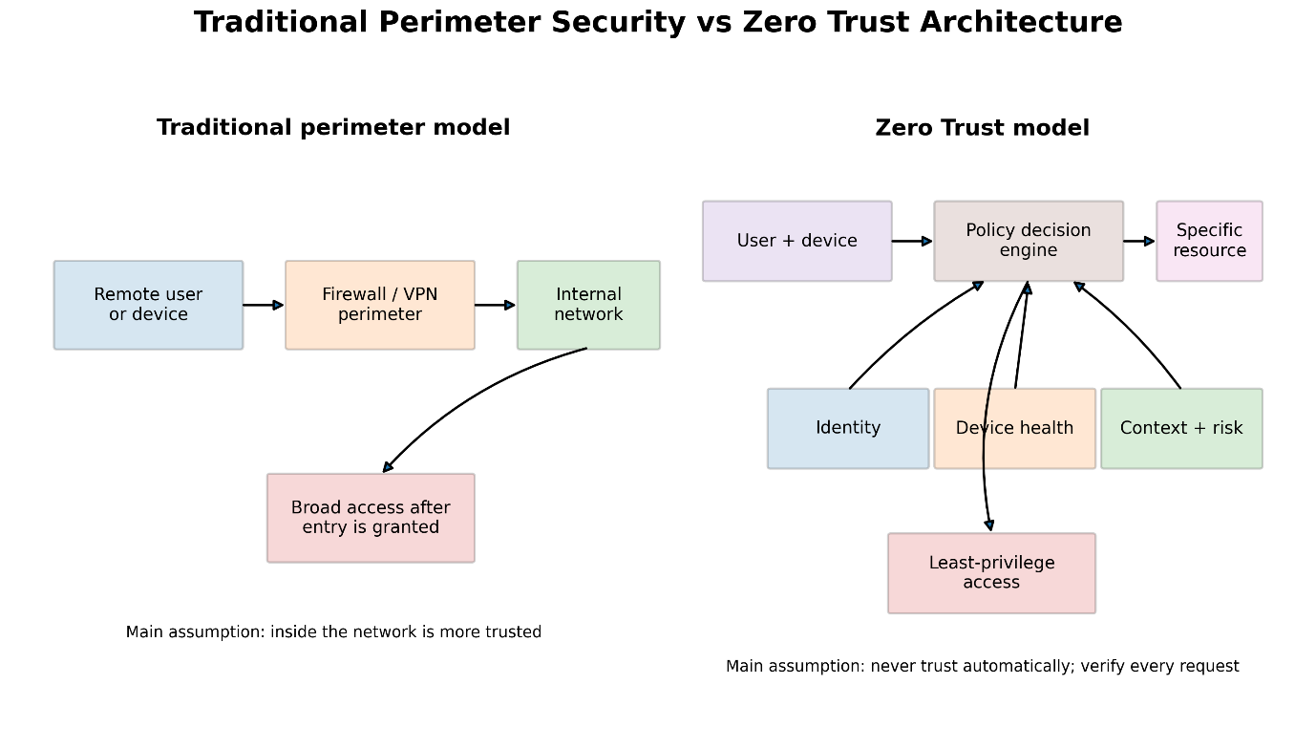

3. Principles and Components of Zero Trust Architecture
The first principle is explicit verification. Every access request should be authenticated and authorised according to current evidence. Strong identity management is essential because the organisation must reliably identify human users, services and devices. Multi-Factor Authentication reduces dependence on passwords, while identity lifecycle management ensures that access is created, changed and removed when employees join, change roles or leave. The United Kingdom National Cyber Security Centre states that authentication and authorisation should consider multiple signals such as user identity, device health, location and status [5].
The second principle is least-privilege access. Users and services should receive only the minimum permissions needed for a specific task. Access should normally be denied unless policy allows it. Permissions may also be time-limited or granted only when required. This reduces the damage that can result from a compromised account. Privileged administrators require particularly strong controls because excessive administrative access can allow an attacker to change systems, create accounts and disable monitoring.
The third principle is continuous assessment. A successful login should not establish permanent trust for the complete session. Zero Trust systems can repeatedly assess identity, device compliance and behaviour. For example, access may be withdrawn if endpoint protection is disabled, the device becomes non-compliant, an impossible travel pattern is identified or a user begins downloading unusually large quantities of sensitive data. This reflects the idea that risk changes during a session.
The fourth principle is resource and data protection. The National Institute of Standards and Technology emphasises protecting resources rather than network segments [3]. Organisations must therefore know what hardware, software, services and data they possess. Data should be classified according to sensitivity, ownership and business value. Plotkin’s approach to data stewardship is relevant because effective governance requires defined ownership, responsibilities and processes for managing data [2]. Without data classification, policy engines cannot apply stricter controls to personal, financial or commercially sensitive information. Plotkin also presents data stewards as an important part of a successful data-governance programme because they convert governance requirements into practical organisational activities.
The fifth principle is segmentation. Microsegmentation divides systems and workloads into small security zones and controls communication between them. Rather than permitting broad internal access, each connection is authorised according to policy. If an endpoint is compromised, segmentation can limit lateral movement and reduce the number of systems reachable by the attacker. However, segmentation policies must reflect real business processes. Poorly designed policies can interrupt legitimate application dependencies or create large numbers of complex rules.
A Zero Trust Architecture commonly includes a policy engine, policy administrator and policy enforcement point. The policy engine evaluates information and decides whether access should be allowed. The policy administrator communicates and applies the decision, while the enforcement point permits, blocks or terminates the connection. Supporting information may come from identity systems, endpoint management, vulnerability scanners, data-protection tools, Security Information and Event Management platforms and threat intelligence.
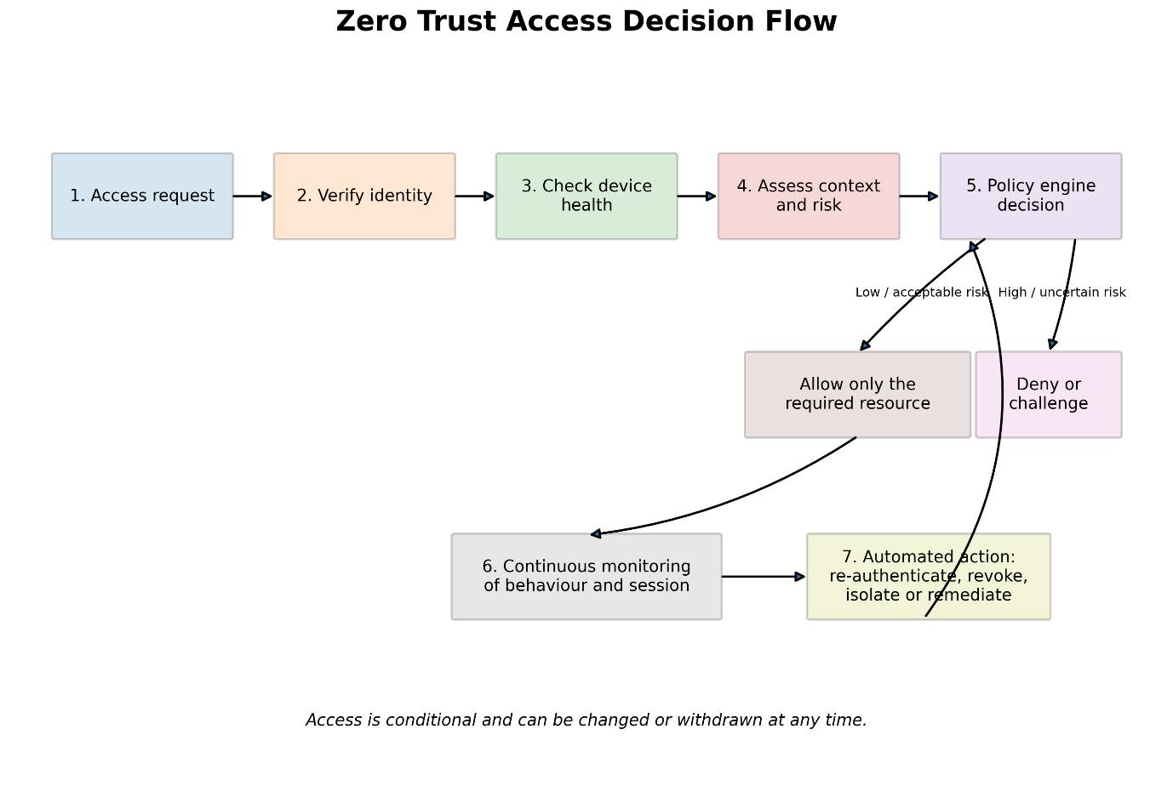
These components demonstrate that Zero Trust depends on integration. The policy engine requires accurate and timely information. If device status is outdated, identity records are incomplete or security tools cannot exchange data, decisions may be incorrect. The National Institute of Standards and Technology’s 2025 implementation guide, based on nineteen example architectures involving twenty-four collaborators, demonstrated that commercially available technologies can be combined to support Zero Trust use cases. However, it also recorded limitations in interoperability and information sharing between products [4].

4. Effectiveness Compared with Traditional Security
Zero Trust provides several advantages over perimeter-based security. First, it reduces implicit trust. Access is based on the specific user, device and resource rather than successful entry into an internal network. This makes stolen credentials less useful when the attacker cannot satisfy device, location or behavioural requirements.
Second, Zero Trust limits lateral movement. Least privilege and segmentation reduce the number of resources available after an initial compromise. In a traditional flat network, one compromised endpoint may expose many systems. Under Zero Trust, each new connection requires a policy decision. This does not guarantee that movement is impossible, but it creates more barriers and more opportunities to detect suspicious activity.
Third, it supports hybrid work more naturally. The National Institute of Standards and Technology states that Zero Trust can enable authorised access to resources across on-premises and multiple cloud environments from different locations and devices [4]. Users can connect directly to approved applications without receiving general access to the organisational network. This can improve both security and performance compared with routing all activity through a central Virtual Private Network.
Fourth, centralised and consistent policy enforcement can improve visibility. Google’s BeyondCorp implementation used access proxies and a shared access-control engine. This created common logging points and enabled policy changes to be applied more consistently [8]. Detailed logs of access decisions can support investigations, compliance evidence and behavioural analysis.
Nevertheless, the superiority of Zero Trust should not be overstated. A Zero Trust policy engine cannot repair vulnerable software, prevent every phishing attack or ensure that data has been correctly classified. If an attacker controls a legitimate account and compliant device, malicious activity may initially appear authorised. Zero Trust must therefore operate alongside secure software development, patch management, Endpoint Detection and Response, backups, encryption, staff awareness and incident response.
It is also inaccurate to suggest that traditional perimeter security should be completely abandoned. External attack surfaces still require protection, denial-of-service attacks still affect internet-facing services and network controls remain useful. The strongest approach combines Zero Trust decision-making with defence in depth. Its real improvement is that internal location no longer provides automatic confidence.

5. Implementation Challenges and Limitations
The first major challenge is visibility. An organisation cannot protect resources it does not know exist. Legacy servers, undocumented applications, personal devices, service accounts and unapproved cloud services may be absent from inventories. Both the National Institute of Standards and Technology and the National Cyber Security Centre recommend discovering users, devices, services and data before designing policies [4], [5]. This discovery process can be expensive and may reveal ownership disputes between departments.
The second challenge is legacy technology. Older applications may not support modern authentication, detailed logging or application-level policy enforcement. Some systems rely on network addresses or shared accounts. Replacing them may be financially or operationally unrealistic. Organisations may therefore need temporary gateways, proxies or hybrid controls. Google’s experience found that unusual protocols, specialist workflows and difficult use cases formed a “long tail” requiring disproportionate migration effort [10].
The third challenge is interoperability. Zero Trust is frequently assembled from tools supplied by different vendors. The National Institute of Standards and Technology’s implementation findings reported that many products did not integrate out of the box in the manner required for complete policy decisions. Multiple policy decision points may hold different information, meaning one system knows that a device is non-compliant while another knows that the user is behaving suspiciously, but neither receives the complete picture [4]. This fragmentation can create inconsistent enforcement and dependence on custom integration.
The fourth challenge is policy complexity. Fine-grained rules can improve security but may become difficult to manage. Incorrect policies may block legitimate work, while overly permissive exceptions can recreate implicit trust. Policies must be understandable, auditable and connected to business processes. Harkins’ “protect to enable” perspective is important because information security should support organisational objectives rather than simply obstruct activity [1]. Business managers, security professionals, data owners and users must therefore participate in policy design.
The fifth challenge is cost and capability. Zero Trust programmes may require identity modernisation, endpoint management, segmentation, monitoring, data classification, skilled staff and new licences. Smaller organisations may lack the expertise to operate complex systems. However, cost should be assessed against risk rather than treated only as technical expenditure. A phased approach can prioritise critical data, privileged users and high-risk applications.
The sixth challenge concerns privacy and user experience. Continuous monitoring may collect detailed information about devices, location and behaviour. Organisations must ensure that monitoring is lawful, proportionate and transparent. Repeated authentication or unexplained access denials can frustrate users and encourage insecure workarounds. Risk-based authentication should therefore apply stronger checks when risk increases while keeping routine access usable.

5.1 Governance and Phased Adoption
A further issue is organisational maturity. The Cybersecurity and Infrastructure Security Agency’s Zero Trust Maturity Model arranges transformation around five pillars and three cross-cutting capabilities, reinforcing that adoption is a progression rather than a single deployment [6]. An organisation may begin by strengthening identities and devices, then extend policy enforcement to networks, applications, workloads and data.
Maturity should be measured through outcomes such as reduced standing privilege, the percentage of managed devices, coverage of Multi-Factor Authentication, the time required to revoke risky sessions and the proportion of critical data governed by explicit policies. Merely purchasing a Zero Trust product does not demonstrate maturity if users retain unnecessary permissions or unmanaged resources remain accessible.
Governance is required to coordinate this progression. Senior management should define risk appetite and funding, security leaders should establish architecture and control requirements, data owners should classify information, and operational teams should maintain identities, endpoints and logs. Independent assurance should test whether policy decisions operate as intended. Without this accountability, Zero Trust may become a collection of unrelated tools rather than a coherent security architecture.
A phased roadmap also lowers operational risk because controls can be tested with selected applications and user groups before wider deployment. The National Institute of Standards and Technology recommends beginning with asset discovery, formulating access policies around business requirements, identifying existing capabilities, addressing gaps and continually improving the architecture as threats and technologies change [4].
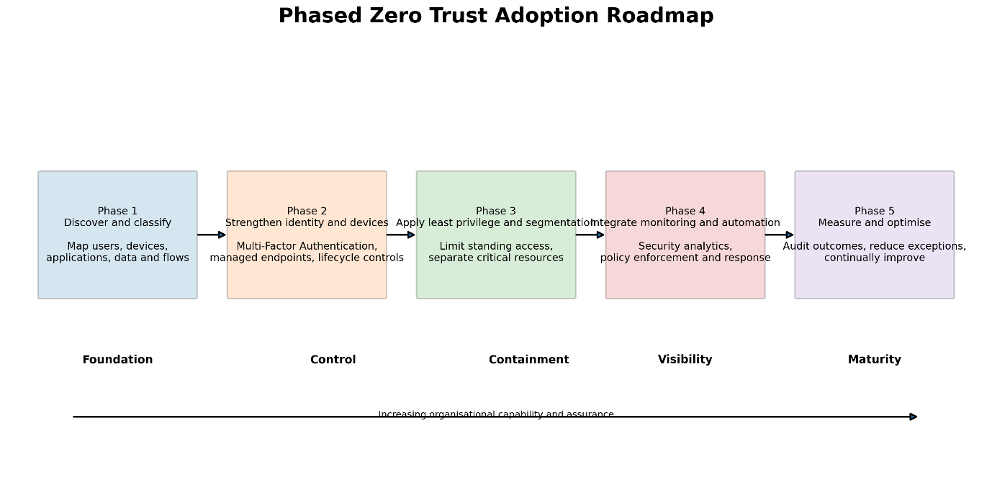

6. Anticipation, Protection, Detection and Automated Response
Zero Trust contributes to anticipation by forcing an organisation to identify assets, data flows, users, dependencies and risks. This discovery supports threat modelling and highlights unmanaged devices, excessive privileges and vulnerable pathways. Continuous inventories and vulnerability information can help organisations predict where a compromise would have the greatest impact.
Protection is provided through Multi-Factor Authentication, least privilege, encryption, device compliance, segmentation and explicit policy enforcement. These controls reduce the probability that a single stolen password or compromised endpoint will provide broad access. Protection is strongest when data stewardship identifies sensitive information and assigns accountable owners.
Detection improves because each access request and policy decision can generate contextual logs. Security Information and Event Management systems can correlate identity, endpoint, network and application events. Behavioural analytics may identify unusual login locations, privilege changes, abnormal downloads or access attempts against unrelated systems. Compared with simple perimeter alerts, this creates a richer view of who is accessing what, from which device and under what conditions.
Automated response becomes possible when monitoring tools, policy engines and Security Orchestration, Automation and Response platforms exchange information. A high-risk event can trigger additional authentication, revoke an access token, terminate a session, isolate a device or block access to sensitive data.
The National Institute of Standards and Technology recommends that endpoint non-compliance should lead to access restriction and, where possible, automatic remediation integrated with configuration and patch-management systems [4]. Automation can reduce attacker dwell time, but poorly tested responses may interrupt essential services. High-impact actions therefore require clear thresholds, human oversight and recovery procedures.
The relationship between the four stages is important. Anticipation identifies the resources and risks requiring attention. Protection applies controls to reduce the likelihood and impact of compromise. Detection determines whether expected behaviour has changed. Automated response acts on that evidence before the attacker can continue. Zero Trust therefore supports a continuous security cycle rather than treating security as a one-time login or perimeter check.

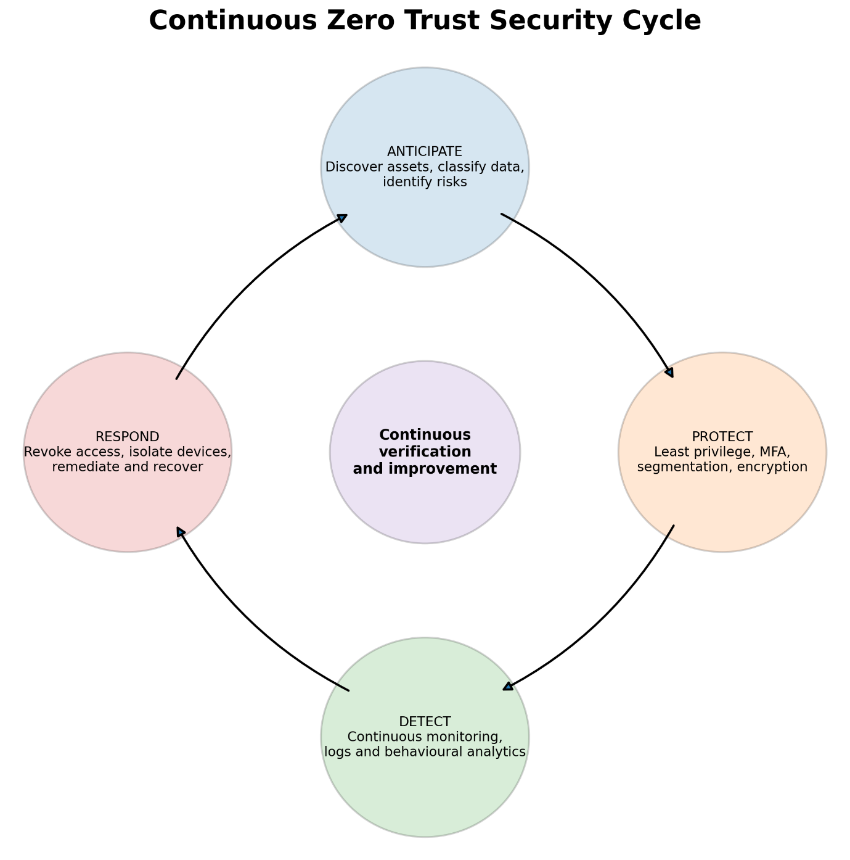

7. Conclusion
Zero Trust Architecture provides a stronger foundation for modern distributed organisations than a security model based mainly on a trusted internal network. Its strengths are explicit verification, least privilege, continuous assessment, segmentation and resource-focused protection. These controls can reduce excessive access, constrain lateral movement and improve visibility across cloud, on-premises and hybrid-working environments.
However, Zero Trust is not automatically effective and should not be presented as a product that eliminates cyber risk. Its success depends on governance, data stewardship, accurate inventories, mature identities, integrated technologies, usable policies and continuous improvement. Legacy systems, vendor fragmentation, cost, privacy concerns and operational complexity can weaken implementation. Traditional controls also remain necessary as part of defence in depth.
The most defensible conclusion is that Zero Trust is more effective than perimeter-based trust when implemented as a phased, risk-led organisational programme. It should begin with critical assets and high-risk access, use measurable policies and expand according to organisational maturity. In this form, Zero Trust can help organisations anticipate threats, protect valuable resources, detect abnormal activity and automate proportionate responses while continuing to enable legitimate business operations.

References
[1] M. W. Harkins, Managing Risk and Information Security: Protect to Enable, 2nd ed. Berkeley, CA, USA: Apress, 2016.
[2] D. Plotkin, Data Stewardship: An Actionable Guide to Effective Data Management and Data Governance, 2nd ed. London, UK: Academic Press, 2021.
[3] S. Rose, O. Borchert, S. Mitchell and S. Connelly, Zero Trust Architecture, NIST Special Publication 800-207, National Institute of Standards and Technology, 2020, doi: 10.6028/NIST.SP.800-207.
[4] O. Borchert et al., Implementing a Zero Trust Architecture, NIST Special Publication 1800-35, National Institute of Standards and Technology, 2025, doi: 10.6028/NIST.SP.1800-35.
[5] National Cyber Security Centre, “Zero Trust Architecture Design Principles,” NCSC Guidance, reviewed Jan. 2026.
[6] Cybersecurity and Infrastructure Security Agency, Zero Trust Maturity Model, Version 2.0, Washington, DC, USA, 2023.
[7] R. Ward and B. Beyer, “BeyondCorp: A New Approach to Enterprise Security,” ;login:, vol. 39, no. 6, pp. 6–11, 2014.
[8] B. Osborn, J. McWilliams, B. Beyer and M. Saltonstall, “BeyondCorp: Design to Deployment at Google,” ;login:, vol. 41, pp. 28–34, 2016.
[9] B. Beyer, C. M. Beske, J. Peck and M. Saltonstall, “Migrating to BeyondCorp: Maintaining Productivity While Improving Security,” ;login:, vol. 42, no. 2, 2017.
[10] G. Gonçalves, K. O’Malley, B. Beyer and M. Saltonstall, “BeyondCorp and the Long Tail of Zero Trust,” ;login:, 2023.

Task 2: Designing a Forward Looking Cybersecurity Programme for Equifax

Introduction
The 2017 Equifax data breach demonstrates that a major cybersecurity incident is rarely caused by one isolated technical error. Attackers exploited an unpatched vulnerability in the Apache Struts framework used by Equifax’s online dispute portal. From May 2017, they maintained access for approximately 76 days and searched interconnected databases for personal information. The compromised data included names, addresses, dates of birth, Social Security numbers and other information capable of supporting identity theft and fraud. Approximately 147 million people were affected.
Investigations identified failures in vulnerability identification, threat detection, network segmentation and data governance. The vulnerable portal had not been correctly identified during patching activity, an expired certificate prevented inspection of encrypted traffic, databases were insufficiently segmented, and attackers obtained unencrypted credentials that allowed access to additional systems. Approximately 9,000 database queries were executed without appropriate restrictions or effective alarms.
The House Committee investigation concluded that the incident was preventable and identified unclear accountability, complex legacy systems, ineffective security measurements and inadequate preparation for supporting affected consumers. These findings demonstrate that Equifax required not merely additional security products, but a coordinated programme connecting governance, policies, risk management, technical controls, compliance and incident response.
This report designs such a programme using the National Institute of Standards and Technology Cybersecurity Framework 2.0, supported by risk management, data stewardship and Zero Trust principles developed in Task 1. It addresses the five assessment components required by the assignment brief: organisational accountability, policies and procedures, strategic governance, risk assessment, and compliance, incident response and protection controls.

1. Organisational Structure and Accountability
Equifax’s first requirement is an organisational structure in which cybersecurity responsibility cannot become unclear or divided between departments. Before the breach, the security function lacked sufficient independence and executive visibility. The House investigation found an execution gap between policy development and operational implementation, while the Government Accountability Office reported that Equifax subsequently created a Chief Information Security Officer role reporting directly to the Chief Executive Officer.
The proposed structure is shown below.
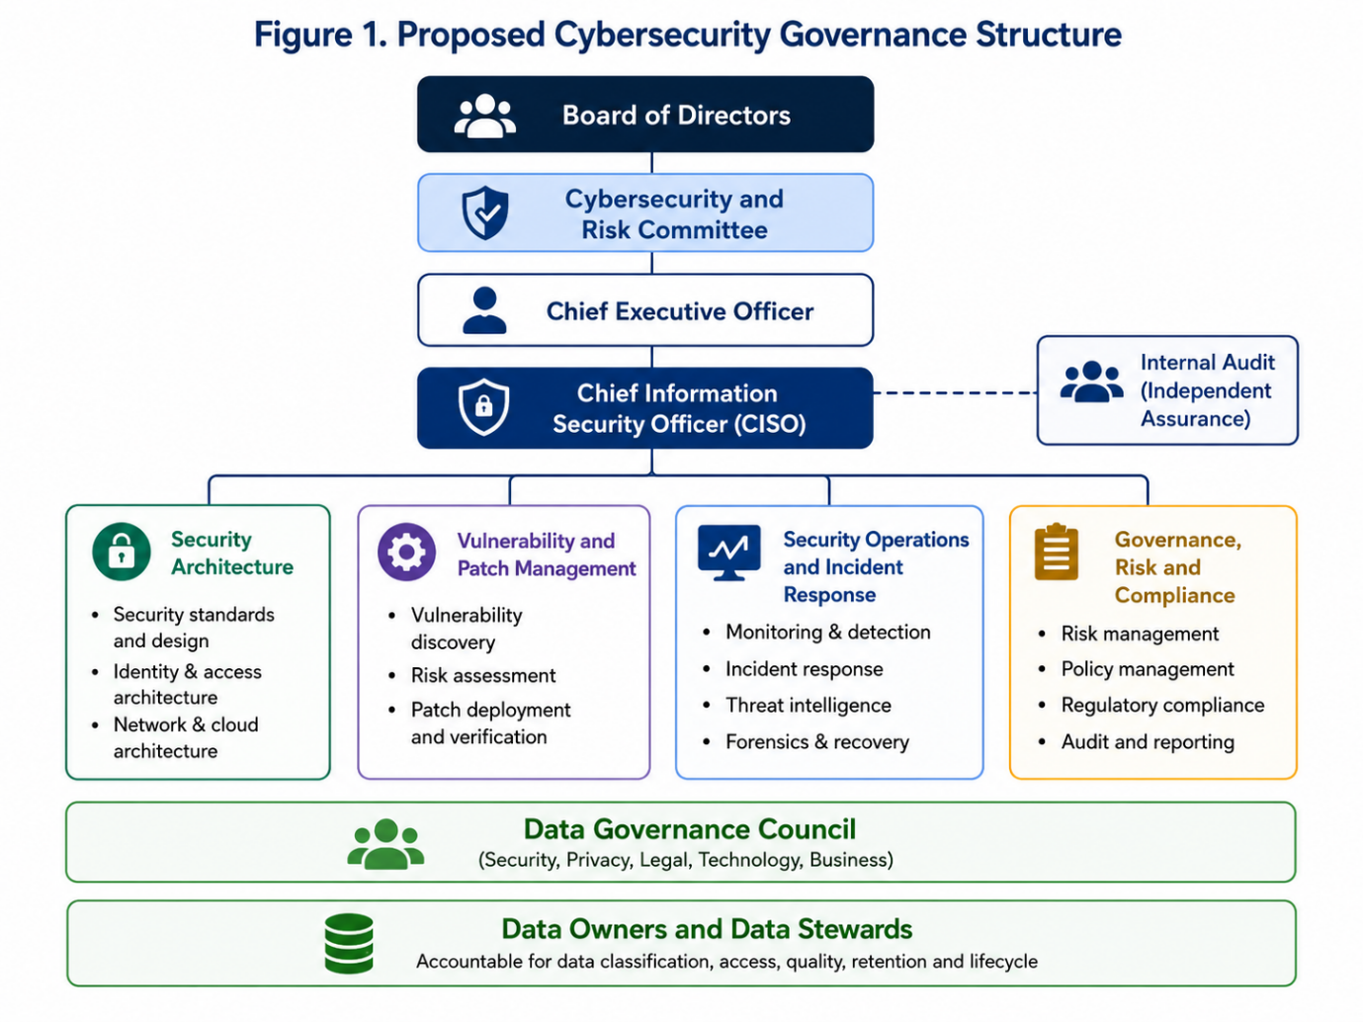
The board should establish the organisation’s cybersecurity risk appetite, approve major investment and receive a quarterly cybersecurity report. Critical vulnerabilities, material incidents and major policy exceptions should be reported immediately rather than waiting for scheduled meetings. A Board Cybersecurity and Risk Committee should challenge management decisions and monitor whether accepted risks remain within agreed tolerance.
The Chief Information Security Officer should report directly to the Chief Executive Officer and have independent access to the board. This prevents security concerns from being subordinated to information technology delivery targets. The Chief Information Officer should remain responsible for technology operations, but the Chief Information Security Officer should define security requirements, assess risk and independently verify whether controls are effective.
Operational responsibility should be divided clearly. The Vulnerability and Patch Management team should identify vulnerabilities, assign owners and verify remediation. Security Architecture should approve segmentation, identity and encryption designs. Security Engineering should integrate security into development. The Security Operations Centre should monitor activity continuously and lead technical incident response. Governance, Risk and Compliance should maintain the legal register, risk register, control evidence and audit programme.
A Data Governance Council should include security, privacy, legal, technology and business representatives. Plotkin’s data-stewardship approach is relevant because sensitive data requires named owners who understand its purpose, location, value, authorised use and retention period [2]. Every critical data domain should therefore have a business data owner and an operational data steward. Accountability should be reflected in job descriptions and performance objectives rather than treated as an informal expectation.

2. Policies and Procedures
Equifax requires enforceable policies that convert governance decisions into measurable operational requirements. The existence of a policy is insufficient unless compliance can be verified through records, dashboards, testing and independent assurance.

2.1 Asset, Vulnerability and Patch Management
A central asset inventory should record every server, application, database, cloud service, software dependency, owner, business purpose, data classification and internet exposure. Automated discovery should identify assets that have not been formally registered. No public-facing application should operate without a named technical owner and business owner.
The patch-management policy should define risk-based service-level targets. For example, a critical vulnerability affecting an internet-facing system should be assessed within 24 hours, temporarily mitigated within 72 hours and fully remediated within seven days unless testing demonstrates that a different timescale is necessary. Any exception should identify compensating controls, an accountable risk owner and an expiry date.
NIST describes enterprise patch management as identifying, prioritising, acquiring, installing and verifying patches across the organisation. It frames patching as preventive maintenance and a necessary cost of operating technology, rather than an optional technical activity [7]. Equifax’s original process failed partly because its notification list was outdated and its scan did not identify the vulnerable portal. The improved procedure must therefore verify successful remediation through authenticated rescanning and configuration evidence rather than assuming that an email or patching instruction has been completed.

2.2 Secure Software Development
The Secure Software Development Lifecycle policy should require threat modelling, security requirements, peer review, static and dynamic testing, dependency scanning, secrets detection and penetration testing. High-risk applications should not enter production until critical findings have been resolved or formally accepted.
NIST’s Secure Software Development Framework recommends integrating security practices into each development lifecycle to reduce vulnerabilities, minimise the effect of undiscovered weaknesses and address recurring root causes [8]. Software components and versions should be recorded so that newly disclosed vulnerabilities can be mapped rapidly to affected applications.

2.3 Data Protection and Access
Sensitive personal information should be classified, minimised and retained only for a justified period. Credentials must never be stored in unencrypted form within ordinary application databases. Passwords, keys and tokens should be held in an approved secrets-management system, rotated regularly and made available only to authorised workloads.
Access should follow least privilege and Zero Trust principles. Each request should be evaluated according to identity, device condition, role, resource sensitivity and risk. Privileged access should be time-limited, logged and protected by Multi-Factor Authentication. Database activity should be monitored, and abnormal query volumes should be blocked or challenged.

2.4 Monitoring and Assurance
The monitoring policy should require centralised logging for identity systems, applications, databases, endpoints, network controls and cloud platforms. Certificate-management systems must automatically discover certificates, issue expiry alerts and renew them before they affect security monitoring.
Policy performance should be measured through indicators such as:
- Percentage of critical assets with confirmed owners
- Percentage of critical patches completed within target
- Number and age of approved exceptions
- Multi-Factor Authentication and endpoint-monitoring coverage
- Mean time to detect and contain incidents
- Percentage of sensitive data stores with approved classification and access reviews
Internal audit should test evidence rather than rely solely on management declarations. Failed controls should generate corrective actions with deadlines and named owners.

3. Governance and Strategic Alignment
The programme should be organised around the six functions of the National Institute of Standards and Technology Cybersecurity Framework 2.0: Govern, Identify, Protect, Detect, Respond and Recover. The framework is suitable because it provides common cybersecurity outcomes for organisations of different sizes and sectors without prescribing one technology. Its addition of the Govern function gives greater visibility to leadership, risk tolerance, policy, legal obligations and supply-chain responsibility [6].
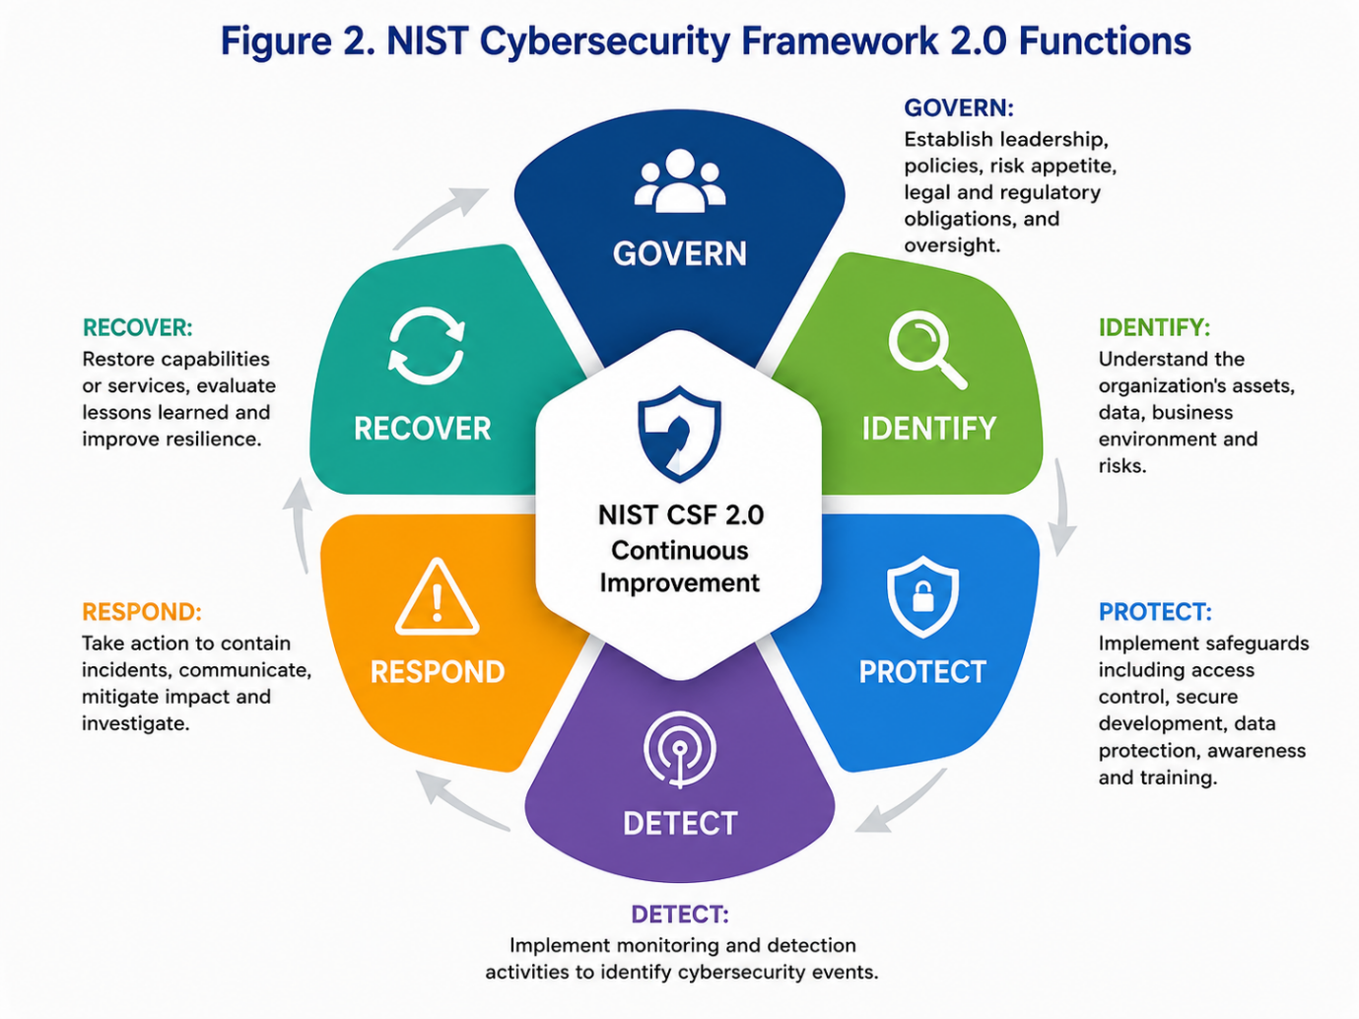
Govern should establish accountability, risk appetite, policies, regulatory requirements and oversight of suppliers. Identify should maintain asset inventories, data maps, business-impact assessments and a prioritised risk register. Protect should implement access control, patching, encryption, secure development, training and segmentation. Detect should use continuous monitoring, endpoint detection, database monitoring and security analytics. Respond should coordinate containment, investigation, communication and legal notification. Recover should restore trusted services, support consumers and apply lessons learned.
The organisation should create a Current Profile showing existing cybersecurity outcomes and a Target Profile describing the required future state. Differences between the two should form a funded improvement roadmap. This avoids purchasing disconnected security tools without understanding the business outcomes they are intended to achieve.
Cybersecurity should also be linked to Equifax’s organisational objectives. Protecting personal information maintains consumer confidence and supports the reliability of credit-reporting and identity-verification services. Effective resilience reduces operational interruption, litigation, regulatory action and contract loss. The Federal Trade Commission settlement required Equifax to pay at least $575 million, potentially rising to $700 million, following allegations that it had failed to take reasonable steps to secure its network. This demonstrates that weak security produces strategic and financial consequences extending far beyond the information technology department.
Harkins’ “protect to enable” perspective supports this alignment [1]. Security should not exist only to block activity. It should enable Equifax to use information confidently while maintaining acceptable risk, legal compliance, operational continuity and public trust.

4. Risk Management and Assessment
Risk assessment should evaluate the likelihood and impact of threats against critical business services and data. A five-point scale can be used, where the risk score equals likelihood multiplied by impact. Ratings of 20–25 are extreme, 12–19 high, 6–11 medium and 1–5 low.
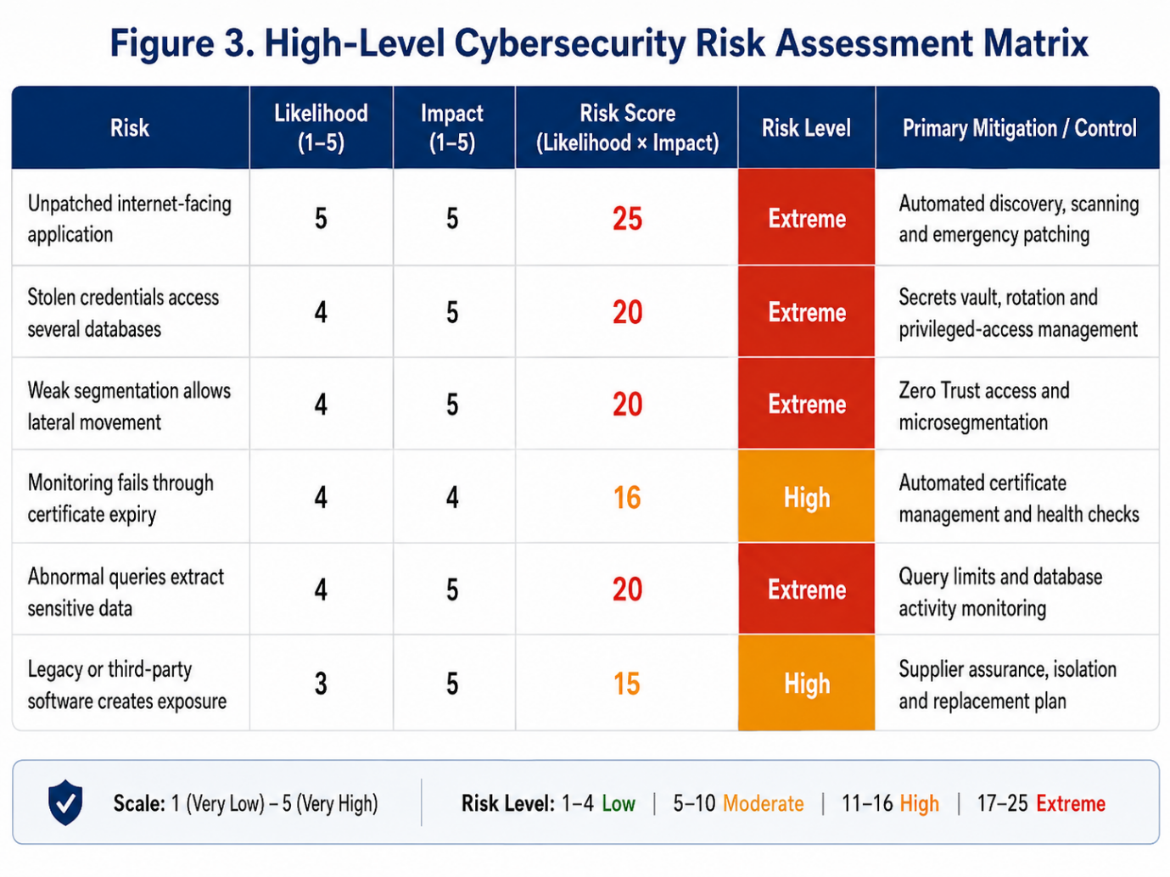
The unpatched public application receives the highest rating because the original breach demonstrated both high likelihood and catastrophic impact. Controls should not depend on one vulnerability email reaching the correct administrator. Asset discovery, software inventories and authenticated scans should provide independent confirmation.
Credential exposure is similarly extreme because the attackers obtained unencrypted usernames and passwords and used them to expand access from the dispute-related databases to numerous unrelated databases. Credentials should therefore be encrypted or vaulted, restricted to individual services and rotated automatically.
Segmentation reduces the number of resources reachable following an initial compromise. Zero Trust does not remove the need to patch the original vulnerability, but it reduces the potential blast radius by requiring separate authorisation for each resource. Query limits and database analytics are also necessary because approximately 9,000 queries were executed without sufficient restriction.
Risk assessments should be reviewed quarterly and whenever there is a major architectural change, serious vulnerability, acquisition or regulatory development. Extreme risks should be reported to executive management immediately. Acceptance of high residual risk should require approval from the relevant business executive and Chief Information Security Officer, with board visibility where the potential impact is material.

5. Compliance, Incident Response and Protection Controls

5.1 Regulatory Alignment and Breach Notification
Equifax operates within a complicated regulatory environment. The Fair Credit Reporting Act governs the accuracy, fairness and privacy of consumer-reporting information. The Gramm-Leach-Bliley Act requires appropriate administrative, technical and physical safeguards for customer information, while the Federal Trade Commission can take action where inadequate data protection constitutes an unfair or deceptive practice. The Federal Trade Commission Safeguards Rule also requires covered financial institutions to maintain a comprehensive information-security programme [3].
A regulatory-obligations register should identify laws, regulators, contractual duties, affected jurisdictions, evidence requirements and notification deadlines. Legal and privacy specialists should participate in incident classification from the beginning rather than being contacted after technical investigation has finished.
The notification procedure should follow a “report early and update later” model. Where United Kingdom personal data is involved and reporting is legally required, the Information Commissioner’s Office states that notification should occur without undue delay and, where feasible, within 72 hours. Affected individuals should also receive clear information where the breach creates a high risk to their rights.
Notifications should describe what happened, the data involved, likely consequences, containment actions and protective steps available to consumers. Messages should be approved by legal, security and communications teams but must not be delayed for reputational reasons. Consumer-support websites and call centres should be capacity-tested because Equifax’s original response channels became overwhelmed.

5.2 Incident Response and Disaster Recovery
Incident response should be integrated throughout cybersecurity risk management, following NIST Special Publication 800-61 Revision 3. NIST states that integrating response into Cybersecurity Framework activities helps organisations prepare, reduce incident impact and improve detection, response and recovery [9].
Equifax should maintain playbooks for exploited vulnerabilities, data exfiltration, compromised credentials, ransomware, malicious insiders and supplier incidents. Each playbook should define severity levels, technical actions, decision authority, evidence preservation, notification requirements and communication templates.
During a serious incident, the Chief Information Security Officer should appoint an incident commander. The response team should include Security Operations, Information Technology, Legal, Privacy, Business Continuity, Communications, Human Resources and customer-support representatives. External forensic investigators, insurers, regulators and law-enforcement agencies should be contacted according to predetermined criteria.
Containment may involve blocking malicious addresses, disabling accounts, isolating endpoints, revoking tokens, restricting database connections and taking vulnerable services offline. Eradication should remove malicious artefacts, patch vulnerabilities, rotate credentials and verify that persistence has been eliminated. Recovery should restore systems from trusted configurations, monitor them closely and confirm that business and security owners accept the remaining risk.
Disaster-recovery plans should define Recovery Time Objectives and Recovery Point Objectives for critical services. Backups should be encrypted, separated from production and regularly restored during exercises. Equifax should also maintain an alternative consumer-notification platform, scalable call-centre arrangements and pre-agreed suppliers so that support remains available during a major incident.
After every significant event, a review should identify technical, procedural and governance failures. Corrective actions should be entered into the risk system, assigned to owners and tracked to closure. Board reporting should concentrate on lessons and unresolved risks rather than attributing blame to one employee.

5.3 Technical Safeguards and Automated Response
Continuous vulnerability scanning should combine external attack-surface monitoring, authenticated internal scanning, dependency analysis and cloud-configuration assessment. Results should be automatically compared with the asset inventory and ticketing system. Critical exposures should alert the Security Operations Centre and responsible owner.
Endpoint Detection and Response should identify malicious processes and allow compromised devices to be isolated. Network Detection and Response should examine east-west and outbound traffic. Security Information and Event Management should correlate events from identity, endpoint, application and database systems, while Security Orchestration, Automation and Response should perform approved actions such as disabling an account, revoking a session or blocking an address.
Sensitive information should be encrypted during transmission and storage. Encryption keys should be separated from the protected data and controlled through dedicated key-management systems. Tokenisation should be considered where applications do not require the original value. Strong authentication, privileged-access management and regular access reviews should prevent one account from receiving unrestricted access.
Database Activity Monitoring and Data Loss Prevention should detect unusual query volumes, sensitive-data access and large outbound transfers. Rate limits would have made the attackers’ thousands of queries more visible and could have slowed or stopped extraction. Segmentation would have prevented the initially compromised portal from communicating freely with unrelated databases.
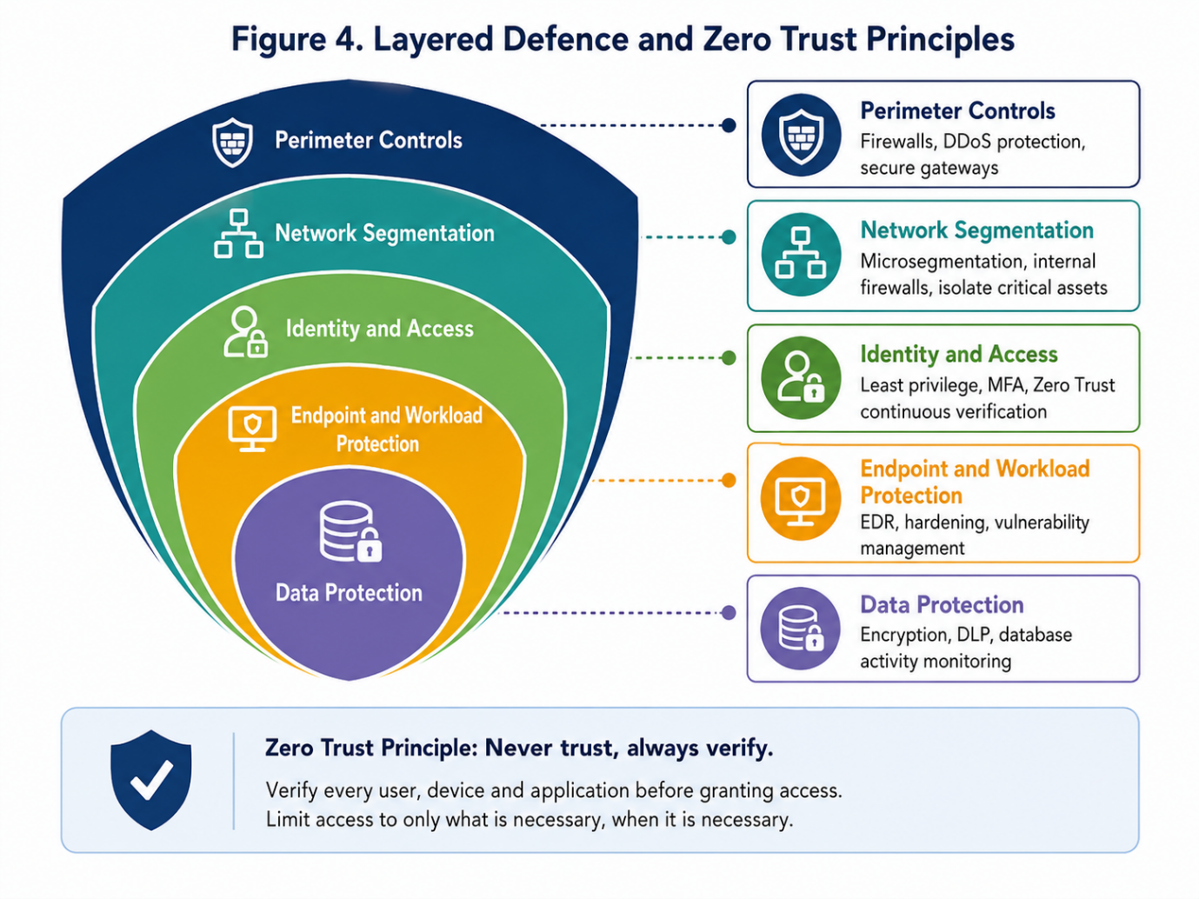
These controls reduce dwell time by increasing the likelihood that suspicious activity is detected quickly and by automating containment. They limit organisational impact through least privilege, segmentation, encryption, query restriction and tested recovery. However, automation must be governed carefully. High-impact actions should use tested rules, complete audit logs and human approval where an incorrect response could interrupt an essential service.

Conclusion
The Equifax breach resulted from a connected set of governance, technical and operational failures rather than one missed patch. The vulnerable application was not correctly identified, monitoring was impaired, databases were insufficiently segmented and sensitive credentials were poorly governed. These weaknesses allowed attackers to remain undetected and expand their access.
The proposed programme responds by establishing board-level accountability, an independent Chief Information Security Officer, enforceable policies, data ownership, risk-based patching, secure development and continuous assurance. The National Institute of Standards and Technology Cybersecurity Framework 2.0 connects these activities with Equifax’s business objectives through Govern, Identify, Protect, Detect, Respond and Recover.
The most important lesson is that cybersecurity must operate as a continuous enterprise-risk programme. Patching could have prevented the initial compromise, while Zero Trust, segmentation, credential protection, monitoring and query restrictions could have limited its scale. Effective incident response and prepared consumer-support services could then have reduced the duration and wider consequences of the breach.

References
[1] M. W. Harkins, Managing Risk and Information Security: Protect to Enable, 2nd ed. Berkeley, CA, USA: Apress, 2016.
[2] D. Plotkin, Data Stewardship: An Actionable Guide to Effective Data Management and Data Governance, 2nd ed. London, UK: Academic Press, 2021.
[3] U.S. Government Accountability Office, Data Protection: Actions Taken by Equifax and Federal Agencies in Response to the 2017 Breach, GAO-18-559, Washington, DC, USA, Aug. 2018.
[4] U.S. House Committee on Oversight and Government Reform, The Equifax Data Breach, Staff Report, Washington, DC, USA, Dec. 2018.
[5] Federal Trade Commission, Federal Trade Commission v. Equifax, Inc., Civil Action No. 1:19-cv-03297-TWT, 2019.
[6] C. Pascoe, S. Quinn and K. Scarfone, The NIST Cybersecurity Framework (CSF) 2.0, NIST CSWP 29, National Institute of Standards and Technology, Feb. 2024, doi: 10.6028/NIST.CSWP.29.
[7] M. Souppaya and K. Scarfone, Guide to Enterprise Patch Management Planning: Preventive Maintenance for Technology, NIST SP 800-40 Rev. 4, Apr. 2022, doi: 10.6028/NIST.SP.800-40r4.
[8] M. Souppaya, K. Scarfone and D. Dodson, Secure Software Development Framework Version 1.1, NIST SP 800-218, Feb. 2022, doi: 10.6028/NIST.SP.800-218.
[9] A. Nelson, S. Rekhi, M. Souppaya and K. Scarfone, Incident Response Recommendations and Considerations for Cybersecurity Risk Management, NIST SP 800-61 Rev. 3, Apr. 2025, doi: 10.6028/NIST.SP.800-61r3.
[10] Information Commissioner’s Office, “UK GDPR data breach reporting,” May 2025.

