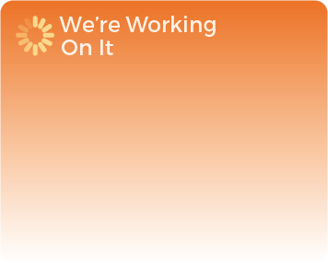


You asked for regular and consistent café services to be available on a Saturday. We have notified operations and are awaiting their reply.
We are in discussions with registry regarding your DBS applications and are hoping to resolve the issue within the next few weeks.

You have asked for face to face weekend support from student services; we cannot provide this at the moment due to various reasons, but you are able to access student services via email if you cannot call into the campus during the week.

You noted that there was difficulty in obtaining id cards on the weekend; We have negotiated with IT&S and your cards should be available shortly.

