By Andrew Ridgeway
Computer Games Development
P148551
The Project Initiation Documentation

Section 1……………………………………………………….2

Section 2……………………………………………………….3

Section 3……………………………………………………….4

Section 4……………………………………………………….4

References…………………………………………………….6

Section 1
This project is used to create awareness for homeless people by creating an app for Street football Wales and this will help with creating a more of awareness to a wider audience across Wales[1].

Background
The project will be building an app for Street Football Wales to increase awareness of the organization. The app will be used for fans, contributors and newcomers to the cause. The cause will help awareness with homeless people on the streets and the app will be used across Wales to help get rid of homeless people off the streets, for example this will increase awareness to help homeless people to be more productive with their lives.

Project Definition
- Purpose: The project will help Street football Wales to decrease homelessness and help the homeless people with a purpose in their life, that's why the app will be used to help Street football Wales.

- Objectives: There will be several objectives to the app that would include:
- There will be a news feed to allow the end user to see updates and progress how the Street Football Wales is doing.
- There will be a donation feature that well allow the end user to giving the option to donate money to Street Football Wales.
- There will be a create fundraisers for Street Football Wales to allow events to raise money for the cause.
- There will be a league tables for Street Football Wales that will show the rankings of their football players.

- Scope: To build a working app that will be used by people across Wales and the features the app will include:
- The end user will be able to create a profile on the app.
- The profile will have features that will include, regular updates on what the team is doing.
- The app will allow the end user to donate money to their causes and it will be optional for the end users to choose to donate money.
- The end user will be capable of buying products online.

- Deliverables: The report will be the first to be started with for the app such as the report will be finished on the 5th of November. The design of the project will be finished between December to January. The prototype of the app will be ready between August to May. The full version of the app will be finished between at the end of May to June.

- Constraints: The type of constraint that app will have such as maintaining the app, this means the app must be constantly maintained to keep it up to date. Keeping the software online this means the app must be constantly paid to stay online. How long will it take for the completion of the app, this means it's unknown how long it would take to build the app. For example, they could take three months or year to complete the app.

- Assumptions: The software will be used to create the app such as off the shelf software may be used or a custom-made software. The type of hardware to use for the development of the app will be computers to create app and then put on phones to see if it works well. There will be several end users to test the app to see if it's working properly and it'll be tested over time. there will be a team to develop app for Street Football Wales.

Section 2
The building of this project will go ahead because by looking at the business case and risk analyse.

Business Case
- Benefits: Help with Street Football Wales awareness and people to join the course, help Street Football Wales too increase their donations.

- Options: The main reason that a phone app was chosen because a lot of people these days are on their phones more. There were other alternative options such as newspaper, improving the website, television, radio and pamphlets.

- Cost and Timescale: The product will be built with a small development team and they will be paid through the course of the timescale the building at this product.

- Cost/Benefit Analysis: Since the product is being built by a small team and the team is using their own equipment to build it, the cost of using equipment will not affect building the product.

Risk Analysis
- Risk Identification: There are going to be several risks that would include:
- Internal: If software or hardware becomes corrupted such as date of creating app could be lost. One of the team members could potentially ruin the app by accident or on purpose.

- External: Street football Wales could be shut down and this would make the app useless. Some outside sources could steal the app from the hardware devices.

- Risk Prevention: making sure to make several backups of the app just in case anything goes wrong, such as one team member could accidentally ruin the app or outside sources could steal it.

Risk Management: Just in case a much bigger are risk happens to the project, for example if Street football Wales suddenly shut down and this would make the app completely useless.

- Risk Monitoring: There will be several backups to make sure certain risk may happen, for example if suddenly the unknown end user go on to the hardware device to delete it.

Section 3
- Project Team: Richard Hankey, Fraser Sweetman, Steffan Davies, Andrew Ridgeway.

- Project Sponsor: Street Football Wales.

Roles and Responsibilities
- Project Manager/Team leader: Richard Hankey, responsible for managing the team.

- Project UI Designer: Steffan Davies, responsible for designing a UI for the app.

- Project Lead Programming/Designer: Andrew Ridgeway, responsible for programme and the designing the app.

- Project Programming: Fraser Sweetman, responsible for creating a working app.

Section 4
The project will be built by using self-hardware and software to develop the app. The project will be keeping track by using Microsoft Project for the timescale.

Initial Project Plan
- Gantt: 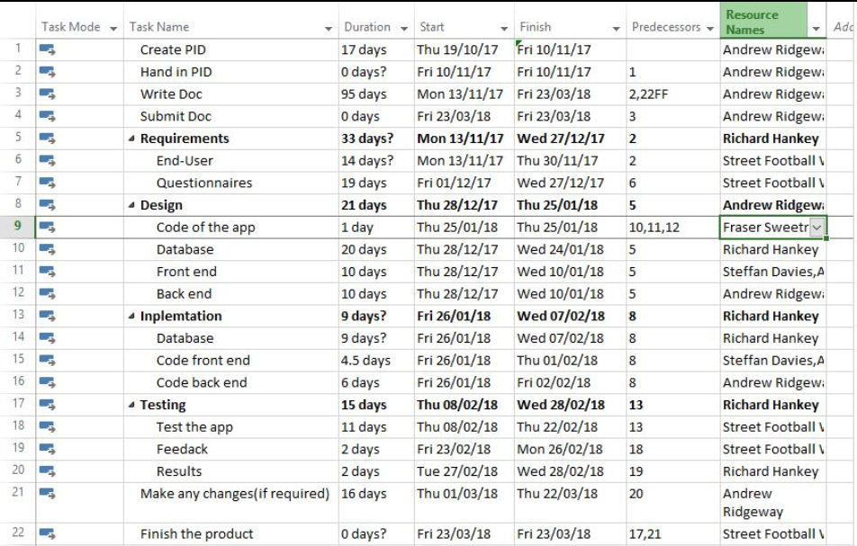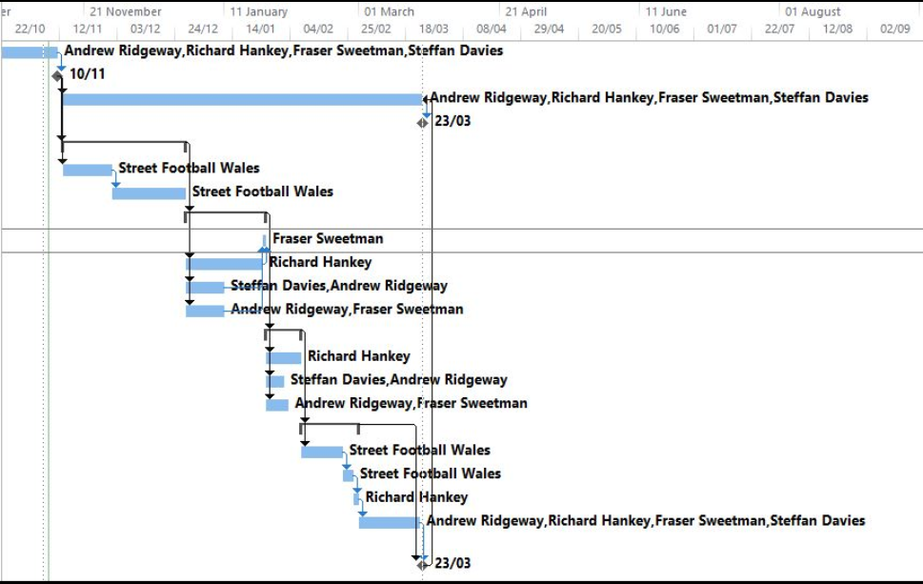

- Project Control: The project time will be managed through Microsoft Project to make sure to keep track and not to go off Topic with keeping the project on a time scale.

- Quality Control: by keeping in to the time scales to make sure the product is finished at a professional level and by testing the product to make sure there's no bugs within the product.

Key Points
The focus for this project is to help Street Football Wales with donations by creating an app. This where allows the end user to contribute donations for the cause for Street Football Wales and this donation will help homeless people.

References
[1] P. Griffiths, “index @ www.streetfootballwales.com,” Street Football Wales, 2017. [Online]. Available: http://www.streetfootballwales.com/. [Accessed: 27-Oct-2017].

