

HTML & CSS Web Development
  - Internet Technology and Security
  - Lecturer: Kemi Ademoye
  - module code: acca4018
Ruzy Aktar | 1708215 | 3/05/2019

Contents page

2) Abstract and brief introduction ………………………………………………………………... [5]

6) Implementation section ………………………………………………………………………...... [9]

10) Validation ………………………….…………………………………………………………………….. [11]

12) Evaluation…………………………………………………………………………………….. [12]

Introduction
For this report the author has been told to design a website, this website will be made from using Microsoft Visual studio 2017. Throughout this report the author will demonstrate her understanding of the standards, concepts, principles and practice that is needed in the implementation of websites. There are two tasks for this report first the individual will be making the website and task 2 will be a report. In this report there will be explanations of why the author chose their topic, and a short summary describing the contents. Provided in this report will be screenshots of the website.
The author has decided to do a blog website and the topic she has chosen is ‘Fitness’, further on this report she will be going into the requirements for this.
Home page
For the home page she named it ‘Rosieys Fitness Blog’. This website is to help people with their journey through fitness or for individuals who are scared or struggling to get the help they need to start. So for the home page she has added a light simple introduction to what fitness is. She has mentioned to her viewers fitness isn’t an easy matter to fix it takes time and dedication. Her introduction and the language the user uses second person as if she is speaking to the person directly for whom ever reads her blog. The author has decided to do this because some individuals may feel like they can’t talk to anyone about their insecurities so reading a blog might seem like it’s a similar live interaction.
The author has used motivational quotes that may encourage an individual reading it, this is encourages them to see fitness in a different light. The author thought this would be a good idea because it may help the thought of fitness really sync in their brain.
On the page there are also healthy fun facts to ease in the viewers, because using distinctive true quotes that may make someone laugh will never make them forget about the fact. The author had thought of this idea to make this blog more fun and easy to read to viewers who may be young and to make the blog more human and not boring. It is known that websites that just have a lot of information but no fun facts or images tend to get less views and nobody really reads the whole blog.
There are also useful health tips that may be useful for some viewers who never knew such facts. The author had gotten this idea to help certain viewers who may have a bad habit that now maybe they can resolve. On the other hand going back to motivational quotes the author had added ‘Try not to think of your journey as a diet’.
This is a good technique and very helpful to those who may not like having a healthy lifestyle where they just live off a strict diet, which then makes individuals not want to try this journey which can be good benefit to their health. The author had made this website based on her own journey through fitness and has found out that you may still eat what you desire but you can also workout and enjoy food as long as you balance everything out, this is the reason why she has added this to her home page. This is the end for the first page.
Health & Beauty Benefits
For the second page the author has decided to call it ‘Health & Beauty Benefits’. She has decided to do this topic because even though fitness and being physically fit is good but individuals must know that being physically fit affects you on the inside and as well as out too. This means about your features on the outside such as your face being one.
The author has mentioned drinking water is very important, therefore she has said to her viewers if they want healthy looking skin they must drink plenty such as 3-5 glasses a day. The author had told this fact to her viewers because some may have acne problems or a lot of pimples and not knowing water is very essential they might not know the reason why they have this problem. By sharing this fact she could be helping someone who is too insecure to talk to someone about this. Again the idea of this blog is to help individuals whom don’t have the courage to speak to someone. A lot of people who has insecure tend to hide away and wonder through the internet for help because it’s less scary than speaking to someone face to face.
However, the author has also mentioned the importance of knowing sugar is bad. She has used statistics to display evidence for her hypothesis. The author knows a lot of people immediately think sugar is just desserts but she has mentioned sugar can be in processed foods. This is helpful to viewers who may have never known or acknowledged this. On that note the author has also discussed many diseases and complications sugar can cause if not fixing this problem by having too much sugar in their system. There are also facts about what to avoid that has a lot of sugar

Helpful workouts
Now on the third page, this is all about workouts that individuals who want to start their fitness journey can try. She has kept it very simple with facts on what each workout does for you. The author has made this page relatable using the idea of making this blog more human and not boring. Instead of using facts and throwing them at the viewers the author has made this blog sympathetic again using motivational language too.
Author has given examples of some activities that may interest individuals over exercising because for some the term ‘exercise’ can trigger them to think too much. But the author has used a method of tricking your mind of having fun over something someone might like doing and this benefits them because it’s a type of exercise which will physical and mentally help an individual for many of their goals on this journey.
Another topic the author has covered is giving examples of exercises that may be of help to some who have no knowledge of this. Viewers might like this if they are interested on starting their journey straight away. Along with naming the exercises she has also said what the exercises help with.
Author has linked fitness to mental health, this is important for some who may be stressed all the time, have anxiety, depression and so forth. Author made this a topic on her page because again some people are afraid to speak out and having this on a blog were you can feel like your speaking to someone might help them through their tough situation.
It has come to the attention of the author that many obese people suffer through depression and anxiety because of how they look, and talking about this may want to make them change their lifestyle so they don’t have to feel like they’re suffering anymore. This is why there are facts on their how to prevent this,
On this page as well as that the author has put her own experience with a picture, along with the picture is a little information of how she has suffered through being scared of trying to be fit and healthy. A lot of people are scared to go to the gym but she has related the topic to her own experience and letting viewers know if she can do it so can they. This is a good technique to help motivate others.

Nutrition
The main focus for this page is to promote healthy eating. The author has come to the attention of individuals being too busy and not having time to make meals on the go. She has put up some ideas that may come to help for those who are very busy.
She has broken down the meals such as breakfast, lunch and dinner and put down some meal ideas. The idea is also to show individuals healthy eating isn’t all bad and thus why she has added pictures of foods to show being healthy isn’t very scary or unappetizing. Again the author has reminded her viewers you can still indulge in what you like but there’s always a balance to everything, this is in one of her fun facts on her page.
There are many more food facts on her face for viewers who may find it useful,

Contact me
This page is very simple, this is for users to contact the author for any information they may require and she has left her social media tags on there.

Screenshots / implementation
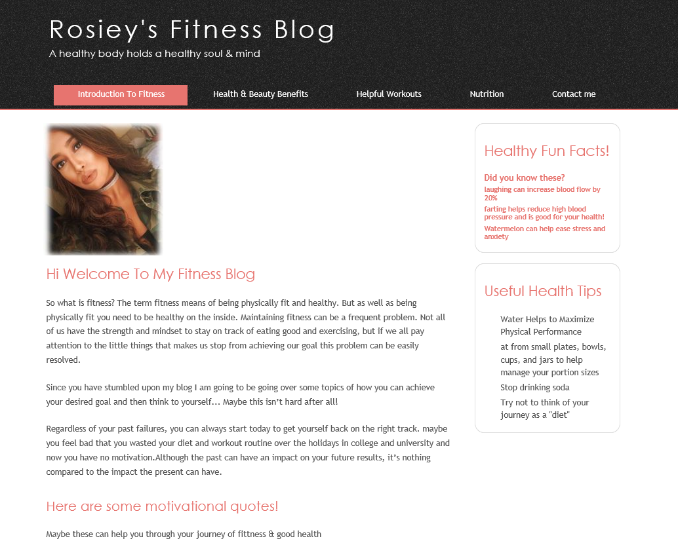

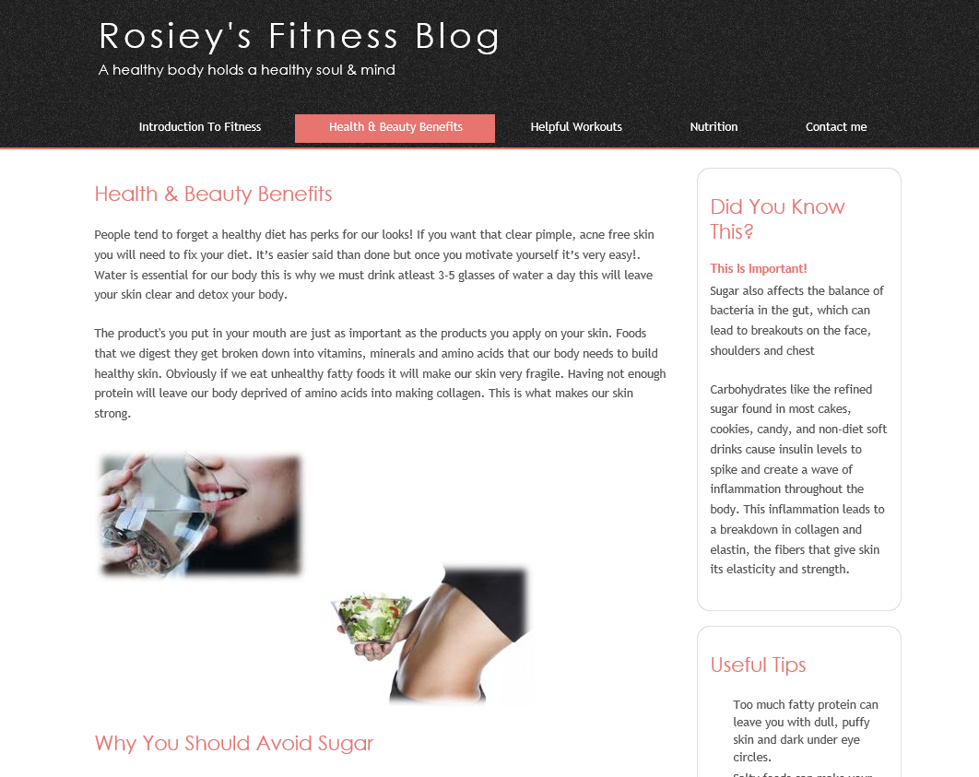

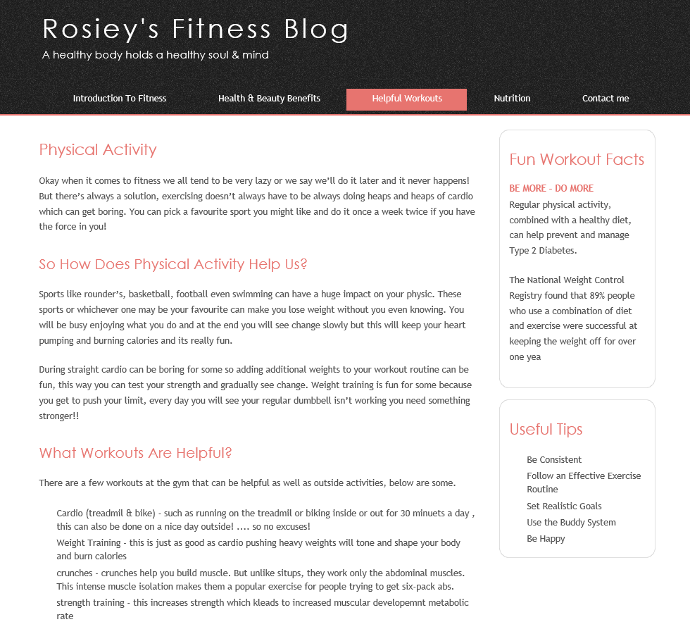

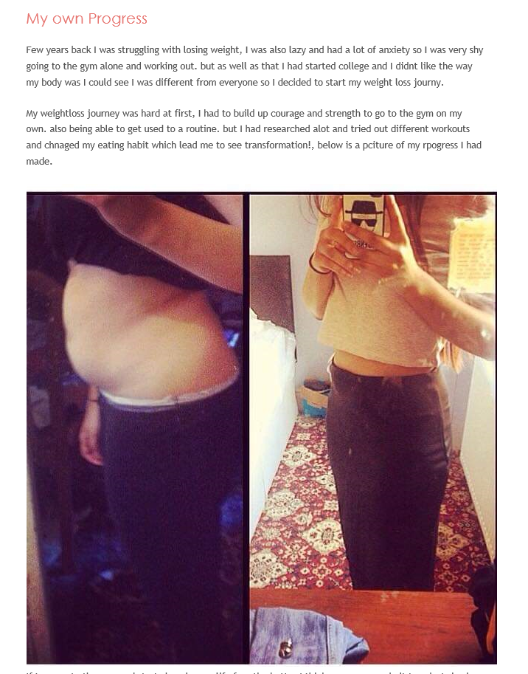

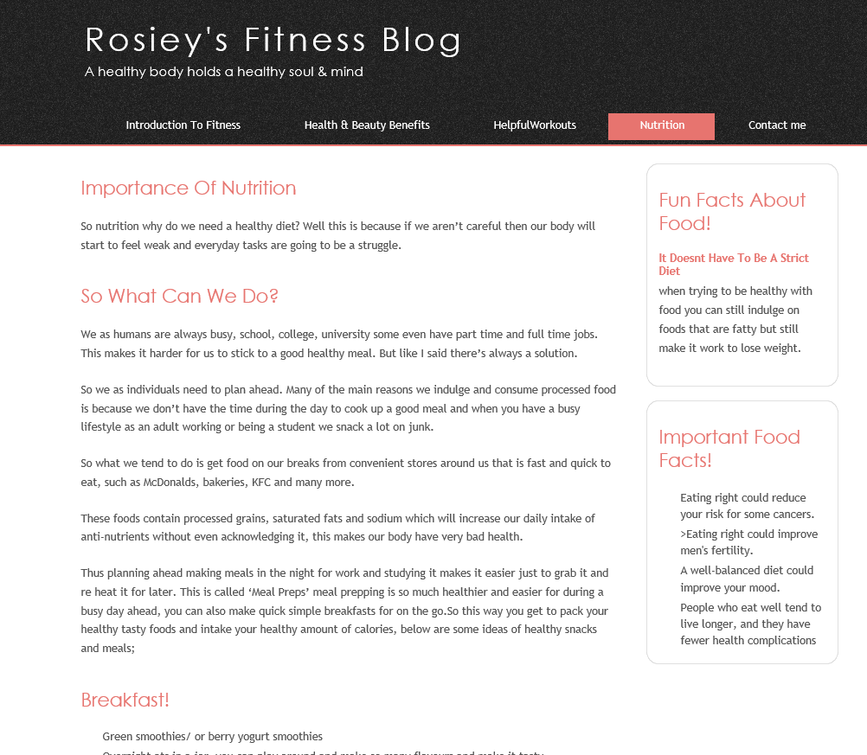

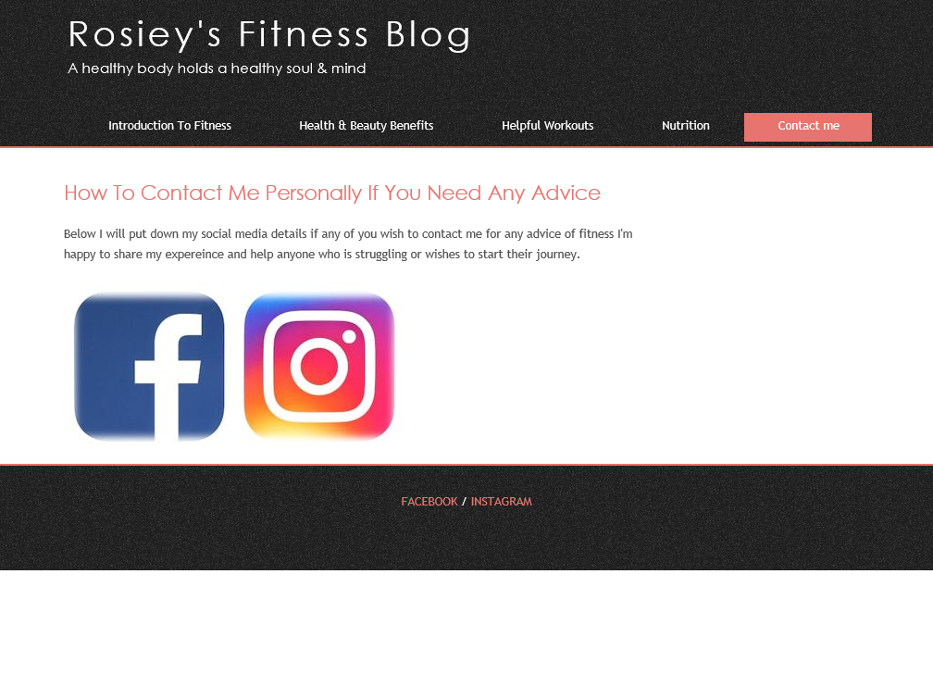

Validation
Code / HTML

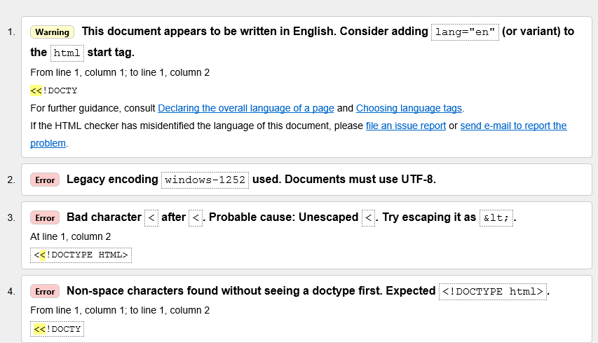
There were some errors found but the website still works perfectly fine, I have gone over them and they don’t need to be removed or changed. Some of the errors are to do with language being used and its telling to change it, and another error being an element ‘head’ missing but again the website works fine. There are few more in the screenshot

CSS
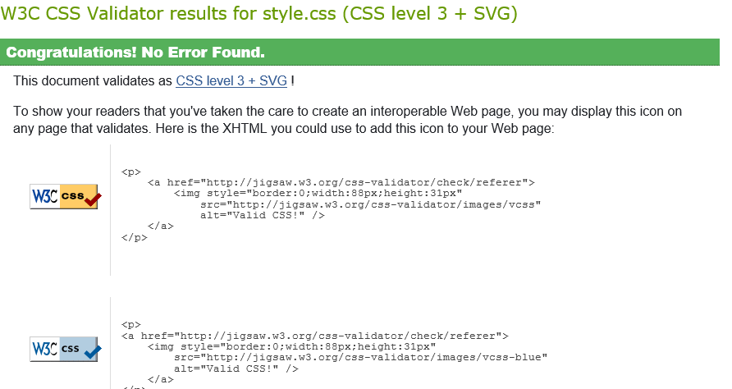
No errors were found during the test.

Evaluation
So for all the pages the author has kept it very simple and readable. The colors she has used are very distinctive and bold. She has added white background to all of them to make pictures and text stand out.
All the main headings are a peachy pink Colour to make them stand out, this has been done to make questions to the viewers more visible. For the first four pages there are side bar boxes on all of them for fun facts as well as important facts to make them stand out to the viewers. The author used this idea to break up the text. Having a lot of text just laid out may seem dull and boring so breaking them up makes it more readable and noticeable to the eyes for every one of the first four pages.
There is a bold textured header to every five pages to make the name of the blog standout. The black colored texture goes well with the main title of the page. Black and white have always been a good combination to make letters and even picture’s to stand out.
To make this blog very relatable to the author she has added her picture to the first page of this website, to make it more comfortable for viewers who may find it hard to speak to someone face to face about their problems so reading a blog coming from a real person may put them at ease.
Another part of the website where the author has made it relatable is the page called ‘Helpful Workouts’. On there the author has added a little introduction of her own progress and how she managed through this journey. Along with this little story she has added a personal picture of herself showing a before and after photo. The author feels like being comfortable with her audience may help others by motivating them to make any change they wish to do.
The author has also used pictures of foods that can help someone to try eating healthy on the ‘nutrition’ page. The idea of this is to make viewers see healthy foods are not boring and can be appetizing and easy to make. The quality of the pictures are good and clear to see. They are also reasonable sizes that’s able to load the page without it buffering for ages.
There are also images of workouts individuals can try and see for themselves it’s not hard. Also the images are viewable and not too big. This is on the ‘Workouts page’.
And last the contact me page is simple, there are tags for the author social media for anyone that may wish to ask for any advice, the author has added pictures of the Instagram and Facebook logo to make it visible to the viewers.

