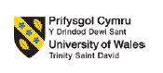

MBA MARKETING MANAGEMENT
LCMB7001

COURSE: MBA GENERAL MANAGEMENT
MODULE CODE: LCMB7001
ASSIGNMENT TITLE: 1
STUDENT NAME: SHAHAM HUSSAIN ELLAMBILAT KUTTYALIPURAM
STUDENT NO: 2130307
LECTURER: TUSHARA BALENDRAN

Executive summary
The marketing management of the Coca-Cola Company has been discussed in the report. The marketing and promotional strategies for the brand including brand awareness among the masses have been discussed in the report. Communication, brand equity, and the total engagement model have also been discussed in the report regarding the Coca-Cola Company. The report contains concise ideas regarding the consumer journey from product selection to advocacy. Consumer journey mapping also has been conducted that denotes different attributes and approaches of individual consumers regarding product purchasing. The market position of the company has been analyzed in the report using SWOT.

Table of Contents
Introduction 3
Background information of the company 3
Definition of communication 4
Communication model 4
Promotional strategies to raise awareness of Coca-Cola 6
Branding and equity 7
Customer's journey to the brand and touchpoints to the organization 7
Explanation of the customer's journey map 9
Aaker’s brand equity model 11
Total engagement model 12
Conclusion 13
References 14

Introduction
Marketing management may be defined as the process of controlling the various marketing aspect from setting up goals for the company, to executing the goals step by step. Marketing management also includes the decisions taken by a firm to get the maximum profit and meet the customer's demand. The 4Ps of the marketing mix that is a product, price, place, and promotion applied to the marketing management of any organization. In this report, the concerned brand Coca-Cola has chosen its promotional strategies, and the customer's journey is also discussed in this report.

Background information of the company
Coca-Cola Company is an American multinational beverage company. The drink was invented in 1886 by pharmacist John Stith Pemberton. Their products have expanded to more than 200 brands and thousands of beverages around the world producing soft drinks and water. The company aims at employing people from diverse communities to about 700,000+ employees across their company and packaging partners. The company prioritizes sustainability in its operations and the communities concerned. The company claims to create a diverse culture, equity, and inclusion within its work sphere. The company creates crafting brands and various choices which people prefer. Hence, gaining popularity among the masses globally. The Coca-Cola system where the local bottlers work to bring the brand has over 225 bottling partners across 900 bottling plants that deliver successfully refreshments to consumers globally.
Coca-Cola is a publicly traded company whose stock is enlisted on the New York Stock Exchange. The company generates revenue by selling its products to retailers and distributors. The target audience for the company lies in the younger generations, whereas the segmentation of the company is based on the customer's age, family size, and income which ultimately make the brand a success globally with its varied products. The commonly follows the concept of price discrimination which involves selling the same good for different prices to different categories of people or customers that the company relies on. The ultimate goal of the Coca-Cola Company mainly focuses on producing the product based on the marketing mix strategy which is product, promotion, price, and place. According to the recent financial report, the company acquired revenue of about $41.32 B which is an increased amount from the last year by about $38.65B (companiesmarketcap.com, 2022). The pricing strategy used by the company is not based on the quantity sold but upon the value created among their customers thereby resorting to the value-based pricing of their products.

Definition of communication
Marketing communication may be defined as the message or the media used to communicate to the market mainly focusing on the demand and supply chain of the products. Marketing communication involves the movement of products, ideas, and services from manufacturers to end users (marketing91.com, 2022). It also involves maintaining a link between the manufacturer, customers, and other stakeholders in the company. The various types of marketing communication include
- Advertising: One of the important techniques as a means of communication is advertising. It involves the act of promoting products and services through advertising to reach out to the masses (Šerić et al., 2022). The company Coca-Cola chooses various advertising mediums such as television, radio, YouTube ads, and many others.
- Public relations: The public relations method of marketing communication is not directly linked to the company where a third party is involved. This kind of marketing communication is effective as the information comes from genuine sources and not from any paid sources of the company. Several sponsorship programs are also initiated to deal with the organization’s commercial operations. It tries to maintain goodwill and better understanding between the organization and the public.
- Sales promotion: The various methods used for sales promotion to attract customers such as discounts, rebates, and coupons: samples given away to the masses, several loyalty programs, and free shipping to the audience. An organization resorts to such a method of promotion to effectively deal with its customers and maximize its profit in a way.

Communication model
The communication model evolves as the communication progresses the model expands to improve the more of the communication model as a process to carry the conversation and meaning to the customers or target audience. The transaction model involves communication as a conceptualization of making relationships rather than the mere sending of messages. The transaction model views communication as a force that shapes realities, the model focuses on creating relationships through communication, and forming intercultural alliances between different communities. The model also relies on establishing the self-concept in understanding and forming communities through interaction (Pressbooks.bccampus.ca, 2022). The role of the sender and receiver varies in this model as compared to other models, as the model instead of relating to participants as senders and receivers of messages. The transaction model rather entitled them to communicators who are involved in the process of communication. The transaction model of communication involves the continuous exchange of information where both the sender and receiver are engaged in communication and takes a turn communicating the message efficiently. The transaction model is efficient for communicators with a similar environment or who share the same social environment. In the transaction model, the efficiency and reliability of the communicated message are dependent on the medium used in communicating.
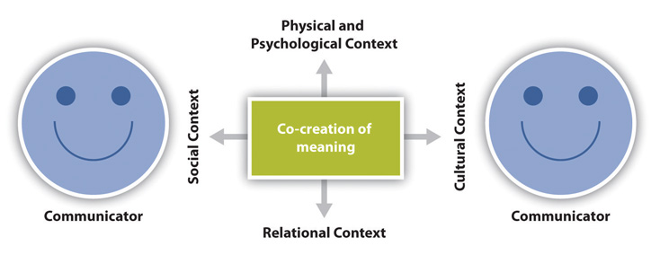
Figure 1: Transaction model of communication
(Source: linkedin.com, 2018)
The transaction model in social context refers to the already stated rules or the unguided norms which facilitate the communication process. Norms on this ground are referred to as the social conventions that are chosen to communicate and are guided by practice trial and error (LinkedIn. com, 2018). Whereas, on the ground of relational context, communication is dependent on the type of interpersonal relationship and the time for which the person is known. Furthermore, the cultural context of the communication involves the various aspects of the identity such as gender, equity, age, nationality, ethnicity, class, and even sexual orientation as well.
The two models are functional in marketing communication namely the Macro model and the Micro model where the sender and the receivers are major contributors to the communication (Managementstudyhq.com, 2022). Where message and media are chosen as communication tools, encoding, and decoding, response and feedback are the main communication functions, and finally, the noise or disruptions created while communicating.
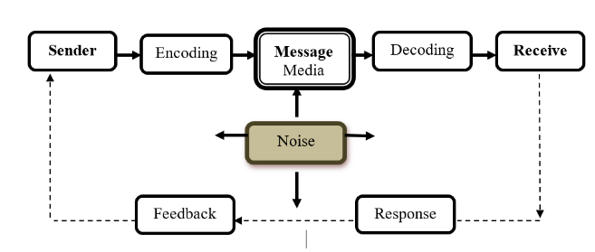
Figure 2: Elements of Communication tools
(Source: Newsmoor.com, 2019)

Promotional strategies to raise awareness of Coca-Cola
Various promotional strategies have been adopted by the brand to create a multi-sensory identity for the global market. The strategies are as follows:
- Create a multi-sensory brand identity: the brand aims at creating a visual representation of its product to the customers. The vibrant colors used while packaging encourages impulse buying (Tien et al., 2019). The Coca cola’s brand identity is substantial and highly recognizable whereby creating a multi-sensory brand identity and marketing will create an overall expansion of their product to the market.
- Diversifying the products: Coca-Cola brand aims to diversify its investment to gain more paths and opportunities in the future. The brand continues to adapt to the external environmental changes a threat from the healthy lifestyle moment and consequently product development and marketing of the products to reach the target audience.
- Create an enduring marketing campaign: the Coca-Cola brand has an unforgettable share of the content marketing campaign and has a notable share in the global marketing campaign. the opportunities of the social media campaigns such as the “share a coke campaign” has a substantial contribution to the market by creating experiences for their customers.
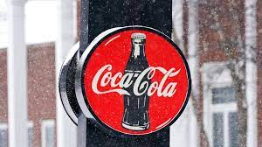
Figure 3: The Coca-Cola Company
(Source: Coca-Cola, 2022)
- Focusing on people’s experience of the product: the brand focuses on creating an emotional response to their products. The feeling of trust and reassurance on the ground of their production and acceptance among the masses create a self-identity of the brand concerned. Thereby, focusing on the people's experience with the product and developing the product based on their expectations goes a long way in creating the brand's success in the long run.
- Keeping the brand relevant in the global market: understanding the changing needs of the customers and keeping relevant to them their products is to which the Coca-Cola brand resorts. The brand constantly keeps in mind the customers, the competitors, and the new entrants to the market and expands its production accordingly.

Branding and equity
Branding is defined as the process of giving a specific meaning to an organization, company, products, and services and thereby being accepted by the customers on the following names or brands. Branding in marketing may be defined as the process through which a relationship can be established between the brand and the customers (Zavattaro et al., 2021). The purpose of establishing a brand is to create loyalty and trust among customers. A good brand purpose creates an identity among the buyers, and fewer competitors as well.
Brand equity may be defined as a marketing term that describes the brand value to the customers. Brand equity is dependent on the perception of the customers and experiences with the concerned brand. The various sources of brand equity such as market research, quality, marketing mix, customer opinion and satisfaction, and also the extension of the brand fall under the category of equity.

Customer's journey to the brand and touchpoints to the organization
A consumer undergoes several stages before purchasing any item from the market. The stages have been distributed among 5 segments which are Awareness, Consideration, Purchasing or decision making, Retention phase, and Advocacy phase. The research of an individual consumer regarding a product has been measured by these 5 stages and by elevating the product according to the principles of the stages Coca-Cola can increase its brand awareness in the market.
Awareness
In the initial stages, the consumer tries to understand his requirements to get the prospective solution. For instance, a consumer has a party and he has nothing to serve his guests. The solution is to buy soft drinks for serving as welcome drinks. It provokes that person to get grab soft drinks.
Consideration
The individual did not directly choose a product at least not for comparing the product with another similar type of product from different brands. Consumes verify that the product contains what they exactly need to not. It has also been checked whether the product of Coca-Cola has more benefits than its substitute products or not. Consumer researches regarding the lament of the product from the internet or the labels.
Purchasing
A consumer only buys a product when it fulfills their condition. Price and quality are the main variables that influence the buying decision of the consumer. More specifically, a consumer tries to get the highest quality at the lowest price. Coca-Cola provides every kind of information that a buyer needs to know on the internet along with prices. It helps the buyer to choose the product of Coca-Cola over other similar products.
Retention
The long-term goal of the company lies in the after-selling services and approaches of the organization. The stage also can be counted as a potential stage to bring development in the products. For instance, to resolve health issues Coca-Cola produces Diet Coke.
Advocacy
The advocacy stage is slightly different from the other stages as consumers are not only a buyer but also became active promoters of the company. More specifically, as the consumers like the products of the company they also offer the known person to use the products, and brand awareness of the market increases automatically.

Analysis
Coca-Cola can create a strong brand reputation in the market based on its soft drinks. The unique logo of the company creates great brand recognition among consumers. Coca-Cola clocked a revenue of 38 billion USD as net revenue in 2021 (statista.com, 2022). Apart from that, it has a global reach that makes portrays the company as a major player in the market. It has more than 2800 products and based on that operates in more than 200 countries (britannica.com, 2022). Collaboration with Costa-Coffee and Fairlife extended the market of Coca-Cola which impacted the profit positively.
Pepsi is one of the main competitors of Coca-Cola and due to that consumer loss of the company is evident. Coca-Cola is the only conducting business over the drinkable item while the competitors like Pepsi have great diversification as it sells Lays and other snacks (finance.yahoo.com, 2022). Coca-Cola is a carbonated drink and has high sugar levels. Health industry-oriented experts advise not to use this kind of soft drink that impacted the company negatively.
The activities of Coca-Cola have increased in developing countries and as a result, the sales proportion of the company increased. Coca-Cola launched a new product called diet coke to bring product variation (Webber-nutrition.co.uk, 2022). Depending on a sustainable supply chain can increase its operation activity which impacted the overall performance of the company positively.
Coca-Cola faces huge controversies due to poor water management issues that impacted the brand image of the company negatively. Due to the usage of mixing pesticides, the water has been polluted and it became a huge controversy for the company (forbes.com, 2022). Pepsi is not the only competitor but some nameless local brands damage the sales ratio of Coca-Cola with low selling prices.

Explanation of the customer's journey map
Customer journey: | Awareness | Discover | Purchase | Use | Advocacy
Customer actions | Customer searches the product on online websites and the internet. | Customers tally the product of Coca-Cola with similar types of products of different brands. The brand might be an international or national one. | Based on the international branding of Coca-Cola consumers purchase it from online stores and offline supermarkets | The product needs to be connected with the different emotions of the consumers. Satisfactory services need to be provided to the consumers for retaining their attention | Consumers preach about the product to their known ones.
Touchpoints | Visit the official website of Coca-Cola, herring the name from others | Live events and meetings | Online stores like Amazon and departmental stores | Through direct interaction with near ones | Video or marketing approaches of the organization
Customer experience | Consumers are quite puzzled by viewing the advertisement of Coca-Cola and other brands on the Facebook | Consumers are interested in the consumer the developed product like Diet Coke based on their experience with the product that has been developed. | Customers are satisfied due to the client-centric approach of the company | Customers effectively participate in the promotion of the brand through word-of-mouth promotion | Contributed to the events of the company
Table 3: Consumer Mapping
(Source: Created by Author)
Consumer scoping
The targeted consumer of the company is the adolescent and Gen Z. The targeted consumer of the company prefers non-alcoholic drinks and involves in events of social gathering.

Aaker’s brand equity model
Aaker’s brand equity model is defined as the set liabilities and assets associated with the brand. The assets include such as loyalty, consumer awareness of the brand, perceptions, and associations linked with the brand (Indeed. com, 2021). The five components of brand equity as per Aaker’s brand equity model are
- Brand loyalty: which is defined as the components that measure the amount of support that a customer has for the brand
- Brand awareness: brand awareness is defined as the public awareness or familiarity with the brand
- Perceived quality: it is referred to as the public understanding of the brand products and services
- Brand associations: it is referred to as the connections that the customers have with the brand
- Proprietary assets: it is the brand's intangible assets including patents, copyrights, intellectual rights, and many others.
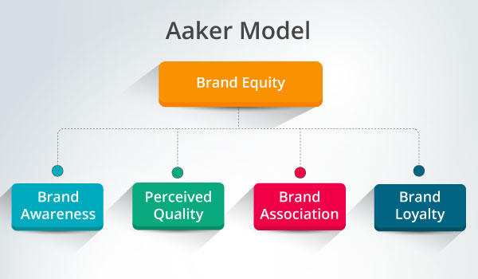
Figure 5: Aaker’s brand equity model
(Source: Created by author)
Aaker’s brand equity model can be used in Coca cola’s marketing operations and branding equity of the company to reach the masses effectively by increasing awareness and maintaining the quality of their products.

Total engagement model
The engagement model is defined as the set of guidelines that are used to develop the relationship between the customers and the development team involved in the process. It includes various responsibilities, obligations, tasks, commitments, and duration of the engagement as well. The total engagement model puts everything in unison effective and efficient way by aligning all the activities of the company for customer engagement including the advertisement, services, various products, and the internal culture as well (Jang et al., 2021). The major benefit of the total engagement model is that it aligns all the fragmented structures into one or integrates all. The Coca-Cola Company has chosen the total engagement model to integrate an accountable and actionable model throughout the company to grow and maximize its potential.
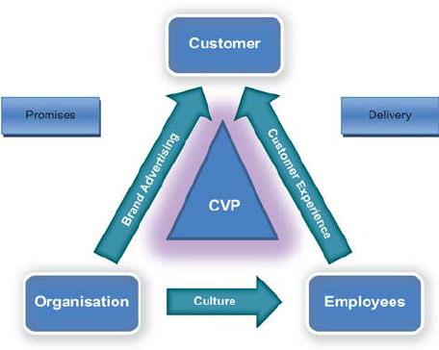
Figure 6: Total Engagement Model
(Source: researchgate.net, 2021)

Conclusion
The marketing management of the company Coca-Cola has been chosen in this report. Brand awareness has been discussed concerning communicating models. Several promotional strategies used by the brand to reach its customers are discussed in the report. The branding and the branding equity for the company are also discussed concerning the total engagement model to integrate and align the various activities in an organization. The customer's journey and the customer's touchpoints are also discussed. The well-known company Coca-Cola has a huge global market share with its products and gained an expansion to the industry in the recent future keeping in mind the sustainability concept of its services. Therefore, the activities in marketing management create a long-term impact on the Coca-Cola Company.

References
britannica.com (2022). “The Coca-Cola Company” Available at: https://www.britannica.com/topic/The-Coca-Cola-Company [Accessed on: 16/8/2022]
businessnewsdaily.com (2022) “How Porter’s Five Forces Can Help Small Businesses Analyze the Competition”. Available at: https://www.businessnewsdaily.com/5446-porters-five-forces.html[ Accessed on: 12th August 2022]
coca-cola (2022)” OUR COMPANY”. Available at: https://www.coca-cola/company.comcompany [ Accessed on: 12th August 2022]
companiesmarketcap.com (2022). ”Revenue for Coca-Cola (KO)”. Available at: https://companiesmarketcap.com/coca-cola/revenue/ [ Accessed on: 13th August 2022]
finance.yahoo.com (2022). “All the brands the Pepsi company owns may surprise you” Available at: https://finance.yahoo.com/news/brands-pepsi-company-owns-may-150000652.html [Accessed on: 16/8/2022]
forbes.com (2022). “Coca-Cola Named The World’s Most Polluting Brand in Plastic Waste Audit” Available at: https://www.forbes.com/sites/trevornace/2019/10/29/coca-cola-named-the-worlds-most-polluting-brand-in-plastic-waste-audit/ [Accessed on: 16/8/2022]
indeed. com (2021)” What Is the Aaker Brand Equity Model? Definition and Components”. Available at: https://www.indeed.com/career-advice/career-development/brand-equity-aaker-model [ Accessed on: 13th August, 202]
Jang, W., Kim, J., Kim, S. and Chun, J.W., (2021). The role of engagement in travel influencer marketing: The perspectives of dual process theory and the source credibility model. Current Issues in Tourism, 24(17), pp.2416-2420.
Linkedin.com (2018) “Marketing Communication Models”. Available at: https://www.linkedin.com/pulse/marketing-communication-models-abolfazl-keshavarzsaleh[ Accessed on: 12th August 2022]
managementstudyhq.com (2022)” The Communication Process”. Available at: https://www.managementstudyhq.com/communication-process.html[ Accessed on: 12TH auGUST, 2022]
marketing91.com (2022). Available at: https://www.marketing91.com/marketing-communication/ [ Accessed on: 12th August 2022]
Newsmoor.com (2019).” Communication Elements- 9 Elements of Communication Process”. Available at: https://newsmoor.com/communication-elements-9-components-of-basic-communication-proc [ Accessed on: 12th August 2022]
Pressbooks.bccampus.ca (2022)” Communication models”. Available at: https://pressbooks.bccampus.ca/professionalcomms/chapter/3-2-the-communication-process-communicatio [ Accessed on: 13th August 2022]
researchgate.net (2021)” Total customer engagement: Designing and aligning key strategic elements to achieve growth”. Available at: https://www.researchgate.net/figure/The-total-engagement-model_fig2_49513186 [ Accessed on: 12th August 2022]
Šerić, M., Ozretić-Došen, Đ. and Škare, V.,( 2020). How can perceived consistency in marketing communications influence customer–brand relationship outcomes? European Management Journal, 38(2), pp.335-343.
statista.com (2022). “Revenue distribution share of the Coca-Cola Company worldwide in 2021, by operating segment” Available at: https://www.statista.com/statistics/271136/coca-colas-revenue-distribution-worldwide-by-operating-segment/#:~:text=In%202021%2C%20Coca%2DCola%20generated,decreased%20by%20roughly%20a%20third. [Accessed on: 16/8/2022]
Tien, N.H., Vu, N.T. and Tien, N.V., 2019. The role of brand and brand management in creating business value case of Coca-Cola Vietnam. International Journal of Research in Marketing Management and Sales, 1(2), pp.57-62.
Webber-nutrition.co.uk (2022). “Is Diet Coke Better Than Regular Coke?” Available at: https://webber-nutrition.co.uk/is-diet-coke-better-than-regular-coke/ [Accessed on: 16/8/2022]
Zavattaro, S.M., Marland, A. and Eshuis, J.,( 2021). Public branding and marketing: Theoretical and practical developments. Public Administration Review, 81(4), pp.728-730.

