Models of communication theories

Student’s Name: Andreea Simion
Student’s ID:2120568
Lecturer’s name:Soban Sadiq
Module Name:Effective Team Working and Communication
Module Code:BMSW4002

Table of Contents
Summary 3
Introduction 3
1. Models of Communication 4
Shannon and Weaver 4
Schramm’s Model of Communication 6
Berlo’s Model of communication 8
Communication Skills 9
Verbal communication 9
Non-verbal communication 9
Listening skills 10
Disadvantages & Advantages – Technology in Communication 10
Conclusion 11
References 12

Summary
This well-organized paper was written with the purpose of defining the parameters of the communication process, elaborating on the significance of this aspect, and describing the various ways in which individuals can apply these concepts in their personal and professional lives. The paper was written with the purpose of defining the parameters of the communication process, elaborating on the significance of this aspect, and describing the various ways in which As a consequence of this fact, there will be a great deal of discourse around the three communication models that are now utilized the most. These communication theories are referred to as the Shannon and Weaver model, the Schramm model, and the Berlo theory. In addition, there will be follow-up information that will describe how each author of the communication models perceives communication and how each author believes communication to be an essential activity, despite the fact that certain factors can have a detrimental impact on communication processes. As a consequence of this, the report will talk about verbal and nonverbal communication, in addition to the significance of and examples of failure in both of these forms of communication. Additionally, the report will talk about the listening process, which is a part of the communication process, but ineffective listening can ruin the entire conversation. To assist readers in comprehending how the development of language has influenced the communication process throughout the course of time, there will be a section highlighting the benefits and drawbacks of speaking through the several technical channels that are currently available.

Introduction
Because words have the ability to either uplift or bring about untold misery, it is critical to make effective use of them at all times. When we talk about communicating, what we really mean is exchanging information back and forth with one another. With the help of this technology, a message can be conveyed either from one person to another or from one area to another. Because it is difficult to convey a message exactly how the sender would like it to be understood by the recipient, accurate communication is desirable. It is critical to exercise extreme caution while choosing one's words in order to avoid unintentionally causing harm through one's speech. It is not something that comes naturally to a person nor is it something that they must be born with in order to have the ability to communicate effectively; rather, it is a skill that can be learned just like any other skill, and it is not something that is innate to them and something that they must be born with in order to have. You only need a small bit of your own time, effort, and commitment to put in the work in order to develop into an outstanding communicator. It is important to keep in mind the significance of communication, and you should start working on your lesson as soon as you can, because it has the ability to enhance the quality of your life. (The Scientific World, 2020)

Models of Communication

Shannon and Weaver
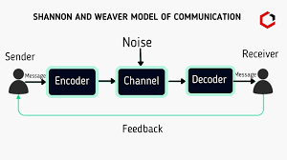

The Shannon-Weaver model of communication is one of the most widely recognized models established to evaluate the communication process. Shannon and Weaver conceptualized this paradigm. A large number of models and hypotheses have been developed in order to analyze the communication process. 1948 saw the development of this concept by Warren Weaver and Claude Shannon. 1948 was the year this vehicle was first introduced. In order to shed light on the process of how a message is transmitted and received, the two individuals developed a mathematical theory of communication that describes how communication occurs between a sender and a receiver. Initially, they believed that this theory was a linear model. Nevertheless, the paradigm maintains that a sender is both the information source and the person who initiates contact. The model is sometimes referred to as information theory in the realm of engineering, where it is largely employed for the purpose of computing machine transmissions. The information is then transported from the brain to the lips as a signal, where it is mixed with a number of other sounds and distractions before being received by the recipient. The Shannon-Weaver model has a number of advantages, including the following: it takes into account the elements that impede successful communication; it enables the discovery and eradication of communication faults and noise; and it takes these factors into consideration. In addition, it takes into consideration the obstacles to good communication. In addition, the model divides the communication process into a number of more manageable steps, making it easier for the listener to comprehend the information being delivered. In addition, the model is relevant to nearly all types of communication because it not only transforms communication into a bidirectional process, but also analyzes communication as a quantifiable process. This is because the model transforms communication into a quantifiable process.(Dickinson, Hendricks, 2022)
Within the example with Pedro and Maria, there was a huge misunderstanding due to the fact that Pedro was unable to decide Maria’s message. She was telling him to bring chicken as he gets home but he understood the message in a negative way such as she is willing to wait him in the kitchen while he gets home. This types of misunderstandings are very often due to the fact that on the phone , we can understand other words similar to what the sender wants to express and for the reason that we do not have a direct connection or face to face with the sender.

Schramm’s Model of Communication
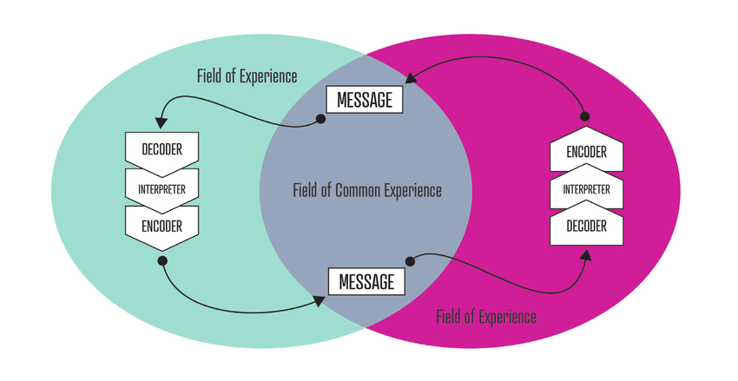

The Schramm Communication Model is a cycle communication model that contains all of the fundamental communication principles and offers a standard explanation and method to communication. This model was developed by Carl Schramm. The Model consists of three major components: encoding, interpreting, and decoding, and it is the ideal kind of model: speaker, receiver, encoding, decoding, feedback, channel, and noise. These components are listed in the following order: encoding, interpreting, and decoding. Because it takes into account the concepts of field of experience, a commonality between the two communicators that makes communication simpler, the Osgood-Schramm model of communication is a circular rather than linear experience involving a sender, who encodes a message, and a receiver, who decodes it. This model involves a sender, who encodes a message, and a receiver, who decodes it. Osgood-model Once a person decodes a message, they are able to re-encode it and send it back to the person who originally sent it, which is why Schramm's model of communication is known as a circular model. This is because it indicates that messages can travel in both directions. Having said that, it also highlights the difficulty of communicating due to the fact that it must take into account interpretation. Communication is negotiated in two-way communication when both the sender and the receiver listen to each other, gather information, and are willing to make adjustments to work together in harmony. Their goal is to negotiate a scenario that is mutually satisfactory, so they listen to each other, gather information, and are willing to make adjustments.(Watt & Vanlear, 1996)
As the Scharmm’s model is mostly relying on the fact that the sender and receiver become in the point of switching positions, they also should be familiar with the terms or know each other in order to create an effective communication. For this reason, Maria and Pedro could have done a successful conversation if the disturbance factors would not exist

Berlo’s Model of communication


David Berlo devised the source-message-channel-receiver model of communication in 1960. This paradigm of communication is referred to as the SMCR model. Smcr's 1960 communication model has four parts: the sender (the sender), message (the message), channel (the channel), and recipient (the recipient). Although the SMCR model of communication is sometimes known as Berlo's Source-Message-Receiver model, it is not the only model of communication. An vital part of any communication process is SMCR, which stands for Source-Message-Channel-Receiver. Berlo created this model in 1949, drawing inspiration from the Shannon-Weaver communication paradigm. When it comes to the effectiveness of communication in general, Berlo has outlined a number of elements that can be considered. The acronym "SMRC" refers to the primary communication process's source, message, channel, and receiver components. There are nine important components to effective communication, and each of these is included. (Collignon, 2016)
Within the case study discussed in class, Maria is the source as she is calling Pedro while he is at work and her statement asking Pedro to bring chicken at home when he finishes work is the information. The receiver is Pedro which was unable to give feedback to Maria as he was at work and misunderstood the message.

Communication Skills

Verbal communication
The sharing of information through the use of words and sounds is an example of verbal communication between two persons. Information is conveyed verbally from one person to another in a conversation. For the sake of a conversation, words are nothing more than a collection of sounds that convey a certain message. Messages are sent through the use of words and sounds, which provides context for a message intended for a certain audience. When it comes to communicating with others, the sender, or communicator, needs to keep one thing in mind: they need to maintain their message clear and concise, as well as keep their concentration during the conversation, in order to maximize the exchange of information. The usage of verbal communication can be enhanced by avoiding the use of needless words. (Griffith & Dunham, 2015)

Non-verbal communication
Touching another individual is a form of nonverbal communication that not only conveys a person's feelings or level of comfort, but also reveals aspects of their personality. Other forms of nonverbal communication that we might use to express ourselves include a strong handshake or a warm embrace, a pat on the back, or the tone and volume of our voice. Whether or not these perceptions are grounded in reality, our nonverbal clues, such as the clothes we choose to wear and how we arrange the furnishings in our houses, can dramatically impact how others are perceived by others. When we tell someone we love them, avoiding eye contact communicates a whole different message than the words themselves. Similarly, a bright smile accentuates the sincerity of our words of congratulations. (Griffith & Dunham, 2015)

Listening skills
Active listening involves hearing with intent, grasping the speaker's words, and interpreting what the speaker is saying so that the listener can understand what the speaker is saying, regardless of whether the listener agrees with what the speaker is saying. It is not necessary to grasp or agree with the speaker in order to engage in active listening. If, while listening to a lecture, you discover that you do not fully comprehend the issue being presented, this does not indicate that you are not an attentive listener; rather, it indicates that you need the concept to be explained to you again so that you may grasp it. You were a highly attentive listener, but you required a more basic explanation of the topic. Listening is considered passive when it provides a secondary function as opposed to being the main activity. Writing during a lecture or texting during class are both indications that the student can listen and may be able to repeat the speaker's words, but this is only a sensory function and does not necessarily indicate that the student has comprehended the speaker's remarks. For instance, writing during a lecture or texting in class are both signs that a student can listen. (Griffith & Dunham, 2015).

Disadvantages & Advantages – Technology in Communication
Among the most disadvantageous aspects regarding the communication by using technology is when you may think texting or using any form of technology to communicate is more private than calling in a busy room. Even though the message was private, the recipient may forward it knowingly or unintentionally. You can't deny having the chat, and the message may be embarrassing or destructive. If you need to deliver an important message, call or chat privately. People who rely heavily on technology to communicate may acquire tunnel vision. These thumb talkers may ignore work, family, and friend duties and become risky drivers. Sitting next to someone texting passionately can make you feel lonely and alienated. Even if you end a communication with a winky face or type in all capital letters to show seriousness, your remarks may be misread via computer, cell phone, or other electronic device. Body language and verbal inflection lose their intricacies. Face-to-face conversations allow for immediate clarification, unlike email conversations, when your friend may become irritated while waiting for you to react.
Even if there are many disadvantages of using technology in the communication process there should be mentioned that one major advantage is the fact that The communication through-technological channel will be more fast than for example sending a letter in Australia, so it is better to-give an e-mail or a text and the person which you want to communicate will be receiving the message instantly. Due to the fact that globalization includes traveling and having conferences all around the world for the big companies and for the medium ones also, technology can be used in the communication process in order to avoid spending incentives on all the above mentioned aspects which is a great advantage. (Goss, 2020)

Conclusion
In conclusion communication is essential even if it is done through verbal nonverbal communication or by using technology due to the fact that we need to be connected with each other’s on many levels such as at work during online classes or even in our social and family lives.

References
- Collignon G., (2016), Understand to Be Understood: By Using the Process Communication Model, pp. 66-78
- Dickinson G., Hendricks B., (2022), Shannon – Weaver Model of communication, [Available Online: https://study.com/learn/lesson/shannon-weaver-model-communication-theory-parts-transmission-model.html], Retrieved on July 30th 2022
- Goss, (2020), The Disadvantages of Using Technology to Communicate, [Available Online: https://itstillworks.com/disadvantages-using-technology-communicate-1025.html], Retrieved on July 30th 2022
- Griffith, B. A. and Dunham, E. B. (2015) Working in teams: moving from high potential to high performance. Chapter 2& 3: Verbal and Non- verbal communication. Los Angeles, (California]:SAGE2015
- Griffith, B. A. and Dunham, E. B. (2015) Working in teams: moving from high potential to high performance. Chapter 4 : Listening communication. Los Angeles, (California]:SAGE2015
- The Scientific World, (2020), The Importance of Communication Skills in Everyday Life, [Available Online: Joi], Retrieved on July 30th 2022
- Watt J. H., Vanlear C. A., (1996), Dynamic Patterns in Communication Process, pp. 311–332

