Assignment 1 – NOSS2026

Tyler Bate (2304031)
UWTSD ACCA5023

Contents
Task 1 – Research 1
Research on Hypervisors 1
Research on IP Addressing 2
Research on Routing 2
Research on Network Services 3
Task 2 4
Task 3 – Reflection 8
3.1 Technical Reflection 8
3.1.2 Personal Reflection 9

Task 1 – Research

Research on Hypervisors
Modern lab and enterprise infrastructures are built around hypervisors, which allow different operating systems to run concurrently on common hardware through virtualisation. Type 1 (bare-metal) and Type 2 (hosted) hypervisors are the two architectural approaches. Type 1 hypervisors improve isolation and performance efficiency by managing virtual machines directly on physical hardware without the need for a host operating system [1]. Type 2 hypervisors, on the other hand, use an operating system that already exists to control device drivers and hardware access [2].
I used a Type 2 hypervisor in the Assignment 1 topology since hardware limitations and accessibility were important factors. Instead of employing specialised enterprise servers, the coursework environment involved leveraging personal workstation hardware to host Windows Server 2022 and a Debian server under the SWANSEA.ACCA domain. Without the need for specialist server hardware or BIOS-level setup changes, hosted hypervisors like VirtualBox enable quick deployment, easier configuration, and interoperability across Windows systems [2].
The topology serves mostly as a controlled learning environment rather than a production network, even though Type 1 hypervisors often provide better isolation and scalability. As a result, the host operating system's performance overhead is acceptable. Additionally, because the lab runs on a separate virtual network rather than an exposed enterprise infrastructure, security threats are reduced.
Although a Type 1 solution would enhance scalability and security in light of the Enhanced Topology expansion, a Type 2 hypervisor is the most practical and accessible implementation option for supporting both Windows and Debian clients under real-world hardware constraints, balancing usability, compatibility, and resource availability [3].

Research on IP Addressing
Packet switching, which divides data into packets and forwards them between networks using logical addressing, is how data is transmitted over the Internet. Regardless of a device's actual location, IP addressing offers the identifying mechanism that enables data transmission and reception. Routers are able to identify forwarding pathways across networks since each packet has source and destination IP addresses [4].
In order to overcome IPv4 exhaustion and facilitate future scaling, IPv6 expands addressing to 128 bits, written in hexadecimal notation, whereas IPv4 addressing employs a 32-bit structure, usually represented in dotted-decimal format (e.g., 192.168.1.10) [5]. Private IPv4 addressing, which reflects actual enterprise design approaches, allows internal communication between servers and clients within the same architecture without using up public address space [6].
By splitting a larger network into smaller logical portions, subnetting plays a crucial part in increasing network efficiency. As a result, broadcast traffic is decreased, management control is enhanced, and services like DHCP and Active Directory may function better across various network roles. Flexible prefix allocation is made possible by Classless Inter-Domain Routing (CIDR), which guarantees that addresses are distributed based on real host requirements rather than rigid class boundaries [7].
I learned from the group activity discussion that routers connect networks by evaluating IP headers and choosing the best paths, whereas switches mostly use MAC addresses to forward traffic within local networks. By facilitating organised communication, scalability, and effective traffic control within the Swansea topology and larger Internet infrastructure, IP addressing thereby directly supports network operation.

Research on Routing
By preserving routes to destination IP addresses, routing controls how packets move between networks. In general, routing strategies can be divided into two categories: static and dynamic. Static routing, which offers simplicity and consistent behaviour but no flexibility, uses manually set routes that are defined by administrators. When network conditions change, dynamic routing protocols dynamically recalculate routes and exchange topological information [8].
Static routing is the best option in the Assignment 1 topology since the network structure is controlled and very modest. By sending client broadcast requests across subnet boundaries to the Windows server that is hosting DHCP services, the Debian server serves as a DHCP relay. For DHCP discovery and response messages to reliably traverse networks, this configuration needs dependable and well-defined routing pathways.
Dynamic protocols such as OSPF are designed for larger or evolving infrastructures where multiple routers and redundant paths exist [9]. Implementing such protocols within this topology would introduce unnecessary complexity and administrative overhead without providing significant operational benefit.
Because administrators can see all traffic paths, static routing enhances the clarity of troubleshooting during deployment, which is a reflection of the topology design. Ensuring that authentication traffic, DNS queries, and DHCP connections continuously reach the relevant services is especially crucial for verifying domain connectivity within SWANSEA.ACCA.
Static routing, which supports stability, simplicity, and regulated service communication while still reflecting fundamental enterprise networking principles, is therefore the most appropriate for the classroom setting.

Research on Network Services
For identity management, automatic configuration, and secure communication, enterprise networks depend on integrated services. A trustworthy infrastructure is created within the topology by the combined efforts of VPNs, DHCP, Active Directory Domain Services (AD DS), and Certificate Authorities.
VPNs ensure the security and integrity of transmitted data by building encrypted tunnels across untrusted networks. By using encryption and authentication techniques, protocols like IPsec securely extend private networks over public infrastructure [10].
By dynamically allocating addresses, gateways, and DNS settings to clients, DHCP streamlines IP configuration. The Debian Server's implementation of a DHCP relay allows for centralised address management across several subnets while preserving administrative effectiveness [11].
Centralised authorisation and authentication are offered via Active Directory Domain Services (AD DS) for the SWANSEA.ACCA domain. Identity management becomes the primary control mechanism in Windows-based enterprise environments, as seen by the way Group Policies enforce uniform security setups [12].
By providing digital certificates for encryption, authentication, and secure services like HTTPS or VPN authentication, Certificate Authorities (CAs) support trust. To avoid trust compromise, safe key storage and appropriate certificate lifecycle management are crucial best practices [13].
When taken as a whole, these services show how contemporary networks improve scalability, administrative control, and overall network resilience by relying on layered security and automation rather than discrete solutions.

Task 2
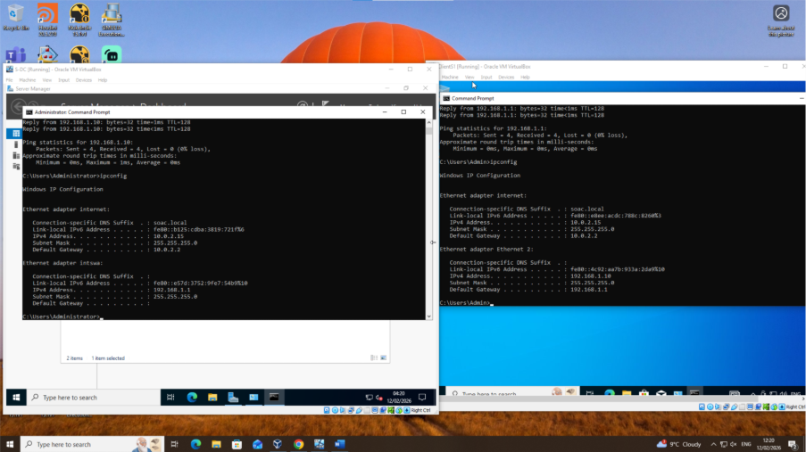
Figure 1: Windows Server 2022 IP configuration showing static addressing applied to support domain services.
This screenshot confirms that the Windows Server was configured with a static IP address, which is required for reliable DNS, Active Directory, and DHCP services within the SWANSEA.ACCA domain.
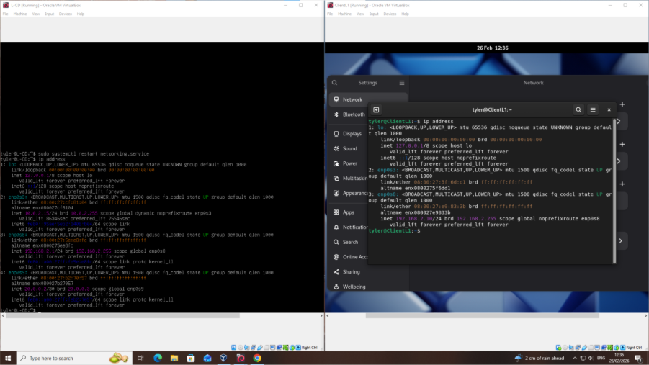
Figure 2: Debian Server network configuration verifying assigned IP address and interface connectivity.
The Debian server was configured with a fixed network address to enable routing and DHCP relay functionality between network segments.
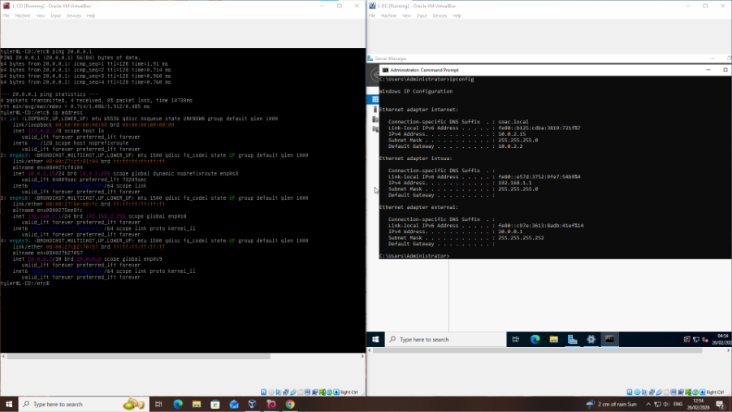
Figure 3: Client and server IP addressing across the topology confirming subnet allocation.
This evidence demonstrates correct IP addressing across all hosts, validating subnet configuration and network planning.
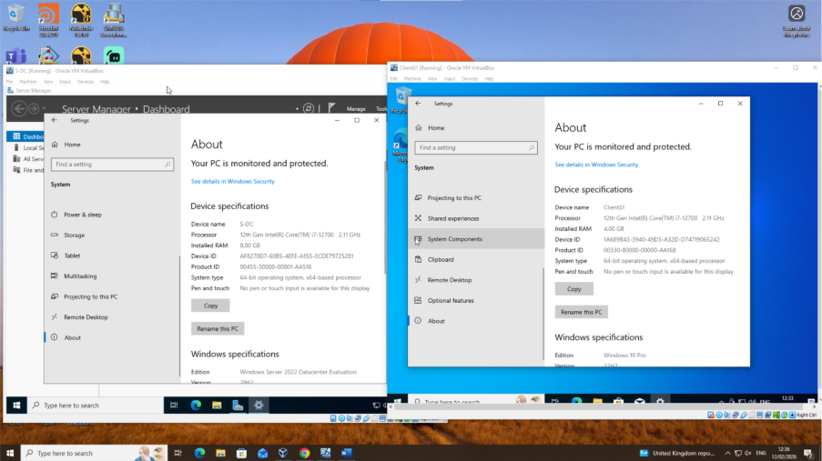
Figure 4: Hostnames configured for domain integration (L-DC and ClientL1).
Renaming systems ensures proper identification within Active Directory and prevents domain join conflicts.
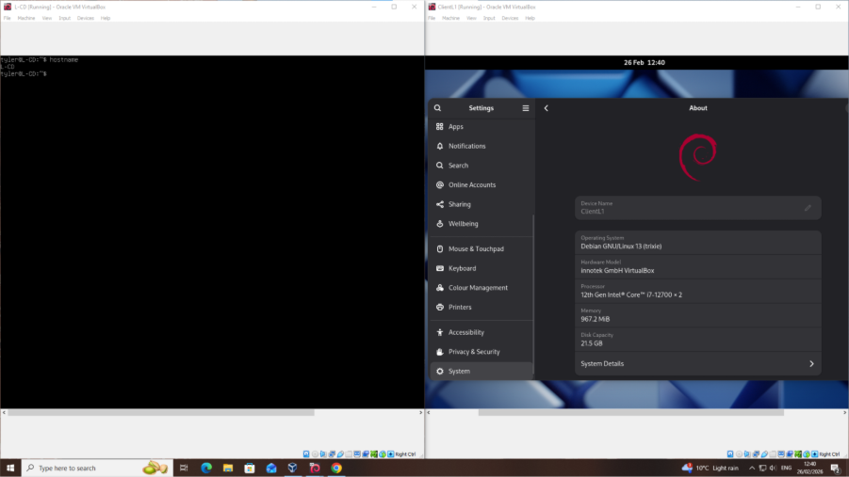
Figure 5: Verification of configured computer names prior to domain communication testing.
Correct naming confirms readiness for domain authentication and DNS resolution.
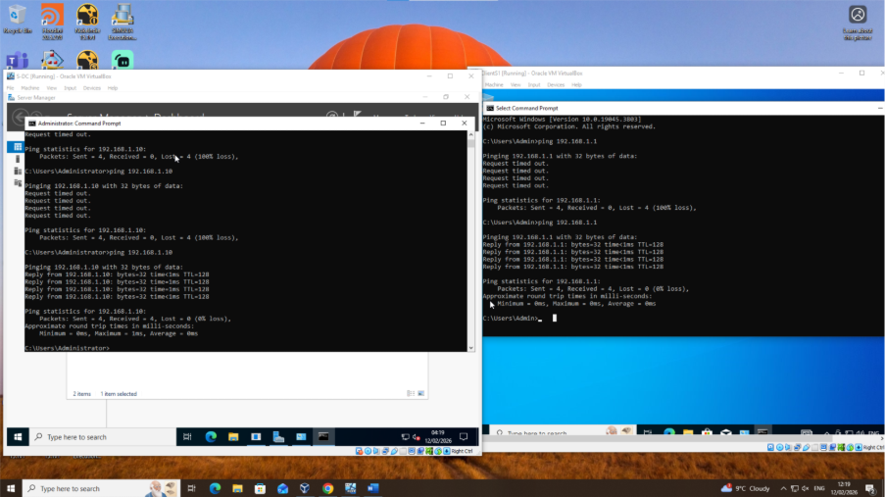
Figure 6: Successful ICMP connectivity test between Windows hosts.
Ping results confirm Layer 3 communication between devices within the configured subnet.
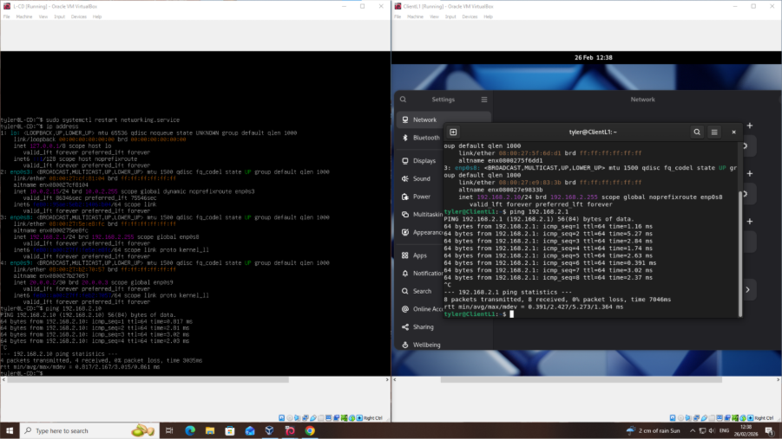
Figure 7: Debian server successfully communicating with network hosts.
This validates correct routing and interface configuration on the Debian system.
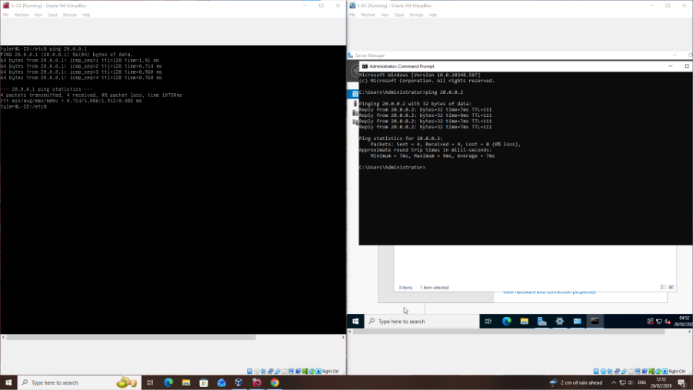
Figure 8: Cross-platform connectivity verification between Debian and Windows Server.
Successful communication demonstrates interoperability between Linux and Windows systems within the topology.

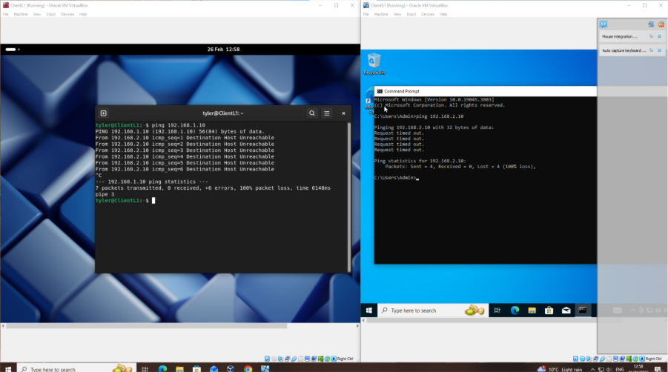
Figure 9: Failed connectivity test between remote clients highlighting routing or segmentation boundaries.
This result demonstrates expected network isolation prior to routing configuration, confirming subnet separation within the topology.

Task 3 – Reflection

3.1 Technical Reflection
A number of configuration issues arose during the Assignment 1 topology deployment, necessitating methodical troubleshooting and validation. Incorrect IP addressing between hosts was one of the initial problems that hindered effective network communication. I found conflicting subnet configurations and confirmed addressing consistency using Linux interface tests and ipconfig. Initial connectivity issues were fixed by adjusting static IP assignments.
Testing communication between the Windows Server 2022 domain controller (SWANSEA.ACCA) and the Debian server also revealed issues with DNS resolution. Instead of a network failure, devices were able to ping by IP address but not by hostname, suggesting a DNS configuration issue. By verifying that clients referred to the domain controller as their primary DNS server and comparing DNS server settings, I was able to diagnose this. Domain communication functioned properly after it was fixed.
Connectivity testing was also impacted by firewall setups, namely ICMP answers during ping validation. Before restoring secure settings, testing was able to verify routing and service availability by temporarily modifying firewall rules. Additionally helpful were failed ping results between certain clients, which showed the expected subnet separation before routing validation.
The general procedure for troubleshooting was as follows: identify symptoms, isolate layers (DNS, routing, and addressing), test gradually, and use connectivity tests to confirm results.

3.1.2 Personal Reflection
My practical grasp of how theoretical networking ideas are applied in actual deployments has improved as a result of this research. Instead of depending on detailed instructions, I became more comfortable using diagnostic tools and analysing network behaviour. Independently troubleshooting problems improved my problem-solving abilities and reaffirmed the significance of preparing service dependencies and IP addresses prior to deployment. My attention to detail and technical confidence for upcoming network implementations have improved as a result of the experience, which demonstrated how little configuration errors can have a big influence on network functionality.

