

Methods and Search Strategy Academic Poster

Student name: Naima Amin
Student ID: 2222407

Module name: Independent Project Methodology Poster
Module code: BMHP6020

What are the mental health outcomes for children in foster care or institutional settings?

01 Introduction and Research Aim  This chapter outlines the methodology used to ensure rigor and credibility in the research process, reflecting the structured planning recommended by Creswell and Creswell (2018). A secondary, desk-based approach was adopted, drawing on peer-reviewed literature to address the research aim. The chapter explains the search strategy, inclusion and exclusion criteria, source validation, and thematic coding, building on the process illustrated in the poster. These steps enhance transparency and strengthen the reliability of the findings (Bryman, 2016, Bell et al., 2019). The overall approach supports a comparative examination of mental health outcomes for children in foster care versus institutional settings, highlighting key patterns, challenges, and implications for policy and practice (Thomas & Johnson, 2020). | 02 Search Strategy  A search strategy is a structured combination of keywords, subject headings, Boolean operators, and filters used to locate relevant literature in academic databases (University of Leeds Library, 2025; HMSOM Library, 2025). For this dissertation, core concepts such as foster care, institutional care, mental health, and placement stability were mapped and developed into search strings across databases including PsycINFO and Scopus. These strings were refined repeatedly, using Boolean operators (AND/OR) and filters for peer-reviewed studies published between 2005 and 2025. This systematic process ensured that the sources identified were credible, relevant, and suited to the focus of the research.
03 Searching for Information  A search strategy is a structured plan of keywords, subject headings, Boolean operators, and filters used to locate relevant literature (Higgins & Green, 2011). For this dissertation, I defined the research question, identified key terms and mapped synonyms, then used Boolean strings to run iterative searches in Scopus, PsycINFO, PubMed, Google Scholar, and the UWTSD catalogue. Filters were applied for 2015–2025, peer-reviewed sources, and UK/Europe relevance we appropriate | 04 Picture / Graph / Visual Aid / Statistics  This bar chart illustrates how many pertinent articles were found across the different academic databases searched. It provides a simple visual overview of which platforms generated the highest volume of relevant literature. This helps demonstrate the breadth of the search process and highlights the most productive databases. The chart acts as a visual aid to support the written methodology, with fuller detail and justification provided within the dissertation chapters.  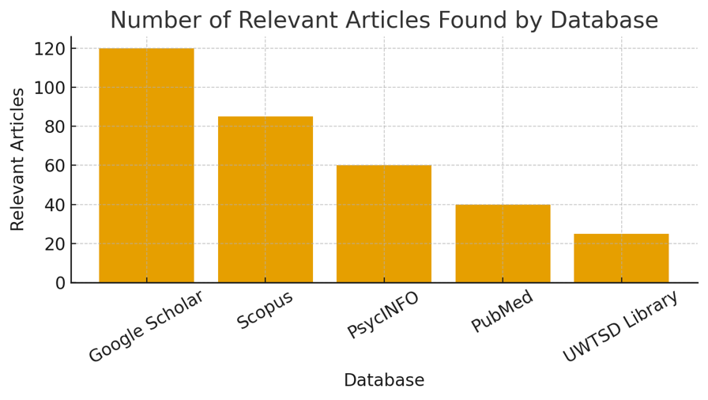
05 Research Validation and Analysis
According to Saunders et al. (2019), validation in secondary research involves assessing the relevance and trustworthiness of existing literature to ensure it is suitable for analysis. This reduces bias and strengthens the reliability of findings. Thematic analysis is then used to identify and organize recurring patterns across studies (Ridley, 2012), forming the structured discussion in Chapter 4. The CRAAP test (Blakeslee, 2004) supports this by offering a clear framework to judge source quality, ensuring only credible evidence informs the dissertation’s conclusions.

06 Inclusion Criteria  To ensure relevance and current evidence, the inclusion criteria centered on choosing peer-reviewed sources that were published during the previous ten years. Studies conducted in the UK were given priority to offer contextual applicability. Furthermore, only fully internet available publications were included, guaranteeing transparency in the research process and continuous availability for evaluation. | 07 Exclusion Criteria  Exclusion criteria included excluding research carried out outside of the UK to preserve contextual emphasis and sources older than ten years to prevent out-of-date material. To guarantee that only trustworthy, open, and regularly available literature influenced the dissertation study, articles that were not entirely available online were also disqualified.
08 Ethical Considerations
In secondary research, ethics focuses on using existing literature responsibly and acknowledging original authors (Resnik, 2020). This includes correctly referencing all sources, avoiding plagiarism, and presenting ideas transparently. Researchers must also respect the confidentiality of participants in the original studies and use anonymized, ethically collected data. Additionally, priority is given to studies that obtained informed consent and ethical approval. Maintaining these standards ensures academic integrity, reduces bias, and strengthens the credibility of the dissertation’s findings.

References
Bell, E., Bryman, A., & Harley, B. (2019). Business Research Methods. 5th ed. Oxford University Press. (Accessed 3rd October 2025).
Bryman, A. (2016). Social Research Methods. 5th ed. Oxford University Press.(Accessed 3rd October 2025).
Creswell, J.W., & Creswell, J.D. (2018). Research Design: Qualitative, Quantitative, and Mixed Methods Approaches. 5th ed. Sage Publications. (Accessed 5th October 2025)
Ridley, D. (2012) The literature review: A step-by-step guide for students. 2nd edn. London: SAGE.
Saunders, M., Lewis, P. and Thornhill, A. (2019) Research methods for business students. 8th edn. Harlow: Pearson Education. (Accessed 5th October 2025)
Thomas, G., & Johnson, P. (2020). Comparative perspectives on child welfare research. Child & Family Social Work, 25(4), 678–689. (Accessed 5th October)
University of Leeds Library. (2025). Literature searching explained: Develop a search strategy.
HMSOM Library. (2025). Developing a search strategy. (Accessed 5th October 2025).

