Certificate of Higher Education in Skills for the Workplace [Level 4]
Module Title: Effective Team Working & Communication
Module Code: BMSW4002
Student Name: Fazlee Zahid
Student Number: 2012168
Module Lecturer: Anita Nan

Contents
Introduction 3
Communication Skill: 3
Definition of communication: 3
Types of communication: 4
Barriers of communication: 4
Models of communication: 5
Case study about communication: 7
Communication in the workplace: 8
Example of poor Communication in workplace: 8
How communication can be improved: 9
Conclusion 9
References 10

Introduction
Teamwork is the process of collaborating with other members of organization and accomplishing the similar goal by the members of an organization. Collaboration among team members requires effective communication. Communication at workplace is the process of connecting different people and personnel of business or organization together with the motive to interact the organizational flow of communication. Different organization follows different process and method of communication (Lane, 2015). In this report, the communication model and communication skills have been highlighted. The purpose of this report is to present the factors of communication to make the reader know about the communication process and adopt the best communication method. The organizational scenario and example have also been provided in this report.

Communication Skill:
The communication skill is the set of the skills that are interacted to share information, send message and collaborate different physical and mental things. The communication skill in organization is the process of sharing information about the process of tasks, functions and activities of an organization. The commanding process, reporting process are interacted by establishing effective communication at workplace.
In organization the communication can be interacted in the above stated way. The motive of communication can be different types. Based on the motive of communication among the individuals in organization, the communication can be stated as formal communication and informal communication.
The formal way of communication is the way of communication which has specific direction and guidance. The motive of formal communication is to derive organizational message and information. On the contrary, the information communication does not have any direction or structure. Personal gossip, direct meeting and talking involves informal communication.

Definition of communication:
Communication is the exchange of thoughts, information or ideas that result in mutual understanding between two or more people. The process requires at least one sender, one receiver and a message that is transmitted within a communication medium. (Maund,et al, 2017).
Communication refers to the activities of transferring information or expressing one’s feeling or thoughts to another (Bear, 2011). Thus people can share their views or ideas by using their language or other methods to other which enhances social activities by helping each other.

Types of communication:
Communication at workplace is the process of interacting the exchange of information and thoughts. Communication takes place with different process among which three methods are most common namely verbal, non-verbal and written communication. These three communication methods are presented below:
- Verbal communication is the way of speaking and exchanging voice tone for communicating with other people.
- Non-verbal communication involves the process of using other things rather than voice or tone like image, picture, gestures, and body language to communicate.
- Written communication is the process of communication that involves representing image and visual things. The direct sight and visualization takes place in such communication. The graphical representation, presentation with power point, use of images, pictures are the example of visual communication.
These are the methods of communication. Based on the motive and perspective of communication, the communication at workplace can be classified in two major types. Formal communication and informal communication.
- Formal communication: Formal communication is the way of communicating with the organizational staffs and workers with official process. The motive of formal communication is to exchange the organizational information used in reporting and commanding about the tasks and activities of an organization.
- Informal communication: The informal communication or personalized communication takes place from person to person which does not motive about the organizational activities. Personal conversation, gossip and casual talks among person are the example of such communication.

Barriers of communication:
In organization the communication process gets hampered by some common barriers for which, the communication at organization remain incomplete. Some of the common reason or barrier for communication at organization are as follows:
- Lack of interest: Some individual in organization holds less interest to communicate with others. They like to keep everything personal and work alone which is a barrier to communication.
- Listening barrier: Some of the individual do not concentrate while listening to superior or colleagues. This leads to inefficiency of the message delivered to other individual.
- Lack of trust: The trust among the individual and reliability with one another builds effective relation for communication. Lack of trust among individual makes it difficult to peruse the motive of communication.
- Lack of knowledge: There are different process that can be incurred for communicating with others. The lack of knowledge about communication with other individual makes it difficult for the individual to communicate with.
- Workplace conflicts: there are different conflicts in workplace which leads to insufficient information to communicate with among the employee and workers of an organization.

Models of communication:
Shannon and Weaver Model of Communication
Shannon and Weaver model of communication is the older and effective model of communication that are used in organizational perspective. The Shannon and Weaver model of communication considers all the social and scientific ways and factors of communication based on which an organization can build effective communication model in the organization (Kraszewski and McEwen, 2010). The model was introduced by Claude Shannon and Warren Weaver in 1948. The Shannon and Weaver model of communication works with following process, presented with the graph below:
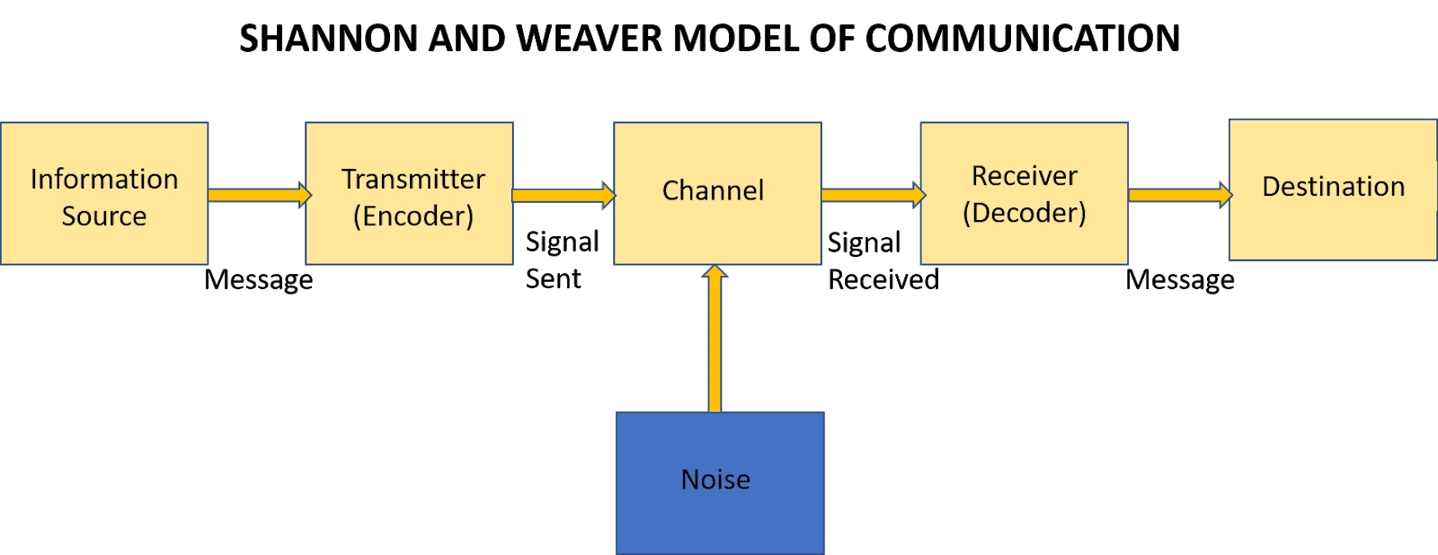
Within this model the information for communication is derived from the source, encoded with the transmitter, signal sent via the channel where noise is present, the receiver receives the encoded message and the destination is fixed with decoded message.
Information source or sender: The sender is the person who is the initiator of the communication with message and information to the receiver.
Transmitter: the transmitter where the information is encoded for the receiver is the process of making it effective for the communication process.
Channel: The channel encompasses the media for connecting the receiver with the sender of information.
Receiver: The receiver receives the message with encoded links. The receiver receives the encoded message which is decoded to make understand by the receiver.
Destination: the decoded information or message is used by the receiver where the motive of the communication is achieved.
Berlo’s model of communication
Berlo’s model of communication is the extended version of Shannon and Weaver model of communication. In this model there are six stages of communication which can be presented with a graph below:

As per the graph, the model is interacted with media, channel and message which is sent to the receiver by the sender or source of the communication by encoding the message. The channel sends the message by decoding them to the receiver (Mandal, 2014).
Schramm Communication Model
The Schramm communication model is a classical communication model that states three main components of communication. It focusses on the sender, receiver and the message in the communication model. There are different other things that are complementary to make communication effective and attain the motive of communication. The process of communication with this model works with the following process.
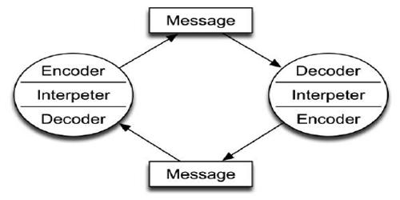

Case study about communication:
The process of communication in an organization is interacted among people to exchange thoughts and ideas among the people. The organizational personnel are involved in communication model to perform the communication activities. The case study about Max and Tamara example of very bad communication.
I think Max was completely lost and did not even focus because of lots of pressure. He was not paying attention and answering two calls same time. He was not organized at all as he is doing everything on his own, he should be more organized. Communication between Max and Tamara could have been successful if Max write down the dates in his dairy and double check that with Tamara after he finish his other call.

Communication in the workplace:
Communication is an important skill someone need for any interaction in workplace. In any workplace good communication in the main factor for success of the business. Effective communication in workplace reduce conflict between the employees and it improves team effectiveness, employee engagement and relationship between the business and clients.
Every organization must be enable to communicate in several direction. There are three types of organizational communication.
- Vertical communication can be two type upward and downward. In upward communication flows towards workers to managers.it can be feedback or suggestions from the lower levels. In downward communication its flows from manager to workers. It can be instruction, order, suggestion, feedback, warning.
- Horizontal communication it is the formal or informal exchange of idea between different individuals or departments at the same level in the organization.
- Diagonal communication is the communication that take place between a manager and a employee of other work groups. For example to design a training module a training manager meeting with an employee of IT.

Example of poor Communication in workplace:
In this part of the report, I will share my poor workplace communication experience. I am working for William Hill as a Shop manager. In our company we always do promotion for the customers. On one occasion company decided to do some promotion in some nominated store. My store was one of them store. But unfortunately, my Area Manager and Marketing department did not communicate with us. We were completely unaware of the promotion and did not received any promotional items. The day before the promotion I received a phone call from my Area Manager asking me what I done about the promotion starting from next day. I told him I am not aware of any promotion like that as no one communicate with me about that. He quickly checked all his emails and realized its his mistake he did not put our shop name in the list of communication. In that way we missed out an opportunity to give our customer a promotion which can give boost to our business.

How communication can be improved:
Being an Area Manager of the company, I believe he should have communicate with all departments of the company to make sure the promotion runs smoothly. And as an Area manager it was his responsibility to communicate with all the shop to inform them, they are participating in this promotion. By that, all the shop can advertise the promotion. For avoiding this kind of situation in future my suggestion is to follow the models of effective communication to improve communication skills. Also, he needs to follow the correct communication method by selecting the best communication channel to communicate within the organization. Also need to identify any barrier affecting the communication process. By doing so he can improve the communication skills.

Conclusion
The communication and collaboration are such thing that appreciates the value of team and its performance. With effective communication, the team of an organization works with the shared values among the members of the team. The members of an organizational team can collaborate with their skills, distribute their responsibilities and share their thoughts about the attainment of common goal. This report is about the communication model at an organization where the detailed aspects of communication have taken place. In this report the models of communication, theories of team development have been explained. The cases of poor communication has also been stated in this report from the company.

References
Ahmed, A., 2015. Learning Journal. Learning journal - Portfolio Assessment,.
Anderson, L., Bolden, R., Burgoyne, J., Collins, J., Dalziel, M., Davies, L., Ford, J., Garvey, B., Gray, D. and Hamlin, B., 2010. Gower Handbook of Leadership and Management Development. 5th ed.
Bear, J., 2011. Communication. London: Macdonald Educational.
Gallagher, K., 2013. Skills Development for Business and Management Students. 2nd ed. Oxford University Press.
Kraszewski, S. and McEwen, A., 2010. Communication skills for adult nurses. Maidenhead: Open University Press.
Lane, D., 2015. CULTURAL APPROACH- Organizational Communication Context. Uky.edu.
Mandal, F., 2014. Nonverbal Communication in Humans. Journal of Human Behavior in the Social Environment, 24(4), pp.417-421.
Maund, A., Schriek, M., and Tinkler, P.K. (2017). Certificate in Higher Education: Skills for the Workplace Student Yearbook. 1st Edition, London: SAGE
Nestor, R., 2013. Bruce Tuckman's Team Development Model. Available at: <http://bruce_tuckman_s_stages_of_team_development_.pdf>
van de Water, T., van de Water, H. and Bukman, C., 2007. A balanced team generating model. European Journal of Operational Research, 180(2), pp.885-906.

