BA DEGREE ASSIGNMENT SPECIFICATION
SCHOOL OF TOURISM & HOSPITALITY
Student name: | Raluca Suciu | Student number: | 2022597
Programmes: | BA International Hotel Management
Module: | Managing Hotel Administration | Module Level (4, 5, 6): | 6
Module code: | BMIH6004 | Contribution to Overall Module Assessment  (%): | 50%
Lecturer: | Christopher Wilkin  Rodrigo Fernandes Aguilera | Internal Verifier: | Lola Villard
Assignment Title: | Student Learning Log (1250 Words  +/-10%) | Assignment No: | 1 of 2
Hand Out Date: | w/c 24th of April 2023 | Submission deadlines: | Monday 16th
 |  |  | of June 2023
Draft Deadline: | Friday 2nd of June 2023 by 23h59 | Return date of | by 23h59
 |  | provisional marks & written feedback: | 10th of July 2023
 |  |  | by 23h59

Table of Contents
Introduction 3
Vocational development 4
Self-development 4
Academic development 6
Conclusion 8
Reference 9

List of Figures
Figure 1: Plan, Do, Check and Act 5
Figure 2: Kolb’s Experiential Learning Cycle 6

Introduction
The placement opportunity is one of the best and the most accessible for any student to gain some first-hand skills and have some academic experience in a field. Here is a reflection based on my placement in the Hilton hotels (Sonnenschein & Hibbins, 2018). Here in the reflection report, I have discussed the different kinds of experiences and problems that I came across during my placement period. Then I discussed how I have solved and how those problems and issues have helped me during my placement period. here some I have used the plan, do, check and act model for interacting with customer services in the hotel management and used Kolb’s Experiential Learning Cycle for my learning experience.

Vocational development
I got the chance to strengthen my academic and professional abilities during my work placement at Hilton Hotels & Resorts, which allowed me to obtain a thorough grasp of the hospitality sector. A quick general summary of my whole placement experience will be provided in this reflection, with particular attention paid to the accomplishment of the goals of the placement, my learning objectives, and the identification of both successful initiatives and lost opportunities. My objective as a vocational trainee was to gain an understanding of the actual hotel operations, and customer service abilities, and build rigid knowledge of hospitality management. Throughout the placement period, I have actively participated in several activities such as front desk jobs, housekeeping, and food and beverage (Bardi, 2011). This allowed me to obtain first-hand experience in many fields, which helped me to achieve my placement goals and objectives.
I developed my interpersonal and communication skills by communicating with my colleagues and customers. The focus on Hilton Hotels’ customer service has helped me with developing my problem-solving skills and having a customer-centric mentality. In this, reflection I have constantly tried to apply some theoretical concepts to connect my academic and placement experience. In retrospect, I could have shown more initiative in looking for possibilities for shadowing and cross-departmental encounters to have a better grasp of how the hotel operates. I also had the option of participating in networking events to meet business people in the field and maybe open doors for potential future employment opportunities. My internship with Hilton Hotels & Resorts was rewarding and a great learning opportunity. Obtaining useful information, increasing my customer service abilities, and laying a foundation in hotel management, helped me accomplish my placement goals.

Self-development
The difficulty of enhancing guest services and efficiently handling customer complaints was one management issue I witnessed and actively participated in during my internship at Hilton Hotels & Resorts. Customer satisfaction and the hotel's name were significantly impacted by this operational problem. I suggest using the "PDCA" (Plan-Do-Check-Act) cycle, a problem-solving approach, to tackle this issue.
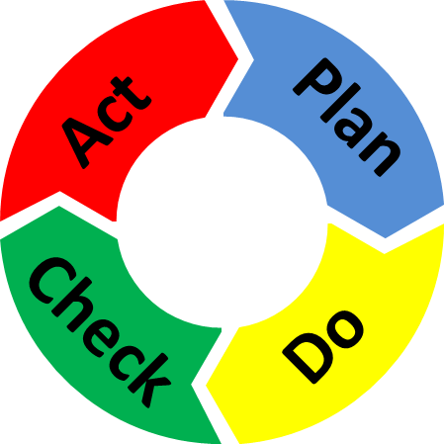
Figure 1: Plan, Do, Check and Act
Source: (Alim & Chen, 2019)
Analysis of present guest service practices is the first phase, followed by planning for areas that need to be improved. Regular feedback gathering, surveys, and examination of customer concerns can help with this. The hotel can address certain problems, including employee training, communication procedures, or operational inefficiencies, by recognizing recurring themes, quality issues, working processes and hotel management issues. Action plans should be created and put into place when the issue areas have been identified. This might entail upgrading communication lines, changing standard operating procedures, or giving employees more training (Casado, 2012). Gradual deployment is best so that there is no disturbance to regular business operations and enough time for workers to adjust. At this point, the efficacy of the solutions put into practice should be evaluated. To track advancements, it is important to regularly analyze performance data, guest input, and satisfaction surveys. The efficiency and viability of the solutions may be better understood with regular communication between personnel and management. The required modifications and improvements should be made in light of the comments and assessments from the previous phase. If the tried-and-true fixes work, they ought to be standardized and included in the hotel's standard operating procedures. However, the procedure should loop back to the planning step for more analysis and solution creation if any problems continue or new difficulties emerge.

Academic development
I actively gained important skills in self-management and growth, task management, using initiative to solve problems at work, communication, and the application of information during my vocational placement at Hilton Hotels & Resorts. My job was to gather knowledge about hotel management, which refers to overseeing different operations of hotels and resorts (Reyes-Menendez & Martinez-Navalon, 2019). Kolb's Experiential Learning Cycle, which consists of four stages—Concrete experience, active experimentation, abstract conceptualization, and reflective observation—will be used to help me reflect on my experiences moving forward.
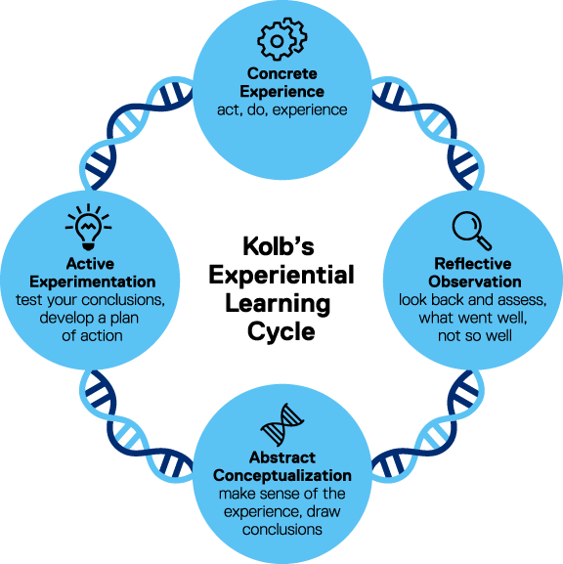
Figure 2: Kolb’s Experiential Learning Cycle
Source: (Morris, 2019)
In the concrete experience stage, I had firsthand experience of dealing with a lot of customer issues in the hotel business which allowed me to gain some good academic skills of problem-solving and communication. for instance, I had a chance to deal with different kinds of customer issues that needed showing empathy, maintaining composure and dealing with difficult customer situations. These encounters helped me to build endurance, flexibility and professionalism in a dynamic workplace (Azar & Ahmad, 2020). In the active experimental stage, I actively experimented with various tactics and ways to strengthen my abilities and effectiveness, drawing on my practical experiences. For instance, I aggressively solicited input from my managers and peers and put their recommendations into practice to improve my customer service methods. To expand my skill set and develop a comprehensive grasp of hotel operations, I also took on new tasks and volunteered for cross-departmental initiatives.
In the abstract conceptualization stage, I established some principles of self-improvement and some self-management process. Ideas linked such as task management, initiative, communication, and knowledge application via reflection and analysis of my experiences. For instance, I discovered the value of time management and prioritization in completing projects and meeting deadlines. I also understood the significance of proactive problem-solving and taking charge of workplace difficulties right away (Pol & Patil, 2019). The reflective observation allowed me to regularly assess my performance, take into account the results, and derive lessons for future development. I thought about how I might improve my spoken and written interactions in both internal and external encounters. I actively looked for opportunities to do this. I also noticed how using my expertise in practical ways, including comprehending consumer preferences and employing successful sales strategies, improved visitor happiness and helped the company meet its goals.

Conclusion
Hilton Hotel offers some extraordinary and tremendous features for placement learning. The practical experience I have gathered in the placement period has been a real pleasure. There were some customer complaints and issues in the hotel premise, dealing with which was a tough situation. there were some possibilities for cross-departmental interactions but I had some limitations for my placement (Frawley & Law, 2018). Overall, I have some practical and academic experience in the field of work in Hilton hotels. I have learned the different aspects of hotel management and have managed to learn a lot from the different kinds of jobs during the placement. There were some mistakes during the room services but I think my experience would have been more exciting if I had a chance for cross-sectional networking.

Reference
Alim, I. and Chen, Y. (2019) ‘Selenium drives a transcriptional adaptive program to block ferroptosis and treat stroke’, Cell, 177(5). doi:10.1016/j.cell.2019.03.032.
Azar, A.S. and Ahmad, A. (2020) ‘The effectiveness of hospitality experiential learning from academic and Industry Perspectives’, Journal of critical reviews, 7(12). doi:10.31838/jcr.07.12.56.
Bardi, J.A. (2011) Hotel Front Office Management. Hoboken, NJ, London: John Wiley and Sons, Inc.
Casado, M.A. (2012) Housekeeping management. Hoboken, NJ, London: John Wiley & Sons.
Frawley, T. and Law, R. (2018) ‘Quality assurance at Hotel Management Tertiary Institutions in Australia: An insight into factors behind domestic and international student satisfaction’, Journal of Hospitality & Tourism Education, 31(1), pp. 1–9. doi:10.1080/10963758.2018.1480961.
Morris, T.H. (2019) ‘Experiential learning – A systematic review and revision of Kolb’s model’, Interactive Learning Environments, 28(8), pp. 1064–1077. doi:10.1080/10494820.2019.1570279.
Pol, R.S. and Patil, H. (2019) ‘Perception of final year hotel management students towards working in hotel industry’, ATITHYA: A Journal of Hospitality, 1(2). doi:10.21863/atithya/2015.1.2.017.
Reyes-Menendez, A. and Martinez-Navalon, J.G. (2019) ‘The impact of e-WOM on hotels management reputation: Exploring TripAdvisor review credibility with the elm model’, IEEE Access, 7, pp. 68868–68877. doi:10.1109/access.2019.2919030.
Sonnenschein, K. and Hibbins, R. (2018) ‘Benefits of work-integrated learning: Perceptions held by Chinese international students enrolled in an Australian University and managers in the Chinese Hotel Industry’, Journal of Hospitality & Tourism Education, 31(3), pp. 139–148. doi:10.1080/10963758.2018.1487784.

